SALES DATA ANALYSIS PROJECT
Sales Performance Dashboard
Full Project Report
Internship Mini Project
Tools: Excel • Power Query • Python • Pandas • NumPy • Matplotlib • Power BI

1. Introduction
Sales Data Analysis is the process of collecting, cleaning, analyzing and visualizing sales information to understand business performance. In this project, a sales dataset containing 250 transaction records was analyzed using Excel/Power Query, Python and Power BI. The final output is an interactive Sales Performance Dashboard containing KPI cards, charts, slicers and business insights.

2. Objectives of the Project
- Understand the structure and quality of the sales dataset.
- Clean duplicate and missing records and prepare the data for analysis.
- Calculate important sales KPIs.
- Analyze product, regional, category, monthly and payment-method performance.
- Create professional charts using Python and Matplotlib.
- Build an interactive dashboard in Power BI.
- Identify important business insights from the results.

3. Dataset Description
The final working dataset contains 250 rows and 11 columns. The main fields and their uses in this project are shown below.
Column | Description | Project Use
Order ID | Unique order identifier | Total Orders KPI
Order Date | Date of the transaction | Monthly Sales Trend
Customer | Customer name | Data field; not used as a KPI
Product | Product purchased | Top Five Products
Category | Product category | Category-wise Sales
Region | Sales region | Regional Sales and Region slicer
Quantity | Number of units sold | Total Quantity Sold KPI
Unit Price | Price per unit | Sales/product analysis
Discount | Discount applied | Data analysis field
Sales | Final sales amount | Main sales KPI and charts
Payment Method | Method used for payment | Payment Method Analysis

4. Tools and Technologies Used
Microsoft Excel: Initial inspection and basic data cleaning.
Power Query: Data transformation and preparation.
Python: Data analysis and calculations.
Pandas: Data loading, cleaning, grouping and aggregation.
NumPy: Numerical analysis support.
Matplotlib: Creation of sales charts.
Power BI: Interactive dashboard, KPI cards, charts and slicers.

5. Data Cleaning and Preparation
The raw data was inspected for duplicate records, missing values and data-type issues. Duplicate records were removed, leaving 250 records for the final analysis. Missing values in Customer and Payment Method were replaced with 'Unknown'. Order Date was converted to a proper date format so that monthly sales could be analyzed.
df["Customer"] = df["Customer"].fillna("Unknown")
df["Payment Method"] = df["Payment Method"].fillna("Unknown")
df["Order Date"] = pd.to_datetime(df["Order Date"], dayfirst=True)

6. Python Analysis
Python was used to calculate summary statistics and group the data for product, regional, category and monthly analysis. Pandas was used for data manipulation, NumPy for numerical support, and Matplotlib for visualization.

7. Key Performance Indicators (KPIs)
The final Power BI dashboard uses four KPI cards. Total Customer is intentionally excluded because it was not used in the final dashboard.
KPI | Dashboard Value | DAX / Calculation
Total Sales | ₹18,913,205.50 | SUM(Sheet1[Sales])
Total Orders | 250 | COUNTROWS(Sheet1)
Total Quantity Sold | 986 | SUM(Sheet1[Quantity])
Average Sales per Order | ₹75,652.82 | DIVIDE(SUM(Sheet1[Sales]), COUNTROWS(Sheet1))

8. Power BI Dashboard
The final dashboard is titled 'Sales Performance Dashboard'. It combines KPI cards, analytical charts, slicers and a Business Insights panel in a single page.
- KPI Cards: Total Sales, Total Orders, Total Quantity Sold and Average Sales Order.
- Monthly Sales Trend: line chart showing sales from January to December.
- Top Five Products: horizontal bar chart showing the five products with the highest sales.
- Payment Method Analysis: donut chart showing the sales contribution of each payment method.
- Regional Sales: column chart comparing Central, East, South, North and West regions.
- Category Wise Sales: bar chart comparing Electronics, Accessories, Office Equipment and Wearables.
- Slicers: Month Name and Region.
- Business Insights: text panel summarizing the main findings from the analysis.
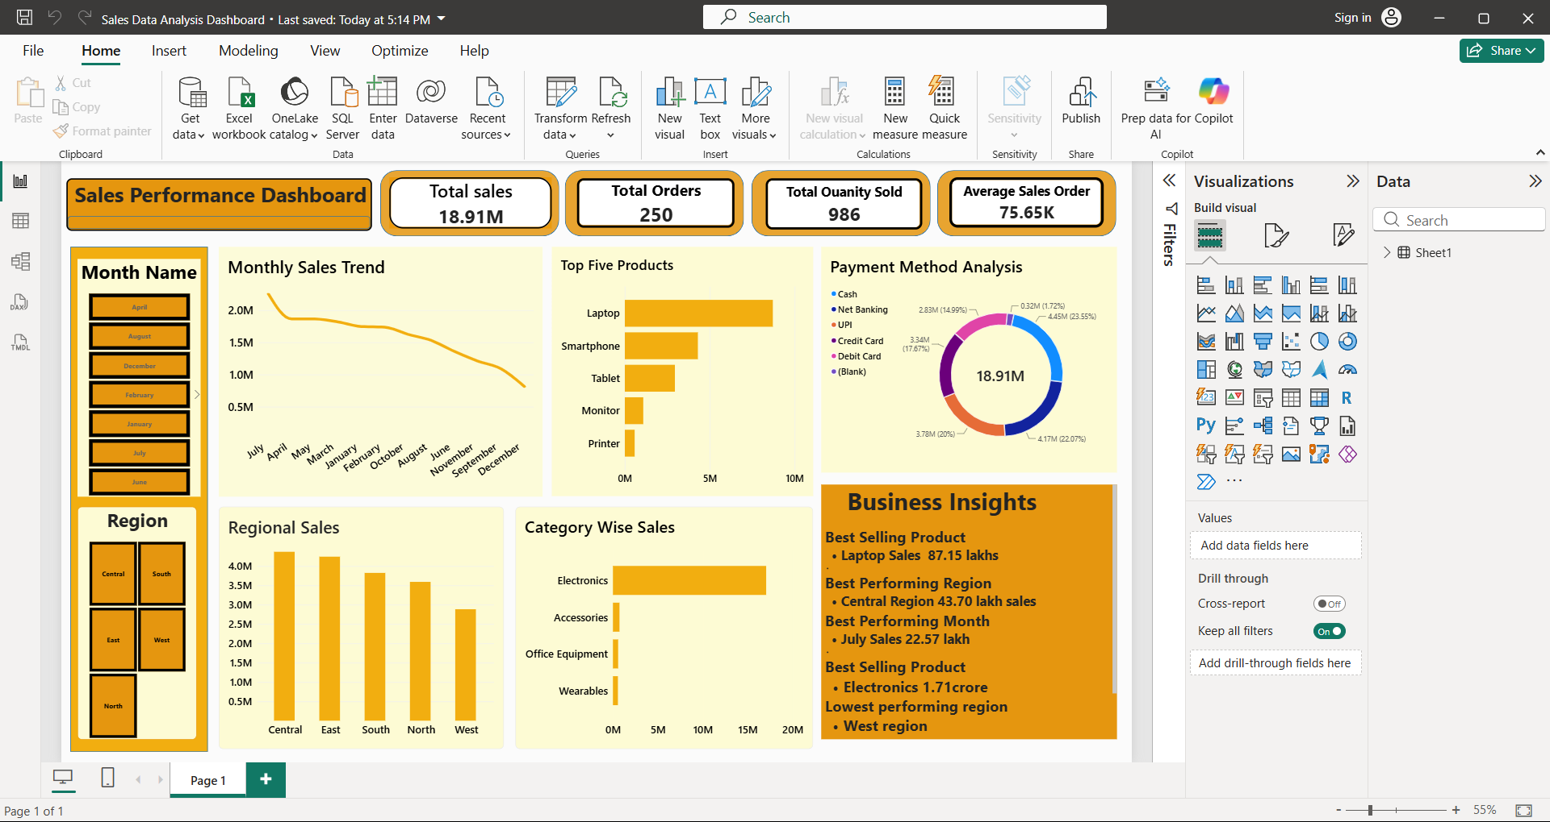
Figure 5. Final Power BI Sales Performance Dashboard

9. Visual Analysis
The following visualizations were created in Python and used as the analytical foundation for the Power BI dashboard.
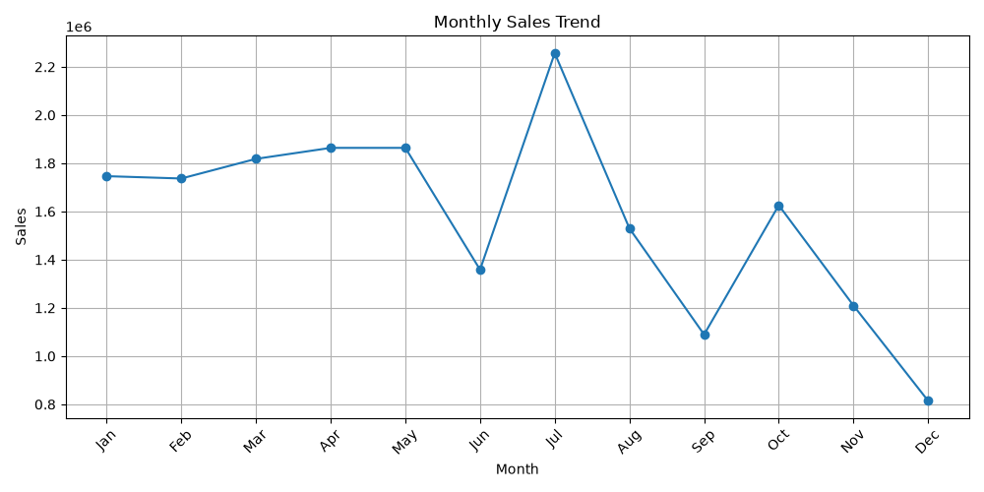
Figure 1. Monthly Sales Trend
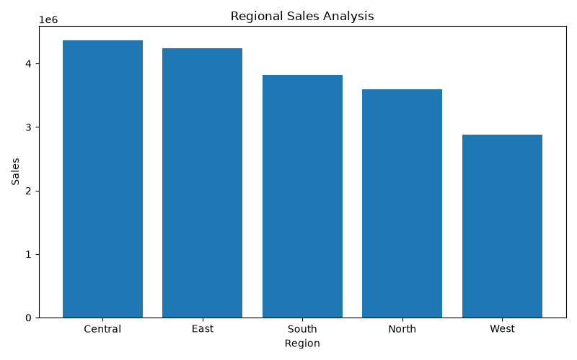
Figure 2. Regional Sales Analysis
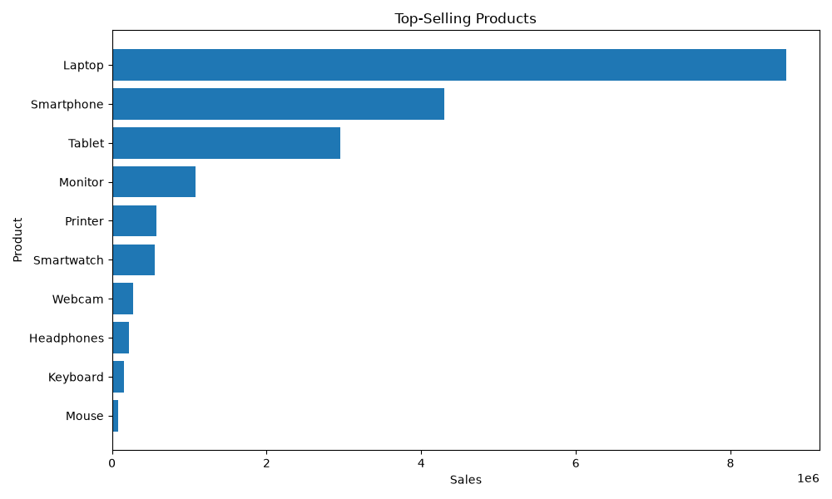
Figure 3. Top-Selling Products
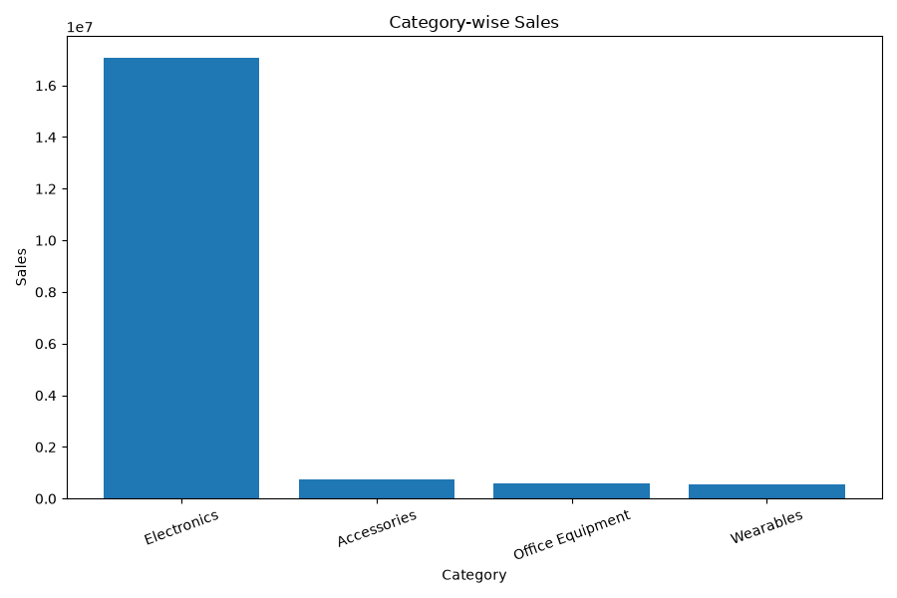
Figure 4. Category-wise Sales Analysis

10. Analysis Results

10.1 Product Analysis
Laptop is the highest-selling product with sales of ₹8,715,757.50. It is followed by Smartphone and Tablet. The Top Five Products chart clearly shows a large gap between the leading product and the remaining products.

10.2 Regional Analysis
Central is the best-performing region with sales of ₹4,370,173.50. West has the lowest regional sales at ₹2,883,638.50.

10.3 Category Analysis
Electronics is the strongest category with sales of ₹17,051,260.00. The category chart shows that Electronics contributes the majority of total sales compared with the other categories.

10.4 Monthly Analysis
December recorded the highest monthly sales at ₹1,090,366.00, while April recorded the lowest at ₹229,358.00. The monthly trend therefore shows noticeable variation in sales during the year.

10.5 Payment Method Analysis
The Payment Method Analysis donut chart compares sales generated through Cash, Net Banking, UPI, Credit Card, Debit Card and the available blank/unknown category. This helps understand how customers are contributing to sales through different payment channels.

11. Business Insights
- Best-Selling Product: Laptop generated ₹8,715,757.50 in sales.
- Best-Performing Region: Central generated ₹4,370,173.50 in sales.
- Best-Performing Month: December recorded the highest monthly sales of ₹1,090,366.00.
- Best-Performing Category: Electronics generated ₹17,051,260.00 and dominates category sales.
- Lowest-Performing Region: West recorded the lowest regional sales of ₹2,883,638.50 and may need improvement.

12. DAX Measures Used in Power BI
Total Sales = SUM(Sheet1[Sales])
Total Orders = COUNTROWS(Sheet1)
Total Quantity Sold = SUM(Sheet1[Quantity])
Average Sales Order = DIVIDE(SUM(Sheet1[Sales]), COUNTROWS(Sheet1))

13. Conclusion
The Sales Data Analysis project successfully transformed a 250-record sales dataset into a useful analytical dashboard. Total sales were ₹18,913,205.50, with 250 orders and 986 units sold. The analysis identified the strongest product, region, category and month, while also highlighting the lowest-performing region. The combination of Python visualizations and Power BI provides both detailed analysis and an easy-to-understand interactive summary for business decision-making.

14. Future Scope
- Add profit and profit-margin analysis if product cost data is available.
- Add sales forecasting for future periods.
- Add year-over-year growth when multiple years of data are available.
- Add drill-through pages for product and regional details.
- Add customer segmentation as a separate future analysis if required.

15. Project Deliverables
- Cleaned sales dataset.
- Python analysis and visualization script.
- Monthly, regional, product and category charts.
- Power BI Sales Performance Dashboard.
- Final project report.

