**Prob3 (c): Mansour**

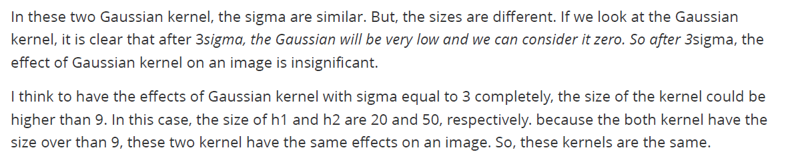

**Prob3 (d): Laurent**

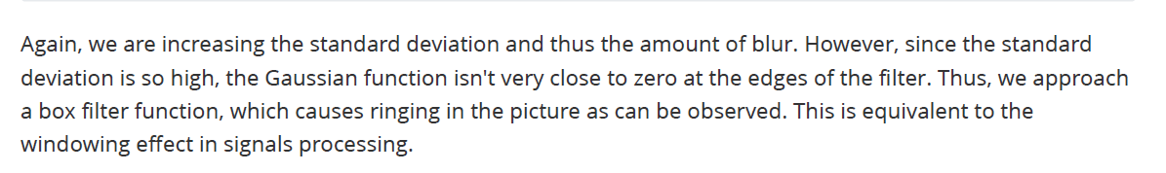

**Prob4** Show a code for problem