Cardiff Metropolitan University
Cardiff School of Technologies
Bachelor of Science with Honours in Software Engineering

IoT-Based NPK Soil Nutrient Monitoring and Fertiliser Recommendation System
A Multi-Tier Field and Advisory Platform for Sri Lankan Agriculture

Module CSE6035 — Development Project
Submitted in [Month, Year]

By
Kiringoda Gamage Madhava Dineth
Cardiff Number: 20311933
ICBT ID: [XX/XXXXX/XX/XX]

This dissertation is submitted in partial fulfilment of the requirements for the degree of Bachelor of Science in Software Engineering

Declaration
This work is being submitted in partial fulfilment of the requirements for the degree of BSc (Hons) Software Engineering and has not previously been accepted in substance for any degree and is not being concurrently submitted in candidature for any degree.
Signed: Madhava (Candidate) Date: 29/08/2026

Supervisor’s Declaration Statement
Student Name: K. G. Madhava Ditneth
Supervisor’s Name: Sajeewani Ponnamperuma Arachchige
I acknowledge that the above named student has regularly attended the meeting, and actively engaged in the dissertation supervision process.
Signed: sajeewani (Supervisor) Date: __/08/2026
Transcribed from the signed declaration form supplied for this submission (see Appendix A for the accompanying supervisor log sheets). The supervisor’s signing date was left as day-blank on the original form — fill in the day if it was later completed, otherwise leave as submitted.

Acknowledgement
Write your own acknowledgements here (two or three short paragraphs): your supervisor, the module leader, the four agriculture extension officers who gave you interview time, ICBT lecturers, and family. This is the one page a marker reads that is entirely in your own voice.

Abstract
Fertiliser decisions in Sri Lanka are routinely made without quantitative knowledge of a plot’s nutrient status. The available alternatives are wet-chemistry laboratory analysis, which is accurate but slow and centralised, and the colorimetric field kit distributed to agrarian service centres since 2021, which is portable but yields only categorical low / medium / high output. The national cost of managing nutrients without data was demonstrated by the 2021 chemical fertiliser import ban and the yield collapse that followed.
This project designed, implemented and functionally evaluated an end-to-end platform that closes part of that gap. An ESP32 microcontroller interfaced to an RS485 three-in-one soil probe over Modbus RTU captures nitrogen, phosphorus and potassium in milligrams per kilogram, displays them on a 20×4 character screen so a reading is usable without connectivity, and posts them as JSON to a Django 6 REST backend over WiFi. The backend validates every reading against a physical-plausibility bound, resolves the transmitting device to a registered plot, and persists it to MySQL with a server-assigned timestamp. A React single-page application and a native Android client then serve three distinct audiences: farmers see one plot in detail, with staged fertiliser quantities derived from published Department of Agriculture programmes and scaled to their registered acreage; administrators maintain the reference data those recommendations depend on; and agricultural officers see soil health, fertiliser demand and crop distribution aggregated across all twenty-five districts.
Two recommendation methods are used, each on the question it suits. Correcting a deficiency in an established crop is a deterministic lookup against crop requirement bands and departmental application rates. Ranking candidate crops for unplanted land is handled by a k-nearest-neighbours classifier (k = 5) trained on 108 labelled samples across nine crop classes, which achieved 31.5 % accuracy under leave-one-out cross-validation. That figure is low, and the reason is stated openly: the training set is synthetic, generated by uniform sampling inside the same crop bands the rule-based engine uses, so the model has no information the rules do not already contain. Sensor readings were likewise not validated against wet-chemistry reference samples. The system is therefore positioned as a field-level screening and trend-monitoring instrument rather than a laboratory substitute. Its principal contribution is architectural rather than algorithmic: a single reading taken for one plot simultaneously produces a fertiliser quantity for the farmer, a point in that plot’s history, and a contribution to the district aggregate on which fertiliser planning actually operates.
Key terms: soil nutrient monitoring, Internet of Things, Modbus RTU, fertiliser recommendation, crop suitability classification, agricultural extension.

Table of Contents
Right-click the field below in Word and choose “Update Field” once the document is final.

Chapter 01: Introduction

1.1 Background
Agriculture remains a cornerstone of Sri Lanka’s economy, employing a significant proportion of the rural workforce and underpinning national food security. Fertiliser management, however, has historically been an area of national vulnerability. The 2021 nationwide ban on chemical fertiliser imports — intended to transition the country to fully organic agriculture — produced sharp yield declines within a single growing season, forcing costly rice imports and contributing to broader economic instability (Drechsel et al., 2025; IWMI, 2025). While the ban was reversed within seven months, the episode exposed a deeper structural problem: farmers and extension officers had no reliable, data-driven means of determining actual soil nutrient status before applying fertiliser, whether organic or chemical.
Traditional soil nutrient testing, conducted through wet-chemistry laboratory analysis, is accurate but slow, costly and geographically inaccessible to many smallholder farmers. In response, the Sri Lankan Department of Agriculture has since 2021 distributed mobile soil test kits to agrarian service centres; that method remains manual and colorimetric, comparing soil colour against a reference booklet to classify nutrient levels as low, medium or high (Department of Agriculture, 2026). The gap between the need for precise, timely nutrient data and the practical means of obtaining it motivates the present study.

1.2 Problem Statement
Fertiliser application decisions in Sri Lanka are routinely made without quantitative knowledge of a plot’s actual nutrient status. The available alternatives are laboratory testing, which is accurate but slow and centralised, and the existing colorimetric field kit, which is portable but produces only categorical output — low, medium or high — rather than numeric values, limiting the precision of any dosage derived from it.
A second, less-examined problem sits above the individual plot. Fertiliser demand planning and subsidy allocation operate at district level, yet the soil data that would inform them is neither collected in a structured form nor aggregated. Even where an individual test is performed, the result informs one farmer’s decision and is then lost.
Add one or two specific operational pain points raised by the extension officers you interviewed (see Section 4.3). A concrete complaint in the officers’ own framing strengthens this section considerably, and a viva panel will look for it.

1.3 Aim
This research aims to design, implement and evaluate an IoT-based soil nutrient monitoring and advisory platform that captures quantitative NPK measurements in the field, translates them into crop-specific fertiliser and cultivation guidance for the person working the land, and aggregates them into district-level information for agricultural planning.

1.4 Objectives
- To design and implement a portable sensing device based on an ESP32 microcontroller and an RS485 NPK probe, capable of capturing nitrogen, phosphorus and potassium readings in the field and displaying them locally without requiring network connectivity.
- To develop a server-side platform using Django REST Framework and MySQL that ingests readings from multiple devices, associates each with a registered plot by device identifier, and enforces validation at the point of ingestion.
- To implement a rule-based fertiliser recommendation engine that compares measured nutrient levels against crop-specific requirement bands and derives staged application quantities from published Department of Agriculture programmes, scaled to the actual area of the plot.
- To implement a machine-learned crop suitability classifier that ranks candidate crops against an observed soil profile, supporting cultivation decisions on unplanted land, and to report its measured accuracy honestly.
- To develop role-differentiated interfaces serving farmers, system administrators and agricultural officers, including a bilingual Sinhala and English web interface designed for outdoor mobile use and a native Android client for the same farmer workflow.
- To evaluate the system through functional and integration testing across the full pipeline, and to document its accuracy limitations and validation requirements honestly.
Confirm these objectives with your supervisor before submission. Section 8.1 evaluates the project directly against them, so an objective you cannot evidence is worse than an objective you did not set.

1.5 Proposed Solution
The solution is an end-to-end pipeline. An ESP32 microcontroller interfaced with an RS485 three-in-one soil probe through a transceiver module captures nitrogen, phosphorus and potassium readings at the plot and displays them on a 20×4 character screen, allowing a reading to be taken and read without a connected phone or laptop. The device transmits each reading as a JSON payload over WiFi to a Django REST Framework backend, which validates it, associates it with a registered plot by device identifier and persists it to MySQL.
A React single-page application presents three distinct views. Farmers see their own plot: current readings, fertiliser quantities for their actual acreage, cost and profitability estimates, and cultivation history. Administrators manage the reference data — crop requirement bands, fertiliser and market prices, crop economics, and the training data behind the classifier. Agricultural officers see district-level aggregates: soil health mapped across the country, fertiliser demand totals and crop distribution. A native Android client, written in Kotlin with Jetpack Compose, provides the same farmer-facing login, registration and dashboard workflow on a phone without a browser.

1.6 Scope and Limitations
The system is scoped to nitrogen, phosphorus and potassium as measured by a low-cost RS485 probe, together with manually entered pH and moisture values — the three-in-one probe used reports N, P and K only, so pH and moisture are typed in on the client rather than sensed. It covers 21 crops for which Department of Agriculture (HORDI) or Department of Export Agriculture guidance was available, across Sri Lanka’s 25 districts.
Sensor readings were not validated against wet-chemistry laboratory reference samples within the timeframe of this project, and the crop-suitability classifier was trained on synthetically generated samples rather than field-collected ones. Both limitations are stated here rather than deferred, because they condition how every output of the system should be read: as a screening and trend-monitoring instrument, not a laboratory-equivalent measurement. Sections 7.3 and 7.4 develop these points and Section 9.2 identifies validation and real training data as the two priority items of further work.

1.7 Structure of the Dissertation
Chapter 2 reviews soil nutrient management in the Sri Lankan context, the existing institutional testing workflow, comparable IoT sensing systems, and the two recommendation paradigms, closing with the research gap this project addresses. Chapter 3 covers feasibility, risk, strategic analysis and the methodology adopted. Chapter 4 sets out the requirements derived from that gap and from interviews with extension officers. Chapter 5 presents the system design across the four architectural layers, the database schema, the two recommendation engines and the interface design. Chapter 6 describes how that design was implemented and the faults encountered along the way. Chapter 7 reports the testing performed and states plainly what was not tested. Chapter 8 evaluates the delivered system against the objectives and against comparable work. Chapter 9 concludes and identifies further work.

Chapter 02: Literature Review

2.1 Soil Nutrient Management in the Sri Lankan Context
Nitrogen, phosphorus and potassium are the primary macronutrients governing crop yield, and their availability varies significantly by region, crop history and management practice. In Sri Lanka the consequences of managing them without data were demonstrated by the 2021 fertiliser import ban, which forced an abrupt transition to organic-only agriculture. Independent assessments found vegetable, maize and rice yields per hectare fell by 57 %, 68 % and 53 % respectively in the short term (Drechsel et al., 2025), while rice harvests dropped by 32 % and tea production by 18 %, with tea export losses alone estimated at USD 425 million (IWMI, 2025).
Before submission, open both sources and confirm each of these five numbers against the text. A misattributed statistic in the opening paragraph of a literature review undermines a marker’s confidence in everything after it.

2.2 Existing Soil Testing Provision
Since 2021 the Ministry of Agriculture has run a programme establishing soil testing facilities at agrarian service centres across most provinces, using mobile soil test kits operated by Agriculture Instructors, with one kit distributed per centre (Ministry of Agriculture, 2026). The methodology remains fundamentally manual: officers collect a sample, air-dry it, and compare colour against a reference booklet to classify nutrient levels as low, medium or high before selecting a recommendation from a lookup table (Department of Agriculture, 2026).
Three properties of this baseline matter for the present work. It is colorimetric and therefore subjective; it is restricted by kit availability to roughly one instrument per centre; and it produces categorical rather than quantitative output, which bounds the precision of any dosage derived from it. This is the institutional workflow a replacement technology would have to improve upon to see adoption.

2.3 IoT-Based Soil Nutrient Monitoring Systems
A growing body of work proposes replacing manual testing with electronic sensing. Early implementations connected an NPK probe through a Modbus transceiver to a microcontroller, forwarding readings to a cloud service and comparing measured values against crop requirements by lookup — architecturally similar to the pipeline implemented here.
Islam et al. (2023) developed a device combining FC-28, DHT11 and JXBS-3001 sensors to capture soil composition, moisture, humidity and temperature, transmitting over MQTT and applying a Random Forest model — chosen for its resistance to overfitting and its exposure of feature importance — to generate crop and fertiliser recommendations. Senapaty, Ray and Padhy (2023) likewise combine IoT soil sensing with a learned recommendation layer, and are cited in Section 5.1 for the transport-protocol argument.
Fathima, Kumar and Bagali (2026) built an embedded real-time NPK monitoring system with dual output to a local display and an Android application, concluding that it was reliable for quantitative nitrogen and phosphorus analysis but only for qualitative trend monitoring of potassium. This is a direct acknowledgement that low-cost electronic NPK sensing does not deliver uniform accuracy across the three macronutrients — a finding this project takes seriously in Section 7.4.

2.4 Sensor Reliability and Calibration
A recurring theme across the literature is that low-cost soil sensors are indirect measurement instruments. Nitrogen readings are typically derived from electrical conductivity and organic matter correlation rather than direct chemical assay; phosphorus estimation is considered less reliable owing to the complexity of soil phosphorus chemistry; potassium is generally the most reliable of the three (Zbotic, 2026). Such sensors are consequently positioned as tools for comparative analysis and trend monitoring rather than substitutes for wet-chemistry testing.
No source reviewed reports a formal accuracy validation of an RS485 NPK probe against wet-chemistry reference samples under Sri Lankan soil conditions specifically. This project does not close that gap, and Section 7.4 says so explicitly rather than implying an accuracy that was never measured.

2.5 Recommendation Approaches: Rule-Based and Machine-Learned
The literature divides into two recommendation paradigms: threshold comparison against crop requirement tables, and learned prediction from labelled soil–crop data (Islam et al., 2023). The trade-off is well understood. A rule-based model is transparent, auditable and requires no training data, which suits a recommendation that a non-technical user must trust and an officer must be able to explain. A learned model can capture non-linear nutrient interactions and produces a natural ranking across many candidate outputs, but depends on labelled data whose availability at useful regional granularity cannot be assumed for Sri Lankan soils — a dependency this project ran directly into, as Section 6.5 reports.
Most reviewed systems adopt one paradigm or the other. The present work uses both, on the observation that the two paradigms suit different questions rather than competing on the same one: correcting a deficiency in an established crop is a lookup against published guidance, whereas ranking candidate crops for an unplanted plot is a classification problem. Section 5.4 develops this argument. If you can find one or two further sources on hybrid or ensemble approaches in agricultural decision support, add them here — the claim that combining the paradigms is appropriate is currently your own reasoning, which is acceptable but would be stronger with support.

2.6 Communication Protocols for Field IoT Devices
MQTT is the protocol most commonly reported in the reviewed IoT agriculture literature. Its publish–subscribe model decouples the sensor node from its consumers, and it is generally reported as the more power-efficient of the two options in continuous monitoring, since its framing overhead per message is far smaller than an HTTP request–response cycle. A specific power-saving percentage was quoted in an earlier draft without a traceable source; the figure has been removed rather than cited loosely. If you locate the controlled comparison, restore the numbers with the citation.
This project nonetheless transmits over HTTP. The reasoning is set out in Section 5.1 and rests on deployment simplicity and diagnosability rather than on a claim that HTTP is technically superior; the power advantage of MQTT is real but was judged not to outweigh the cost of operating a broker at this scale, particularly given that the prototype device is mains- or USB-powered rather than running on a constrained battery budget. Confirm how your device is powered and state it in Section 5.2.1 — if it does run on a battery, this justification needs revisiting honestly.
LoRaWAN was considered for its long-range, low-power profile, widely used in large-scale precision agriculture, but requires dedicated gateway infrastructure disproportionate to a single-device deployment. It is noted in Section 9.2 as a candidate should the system scale toward permanently deployed sensor networks.

2.7 Comparative Analysis of Existing Systems
System | Sensing | Transport | Recommendation | Users served | Lab-validated
Islam et al. (2023) | FC-28, DHT11, JXBS-3001 | MQTT | Random Forest | Farmer | Partial
Fathima et al. (2026) | Embedded NPK | Local + app | Threshold | Farmer | N and P only
DoA field kit | Colorimetric | Manual booklet | Category lookup | Extension officer | N/A (manual)
This project | RS485 NPK, ESP32, local LCD | HTTP REST | Rule-based + KNN | Farmer, administrator, officer | No (Section 7.4)
Table 2.1: Comparison of reviewed systems against the present work

2.8 Research Gap
Three gaps emerge. First, the reviewed systems each serve a single user type — almost always the individual farmer — and none connect field measurement to the district-level aggregation on which fertiliser planning and subsidy allocation actually operate. Data collected for one plot informs one decision and is then lost.
Second, sensor reliability across the three macronutrients is inconsistently reported, with most systems presenting NPK output as uniformly trustworthy despite evidence that accuracy differs materially between them.
Third, no reviewed system benchmarks itself against Sri Lanka’s existing colorimetric field workflow — the actual institutional baseline any replacement must outperform.
This project addresses the first gap directly by implementing farmer, administrator and officer interfaces over a shared data model, so that a reading taken for one plot also contributes to a district picture. It addresses the second by acknowledging per-macronutrient reliability differences rather than treating NPK as one class. It addresses the third by positioning the system explicitly as an upgrade path from the agrarian service centre kit rather than as a laboratory substitute.

Chapter 03: Project Planning and Methodology

3.1 Feasibility

3.1.1 Technical Feasibility
The stack — ESP32, RS485 NPK probe, Django REST Framework, MySQL, React, Kotlin/Jetpack Compose — uses mature, well-documented technologies with active community support. Each component was independently prototyped before integration, confirming viability. The principal technical risk lay in the Modbus link between microcontroller and probe, which is why that path was established first (Section 6.1).

3.1.2 Economic Feasibility
Hardware costs are low relative to laboratory testing fees, and every software component used is open-source with no licensing cost. The backend runs on the WAMP stack already installed for development, and the frontend build tooling is free.
Insert your actual bill of materials as a small table here: ESP32 DevKit, RS485 transceiver module, three-in-one NPK probe, 20×4 I2C LCD, cabling and enclosure, with unit costs in LKR and a total. Then compare that total against the fee for a single wet-chemistry soil test. A concrete figure makes this argument far stronger than a general claim of affordability, and Appendix J is reserved for the receipts.

3.1.3 Operational Feasibility
The system targets users already operating within an established institutional structure. Extension officers already carry and operate the existing mobile soil test kit as part of their role, which reduces adoption friction relative to introducing an entirely new workflow. The farmer-facing interface was designed on the assumption of low technical literacy and outdoor mobile use, discussed in Section 5.5, and is available both as a browser application and as an installable Android package.

3.1.4 Schedule Feasibility
Insert your project timeline or Gantt chart summary with the module start date and key milestones. The brief lists project registration, proposal, two progress submissions and final submission — map your work against those five checkpoints and reference the chart in Appendix K.

3.2 Risk Management
Risk | Likelihood | Impact | Mitigation and outcome
RS485 Modbus communication failure | High (occurred) | High | Root-caused to transposed A/B conductors and a loose terminal; resolved by correcting polarity and reseating connections (Section 6.6.1). Prompted the plausibility filter in Section 5.2.3.
Sensor accuracy variance across soil types and macronutrients | Medium | High | Documented as a stated limitation (Section 7.4); system positioned as a screening rather than laboratory-equivalent instrument.
No labelled field data for the classifier | High (occurred) | High | A synthetic seeding routine was written so the pipeline could be built and demonstrated; the consequence for accuracy is reported openly in Sections 6.5 and 7.3 rather than concealed.
Backend routing fault causing 404 responses | Medium (occurred) | Medium | Root-caused to a URL configuration mismatch between the client call and urls.py; resolved by auditing the route table against the frontend API calls (Section 6.6.2).
Scope creep | High | Medium | Prioritisation by necessity: the core sensing-to-recommendation path was delivered before economics, mapping, classification and the Android client were added.
Add any further risk you actually encountered
Table 3.1: Risk register with realised outcomes

3.3 SWOT Analysis
Strengths. Quantitative readings in place of categorical colour matching; a single data model serving three user types; local LCD display allowing field use without connectivity; a low-cost open-source stack; alignment of fertiliser output with published departmental programmes; a bilingual interface delivered on both web and native Android.
Weaknesses. Sensor accuracy not validated against laboratory reference; a single prototype device rather than a tested fleet; a classifier trained on synthetic rather than field data; no automated test suite; no formal user acceptance testing session conducted.
Opportunities. The government soil-testing programme provides an institutional adoption pathway; the district aggregation layer addresses a planning need no reviewed system serves; the architecture extends to other South Asian contexts with comparable extension structures.
Threats. Hardware durability under field moisture and dust; dependence on probe reliability; volatility in fertiliser subsidy policy affecting relevance.

3.4 PESTEL Analysis
- Political. The 2021 ban and its reversal demonstrated that fertiliser policy is volatile; subsequent investment in soil-testing infrastructure signals institutional support for data-driven decisions.
- Economic. Foreign exchange constraints make fertiliser import cost a persistent national concern, and reduced over-application lowers farmer input cost directly.
- Social. Distrust of top-down agricultural policy following the 2021 crisis suggests that officer-mediated deployment, working through an existing relationship, may be received better than a direct-to-farmer application.
- Technological. Rising rural mobile penetration supports a browser-based interface and an Android client; falling component costs make field-grade hardware viable at student-project budgets.
- Environmental. Over-application contributes to nutrient runoff and soil degradation; dosage precision supports sustainability objectives directly.
- Legal. No specific Sri Lankan regulation currently governs agricultural IoT data collection, but the system stores owner names, contact numbers, district and plot coordinates, so data protection considerations apply. What was done: farmer and staff passwords are stored only as Django salted hashes, never in plaintext; session tokens are 32-byte random values rotated on every login; and every land-scoped endpoint is authorised server-side against that token. What was not done: the deployment runs over plain HTTP with Django’s development settings (DEBUG enabled, all hosts and all CORS origins permitted), no transport encryption, no data retention or deletion policy, and no consent record for the stored contact details. These are development-configuration limitations and are listed in Section 8.3.

3.5 Methodology

3.5.1 Development Methodology
An iterative, incremental methodology was adopted. This was justified by the interdependence of hardware and software work: firmware changes required backend endpoint changes and vice versa, a coupling a linear model would not accommodate without substantial rework. Iteration allowed the Modbus fault and the routing fault to be isolated and fixed without blocking parallel frontend work, and allowed the Android client to be added late in the schedule against an API that was by then stable.

3.5.2 Design Methodology
The design was driven by the entity model. The domain has stable, well-understood entities — a reading belongs to a field, a field belongs to a farm, a market price belongs to both a crop and a market — so the schema was designed first and the API surface derived from it, with the Django ORM generating the physical tables through fourteen sequential migrations. Object-oriented structure follows from that: each entity is a model class carrying its own validation and derived properties (for example the total cultivation cost per acre computed on CropEconomics). The use case, entity–relationship and architecture diagrams in Chapters 4 and 5 document that model. If your supervisor expects full UML sequence and class diagrams as well, add them to Appendix E and reference them here.

3.5.3 Evaluation Methodology
Functional and integration testing was used to verify the system end to end, described in Chapter 7, together with a reported cross-validation accuracy for the classifier. Sensor accuracy validation against laboratory reference was explicitly scoped out and is identified as priority further work.

3.5.4 Project Management
State how you tracked work — a Kanban board, an issue tracker, a written plan, weekly supervisor check-ins. Name the tool if you used one. Version control was Git, with the project held in a single repository covering firmware, backend, web client and Android client, which is evidence for this section. Your supervisor meeting logs are evidence here as well as an appendix requirement.

Chapter 04: Requirement Analysis

4.1 Overview
This chapter presents the functional and non-functional requirements derived for the system, informed by the gap identified in Chapter 2 and by requirement gathering conducted with prospective users.

4.2 Requirement Gathering Technique
Requirements were gathered primarily through semi-structured interviews with four agriculture extension officers. This was selected over a broad questionnaire because the target group — officers with direct field experience of the existing manual workflow — is small and specialised. Qualitative interviews were judged more effective than a wide-reach survey for surfacing operational constraints and feature priorities, and permitted follow-up questions that a fixed-response instrument could not.
A formal questionnaire was therefore not administered. If you also spoke informally to farmers, or observed the existing kit in use, say so here — secondary methods strengthen the methodology mark even when informal, provided they are described accurately.

4.3 Interviews
This section carries disproportionate weight at the viva and must be filled with real detail. Include: approximately when the interviews took place; whether they were in person, by telephone or online; roughly how long each lasted; the areas your questions covered; and whether participants consented to their input being used. Do not name individuals — refer to them as Officer A to Officer D.
Then give two to four specific points the officers actually raised, in their framing rather than yours. A marker can tell the difference between reported findings and reconstructed ones, and this is the section they will probe. The interview schedule and consent form belong in Appendix C.

4.4 Summary of Findings
Once 4.3 is written, draw out three or four recurring themes and map each onto a requirement in Section 4.5. For example, a theme about categorical output being insufficient for dosage decisions maps to FR6; a theme about one officer covering many plots maps to FR11 and the district aggregation requirement; a theme about farmers not reading English maps to FR17. The mapping is what turns interviews into requirements rather than decoration — set it out as a small two-column table (Theme → Requirement ID).

4.5 Functional Requirements
ID | Requirement | Priority | Status
FR1 | The device shall capture nitrogen, phosphorus and potassium readings from an RS485 Modbus probe. | Must | Implemented
FR2 | The device shall display captured readings on a local 20×4 screen without requiring network connectivity. | Must | Implemented
FR3 | The device shall reject readings that fail CRC validation or fall outside physically plausible bounds, and indicate the fault condition to the operator. | Must | Implemented
FR4 | The device shall transmit valid readings to the backend over HTTP, identifying itself by device identifier. | Must | Implemented
FR5 | The system shall persist readings with a server-assigned timestamp and associate each with a registered plot. | Must | Implemented
FR6 | The system shall calculate staged fertiliser quantities from crop-specific requirement bands and published application rates, scaled to the registered area of the plot. | Must | Implemented
FR7 | The system shall rank candidate crops by suitability against an observed soil profile for unplanted land. | Must | Implemented
FR8 | The system shall authenticate farmers by Land ID and password, and staff by username and password with an associated role. | Must | Implemented
FR9 | The system shall restrict access to district-level and administrative functions by role. | Must | Implemented
FR10 | The system shall present current readings, recommendations and reading history to the farmer for their own plot only. | Must | Implemented
FR11 | The system shall present district-level soil health, fertiliser demand and crop distribution aggregates to authorised officers. | Must | Implemented
FR12 | The system shall allow administrators to maintain crop requirement bands, fertiliser prices, market prices and crop economics without redeployment. | Must | Implemented
FR13 | The system shall estimate cultivation cost and projected profit for a crop on a given plot area. | Should | Implemented
FR14 | The system shall detect and surface anomalous readings including out-of-range, stuck-sensor and spike conditions. | Should | Implemented
FR15 | The system shall project short-term nutrient trends from recent readings, and indicate when data is insufficient to do so. | Should | Implemented
FR16 | The system shall generate a printable and downloadable fertiliser plan (PDF) and data exports (XLSX) for a plot. | Should | Implemented
FR17 | The system shall present all interfaces and agronomic content in both Sinhala and English. | Must | Implemented
FR18 | The system shall provide a native Android client offering the farmer registration, login and dashboard workflow. | Could | Implemented
Table 4.1: Functional requirements, MoSCoW priority and delivery status
Check this list against what you actually demonstrate at the viva and against the themes in Section 4.4. Every row above was verified against the source code, but if you decide a requirement was not really met, change its status rather than deleting the row.

4.6 Non-Functional Requirements
ID | Requirement | Category | Target / measured
NFR1 | End-to-end latency from reading capture to dashboard visibility | Performance | Bounded by the 5 s device transmission interval and the 6 s client poll; not formally benchmarked (Section 7.5)
NFR2 | The device shall recover automatically from transient network loss without operator intervention | Reliability | 20 s WiFi association timeout, re-checked on every 5 s cycle
NFR3 | The farmer interface shall be legible and operable outdoors on a mobile device in direct sunlight | Usability | 13 px minimum text, 44 px minimum touch targets (36 px in dense tables)
NFR4 | Credentials shall be stored hashed and session tokens rotated on each login | Security | Django salted password hashing; 32-byte random token rotated per login
NFR5 | Authorisation shall be enforced server-side at each endpoint, not by interface concealment alone | Security | Token/role decorators on every land- and staff-scoped route
NFR6 | The backend shall accept readings from multiple concurrent devices without loss or misattribution | Scalability | Device-to-plot mapping implemented; tested with one physical device only
NFR7 | All interface text and agronomic content shall be available in Sinhala and English | Accessibility | 525 Sinhala/English key pairs in the client translation table
Table 4.2: Non-functional requirements

4.7 Use Cases
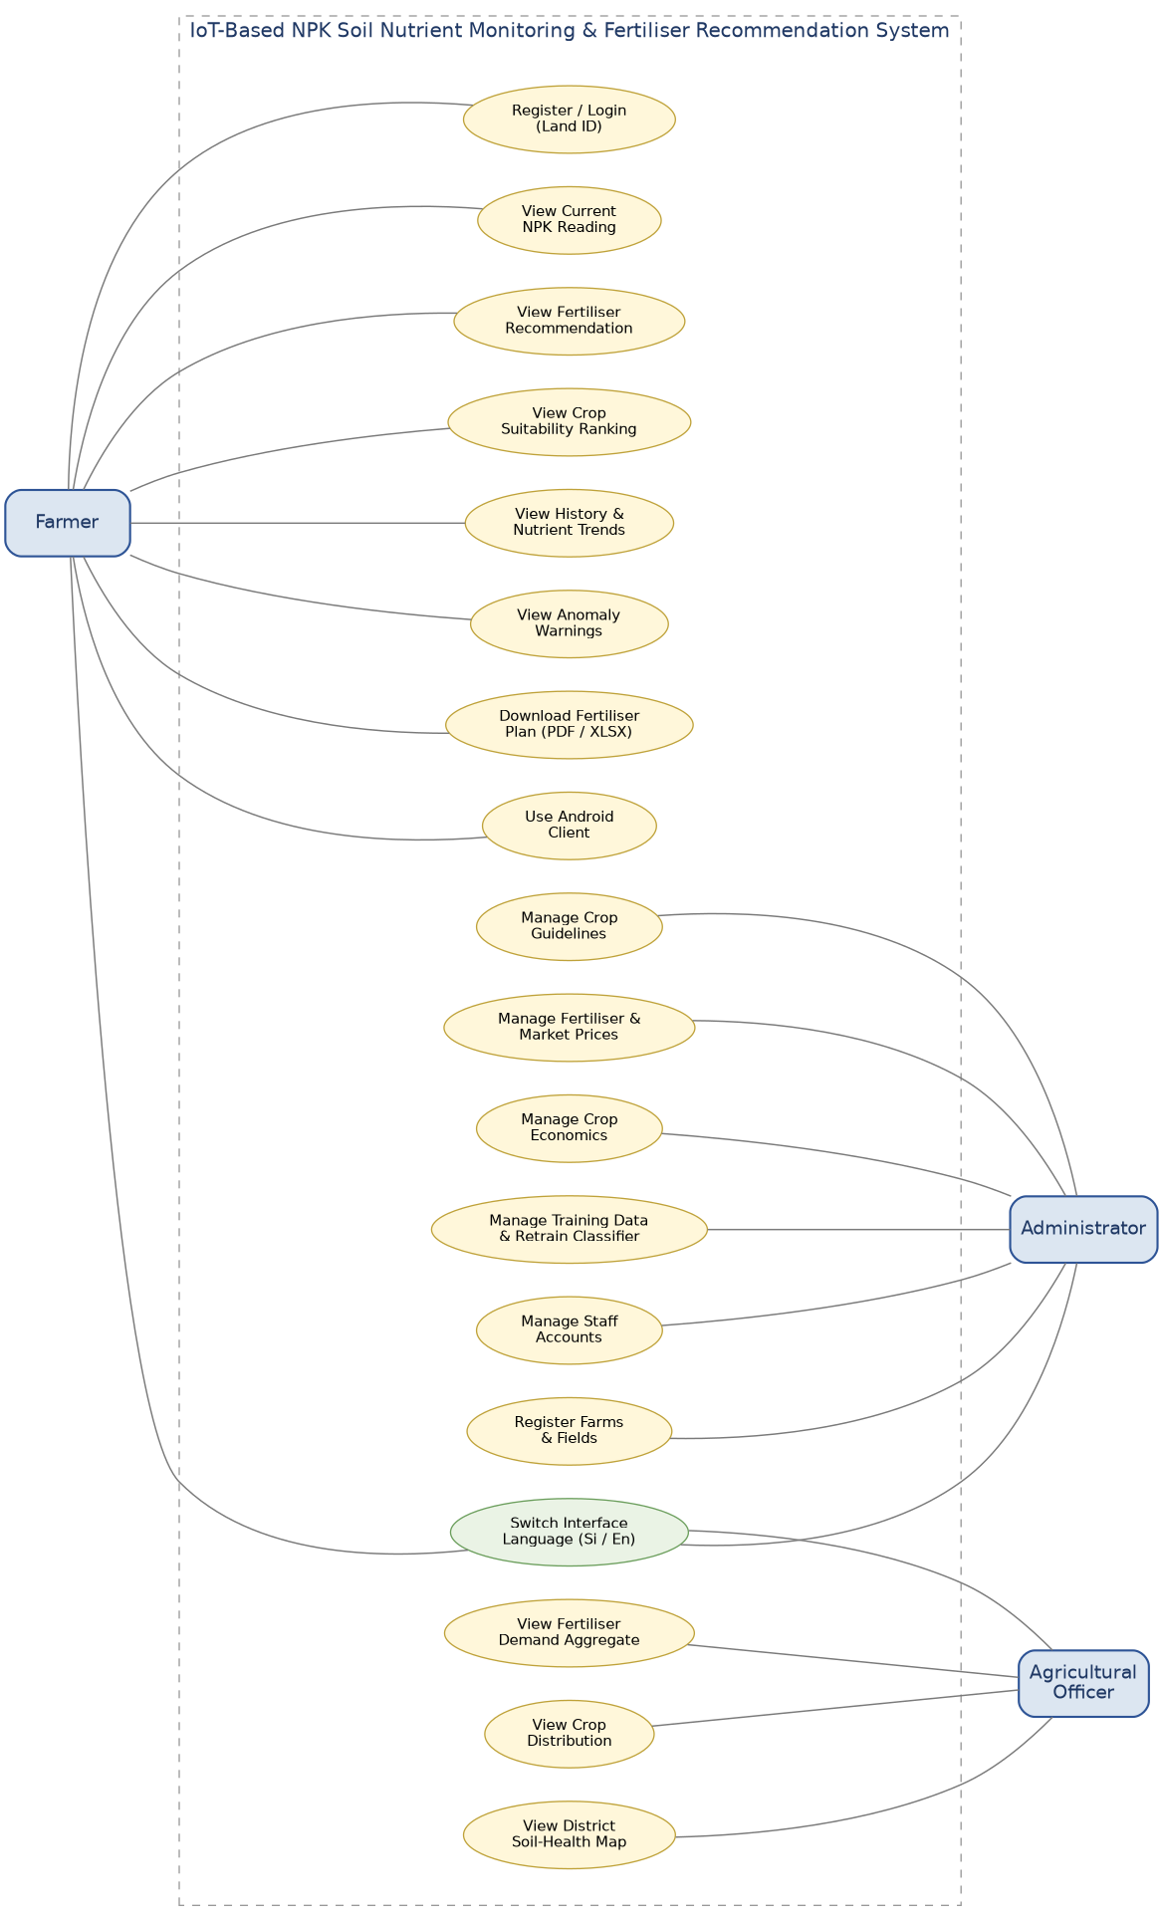
Figure 4.1: Use case diagram — farmer, administrator and officer actors, derived from the functional requirements of Section 4.5

Chapter 05: System Design

5.0 Chapter Overview
This chapter turns the requirements of Chapter 4 into a design. It sets out the four-layer architecture and the transport decision behind it, the hardware subsystem and the two-stage data-integrity check applied before a reading leaves the microcontroller, the relational schema and its normalisation, the two recommendation engines and the reasoning for using each where it fits, and finally the interface design for three user roles working in very different conditions.

5.1 System Architecture
The system adopts a four-layer architecture comprising a sensing layer, a transport layer, an application layer and a presentation layer. This separation allows the embedded firmware, the server-side business logic and the user interfaces to evolve independently, and permits a single backend instance to serve readings originating from multiple physical field devices.
Sensing layer. Soil nutrient acquisition is performed by an ESP32 development board interfaced to an RS485 three-in-one NPK probe over Modbus RTU. The microcontroller issues a function-code 0x03 request to slave address 0x01, reading three holding registers beginning at 0x001E, which return nitrogen, phosphorus and potassium concentrations in mg/kg. Communication runs at 4800 baud 8N1, the default configuration of the sensor family used. UART2 was remapped to GPIO25 (receive) and GPIO26 (transmit) rather than retaining the default GPIO16/17 assignment, because the latter conflicts with PSRAM addressing on ESP32-WROVER variants. A 20×4 HD44780 character display, driven over I2C through a PCF8574 backpack at address 0x27, provides local readout independent of network availability.
Transport layer. The transport layer employs direct HTTP POST requests rather than a publish–subscribe protocol such as MQTT. Although MQTT is widely recommended for IoT deployments due to its lightweight framing and support for intermittent connectivity (Senapaty, Ray and Padhy, 2023), it introduces an additional infrastructure component — a broker — that must be configured, secured and monitored. A REST endpoint proved substantially easier to diagnose during development: a failed transmission returns an immediate HTTP status code, which the firmware surfaces directly on the field display as “Server: OK sent”, “Server: HTTP 422” or “Server: no link”, whereas broker-mediated failures require inspection of both device and broker logs to localise the fault. Each transmission carries a JSON payload of the form {"n":210,"p":34,"k":180,"device_id":"esp32-field-1"}, posted to the /api/reading/ endpoint.
Readings are transmitted at five-second intervals. A higher sampling rate was considered unnecessary because soil nutrient concentrations change over timescales of days to weeks rather than seconds, so sub-second reporting would yield no additional decision-relevant information while increasing both sensor duty cycle and network traffic. The interval was also selected in relation to the dashboard’s device-liveness check, which classifies a device as offline once 20 seconds have elapsed since the most recent reading. A five-second cadence therefore allows up to four transmissions inside that window, so three consecutive dropped packets can occur before the interface reports the device offline — an isolated failed POST never produces a spurious offline indication.
Application layer. Server-side processing is implemented in Django 6 with Django REST Framework, backed by a MySQL relational store running under the WAMP stack on port 3306 with the InnoDB engine and utf8mb4 character set forced per connection. All request handling is synchronous: no message broker or asynchronous task queue is employed. This decision reflects the workload characteristics of the deployment — request volume is bounded by the number of registered devices, and the heaviest operations, PDF report generation and spreadsheet export, are user-initiated and infrequent. Introducing a task queue would have added a Redis instance and at least one worker process to deploy, supervise and monitor, without a corresponding benefit at this scale, although Section 9.2 notes the conditions under which this decision would need revisiting.
Presentation layer. Two clients consume the same REST API. The primary client is a single-page React 19 application built with Vite and styled with Tailwind CSS, using Leaflet for the district map, Recharts for the trend and comparison charts and three.js for the rotating district globe on the officer portal. A native Android client written in Kotlin with Jetpack Compose provides the farmer registration, login and dashboard workflow on a phone without a browser. Because the transport layer is unidirectional — devices push, the server stores — the interfaces obtain fresh data by polling rather than receiving pushed updates; the device-status indicator polls every six seconds, closely tracking the firmware’s five-second transmission cadence.
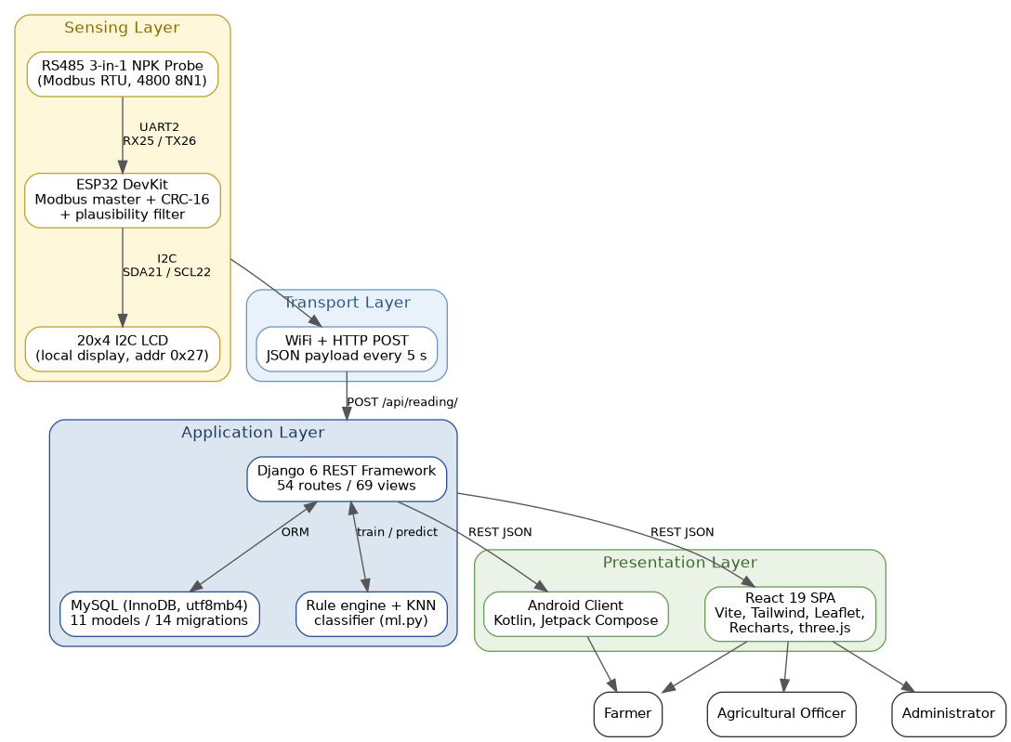
Figure 5.1: System architecture — sensing, transport, application and presentation layers

5.2 Hardware Design
The hardware subsystem was assembled from commercially available components rather than custom-fabricated boards, prioritising reproducibility and field serviceability. An officer or farmer encountering a fault should be able to source a replacement part locally rather than await a bespoke assembly.

5.2.1 Component Selection
Component | Specification | Selection rationale
ESP32 DevKit | Dual-core 240 MHz, integrated 802.11 b/g/n WiFi | On-board WiFi eliminates a separate radio module, reducing part count, cost and points of failure relative to an Arduino-plus-shield arrangement
RS485 three-in-one NPK probe | Modbus RTU, 4800 8N1, 0–1999 mg/kg nominal range | Differential RS485 signalling tolerates the long cable runs and electrical noise typical of field conditions, unlike single-ended analogue probes
RS485 transceiver module | TTL to RS485, auto-direction | Auto-direction switching removes the need for a dedicated control line, freeing a GPIO and simplifying the wiring harness
20×4 character display | HD44780 controller, PCF8574 I2C backpack at 0x27 | Four lines accommodate a title, a full reading, the device IP and server status on one screen; I2C requires only two pins
Table 5.1: Component selection and rationale
The firmware retains a compile-time flag (RS485_AUTO_DIR) permitting operation with a conventional MAX485 module whose DE and RE pins are tied together and driven from GPIO4, so the design is not dependent on the availability of a single module variant. Add the power arrangement here — mains adapter, USB power bank or battery — together with any enclosure. This matters because Section 2.6 justifies the transport choice partly on power not being the binding constraint.

5.2.2 Interface Assignment
Two independent buses operate concurrently. The RS485 link uses UART2 with receive on GPIO25 and transmit on GPIO26; the display uses I2C with SDA on GPIO21 and SCL on GPIO22. Because the buses occupy separate peripheral blocks and distinct pins, no arbitration or multiplexing is required. The probe’s power conductor is fed from 5–12 V depending on the model, sharing a common ground with the ESP32.
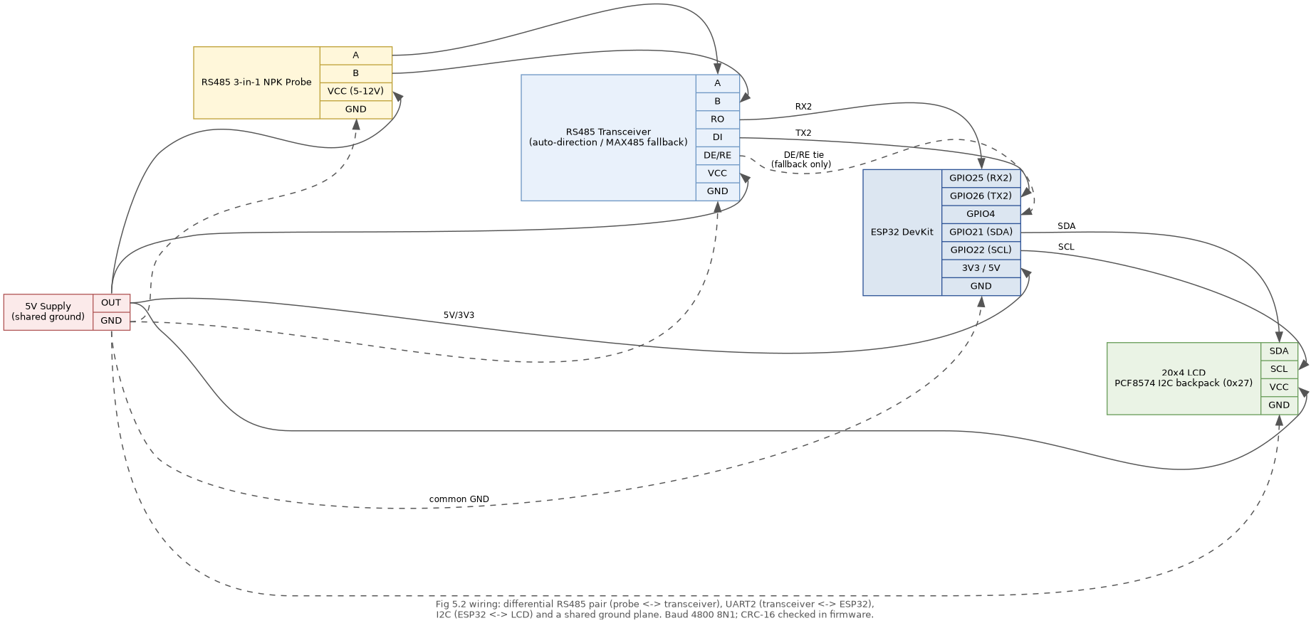
Figure 5.2: Wiring schematic — RS485 probe, transceiver, ESP32 and I2C LCD

5.2.3 Data Integrity at Source
Two validation stages are applied before a reading leaves the microcontroller.
The first is protocol-level. Each Modbus response is verified against a CRC-16 checksum computed with the standard Modbus polynomial 0xA001 from an initial value of 0xFFFF, with the transmitted checksum appended low byte first per the specification. A well-formed reply is exactly eleven bytes — slave address, function code, byte count, six data bytes and two checksum bytes. Frames that are short, that fail the checksum, or that present an unexpected slave address or function code are discarded and the cycle abandoned, each with its own distinct message on the serial monitor.
The second stage addresses a failure mode observed during development that checksum validation alone does not detect. A structurally valid frame may still carry physically impossible values — a potassium reading of 52,480 mg/kg was recorded when the RS485 A and B conductors were transposed, a fault documented in Section 6.6.1. Because the frame was well-formed its checksum was correct, and the erroneous value would otherwise have propagated to the database and into a fertiliser recommendation. A plausibility filter was therefore introduced, rejecting any reading in which nitrogen, phosphorus or potassium exceeds 3,000 mg/kg — a threshold set above the probe’s nominal ceiling of approximately 1,999 mg/kg to allow legitimate headroom while excluding values no soil could exhibit. Rejected readings are neither displayed nor transmitted; the display instead reports “Sensor: bad data” and “Check A/B, baud, reg”, directing the operator toward the likely cause.
This layered approach means the backend can treat any received reading as syntactically valid and physically plausible, and a corresponding server-side bound is nonetheless enforced at the ingestion endpoint as defence in depth (Section 6.3.1), since a payload may originate from a source other than the current firmware build.

5.3 Database Design
The persistence layer is a MySQL relational database accessed through the Django object-relational mapper across fourteen sequential migrations. A relational store was chosen over a document database because the domain is characterised by well-defined entities with stable relationships — a reading belongs to a field, a field belongs to a farm, a market price belongs to both a crop and a market — and because the profitability and district-aggregation features depend on joins and aggregate queries that relational engines execute efficiently.

5.3.1 Entity Overview
The schema comprises eleven models in four functional groups, shown with their fields and cardinalities in Figure 5.3.
Identity and land registration. The Field entity is the primary unit of farmer-facing operation, holding a generated six-character Land ID, a hashed password, owner name, contact number, district, area in acres, the currently cultivated crop and a mode flag distinguishing an established crop from an unplanted plot. Land ID generation deliberately draws from a 32-character alphabet that excludes 0, O, 1 and I to prevent transcription errors when an identifier is written on paper and later re-entered — a realistic concern given that the identifier is displayed only once, at registration. Six characters from that alphabet yield roughly 1.07 billion combinations, and the generator retries on collision against the existing rows. An auth_token field holds the current session token described in Section 6.3.2. The StaffAccount entity holds credentials for officers and administrators together with a role attribute constrained to government, agronomist or administrator, which drives the access control described in Section 5.5.
Sensing and telemetry. Reading stores each nutrient observation — nitrogen, phosphorus, potassium, pH, moisture and temperature — with a server-assigned timestamp, all nutrient columns nullable because the three-in-one probe reports only N, P and K. Farm and Field provide a two-level physical hierarchy: a farm groups several fields under a common owner and location, while each field carries a device_id mapping a specific ESP32 unit to a specific plot. This mapping is the mechanism by which one backend instance supports multiple concurrent deployments; on ingestion the device identifier in the payload is matched against registered fields and the reading attached automatically.
Agronomic reference data. CropGuideline holds the acceptable nitrogen, phosphorus, potassium, pH and moisture bands for each crop, together with a watering schedule, a market price per kilogram and localised advisory notes in Sinhala and English. FertilizerType records each fertiliser and its unit price — urea, triple superphosphate and muriate of potash are seeded at 45, 60 and 75 LKR per kilogram respectively as editable starting values. These tables externalise domain knowledge that would otherwise be hard-coded, allowing an administrator to revise thresholds or prices as departmental guidance changes without redeployment.
Economics. Market records named selling points — six Dedicated Economic Centres are seeded, including Dambulla, Meegoda and Keppetipola — MarketPrice records a price per crop per market on a given date under a composite uniqueness constraint, and CropEconomics records expected yield per acre alongside fertiliser, labour, seed and other cost components. CostEstimate persists each costed fertiliser plan so that the administrative cost report and the district demand roll-up have something to aggregate. Together these support the profitability estimation described in Section 5.4.
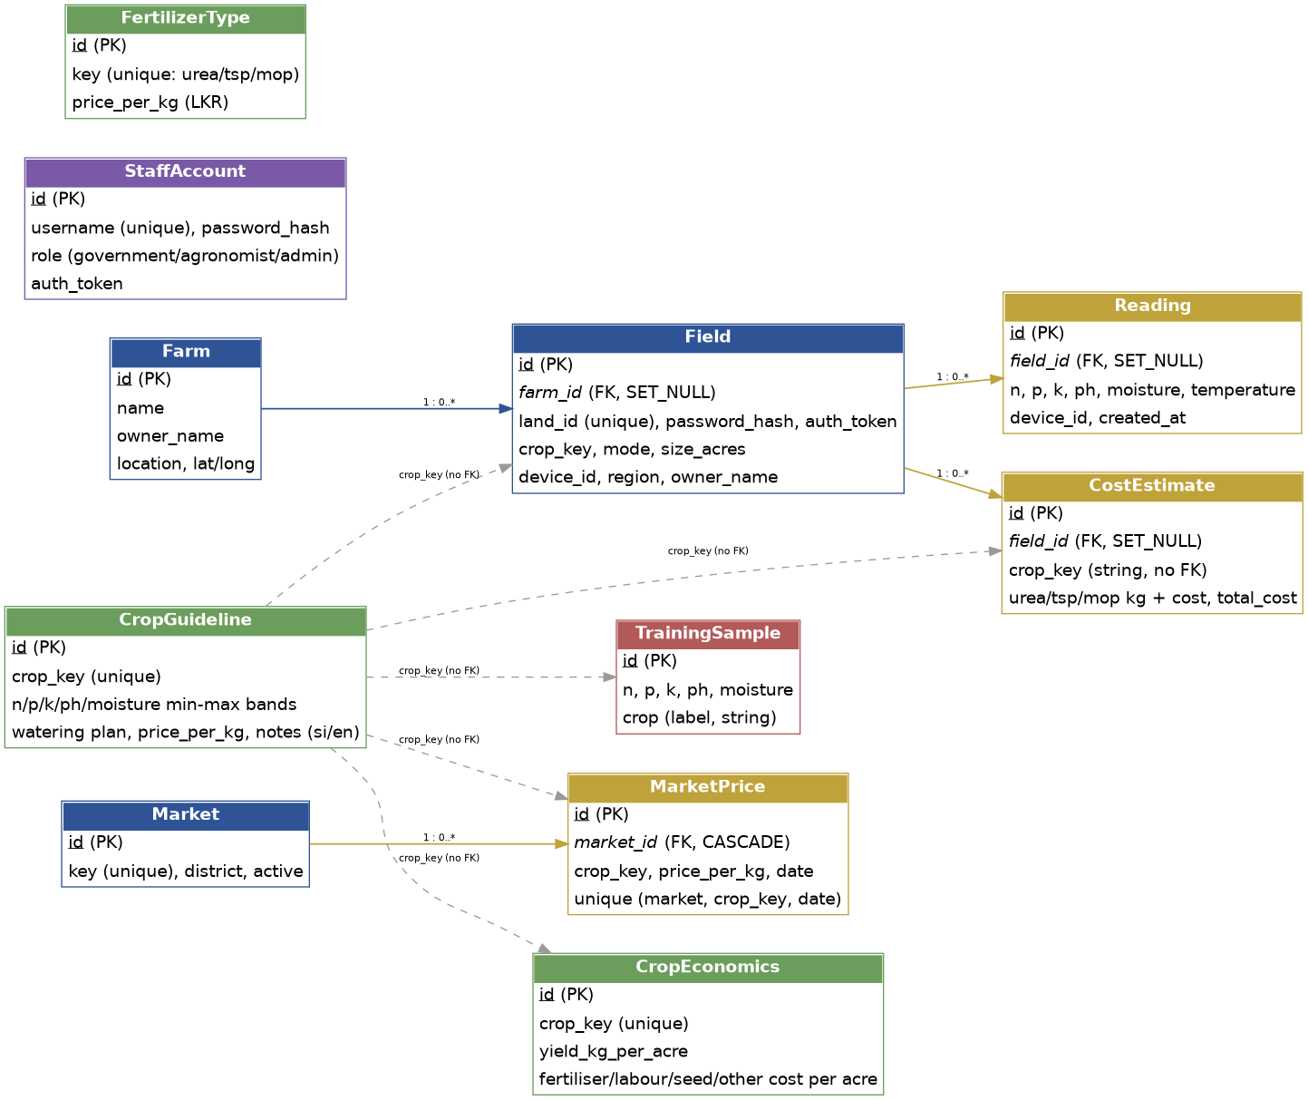
Figure 5.3: Entity–relationship diagram — eleven models across four functional groups; dashed lines mark the unenforced crop_key string reference discussed in Section 5.3.3

5.3.2 Normalisation
The schema is normalised to third normal form. Market pricing illustrates the rationale: prices vary by both crop and market and change over time, so storing a price directly on the crop record would introduce update anomalies and preclude historical comparison. Separating Market from MarketPrice allows a crop to be priced independently at each selling point while keeping each price a single authoritative row, enforced by a unique constraint on (market, crop, date) so that re-entering a price for the same day updates rather than duplicates it.
One deliberate departure concerns the relationship between Farm and Field. Field was introduced first, as the plot a reading attaches to and the unit fertiliser quantity is scaled against; Farm was added afterwards, when multi-plot ownership needed representing, and Field also acquired the login credentials when the farmer account system was designed around the plot rather than the person. The consequence is that Field carries both physical attributes (area, coordinates, device identifier) and identity attributes (Land ID, password hash, session token), and duplicates owner_name with Farm. A cleaner model would separate an Owner entity from the Plot it owns. This is an honest account of an evolutionary decision — a marker may well ask, and it is worth more than a retrofitted justification. Confirm it matches your own recollection of the order you built things in.

5.3.3 Referential Integrity and Retention
Foreign key constraints are enforced at the database level rather than in application code alone, with deletion behaviour defined per relationship. Deleting a field sets the field reference on its readings and cost estimates to NULL rather than cascading, so historical measurements survive the deregistration of a plot and remain available for district aggregation. Deleting a farm likewise nullifies the reference on its fields rather than removing them. Deleting a market cascades to that market’s price rows, which is correct because a price has no meaning without the market it was quoted at.
One weakness should be recorded. Crops are referenced by a plain crop_key string rather than by a foreign key to CropGuideline, so deleting a crop guideline does not raise a constraint error; it silently leaves fields, cost estimates and market prices pointing at a key with no reference data behind it. The recommendation code tolerates this — a missing guideline simply produces no bands — but a proper foreign key with restricted deletion would be the correct fix, and it is listed in Section 9.2.
Reading volume grows without bound: a single device transmitting every five seconds produces 17,280 rows per day. Query patterns were designed accordingly. The farmer-facing history view retrieves the most recent fifty readings, the anomaly check the most recent twenty, and the liveness check only the single latest row, all served through the model’s default descending timestamp ordering rather than by full table scans. No archival or roll-up policy has been implemented, and at sustained multi-device deployment one would be needed.

5.4 Recommendation Engine Design
The system generates two distinct classes of advice depending on the state of the land. Where a crop is already established the question is corrective: which nutrients are deficient, and what application will address the deficit. Where the land is unplanted the question is selective: given the soil’s current composition, which crops are best suited to it. These are addressed by two separate engines using different techniques.

5.4.1 Rule-Based Fertiliser Recommendation
For established crops the engine is deterministic. The averaged reading is compared against the acceptable band for the selected crop, and each of the five parameters classified as below range, within range or above range. Deficient nutrients are mapped to the corresponding fertiliser — nitrogen to urea, phosphorus to triple superphosphate, potassium to muriate of potash — and the recommended quantity drawn from the Department of Agriculture’s published programme for that crop, which specifies application rates by growth stage in kilograms per hectare (Department of Agriculture, 2026). Twenty-one crops carry such a programme, compiled from DOA HORDI crop pages and Department of Export Agriculture guidance. The client holds these programmes; the server converts them to a real quantity by multiplying the per-hectare rate by the plot’s area in hectares (acres × 0.404686) and pricing the result against the administrator-maintained fertiliser prices, so the farmer receives a quantity and a cost expressed for their actual land rather than a per-hectare figure requiring conversion.
The tomato programme illustrates the structure of this reference data:
Application stage | Urea kg/ha | TSP kg/ha | MOP kg/ha
Basal, 1–2 days before planting | 65 | 325 | 65
First top dressing, 3 weeks after planting | 65 | — | —
Second top dressing, 6 weeks after planting | 65 | — | 65
Total | 195 | 325 | 130
Table 5.2: Fertiliser programme for tomato, after Department of Agriculture (2026)
The same source specifies a reduced triple superphosphate rate of 215 kg/ha for Badulla District. This district exception is not implemented. The crop table holds one schedule per crop with no regional variant, so a plot registered in Badulla receives the national rate. The district is captured on every registered plot and is already used for aggregation, so the data needed to apply the exception exists; only the per-district schedule does not. The point is carried into Sections 8.3 and 9.2 rather than left unstated.
pH and moisture are handled as separate advisories rather than fertiliser recommendations, since they call for amendment rather than nutrient supply — lime or sulphur for pH correction, irrigation or drainage adjustment for moisture.
A deterministic approach was chosen for this pathway in preference to a learned model for three reasons. First, the mapping from deficiency to remedy is already codified in departmental guidance, so a model would at best reproduce an existing rule set while introducing opportunities for error. Second, the recommendation must be explicable: an officer needs to state why a particular quantity is advised, and a rule chain supports this directly where a learned model does not. Third, alignment with official guidance matters institutionally — a recommendation departing from the departmental programme is unlikely to be adopted regardless of its technical merit.

5.4.2 Machine-Learned Crop Suitability
For unplanted land the problem is different in kind. Rather than a single crop with a known target range, the system must rank all candidate crops against an observed soil profile. Expressing this as rules would require a comparison matrix growing with the number of crops and offering no natural means of ordering partial matches.
A k-nearest-neighbours classifier was selected, implemented from first principles in pure Python rather than through scikit-learn. It takes a five-dimensional feature vector — nitrogen, phosphorus, potassium, pH and moisture — z-score normalises each feature so that a nutrient measured in the hundreds does not dominate a pH measured in single digits, and returns crops ranked by a distance-weighted vote in which each of the k nearest neighbours contributes 1/(d + ε) to its class.
KNN was chosen over alternatives such as decision trees or neural networks for four reasons that were genuinely operative in this project. It performs acceptably on very small training sets, which is the regime this project is in. It has no iterative training step, so retraining after an administrator adds samples completes in well under a second and can be exposed as a button rather than a batch job. Its predictions are traceable to specific neighbouring samples, which supports the explanation an officer needs to give. And it produces a ranking across all classes naturally, which is exactly the output the unplanted-plot question calls for. A secondary but real consideration was that the implementation has no third-party dependency at all, so the recommendation engine runs anywhere Django runs even when no compiled machine-learning wheels are available for the installed Python build.
The classifier is trained on labelled samples held in the TrainingSample table, and retraining is exposed as an administrative operation rather than occurring automatically, so that a new model is promoted only after its reported accuracy has been reviewed. The trained model — normalisation parameters, the normalised sample matrix, labels, classes and the accuracy estimate — serialises to a single JSON file on disk.
The deployed model was trained on 108 labelled samples spanning nine crop classes (beans, brinjal, cabbage, capsicum, carrot, okra, potato, radish and tomato, twelve samples each) with k = 5, and achieved 31.5 % accuracy under leave-one-out cross-validation. Every sample is held out in turn and predicted from the remaining 107, so this is a generalisation estimate rather than a measure of fit. Against a nine-class baseline of 11.1 % it is about 2.8 times chance, but it is a weak result and Section 7.3 explains why.

5.4.3 Cross-Verification
The two engines are complemented by a third, independent calculation. Alongside the model’s predictions the interface displays a deterministic suitability score for each crop, computed client-side as the degree of overlap between the observed reading and that crop’s stored parameter bands: each of the five parameters scores 100 if the value falls inside the band and otherwise decays linearly with the distance outside it, expressed as a share of the band width, and the five are averaged to a percentage.
The intention was deliberate redundancy: agreement between an opaque model and a transparent score corroborates a recommendation, and disagreement is itself informative. That intention is only partly met, and the reason must be stated. The training samples were generated by uniform sampling inside per-crop nutrient ranges that are the same ranges the band-overlap score compares against (Section 6.5). The two calculations therefore derive from a common source, and agreement between them is weaker evidence than genuine independence would provide. Presenting both still allows an officer to exercise judgement rather than deferring to an opaque output, which is consistent with the screening framing adopted throughout this project, but the corroboration claim is retracted until the classifier is retrained on field-collected samples.
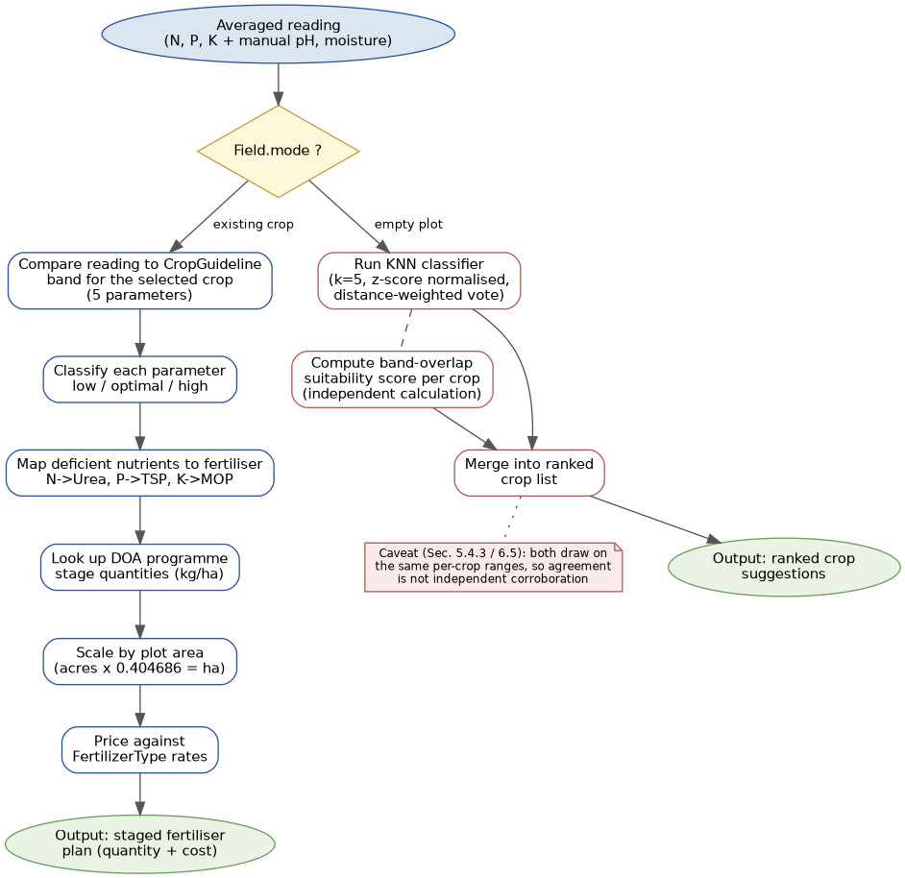
Figure 5.4: Recommendation engine decision flow — rule-based (left) and KNN + band-overlap (right) paths

5.5 User Interface Design
The interface serves three distinct user populations with materially different needs, and its design is organised around that division rather than around a single generalised view.

5.5.1 Role-Based Interface Separation
Farmer interface. The primary working screen presents a single plot at a time: current nutrient readings with a status badge per parameter, the resulting fertiliser recommendation with staged quantities, cost and profitability estimates, anomaly warnings, a nutrient trend forecast and cultivation history. Access is granted by Land ID and password, and a session is scoped to that one plot. The same workflow is available as a native Android application (package lk.npk.soil, minimum SDK 26) built with Jetpack Compose and Material 3, offering registration, login and the dashboard against the same REST API.
Administrative interface. Organised as tabbed sections, this interface manages the reference data on which farmer-facing recommendations depend — fertiliser and market prices, crop economics, the classifier and its training samples, farm and field registration, cost reporting and staff accounts. It is used infrequently, but its edits propagate to every farmer using the system.
Officer interface. The national view inverts the farmer perspective: rather than one plot in detail, it presents aggregates across all registered plots by district — soil health scores on a Leaflet map of Sri Lanka and a three-dimensional district globe, average nutrients per district, fertiliser demand totals in kilograms and rupees, and crop distribution. A district is scored 0–100 by averaging how far its mean nitrogen, phosphorus, potassium, pH and moisture sit inside broad sufficiency bands, so the map reads as a coarse policy signal rather than a crop-specific recommendation.
Access is governed by the role attribute on the StaffAccount record, ranked government < agronomist < administrator. Government and agronomist roles reach the national view; the administrator role additionally reaches staff management and reference-data editing. Authorisation is enforced server-side at each endpoint through decorators that resolve the session token before the view body runs, so concealing a control in the interface is not the sole barrier to the underlying operation.

5.5.2 Design for Field Conditions
The farmer interface is used outdoors, on a phone, frequently in direct sunlight — conditions under which conventional interface defaults degrade badly. Several adaptations were applied unconditionally rather than offered as a toggle, on the reasoning that a user standing in a field is unlikely to discover and enable an accessibility setting at the moment they need it.
Body text is set above the typical mobile default and small text is subject to a 13-pixel floor, since the smallest text on a screen is the first to become illegible under glare. Grey text is darkened beyond the nominal WCAG AA threshold, as contrast ratios specified for indoor viewing understate the requirement in bright ambient light. Interactive targets are a minimum of 44 pixels, reduced to 36 within dense tables, accommodating imprecise touch input from a user who may be wearing gloves or working one-handed. Card borders are rendered firmly and numeric tables use tabular figures with alternating row shading, aiding column alignment when the screen is read at an angle. Layouts are hardened against horizontal overflow at narrow widths, and animation is suppressed where the operating system signals a reduced-motion preference.

5.5.3 Localisation
The interface operates in Sinhala and English, switchable from any screen. Localisation extends beyond static labels to the agronomic content itself — crop names, growth-stage descriptions, watering advice and cultivation notes — through a translation table holding 525 Sinhala/English key pairs, with a second set of Sinhala strings stored per crop in the database. This is not a peripheral feature: an advisory system whose recommendations are available only in English excludes a substantial proportion of its intended users, and the credibility of a recommendation depends partly on its being expressed in the language in which the recipient reasons about their work.

5.5.4 Offline Behaviour
Network availability in rural deployment cannot be assumed, and the design acknowledges this at two levels. The field device displays each reading on its local screen before any transmission is attempted, so a nutrient value remains readable when connectivity is unavailable, and the display distinguishes a sensor fault from a WiFi fault from a server rejection rather than collapsing them into one error state. The web interface, by contrast, requires connectivity and states device status explicitly rather than displaying stale figures as though current: a device is marked offline once twenty seconds elapse without a reading, and the scan control is disabled with an explanatory message rather than silently failing.
Figure 5.5
Insert a screenshot of the farmer dashboard: current NPK cards with status badges, the fertiliser programme table and the cost panel.
Figure 5.5: Farmer dashboard
Figure 5.6
Insert a screenshot of the national officer portal: the district soil-health map, the KPI row and the fertiliser demand table.
Figure 5.6: National officer portal

Chapter 06: Implementation

6.0 Chapter Overview
This chapter describes how the design presented in Chapter 5 was realised. It proceeds from the embedded firmware through the server-side application to the client interfaces, and concludes with the machine-learning pipeline and an account of faults encountered. Emphasis is placed on decisions that emerged during construction rather than at design time.

6.1 Development Environment and Tooling
Layer | Technology | Version
Firmware | Arduino IDE with ESP32 core; WiFi.h, HTTPClient.h, Wire.h, LiquidCrystal_I2C (Frank de Brabander) | Board: ESP32 Dev Module; serial 115200 baud
Backend framework | Python / Django | Django 6.0.5 (project pinned >= 5.0, < 7.0)
API layer | Django REST Framework | >= 3.15
CORS / DB driver | django-cors-headers; PyMySQL | >= 4.0; >= 1.1
Database | MySQL under WAMP (InnoDB, utf8mb4, port 3306) | Schema built by 14 migrations
ML / analytics | Pure-Python KNN (project code); NumPy; scikit-learn (trend regression) | NumPy >= 1.26; scikit-learn >= 1.4
Reporting | openpyxl (XLSX); ReportLab (PDF) | >= 3.1; >= 4.0
Frontend | React with Vite and Tailwind CSS | React 19.2.6; Vite 8.0.12; Tailwind 4.3.1
Mapping / 3-D | Leaflet; three.js | Leaflet 1.9.4; three.js 0.180.0
Charting | Recharts | 3.8.1
Icons / linting | lucide-react; ESLint | 1.21.0; ESLint 10.3.0
Mobile client | Kotlin, Jetpack Compose, Material 3 | Compose BOM 2024.10.01; compileSdk/targetSdk 34, minSdk 26, JVM 17
Version control | Git (single repository: firmware, backend, web, Android) | —
Table 6.1: Implementation stack and versions
Development followed an incremental approach, with the firmware and backend brought to a working end-to-end path before either was elaborated. This ordering was deliberate: the sensor-to-database link carried the most unknowns, and establishing it early meant subsequent work built on verified rather than assumed behaviour.

6.2 Firmware Implementation

6.2.1 Modbus Communication
The firmware constructs Modbus RTU request frames directly rather than relying on a library, giving explicit control over framing and timing. A request comprises the slave address, function code 0x03, the starting register address, the register count and a CRC-16 checksum appended low byte first. The checksum routine implements the standard Modbus polynomial 0xA001 with an initial value of 0xFFFF.
Before each transmission the receive buffer is flushed of residual bytes, preventing a partial frame from a previous cycle being interpreted as the start of the current response. After writing the request the firmware blocks until transmission completes, then returns the line to receive state — redundant on auto-direction hardware but retained so the same code operates correctly on modules with explicit direction control. Responses are read with a one-second timeout against an expected length of eleven bytes, and the three nutrient values are reconstructed from consecutive byte pairs in big-endian order. The full listing appears in Appendix D.

6.2.2 Diagnostic Provisions
Every received frame is echoed to the serial monitor in hexadecimal before interpretation. This was added during development in response to the difficulty of distinguishing failure modes that present identically at the application level: a wiring fault, an incorrect baud rate and an incorrect register address all yield no usable reading, but produce visibly different raw responses — respectively no bytes, malformed bytes, and a well-formed frame of zeros. Retaining the facility in deployed firmware allows the same diagnosis to be performed in the field, and the README documents the two most common remedies (trying start register 0x0000 instead of 0x001E, and confirming 4800 against 9600 baud). Failure conditions are distinguished on the display rather than collapsed into a single error state, so an operator without serial access can tell a sensor fault from a network fault from a server fault.

6.2.3 Network Transmission
WiFi association is attempted with a twenty-second timeout and re-checked before each transmission cycle, so a device recovers automatically from a transient outage without a restart. On successful association the assigned IP address is shown on the third line of the display, allowing connectivity to be confirmed on site. The reading is serialised as a JSON object containing the three nutrient values and the device identifier, and posted to the configured endpoint; the HTTP status code is then translated into a short status line on the fourth line of the display.

6.3 Backend Implementation
The backend exposes 54 routes served by 69 view functions across a 1,676-line views module, with the data model, serialisers, the KNN implementation and the trend model held in separate modules.

6.3.1 Ingestion Endpoint
The ingestion endpoint accepts the firmware payload and performs three operations. It filters the body to a whitelist of recognised nutrient keys and validates each of nitrogen, phosphorus and potassium against the same 0–3,000 mg/kg bound enforced in firmware, returning HTTP 422 with a specific message on violation — defence in depth, since a payload may originate from a source other than the current firmware build. It resolves the device identifier against registered fields, attaching the reading to the corresponding plot where a match exists and storing it unattached where none does, so a quick scan from an unregistered device is retained rather than rejected. It then persists the reading with a server-assigned timestamp, deliberately not trusting a device-supplied time, as the ESP32 has no real-time clock and therefore no reliable notion of wall-clock time.

6.3.2 Authentication
Two authentication paths operate independently. Farmers authenticate with a Land ID and password, receiving a 32-byte random token that is rotated on each login so that a token disclosed on a shared device is invalidated by the next legitimate sign-in; the token travels in an X-Land-Token header or as a bearer token, and a decorator resolves it to the plot before any land-scoped view body executes, so a missing or unknown token yields 401 and no data leaks. Failed logins return an identical message whether the identifier or the password was wrong. Staff authenticate with a username and password, receiving a role that governs endpoint authorisation through a ranked role check.
Two weaknesses are recorded rather than concealed. A legacy password-only administrative gate remains in the codebase; it predates the staff account system and is retained solely as a bootstrap mechanism for initial deployment, where no staff account yet exists from which to create the first staff account. And the minimum farmer password length is four characters, which is too short. Both are addressed in Section 9.2.

6.3.3 Recommendation and Analysis Endpoints
Six endpoints carry most of the non-trivial logic.
- Reading comparison takes a reading and a crop key and returns each of the five parameters classified as low, optimal or high against that crop’s stored band, which is what drives the status badges and the deficiency mapping on the client.
- Cost estimation receives the per-hectare urea, TSP and MOP totals summed across the growth stages of the client’s DOA programme, together with the crop and the plot area. It converts acres to hectares, multiplies out the real quantities, prices them against the administrator-maintained fertiliser prices, and persists the result as a CostEstimate row — persisting rather than only computing is what makes the administrative cost report and the district demand roll-up possible at all.
- Profit estimation finds the best current price for the crop across all active markets, multiplies by the expected yield per acre and the plot area, subtracts the summed per-acre cost components, and returns income, cost and profit together with the market that produced the best price. A companion endpoint runs the same calculation across every crop so the client can rank them by projected profit.
- Anomaly detection examines the twenty most recent readings for three signals: a pH outside 3.0–9.5 or a moisture outside 0–100 %; a stuck sensor, indicated by the three most recent readings carrying identical N, P and K; and a spike, defined as a nutrient more than tripling between consecutive readings while also rising by more than 150 units in absolute terms. The two conditions on a spike are both required, so a small value doubling from 2 to 6 is not flagged.
- District aggregation is implemented as three endpoints. Fertiliser demand buckets every registered plot and every logged cost estimate by district, returning urea, TSP and MOP kilograms, total cost and the dominant crop per district plus a national total. Soil health takes each plot’s most recent reading, averages the five parameters per district, and scores each district 0–100 by how far those averages sit inside broad sufficiency bands (N 80–250, P 20–60, K 110–320 mg/kg, pH 5.5–7.5, moisture 40–80 %), with a linear rather than binary penalty for values just outside. Crop distribution returns the national planting mix by crop and by district.
- Trend forecasting is the one place a statistical method is applied directly. A scikit-learn linear regression is fitted to nutrient value against elapsed days and projected forward a configurable horizon, reported with its coefficient of determination. The data-sufficiency guards are deliberate and are the substantive part of the design: fewer than five readings, or an observed span covering less than half the requested horizon, returns an explicit insufficient-data response with the reason rather than a projection; an R² below 0.25 marks the trend unreliable and reports direction as “uncertain” with no numeric projection; and any projection is clamped to within one observed range beyond the minimum and maximum actually seen, so a noisy fit cannot extrapolate to an absurd value. The endpoint reports when it has clamped.
A complete route reference is provided in Appendix G.

6.3.4 Report Generation
Fertiliser plans are rendered server-side as PDF using ReportLab, and reading histories and cost estimates as spreadsheets using openpyxl. The plan endpoint takes the computed programme rows from the client but reads the plot’s identity — name, owner, Land ID and district — from the session rather than the request body, so the printed slip is authoritative and cannot be forged by editing a payload. These operations run synchronously within the request cycle, which is acceptable at the current scale but is the operation most likely to require asynchronous handling as deployment grows. Time a plan generation and a spreadsheet export for a typical plot and record the figures in Section 7.5.

6.4 Frontend Implementation

6.4.1 State and Data Flow
The web client is a single React application file of 4,955 lines containing 21 named presentational and container components plus the root dashboard component. State is held entirely in local component state — 106 useState hooks and 26 useEffect hooks — with no React Context and no external state library; shared values are passed down as props, and the language selection, session token and active plot are threaded from the root component to the components that need them. This is a monolithic structure and is reported as such rather than described as modular. It has a real cost: the root component holds a large amount of unrelated state, and prop threading through several levels makes a change to one panel harder to reason about than it should be. The obvious decomposition is to split the three role views into separate route-level modules, lift session and language into a Context provider, and move each panel into its own file with a typed props interface; the component boundaries already exist as functions, so the work is mechanical rather than structural.
Data flow follows the unidirectional transport. Reference data — crop guidelines, fertiliser prices, markets — is fetched once when a view mounts. The device liveness indicator polls the latest reading every six seconds and marks the device offline when the newest reading is more than twenty seconds old. Readings themselves are pulled on demand when the farmer presses Scan rather than streamed, and history, anomalies, forecasts and profit figures are refreshed after each completed scan. Where the backend is unreachable the client keeps the last locally computed reading visible and labels the state rather than blanking the screen.

6.4.2 Sample Averaging
The scan workflow requires three samples before producing a recommendation, averaging them automatically and displaying collection progress so the requirement is visible rather than appearing as an unexplained delay. This was introduced after observing variation between consecutive readings at the same location, and reflects standard soil sampling practice: a single probe insertion characterises a few cubic centimetres of soil, which may not represent the plot. The interface instructs the user, in both languages, to take the three samples at different points of the same plot.

6.4.3 Anomaly Presentation
The three anomaly classes returned by the backend are surfaced in plain language rather than as statistical flags, on the reasoning that the intended user needs to know what action to take rather than which threshold was crossed. A stuck sensor prompts a probe-reseating check; a spike prompts a wiring check; an out-of-range pH or moisture prompts a re-entry check, since those two values are typed in by hand.

6.4.4 Android Client
The Android client is a Jetpack Compose application in Kotlin targeting API 34 with a minimum of API 26, structured as five screens and three supporting modules: an API client wrapping the same REST endpoints, a data model layer, a local recommendation module mirroring the band comparison, a theme and a shared UI component set. It covers the farmer path — register a land, log in, view the current reading and the resulting guidance — and is distributed as a debug APK. It exists because a browser is not always the natural tool on a low-end phone in a field, and because an installable application can later hold an offline cache that a web page cannot easily match. Confirm which device or emulator you tested the APK on, and add two screenshots to Appendix I.

6.5 Machine Learning Pipeline
The provenance of the training data must be stated plainly, because it determines how every classifier result in this dissertation should be read. The 108 training samples are synthetic. An administrative seeding operation generates them by drawing, for each of nine crops, twelve samples uniformly at random from per-crop ranges for nitrogen, phosphorus, potassium, pH and moisture that are hard-coded in the backend. No field-collected sample, and no sample labelled by an observed cultivation outcome, is present in the training set.
Two consequences follow, and neither is hidden elsewhere in this document. First, the classifier cannot learn anything the ranges do not already contain: it is, at best, a smoothed reconstruction of a lookup table, which is a substantial part of why the measured accuracy is low. Second, those per-crop ranges are the same bands the deterministic suitability score compares against, so the cross-verification described in Section 5.4.3 is not the independent check it was designed to be. The honest position is that the machine-learning pathway is a working pipeline demonstrated end to end — data management, training, accuracy reporting, model persistence, prediction — rather than a validated agronomic model, and Section 9.2 places field-collected labelled samples at the top of the further-work list alongside sensor validation.
The pipeline exposes four operations administratively: seeding starter data, adding or deleting individual labelled samples, training, and testing a prediction against arbitrary input. Training is manual rather than automatic so that a model is promoted only after its reported accuracy has been reviewed, and the administrative panel displays the sample count, class count, per-class counts and accuracy of the currently loaded model.

6.6 Faults Encountered and Resolved

6.6.1 RS485 Link Failure
Symptom. No response was received from the probe; the display reported a read failure, though not on every polling cycle, which made the fault harder to characterise initially.
Diagnosis. The raw-frame serial output showed zero bytes received, which excluded a decoding fault and localised the problem to the physical layer. Inspection revealed the A and B conductors transposed and one terminal insufficiently seated — the loose terminal explaining the intermittency.
Resolution. The conductors were corrected against the probe datasheet pinout and the terminals reseated, after which valid frames were received consistently. The fault had a second consequence: during the intermittent period several frames arrived with valid checksums but impossible values, of which K = 52,480 mg/kg is the recorded example, and this is what prompted the plausibility filter described in Section 5.2.3 and its server-side counterpart. Confirm this sequence matches what actually happened — if the filter was added for a different reason, correct it.

6.6.2 Endpoint Routing Fault
Symptom. A 404 response was returned from an endpoint whose view function was correctly defined and importable, while neighbouring endpoints in the same module worked.
Diagnosis. Fill in the actual mistake from your git history or recollection: a missing trailing slash on the client call, a path segment spelled differently from the route, a pattern placed after a catch-all, or a route never added to urls.py at all. Say how you narrowed it down — Django’s debug page lists every pattern it tried in order, which is normally what reveals it immediately.
Resolution. State the correction and what it changed about your practice. If this fault is why you started defining the client URL strings in one place, or why you began checking the debug pattern list first, say so; the route table now holds 54 paths, so a systematic convention matters more than it did at ten.

Chapter 07: Testing and Results

7.1 Testing Strategy
Testing was manual, functional and integration-focused, exercising the full pipeline from capture at the probe through to display in the browser and on the Android client, and confirming that each component correctly passed data to the next. No automated test suite was written: the Django application contains no test module and the frontend has no test runner configured. This is stated plainly rather than implied otherwise. In its place, three practical substitutes were used during development. The firmware’s raw-frame serial output made the sensing layer inspectable at the byte level. The backend was exercised independently of the hardware by posting synthetic readings with a command-line HTTP client, which is documented in the project README so the whole pipeline can be demonstrated without a probe attached. And the two calculation paths that would fail silently — fertiliser quantity and district aggregation — were checked against figures worked by hand, which is why test cases TC10 and TC16 below are the most valuable rows in the table.
The absence of automated tests is a genuine weakness. With 54 routes and a calculation chain running from a per-hectare rate through an area conversion to a priced quantity, a regression suite covering even the six calculation endpoints would materially reduce the risk of a silent arithmetic fault, and it is listed in Section 9.2.

7.2 Test Cases
ID | Test case | Expected result | Actual | Pass
TC01 | Device reads NPK values from the RS485 probe | Valid 11-byte frame, CRC verified, three values decoded
TC02 | Device displays reading on local screen | Values visible on line 2 with no network
TC03 | Device rejects an implausible reading (> 3000 mg/kg) | Not displayed or transmitted; “Sensor: bad data” shown
TC04 | Device recovers after WiFi loss | Re-associates within 20 s and resumes without restart
TC05 | Backend ingests a posted reading | Persisted with server timestamp and correct field
TC06 | Backend rejects an out-of-bound payload | HTTP 422 naming the offending nutrient
TC07 | Reading with unknown device identifier | Stored unattached (field = NULL), HTTP 200, field: null
TC08 | Farmer login with valid credentials | Token issued and rotated; dashboard reachable
TC09 | Farmer token used against a staff endpoint | Rejected server-side with 401
TC10 | Fertiliser quantity for a known reading and crop | Matches hand-calculated DOA figure scaled to acreage
TC11 | Crop ranking for an unplanted plot | KNN ranking and band-overlap score both returned
TC12 | Trend forecast with fewer than five readings | Explicit insufficient-data response, not a projection
TC13 | Stuck-sensor anomaly detection | Flagged after three identical consecutive readings
TC14 | Language toggle | All interface and agronomic text switches
TC15 | Fertiliser plan PDF generation | Correct plot, owner, Land ID, crop, reading and quantities
TC16 | District aggregation with multiple plots | Averages and totals correct against hand calculation
TC17 | Android client login and dashboard | Same reading and guidance as the web client
Table 7.1: Functional and integration test cases
Run each of these and fill in the actual result and outcome. Where a test fails, record the failure and its cause rather than removing the row — a documented failure with an explanation is evidence of testing, whereas a table of uniform passes invites the question of whether the tests were run at all. Paste the execution log into Appendix H.

7.3 Classifier Evaluation
The deployed model was trained on 108 samples across nine crop classes, twelve samples per class, with k = 5. Accuracy was measured by leave-one-out cross-validation: each sample is withheld in turn and predicted from the remaining 107, so the reported figure estimates generalisation rather than fit. The result is 31.5 % (34 of 108 samples correctly classified).
Property | Value
Algorithm | k-nearest neighbours, distance-weighted vote, z-score normalised features
k | 5
Features | N, P, K (mg/kg), pH, moisture (%)
Training samples | 108 (synthetic; 12 per class)
Classes | 9 — beans, brinjal, cabbage, capsicum, carrot, okra, potato, radish, tomato
Validation method | Leave-one-out cross-validation
Accuracy | 31.5 % (nine-class chance baseline 11.1 %)
Table 7.2: Crop-suitability classifier configuration and measured accuracy
Three things should be said about this figure. First, it is honest: it is a held-out estimate, not a training-set score, and the training-set score would have been considerably higher and considerably less meaningful. Second, it is weak — roughly 2.8 times chance on nine classes is far below what a deployable agronomic recommender would need, and no cultivation decision should rest on the top-ranked crop alone. Third, the cause is identifiable rather than mysterious. The nine crops chosen are all vegetables with heavily overlapping nutrient requirements: capsicum, tomato and brinjal, for instance, share almost the whole of their nitrogen and potassium ranges. Samples drawn uniformly at random from overlapping boxes are, by construction, frequently closer to a neighbouring crop’s sample than to their own label, so the ceiling on achievable accuracy is set by the data-generation method and not by the choice of classifier. A different algorithm on the same data would not fix this.
The corollary, stated in Sections 5.4.3 and 6.5, is that the band-overlap score presented alongside the model is computed from the same ranges the samples were drawn from, so the two outputs are not independent and their agreement is not corroboration. The classifier is therefore reported here as a functioning pipeline with a measured and disappointing accuracy, not as a validated recommendation engine. Retraining on field-collected samples labelled by observed cultivation outcome is the single change that would make the number meaningful, and it heads Section 9.2.

7.4 Sensor Accuracy: Scope and Limitation
Testing was limited to functional and integration verification. Formal validation of readings against wet-chemistry laboratory reference samples was not conducted within the timeframe of this project. This is stated explicitly rather than omitted, and is consistent with the pattern noted in Section 2.4: low-cost RS485 probes are widely positioned as comparative and trend-monitoring instruments rather than laboratory-equivalent devices, with even validated systems in the literature reporting reliable quantitative output for only a subset of the three macronutrients (Fathima et al., 2026).
Consequently the system’s output should be interpreted as field-level nutrient screening — useful for identifying which plots warrant closer inspection or formal laboratory testing, and for tracking change over time at a single plot — not as a laboratory-equivalent measurement. This framing is consistent with the system’s positioning against the existing agrarian service centre kit (Section 2.2), which is itself a screening instrument rather than a laboratory substitute. Validation against reference samples is identified as priority further work.

7.5 Performance
End-to-end latency was not formally benchmarked. Its bounds are nonetheless known from the design: a reading becomes visible on the dashboard within one device transmission interval (5 s) plus one client poll interval (6 s) of being taken, so under normal conditions the observed delay is a few seconds and never structurally exceeds about eleven seconds. The local LCD, by contrast, updates before any transmission is attempted, so the field reading itself is effectively immediate.
Measure and record three figures rather than leaving this section on design bounds alone: the wall-clock time from pressing Scan to the reading appearing on the dashboard, the PDF plan generation time for a typical plot, and the XLSX export time for a plot with a few hundred readings. If you do not benchmark formally, state that plainly and give the approximate observation rather than inventing a figure.

7.6 User Acceptance
A structured user acceptance testing session was not conducted. The requirement-gathering interviews with four extension officers (Section 4.3) provided qualitative input that shaped the design, particularly the field-legibility and bilingual requirements, but no participant used the finished system under observation.
If you demonstrated the working system to any officer or farmer and received feedback — even informally, even briefly — report it here with an approximate date and what was said. This is currently the weakest section in the chapter, and one documented demonstration would strengthen it substantially.

Chapter 08: Evaluation and Discussion

8.1 Objectives Against Achievement
Objective (Section 1.4) | Status | Evidence
Portable ESP32 and RS485 sensing device with local display | Achieved | Sections 5.2, 6.2; fault resolved at 6.6.1; TC01–TC04
Server-side ingestion platform associating readings with plots | Achieved | Sections 5.3, 6.3.1; TC05–TC07
Rule-based fertiliser engine derived from DOA programmes and scaled to acreage | Achieved | Sections 5.4.1, 6.3.3; TC10
Machine-learned crop suitability classifier with honest accuracy reporting | Partially achieved | Sections 5.4.2, 6.5, 7.3 — pipeline complete and accuracy measured (31.5 %), but trained on synthetic data, so no agronomic validity is claimed
Role-differentiated bilingual interfaces, web and Android | Achieved | Sections 5.5, 6.4; TC08, TC09, TC14, TC17
Functional and integration evaluation with honest limitation reporting | Partially achieved | Chapter 7 — manual testing performed and limitations documented; no automated suite, no laboratory validation, no formal acceptance testing
Table 8.1: Objectives against delivered outcome
Four of the six objectives were met in full. The two marked partially achieved are marked so deliberately: in each case the artefact exists and works, but the evidence needed to claim it does its job is missing. An objective marked partially achieved with a clear explanation is worth more than one marked achieved that a viva question then unpicks.

8.2 Comparison with Existing Systems
The systems reviewed in Chapter 2 are, without exception, single-audience: they serve the individual farmer, and the reading taken informs one decision before being discarded. The distinguishing characteristic of this project is that the same reading serves three purposes simultaneously — a fertiliser quantity for the person working the plot, a data point in that plot’s history, and a contribution to a district aggregate available to planners. Whether that architecture delivers value in practice is untested here, but it addresses a gap the reviewed literature leaves open.
On recommendation approach, this project differs from both paradigms in the literature by using each where it fits rather than choosing between them. Against Islam et al. (2023), which applies a learned model throughout, the rule-based pathway here is less able to capture nutrient interactions but produces recommendations traceable to published departmental guidance — a property that matters more for institutional adoption than marginal accuracy. Against threshold-only systems such as Fathima et al. (2026), the classifier adds a capability threshold rules cannot provide: ranking many candidate crops against one soil profile. That said, the comparison must be made carefully: those systems report accuracy figures earned on real labelled data, and this project’s 31.5 % was earned on synthetic data. The architectural claim stands; the modelling claim does not yet.
Against the operative baseline — the colorimetric field kit — the system produces numeric rather than categorical output, which is the difference between selecting a recommendation from a lookup table and calculating a quantity for a specific area, and it does so in Sinhala on a device the user already owns. That is a genuine improvement in precision and in accessibility. It is not, however, an improvement in accuracy, because accuracy was never measured (Section 7.4).

8.3 Limitations
- Readings were not validated against wet-chemistry laboratory reference samples, so the system’s quantitative accuracy is unknown and its output should be read as screening rather than measurement.
- The classifier was trained on 108 synthetic samples generated from the crop bands themselves, and measured 31.5 % under leave-one-out cross-validation. It has no demonstrated agronomic validity, and the band-overlap cross-check presented alongside it is not independent of it.
- A single prototype device was built and tested. The device-to-plot mapping that supports multiple concurrent sensors is implemented but has never been exercised with more than one physical unit.
- No automated test suite exists for either the backend or the frontend; all testing was manual.
- The documented Badulla District exception to the tomato TSP rate is not implemented; the crop table holds one national schedule per crop.
- The web client is a single 4,955-line file with no state-management layer, which is a maintainability rather than a functional limitation but a real one.
- Crops are referenced by an unconstrained string key rather than a foreign key, so deleting a crop guideline silently orphans the rows that referenced it.
- The deployment runs under Django development settings — debug enabled, all hosts allowed, all CORS origins permitted, plain HTTP — and the legacy administrative password gate remains in the codebase as a bootstrap mechanism. The minimum farmer password length is four characters.
- No structured user acceptance testing session was conducted, so usability claims rest on design reasoning rather than observed use.
- Add any others you know of. A thorough limitations section is a strength, not an admission — markers reward it, and it protects you at the viva by demonstrating you already know what would otherwise be used to challenge you.

8.4 Critical Reflection
This section cannot be templated and a marker will recognise it if it is. Two or three paragraphs, in your own voice, addressing three things honestly. Prompts follow — replace them with what actually happened to you.
What took far longer than expected and why. The RS485 link is the obvious candidate: an intermittent physical-layer fault that produced three different symptoms and could not be diagnosed at the application level at all until the raw frame dump was added. Reflect on what that taught you about making a system observable before trying to debug it.
What you would approach differently with hindsight. The strongest available answer is the training data: building the machine-learning pipeline before securing any real labelled samples meant the pipeline works and the model does not, and the honest conclusion is that the sequencing was wrong — either the samples should have been collected first, or the classifier should have been scoped out and the effort spent on validating the sensor instead. The monolithic frontend file is a second candidate, and the decision to skip automated tests a third.
What you learned that you did not anticipate learning. Candidates from this project: that a checksum proves a frame is intact but says nothing about whether its contents are possible; that an accuracy figure is only as meaningful as the data behind it; and that the hardest part of a three-tier system was not any one tier but keeping the contract between them stable while all three changed.

Chapter 09: Conclusion and Future Work

9.1 Summary of Contributions
This project designed, implemented and functionally tested an IoT-based soil nutrient monitoring and advisory platform for the Sri Lankan agricultural context. The system captures quantitative nitrogen, phosphorus and potassium readings using an ESP32 and an RS485 probe over Modbus RTU, validates them twice before they reach storage, displays them locally for use without connectivity, and transmits them to a Django platform that associates each reading with a registered plot by device identifier.
From those readings the system produces two classes of guidance by two distinct methods: fertiliser quantities derived deterministically from published Department of Agriculture programmes for 21 crops and scaled to the actual area of the plot, and crop suitability rankings produced by a k-nearest-neighbours classifier, cross-checked against a band-overlap calculation. Both are presented through role-differentiated bilingual interfaces serving farmers, administrators and agricultural officers across 25 districts, on the web and on Android, with the officer view aggregating readings to district level for soil health, fertiliser demand and crop distribution.
The principal contribution relative to the reviewed literature is architectural rather than algorithmic: connecting individual field measurement to district-level aggregation, so that a reading taken for one plot also informs planning at the level at which fertiliser policy actually operates. The principal limitations, stated throughout rather than deferred to a final paragraph, are that sensor accuracy was never validated against laboratory reference and that the classifier was trained on synthetic data and measured 31.5 %. Both condition how every quantitative output of the system should be read.

9.2 Future Work
- Sensor validation against laboratory reference samples. The highest priority. Until measured values are compared against wet-chemistry analysis across a range of Sri Lankan soil types, every quantitative claim the system makes remains unverified.
- Replacement of the synthetic training set with field-collected samples labelled by observed cultivation outcome rather than by reference band. This is what would make the classifier a model rather than a smoothed lookup table, and it is also what would make the band-overlap cross-check genuinely independent of it. A larger and more diverse set with crops whose requirements overlap less would raise the achievable ceiling as well.
- District-specific fertiliser programmes, encoding documented regional variations such as the Badulla triple superphosphate exception, which the current single-schedule-per-crop model cannot represent. The district is already captured on every plot, so the data model change is small.
- An automated regression suite, covering at minimum the six calculation endpoints and the ingestion validation path, so that an arithmetic change cannot silently alter a recommended quantity.
- Production hardening. Disable debug mode, restrict allowed hosts and CORS origins, serve over HTTPS, raise the minimum password length, replace the legacy administrative gate with a first-run setup flow that creates the initial staff account without a hard-coded credential, and convert crop_key into a proper foreign key with restricted deletion.
- Frontend decomposition, splitting the single application file into route-level modules with session and language held in a Context provider — mechanical work that materially improves maintainability.
- Asynchronous handling of report generation. Currently synchronous and acceptable at present scale, this becomes the binding constraint first as concurrent use grows; a task queue would be the appropriate response at that point rather than now. A reading retention or roll-up policy belongs with it, since one device produces 17,280 rows a day.
- Offline-capable clients. The device displays readings without connectivity but neither client functions offline. A progressive web application with local caching, and a local store in the Android client, would extend usability in areas with intermittent coverage.
- Weather data integration, contextualising nutrient trends against rainfall and enabling irrigation advice grounded in forecast rather than in a generic schedule.
- LoRaWAN evaluation should the system move from officer-operated portable devices toward permanently installed multi-plot sensor networks, where gateway infrastructure becomes proportionate.
- Ruggedised enclosure and probe assembly, moving from breadboard prototype to a field-durable instrument capable of sustained outdoor use.

References
Department of Agriculture, Sri Lanka (2026) HORDI – Crops. Available at: https://doa.gov.lk/hordi-crops/ (Accessed: 27 August 2026).
Department of Agriculture, Sri Lanka (2026) Soil Test Kit — RRDI Technology Soil Science. Available at: https://doa.gov.lk/rrdi_technology_soilscience_soiltestkit/ (Accessed: 26 August 2026).
Drechsel, P., Madhuwanthi, P., Nisansala, D., Ramamoorthi, D. and Bandara, T. (2025) ‘On the feasibility of an agricultural revolution: Sri Lanka’s ban of chemical fertilizers in 2021’, Food Security. Available at: https://link.springer.com/article/10.1007/s12571-025-01528-6 (Accessed: 26 August 2026).
Fathima, N., Kumar, S.B.V. and Bagali, M.U. (2026) ‘An Embedded IoT-Based System for Real-Time NPK Soil Quality Monitoring in Precision Agriculture’, Engineering, Technology and Applied Science Research, 16(2), pp. 33211–33217.
International Water Management Institute (2025) What Sri Lanka’s ban of chemical fertilizers in 2021 can teach the world. Available at: https://www.iwmi.org/blogs/challenges-and-opportunities-for-an-agro-ecological-transformation/ (Accessed: 26 August 2026).
Islam, M.R., Oliullah, K., Kabir, M.M., Alom, M. and Mridha, M.F. (2023) ‘Machine learning enabled IoT system for soil nutrients monitoring and crop recommendation’, Journal of Agriculture and Food Research, 14, Art. 100880.
Ministry of Agriculture and Plantation Industries, Sri Lanka (2026) Agri Technology — Establishment of Soil Testing Facilities at Agrarian Service Centres. Available at: https://agrimin.gov.lk/about-us/divisions-departments/agri-technology/ (Accessed: 26 August 2026).
Senapaty, M.K., Ray, A. and Padhy, N. (2023) ‘IoT-Enabled Soil Nutrient Analysis and Crop Recommendation Model for Precision Agriculture’, Computers, 12(3), Art. 61. Verify this entry against the published article before submission — it completes the citation used in Section 5.1.
Zbotic (2026) Soil NPK Sensor: Measure Nutrients for Smart Farming. Available at: https://zbotic.in/soil-npk-sensor-measure-nutrients-for-smart-farming/ (Accessed: 26 August 2026).

Verify every reference above against Cite Them Right Online before submission, and confirm each source says what is attributed to it — the numeric claims in Section 2.1 especially. The MQTT power-comparison figures were removed from Section 2.6 because no traceable source was found; restore them only with a citation.

Appendices
Appendices are excluded from the word count. This is where supporting material belongs — use it generously.
Appendix | Contents | Status
A | Supervisor meeting log sheets, signed | 6 of the required minimum 10 sessions logged and reproduced below; remaining sessions to be appended as they occur
B | Research ethics approval documentation | REQUIRED — you conducted interviews
C | Interview question schedule and consent form | To add
D | ESP32 firmware listing (npk.ino, 285 lines) | Available in the repository
E | Database schema and full entity–relationship diagram (eleven models, 14 migrations) | Figure 5.3 (Section 5.3.1) reproduced here; full migration listing available in the repository
F | Complete crop guideline dataset for all 21 crops | Available in the repository
G | Full API endpoint reference (54 routes) | Available in the repository
H | Test execution log for Table 7.1 | To add once the tests are run
I | Interface screenshots across the three roles, plus the Android client | To add — you will supply these
J | Bill of materials with costs | To add
K | Project timeline / Gantt chart | To add
Table A.1: Appendix contents and status

Appendix A: Supervisor Meeting Log Sheets
Student: Kiringoda Gamage Madhava Dineth · Cardiff Number: 20311933 · Intake: BSc SE Batch 09
Project Title (as logged with the supervisor): Smart IoT Soil Analysis & Fertilizer Decision Support System for Agriculture
Supervisor: Sajeewani Ponnamperuma Arachchige · Coordinator: Madhuri Arambawela
Each session recorded below lasted more than fifteen minutes, per the log sheet’s own requirement, and was signed by the supervisor at the time. The brief requires a minimum of ten such sessions across the project; the six reproduced here run from proposal approval to the start of the design chapter, and this table is intended to be extended with the remaining sessions before final submission rather than treated as complete.
No. / Date | Work progress noted by student | Items for discussion | Action list for next session
01  16/06/2026 | Presented the proposal and got approval. | Basic discussion to start project; briefing on literature review. | 1. Start writing introduction chapter. 2. Search for literature.
02  24/06/2026 | Introduction chapter writing. | Literature review writing. | Write the project literature review.
03  03/07/2026 | Introduction chapter completed; literature review draft writing in progress. | Review of existing IoT-based soil monitoring systems; structure of the literature review chapter. | 1. Complete the literature review chapter. 2. Compare existing similar systems and identify the research gap.
04  15/07/2026 | Literature review chapter completed and the research gap identified. | Methodology chapter; selecting the development methodology and requirement-gathering methods. | 1. Write the methodology chapter. 2. Prepare a questionnaire for farmers and collect requirements.
05  29/07/2026 | Methodology chapter written; questionnaire distributed and requirements collected from farmers. | Analysis of the collected requirements; system design and hardware selection (ESP32, NPK sensor). | 1. Finalise functional and non-functional requirements. 2. Prepare UML diagrams and the system architecture for the design chapter.
06  12/08/2026 | Requirement analysis completed; use case, sequence and ER diagrams drawn for the design chapter. | System architecture, database design and starting the implementation phase. | 1. Complete the design chapter. 2. Start implementation — sensor node setup and dashboard prototype.
Table A.2: Supervisor meeting log, Sessions 1–6 (transcribed from the signed log sheets)
Note for the student: Session 5’s log records a questionnaire distributed to farmers, while Chapter 4 as drafted describes requirement gathering through semi-structured interviews with four agriculture extension officers, consistent with what you confirmed separately. Both may genuinely have happened at different points as the approach was refined with your supervisor; if so, briefly say so in Section 4.2 so the log and the methodology chapter read as consistent at the viva. The log entries above are reproduced as signed and have not been altered.

Outstanding Items
Working checklist of everything still highlighted in this document. Delete this section before submission. Resolved in this pass: name and Cardiff Number on the title page, the Declaration page, Appendix A (6 of 10 supervisor sessions), and the use case, architecture, wiring, ER and recommendation-flow diagrams (Figures 4.1 and 5.1–5.4).
Item | Section | Where to find it
ICBT ID and submission month | Title page | You
Acknowledgements, in your own voice | Front matter | You
Officer pain points quoted in the problem statement | 1.2 | Your interview notes
Verify the 2021 yield-decline figures | 2.1 | Drechsel et al.; IWMI
MQTT/HTTP power comparison citation (figures removed) | 2.6 | Locate the study or leave as written
Hybrid/ensemble recommendation sources | 2.5 | One or two further citations
Bill of materials with costs | 3.1.2 | Your receipts → Appendix J
Project timeline / Gantt chart | 3.1.4 | Your plan → Appendix K
Any further risk you encountered | 3.2 | Your recollection
UML sequence/class diagrams if your supervisor expects them beyond the ER diagram | 3.5.2 | Appendix E
Project management tool / tracking method | 3.5.4 | What you actually did
Interview logistics and specific officer input (dates, duration, direct quotes) | 4.3, 4.4 | Your notes — highest viva risk if vague
Reconcile the questionnaire noted in the log (Appendix A, Session 5) with the interview-based methodology in 4.2 | 4.2 | A sentence or two on how the approach evolved
Device power arrangement and enclosure | 5.2.1 | Your build
Farmer dashboard and officer portal screenshots | Figures 5.5–5.6 | You will supply these
Confirm the Farm/Field evolution account | 5.3.2 | Your design history
Confirm the plausibility-filter sequence | 6.6.1 | Your recollection
Routing fault specifics and what it changed | 6.6.2 | Git history or recollection
Android test device / emulator + screenshots | 6.4.4 | Appendix I
Report generation timing | 6.3.4, 7.5 | Measure
Test results for all seventeen cases | 7.2 | Run them → Appendix H
Latency measurements | 7.5 | Measure
Any demonstration feedback received | 7.6 | Your recollection
Further limitations | 8.3 | Your judgement
Critical reflection | 8.4 | Only you can write this
Verify the Senapaty et al. reference | References | Cite Them Right
Remaining supervisor sessions (4 more needed for the required minimum of 10) | Appendix A | Your future sessions
Research ethics approval documentation and interview consent form | Appendices B, C | Required by the brief

