**EC2(Elastic Cloud Computing)**

Why Ec2 ?

* To Launch an Instance or Server or VM.

Backend Process:

Physical server(Host)

S3

S2

S1

XEN Server

XEN Server

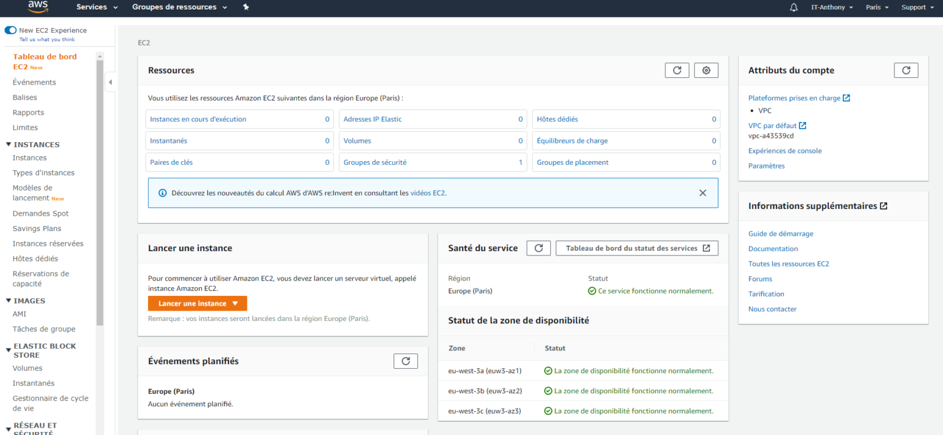

[This Photo](https://notamax.be/amazon-aws-installation-de-docker-sur-une-instance-ec2/) by Unknown Author is licensed under [CC BY-SA-NC](https://creativecommons.org/licenses/by-nc-sa/3.0/)