EXPERIMENT 10

Visual Representation of Multiple Access Techniques
Subject | Mobile Computing
Tool | Figma
Name / Reg. No. | Madhavan S /192425113
Date

Aim
To create a visual representation in Figma showcasing the differences between the multiple access techniques FDMA, TDMA, CDMA and OFDMA.

Tools Required
- Figma (web or desktop)
- Rectangle, Line and Text tools
- Auto Layout and Components
- Layout grid for the time-frequency plane

Theory
Multiple access techniques let many users share the limited radio spectrum of a cell. They divide the shared resource in frequency, time, code or a combination of these.
Each technique is easily drawn on a time-frequency plane with frequency on the vertical axis and time on the horizontal axis, where each user's allocation is a coloured area.
- FDMA: each user receives a separate frequency channel for the whole call (1G AMPS).
- TDMA: users share one frequency but transmit in different time slots (GSM uses TDMA over FDMA).
- CDMA: all users transmit together over the same band and are separated by unique spreading codes (IS-95, UMTS).
- OFDMA: the band is split into orthogonal subcarriers allocated to users in time-frequency blocks (LTE downlink, 5G NR, Wi-Fi 6).
- SDMA: separation by space using directional antennas and beamforming.

Design Specification
Element | Specification
Canvas | Landscape 1440 x 900 with four equal panels (320 x 320 each)
Axes | Vertical axis labelled Frequency, horizontal axis labelled Time
Colours | One colour per user: blue, orange, green, purple (kept constant in all panels)
Panel content | FDMA horizontal bands, TDMA vertical slots, CDMA overlapping outlined layers, OFDMA grid blocks
Comparison table | Rows: resource shared, interference, capacity, example standard

Procedure in Figma
Step | Action | Details
1 | Create the canvas | Create a 1440 x 900 frame named 'Multiple Access'. Add four 320 x 320 sub-frames in a row using Auto Layout.
2 | Draw the axes | In each panel add arrows for Time (x) and Frequency (y) with labels.
3 | Build FDMA | Draw four horizontal rectangles stacked vertically, each spanning the full time axis. Label User 1 to User 4.
4 | Build TDMA | Draw four vertical rectangles side by side, each spanning the full frequency axis.
5 | Build CDMA | Draw four overlapping coloured rectangles over the entire plane with different outline colours. Add a caption 'Separated by codes'.
6 | Build OFDMA | Draw a 4 x 4 grid and colour cells to show users receiving different subcarrier and time blocks.
7 | Add the comparison table | Below the panels create a table (Auto Layout) comparing the techniques.
8 | Interactive highlight (optional) | Make each panel a component with a hover variant that enlarges it and shows a text description.
9 | Export | Export the frame as PNG and PDF.

Prototype Interactions
- Hover on a panel enlarges it and displays a definition.
- Clicking a user colour highlights only that user's allocation in every panel.
- A toggle switches between 'Concept' and 'Example standard' views.

Expected Output
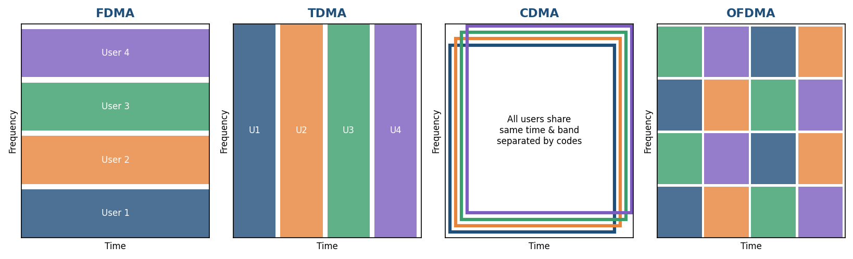
Fig. 10.1 Reference layout to be recreated in Figma

Result
A visual comparison of FDMA, TDMA, CDMA and OFDMA on time-frequency planes was created in Figma along with a summary table.

Viva Questions
- How does TDMA differ from FDMA?
- Why does CDMA need power control?
- What are orthogonal subcarriers?
- Which multiple access scheme is used in GSM and in LTE?

