Experiment 1: Components of a Basic Cellular System

Question
Q1. Use Figma to create an interactive diagram illustrating the components of a basic cellular system.

Aim
To design an interactive diagram in Figma that shows the main components of a basic cellular system and the interfaces that connect them.

Figma Design
design link:
https://www.figma.com/design/aXAC8KDNMxH50dbDXHIduM/Untitled?node-id=3-647&m=dev&t=ceeAWgCXCdMTdRWJ-1
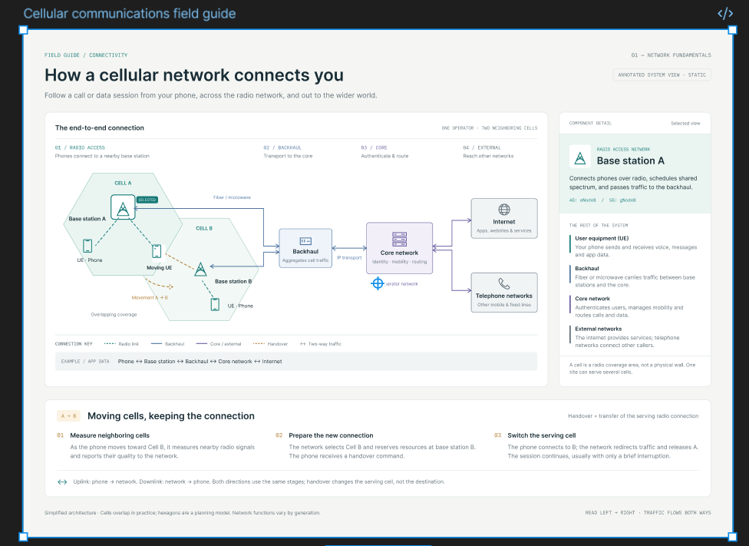
Figure 1: Components of a basic cellular system (Frame: Cellular_System_Overview)

Theory
A cellular system divides a service area into cells. Each cell is served by a base transceiver station (BTS), and the same frequencies are reused in cells that are far enough apart. The mobile station talks to the BTS over the radio (Um) interface. Several BTSs are controlled by a base station controller (BSC), and the BSC connects to a mobile switching centre (MSC). The MSC uses the HLR, VLR, AuC and EIR databases for subscriber, security and equipment information, and links the network to the PSTN, the Internet and other operators.

Procedure
- Open Figma, create a Design file and add a Frame (F) of 1440 × 900 px named Cellular_System_Overview.
- Draw four dashed container rectangles: Mobile Station, Base Station Subsystem (BSS), Network Switching Subsystem (NSS) and External Networks.
- Create each block (ME, SIM, BTS, BSC, MSC, VLR, HLR, AuC, EIR, GMSC) as a rounded rectangle with a text label. Convert repeated blocks to components (Ctrl+Alt+K) so the style stays consistent.
- Join the blocks with arrows and label the interfaces Um, Abis, A, B, C and F. Use a dashed red line for the radio link.
- Draw a seven-cell hexagon cluster with the Polygon tool to show frequency reuse.
- Create a small overlay frame for every component that describes its function.
- Open the Prototype tab. For each block add the interaction On click → Open overlay (Smart animate) and add a close button to each overlay.
- Press Present and click every block to confirm that each hotspot opens the correct overlay.

Components and Their Functions
Component | Function
Mobile Equipment (ME) | Handset hardware with radio transceiver; identified by the IMEI.
SIM | Stores the subscriber identity (IMSI) and authentication key (Ki).
BTS | Radio transmitter/receiver that serves one cell over the Um interface.
BSC | Controls several BTSs; manages radio channels and handover.
MSC | Switches calls, sets up and releases connections, and handles mobility.
VLR | Temporary database of subscribers currently in the MSC area.
HLR | Permanent database of subscriber profiles and current location.
AuC | Generates authentication triplets and ciphering keys.
EIR | Holds lists of valid, stolen or barred equipment (IMEI).
GMSC | Gateway that routes calls to and from external networks.
OMC | Monitors the network and supports billing and fault management.

Result: An interactive diagram of a basic cellular system was created in Figma. It shows the mobile station, BSS, NSS and external networks, the interfaces Um, Abis, A, B, C and F, and a seven-cell frequency-reuse cluster. In Present mode each block opens an overlay describing its function, so the diagram can be explored by clicking.

