EXPERIMENT 6

Simulating a Handoff Scenario in a Mobile Network
Subject | Mobile Computing
Tool | Figma
Name / Reg. No. | Madhavan S /192425113
Date

Aim
To simulate a handoff (handover) scenario in a mobile network using Figma and to visualize each stage of the process through frames and an interactive prototype.

Tools Required
- Figma (web or desktop) with a free account
- Figma Prototype mode (Smart Animate)
- Auto Layout and Components
- Optional plugin: Chart or Figmotion for the signal graph

Theory
Handoff is the process of transferring an ongoing call or data session from one base station (cell) to another without dropping the connection when the mobile station (MS) moves across a cell boundary. It is the key mechanism that makes mobility possible in a cellular system.
The network decides to hand off by comparing measurements such as received signal strength (RSSI/RSRP), signal quality (SINR/BER) and distance. A hysteresis margin and a threshold prevent the 'ping-pong' effect, where the call bounces repeatedly between two cells.
- Hard handoff (break-before-make): the old link is released before the new link is set up. Used in GSM and FDMA/TDMA systems.
- Soft handoff (make-before-break): the MS is connected to both cells for a short time. Used in CDMA/UMTS.
- Intra-cell, inter-cell, inter-BSC and inter-MSC handoffs differ in which network node controls the change.
- Network-controlled (1G), mobile-assisted (GSM, MAHO) and mobile-controlled (DECT) handoff differ in who makes the decision.

Design Specification
Element | Specification
Canvas | Desktop frame 1440 x 900 for the simulation; mobile frame 390 x 844 for the handset view
Colours | Blue #1F4E79 (serving BTS), Green #3A9E6B (target BTS), Orange #E8833A (mobile station), Red #D64545 (threshold)
Typography | Inter or Roboto: 24 px titles, 14 px labels, 12 px captions
Components | BTS tower, coverage circle, MS icon, signal graph, status banner
Frames | Frame 1 Idle, Frame 2 Approaching boundary, Frame 3 Measurement report, Frame 4 Handoff command, Frame 5 Connected to BTS B

Procedure in Figma
Step | Action | Details
1 | Create a file | Open Figma, create a new Design file named 'Handoff Simulation' and add a 1440 x 900 frame.
2 | Draw the cells | Use the Ellipse tool to draw two overlapping circles (coverage areas). Fill with 15 % blue and 15 % green. Place a tower icon at each centre and label them BTS A and BTS B.
3 | Create the MS | Draw a small orange circle for the mobile station. Make it a Component so that it can be reused in all frames.
4 | Add the signal graph | Below the cells draw two crossing lines for signal A (falling) and signal B (rising). Add a dashed red line for the minimum usable level and a shaded band for the hysteresis margin.
5 | Duplicate frames | Duplicate the frame four times (Ctrl+D). In each frame move the MS further from BTS A towards BTS B and move a marker along the graph.
6 | Add status banners | Add an Auto Layout text banner at the top of each frame: 'Connected to BTS A', 'Measuring neighbours', 'Handoff request sent', 'Handoff command received', 'Connected to BTS B'.
7 | Wire the prototype | Switch to Prototype mode. Connect Frame 1 to Frame 2, and so on, using 'After delay 1200 ms' with Smart Animate and Ease-in-out 600 ms so that the MS glides across.
8 | Add a Replay button | In the last frame add a Replay button linked back to Frame 1 on click.
9 | Run and record | Press Play (Present). Check that the MS animates and the banner updates. Export frames as PNG for the record.

Prototype Interactions
- Auto-advance with Smart Animate shows the MS moving from BTS A to BTS B.
- On the graph, a marker slides along the curves and stops at the crossing point.
- Click on the BTS B coverage circle to open an overlay explaining the target cell.
- Replay button resets the scenario.

Expected Output
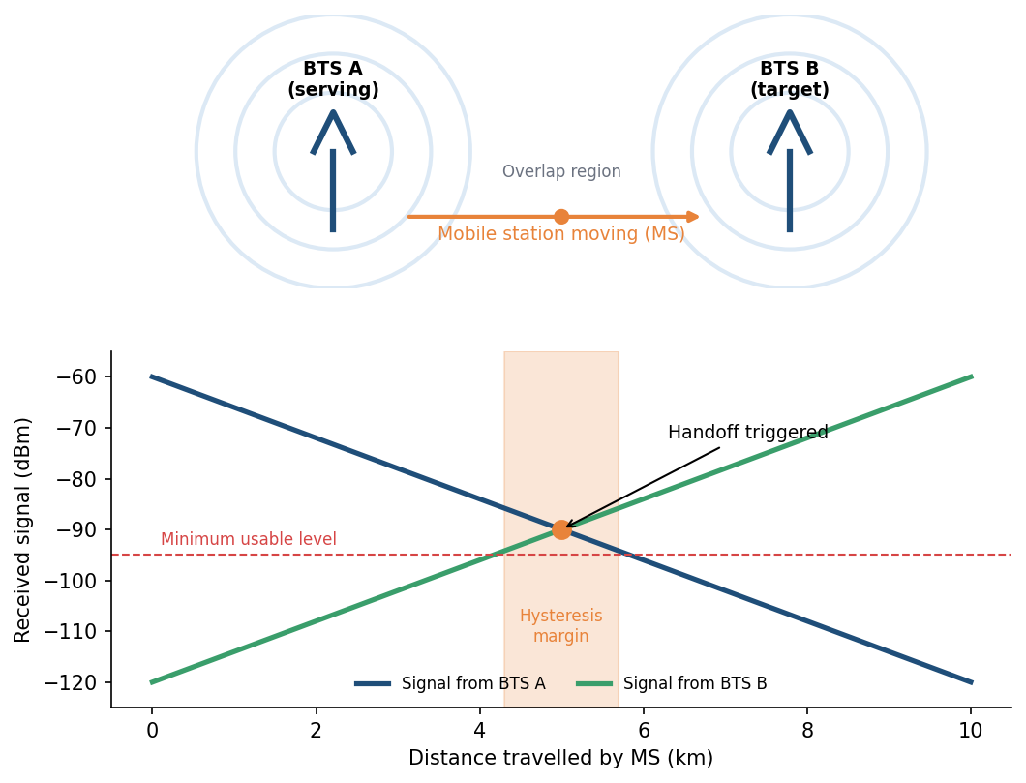
Fig. 6.1 Reference layout to be recreated in Figma

Result
A five-frame interactive Figma prototype was created that visualizes the handoff of a mobile station from BTS A to BTS B, including measurement, decision and execution phases, along with the signal-strength graph.

Viva Questions
- Differentiate hard and soft handoff.
- What is hysteresis and why is it used?
- Which node decides a handoff in GSM?
- What causes the ping-pong effect and how is it avoided?

