EXPERIMENT 7

Dashboard Prototype Showing Performance Criteria of a Cellular System
Subject | Mobile Computing
Tool | Figma
Name / Reg. No. | Madhavan S /192425113
Date

Aim
To develop a dashboard prototype in Figma that displays the key performance criteria of a cellular system such as call drop rate, handover success rate, throughput, signal strength and blocking probability.

Tools Required
- Figma (web or desktop)
- Auto Layout, Components and Variants
- Plugins: Chart, Data Populator (optional)
- Grid and Layout Grid for alignment

Theory
The performance of a cellular system is judged with Key Performance Indicators (KPIs) collected by the network operations centre. Operators monitor these values to detect congestion, coverage holes and equipment faults.
A good dashboard presents a few high-value numbers at the top (KPI cards), trends over time in the middle (line charts) and a comparison by cell or region (bar charts or tables), with filters to change the time window.
- Call Drop Rate (CDR) = dropped calls / total established calls x 100.
- Call Setup Success Rate (CSSR) = successful setups / attempts x 100.
- Handover Success Rate = successful handovers / handover attempts x 100.
- Blocking probability: the chance that a new call finds all channels busy (Erlang B).
- Throughput, latency, RSSI/RSRP and SINR describe data quality and coverage.
- Spectral efficiency and capacity (Erlangs per cell) show how well the spectrum is used.

Design Specification
Element | Specification
Canvas | Desktop 1440 x 900, 12-column layout grid, 24 px gutter
Header | Dark blue bar #1F4E79 with title, date-range dropdown and refresh icon
KPI cards | Four cards (200 x 100): CDR, handover success, throughput, average RSSI. Green for healthy, red for breach
Charts | Line chart for throughput over 24 h; horizontal bar chart for blocking probability by cell
Filters | Region, technology (2G/3G/4G/5G) and time-range dropdowns as Variants

Procedure in Figma
Step | Action | Details
1 | Set up the file | Create a new file 'Cellular Dashboard' and a 1440 x 900 frame. Add a 12-column layout grid (Ctrl+Shift+4).
2 | Build the header | Draw a full-width rectangle (height 64). Add the title text and a dropdown component on the right.
3 | Create the KPI card component | Make a rectangle with 12 px radius, add label, value and a small trend arrow. Wrap in Auto Layout and press Ctrl+Alt+K to create a component.
4 | Create variants | Add variants 'Good', 'Warning' and 'Critical' that change the value colour. Place four instances and set their values.
5 | Insert charts | Use the Chart plugin (or draw with Line and Rectangle tools) to create the throughput line chart and blocking-probability bars. Use realistic sample values.
6 | Add the table | Add a table of cells with columns Cell ID, Users, Utilisation and Status, built with Auto Layout rows.
7 | Prototype the filters | Create a second frame with another time range. Connect the dropdown to it with 'On click, Change to' and Smart Animate.
8 | Add hover states | Use component variants with 'While hovering' to highlight a card and show a tooltip.
9 | Present and review | Run the prototype, check spacing and contrast, and export the dashboard as PNG or PDF.

Prototype Interactions
- Dropdown changes the time window from 24 h to 7 days.
- Hovering over a KPI card shows its formula in a tooltip.
- Clicking a cell row opens a detail overlay.
- Status colours change with component variants.

Expected Output
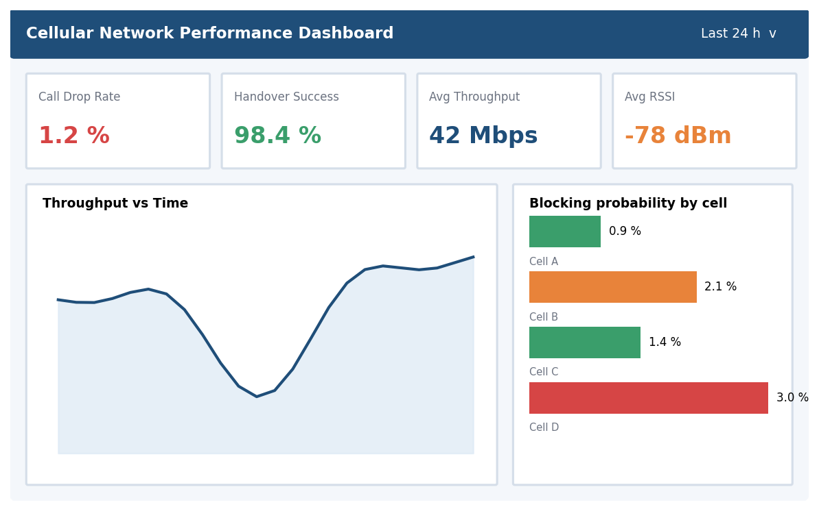
Fig. 7.1 Reference layout to be recreated in Figma

Result
An interactive cellular-system performance dashboard prototype was designed in Figma, displaying KPI cards, a throughput trend, blocking probability by cell and a cell status table.

Viva Questions
- Define call drop rate and handover success rate.
- What does blocking probability indicate?
- Why are variants useful for KPI cards?
- Which KPIs indicate a coverage problem?

