EXPERIMENT 9

User Interface Prototype for a GSM Service
Subject | Mobile Computing
Tool | Figma
Name / Reg. No. | Madhavan S /192425113
Date

Aim
To design a user interface prototype in Figma for a GSM service covering voice calling, SMS and SIM/network settings.

Tools Required
- Figma (web or desktop)
- Mobile frame preset (iPhone or Android, 390 x 844)
- Components, Variants and Auto Layout
- Prototype mode with Smart Animate and overlays

Theory
GSM (Global System for Mobile Communications) is a digital, circuit-switched cellular standard that provides voice calls, SMS, supplementary services and low-rate data. Its architecture has the Mobile Station (ME + SIM), Base Station Subsystem (BTS, BSC) and Network Switching Subsystem (MSC, HLR, VLR, AuC, EIR).
The user interface of a GSM service exposes these functions to the subscriber: dialling, call log, messaging, SIM and network selection, roaming and supplementary services such as call forwarding and call waiting.
- Core screens: Dialer, Call in progress, Call log, Messages, Conversation, SIM and Network settings.
- Status bar shows signal bars, network type, roaming indicator and battery.
- Supplementary services: call forwarding, call barring, call waiting, caller ID.
- SIM details: operator name, IMSI-linked number, PIN lock, network mode.

Design Specification
Element | Specification
Frame | 390 x 844 mobile frames, 16 px side padding
Palette | Blue #1F4E79 header, green #3A9E6B call button, red #D64545 end-call button
Typography | Inter: 20 px header, 16 px body, 12 px status text
Components | Keypad button, list item, message bubble, toggle, bottom navigation
Screens | Dialer, Calling, Call log, Messages, Chat, SIM and Network

Procedure in Figma
Step | Action | Details
1 | Create frames | Add a mobile frame and duplicate it for each of the six screens. Name them clearly.
2 | Design the status bar | Create a component with signal bars, 'GSM/4G' label and battery. Reuse it at the top of each screen.
3 | Build the dialer | Make a keypad button component (64 px circle). Use a 3 x 4 Auto Layout grid. Add the number display and a green Call button.
4 | Design the Calling screen | Show contact name, timer, and mute, speaker and keypad buttons with a red End button.
5 | Build Messages | Create message bubble components (sent and received variants) and a text input bar.
6 | Build SIM and Network settings | Create list items with toggles for Roaming, Network mode and Call forwarding.
7 | Add bottom navigation | Create a four-tab component (Calls, Messages, Contacts, Settings) with active and inactive variants.
8 | Connect the prototype | In Prototype mode link Call to Calling screen, End to Dialer, tab icons to their screens, and the Roaming toggle to an overlay warning about charges.
9 | Test | Present the prototype on desktop or the Figma mobile app and fix any dead ends.

Prototype Interactions
- Pressing Call opens the Calling screen with a running timer.
- Bottom navigation switches between screens with Smart Animate.
- Roaming toggle shows a confirmation overlay.
- Keypad buttons have pressed states.

Expected Output
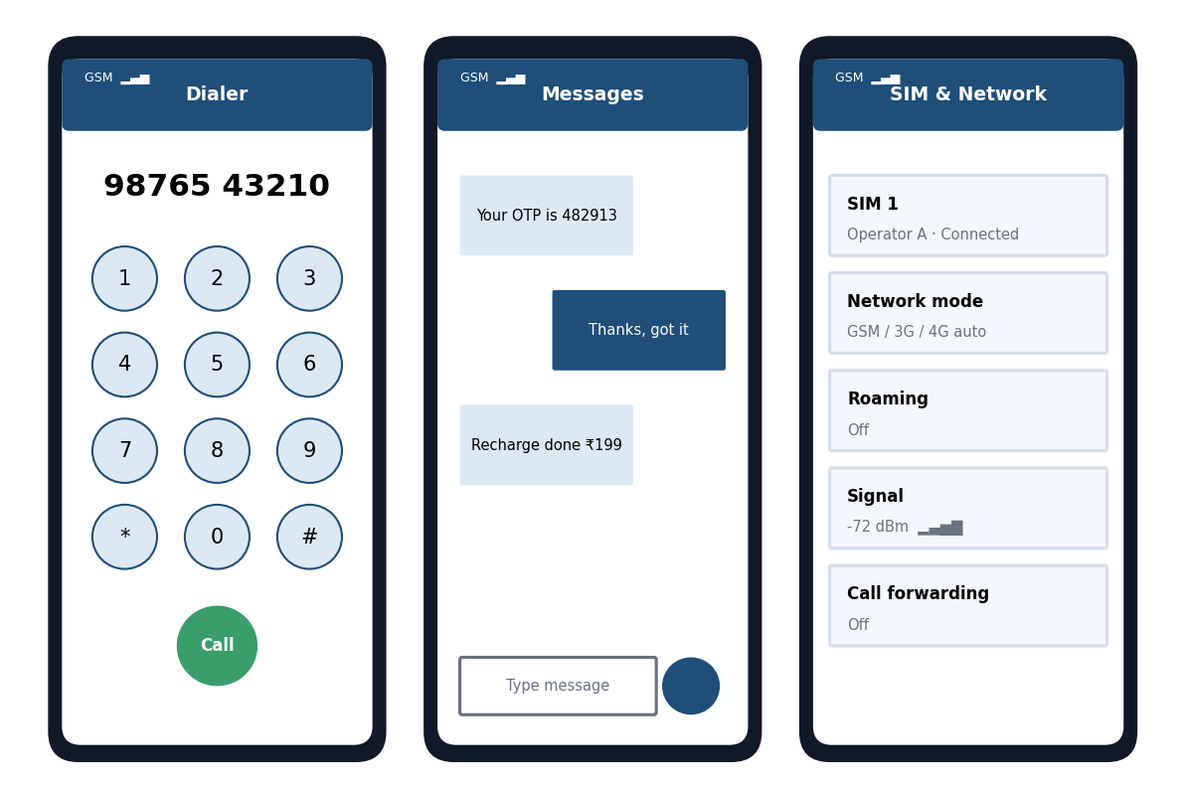
Fig. 9.1 Reference layout to be recreated in Figma

Result
A six-screen interactive GSM service prototype was built in Figma with dialer, call, messaging and SIM/network settings screens.

Viva Questions
- Name the main elements of the GSM architecture.
- What is the role of the SIM card?
- Which supplementary services are available in GSM?
- How is the roaming status shown to the user?

