EXPERIMENT 8

Infographic Explaining Public Land Mobile Network (PLMN)
Subject | Mobile Computing
Tool | Figma
Name / Reg. No. | Madhavan S /192425113
Date

Aim
To create an infographic in Figma that explains the concept, structure and identification of a Public Land Mobile Network (PLMN).

Tools Required
- Figma (web or desktop)
- Shapes, Auto Layout and Components
- Iconify or Material Icons plugin
- Frame size 1080 x 1920 (portrait infographic)

Theory
A Public Land Mobile Network (PLMN) is a land-based mobile network operated by one operator in a given country to offer public mobile telecom services. Every operator in a country runs its own PLMN, and a subscriber is attached to the home PLMN (HPLMN) of the SIM provider.
A PLMN is identified by the PLMN ID, which is the Mobile Country Code (MCC) followed by the Mobile Network Code (MNC). The same pair forms the first digits of the IMSI and appears in the broadcast system information of every cell.
- MCC: 3 digits that identify the country (for example India uses 404 and 405).
- MNC: 2 or 3 digits that identify the operator within that country.
- HPLMN is the subscriber's home network; VPLMN is a visited network while roaming.
- Hierarchy: PLMN contains MSC/VLR areas, which contain Location Areas (Tracking Areas in LTE), which contain cells.
- Roaming agreements let a subscriber use a VPLMN, and the PLMN selection lists preferred networks.

Design Specification
Element | Specification
Canvas | Portrait frame 1080 x 1920, 80 px outer margin, 8 px spacing scale
Palette | Blue #1F4E79, Orange #E8833A, Green #3A9E6B, light background #F4F7FB
Typography | Poppins or Inter: 56 px title, 32 px section headers, 20 px body
Sections | 1 What is a PLMN, 2 PLMN ID = MCC + MNC, 3 Network hierarchy, 4 HPLMN and VPLMN roaming, 5 Key facts
Icons | Tower, globe, SIM card, phone, arrows

Procedure in Figma
Step | Action | Details
1 | Create the frame | Make a 1080 x 1920 frame named 'PLMN Infographic'. Fill with the light background.
2 | Add the title block | Add a title 'Public Land Mobile Network (PLMN)' and a one-line definition under it.
3 | Draw the PLMN ID bar | Create a wide rounded rectangle and split it into two coloured boxes labelled MCC (3 digits) and MNC (2-3 digits). Add small captions below each.
4 | Draw the hierarchy | Place a PLMN box, three Location Area boxes and cells below. Connect with straight connectors (Shift+C) so lines follow the boxes.
5 | Add the roaming section | Draw two networks side by side (Home PLMN and Visited PLMN). Add a SIM icon and a two-way arrow labelled 'Roaming agreement'.
6 | Add icons | Use the Iconify plugin to insert tower, globe and SIM icons. Keep stroke weight uniform.
7 | Add key facts | Create three Auto Layout cards with short facts (identification, operator, roaming).
8 | Check alignment | Use Align tools and the layout grid. Make sure contrast is readable.
9 | Export | Select the frame and export as PNG at 2x and PDF.

Prototype Interactions
- Optional: link each section header to a frame that expands with more detail.
- Hover state on MCC and MNC boxes shows an example value.
- Section anchors allow click-to-scroll navigation.

Expected Output
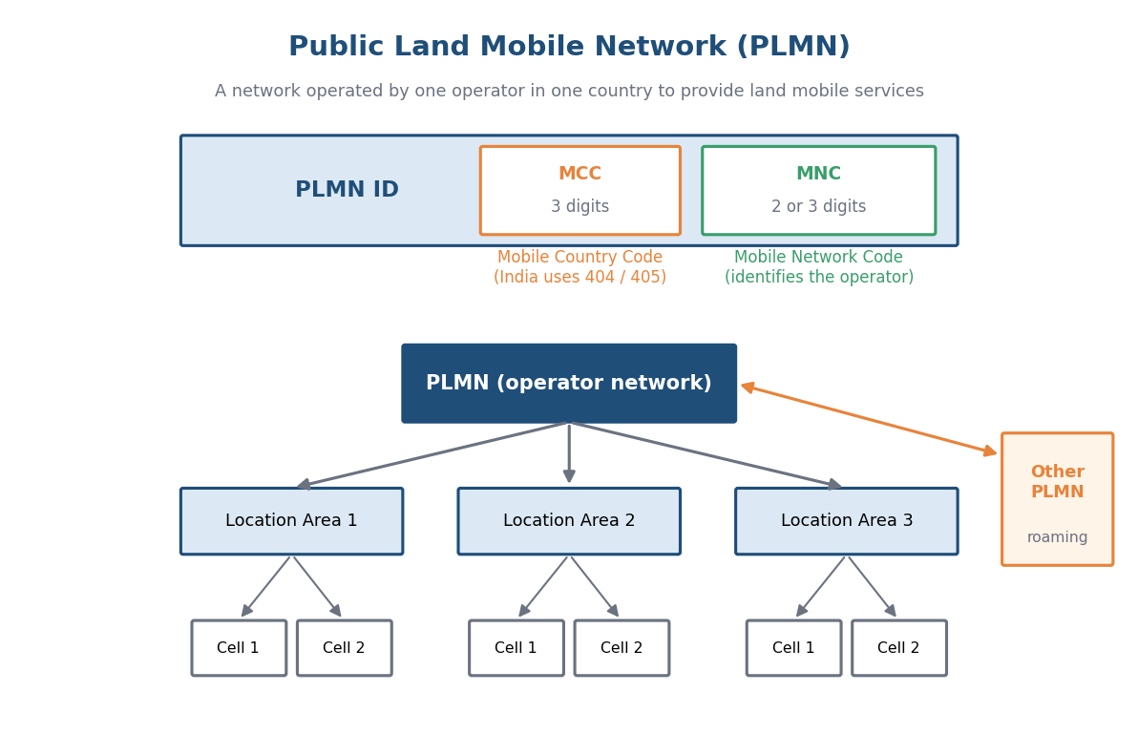
Fig. 8.1 Reference layout to be recreated in Figma

Result
A clear, single-page infographic explaining PLMN, its MCC + MNC identification, hierarchy and roaming was created in Figma.

Viva Questions
- What is a PLMN?
- How is a PLMN identified?
- Differentiate HPLMN and VPLMN.
- Where is the PLMN ID used in the network?

