EXPERIMENT 11

Wireframe for a Mobile Application with Security Measures
Subject | Mobile Computing
Tool | Figma
Name / Reg. No. | Madhavan S /192425113
Date

Aim
To design a wireframe in Figma for a mobile application that incorporates security measures such as strong authentication, two-factor verification, biometric login, encryption indicators and a security centre.

Tools Required
- Figma (web or desktop)
- Wireframe kit or plain grey boxes
- Mobile frame 390 x 844
- Prototype mode

Theory
Mobile applications handle sensitive data over wireless links, so the design must support confidentiality, integrity, authentication and availability. A wireframe is a low-fidelity layout that fixes where security controls appear and how the user moves through them before visual design starts.
Good security UX is not only protection but also clarity: the user should understand the current protection state, be asked for the right step at the right time and recover easily from errors.
- Authentication: username and password with strength meter, biometric (fingerprint or face) and PIN fallback.
- Two-factor authentication: OTP by SMS or authenticator app, with a resend timer and attempt limit.
- Session security: auto-logout after inactivity, device list and remote sign-out.
- Data protection indicators: encrypted connection, VPN and app lock status.
- Privacy controls: permission prompts, login alerts and a clear 'Report suspicious activity' option.
- Error states: wrong password, locked account, expired OTP.

Design Specification
Element | Specification
Frames | 390 x 844 mobile frames for Splash, Login, Biometric, OTP verification, Security centre, Device list, Alerts
Style | Low-fidelity: grey #EEF1F5 boxes, 1 px grey outline, one accent blue for primary actions
Components | Input field, primary button, OTP box, toggle row, alert banner, bottom sheet
Grid | 4 px baseline, 16 px margins
Labels | Annotate each control with the security purpose (for example 'rate-limited')

Procedure in Figma
Step | Action | Details
1 | Plan the flow | On a FigJam or a Figma page sketch the flow: Splash > Login > OTP > Home > Security centre.
2 | Create base frames | Make seven mobile frames and name them in flow order.
3 | Design Login | Add logo placeholder, username, password with show/hide icon, strength bar, Sign in button and 'Use biometric' option.
4 | Design OTP verification | Add six OTP boxes, Verify button, resend countdown and 'Trust this device' checkbox.
5 | Design Security centre | Add a status banner (Device secure), toggle rows for encryption, VPN, app lock and login alerts, and a 'Run security scan' button.
6 | Design alerts and errors | Create a bottom sheet for 'New device login' with Allow and Block buttons. Create an error variant for wrong OTP.
7 | Add annotations | Place small yellow notes beside key controls to explain the security measure.
8 | Link the prototype | Connect buttons to their next screen. Add 'Wrong OTP' as an alternate path.
9 | Review | Test every path in Present mode. Verify that each frame has a way back and no dead end.

Prototype Interactions
- Biometric button simulates success and goes to Home.
- Wrong OTP shows an error variant and a retry counter.
- Toggle rows flip between On and Off using variants.
- New device login bottom sheet appears as an overlay.

Expected Output
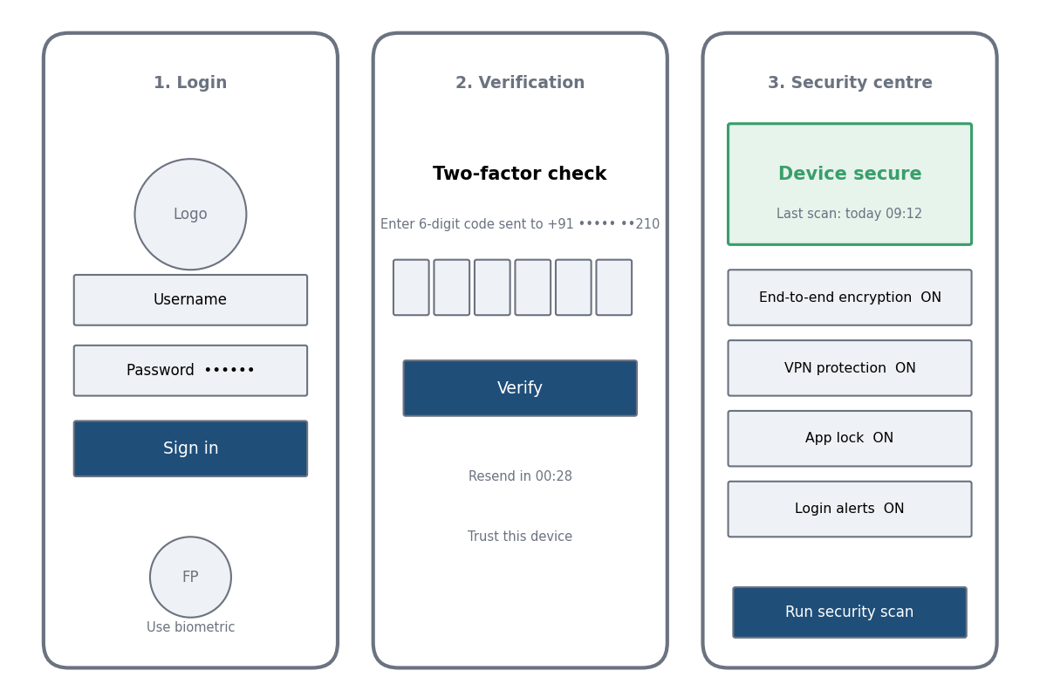
Fig. 11.1 Reference layout to be recreated in Figma

Result
A seven-screen security-focused mobile app wireframe with authentication, OTP, biometric and a security centre was designed and linked as a clickable prototype in Figma.

Viva Questions
- What is two-factor authentication?
- Why are OTPs time-limited?
- What risks does a mobile app face over wireless networks?
- How does a wireframe differ from a high-fidelity design?

