EXPERIMENT 13

Infographic Comparing Mobile Communication and Mobile Computing
Subject | Mobile Computing
Tool | Figma
Name / Reg. No. | Madhavan S /192425113
Date

Aim
To design an infographic in Figma that compares mobile communication with mobile computing in terms of focus, requirements, examples and challenges.

Tools Required
- Figma (web or desktop)
- Auto Layout, Components and Styles
- Icon plugin
- Frame size 1440 x 1024

Theory
Mobile communication refers to the infrastructure and technology that allow information (voice, data, video) to be exchanged wirelessly while the user moves. It covers radio propagation, cellular architecture, handoff, multiple access and protocols.
Mobile computing refers to the use of portable computing devices, software and services that work while the user is on the move. It covers hardware, mobile operating systems, applications, context awareness and data synchronisation. The two are interdependent: mobile computing relies on mobile communication for connectivity.
- Mobile communication: spectrum, base stations, signalling, handoff, roaming, QoS.
- Mobile computing: portable devices, OS (Android, iOS), apps, middleware, offline data and synchronisation.
- Shared challenges: security, bandwidth variation and mobility management.
- Specific challenges: fading and interference for communication; battery life and small screens for computing.

Design Specification
Element | Specification
Canvas | 1440 x 1024, two-column layout split by a centre divider
Colours | Blue for communication, orange for computing, neutral grey for common area
Rows | Focus, Core requirements, Examples, Challenges, Layers, Typical technologies
Centre | Venn-style overlap labelled 'Common: wireless connectivity, mobility, security'
Icons | Tower for communication, smartphone/laptop for computing

Procedure in Figma
Step | Action | Details
1 | Create the frame and grid | Make a 1440 x 1024 frame with a two-column layout grid.
2 | Add the title | Add the title 'Mobile Communication vs Mobile Computing' and a short subtitle.
3 | Build the column headers | Create two header cards with icon and heading in the respective colours.
4 | Create the row component | Build an Auto Layout row component with a left cell, a centre label and a right cell. Duplicate it for every comparison row.
5 | Fill the content | Write short phrases in each cell and keep text to two lines.
6 | Add the overlap section | Draw two overlapping circles under the table with the shared characteristics in the intersection.
7 | Add a summary strip | At the bottom add a one-line takeaway: 'Communication carries the data; computing uses it.'
8 | Polish | Apply text and colour styles, check spacing and contrast.
9 | Export | Export as PNG and PDF.

Prototype Interactions
- Hover on a row highlights both cells.
- Optional toggle shows or hides the Venn overlap.

Expected Output
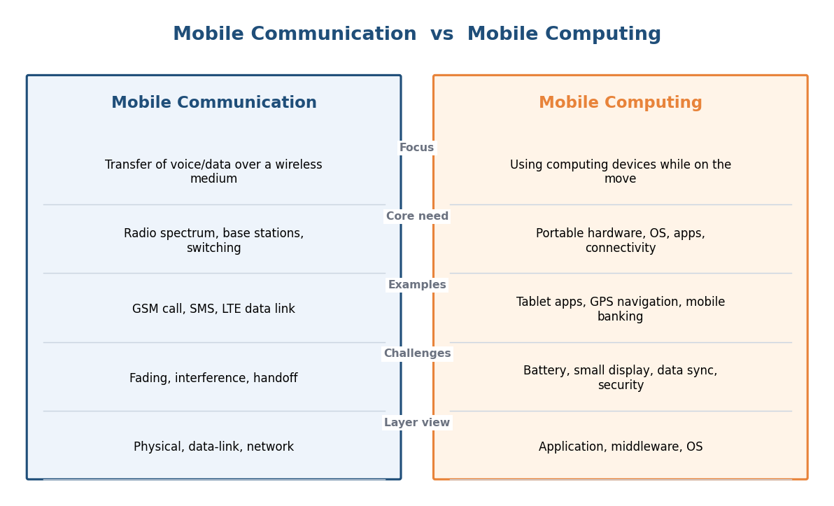
Fig. 13.1 Reference layout to be recreated in Figma

Result
A two-column comparison infographic of mobile communication and mobile computing with a shared-characteristics overlap was created in Figma.

Viva Questions
- Define mobile communication and mobile computing.
- Give two challenges specific to mobile computing.
- How are the two interdependent?
- Name any two mobile operating systems.

