EXPERIMENT 12

Interactive Diagram Illustrating the Evolution from 1G to 5G
Subject | Mobile Computing
Tool | Figma
Name / Reg. No. | Madhavan S /192425113
Date

Aim
To create an interactive diagram in Figma that illustrates the evolution of mobile communication from 1G to 5G, with details of each generation shown on click.

Tools Required
- Figma (web or desktop)
- Component Variants and Interactive Components
- Prototype overlays and Smart Animate
- Icon plugin (optional)

Theory
Mobile communication has evolved roughly every decade. Each generation introduced a new radio technology, higher data rate and new services.
The diagram arranges generations on a timeline and lets the viewer open a detail card for each, showing technology, data rate, switching type and key services.
- 1G (1980s): analog voice, FDMA, AMPS and NMT, about 2.4 kbps, poor security.
- 2G (1991): digital voice and SMS, GSM (TDMA) and IS-95 (CDMA), encryption, circuit switching.
- 2.5G/2.75G: GPRS and EDGE introduce packet switching, up to about 170 to 384 kbps.
- 3G (2001): UMTS/WCDMA and HSPA, mobile internet and video calls, 2 to 42 Mbps.
- 4G (2010): LTE and LTE-Advanced, all-IP, OFDMA, 100 Mbps to 1 Gbps.
- 5G (2019): NR, eMBB, URLLC, mMTC, network slicing, up to multi-Gbps and very low latency.

Design Specification
Element | Specification
Canvas | Landscape 1440 x 900
Timeline | Horizontal line with six circular nodes (1G, 2G, 2.5G, 3G, 4G, 5G)
Node component | Variants: Default, Hover and Selected (larger, filled colour)
Detail card | Overlay component with title, year, technology, data rate, key services and a Close button
Palette | Grey to red gradient across generations to suggest progress

Procedure in Figma
Step | Action | Details
1 | Create the frame | Make a 1440 x 900 frame 'Evolution 1G to 5G' and add a heading.
2 | Draw the timeline | Draw a horizontal line and place six evenly spaced circles. Add year labels above and generation labels inside.
3 | Make the node component | Convert one circle into a component. Add variants Default, Hover and Selected and apply them to all nodes.
4 | Add summary boxes | Below every node add a small box with technology and data rate.
5 | Create detail cards | Design a card component with fields for each generation. Duplicate it six times with the correct content.
6 | Link the nodes | In Prototype mode set each node to 'On click, Open overlay' with its card, position centred, Move-in animation.
7 | Add navigation | Add Previous and Next arrows inside the cards to move between generations.
8 | Add the progress line | Animate a coloured line growing under the timeline using Smart Animate on a start frame.
9 | Test | Present the file and click through all six generations. Export a static PNG as well.

Prototype Interactions
- Click on a node opens its detail card as an overlay.
- Hover enlarges the node.
- Next and Previous move through generations.
- Timeline progress animates on load.

Expected Output
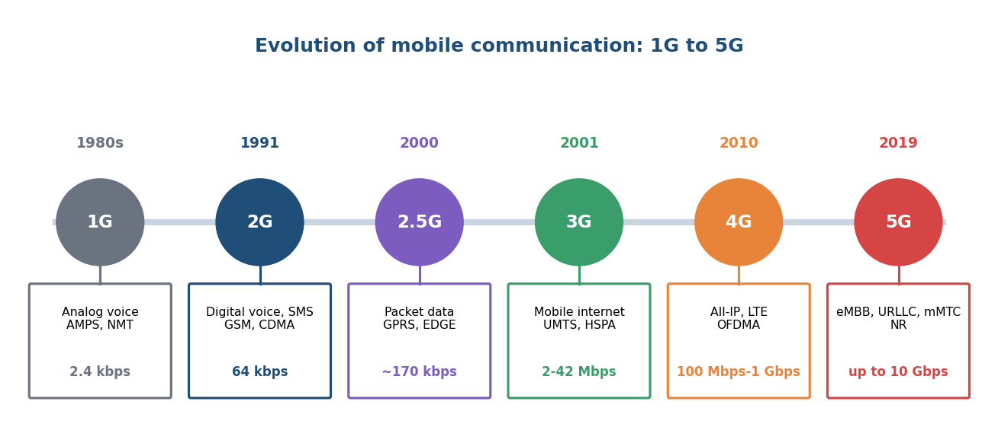
Fig. 12.1 Reference layout to be recreated in Figma

Result
An interactive 1G to 5G evolution diagram was built in Figma where each generation opens a detail card with its technology, data rate and services.

Viva Questions
- Which technology introduced packet switching?
- What is the major difference between 3G and 4G?
- Name the three usage scenarios of 5G.
- Which multiple access technique does 4G use in the downlink?

