EXPERIMENT 14

Flowchart Explaining the Operation of General Packet Radio Service (GPRS)
Subject | Mobile Computing
Tool | Figma
Name / Reg. No. | Madhavan S / 192425113
Date

Aim
To develop a flowchart in Figma that explains the operation of GPRS, from attach to data transfer and detach.

Tools Required
- Figma (web or desktop)
- Shapes and Connectors (Shift+C) or FigJam flowchart shapes
- Auto Layout and Components
- Optional: Flowchart plugin

Theory
General Packet Radio Service (GPRS) is a packet-switched data service added to GSM (2.5G). It allocates radio resources only when data is sent, so many users can share time slots and are billed per data volume. It reaches up to about 170 kbps by using multiple time slots.
GPRS adds two core nodes to GSM: the Serving GPRS Support Node (SGSN), which handles mobility, authentication and routing to the mobile station, and the Gateway GPRS Support Node (GGSN), which connects to external packet data networks and assigns IP addresses. A Packet Control Unit (PCU) at the BSC manages the radio packets.
- GPRS Attach: the MS registers with the SGSN, which authenticates it with the HLR.
- PDP context activation: the MS requests a session with an Access Point Name; the GGSN allocates an IP address.
- Data transfer: packets flow MS - BTS - BSC/PCU - SGSN - GGSN - Internet, tunnelled by GTP between SGSN and GGSN.
- GPRS Detach / PDP deactivation releases the resources.
- Interfaces: Gb (PCU to SGSN), Gn (SGSN to GGSN), Gi (GGSN to external network).

Design Specification
Element | Specification
Canvas | Portrait 1080 x 1600
Shapes | Rounded rectangle for process, diamond for decision, green terminator for Start and End
Colours | Blue process boxes, orange decision, red for failure path, green for start and end
Connectors | Straight arrows with labels 'Yes' and 'No'
Side panel | Mini architecture strip: MS, BTS, BSC/PCU, SGSN, GGSN, Internet

Procedure in Figma
Step | Action | Details
1 | Create the frame | Add a 1080 x 1600 frame named 'GPRS Flowchart'.
2 | Place the Start terminator | Add a green rounded rectangle labelled 'Start: MS powers on'.
3 | Add process boxes | Add boxes in order: GPRS Attach request, SGSN authenticates with HLR, PDP context activation, GGSN allocates IP address, Data transfer.
4 | Add the decision | Insert a diamond 'Authentication successful?'. The Yes branch continues; the No branch goes to a red 'Reject attach' box and then End.
5 | Connect with arrows | Use connectors so that arrows stay attached when boxes move. Label branches.
6 | Add the End step | Add 'GPRS Detach / PDP deactivation' and a green End terminator.
7 | Add the architecture strip | Draw six small boxes (MS, BTS, BSC/PCU, SGSN, GGSN, Internet) and label interfaces Um, Abis, Gb, Gn and Gi.
8 | Add interactivity (optional) | Link each process box to an overlay with a short explanation of that step.
9 | Review and export | Run Present mode to test overlays. Export as PNG and PDF.

Prototype Interactions
- Clicking a process box opens an overlay with the step explanation.
- Highlight path: hover on the architecture strip highlights the corresponding step.
- Failure branch can be toggled to show the reject scenario.

Expected Output
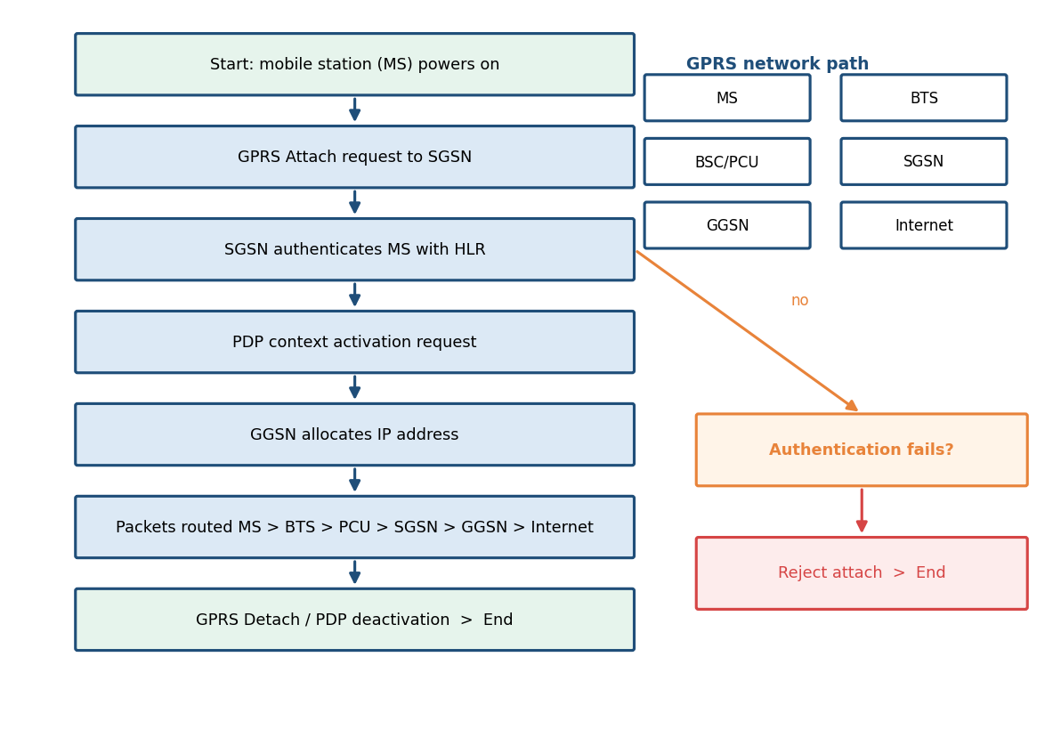
Fig. 14.1 Reference layout to be recreated in Figma

Result
A GPRS operation flowchart covering attach, authentication, PDP context activation, packet transfer and detach was created in Figma, with the supporting architecture strip.

Viva Questions
- What are SGSN and GGSN?
- How does GPRS differ from circuit-switched GSM data?
- What is a PDP context?
- Which interfaces connect PCU, SGSN and GGSN?

