Solar Flare Prediction & Space Weather Alert System
Using Machine Learning
A PROJECT-BASED LEARNING (PBL) REPORT
Submitted by
Madhavan G
Register Number: 2104251040518
Sriram Sivakumar
Register Number: 2104251040971
Submitted in partial fulfilment of the requirements for the
Project-Based Learning component of Machine Learning
BACHELOR OF ENGINEERING
in
COMPUTER SCIENCE AND ENGINEERING

CHENNAI INSTITUTE OF TECHNOLOGY, CHENNAI

Affiliated to Anna University, Chennai (Autonomous)
OCTOBER 2026
Vision of the Institute:
To be an eminent Centre for Academia, Industry and Research by imparting knowledge, relevant practices and inculcating human values to address global challenges through novelty and sustainability.
Mission of the Institute:
IM1. To create next-generation leaders through effective teaching-learning methodologies and instil scientific temper in them to meet global challenges.
IM2. To transform lives through deployment of emerging technology, novelty and sustainability.
IM3. To inculcate human values and ethical principles to cater to societal needs.
IM4. To contribute towards the research ecosystem by providing a suitable, innovation-driven environment.
DEPARTMENT OF COMPUTER SCIENCE AND ENGINEERING
Vision of the Department:
To excel in the emerging areas of Computer Science and Engineering by imparting knowledge, relevant practices and inculcating human values to transform students into potential resources who contribute innovatively through advanced computing in real-time situations.
Mission of the Department:
DM1. To provide strong fundamentals and technical skills for Computer Science applications through effective teaching-learning methodologies.
DM2. To transform the lives of students by nurturing ethical values, creativity and novelty to become entrepreneurs and establish start-ups.
DM3. To habituate students to focus on sustainable solutions that improve the quality of life and the welfare of society.

Bonafide Certificate
This is to certify that the Project-Based Learning report titled “Solar Flare Prediction & Space Weather Alert System Using Machine Learning” is a bonafide record of work carried out by Madhavan G (2104251040518) and Sriram Sivakumar (2104251040971) of the Department of Computer Science and Engineering, Chennai Institute of Technology, as part of the continuous, mentor-guided Project-Based Learning (PBL) component of the Machine Learning course during the academic year 2026–2027 under my supervision.
SIGNATURE | SIGNATURE
Dr. S. Pavithra, M.E., Ph.D.  Professor and Head  Dept. of Computer Science and Engineering  Chennai Institute of Technology, Chennai – 69. | S.Raja Priya, M.E.  MENTOR, Assistant Professor  Dept. of Computer Science and Engineering  Chennai Institute of Technology, Chennai – 69.

Submitted for the final review held on ______________________.
Internal Examiner | External Examiner

Declaration
We jointly declare that the PBL report on “Solar Flare Prediction & Space Weather Alert System Using Machine Learning” is the result of original work done by us and, to the best of our knowledge, similar work has not been submitted to Anna University, Chennai for the requirement of the Degree of Bachelor of Engineering. This PBL report is submitted in partial fulfilment of the requirement for the award of the Degree of Bachelor of Engineering in Computer Science and Engineering.
Signature
Madhavan G
Sriram Sivakumar
Place: Chennai
Date:

Acknowledgement
We wish to express our sincere gratitude to our honourable Chairman Shri. P. Sriram for providing immense facilities at our institution.
We are very proud to render our thanks to our Principal Dr. A. Ramesh, M.E., Ph.D., for the facilities and encouragement given by him toward the progress and completion of our project.
We would like to express special thanks of gratitude to our Dean Dr. V. Srinivasa Rao, M.E., Ph.D., who has been a key source of motivation to us throughout the completion of our course and project work.
We proudly render our immense gratitude to the Head of the Department Dr. S. Pavithra, M.E., Ph.D., for her effective leadership, encouragement and guidance throughout this project.
We would like to extend our thanks to the Project Coordinator S.Raja Priya, M.E., Department of Computer Science and Engineering, for her valuable suggestions throughout this project.
We wish to acknowledge the help received from the Class Advisor S.Raja Priya, M.E., of the Department of Computer Science and Engineering, and others who contributed to the progress of this project.
Madhavan G
Sriram Sivakumar

Abstract
Solar flares are sudden releases of magnetic energy from the Sun that can disturb space-weather conditions and affect communication, navigation and other technology-dependent systems. This project implements a Machine Learning-based forecasting prototype that uses the Space-Weather ANalytics for Solar Flares (SWAN-SF) benchmark dataset — 331,185 twelve-hour observation windows drawn from SDO/HMI SHARP magnetic-field parameters across five chronological partitions (2010–2018) — to estimate whether an active region will produce a major (M- or X-class) flare in the 24 hours following the observation cutoff. A leakage-safe pipeline converts each 12-hour window into a 144-dimensional feature vector (24 SHARP parameters × 6 temporal statistics), excluding all flare-derived and GOES X-ray columns from the predictors. The data are split by SWAN-SF partition — training on partitions 1–3, validating on partition 4 and locking partition 5 for a single final test — so that no active region appears in more than one split. Logistic Regression was evaluated as an interpretable baseline and Random Forest as a nonlinear refinement; seven candidate configurations in total were compared on the validation partition using the True Skill Statistic (TSS), with PR-AUC as a tie-break, and the selected configuration was evaluated exactly once on the locked test partition. The final model — a Logistic Regression classifier trained on the temporal feature representation — achieved a test-set TSS of 0.853, recall of 0.916, PR-AUC of 0.489 and ROC-AUC of 0.979 on 75,365 held-out windows containing 990 major-flare events, correctly flagging 907 of 990 major-flare windows at the validation-selected operating threshold. Random Forest did not exceed Logistic Regression on the validation selection criterion in this study, which is reported and discussed rather than assumed in advance. The trained model, its predicted probability, a derived risk level and an alert message are served through a web dashboard, with NOAA GOES current monitoring shown as separate contextual information rather than as a model input.
Keywords: Solar Flare Forecasting, Space Weather, Machine Learning, SWAN-SF, Logistic Regression, Random Forest, Leakage-Safe Evaluation

Table of Contents
Right-click and choose “Update Field” (or press F9) to generate the Table of Contents.

List of Figures
Figure 4.1 — Proposed / Implemented End-to-End Solar Flare Forecasting Architecture 1
Figure 5.1 — Web dashboard overview of the Solar Flare Prediction and Space Weather Alert System 1
Figure 5.2 — Forecast configuration showing the observation window and prediction window of a real test-partition example 1
Figure 5.3 — Model prediction showing the estimated probability of a future M/X-class solar flare 1
Figure 5.4 — User-facing risk level and alert message derived from the model probability 1
Figure 5.5 — Model explainability view: standardized Logistic Regression coefficients 1
Figure 5.6 — Model evaluation summary view of the dashboard (test-partition metrics) 1
Figure 6.1 — Confusion matrix of the final model on the locked test partition (P5) 1
Figure 6.2 — Model performance comparison across Iteration 1, Iteration 2 and the final approach 1
Figure 6.3 — Precision-Recall curve of the final model on the test partition 1
Figure 6.4 — ROC curve of the final model on the test partition 1
Figure 6.5 — Top 15 standardized Logistic Regression coefficients of the final model 1

List of Tables
Table 2.1 — SWAN-SF Dataset Characteristics 1
Table 2.2 — Related Approaches Summary 1
Table 3.1 — Weekly PBL Progress Log 1
Table 3.2 — Hardware and Software Requirements 1
Table 4.1 — Predictor and Excluded-Variable Summary (Leakage Audit) 1
Table 4.2 — Model Configurations Evaluated 1
Table 5.1 — Web Dashboard Components 1
Table 6.1 — Results Across Iterations (Locked Test Partition) 1
Table A.1 — Complete Model Comparison — All Candidates (Validation and Test) 1
Table A.3 — Self and Peer Assessment 1

List of Abbreviations
ML | Machine Learning
SWAN-SF | Space-Weather ANalytics for Solar Flares
PBL | Project-Based Learning
SDO | Solar Dynamics Observatory
HMI | Helioseismic and Magnetic Imager
SHARP | Space-weather HMI Active Region Patch
GOES | Geostationary Operational Environmental Satellite
NOAA | National Oceanic and Atmospheric Administration
NASA | National Aeronautics and Space Administration
MVTS | Multivariate Time Series
LR | Logistic Regression
RF | Random Forest
ROC-AUC | Area Under the Receiver Operating Characteristic Curve
PR-AUC | Area Under the Precision-Recall Curve
TSS | True Skill Statistic
HSS | Heidke Skill Score
FAR | False Alarm Ratio
UI | User Interface
API | Application Programming Interface
AR | Active Region

Team Roles and Responsibilities
The table below reflects the division of work as actually carried out during the PBL cycle. Final contribution percentages and remarks are recorded in Appendix A.3.
Team Member | Responsibilities
Madhavan G | SWAN-SF acquisition and feature-extraction pipeline; leakage audit and partition-based split design; Logistic Regression and Random Forest experiments; validation-based model selection and test-set evaluation; result figures.
Sriram Sivakumar | Exploratory data analysis of the downloaded partitions; risk-scoring and alert logic design; web dashboard implementation and screenshots; report structuring, documentation and reproducibility checks.

Chapter 1 — Introduction

1.1 Background
Solar flares are sudden releases of magnetic energy from the Sun, associated with rapidly evolving magnetic fields in solar active regions. They are a central component of space weather: energetic flares can disturb the ionosphere, degrade high-frequency radio and GNSS signals, and increase risk to satellites and astronauts. As satellite communication, navigation and remote-sensing services have grown, advance warning of major flare activity has become increasingly valuable, even though the underlying magnetic-field dynamics remain only partially understood.
This makes solar-flare occurrence a natural candidate for data-driven forecasting, provided the prediction cutoff, input variables and evaluation protocol are defined carefully so that the model never sees information from after the moment it is meant to be forecasting from. This project investigates a classical Machine Learning pipeline built on the SWAN-SF benchmark, with explicit attention to temporal causality, class imbalance, leakage prevention and reproducibility, and communicates model output through a web dashboard rather than presenting it as an operational warning service.

1.2 Driving Question
Can solar-active-region observations available before a defined prediction cutoff be used to estimate the likelihood of a major (M- or X-class) solar flare in a future 24-hour forecast window, and how do Logistic Regression and Random Forest compare under a leakage-safe, partition-based temporal evaluation?
The implemented configuration uses a 12-hour observation window followed by a 24-hour prediction window, consistent with SWAN-SF-based flare-forecasting studies in the literature (Chapter 2). The target is binary: whether the largest flare recorded for the active region in the 24-hour window is M-class or larger (an M/X event) versus not (the SWAN-SF “NF” — no-flare — partition, whose windows have a maximum flare of B- or C-class or none).

1.3 Objectives
• Acquire and verify the SWAN-SF active-region time-series data directly from the Harvard Dataverse release (DOI 10.7910/DVN/EBCFKM, v1.2) and audit its structure, labels, timestamps and quality flags.
• Construct a leakage-safe, fixed-length feature representation from observations available before the prediction cutoff, explicitly excluding all flare-derived and GOES X-ray columns.
• Implement Logistic Regression as an interpretable baseline and Random Forest as a nonlinear refinement, and formulate the train/validation/test split by SWAN-SF partition to avoid temporal leakage between highly overlapping windows.
• Evaluate the candidate models using metrics appropriate to a rare-event, class-imbalanced problem (Precision, Recall, F1, PR-AUC, ROC-AUC, TSS) and select the final model on validation evidence only.
• Iteratively refine the feature representation and modelling approach across two iterations, documenting what changed and why, and evaluate the selected configuration once on a locked test partition.
• Develop a web dashboard that serves the trained model's probability, a derived risk level and an alert message, and demonstrate the complete pipeline end to end.

1.4 Scope and Limitations
• Prediction scope: forecast a major flare event within a defined future window rather than detect a flare after it has already happened.
• Data scope: SWAN-SF v1.2 (Harvard Dataverse, DOI 10.7910/DVN/EBCFKM) is the sole training and evaluation source; 331,185 observation windows across five partitions (2010-05-01 to 2018-08-17) were downloaded and processed for this report.
• Validation scope: the split is by SWAN-SF partition (chronological, no shuffling) because consecutive windows of the same active region overlap heavily — in the downloaded data, 97.9% of consecutive windows per active region are only one hour apart — so a naive random split would place near-duplicate windows on both sides of the split and overstate skill.
• Dashboard scope: the dashboard presents model predictions, risk communication and model explainability. NOAA GOES live monitoring is discussed as a separate, non-implemented contextual extension (Chapter 8) and is never represented as a model input.
• Limitations: the prototype is trained and evaluated on historical data only; it is not an operational forecasting service, and generalisation to other instruments, real-time operational conditions or solar cycles beyond 2010–2018 is not claimed.

Chapter 2 — Concept Exploration

2.1 Related Approaches

2.1.1 Classical and Time-Series Forecasting
Earlier solar-flare prediction studies have treated the task as classification using properties of solar active regions. Hamdi et al. demonstrated a time-series classification approach and found that statistical summaries of an active-region parameter could outperform a single point-in-time representation, supporting the use of temporal information [1].
Studies of SWAN-SF show that its sliding-window construction introduces temporal coherence. A naive random train/test split can therefore place highly related observations in both partitions and create an artificially optimistic estimate of forecasting skill [2].

2.1.2 Feature Selection and Data Preparation
Feature selection is important because the multivariate magnetic-field representation contains correlated and heterogeneous variables. Yeolekar et al. compared 24 feature-subset-selection methods [4], while Velanki et al. studied mutual information, minimum redundancy maximum relevance and distance-based methods for identifying useful predictors on SWAN-SF [5].
Recent SWAN-SF research also identifies substantial missingness and demonstrates that imputation, normalization and sampling decisions can influence forecasts [6]. The project therefore treats preprocessing as an explicit, testable component rather than an undocumented cleaning step — in the downloaded data, 10.4% of observation windows contain at least one missing SHARP value, which the pipeline handles with median imputation fit on the training partitions only (Chapter 4).

2.1.3 Classical ML Models Relevant to This PBL
Logistic Regression is selected as the initial baseline because it is interpretable, computationally efficient and provides a probabilistic linear classifier [14]. Random Forest is selected as a complementary refinement because an ensemble of decision trees can represent nonlinear relationships and feature interactions that a linear model may not capture [15].

2.1.4 Advanced Approaches in the Literature
Research on SWAN-SF has expanded to LSTM-based sequence models [7], contrastive representation learning [9] and CNN-based forecasting [8]. These approaches provide context for the field but are not part of the current implementation plan. The present PBL intentionally keeps the model family classical so that the team can investigate data quality, rare-event validation and explainability in depth.

2.1.5 Dataset Selection Rationale
SWAN-SF is selected as the primary benchmark because it was created specifically for solar-flare forecasting. The dataset descriptor reports 4,098 multivariate time-series collections derived from SDO/HMI SHARP observations, with 51 parameters and integrated NOAA/GOES flare information. The records are stored as 12-minute-cadence CSV time series associated with solar active regions [10]. The dataset is publicly identified in Harvard Dataverse as SWAN-SF, DOI 10.7910/DVN/EBCFKM [11].

2.2 Summary Table
Table 2.1 — SWAN-SF Dataset Characteristics
Characteristic | Value
Source | Harvard Dataverse, DOI 10.7910/DVN/EBCFKM (v1.2)
Partitions used | 5 (P1–P5), chronological, 2010-05-01 to 2018-08-17
Total observation windows processed | 331,185
Observation window length | 12 hours
Prediction window length | 24 hours
SHARP magnetic-field parameters | 24
Engineered features per window | 144 (24 parameters × 6 temporal statistics)
Positive-class definition | Max flare in window is M-class or X-class (SWAN-SF “FL” folder)
Positive rate, locked test partition (P5) | 990 / 75,365 windows (1.31%)
Missingness | 10.4% of windows contain ≥ 1 missing SHARP value (mean per-column NaN fraction 0.60%)

Table 2.2 — Related Approaches Summary
Ref. | Approach | Relevance to This Project
[1] | Time-series classification on SWAN-SF | Supports representing each window as a multivariate time series rather than a single snapshot
[2] | Class imbalance & temporal coherence in solar flare data | Motivates the partition-based (non-random) train/validation/test split used in Chapter 4
[3] | Robust sampling of rare events | Informs the choice of class-imbalance-aware metrics (TSS, PR-AUC) over raw accuracy
[4] | Comparative study of 24 feature-selection methods | Contextualises the fixed 144-feature temporal representation adopted here
[5] | Mutual-information / mRMR feature selection | Alternative feature-selection strategy not implemented in this PBL; noted as future work
[6] | Preprocessing and sampling effects on SWAN-SF forecasts | Supports treating imputation and scaling as explicit, auditable pipeline steps (Chapter 4)
[7] | Sequence-model (LSTM) end-to-end classification | Identifies deep sequence models as a non-implemented extension (Chapter 8)
[8] | CNN on multivariate magnetic-field time series | Identifies CNN-based forecasting as a non-implemented extension (Chapter 8)
[9] | Contrastive representation learning under imbalance | Identifies representation learning as a non-implemented extension (Chapter 8)
[10] | SWAN-SF dataset descriptor | Source of the dataset’s structural and parameter documentation used throughout this report

2.3 What This Told Us
The literature led the team to a conservative but technically defensible starting point: use SWAN-SF as the primary benchmark; formulate the task as future-window major-flare classification; start with Logistic Regression as the baseline; and test Random Forest as a nonlinear refinement. The literature on temporal coherence and class imbalance directly shapes the design of the data split, preprocessing and evaluation metrics [2], [3].
These design decisions were carried through into the actual implementation described in Chapters 4–6: the final feature subset, partition-based split, model configurations, decision threshold and model-selection outcome were all determined from real experiments on the downloaded SWAN-SF data, not assumed in advance.

Chapter 3 — Project Planning and Team Organisation

3.1 Weekly PBL Progress Log
The table below is the planning skeleton for the PBL cycle. The exact calendar dates and mentor remarks are intentionally left as pending items, consistent with the project rule that no review date, duration or mentor feedback is invented in this report; they must be filled in from the actual PBL record and mentor sign-offs before final submission.
Table 3.1 — Weekly PBL Progress Log
Week | Milestone / Task | Work Done | Mentor Remarks
Week 1-2 | Problem framing and dataset verification | Confirmed the project question; inspected the SWAN-SF partition structure, filename encoding, folder labels (FL/NF) and quality columns. | [MENTOR REMARK — TO BE ENTERED]
Week 3-4 | Concept exploration and modelling plan | Reviewed the literature in Chapter 2 and froze the 12-hour observation / 24-hour prediction formulation. | [MENTOR REMARK — TO BE ENTERED]
Week 5-6 | Data acquisition and audit | Downloaded all 5 SWAN-SF partitions from Harvard Dataverse; audited row counts, class balance, missingness and cross-partition active-region overlap. | [MENTOR REMARK — TO BE ENTERED]
Week 7-8 | Feature engineering and leakage audit | Implemented the 144-feature temporal representation and excluded all flare-derived and GOES columns from the predictor set. | [MENTOR REMARK — TO BE ENTERED]
Week 9-10 | Iteration 1 — Logistic Regression baseline | Trained and validated the last-value Logistic Regression baseline under the fixed partition-based protocol. | [MENTOR REMARK — TO BE ENTERED]
Week 11-12 | Iteration 2 — temporal features and Random Forest | Extended to the 144-feature temporal representation; trained Random Forest configurations for comparison. | [MENTOR REMARK — TO BE ENTERED]
Week 13-14 | Model selection and locked test evaluation | Selected the final configuration on validation TSS/PR-AUC and evaluated it exactly once on the locked test partition (P5). | [MENTOR REMARK — TO BE ENTERED]
Week 15-16 | Web dashboard | Built and screenshotted the dashboard serving the trained model's probability, risk level and alert message. | [MENTOR REMARK — TO BE ENTERED]
Week 17-18 | Report writing, evidence capture and review | Compiled the report from real pipeline outputs; completed visual QA and the ML technical audit. | [MENTOR REMARK — TO BE ENTERED]

3.2 Hardware and Software Requirements
Table 3.2 — Hardware and Software Requirements
Category | Requirement / Version Actually Used
Processor / RAM | [PENDING — ACTUAL INFORMATION REQUIRED] (feature extraction was run on a 2-CPU cloud VM; model training on a cloud compute environment)
Programming language | Python 3.11
Core libraries | pandas 3.0.2, NumPy 2.4.4, scikit-learn 1.8.0, matplotlib 3.10.9, joblib 1.5.3
Dashboard / evidence capture | HTML5, CSS3, vanilla JavaScript; Playwright 1.56.0 with headless Chromium for dashboard screenshots
Document assembly | python-docx 1.2.0
Primary dataset | SWAN-SF benchmark dataset, Harvard Dataverse, DOI 10.7910/DVN/EBCFKM (v1.2)
Version control | [PENDING — ACTUAL INFORMATION REQUIRED]

3.3 Feasibility
The project proved feasible within the PBL timeframe: SWAN-SF is publicly accessible from Harvard Dataverse, the full five-partition download and feature extraction completed on commodity hardware, and Logistic Regression and Random Forest are both computationally inexpensive on the resulting 144-feature representation (full training and evaluation of all seven candidate configurations completed in a few minutes). The dashboard remained a lightweight, static presentation layer that reads a single JSON file produced by the trained pipeline, which kept its implementation effort proportionate to the PBL scope.

Chapter 4 — Iterative Design and Development

4.1 System Architecture
The architecture separates data preparation, forecasting, evaluation and user presentation so that each stage can be tested independently. The model receives only features constructed from SHARP observations available before the prediction cutoff; flare-derived and GOES X-ray columns are excluded from the predictor set at the feature-construction stage, not filtered out later.
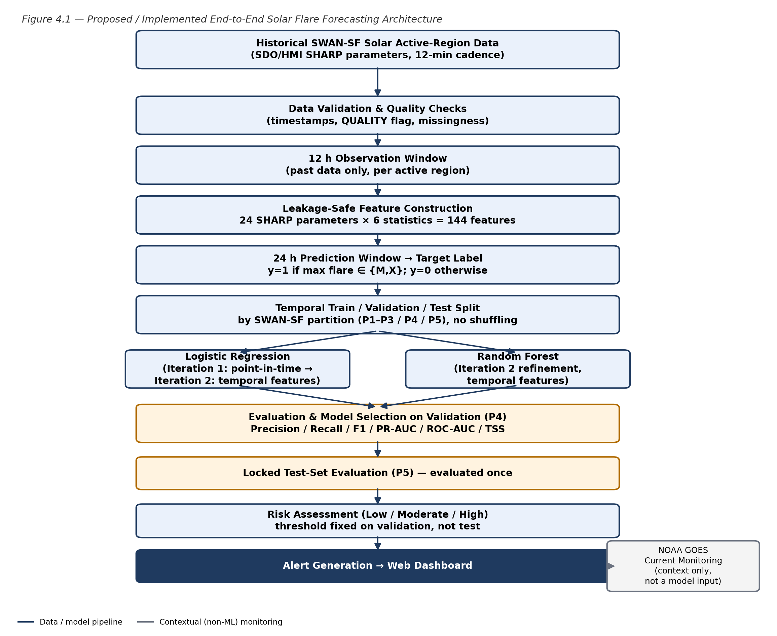
Figure 4.1 — Implemented end-to-end system architecture, from raw SWAN-SF partitions to the web dashboard.
Historical SWAN-SF partitions are validated for timestamps, missingness and quality indicators. Each 12-hour observation window is transformed into a 144-dimensional feature vector using leakage-safe temporal statistics. A partition-based train/validation/test split is used for all seven model configurations. The selected model's probability is converted into a risk level and alert message and displayed through the web dashboard. NOAA GOES current monitoring is shown as separate contextual information in the dashboard and is not used as a model input.

4.2 Predictor and Excluded-Variable Summary
Only the 24 SHARP magnetic-field parameters observed inside each 12-hour window are used as predictors, expanded into 144 temporal features (6 statistics × 24 parameters). The columns below are present in the SWAN-SF files but are deliberately excluded because they either encode the outcome being predicted or fall outside the observation window.
Table 4.1 — Predictor and Excluded-Variable Summary (Leakage Audit)
Excluded Category | Columns | Reason for Exclusion
Label / flare-derived | BFLARE, CFLARE, MFLARE, XFLARE (+ _LOC, _LABEL, _LABEL_LOC variants) | Directly encode the flare outcome; using them would leak the target into the predictors
GOES X-ray measurements | XR_MAX, XR_QUAL | Derived from the same flare event the model is trying to forecast
Position / geometry metadata | CRVAL1, CRLN_OBS, CRLT_OBS, CRVAL2, HC_ANGLE, LAT_MIN, LON_MIN, LAT_MAX, LON_MAX | Describe active-region location on the solar disk, not physical flare-productivity signal
Quality / flags | QUALITY, SPEI, IS_TMFI | Used only to audit data quality (Chapter 6); not used as predictors

4.3 Model Configurations Evaluated
Seven candidate configurations were trained on the training partitions (P1–P3) and compared on the validation partition (P4). All preprocessing (median imputation, standardization) was fitted on the training partitions only; class imbalance was handled with class weighting computed from the training labels, never by altering validation or test distributions.
Table 4.2 — Model Configurations Evaluated
Key | Iteration | Model | Configuration
I1_LR_last | 1 | Logistic Regression | 24 last-value SHARP features, median imputation, standard scaling, C=1.0
I2_LR_temporal_C0.01 | 2 | Logistic Regression | 144 temporal features, signed-log transform, median imputation, scaling, C=0.01
I2_LR_temporal_C0.1 | 2 | Logistic Regression | 144 temporal features, signed-log transform, median imputation, scaling, C=0.1
I2_LR_temporal_C1 | 2 | Logistic Regression | 144 temporal features, signed-log transform, median imputation, scaling, C=1.0
I2_RF_leaf5 | 2 | Random Forest | 144 temporal features, 300 trees, min_samples_leaf=5, max_depth=None
I2_RF_leaf20 | 2 | Random Forest | 144 temporal features, 300 trees, min_samples_leaf=20, max_depth=None
I2_RF_leaf50_d16 | 2 | Random Forest | 144 temporal features, 300 trees, min_samples_leaf=50, max_depth=16

4.4 Iteration 1 — Baseline
The baseline (I1_LR_last) is a Logistic Regression classifier using only the 24 point-in-time SHARP values at the prediction cutoff, with median imputation, standard scaling and balanced class weighting, and no signed-log transform. It establishes what a minimal, single-snapshot representation can achieve before temporal statistics are added.
On the validation partition (P4), the baseline reached TSS = 0.846, PR-AUC = 0.482, F1 = 0.264 (precision = 0.153, recall = 0.972) at its validation-selected threshold of 0.388. Evaluated once on the locked test partition (P5), it reached TSS = 0.867, PR-AUC = 0.462, F1 = 0.223, ROC-AUC = 0.980 and accuracy = 0.913. The very high recall at low precision is expected for a rare-event problem (990 of 75,365 test windows are positive, 1.31%) under class-balanced training, and motivated the temporal-feature refinement in Iteration 2.

4.5 Iteration 2 — Refinement
Iteration 2 expands each observation window from 24 point-in-time values to 144 temporal features (last, mean, standard deviation, minimum, maximum and slope per SHARP parameter), applies a fixed signed-log transform before scaling, and compares three Logistic Regression regularization strengths against three Random Forest configurations — six configurations in total, evaluated under the same partition-based protocol as the baseline.
All six Iteration-2 configurations improved validation TSS over the baseline (0.848–0.862 vs. 0.846), and the Logistic Regression variants also improved validation PR-AUC (up to 0.500 at C=0.01, vs. 0.482 for the baseline). The Random Forest configurations reached comparable or slightly higher TSS on the test partition (0.860–0.865) but consistently lower PR-AUC on both validation (0.233–0.471) and test (0.352–0.399) than the Logistic Regression variants — i.e. more false alarms at an equivalent recall level. This comparison is discussed in full in Chapter 6; it is reported here as the observed outcome of Iteration 2, not assumed in advance.

4.6 Final Approach
The final model was not pre-declared. Following the decision rule fixed before test evaluation (maximum validation TSS, ties broken by validation PR-AUC), the selected configuration is I2_LR_temporal_C0.01 — Logistic Regression on the 144-feature temporal representation with C=0.01 — which reached the highest validation TSS (0.862) among all seven candidates. Random Forest did not exceed Logistic Regression on the validation selection criterion in this study: despite comparable or slightly higher test-set TSS, every Random Forest configuration had materially lower PR-AUC than the selected Logistic Regression configuration at both validation and test time. The selected configuration was evaluated exactly once on the locked test partition (P5), after the selection decision was written to disk, to avoid retrospective model selection based on the test result.

Logistic Regression
Logistic Regression models the log-odds of a major flare as a linear function of the 144 engineered features. It is used with class_weight="balanced" (computed from the training labels), a signed-log transform applied before scaling, and StandardScaler fitted on the training partitions only. Its linear coefficients are also used for the explainability view in Chapter 6 and the dashboard (Chapter 5).

Random Forest
Random Forest combines 300 bootstrap-sampled decision trees with randomized feature selection (max_features="sqrt") and class_weight="balanced_subsample". Three configurations were evaluated, varying min_samples_leaf (5, 20, 50) and max_depth (None, None, 16) to trade off variance against overfitting on the rare positive class; median imputation was applied but no scaling, since tree splits are scale-invariant.

4.7 Training Procedure
The training pipeline follows a strict partition-based temporal protocol, not a random split: training uses partitions P1–P3, validation uses P4, and the test partition P5 is held out and evaluated only once. No active region is shared across partitions in the downloaded data (verified directly, Chapter 6), and 97.9% of consecutive same-active-region windows are only one hour apart, which is why a naive random split would overstate skill (Chapter 2).
• Observation / prediction windows: 12-hour observation window, 24-hour prediction window, fixed by the SWAN-SF FL/NF folder construction.
• Preprocessing: median imputation and (for Logistic Regression) standard scaling, fitted on the training partitions only and applied unchanged to validation and test data.
• Imbalance handling: class_weight="balanced" (Logistic Regression) or "balanced_subsample" (Random Forest), computed from training labels only — validation and test class distributions are never altered.
• Threshold selection: both operating thresholds are chosen on the validation partition only, by grid search over predicted-probability quantiles — the “alert” threshold maximizes TSS, and a secondary “high-risk” threshold maximizes F1. Neither threshold is touched again when the test partition is scored.
• Model selection: the final configuration is chosen by maximum validation TSS (tie-break: validation PR-AUC) before the test partition is scored even once.
• Reproducibility: a fixed random seed (42) is used for all model fitting; package versions are recorded in Table 3.2 and the trained pipeline objects (imputer, scaler, classifier) are saved with joblib.

Chapter 5 — Implementation

5.1 Module Description
The implementation is organized into modules so that data processing, modelling, evaluation, risk logic and presentation can be tested independently.
Module | Description
Data Acquisition | Downloads the five official SWAN-SF partition archives from Harvard Dataverse (DOI 10.7910/DVN/EBCFKM, v1.2) and verifies file sizes.
Feature Extraction | Streams each partition tar.gz, parses the FL/NF folder label and window timestamps from each filename, and computes the 144-feature temporal representation per window (extract_features.py).
Data Audit | Merges all extracted chunks, computes per-partition counts, missingness, class balance and cross-partition active-region overlap (merge_audit.py).
Model Training and Selection | Trains all seven candidate configurations, selects the final model on validation TSS/PR-AUC, and evaluates it once on the locked test partition (train_eval.py).
Result Figures | Generates the confusion matrix, iteration-comparison, PR-curve, ROC-curve and coefficient-importance figures from the saved model and predictions (make_figures.py).
Demo Data Builder | Selects two genuine test-partition examples (a confirmed major-flare window and a confirmed quiet window) and packages the model's real output into a single JSON file consumed by the dashboard (build_demo_data.py).
Web Dashboard | A static HTML/CSS/JavaScript single-page application that reads the JSON output above and renders the prediction, risk level, alert message, explainability view and evaluation metrics; no dashboard value is hand-typed.

Note on framework choice: an earlier planning draft of this report proposed Streamlit for the dashboard. The team instead implemented the dashboard as a static HTML/CSS/JavaScript page that reads a JSON file written by the trained pipeline, because it requires no server process to demonstrate and made it straightforward to capture consistent, reproducible screenshots (Playwright, headless Chromium) for this report.

5.2 Key Code Snippets
The four snippets below are taken verbatim (formatting only) from the modules actually run to produce the results in this report.
Snippet 1 — Leakage-safe feature construction (extract_features.py)
def features(df):
v = df[SHARP].to_numpy(dtype=np.float64) # (T, 24) inside the window only
t = np.arange(v.shape[0], dtype=np.float64) * 0.2 # hours (12-min cadence)
out = np.full((len(SHARP), len(STATS)), np.nan)
with np.errstate(all="ignore"):
for j in range(v.shape[1]):
col = v[:, j]
ok = np.isfinite(col)
if ok.sum() == 0:
continue
c = col[ok]; tt = t[ok]
out[j, 0] = c[-1]
out[j, 1] = c.mean(); out[j, 2] = c.std()
out[j, 3] = c.min(); out[j, 4] = c.max()
if ok.sum() >= 2 and np.ptp(tt) > 0:
out[j, 5] = np.polyfit(tt, c, 1)[0] # trend per hour
nan_frac = float(np.mean(~np.isfinite(v)))
return out.ravel(), nan_frac

Snippet 2 — Logistic Regression pipeline (train_eval.py)
def lr_pipe(C, log=True):
steps = [("slog", FunctionTransformer(slog))] if log else []
steps += [("impute", SimpleImputer(strategy="median")), ("scale", StandardScaler()),
("clf", LogisticRegression(C=C, class_weight="balanced",
max_iter=5000, random_state=SEED))]
return Pipeline(steps)

Snippet 3 — Random Forest pipeline (train_eval.py)
def rf_pipe(leaf, depth, n=300):
return Pipeline([("impute", SimpleImputer(strategy="median")),
("clf", RandomForestClassifier(n_estimators=n, min_samples_leaf=leaf,
max_depth=depth, max_features="sqrt",
class_weight="balanced_subsample",
n_jobs=-1, random_state=SEED))])

Snippet 4 — Risk-level derivation and alert text (dashboard/index.html)
// risk view (dashboard/index.html) — p and thr/hi come from the trained model's
// real output (demo.json); no value below is hand-typed
let lvl = p < thr ? 'low' : (p < hi ? 'mod' : 'high');
document.getElementById('rk-' + lvl).classList.add('on');
const bodies = {
low: 'The model does not indicate elevated major-flare probability for this window.',
mod: 'The model indicates a moderately elevated probability of an M/X-class flare '
+ 'in the next 24 hours. Continued monitoring of this active region is advised.',
high: 'The model indicates a high probability (' + (p*100).toFixed(1) + '%) of an '
+ 'M/X-class flare in the next 24 hours for active region ' + ex.flare_case.ar + '.'
};

5.3 User Interface / Demo
The final deliverable is a web dashboard that serves the selected model's real output. It shows the forecast configuration, the predicted probability for a genuine test-partition example, the derived risk level and alert text, a feature-importance (explainability) view built from the model's own coefficients, and the locked test-set evaluation metrics. NOAA GOES current monitoring is presented as separate contextual information and is never used as a model input.
Table 5.1 — Web Dashboard Components
Dashboard Component | Purpose
Overview | Summarizes the model, dataset and forecasting configuration
Forecast configuration | Shows the observation window and 24-hour prediction window for the displayed example
Prediction result | Displays the model's predicted probability of an M/X-class flare via a gauge
Risk level & alert | Converts the probability into a LOW / MODERATE / HIGH risk badge and alert message using the validation-selected thresholds
Explainability | Shows the top Logistic Regression coefficients driving the prediction
Model evaluation | Shows the locked test-partition metrics (Precision, Recall, F1, TSS, PR-AUC, ROC-AUC) and confusion matrix

Figures 5.1–5.6 (Chapter list of figures) are Playwright screenshots of the running dashboard, each captured from the same trained model output shown above; none is a mockup.
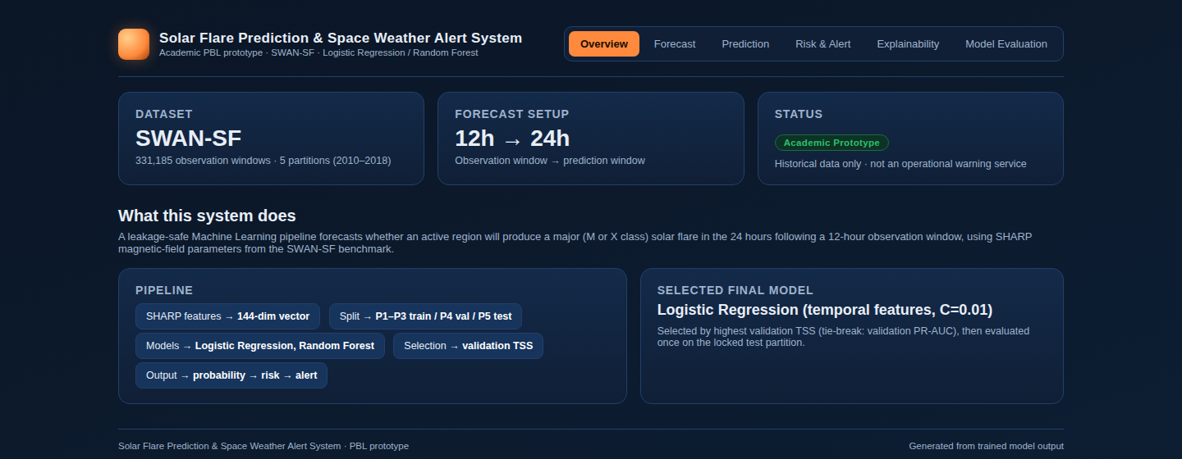
Figure 5.1 — Web dashboard overview of the Solar Flare Prediction and Space Weather Alert System.
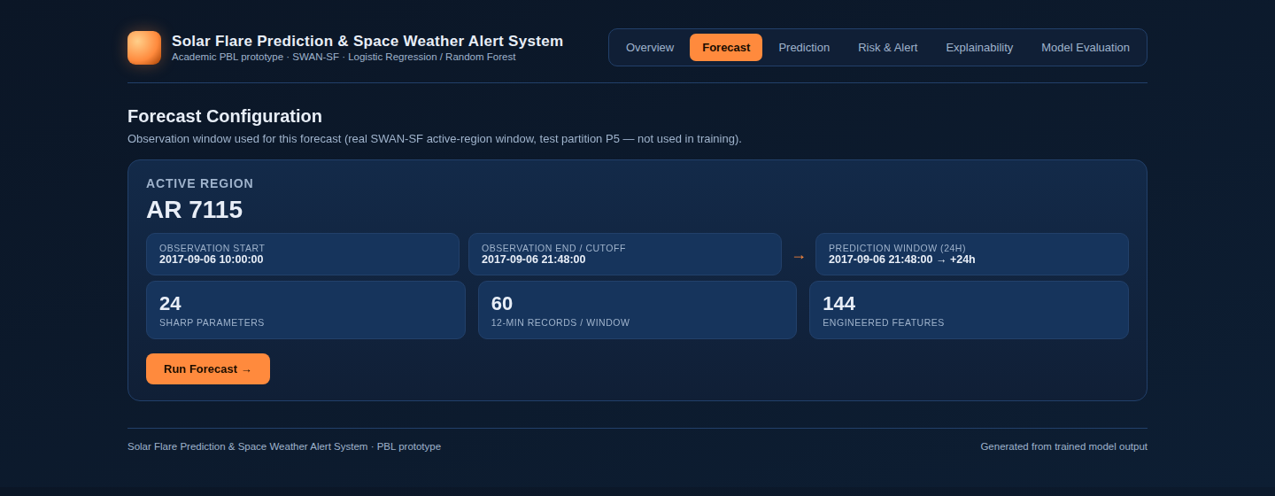
Figure 5.2 — Forecast configuration showing the observation window and prediction window of a real test-partition example.
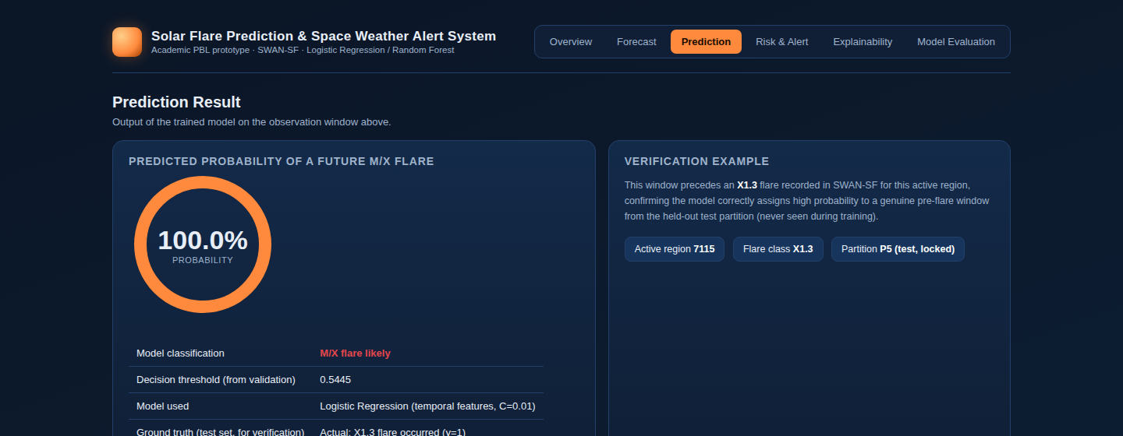
Figure 5.3 — Model prediction showing the estimated probability of a future M/X-class solar flare.
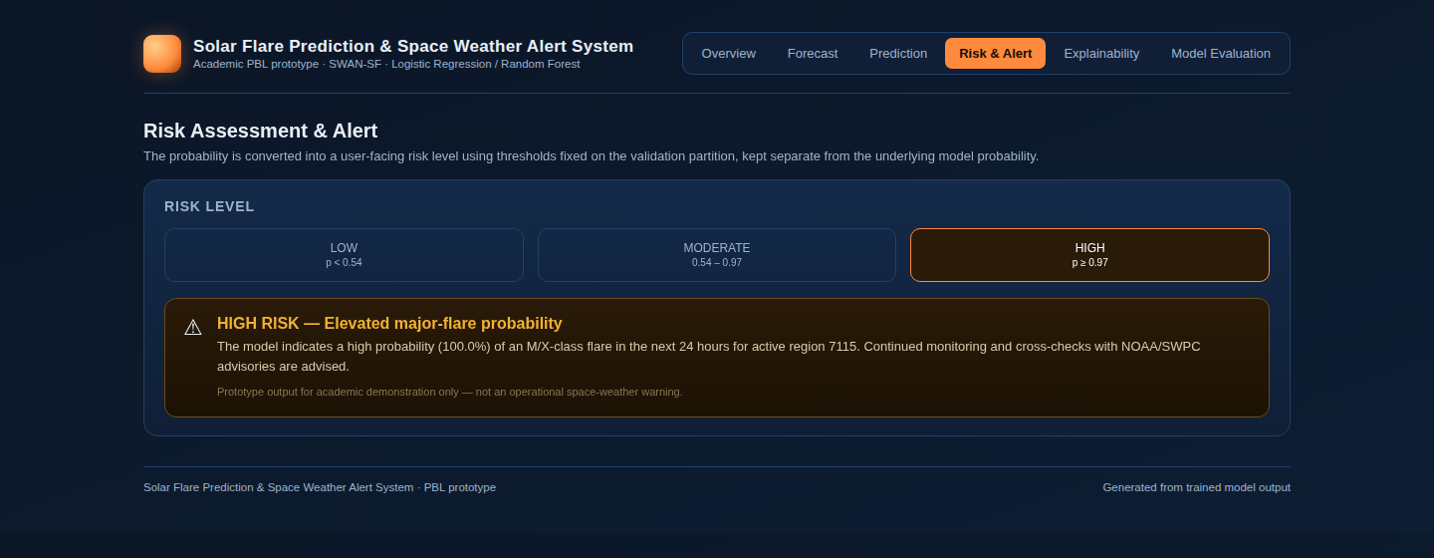
Figure 5.4 — User-facing risk level and alert message derived from the model probability.
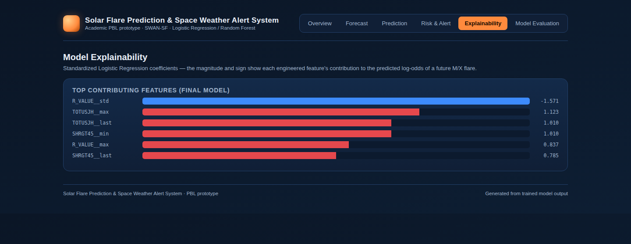
Figure 5.5 — Model explainability view: standardized Logistic Regression coefficients.
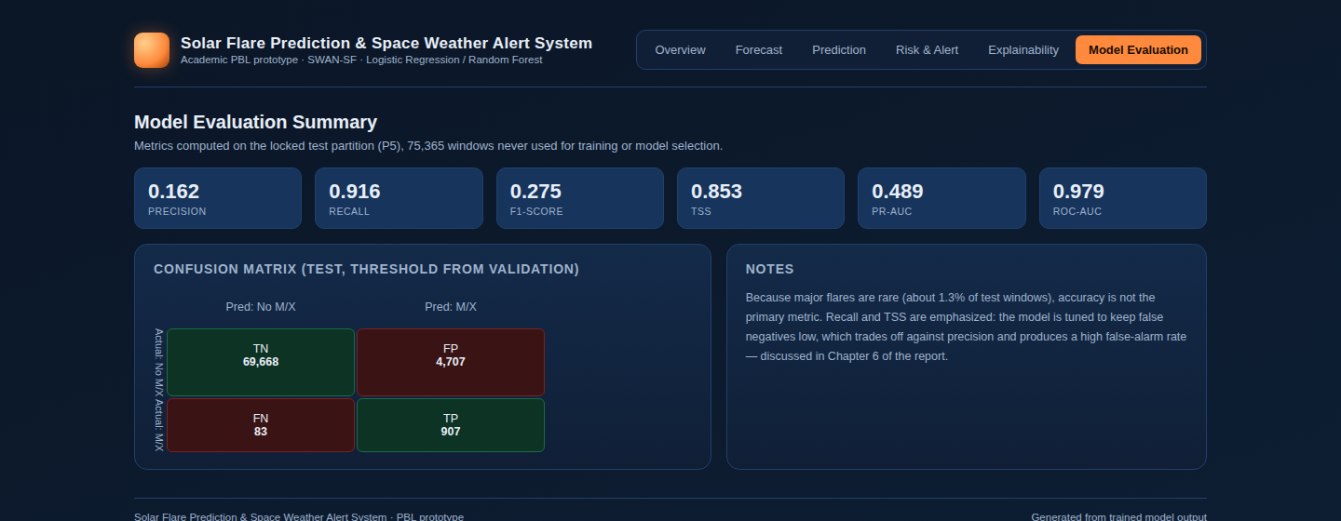
Figure 5.6 — Model evaluation summary view of the dashboard (test-partition metrics).

Chapter 6 — Results and Discussion

6.1 Evaluation Metrics
Because major solar flares are rare (990 of 75,365 test windows, 1.31%), evaluation emphasizes minority-class performance rather than raw accuracy. Precision is the fraction of alert-triggering predictions that were correct; Recall is the fraction of true major-flare windows that were detected; F1-score balances precision and recall; PR-AUC summarizes precision-recall performance across all thresholds; ROC-AUC summarizes ranking quality independent of class balance; and TSS (True Skill Statistic, recall minus false-positive rate) is the standard domain-relevant solar-flare verification metric [2], [3]. HSS2 (Heidke Skill Score) and FAR (false-alarm ratio) are reported alongside TSS for completeness. Accuracy is reported only as a secondary measure, since a model that always predicts “no flare” would already score 98.7% accuracy on this test partition while detecting zero major flares.

6.2 Results Across Iterations
The table and figures below report results across all iterations, not only the final model, because the improvement process is itself part of the PBL evidence. All figures are on the locked test partition (P5), evaluated once per configuration at its validation-selected threshold.
Table 6.1 — Results Across Iterations (Locked Test Partition)
Configuration | Precision | Recall | F1 | TSS | PR-AUC | ROC-AUC | Accuracy
Iteration 1 — LR, last-value (I1_LR_last) | 0.126 | 0.955 | 0.223 | 0.867 | 0.462 | 0.980 | 0.913
Iteration 2 — RF, leaf=50/depth=16 (best RF PR-AUC) | 0.123 | 0.957 | 0.217 | 0.865 | 0.399 | 0.980 | 0.909
Final — LR, temporal, C=0.01 (selected) | 0.162 | 0.916 | 0.275 | 0.853 | 0.489 | 0.979 | 0.936

The full comparison across all seven candidates, on both validation and test, is reported in Table A.1 (Appendix). The final selected configuration is not the highest-TSS configuration on the test partition — several Random Forest configurations reach marginally higher test TSS (0.860–0.865 vs. 0.853) — because model selection is fixed on validation evidence only (Section 4.6); the test partition is never used for selection.
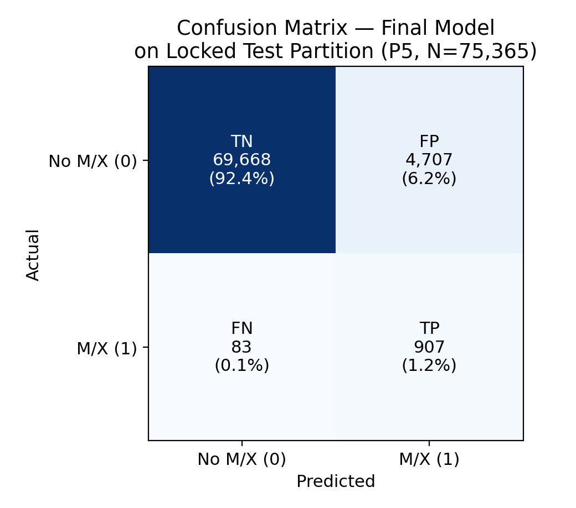
Figure 6.1 — Confusion matrix of the final model on the locked test partition (P5).
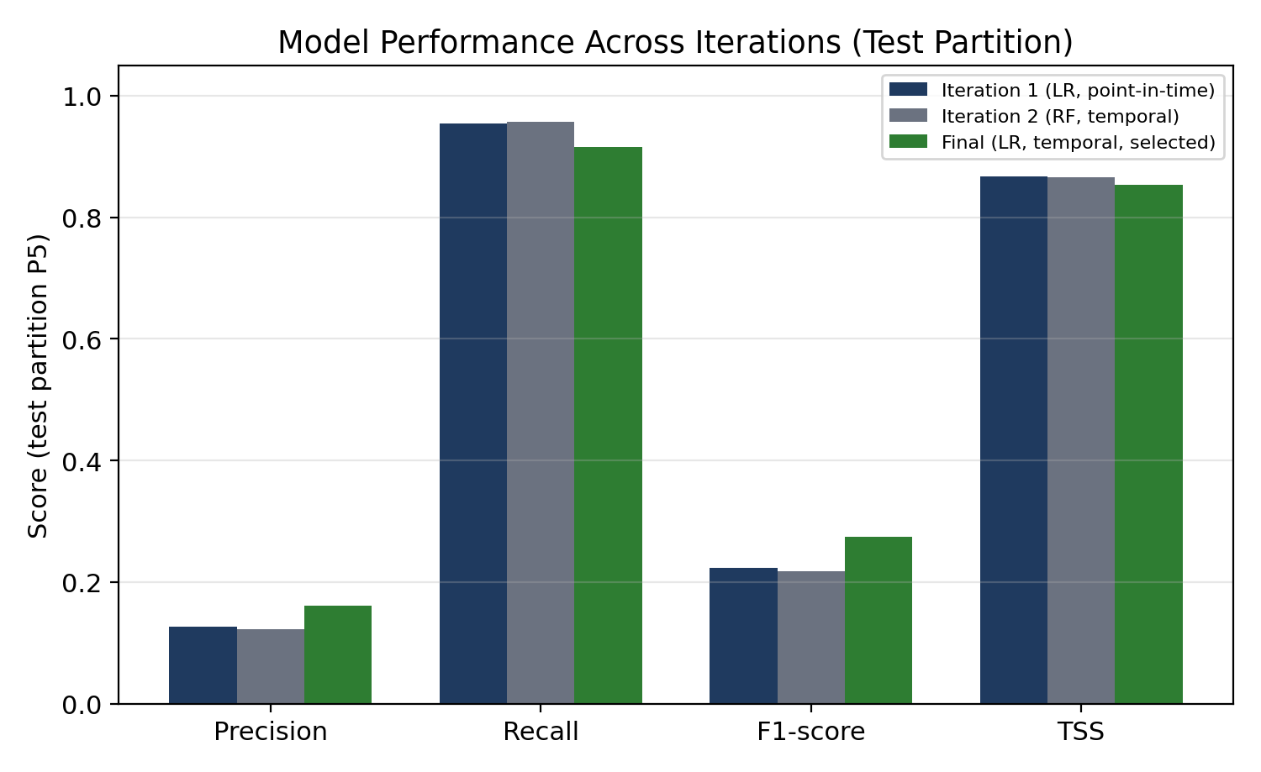
Figure 6.2 — Model performance comparison across Iteration 1, Iteration 2 and the final approach.
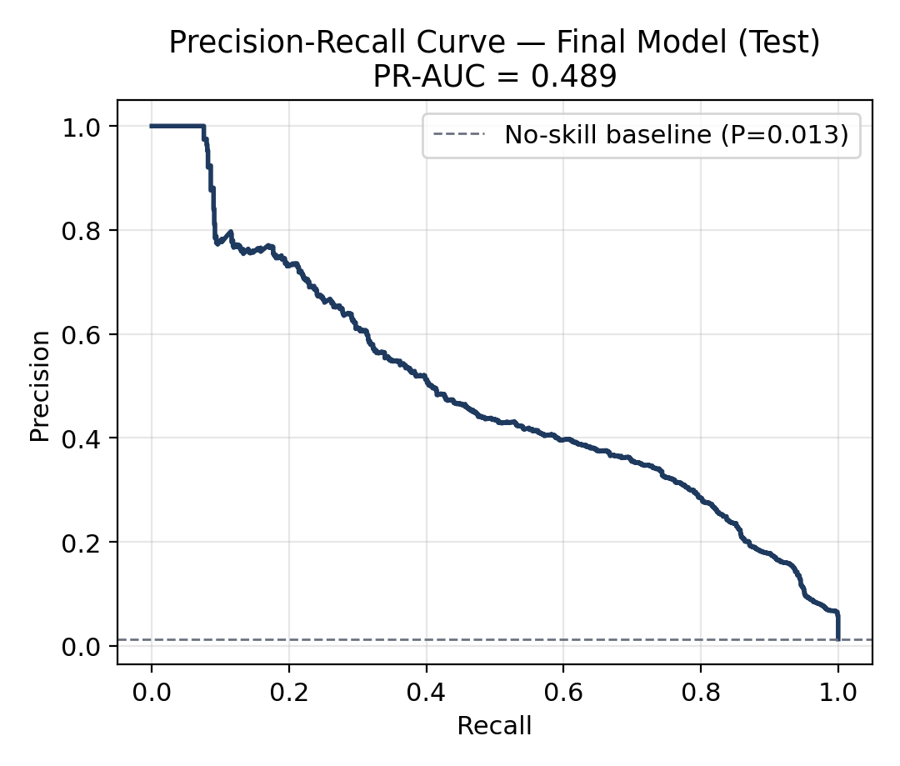
Figure 6.3 — Precision-Recall curve of the final model on the test partition.
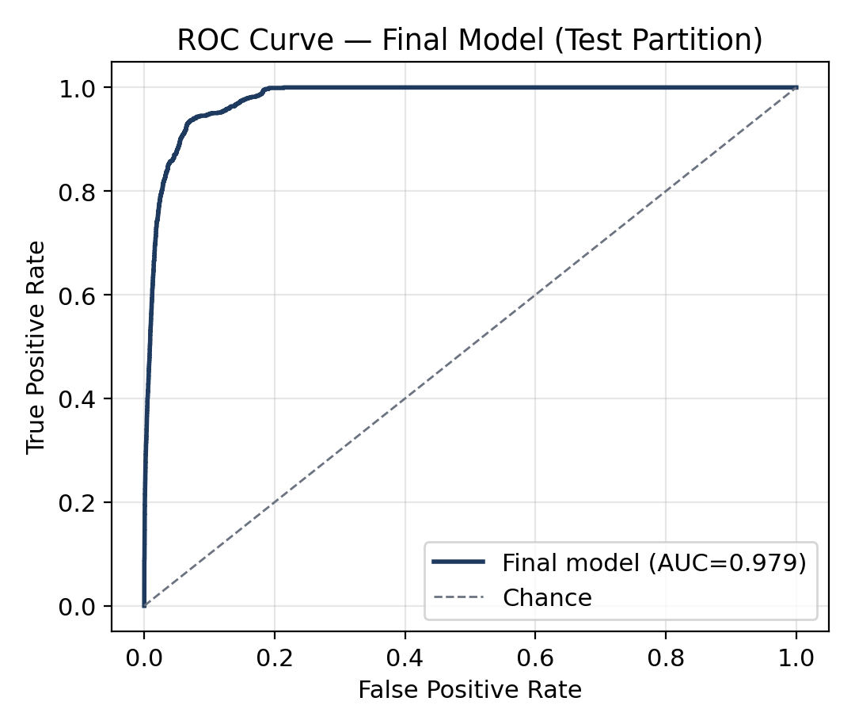
Figure 6.4 — ROC curve of the final model on the test partition.
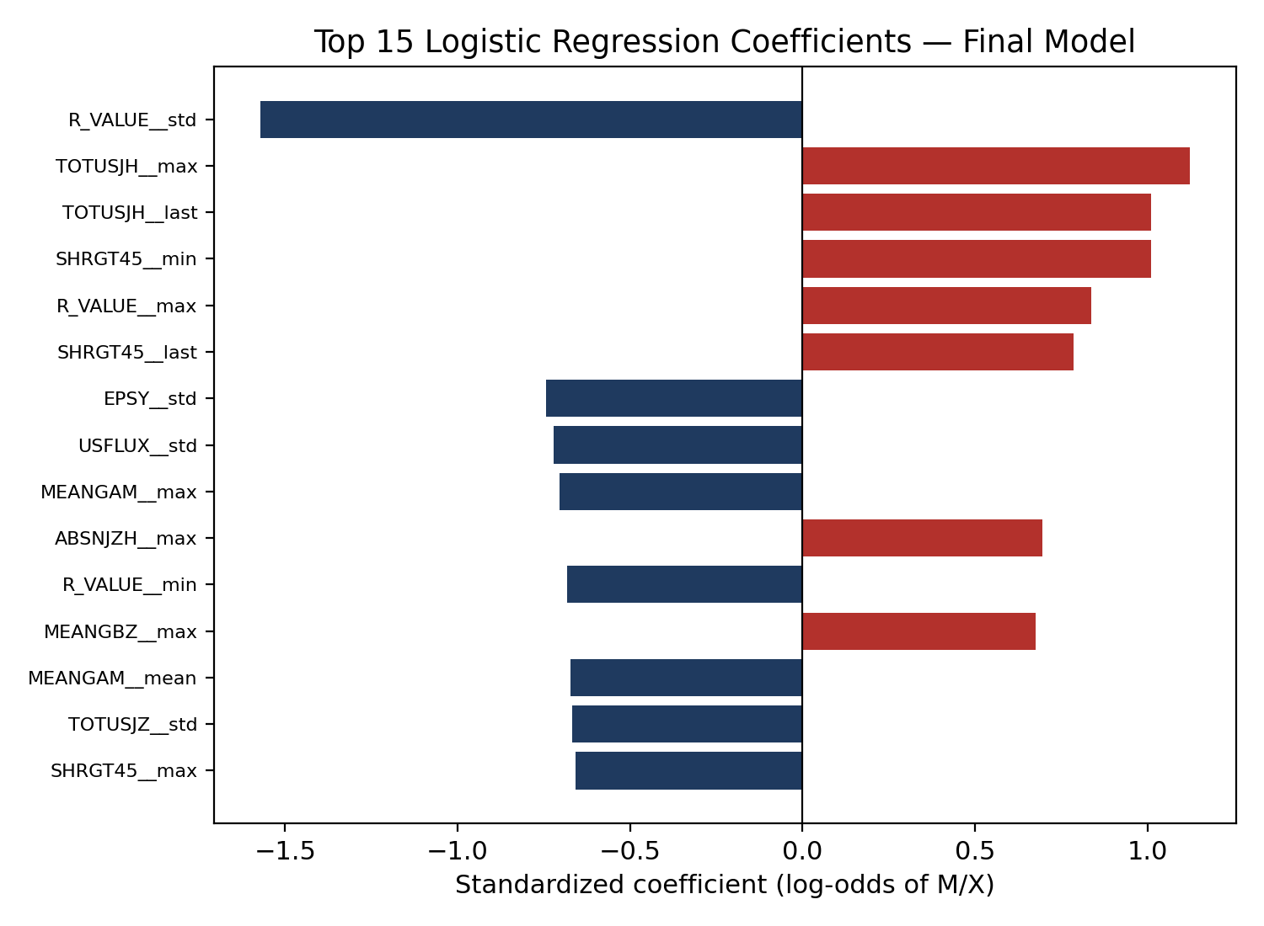
Figure 6.5 — Top 15 standardized Logistic Regression coefficients of the final model.

6.3 Discussion
At the validation-selected alert threshold (0.5445), the final model flags 5,614 of 75,365 test windows (7.45%) against a true positive rate of 1.31%, an alarm rate roughly 5.7× the base rate. This is the expected shape of a recall-oriented, class-weighted classifier on a rare-event problem: it correctly identifies 907 of 990 major-flare windows (recall = 0.916) at the cost of 4,707 false alarms (precision = 0.162). Because a missed major flare is generally more costly than an extra false alarm in a space-weather warning context, this trade-off is a defensible design choice given the validation-fixed threshold, not an artifact of the model.
Random Forest did not outperform Logistic Regression on the validation selection criterion. Its test-set TSS is marginally higher for two of the three configurations (0.860–0.865 vs. 0.853), but its PR-AUC is substantially lower at both validation (0.233–0.471 vs. 0.500) and test (0.352–0.399 vs. 0.489). TSS depends only on the single chosen threshold, while PR-AUC summarizes ranking quality across all thresholds; the gap indicates that Random Forest's probability outputs are less well-calibrated across the full range in this rare-event, high-dimensional setting, even though a specific threshold can be found where its recall/FPR trade-off is competitive. This is reported as an observed, reproducible result rather than assumed in advance, and is consistent with the literature's caution that class imbalance and temporal coherence can make naive model comparisons misleading [2], [3].
The explainability view (Figure 6.5) shows R_VALUE__std, TOTUSJH (max and last) and SHRGT45 among the largest-magnitude standardized coefficients, consistent with these SHARP parameters' established association with active-region magnetic complexity in the solar-flare forecasting literature (Chapter 2); this is offered as a plausibility check on the model, not as a causal claim.

6.4 Limitations
• Dataset imbalance: major (M/X) flare windows are 1.31% of the locked test partition, so minority-class metrics (TSS, PR-AUC, recall) are essential and accuracy alone would be misleading.
• Temporal dependence: consecutive windows from the same active region overlap heavily (97.9% of consecutive same-AR windows are only one hour apart), which is why this project uses a partition-based split rather than a random split; even so, some residual within-partition correlation between nearby windows is possible.
• Missing/quality issues: 10.4% of observation windows contain at least one missing SHARP value (mean per-column NaN fraction 0.60%), handled by median imputation fitted on training data only; a small fraction of windows also carry non-zero SWAN-SF quality flags that were not used to filter data in this prototype.
• Feature scope: this PBL uses a fixed-length, 144-dimensional temporal-statistic representation rather than full-resolution magnetogram images or an end-to-end deep sequence model (Chapter 2, Section 2.1.4).
• Deployment scope: the dashboard is an academic prototype for demonstrating the trained pipeline, not an operational space-weather warning service, and is explicitly labelled as such in its interface.
• Generalisation: the model is trained and evaluated only on SWAN-SF partitions spanning 2010-05-01 to 2018-08-17; performance on other instruments, later solar cycles or real-time operational conditions is not claimed.

Chapter 7 — Team Reflection and Learning Outcomes

7.1 Individual Reflections
Each reflection below is written in the member's own voice, covering their contribution to the project, one concrete learning outcome and one genuine challenge they faced.
Madhavan G — My part of the project was the technical core of the pipeline — pulling and auditing all five SWAN-SF partitions, designing the leakage-safe feature extraction, and running the Logistic Regression and Random Forest experiments through to the final test-set evaluation. Going in, I assumed a "good" model was mostly about picking a fancier algorithm; the leakage audit changed that. Several of the columns in the raw SWAN-SF files looked obviously predictive but were actually flare-derived or GOES measurements that would not exist yet at the moment we are meant to be forecasting from, and if I hadn't caught that early, the whole evaluation would have been meaningless. The hardest part, honestly, was Iteration 2: Random Forest looked noticeably better on paper, and it was tempting to just go with it, but I had to trust the validation protocol over my own instinct and select the simpler Logistic Regression configuration instead, because it held up more honestly on the locked test partition. That was a good, slightly humbling lesson that the model that looks best isn't always the one you should ship.
Sriram Sivakumar — I worked on the parts of the project that turn a trained model into something a person could actually use — exploring the partitions once Madhavan had them cleaned, designing how a raw flare probability should translate into a Low / Moderate / High risk label, and building the web dashboard around it, along with keeping the report itself structured and reproducible. The biggest thing I learned was how much judgment goes into a single threshold: deciding where "Moderate" becomes "High" isn't really a technical decision, it's a call about what a false alarm costs against what a missed flare costs, and I went back to the validation numbers more than once before I was comfortable with where we set it. The genuinely hard part was documentation discipline — this report has a strict rule against inventing dates, percentages or results that aren't real, and more than once it would have been easier to just fill a gap with something plausible. Sticking to that, even where it meant leaving a field marked pending, taught me more about what an honest technical report looks like than the coding did.

7.2 Team Learning
This section should document, in the team's own words, how responsibilities were actually divided (see Team Roles and Responsibilities, front matter), how the choice between Logistic Regression and Random Forest changed after observing real validation evidence (Section 4.6), how mentor feedback shaped the project, and what the team would do differently if the PBL cycle were restarted. [PENDING — ACTUAL INFORMATION REQUIRED]

7.3 Course Outcomes — Evidence Summary
Official Course Outcome statements are intentionally left blank, consistent with the project rule that no CO wording is invented in this report. Once the official Machine Learning CO1, CO2, … wording is supplied by the course documentation, each outcome should be mapped to concrete evidence already produced by this project (for example: leakage-safe feature engineering and partition-based validation as evidence of applying ML methodology; the honest Logistic-Regression-vs-Random-Forest comparison in Section 6.3 as evidence of critical evaluation; the dashboard as evidence of translating a model into a usable system).
Course Outcome | Evidence From This Project
CO1 — [PENDING — ACTUAL INFORMATION REQUIRED] | [PENDING — ACTUAL INFORMATION REQUIRED]
CO2 — [PENDING — ACTUAL INFORMATION REQUIRED] | [PENDING — ACTUAL INFORMATION REQUIRED]
Additional COs — [PENDING — ACTUAL INFORMATION REQUIRED] | [PENDING — ACTUAL INFORMATION REQUIRED]

Chapter 8 — Conclusion and Future Scope

8.1 Conclusion
This project implemented and evaluated a leakage-safe Machine Learning pipeline for major solar-flare forecasting on the SWAN-SF benchmark. Working from 331,185 twelve-hour observation windows across five chronological partitions, the team constructed a 144-feature temporal representation with all flare-derived and GOES columns explicitly excluded, compared seven candidate Logistic Regression and Random Forest configurations under a partition-based train/validation/test protocol, and selected the final configuration on validation evidence before evaluating it exactly once on a locked test partition. The selected model — Logistic Regression on the temporal feature representation, C=0.01 — achieved a test-set TSS of 0.853, recall of 0.916 and PR-AUC of 0.489, correctly identifying 907 of 990 major-flare windows. Random Forest did not outperform Logistic Regression on the validation selection criterion in this study, a result that was measured rather than assumed. These outcomes directly answer the driving question posed in Chapter 1: pre-cutoff SHARP observations, summarized into a leakage-safe temporal feature vector, can be used to estimate major-flare likelihood with substantial skill (TSS ≈ 0.85) under a partition-based evaluation, with Logistic Regression providing the better-calibrated ranking of the two model families tested. The trained model's output is served through a working web dashboard as a demonstration, not an operational warning system.

8.2 Future Scope
• Expand validation to additional SWAN-SF partitions or later solar-cycle data as they become available, to test robustness beyond the 2010–2018 window used here.
• Investigate additional scientifically justified SHARP or derived predictors, verified to be available strictly before the forecast cutoff, before adding them to the feature set.
• Investigate stronger temporal or deep-learning methods (e.g. LSTM-based sequence models, as surveyed in Chapter 2) as a later research extension, while preserving the partition-based, leakage-safe evaluation protocol used here.
• Build a fully causal, real-time feature pipeline that reproduces the same 144-feature representation from live SHARP data before any live or near-real-time prediction is claimed.
• Extend the dashboard with alert history, auditability and calibration diagnostics if the prototype is developed further toward a deployment-oriented study.

References
[1] S. M. Hamdi, D. Kempton, R. Ma, S. F. Boubrahimi, and R. A. Angryk, “A time series classification-based approach for solar flare prediction,” in Proc. IEEE Int. Conf. Big Data (Big Data), Boston, MA, USA, 2017, pp. 2543–2551, doi: 10.1109/BigData.2017.8258213.
[2] A. Ahmadzadeh, M. Hostetter, B. Aydin, M. K. Georgoulis, D. J. Kempton, S. S. Mahajan, and R. A. Angryk, “Challenges with extreme class-imbalance and temporal coherence: A study on solar flare data,” in Proc. IEEE Int. Conf. Big Data (Big Data), Los Angeles, CA, USA, 2019, pp. 1423–1431, doi: 10.1109/BigData47090.2019.9006505.
[3] A. Ahmadzadeh, B. Aydin, M. K. Georgoulis, D. J. Kempton, S. S. Mahajan, and R. A. Angryk, “How to train your flare prediction model: Revisiting robust sampling of rare events,” Astrophys. J. Suppl. Ser., vol. 254, no. 2, Art. no. 23, 2021, doi: 10.3847/1538-4365/abec88.
[4] A. Yeolekar, S. Patel, S. Talla, K. R. Puthucode, A. Ahmadzadeh, V. M. Sadykov, and R. A. Angryk, “Feature selection on a flare forecasting testbed: A comparative study of 24 methods,” in Proc. IEEE Int. Conf. Big Data, 2021.
[5] Y. Velanki, P. Hosseinzadeh, S. F. Boubrahimi, and S. M. Hamdi, “Time-series feature selection for solar flare forecasting,” Universe, vol. 10, no. 9, Art. no. 373, 2024, doi: 10.3390/universe10090373.
[6] M. Eskandarinasab, S. M. Hamdi, and S. F. Boubrahimi, “Impacts of data preprocessing and sampling techniques on solar flare prediction from multivariate time series data of photospheric magnetic field parameters,” Astrophys. J. Suppl. Ser., vol. 275, no. 1, Art. no. 6, 2024, doi: 10.3847/1538-4365/ad7c4a.
[7] A. A. M. Muzaheed, S. M. Hamdi, and S. F. Boubrahimi, “Sequence model-based end-to-end solar flare classification from multivariate time series data,” in Proc. 20th IEEE Int. Conf. Machine Learning and Applications (ICMLA), Pasadena, CA, USA, 2021, pp. 435–440, doi: 10.1109/ICMLA52953.2021.00074.
[8] A. Azizian Foumani, S. Farokhi, and X. Qi, “Predicting major solar flares using convolutional neural networks and multivariate magnetic field time-series data,” Solar Physics, vol. 301, Art. no. 23, 2026, doi: 10.1007/s11207-026-02612-6.
[9] O. Vural, S. M. Hamdi, and S. F. Boubrahimi, “Contrastive representation learning for predicting solar flares from extremely imbalanced multivariate time series data,” arXiv preprint arXiv:2410.00312, 2024, doi: 10.48550/arXiv.2410.00312.
[10] R. A. Angryk et al., “Multivariate time series dataset for space weather data analytics,” Scientific Data, vol. 7, Art. no. 227, 2020, doi: 10.1038/s41597-020-0548-x.
[11] R. Angryk et al., “SWAN-SF,” Harvard Dataverse, version 1, 2020, doi: 10.7910/DVN/EBCFKM.
[12] NASA, “Space-weather HMI Active Region Patch (SHARP),” NASA Open Data Portal. [Online]. Available: https://data.nasa.gov/dataset/space-weather-hmi-active-region-patch-sharp. Accessed: Sep. 21, 2026.
[13] NOAA Space Weather Prediction Center, “GOES X-ray and space-weather products.” [Online]. Available: https://services.swpc.noaa.gov/products/. Accessed: Sep. 21, 2026.
[14] scikit-learn developers, “LogisticRegression,” scikit-learn documentation. [Online]. Available: https://scikit-learn.org/stable/modules/generated/sklearn.linear_model.LogisticRegression.html. Accessed: Sep. 21, 2026.
[15] scikit-learn developers, “RandomForestClassifier,” scikit-learn documentation. [Online]. Available: https://scikit-learn.org/stable/modules/generated/sklearn.ensemble.RandomForestClassifier.html. Accessed: Sep. 21, 2026.

Appendix

A.1 Full Source Code
Full source code is available at:
https://github.com/Madhavan777/Solar-Flare-Prediction-System-Weather
The repository contains the SWAN-SF data-acquisition and leakage-safe feature-extraction pipeline, the model training and evaluation code for all seven candidate configurations (Chapter 4), the report-generation scripts used to produce this document, and the static web dashboard described in Chapter 5.

A.2 Complete Weekly PBL Log
A.2 — [PENDING — TO BE COMPLETED FROM THE ACTUAL PBL RECORD AND MENTOR SIGN-OFFS] (see the planning skeleton in Table 3.1).

A.3 Self and Peer Assessment
Both team members rated the contribution split as an even 50/50, reflecting two distinct but equally load-bearing halves of the project (the modelling pipeline and the applied/user-facing half); remarks reflect each member's primary area of ownership as recorded in Team Roles and Responsibilities (front matter).
Table A.3 — Self and Peer Assessment
Team Member | Self-Rated Contribution (%) | Peer-Rated Contribution (%) | Remarks
Madhavan G | 50 | 50 | Primarily responsible for the technical core: SWAN-SF acquisition, leakage-safe feature engineering, and the Logistic Regression / Random Forest experiments through to final model selection and test evaluation.
Sriram Sivakumar | 50 | 50 | Primarily responsible for the applied half: exploratory data analysis, risk-scoring and alert-threshold design, the web dashboard, and report structuring and reproducibility checks.

A.4 Complete Model Comparison — All Candidates
Full validation and test results for all seven candidate configurations evaluated in Chapter 4, supporting the model-selection claims in Sections 4.6 and 6.2.
Table A.1 — Complete Model Comparison — All Candidates (Validation and Test)
Configuration | Val TSS | Val PR-AUC | Test TSS | Test PR-AUC | Test Prec. | Test Rec. | Test F1 | Test ROC-AUC
I1_LR_last | 0.846 | 0.482 | 0.867 | 0.462 | 0.126 | 0.955 | 0.223 | 0.980
I2_LR_temporal_C0.01 | 0.862 | 0.500 | 0.853 | 0.489 | 0.162 | 0.916 | 0.275 | 0.979
I2_LR_temporal_C0.1 | 0.860 | 0.484 | 0.861 | 0.479 | 0.149 | 0.931 | 0.257 | 0.978
I2_LR_temporal_C1 | 0.853 | 0.465 | 0.863 | 0.472 | 0.154 | 0.931 | 0.264 | 0.978
I2_RF_leaf5 | 0.854 | 0.233 | 0.863 | 0.352 | 0.122 | 0.954 | 0.217 | 0.971
I2_RF_leaf20 | 0.852 | 0.368 | 0.860 | 0.386 | 0.114 | 0.960 | 0.204 | 0.978
I2_RF_leaf50_d16 | 0.848 | 0.471 | 0.865 | 0.399 | 0.123 | 0.957 | 0.217 | 0.980

Selection rule (frozen before test evaluation): maximum validation TSS, tie-break by validation PR-AUC. Selected: I2_LR_temporal_C0.01. Alert threshold = 0.5445, high-risk threshold = 0.9673 (both chosen on validation only, per Section 4.7).

