**DBMS PROJECT**

**Team Members:**

Aniket Anand (RA1911003010892)

Madhavendra Srivastava (RA1911003010901)

**ABSTRACT**

Library is place where all kind of books are available. Intranet Library

Management system is a web based application. This system contains list of all the

books and can be accessed by remote users concurrently from any where in the

campus. But for that users must be registered user. This system is three tier

architecture.

Client sends requests, on receiving the request the server processes it

and extracts the data from database and sends the result back to the client. This

system provides separate interface and login for librarian, students and faculties.

Librarian can modify data base.

The project's main aim is to build a management system more like a website which

* Can create a computerized management system for a library
* Has the capability to issue books
* Has the capability to return books
* Has an administrator account
* Can manage users through administrator account
* Has customized profile with photo of the user
* Tracks the books that users have issued
* Keeps the databases correct and up-to-date
* Can store all the book and user data in a proper manner

This system generates reports that can be used in analyzing the

library performance. Thus the management can take appropriate steps to improve

the facilities

ER DIAGRAM OF

LIBRARY MANAGEMENT SYSTEM

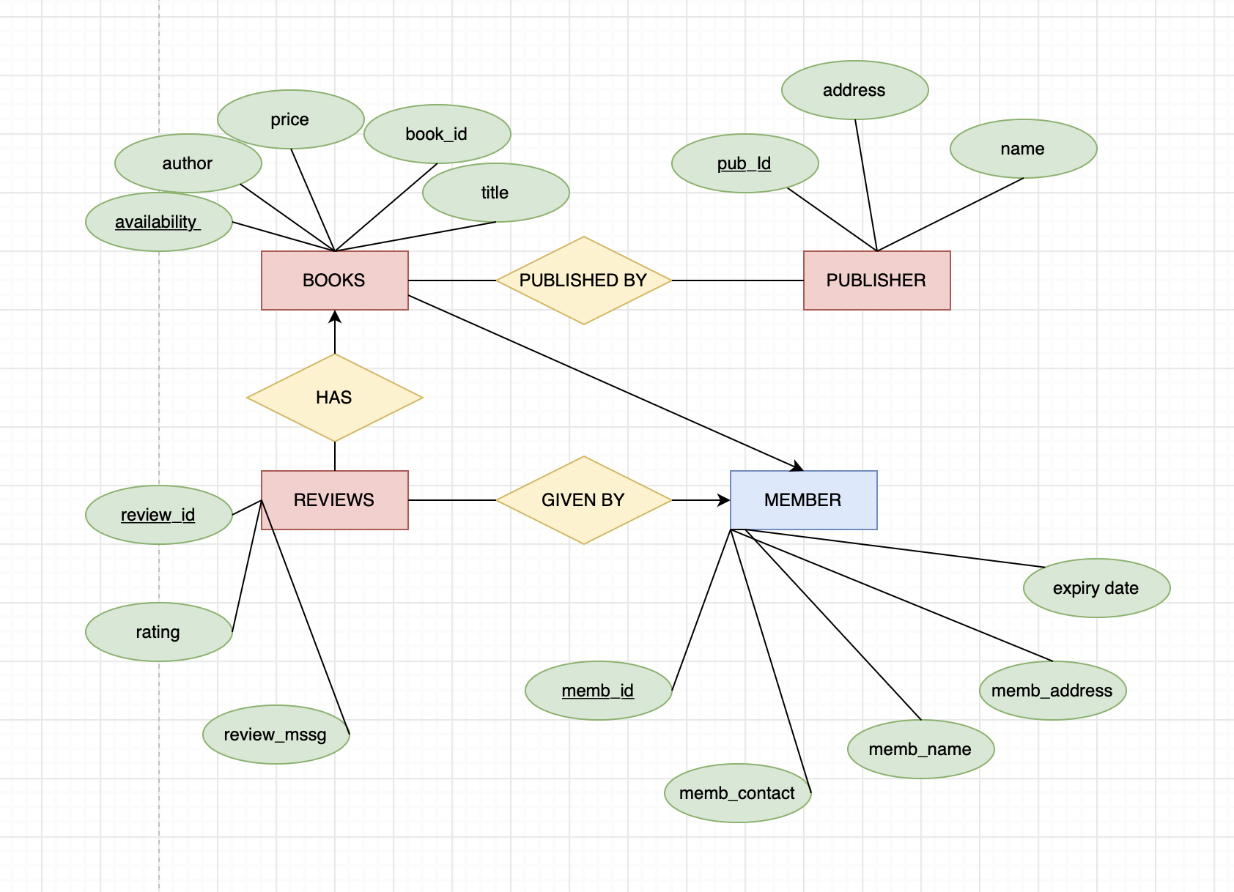

**Database Name: Student**

|  |  |  |  |
| --- | --- | --- | --- |
| **Field Name** | **Data Type** | **Size** | **Relation** |
| Name | Varchar | 50 | Not null |
| Reg_no | Varchar | 50 | Primary key |
| Date_of_issue | Datetime |  | Not null |
| Addresss | Varchar | 50 | Not null |
| Date_of_return | Datetime |  | Not null |
| Course | Varchar | 50 | Not null |
| Book_Serial_No | Varchar | 50 | Foreign key |
| Gender |  | 50 |  |

**Database Name : Book_Details**

|  |  |  |  |
| --- | --- | --- | --- |
| **Field Name** | **Data Type** | **Size** | **Relation** |
| Book_serial_No | Varchar | 50 | Primary key |
| Author | Varchar | 50 | Not null |
| Title | Varchar | 50 | Not null |
| Publication | Varchar | 50 | Not null |
| Edition | Varchar | 50 | Not null |
| No_of_copies | int |  | Not null |
| Volumn | Varchar | 50 | Not null |
| Date_purchased | Varchar | 50 | Not null |
| Price | Decimal | (18,2) | Not null |
| Availability | Varchar(50) | 50 | Not null |

**Database Name: Issue**

|  |  |  |  |
| --- | --- | --- | --- |
| **Field Name** | **Data Type** | **Size** | **Relation** |
| Regno | Varchar | 50 | Foreign key |
| Date_of_issue | Datetime |  | Not null |
| Date_of_return_ | Datetime |  | Not null |
| Book_Serial_No | Varchar | 50 | Not Null |
| Name | Varchar | 50 | Not null |
| Course | Varchar | 50 | Not null |
| Author | Varchar | 50 | Not null |
| Volumn | Varchar | 50 | Not null |
| Edition | Varchar | 50 | Not null |

**Database Name: Return**

|  |  |  |  |
| --- | --- | --- | --- |
| **Field Name** | **Data Type** | **Size** | **Relation** |
| Regno | Varchar | 50 | Foreign key |
| Accno | Varchar | 50 | Not Null |
| Date_of_return | Datetime |  | Not null |
| Date_of_issue | Datetime |  | Not null |
| Name | Varchar | 50 | Not null |
| Course | Varchar | 50 | Not null |
| Author | Varchar | 50 | Not null |
| Volumn | Varchar | 50 | Not null |
| Edition | Varchar | 50 | Not null |