
Hochschule Flensburg Wind Energy Technology Institude
University of Applied Science Research on wind Energy

Power Prediction and Energy Arbitrage Modelling for Wind Farms Using Machine Learning

Market Integration and Commercial Optimization, WiSe 2025/26
Master’s degree in Wind Engineering, Flensburg, Germany

Submitted by
Karan Soni (760153)
Madhvesh Gorakhiya (730251)

Supervising Professors:
Prof. Dr. Andreas Heinen

Date of submission:
26.01.2025

Table of Contents
1. Introduction and Motivation 1
2. Literature Review 2
2.1 The Economics of Variable Renewable Energy 2
2.2 Power to Gas and Flexibility Options 2
2.3 Electrolysis Technology Assessments 2
2.4 Machine Learning in Wind Energy 2
2.5 Gap Analysis 3
3. Data Sources and Model Workflow 4
3.1 Data Sources 4
3.2 Model Workflow 4
4. ML Models 8
4.1 Regression model 8
4.2 Classification Regression Model 9
5. Hydrogen Storage concept 10
5.1 Dispatch Logic and control algorithm 10
5.2 Validation and energy Balance 11
6. Results 12
6.1 Wind Farm Model (Regression Model) 12
6.2 Decision Arbitrage Model (Logistic Regression Model) 13
6.3 Economical Analysis 15
7. Discussion 17
7.1 Interpretation of results 17
7.2 Limitations of the study 17
7.3 Practical implications for wind farm operators 17
8. Conclusion 19
9. References 20
10. Appendices 21

Introduction and Motivation
Wind energy is one of the fastest-growing renewable industries in Germany. It plays a critical role in reducing carbon emissions and achieving sustainability targets. [1] However, wind power generation is variable because wind speeds fluctuate continuously, making it difficult to predict power output accurately. This variability creates significant challenges for electricity markets, where prices also fluctuate strongly. Wind production is high during low-price periods, selling electricity immediately can reduce profits for wind-farm operators. [2] Storing energy for later sale may increase revenue, but deciding when to store or sell is complex.
Machine Learning (ML) is good suited for improve forecasting and operational decisions. [3] ML models can capture nonlinear patterns in wind speed and power output, enabling more accurate predictions compared to traditional statistical methods. Forecasting is essential not only for grid stability but also for implementing energy arbitrage strategies, which allow operators to maximize profits during price fluctuations. [4] However, uncertainty in electricity prices and wind power output makes revenue prediction challenging. Selling at the wrong time or storing energy unnecessarily can lead to financial losses.
This report investigates two critical research questions:
- Can machine-learning models accurately predict wind-farm power output and identify the optimal hours to STORE or SELL energy?
- If low-price energy is stored as hydrogen, can the hybrid wind-hydrogen system remain economically profitable?
The primary objectives of this study are to develop and evaluate ML-based models for wind power forecasting and to assess the economic evaluation of hydrogen-based energy storage in arbitrage scenarios.
Motivation of this study is the opportunity to learn and apply ML techniques within the context of wind-power forecasting and energy-decision optimization. Working with real wind-energy data allows hands-on experience in building predictive models, while exploring store or sell decisions strengthens understanding of how data-driven methods can support operational strategies. The focus is therefore not only on producing results, but on developing practical skills in ML, forecasting, and decision-making for renewable-energy applications.

Literature Review

2.1 The Economics of Variable Renewable Energy
The economic dynamics of variable renewable energy (VRE) have been the subject of extensive academic inquiry. Seminal work by Hirth (2013) established the concept of the "value drop" or merit-order effect, demonstrating that the market value of VRE declines as its penetration level increases. Hirth’s analysis indicates that at high penetration rates, the marginal value of wind energy can fall to between 50% and 80% of the average electricity price. This theoretical framework is crucial for understanding the current market conditions in Germany, where the expansion of wind capacity has led to an increased frequency of low and negative price hours. [5]

2.2 Power to Gas and Flexibility Options
To mitigate the decline in market value, recent literature has focused on flexibility options such as storage and sector coupling. The concept of Power-to-Gas (PtG)—converting electricity into hydrogen—has gained prominence as a means of providing long-duration storage and accessing new revenue streams. Glenk and Reichelstein (2019) proposed the "synergistic" design of wind and hydrogen systems, arguing that the economics of PtG are maximized when the electrolyzer operates flexibly rather than as a baseload consumer. Their findings suggest that by utilizing electricity only during periods of low opportunity cost, integrated systems can achieve profitability even with high capital costs. [6]

2.3 Electrolysis Technology Assessments
The selection of appropriate electrolysis technology is critical for the effective coupling with variable wind generation. Comparative studies by Buttler and Spliethoff (2018) evaluate the performance characteristics of Alkaline (AEL), Proton Exchange Membrane (PEM), and Solid Oxide (SOEC) electrolyzers. While AEL technology is more mature and less expensive, PEM electrolyzers offer superior dynamic response, capable of ramping from standby to full load in seconds. Furthermore, PEM systems maintain high efficiency across a wider partial load range, making them particularly suitable for following the volatile output of onshore wind farms. Based on these technical attributes, this thesis selects PEM technology as the basis for the proposed system design. [7]

2.4 Machine Learning in Wind Energy
“A Comprehensive Review of Wind Power Prediction Based on Machine Learning” [8] article present one of the most comprehensive and up-to-date reviews on machine learning (ML) applications in wind power prediction, highlighting why ML has become an essential of modern wind engineering. The authors emphasize that ML is a fast-growing and widely applied field within renewable energy because it is non linear behaviour and frequent fluctuations wind that traditional physical or statistical models fail to capture effectively. Machine learning addresses these challenges by providing more mathematical, data-driven, and accurate solutions, enabling models to represent complex aerodynamic, meteorological, and operational relationships that would otherwise be extremely difficult to build manually.
A key strength discussed in the paper is that ML models learn directly from historical operational data, including wind speed, direction, turbulence intensity and temperature. By identifying hidden patterns and correlations in these datasets, ML algorithms continuously improve prediction accuracy over time. Techniques such as regression models, convolutional neural networks (CNNs), long short-term memory networks (LSTMs), and ensemble methods like XGBoost are shown to significantly classical models when dealing with highly nonlinear, multivariate inputs. The paper also explains how ML not only predicts wind power more accurately but also enhances engineering decision-making,
Overall, the paper concludes that machine learning is becoming an most fast geowing field for the renewable energy sector because it can extract deep insights from large historical datasets, adapt to new conditions, and provide high-accuracy forecasts that support more efficient and sustainable wind energy operations. [8]

2.5 Gap Analysis
Although existing studies examine wind power forecasting, renewable energy economics, and power-to-gas systems, these areas are mostly addressed in isolation. Limited research integrates machine-learning-based wind forecasting with real-time electricity price dynamics to support store or sell decisions. Moreover, the economic viability of wind-hydrogen systems under price uncertainty and forecast errors remains insufficiently explored. This study addresses these gaps by combining ML forecasting, arbitrage decision-making, and hydrogen storage economics analysis.

Data Sources and Model Workflow
This section describes the data sources, preprocessing and model workflow steps used to construct the simulation framework, including wind resource data, electricity market prices, grid constraints, and system component modeling.

3.1 Data Sources
The validity of the simulation relies on the quality of the input data. Wind resource data was obtained from the ERA5 reanalysis dataset provided by the European Centre for Medium-Range Weather Forecasts (ECMWF). Wind speed vectors were extracted for the specific coordinates of the Bürgerwindpark Reußenköge (54.60°N, 8.90°E) at a height of 100 meters, corresponding to the hub height of the installed Vestas V112 turbines. [9]
Wholesale electricity prices were sourced from the ENTSO-E Transparency Platform, utilizing the Day-Ahead spot prices for the Germany-Luxembourg (DE-LU) bidding zone. To simulate grid constraints, the study utilized official redispatch logs from the TenneT TSO, accessed via the Energy-Charts platform. Specifically, the dataset for "Current-Induced Load Decrease" was employed as a proxy for regional curtailment events. This data was normalized to create a dimensionless "stress factor," allowing the regional grid state to be mapped onto the specific output of the wind farm. [10]
The wind farm’s power output is modeled as a function of wind speed using the manufacturer’s operational power curve of the Vestas V112-3.3 MW turbine. The wind farm is located in Reußenköge, Germany, and consists of 51 identical turbines currently in operation. [11] The turbine power curve is used to convert wind speed into electrical power output, forming the basis for estimating the total wind farm generation output of all turbines. [12] This approach focuses on accurately translating wind speed variations into corresponding power production.
The electrolyzer is modelled as a controllable load with a capacity of 50 MW. The hydrogen production rate is calculated based on the specific energy consumption of the Siemens Silyzer 300 system, modelled at 52.2 kWh per kilogram of hydrogen. The model incorporates a variable efficiency curve to account for performance variations at partial loads, although a constant efficiency approximation is utilized for the primary techno-economic analysis to provide a conservative estimate of production volumes. [13]

3.2 Model Workflow
The main model flow of the project show in Figure 3.1. First, data are collected from open source resources, which have already been described in Section 3.1. After data collection, the overall model workflow is divided into three main stages: pre-processing, processing, and post-processing. Each of these stages plays a critical role in the system and is explained in detail in the following paragraphs.
Figure 3. 1: Main Model Flow Chart
Figure 3.2 illustrates the flowchart of the pre-processing steps. Before proceeding to the modeling stage, one of the most important tasks is to load the dataset and clean it according to the project requirements. The complete pre-processing workflow, including all performed operations, can be clearly understood from the flowchart.
Outputs are computed at hourly, daily, and monthly levels from the processed data. This multi-resolution analysis is conducted to examine how the models accuracy changes when more narrower time-based data are used. A detailed discussion and comparative analysis of these results are presented in the Results chapter.
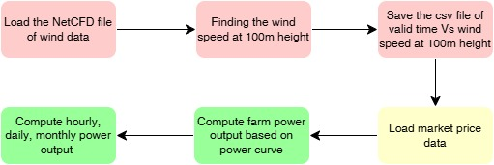
Figure 3. 2: Preprocessing Flow Chart
Figure 3.3 presents the flowchart of the processing workflow, which consists of three main models. The first model is the Linear and Polynomial Regression model, used for predictive analysis. The second model is the Logistic Arbitrage model, which supports decision-making processes. The third is the Hydrogen model, which is based on simulation techniques.
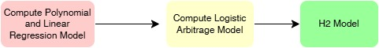
Figure 3. 3: Processing Flowchart
Further detailed flowcharts are provided in Figures 3.4, 3.5, and 3.6, which illustrate the implementation logic of each model and outline how they are coded in Python. Figure 3.4 shows the workflow of the Polynomial Regression model, which is used to compute wind farm power output and compare its performance with the Linear Regression model. Figure 3.5 illustrates the Logistic Regression model, which is applied to determine whether the generated energy should be stored or sold. Figure 3.6 presents the Hydrogen arbitrage model, a simulation-based approach used to model the hydrogen system and calculate key economic parameters.
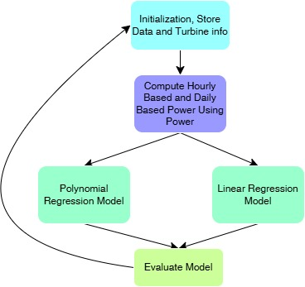 | 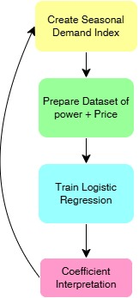
Figure 3. 4: Linear and Polynomial Regression Model Flowchart | Figure 3. 5: Logistic Regression Flowchart
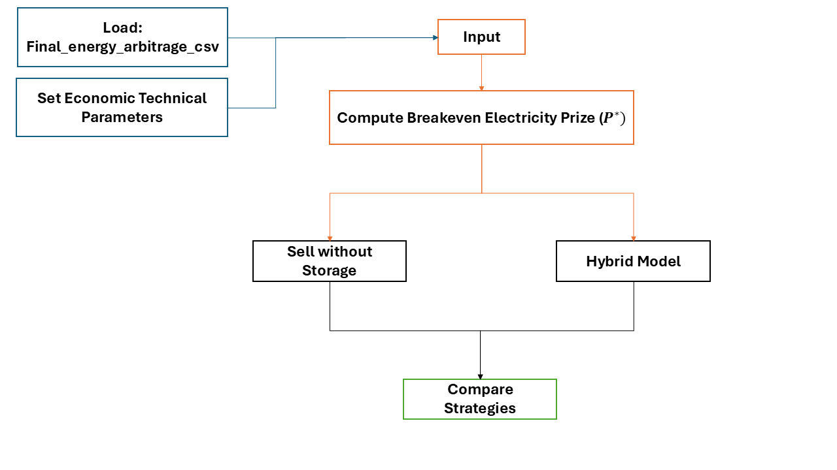
Figure 3. 6: Hydrogen Arbitrage Model Flowchart
The upcoming chapters provide a detailed explanation of each model, including their methodologies, parameters, and results. These sections offer further insights into model behaviour, performance evaluation, and economic analysis.
Figure 3.7 illustrates the final post-processing stage of the overall model workflow. In this stage, the results generated by the different models are processed and visualized through various plots and graphs. Each of the three models produces its own set of graphical outputs, which are used to analyse and interpret model performance.
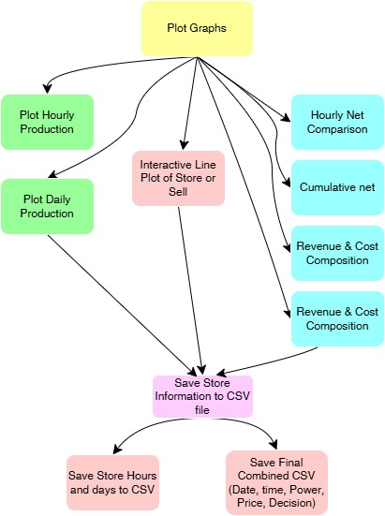
Figure 3. 7: Post Processing Flowchart
In addition to visual outputs, a final CSV file is generated to store the results from all models for further analysis. The result plots and graphical interpretations are explained in detail in the Results chapter.

ML Models
Machine Learning (ML) is increasing using in renewable energy systems to improve forecasting and operational decision-making. In this report, ML models help predict power output and support strategies for energy arbitrage, such as deciding whether to store energy or sell it. This study focuses on two models: Regression Model, which predicts wind power output based on input parameters and Classification Regression Model, which classifies operational decisions into STORE or SELL based on input parameters. These models will be explained in detail in the following subsections.

4.1 Regression model
Before this chapter, we have already described the source of the CSV file and the location of wind farm. In this study, we implemented two regression models, which are Linear Regression and Polynomial Regression. These models were chosen because they are simple and easy to implement. It is suitable for starting models for this research.

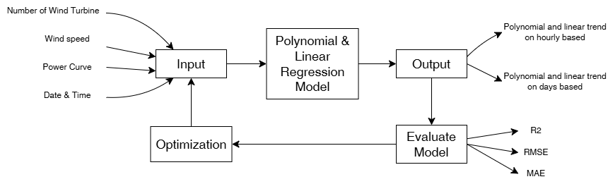
Figure 4. 1: Block Diagram of Wind farm Model (own)
In the flowchart, the modelling process considers four key input parameters are the number of wind turbines, wind speed, the power curve, and date/time information. These features were selected because they have a direct influence on wind power generation and are critical for accurate forecasting. After applying the ML models, we focused on generating two types of outputs. First, the polynomial and linear trends on an hourly basis. Second, , the polynomial and linear trends on a daily basis.
Once the models were trained and predictions obtained, we conducted an evaluation to determine which model performed best for the given dataset, which are discussed in detail in the Results section. Although optimization techniques could further improve model accuracy such as tuning or more input parameters or use different machine learning models, these were not implemented due to time constraints.

Classification Regression Model
The next model focuses on classification, specifically deciding whether to sell or store energy. For this task, we used a classification approach, and among the various available models, we selected Logistic Regression. This choice was made because Logistic Regression is simple, easy to implement, and requires fewer input parameters. The future, if the number of input parameters increases, more advanced models such as neural networks could be considered, as they offer greater predictive power for complex datasets. [8]
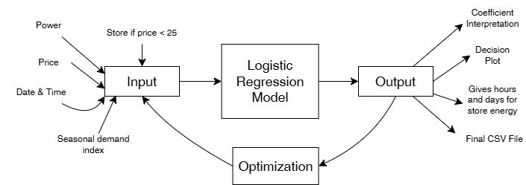
Figure 4. 2: Decision Arbitrage Model (own)
The inputs for this classification model include the predicted power on an hourly basis (obtained from the regression models), electricity price from the CSV file, date and time, and seasonal demand (assumed for this study (see table 4.1)). It is important to note that real hourly seasonal demand data in future work would improve accuracy significantly. In figure 4.2, the Logistic Regression model processes these inputs to produce several outputs. First, coefficient interpretation, which indicates the influence of each factor on the decision. Second, a decision plot showing whether to sell or store energy. Third, recommended hours and days for storing energy. Last but not least, a final CSV file containing date, hour, predicted power, price, and the store/sell decision.
Season | Months | Factor
Winter | 12, 1, 2 | 1.2
Spring | 3, 4, 5 | 0.9
Summer | 5, 7, 8 | 0.8
Autumn | 9, 10, 11 | 1
Table 4. 1: Seasonal Demand
The evaluation of this model and its performance metrics will be discussed in the Results section, while additional details and supporting figures are provided in the Appendix. Optimization techniques such as Adam optimizer or gradient descent could be applied to improve model performance, however, due to time limitations, these were not implemented in the current work.

Hydrogen Storage concept
The hydrogen production subsystem is predicated on Proton Exchange Membrane (PEM) technology, specifically modeled after the performance parameters of the Siemens Silyzer 300 system. The PEM technology was selected over the lower-cost Alkaline electrolysis due to its superior operational flexibility. The intermittent nature of onshore wind requires an electrolyzer capable of rapid load ramping; the Silyzer 300 can ramp from 10% to 100% load in under one minute, allowing the system to capture transient price spikes and effectively utilize volatile wind power that would be inaccessible to a slower-responding Alkaline system. [13]
The capacity of the electrolyzer was set at 50 MW, representing a "sizing ratio" of approximately 24% relative to the wind farm’s total capacity. This sizing decision is derived from an optimization analysis aimed at maximizing the utilization factor of the electrolyzer while minimizing capital expenditure (CAPEX). A larger electrolyzer (e.g., 100 MW or equal to the wind capacity) would result in diminishing returns, as the upper capacity would sit idle for the majority of the year. Conversely, a smaller system would fail to capture the significant volumes of curtailed energy available during peak wind events. The 50 MW capacity strikes an optimal balance, allowing for high full-load hours by absorbing both the base production during low-price periods and the peak production during grid congestion events.

5.1 Dispatch Logic and control algorithm
The core operational intelligence of the digital twin is encapsulated in a Python-based dispatch algorithm that executes a hierarchical decision tree for each hour of the simulation year 0 to 8760. The logic is designed to maximize the economic value of every megawatt-hour generated, prioritizing the prevention of energy waste followed by revenue maximization.
The algorithm first calculates the theoretical power potential of the wind farm based on the meteorological data. Immediately following this, the "Grid Constraint Module" assesses the regional grid status using the normalized TenneT redispatch data. If a "Current-Induced Load Decrease" signal is active for hour, the algorithm calculates a mandated curtailment cap, effectively splitting the wind potential into "grid-compliant" power and "curtailed" power. In a standard wind-only scenario, this curtailed power would be lost. However, the hybrid control logic prioritizes this energy stream, diverting it directly to the electrolyzer. This energy is treated as having a marginal cost of zero, as it cannot be sold to the grid. [14]
Following the grid constraint check, the algorithm executes the "Arbitrage Module." The system compares the Day-Ahead electricity price against a calculated breakeven threshold. This threshold is derived from the target sale price of hydrogen (assumed at €5.0/kg) and the system efficiency (52.2 kWh/kg), resulting in a breakeven electricity price of approximately €95.79/MWh. If Spot price is below this threshold—indicating that the electricity is "cheap"—the system diverts available grid-compliant power to the electrolyzer until the 50 MW capacity is filled. If Spot price exceeds the threshold, the system prioritizes selling electricity to the grid to capture the high market value.

5.2 Validation and energy Balance
The integrity of the simulation was verified through a rigorous energy balance check. The total energy input to the system (Wind Potential) was cross-referenced against the sum of Energy Sold to Grid, Energy Converted to Hydrogen, and Energy Curtailed (if any remained uncaptured). The validation process confirmed that the electrolyzer never exceeded its 50 MW rated capacity and that the storage tank levels remained within the physical bounds of 0 to 50 tons. Furthermore, the "Stress Factor" scaling method for redispatch was calibrated against historical annual curtailment reports for Schleswig-Holstein to ensure the 4.88% derived rate aligned with empirical regional averages.

Compute Breakeven Electricity Prize:
$$P^{*}\left(\frac{Euro}{MWh}\right)= \frac{\left(H_{2} price-variable O\&M\right)*1000}{Electricity required to produce 1 kg H_{2}}$$

Results
This section discusses the results of the wind farm model, the decision arbitrage model, and a comparison between selling without storage and using a hybrid model.

6.1 Wind Farm Model (Regression Model)
Figures 6.1 and 6.2 illustrate the prediction of wind power output. In Figure 6.1, the x-axis represents the day, and the y-axis represents power output in kilowatts (kW), which is calculated using the power curve corresponding to wind speed. The blue line shows the actual power generation on a daily basis, while the dotted green line represents the prediction trend using the Linear Regression model, and the red line shows the prediction trend using the Polynomial Regression model.
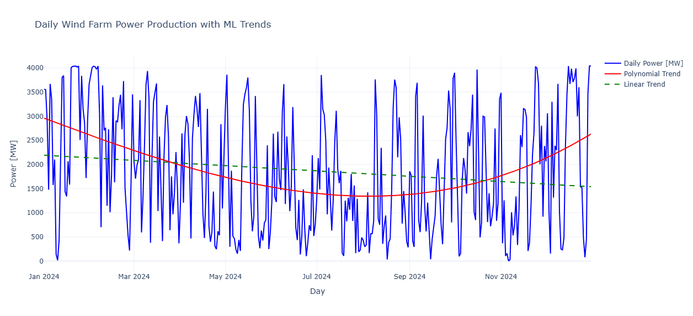
Figure 6. 1: Daily Wind Farm Power Production with ML
The evaluation metrics for these models are as follows:
- Polynomial Regression: R² = 0.14, RMSE = 1155, MAE = 993
- Linear Regression: R² = 0.02, RMSE = 1230, MAE = 1079
R² = Coefficient of Determination, RMSE = Root Mean Squared Error, MAE = Mean Absolute Error
Comparing these two models, the Polynomial Regression model performs better than the Linear Regression model. However, the R² value is still very close to zero, indicating that neither model provides strong predictive capability for daily-based data. This suggests that the models are not suitable for accurate prediction at the daily level. Therefore, in the next section, we explore a more detailed approach by calculating power predictions on an hourly basis, which is explained in the following paragraphs.
In Figure 6.2, the x-axis represents the hours, and the y-axis represents power output in kilowatts (kW). The sky blue line shows the actual power generation on a hours basis, while the dotted green line represents the prediction trend using the Linear Regression model, and the red line shows the prediction trend using the Polynomial Regression model.
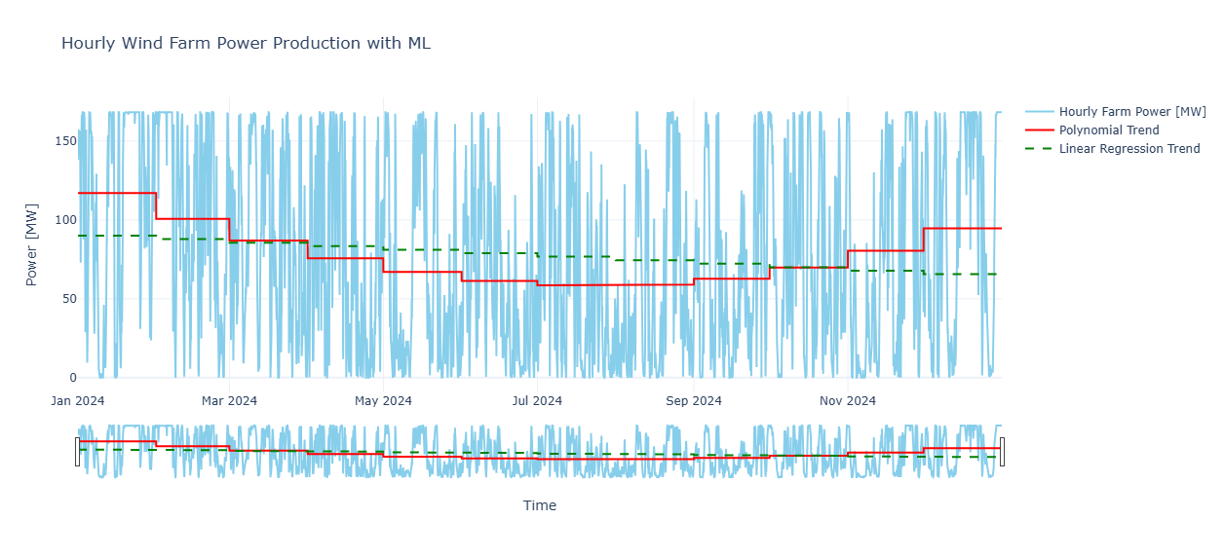
Figure 6. 2: Hourly wind Farm Power Production with ML
The evaluation metrics for these models are as follows:
- Polynomial Regression: R² = 0.94, RMSE = 3347, MAE = 2723
- Linear Regression: R² = 0.16, RMSE = 12308, MAE = 10524
Comparing these two models, the Polynomial Regression model performs significantly better than the Linear Regression model. The R² value for Polynomial Regression is close to 1, indicating a strong fit and good predictive capability. However, further improvements are possible by applying optimization techniques or exploring more advanced models. Additionally, introducing more input parameters in the future could enhance prediction accuracy. It is also important to note that this analysis uses only 2024 data; incorporating multiple years of data and applying advanced ML models would likely result in more accurate predictions.

Decision Arbitrage Model (Logistic Regression Model)
In Figure 6.3, the x-axis represents the hours, while the y-axis displays two aspects: the SELL or STORE decision and the electricity price. The yellow line shows the electricity spot price, the dotted green line represents the decision to store energy, and the red line indicates the decision to sell energy to the grid.
From the figure 6.3, it is evident that most storage decisions occur during spring and summer periods. This is likely because power demand is lower during these seasons, resulting in reduced profitability when selling electricity directly to the grid. According to the model, the total number of hours designated for storage is 1147. For detailed information on the specific dates, times, and prices associated with these storage decisions, refer to the store_hours.csv file located in the Graphs folder of the GitHub repository.
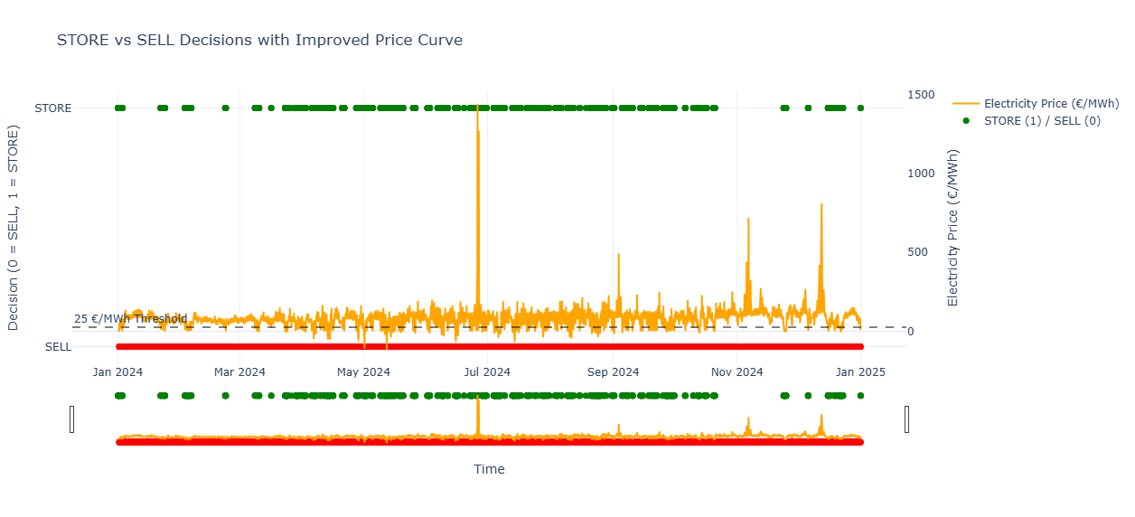
Figure 6. 3: Store Vs Sell Decisions with Improved Price Curve
Figure 6.4 presents a heatmap illustrating the STORE decision across different hours of the day. This visualization provides a more detailed view of which specific hours are recommended for storing electricity rather than selling it to the grid, primarily due to lower profitability during those periods. In the heatmap, green areas indicate hours where storing electricity is advised, while red areas represent hours where selling electricity is recommended. From the graph, it is evident that most storage decisions occur between 05:00 and 14:00, which typically corresponds to times of lower demand and reduced market prices.
From the Logistic Regression model, there were three key coefficients, Power, Price, and Seasonal Demand, with respective values of -0.01, -2.82, and -0.09. These values indicate the relative influence of each factor on the STORE or SELL decision. The negative coefficient for Price (-2.82) suggests that electricity price has the strongest impact on the decision-making process compared to the other factors. This means that when prices are low, the model is more likely to recommend storing energy rather than selling it to the grid.
While price is currently the most influential factor, it is possible to prioritize other parameters depending on operational strategies. For this study, price was considered the primary factor. In future work, adding more parameters such as real-time demand, weather forecasts, or storage costs could lead to more advanced and accurate results.
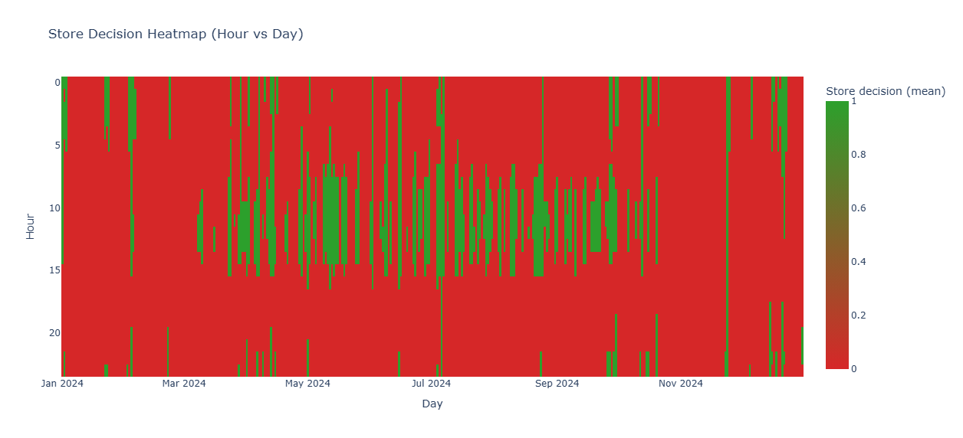
Figure 6. 4: Store Decision Hour Vs Day

Economical Analysis
After obtaining results from Model 2, which determines whether to store or sell energy on a hours basis, we compared the net value of two scenarios, first is selling energy without storage and second is selling energy with storage. In this project, hydrogen storage was used as the primary storage system. The input parameters for the hydrogen model such as electrolyzer capacity, hydrogen production cost, and operational constraints have already been explained in the previous chapter.
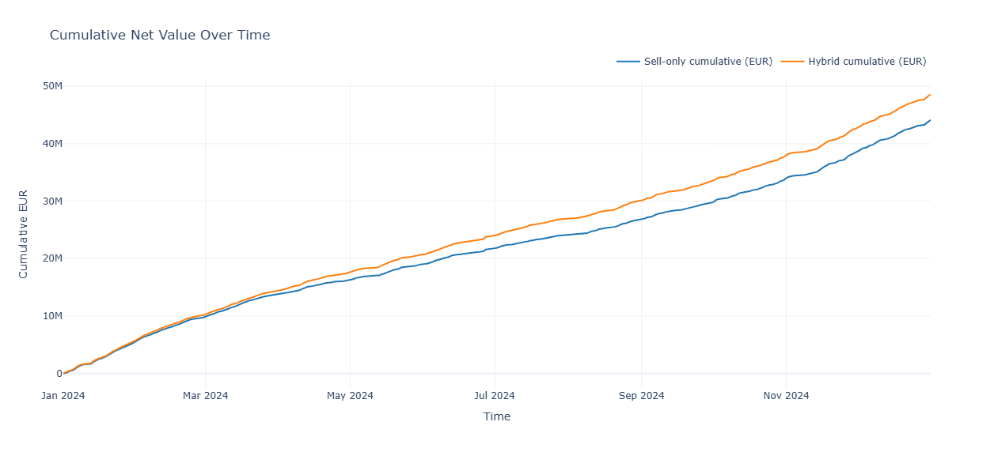
Figure 6. 5: Comparison of Net Value of With or With Storage power
Figure 6.5 illustrates the comparison of net value between two strategies, selling energy directly to the grid without storage and storing energy before selling. The x-axis represents time in hours, while the y-axis shows the net value achieved from each strategy. The blue line represents the net value when energy is sold directly to the grid without storage, and the orange line represents the net value when energy is stored and then sold based on the arbitrage strategy.
From the figure 6.5, it is clear that the storage-based strategy provides higher profitability compared to selling without storage. The final annual net value for selling without storage is approximately €44 million, whereas the net value for the storage-based strategy reaches €48.5 million. Hydrogen storage significantly improves economic performance. However, further enhancements are possible by introducing additional input parameters, using more historical data, and applying advanced optimization techniques. Due to time limitations, optimization was not the focus of this study but is recommended for future work.

Discussion
This section explain on the key findings of the study and evaluates how well the proposed models addressed the objectives. The discussion also highlights the advantages and disadvantages of the approach. The aim is to interpret the results in a practical and meaningful context.

7.1 Interpretation of results
The results of this study show that machine-learning methods can support decision-making in hybrid wind–hydrogen systems. The polynomial regression model captured the non-linear relationship between wind speed and power output, producing a more realistic power curve compared to a simple linear regression model. This indicates that ML based prediction can provide more accurate estimate of hourly based compare to days based model.
The logistic regression model demonstrated that store vs sell decisions can be decided using price, power data and some initial conditions. The model consistently identified low-price hours as suitable for storage and high-price hours as suitable for selling electricity. This behaviour aligns with economic logic and confirms that ML can be used to support arbitrage strategies in real-time operations.
When the stored energy was converted into hydrogen, the results showed that the hybrid system can more benefit then sell energy direct to grid. However, profitability depends strongly on the spread between low-price and high-price periods.

Limitations of the study
There are several limitations of this project. First, the ML models used in this study were relatively simple. More advanced models such as random forests, gradient boosting, or neural networks may provide higher accuracy. Second, the dataset included only a limited set of parameters. Important variables such as air density, turbulence intensity, wind direction, turbine downtime, and more advance power curves were not included, which may reduce prediction accuracy.
The store or sell decision model used a fixed price threshold of 25 €/MWh. [13] Real electricity markets are more dynamic, and optimal thresholds may vary by season, demand, or market conditions. Additionally, the hydrogen model was simplified and did not include detailed electrolyzer efficiency curves, storage losses and real data based operational costs. Finally, the analysis was based on one year of data, which may not capture rare event or changing prise in every years.

Practical implications for wind farm operators
Despite these limitations, the findings have practical relevance. Improved power prediction can help operators plan grid interactions, schedule maintenance, and reduce uncertainty. Automated store or sell decisions can reduce on manual judgment and support more consistent economic performance. Hydrogen storage offers a pathway to reduce curtailment and storage energy during periods of low market prices.
However, operators must consider that hydrogen profitability is highly depended to market conditions. Hybrid wind–hydrogen systems may become increasingly viable for long-term energy storage and revenue optimization.

Conclusion
The results of this study show that machine learning methods can effectively support decision-making in hybrid wind–hydrogen energy systems. The power-prediction model successfully captured the non-linear behaviour of wind-farm output, providing a reliable estimate of hourly energy availability. Base on this, the store and sell classification model showed that electricity price patterns can be used for arbitrage decisions, identifying low-price periods suitable for hydrogen production and high-price periods suitable for selling electricity to the grid. The economic benefit, however, was highly dependent on electricity price volatility and the efficiency of the hydrogen storage system. Overall, hydrogen storage improved revenue. These findings suggest that hybrid wind–hydrogen systems can contribute to reducing curtailment and increasing flexibility, but profitability is not guaranteed and depends on external factors.
However, the results are showing, the study have several limitations. The ML models were trained on a limited parameters and one year of data (2024), which may not fully capture seasonal variability or rare price events. The hydrogen storage model was simplified and did not include detailed parameters. These constraints may affect the accuracy and generalizability of the findings.
To further improve the overall efficiency and reliability of this project, several directions for future work are suggested. First, expanding the set of input parameters such as additional wind features (air density, wind direction, turbulence) and refining the power curve could enhance prediction accuracy. Second, implementing more advanced machine learning techniques, including higher-order polynomial regression, gradient descent optimization, random forests, and deep learning models, would provide better forecasting performance. Real-time prediction and adaptive decision thresholds could make the STORE or SELL model more responsive to rapidly changing market conditions. Additionally, expanding more economic features such as forecasted electricity prices, real seasonal demand profiles, and market trends would improve the arbitrage strategy. A more detailed hydrogen storage model, including electrolyzer efficiency curves, storage losses, and comprehensive cost analysis, would allow for a realistic assessment of long-term profitability. Last but not least, testing the models with multi-year datasets and real measurements data would strengthen the models prediction.

References

[1] | BWE, “Germany wind energy in numbers,” Bundesverband windenergie e.V, 2024. [Online]. Available: https://www.wind-energie.de/english/statistics/statistics-germany/. [Accessed 12 01 2026].
[2] | P. Patzelt, “Renewable Energy Supply Shocks from Wind Electricity,” 2025.
[3] | M. Skibicki, “Machine Learning in Forecasting vs. Traditional Methods,” STXNEXT, 16 April 2025. [Online]. Available: https://www.stxnext.com/blog/machine-learning-in-forecasting-vs-traditional-forecasting-methods. [Accessed 12 January 2026].
[4] | Ö. A. Karaman, “Prediction of Wind Power with Machine Learning Models,” no. MDPI, 2023.
[5] | L. Hirth, “The market value of variable renewables: The effect of solar wind power variability on their relative price,” ScienceDirect, vol. 38, pp. 218-236, 2013.
[6] | S. r. Gunther Glenk, “Economics of converting renewable power to hydrogen,” Nature Energy, vol. 4, pp. 16 - 222, 2019.
[7] | H. s. Alexander Buttler, “Current status of water electrolysis for energy storage, grid balancing and sector coupling via power-to-gas and power-to-liquids: A review,” ScienceDirect, vol. 82, pp. 2440 - 2454, 2018.
[8] | H. G. Y. Z. Z. Z. Zongxu Liu, “A Comprehensive Review of Wind Power Prediction Based on Machine Learning: Models, Applications, and Challenges,” MDPI, p. 17, 2025.
[9] | Climate Data Store, “ERA5 hourly data on single levels from 1940 to present,” 14 June 2018. [Online]. Available: https://cds.climate.copernicus.eu/datasets/reanalysis-era5-single-levels?tab=overview. [Accessed 25 11 2025].
[10] | Energy-Charts, “Annual electricity spot market prices in Germany,” Fraunhofer ISE, [Online]. Available:  https://www.energy-charts.info/charts/price_average/chart.htm?l=en&c=DE&interval=year&year=2024. [Accessed 25 11 2025].
[11] | NS ENERGY, “Reußenkoge Wind Farm Expansion,” 26 July 2019. [Online]. Available: https://www.nsenergybusiness.com/projects/reusenkoge-wind-farm-expansion/?cf-view. [Accessed 22 11 2025].
[12] | Vestas, “Vestas V112-3.3-3,30MW - Wind turbine,” Vestas, [Online]. Available: https://en.wind-turbine-models.com/turbines/693-vestas-v112-3.3 . [Accessed 20 12 2025].
[13] | SIEMENS ENERGY, “Green hydrogen production,” Siemens Energy, [Online]. Available: https://www.siemens-energy.com/global/en/home/products-services/product-offerings/hydrogen-solutions.html. [Accessed 15 11 2025].
[14] | TENNET, “Ensuring the affordability of electricity with our grid,” TENNET, 2024. [Online]. Available:  https://www.tennet.eu/de-en/about-us/our-strategy/security-supply/affordability. [Accessed 21 11 2025].

10. Appendices
GitHub Link
On our GitHub homepage, we have attached code, our report and presentation. If you want to gain more knowledge about the topic, please check out our GitHub.
https://github.com/MadhaveshG/wind-h2-arbitrage

