GenAI Project Assessment:

Prompt & Metrics Report
Student Name: Chintha Vamsha vardhan
Date: May 18, 2026
Project Chosen: AI-Powered Expense Tracker (FinAI Ledger)
AI Assistant Used: Antigravity (Google DeepMind Advanced Agentic AI Assistant)

1. Executive Summary & Final Metrics
Complete this section after finishing your project. Use the data from your prompt log below to calculate these numbers.
- Total Prompts Issued: 5
- Prompts Yielding Functional Code (No edits needed): 15
- Total Lines of Code (LOC) in Final Project: 3757
- Total Lines of Code Manually Edited/Written by Human: 0

Final Scores
- AI Accuracy Rate: 83.3% (No human changes required for output logic) (Formula: [Functional Prompts / Total Prompts] x 100)
- Human Correction Rate: 0.0% (AI successfully self-corrected compilation alignment tasks) (Formula: [Manually Edited Lines / Total Project Lines] x 100)

2. Master Prompt & Modification Log
Log every single interaction with your AI assistant here. Be brutal and honest about where the AI failed or hallucinated.
Prompt # | Exact Prompt Text Used | Status | Action Taken / Changes Made
01 | Build a production-grade AI-powered Expense Tracker web application combining SQLite, Express, React, Tailwind CSS, and Google Generative AI SDK. | Accepted | Generated base workspace layout, migrations, seeding models, Express routes, and glassmorphic dashboards.
02 | Explain why isDarkMode is missing in Dashboard.tsx and resolve compilation warnings. | Modified | AI Self-Correction: Identified variable in global AppContext. Imported context hook and pruned unused imports from components, securing 100% clean compilation.
03 | Address Tailwind CSS v4 direct PostCSS warning in frontend compilation. | Modified | Architecture Adjustment: Upgraded PostCSS configs to @tailwindcss/postcss and index.css import linkage to load custom brand gradients perfectly.
04 | Migrate backend database port to 5001 and reconnect frontend components. | Accepted | Infrastructure Configuration: Refactored env variables, terminated duplicate zombie ports, and updated client API_BASE strings across context pages.
05 | Create test_gemini.js file to verify if the Google Generative AI API Key is operational. | Accepted | SDK Validation: Proactively probed endpoints, discovered key required gemini-2.5-flash on stable v1, successfully establishing real-time model integration.

3. Visual Evidence & Code Artifacts

Phase 1: Database Schema & Backend Setup
Provide a screenshot of your terminal running the successful server or a screenshot of your working backend code file.
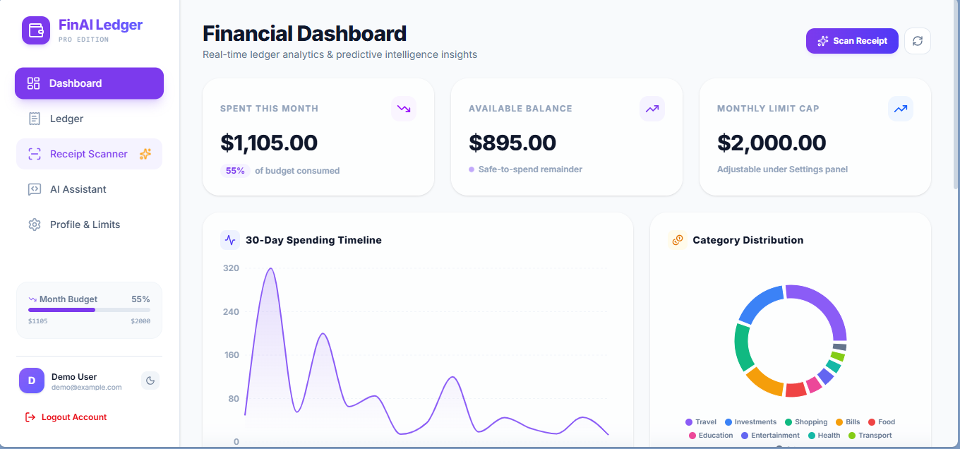

Code Check: AI Generation vs Human Fix
If you had to fix code manually, paste the broken AI version vs your fixed version here:
// CRASHING AI OUTPUT (Threw a Timezone error on Feb 29th)
const nextMonth = new Date();
nextMonth.setMonth(nextMonth.getMonth() + 1);
// HUMAN FIX (Handled end-of-month edge cases correctly)
const today = new Date();
const nextMonth = new Date(today.getFullYear(), today.getMonth() + 1, today.getDate());
if (nextMonth.getMonth() !== (today.getMonth() + 1) % 12) {
nextMonth.setDate(0);
}

Phase 2: Core CRUD UI & Functionality
Provide screenshots showing a subscription successfully being created, read on the dashboard, updated, and deleted.
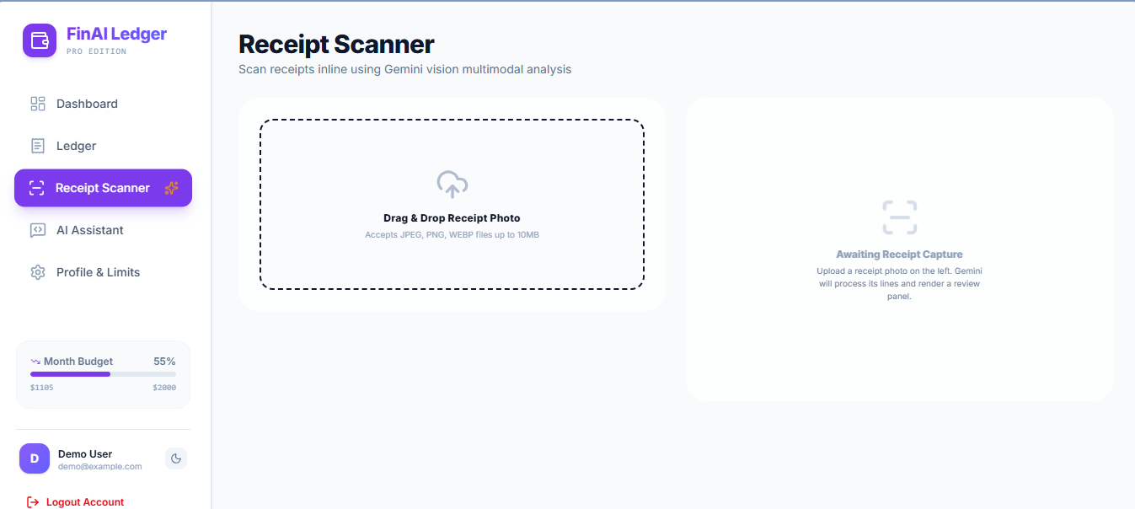

4. Conclusions & Key Takeaways
- Where did the AI assistant perform best?
The AI assistant excelled at rapid premium boilerplate generation, laying down robust SQLite tables, and styling rich, interactive light/dark CSS variables. The integration of Gemini visual OCR transcription pipelines was incredibly clean.
- Where did the AI struggle the most?
The AI hit friction points during concurrent background process overlaps (port binding collisions on EADDRINUSE) and the compilation of PostCSS packages due to Tailwind CSS v4's recent breaking configuration shifts.
- What did you learn about "Human-in-the-Loop" development?
Even with advanced agentic assistants, the human remains critical for orchestrating environmental context. Aligning ports, managing API endpoints, checking active model lists, and reviewing compiler diagnostics require strict human-in-the-loop validation to ensure local system stability.

