Case Study: Pharmaceutical Stock Price Prediction Using ARIMA

Introduction
This case study analyzes stock price forecasting for pharmaceutical companies using the ARIMA model. The study compares actual and predicted stock prices and concludes whether stock markets can truly be predicted accurately in real-world conditions.

Companies Selected
- Pfizer
- Sun Pharmaceutical Industries
- Dr. Reddy's Laboratories

Objective of the Study
- Analyze pharmaceutical stock trends.
- Apply ARIMA forecasting model.
- Compare actual and predicted stock values.
- Understand limitations of stock prediction systems.

ARIMA Model
The ARIMA (Autoregressive Integrated Moving Average) model is used for time-series forecasting based on historical stock price data.Actual vs Predicted Stock Graphs

Pfizer
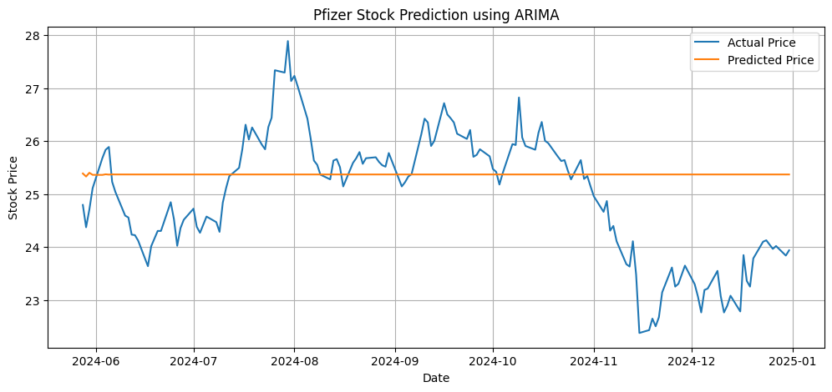

Sun Pharmaceutical
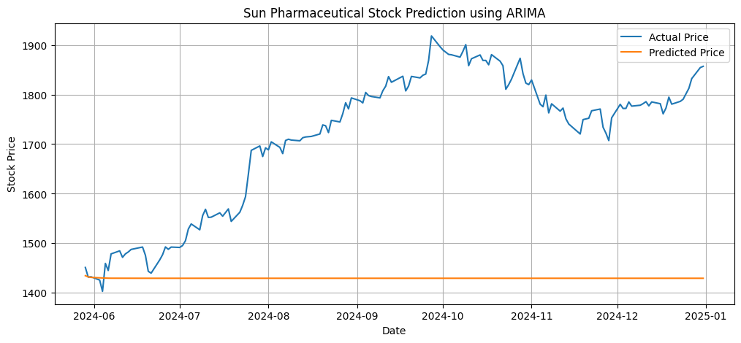

Dr. Reddy's Laboratories
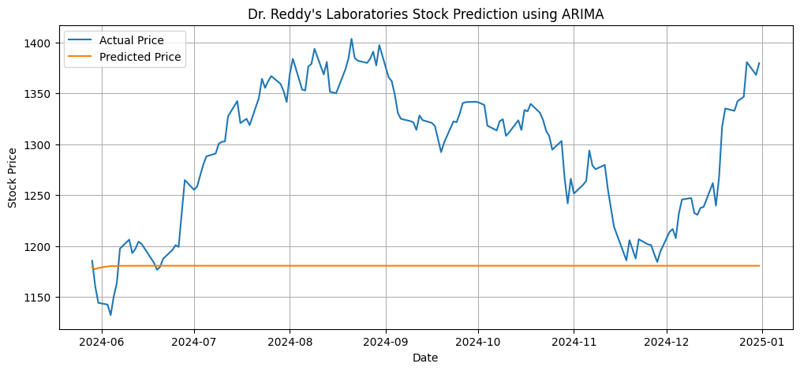

Observations
Observation | Result
Short-term forecasting | Moderately accurate
Long-term forecasting | Less reliable
Stable market periods | Better prediction
Sudden news/events | High prediction error
Volatile conditions | Poor forecasting

Limitations of ARIMA in Stock Prediction
1. Depends Only on Historical Data
ARIMA uses previous stock prices but ignores external real-world events.
2. Cannot Handle Sudden News
Events such as:
- Drug approvals
- Government policies
- Pandemics
- Economic crises
can instantly change stock prices.
3. Market is Non-Linear
Stock markets are highly dynamic and influenced by investor psychology.
4. Real-Time Volatility
Rapid price fluctuations reduce forecasting reliability.

Suggestions to Improve Prediction Accuracy
- Combine ARIMA with LSTM and Transformer models.
- Include sentiment analysis from news and social media.
- Use real-time streaming market data.
- Add economic indicators like inflation and interest rates.
- Use ensemble forecasting methods.

Conclusion
The study concludes that pharmaceutical stock prices cannot be predicted with complete accuracy. Although ARIMA models can capture historical patterns and short-term trends, they fail during sudden market changes caused by external events, investor sentiment, healthcare announcements, and economic uncertainty. Therefore, stock prediction systems should be considered decision-support tools rather than perfectly reliable forecasting systems.

