http://localhost:8080/api/getproductdetails?id=1

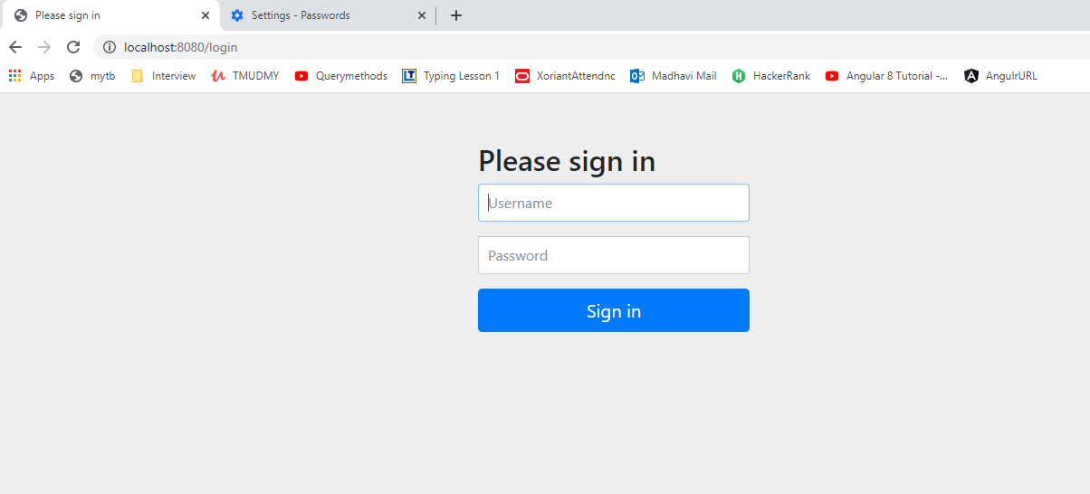

Give username as **user** password as **user**

**JSON Output:**

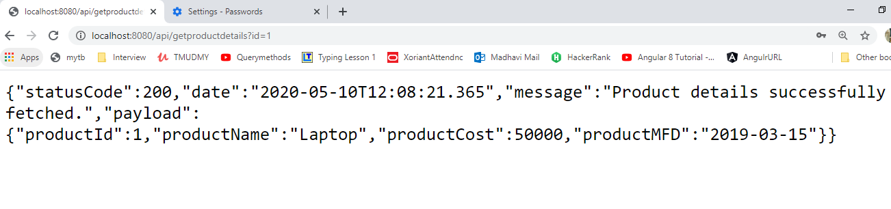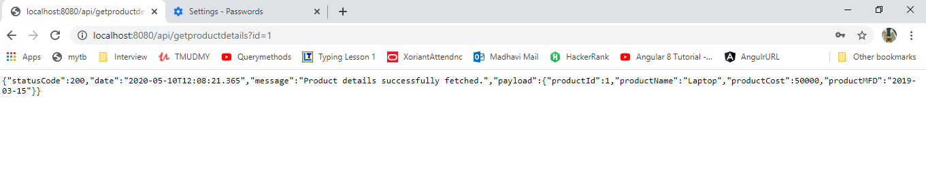

{"statusCode":200,

"date":"2020-05-10T11:46:56.751",

"message":"Product details successfully fetched.",

"payload":{

"productId":1,

"productName":"Laptop",

"productCost":50000,

"productMFD":"2019-03-15"}

}

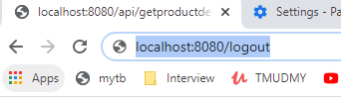

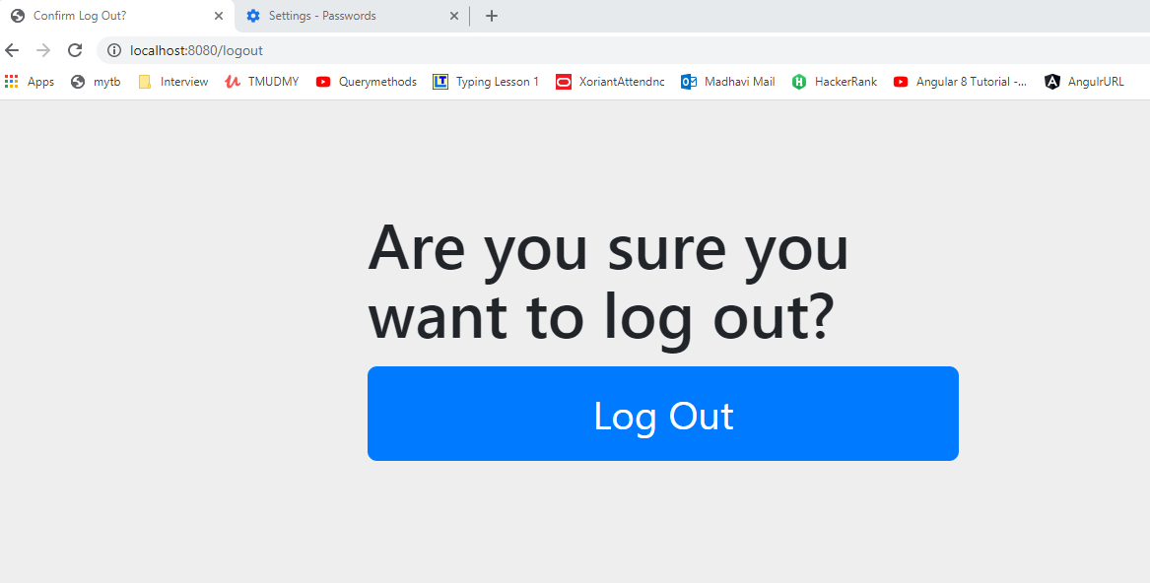

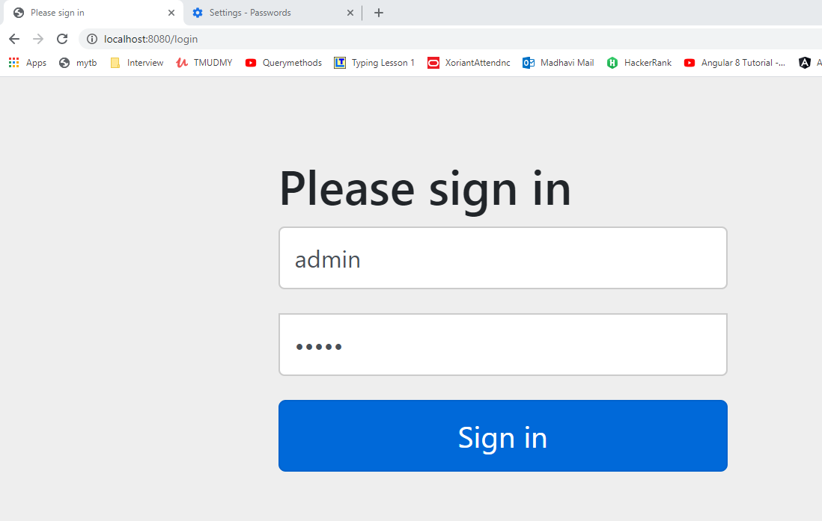

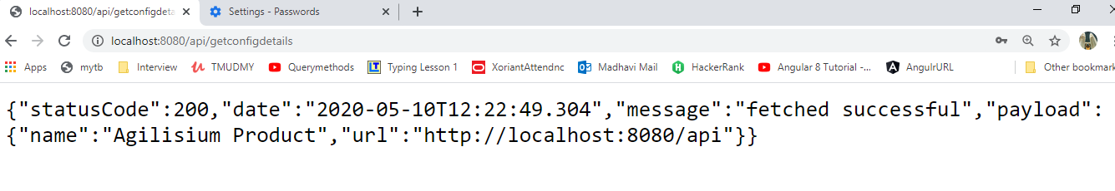

JSON output:

{"statusCode":200,

"date":"2020-05-10T12:01:02.41",

"message":"fetched successful",

"payload":{

"name":"Agilisium Product",

"url":"http://localhost:8080/api"}

}