CIA - Component 1
Course: STA405-6 Sampling Techniques
Topic: Simple Random Sampling (SRS)
Student: Madhavi Krishna K K
Reg No: 2341450
Class: 6 BSc DS

1. Define the population clearly and describe the sampling frame.
Chosen population: Undergraduate students enrolled in the BSc Data Science program, third year, at XYZ College during the current semester.

Population: All students who are officially registered for the third‑year BSc Data Science courses in the current semester. This population includes both full‑time and part‑time students who meet the registration criteria and attend classes (N = 500, hypothetical).

Sampling frame: The sampling frame is the up‑to‑date student registry list provided by the college administration for third‑year BSc Data Science students. The registry contains unique student IDs, full names, email addresses, and roll numbers. A sampling frame is generated in R.

2. Describe the exact steps you will follow to select a sample using Simple Random
- Obtain the sampling frame: an electronic CSV containing all third-year BSc Data Science students with unique IDs (e.g., student_id).
- Assign each student a unique integer index from 1 to N (e.g., 1..500). This index will be the sampling key.
- Decide the sample size n. For this study assume n = 50 (10% of population), unless another size is required by the instructor.
- Set a reproducible random seed for reproducibility (e.g., in R: set.seed(12345)).
- Use a random number generator to draw n indices from 1..N uniformly at random without bias. In SRSWOR (most common), select n distinct indices; in SRSWR select n indices with possible repetition.
- Retrieve student records from the sampling frame corresponding to the drawn indices to form the sample.
- Verify sample integrity: check for duplicates (if SRSWOR there should be none), ensure all selected IDs are valid, and prepare the sample data for analysis (anonymize if required).
- Document the sampling procedure, seed, and the final sample indices for auditability and reproducibility.
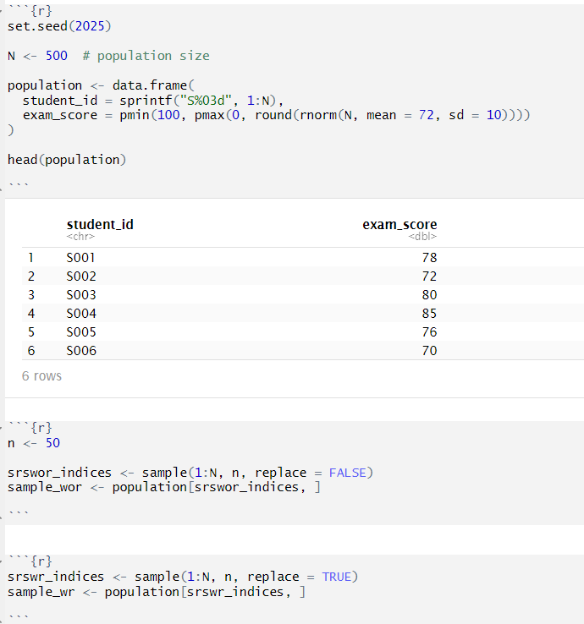

---------------------------------------------------------------------

3. List three advantages and three limitations of SRS in context of your study.
Advantages
- Unbiased selection: Every student has an equal chance of selection, reducing selection bias and supporting valid inference about population means (e.g., average assignment score).
- Simplicity and transparency: SRS is easy to explain and reproduce (seeded RNG), making it acceptable for academic auditing and inspection.
- Statistical properties: Many standard estimators (sample mean, sample proportion) have well-known sampling distributions under SRS, allowing straightforward variance estimation and confidence intervals.
Limitations
- Frame dependence: SRS requires a complete and accurate sampling frame. If the roster misses students (e.g., late adds) or contains duplicates, estimates will be biased.
- Inefficient for heterogeneous populations: If students differ greatly by year-section or specialization, SRS may be less efficient than stratified sampling at reducing variance for estimates of subgroup means.
- Logistics and nonresponse: Selected students may not respond or be available (attendance issues), leading to nonresponse bias. SRS does not by itself address systematic nonresponse.
---------------------------------------------------------------------

4. Explain the difference between SRS With Replacement (SRSWR) and SRS Without Replacement (SRSWOR) conceptually.

SRS With Replacement (SRSWR): Each draw selects a unit from the population and then that unit is "returned" to the population before the next draw. Therefore, the same unit can be selected multiple times. Each draw is independent with probability 1/N for every unit.
SRS Without Replacement (SRSWOR): Once a unit is selected, it is removed from the population and cannot be selected again in the same sample. Draws are dependent because the pool of remaining units changes after each draw.
Key conceptual consequences
- Probability of selection: In SRSWR the probability a particular unit appears in any single draw is 1/N. In SRSWOR the probability a particular unit is selected at least once in the sample of size n equals n/N (for the event of being selected at a specific draw), but the inclusion probability across the whole sample is n/N (more formally for equal probability sampling without replacement each unit has inclusion probability π_i = n/N).
- Variance of estimators: For the sample mean $\overset{ˉ}{X}$, the variance under SRSWR is ${Var}_{WR}(\overset{ˉ}{X})=σ^{2}/(n)$, where $σ^{2}$is population variance. Under SRSWOR the variance is ${Var}_{WOR}(\overset{ˉ}{X})=(1-f) σ^{2}/n$where $f=n/N$is the sampling fraction; equivalently the finite population correction (FPC) factor $1-f$reduces variance when sampling without replacement. Thus SRSWOR yields smaller variance than SRSWR when n is not negligible compared to N.
- Practical note: When population size N is large and sampling fraction f = n/N is small (e.g., f < 0.05), the difference between SRSWR and SRSWOR is negligible and formulas for SRSWR are often used as approximations.

Variance difference:
Var(WR)(X̄) = σ² / n
Var(WOR)(X̄) = (1 − n/N) * σ² / n
SRSWOR has lower variance due to the finite population correction.

5. Using R, generate a hypothetical population dataset related to your chosen population and compare the results of Simple Random Sampling With Replacement (SRSWR) and Simple Random Sampling Without Replacement (SRSWOR).
Below I provide R code to create a hypothetical population dataset of N = 500 students and to perform SRSWR and SRSWOR with n = 50. The code computes sample means and variances for a variable exam_score and compares them. (I include equivalent Python simulation results in accompanying files/outputs.)
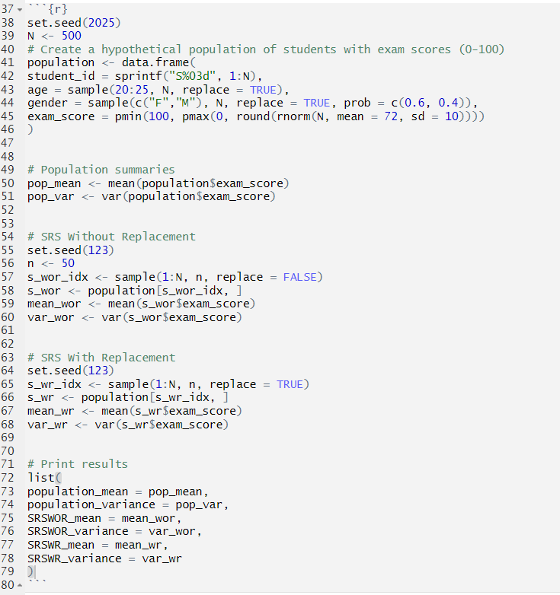

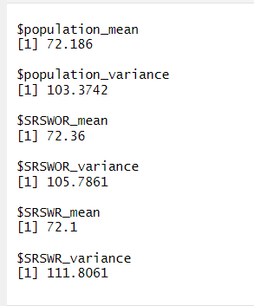
Interpretation guidance:
- You should observe that both sample means (SRSWR and SRSWOR) are close to the population mean but differ due to sampling variability.
- The sample variance of observations in the drawn sample (var_wor vs var_wr) measures within-sample variability and will usually be similar; however the variance of the sample mean across repeated samples will follow the theoretical relationship described earlier: Var_WOR(\bar{X}) = (1 - n/N) \sigma^2 / n which is smaller than Var_WR(\bar{X}) = \sigma^2 / n by the factor (1 - n/N).
Suggested extension (repeat simulation): To empirically demonstrate the reduction in variance, repeat the sampling many times (e.g., 1000 replications) and compute the sampling distribution variance of $\overset{ˉ}{X}$under both methods—SRSWOR will show the finite population correction.

---------------------------------------------------------------------

Conclusion
Simple Random Sampling is an intuitive and theoretically justified method for selecting unbiased samples when a complete sampling frame is available. For this study of third-year BSc Data Science students we recommend SRSWOR (without replacement) to take advantage of the finite population correction and reduce estimator variance, provided that the sampling frame is accurate and nonresponse is managed.

