Logo Redesign Report – Cream Stone: A

Fresh Take on a Tasty Brand

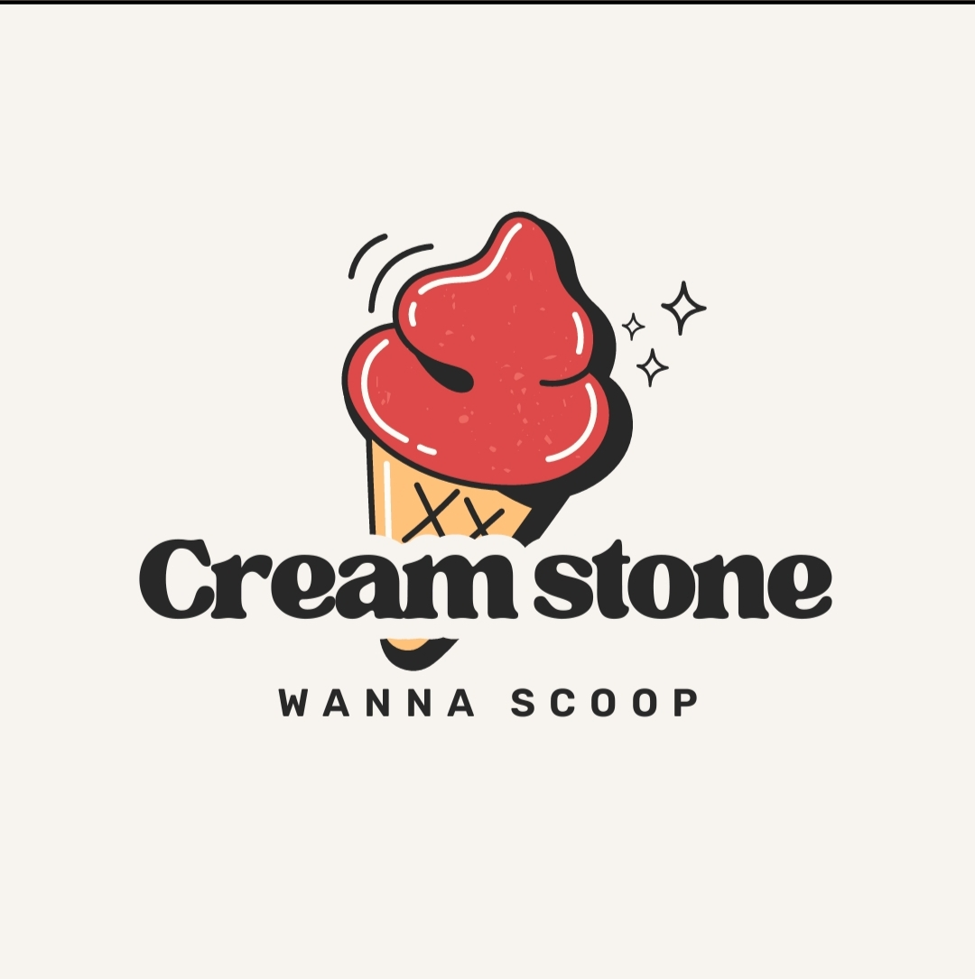

Name: Solleti Venkata Madhavi

College: Anil Neerukonda Institute of Technology and Sciences

🧾 Logo Redesign Report – Cream Stone: A Fresh Take on a Tasty Brand

📌 Task Overview

Task Name: Logo Redesign

Objective: To redesign the existing “Cream Stone” logo by blending modern aesthetics with the brand’s original identity.

Goal: Enhance visual appeal, maintain brand recall, and produce versatile logo variations suitable for digital and print media.

🎨 1. Understanding the Existing Logo

The current logo of Cream Stone consists of:

- A playful red ice cream scoop placed on a waffle cone, outlined with thick black strokes.

- Sparkling effects on the top-right of the scoop – suggesting shine, delight, and sweetness.

- Typography: The brand name “Cream stone” is written in a bold serif font. The font gives a slightly retro, warm vibe.

- Tagline: Below the brand name, the phrase “WANNA SCOOP” is displayed in uppercase sans-serif, simple and direct.

Mood and Feel:

The logo communicates fun, youthfulness, and a friendly ice cream parlour vibe. It appeals mainly to a younger crowd — kids, teens, and families.

🎯 2. Purpose Behind the Redesign

While the current logo is charming and nostalgic, it requires a modern facelift to align with today's design trends and brand evolution.

The redesign should:

- Retain the essence of the brand that customers love.

- Improve visual flexibility and scalability across platforms (social media, signage, packaging).

- Reflect a more professional, minimal, and premium design language.

- Ensure consistency and elegance while maintaining that element of fun.

✏️ 3. Strategic Design Approach

✅ A. Retaining Brand Identity

We aim to keep the brand recognisable by preserving:

- The iconic ice cream cone and scoop motif.

- The dominant red colour, symbolising flavour, fun, and indulgence.

- The name “Cream stone” and tagline “Wanna Scoop”.

🎨 B. Infusing Modern Design Techniques

To modernise the logo, we propose the following:

1. Typography Upgrade

- Replace the bold serif with a sleek sans-serif or soft rounded font.

- A clean font makes the logo feel modern, digital-ready, and elegant.

- Tagline to be kept in uppercase but with lighter weight to avoid overpowering the brand name.

2. Colour Refinement

- Use a refreshed red shade, possibly coral or raspberry, which feels richer and more current.

- Add a secondary accent colour like mint green or teal for contrast in dual-tone applications.

- Stick to flat design colours or subtle gradients to match current branding norms.

3. Icon Simplification

- Redraw the cone and scoop using minimal vector shapes with thinner outlines.

- Make the sparkles subtle and stylistically consistent (line-art style).

- Ensure the scoop shape is smooth and recognisable even in smaller sizes.

4. Layout Optimisation

- Maintain clear spacing and alignment for responsive use on mobile, web, or print.

- Ensure the logo looks stunning in monochrome, colour, or negative space versions.

🔄 4. Proposed Logo Variations

We suggest four creative variations for specific use cases:

A. Full Logo Lockup

- Includes icon, brand name, and tagline.

- Ideal for store signage, banners, website headers, and packaging.

B. Icon-Only Version

- Just the scoop and cone.

- Perfect for app icons, social media DP, stickers, and stamps.

C. Typography-Driven Version

- Text-only version with unique customisation (e.g., using a mini scoop as a dot on 'i' or swirl under the name).

- Best for receipts, emails, and corporate material.

D. Circular Badge Layout

- Enclosed logo in a badge or seal format.

- Excellent for labels, loyalty cards, branded merch, or packaging stickers.

✨ 5. Why This Redesign Will Work

- Maintains emotional connection with the original.

- Reflects contemporary taste and design language.

- Adapts well across digital and physical formats.

- Appeals to a broad audience, from Gen Z to families.

This refresh is not just about visual change — it’s about evolving with the times while staying rooted in brand values.

✅ 6. Conclusion

The redesigned Cream Stone logo is aimed at striking the perfect balance between tradition and trend.

By preserving what makes the brand lovable and introducing refined, scalable, and aesthetically pleasing updates, the logo will not only look more premium but also perform better across all customer touchpoints.