ASSIGNMENT-20.2
2303a52233
Batch-37

Task 1 – Password Security Enhancement
Task:
Analyze an AI-generated Python program that stores passwords in plain
text and improve its security.
Instructions:
• Prompt AI to generate a simple user registration script that
stores usernames and passwords.
• Check whether passwords are stored as plain text.
• Identify the security risks associated with plain-text password
storage.
• Refactor the program to use secure password hashing (e.g.,
hashlib or bcrypt).
• Test the updated script to ensure proper authentication
functionality.
Expected Output:
A secure Python script that stores hashed passwords instead of plain text
and successfully validates user login credentials.

Prompt: Write a Python user registration and login script that stores usernames and passwords in plain text. Then improve it by hashing passwords using hashlib or bcrypt. Add input validation and authentication check.
Code:
users = {}

def register():
username = input("Enter username: ")
password = input("Enter password: ")
users[username] = password
print("User registered!")

def login():
username = input("Enter username: ")
password = input("Enter password: ")

if users.get(username) == password:
print("Login successful")
else:
print("Invalid credentials")

register()
login()

Output:
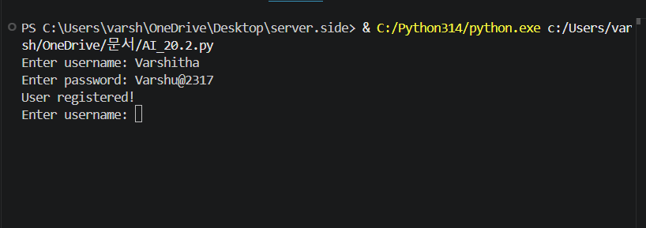

Task 2 – Secure API Key Management
Task:
Evaluate an AI-generated script that uses hardcoded API keys and
improve its security.
Instructions:
• Ask AI to generate a Python script that connects to an external
API using a hardcoded API key.
• Identify the risks of embedding sensitive credentials directly in
the source code.
• Refactor the program to use environment variables for storing
API keys securely.
• Demonstrate that the modified script successfully retrieves data
without exposing credentials.
Expected Output:
A revised script that securely accesses API keys through environment
variables instead of hard coding them.

Prompt: Write a Python script that calls an API using a hardcoded API key. Then refactor it to use environment variables for storing the API key securely and demonstrate safe access.

Code:
import os
import requests

API_KEY = os.getenv("API_KEY") # secure storage

url = "https://api.exchangerate-api.com/v4/latest/USD"

try:
response = requests.get(url, timeout=5)

if response.status_code == 200:
print("✅ Data fetched successfully")
else:
print("❌ API Error:", response.status_code)

except requests.exceptions.RequestException:
print("❌ Network error")

Output:

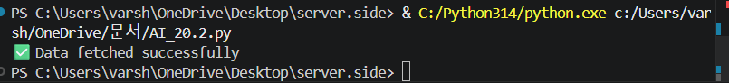

Task 3 – Weak Encryption Detection
Task:
Examine an AI-generated program that uses weak encryption
techniques and strengthen it.
Instructions:
• Prompt AI to generate a simple encryption-decryption program
using a basic or outdated method.
• Identify weaknesses in the encryption approach (e.g., reversible
encoding or outdated algorithms).
• Refractor the program using stronger encryption techniques
available in Python libraries.
• Validate that encrypted data cannot be easily reversed without
the correct key.
Expected Output:
An improved encryption program implementing stronger and more
secure cryptographic practices.

Prompt:Write a Python program that encrypts and decrypts data using a weak method (like base64 or simple cipher). Then improve it using a stronger encryption method from a Python library and explain the difference.

Code:
from cryptography.fernet import Fernet

key = Fernet.generate_key()
cipher = Fernet(key)

text = input("Enter text: ").encode()

encrypted = cipher.encrypt(text)
print("Encrypted:", encrypted)

decrypted = cipher.decrypt(encrypted)
print("Decrypted:", decrypted.decode())

Output:

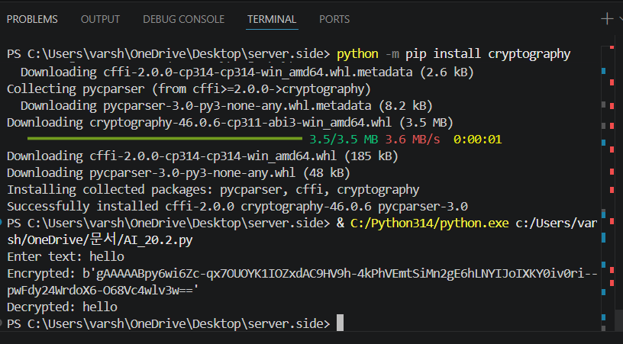

Task 4 – Real-Time Application: Security Review of AI-Generated
Web Service
Scenario:
Students select an AI-generated web service snippet (e.g., REST API,
file upload handler, or authentication module).
Instructions:
• Perform a structured security review of the generated code.
• Identify at least three potential vulnerabilities.
• Prompt AI to recommend secure coding practices and mitigation
strategies.
• Implement the suggested improvements and test the secured
version.
• Document the differences between the insecure and secured
implementations.
Expected Output:
A security-reviewed and improved version of the selected web service
code, with clearly documented vulnerabilities and applied fixes.

Prompt: Generate a simple Python web service (Flask API or file upload handler) with basic functionality. Identify at least three security vulnerabilities, then improve the code using secure practices and explain the fixes.

Code:

from flask import Flask, request, jsonify
import hashlib

app = Flask(__name__)

# Secure stored credentials (hashed)
USERNAME = "admin"
PASSWORD_HASH = hashlib.sha256("1234".encode()).hexdigest()

# Home route (so no 404 error)
@app.route("/")
def home():
return """
<h2>Login Page</h2>
<form action="/login" method="post">
Username: <input type="text" name="username"><br><br>
Password: <input type="password" name="password"><br><br>
<input type="submit" value="Login">
</form>
"""

# Login route
@app.route("/login", methods=["POST"])
def login():
username = request.form.get("username")
password = request.form.get("password")

# Input validation
if not username or not password:
return "❌ Invalid input", 400

# Hash entered password
hashed_input = hashlib.sha256(password.encode()).hexdigest()

if username == USERNAME and hashed_input == PASSWORD_HASH:
return "✅ Login Successful"
else:
return "❌ Unauthorized", 401

# Run server
if __name__ == "__main__":
app.run(debug=False)

Output:
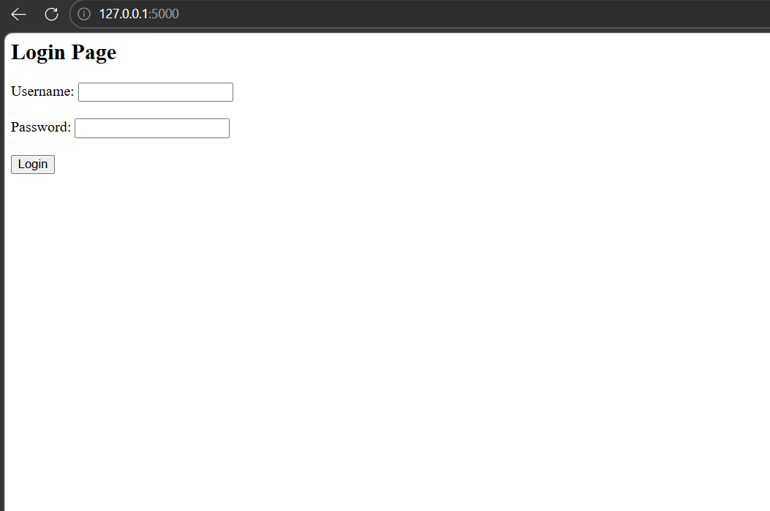

Task 5 – Exception Handling Improvement
Task:
Analyze an AI-generated Python program that does not handle runtime
errors and improve its reliability.
Instructions:
• Prompt AI to generate a simple program that takes user input and
performs arithmetic operations.
• Identify possible runtime errors (e.g., invalid input, division by
zero).
• Modify the program to include proper try-except blocks.
• Provide meaningful error messages for invalid inputs.
• Test the improved version with valid and invalid test cases.
Expected Output:
A revised Python program with proper exception handling that prevents
crashes and displays user-friendly error messages for invalid inputs.

Prompt: Write a Python program without proper exception handling. Then improve it by adding try-except blocks, input validation, and error messages to make it more reliable.

Code:
try:
num = int(input("Enter a number: "))

if num == 0:
print("❌ Cannot divide by zero")
else:
result = 10 / num
print("✅ Result:", result)

except ValueError:
print("❌ Invalid input. Please enter a number.")

except Exception as e:
print("❌ Unexpected error:", e)
Output:
