Assignment -14.3

Batch: 37
Roll No: 2303A2233
Lab: 14.3

Task 1: AI- Assisted Personal Portfolio Website
Scenario
A student wants to showcase academic projects, technical skills, and contact information through a personal portfolio website. AI tools are used to speed up development while maintaining quality and customization.
Tasks
1. Use GitHub Copilot to generate a semantic HTML structure with sections:
o Home o
About o
Projects o
Contact
- Ask Copilot to suggest responsive CSS using Flexbox or Grid.
- Customize AI-generated CSS to add:
o Hover effects on project cards o
Smooth scrolling navigation

Prompt
Generate a responsive personal portfolio website using HTML5, CSS3, and JavaScript.
- Use semantic HTML structure with sections: Home, About, Projects, and Contact.
- Create a navigation bar that scrolls smoothly to each section.
- Design the Projects section using CSS Flexbox or Grid with project cards.
- Add hover effects to the project cards (scale effect or shadow).
- Ensure the layout is fully responsive for desktop, tablet, and mobile screens.
- Implement smooth scrolling navigation using JavaScript. - Use modern styling with clean typography and spacing.

Code:
Index.html
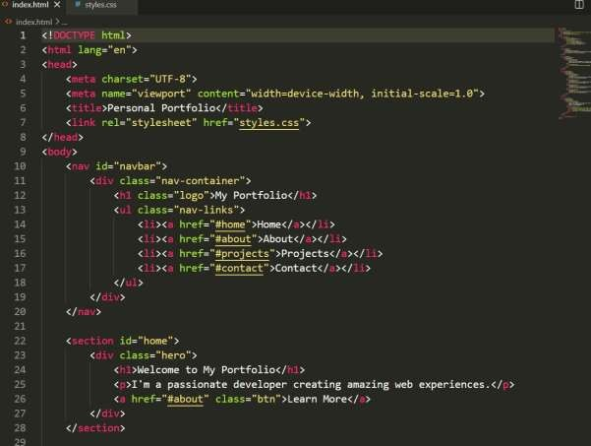
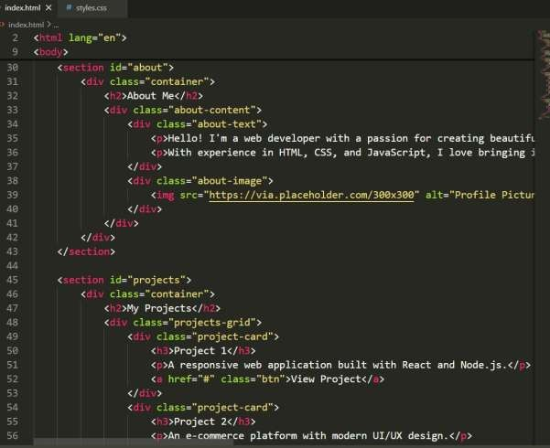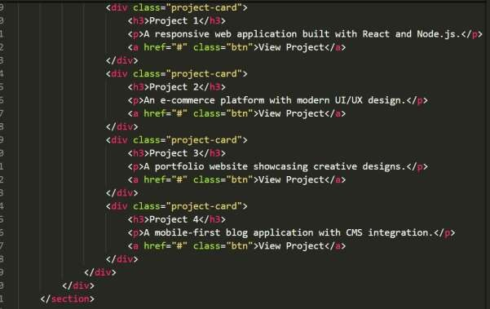
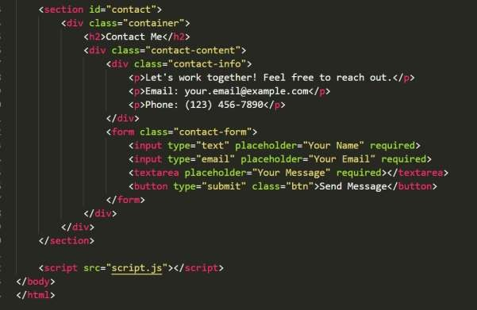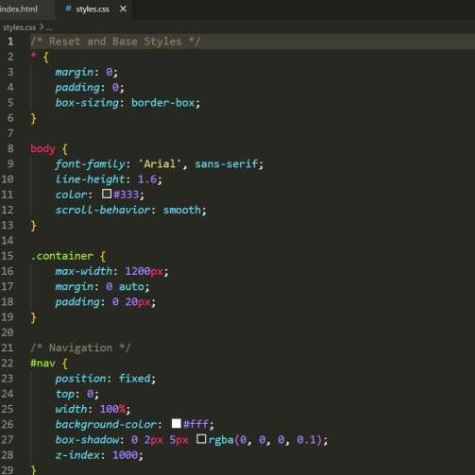
Style.css

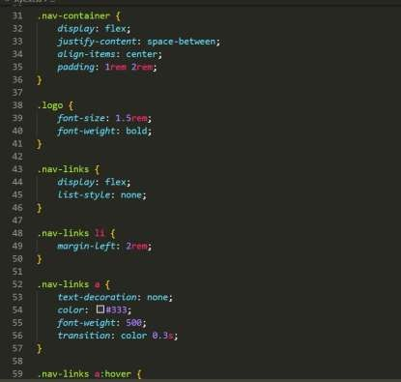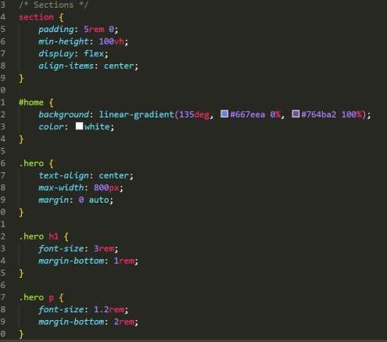

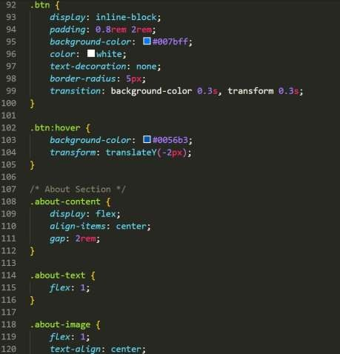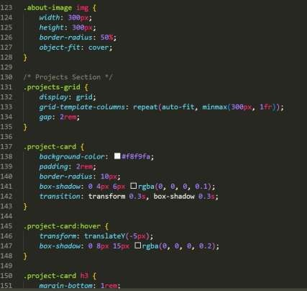

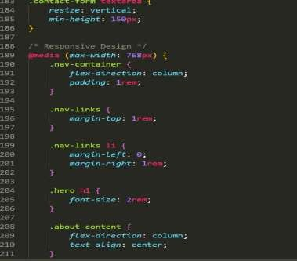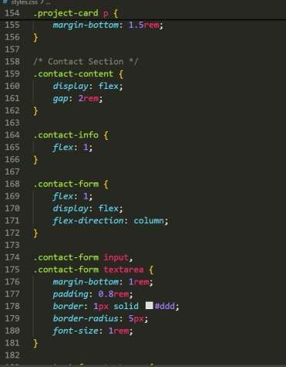
Output:

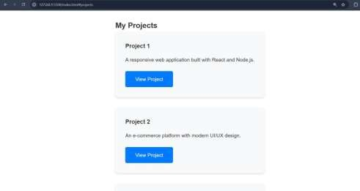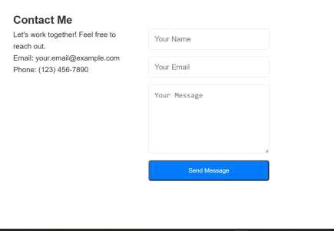

Code Explanation The personal portfolio website is built using HTML, CSS, and JavaScript to showcase a student’s profile, skills, projects, and contact details.

HTML Structure
The HTML file creates the structure of the website using semantic tags.
- The <header> section contains the navigation bar with links to different sections such as Home, About, Projects, and Contact.
- Each section is created using <section> tags with unique IDs so that navigation links can scroll to the correct part of the page.
- The Projects section displays project cards that contain project title and description.
- The Contact section includes contact information or a form.

CSS Styling
CSS is used to improve the visual appearance of the portfolio.
- Flexbox or Grid is used to arrange project cards in a structured layout.
- Hover effects are added to project cards using the :hover selector to create animations such as scaling or shadow effects.
- Media queries are used to make the website responsive, ensuring it adapts properly to desktop, tablet, and mobile screens.

JavaScript Functionality
JavaScript is used to enhance user interaction.
- Smooth scrolling is implemented so that when users click navigation links, the page smoothly scrolls to the corresponding section.
- Event listeners detect navigation clicks and trigger scrolling behavior.
This results in a responsive and interactive personal portfolio website.

Task 2: AI-Generated Restaurant Landing Page
Scenario
A local restaurant requires a simple yet attractive landing page to display its
offerings. The developer uses AI assistance to rapidly generate UI components.
Tasks
1. Use Copilot to create a navigation bar with links:
- Ho
me o Menu
- Ga
llery o
Contact
- Generate a menu section styled with CSS cards.
- Implement a JavaScript-based image slider for the gallery using Copilot suggestions.
- Customize animations or transitions for better user experience.
Expected Outcome
- Fully functional restaurant landing page
- Responsive navigation bar
- Working image slider with smooth transitions
Prompt used:
Create a responsive restaurant landing page using HTML, CSS, and JavaScript.
- Add a navigation bar with links: Home, Menu, Gallery, Contact.
- Create a hero section with restaurant name and tagline.
- Design a Menu section using CSS cards to display food items with name, image, and price.
- Create a Gallery section with an image slider using JavaScript.
- The image slider should have automatic sliding and next/previous controls.
- Add smooth hover animations on menu cards.
- Ensure the page is responsive using Flexbox or CSS Grid.
AI Generated Code:

Index.html
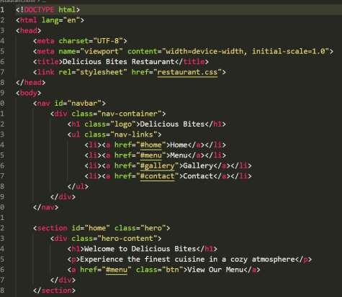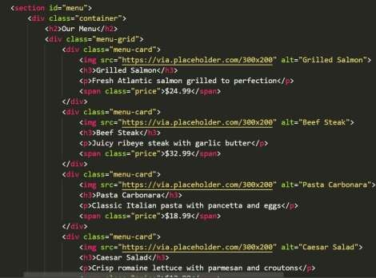
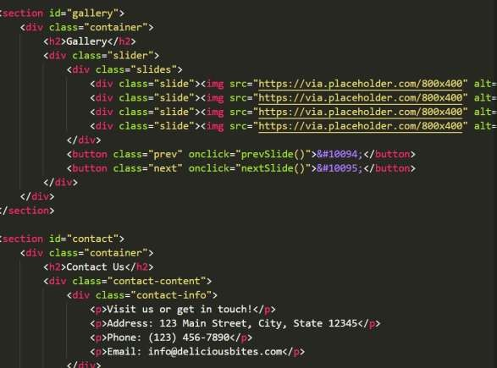

Style.css
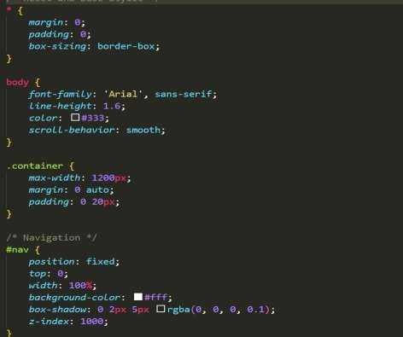
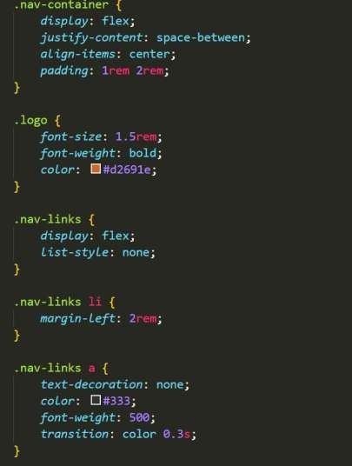
Output:
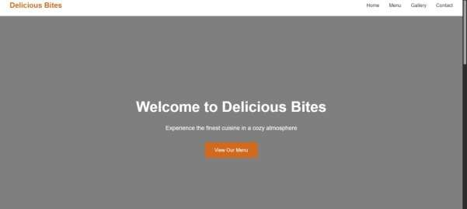
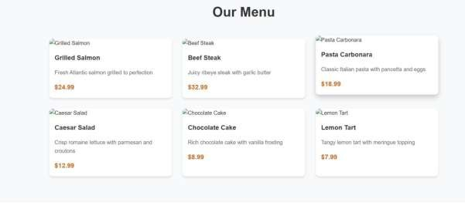
Code Explanation:
The restaurant landing page is designed to present the restaurant’s menu, images, and contact details using HTML, CSS, and JavaScript.

HTML Structure
The HTML file organizes the layout of the page.
- The <nav> element contains navigation links: Home, Menu, Gallery, and Contact.
- The Home section acts as a hero section displaying the restaurant name and tagline.
- The Menu section uses card layouts to display food items including image, name, and price.
- The Gallery section displays restaurant images inside a slider container.

CSS Styling
CSS is used to style the landing page.
- Flexbox or Grid layout is used to arrange menu items in cards.
- Each card includes padding, shadows, and border-radius for a modern design.
- Hover animations highlight menu items when users move the mouse over them.
- Media queries ensure the website is responsive across different screen sizes.

JavaScript Functionality
JavaScript is used to implement the image slider in the gallery section.
- A slider function cycles through images automatically.
- Buttons allow users to navigate between images using next and previous controls.
- Smooth transitions improve the user experience.
This creates a visually attractive restaurant landing page with interactive gallery functionality.

Task 3: AI-Powered Event Registration Form
Scenario
SR University is hosting a technical fest and requires an online registration form with real-time validation to ensure accurate user input.
Tasks
1. Ask Copilot to generate an HTML form with the following fields:
o Name o Email o Phone Number o Department o Event
Selection
- Use AI assistance to style the form using CSS for readability and accessibility.
- Implement JavaScript validation using Copilot: o Email format validation o Phone number length validation o Required field checks
Expected Outcome
- User-friendly and visually appealing form
- Real-time validation messages • Prevention of invalid submissions
Prompt used:
Generate an event registration form using HTML, CSS, and JavaScript.
Form fields: Name, Email, Phone Number, Department, and Event Selection (dropdown).
- Style the form with modern CSS for readability and accessibility.
- Add real-time JavaScript validation:
- Email format validation
- Phone number should be exactly 10 digits
- All fields must be required
- Show validation error messages below the fields.
- Prevent form submission if inputs are invalid.
- Ensure the form layout is responsive and mobile friendly.
AI Generated Code:
Index.html
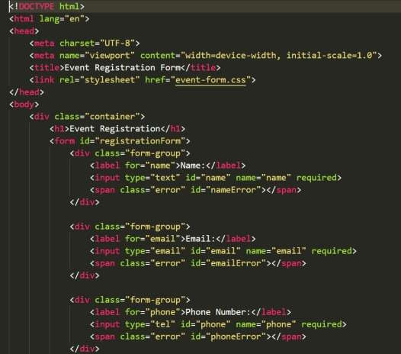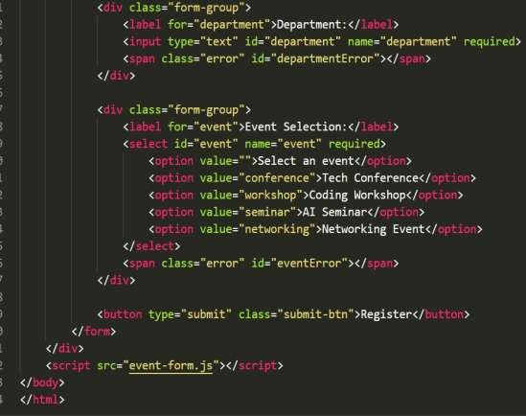

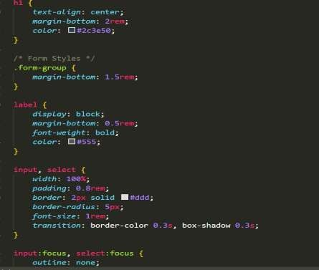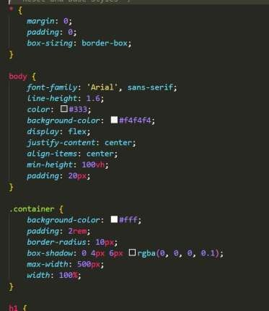

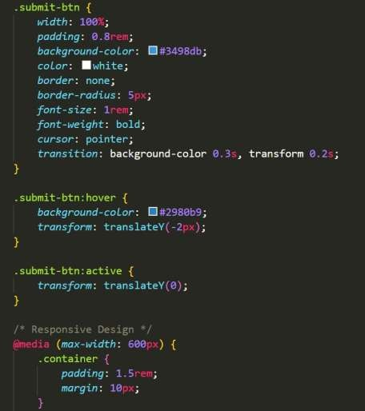
Output:
O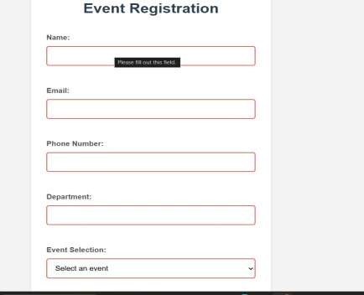 Code explanation:
The event registration form allows users to register for an event while ensuring correct data entry using HTML, CSS, and JavaScript validation.

HTML Structure
The HTML form collects user information.
The form includes the following input fields:
- Name
- Email
- Phone Number
- Department
- Event Selection (Dropdown)
Each field uses <input> or <select> elements and includes labels for accessibility.

CSS Styling
CSS improves the visual appearance of the form.
- The form container is centered on the page with padding and border styling.
- Input fields are styled with consistent spacing, font size, and border design.
- Buttons are styled with hover effects for better user interaction.

JavaScript Validation
JavaScript ensures the user enters valid information.
The validation includes:
- Email validation using pattern matching to confirm a proper email format.
- Phone number validation to ensure exactly 10 digits are entered.
- Required field validation to prevent empty submissions.
If incorrect data is entered, error messages are displayed and the form submission is prevented.
This ensures accurate and valid user registration data.

Task 4: AI-Assisted E-Commerce Product Page
Scenario
A startup is developing a basic e-commerce product page to showcase products and manage simple cart functionality.
Tasks
- Use Copilot to generate a grid-based product catalog using HTML and
CSS.
- Implement an “Add to Cart” feature using JavaScript.
- Modify AI-generated code to include: o Cart item counter at the top-right corner o Visual feedback when a product is added
Expected Outcome
- Functional product catalog
- Working cart counter • Interactive user experience AI Generated Code:
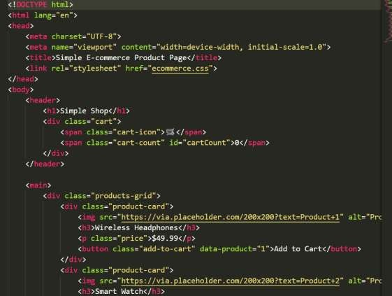
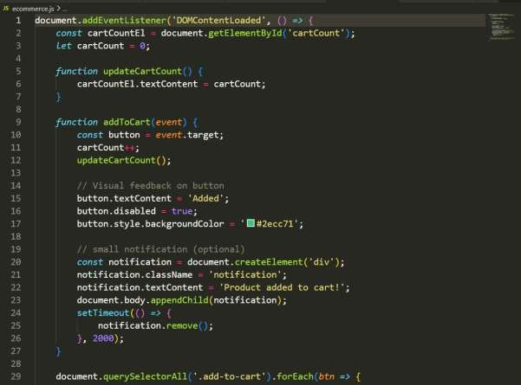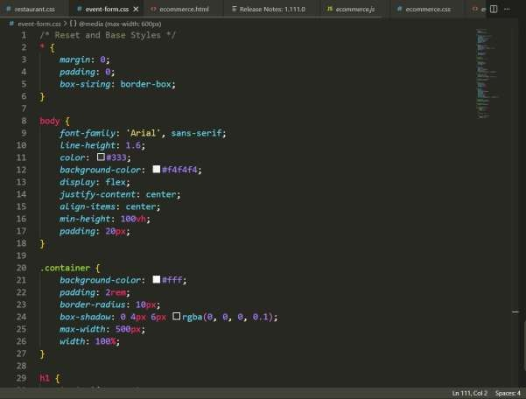

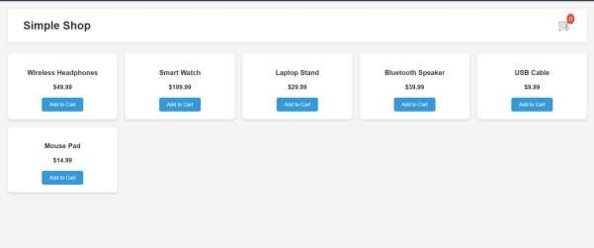
Task 5: Responsive Web Page Layout

Code Explanation
The responsive webpage layout demonstrates the basic structure of a webpage using HTML and CSS.

HTML Structure
The webpage contains three main sections:
- Header o Displays the website title and
navigation links.
- Main Content Area o Contains placeholder text, images, or articles.
- Footer o Displays copyright information or
contact details.
Semantic HTML tags such as <header>, <main>, and <footer> improve readability and accessibility.

CSS Styling
CSS is used to arrange the layout.
- Flexbox or Grid layout organizes content properly across the page.
- The header and footer are styled with background colors and padding.
- The main section contains text and images aligned neatly.

Responsive Design
Media queries are used to make the layout responsive.
- On desktop screens, content is displayed in wider layouts.
- On tablets, elements adjust to medium screen sizes.
- On mobile devices, elements stack vertically for better readability.
This ensures the webpage adapts smoothly to different screen sizes.
AI Generated Code –

