Assignment-15.2
2303A52233
Batch-37

Task Descriptor-1:
(Setup Fast API Backend ) Instructions: • Install Fas tAPI and Uvicorn. • Use AI to generate a basic FastAPI application with one endpoint Sample Code: from fastapi import FastAPI app = FastAPI() @app.get("/") def read_root(): return {"message": "Welcome to AI-powered FastAPI"} Expected Output: Running the server and accessing: http://127.0.0.1:8000/ Response: {"message": "Welcome to AI-powered FastAPI"}
Prompt:-
Generate a simple FastAPI application in Python. Requirements: - Import FastAPI - Create FastAPI app - Create one GET endpoint "/" - The endpoint should return JSON message: {"message": "Welcome to AI-powered FastAPI"} The code should run using uvicorn and be beginner friendly.
Output:-
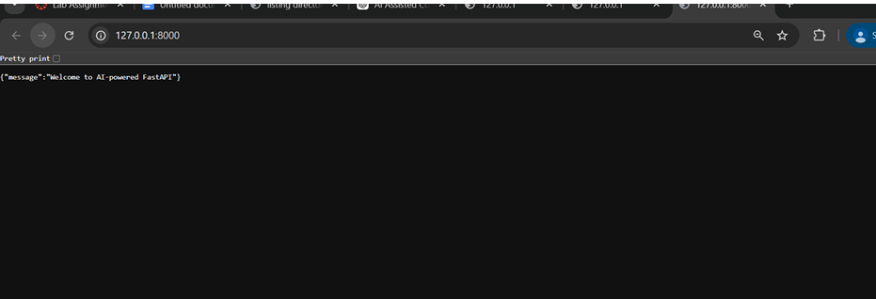

Task Descriptor- 2:
(API – Create and Read Items) Instructions:
• Implement endpoints to add and retrieve products.
• Use a Python list as temporary storage.
Sample Code: items = [] @app.get("/items") def get_items(): return items @app.post("/items") def add_item(item: dict): items.append(item) return {"message": "Item created", "item": item} Expected
Output: GET /items → [] POST /items with {"name":"Pen","price":20} → {"message":"Item created","item":{"name":"Pen","price":20}}
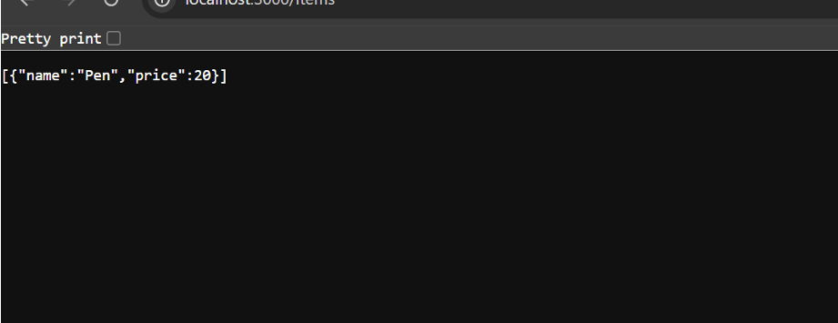
Task Descriptor- 3:
(Update Existing Item) Instructions:
• Use AI to generate an endpoint to update an item using its index. Sample Code: @app.put("/items/{index}") def update_item(index: int, item: dict): if index >= len(items): return {"error": "Item not found"} items[index] = item return {"message": "Item updated", "item": item}
Expected Output: PUT /items/0 with {"name":"Pencil","price":10} → {"message":"Item updated","item":{"name":"Pencil","price":10}}
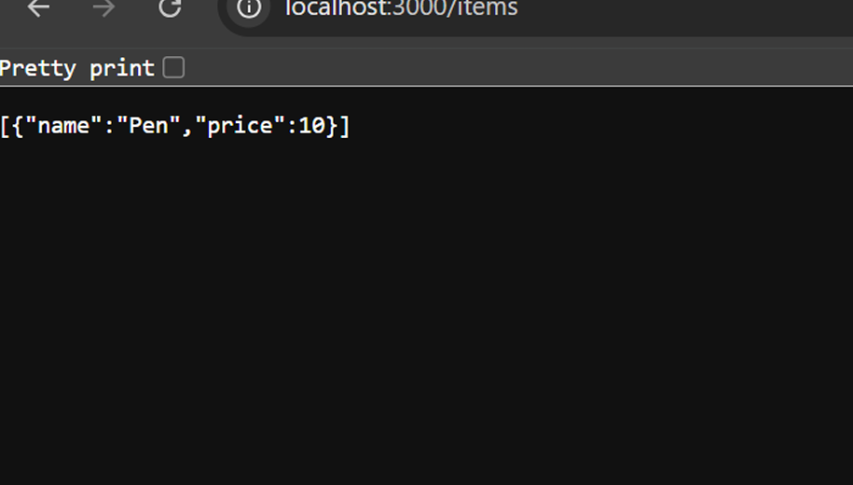
Task Descriptor- 4:
(Delete Item) Instructions:
• Implement deletion of an item by index.
Sample Code: @app.delete("/items/{index}") def delete_item(index: int): if index >= len(items): return {"error": "Item not found"} removed = items.pop(index) return {"message": "Item removed", "item": removed}
Expected Output: DELETE /items/0 → {"message":"Item removed","item":{"name":"Pencil","price":10}}
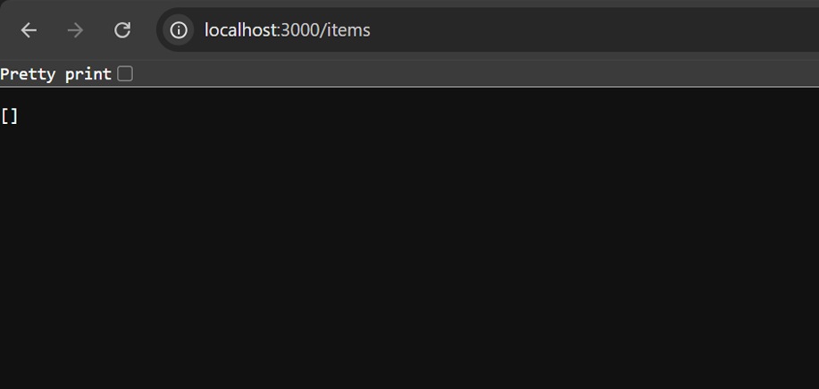
Task Descriptor -5:
(Add Auto-Generated Documentation) Instructions: • Use AI to add inline comments and docstrings for all endpoints. • Optionally, integrate Swagger / Flask-RESTX to auto-generate API documentation. Sample Code: @app.route('/items', methods=['GET']) def get_items(): """ GET /items Returns a list of all items in the store. """ return jsonify(items)
Expected Output: • Clear documentation for all endpoints, e.g., via /docs if using Swagger. • Students should be able to see endpoint description, methods, and sample payloads.
