ASSIGNMENT - 22.3
Ch.Madhavi
2303a52233
Batch-37
Task 1 – Bias Detection in AI Suggestions (Alternative Example)
Example Scenario:
Ask AI to generate a resume shortlisting algorithm multiple times.
• Change prompt wording (e.g., “select best candidate” vs “ensure
diversity”).
• Compare outputs and logic.
Discussion Points:
• Does the AI favor certain qualifications, backgrounds, or
experiences?
• How could biased shortlisting algorithms affect equal
employment opportunities?
Prompt:
Generate a Python algorithm to shortlist candidates for a job based on qualifications, experience, and skills. Then modify the algorithm to ensure diversity and fairness in selection. Provide both versions for comparison.

Code:

candidates = [
{"name": "A", "experience": 5, "degree": "BTech"},
{"name": "B", "experience": 2, "degree": "Diploma"},
{"name": "C", "experience": 4, "degree": "BTech"}
]

# Biased selection
selected = [c for c in candidates if c["degree"] == "BTech"]

print("Biased Selection:", selected)

# Fair selection
fair_selected = [c for c in candidates if c["experience"] >= 3]

print("Fair Selection:", fair_selected)

Output:
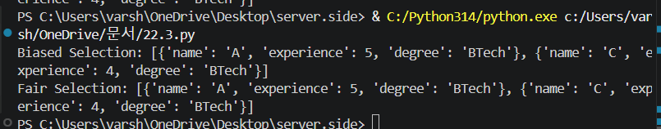

Task 2 – Privacy and Sensitive Data Handling (Alternative
Example)
Example Scenario:
Ask AI to write code for processing student academic records (roll
number, marks, email).
Discussion Points:
• How should student identity data be masked or encrypted?
• What privacy laws (e.g., FERPA, GDPR-like principles) are
relevant?
• What ethical responsibility does the programmer have when
using AI-generated code?

Prompt:Write a Python program to process student records including roll number, marks, and email. Then improve it by masking sensitive data and using basic encryption techniques. Explain privacy considerations.

Code:
import hashlib

student = {
"roll": 101,
"marks": 90,
"email": "student@gmail.com"
}

# Mask email
masked_email = student["email"][:3] + "***@gmail.com"

# Encrypt roll number
encrypted_roll = hashlib.sha256(str(student["roll"]).encode()).hexdigest()

print("Roll:", encrypted_roll)
print("Marks:", student["marks"])
print("Email:", masked_email)

Output:
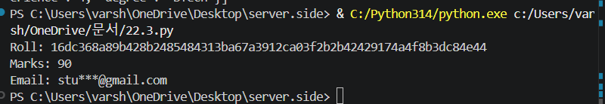

Task 3 – AI-Generated Security Risks (Alternative Example)
Example Scenario:
Use AI to generate a payment processing script for an online shopping
system.
Student Tasks:
• Identify risks such as:
o Plain-text card data storage
o Missing input validation
• Propose ethical coding standards to prevent financial fraud and
Misuse.

Prompt: Generate a Python script for processing online payments. Then identify security risks such as storing card details in plain text and missing input validation. Improve the code with secure practices.

Code:
card_number = input("Enter card number: ")
amount = input("Enter amount: ")

# Mask card number
masked_card = "**** **** **** " + card_number[-4:]

# Validate amount
if not amount.isdigit():
print("❌ Invalid amount")
else:
print("Processing payment with card:", masked_card)

Output:
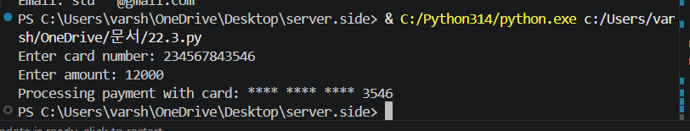
Task 4 – Accountability in Human–AI Collaboration (Alternative
Example)
Scenario:
AI generates code for an autonomous traffic signal control system.
Discussion Questions:
• If a software error causes accidents, who is accountable?
• Should responsibility lie with:
o AI tool developers
o Software engineers
o Government authorities deploying the system?
Students submit a short reflection on accountability.

Prompt: Generate a basic code example for an automated traffic signal control system. Then discuss potential risks and explain who is accountable if failures occur, including developers, AI tools, and authorities.

Code:
import time

traffic = ["RED", "GREEN", "YELLOW"]

for signal in traffic:
print("Signal:", signal)
time.sleep(2)

Output:
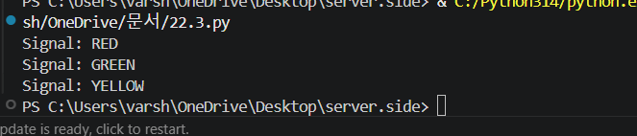

Task 5 – Limitations of AI in Critical Systems (Alternative
Example)
Example Scenario:
Ask AI to generate code for an aircraft maintenance fault detection
system.
Discussion Points:
• Can AI-generated code be trusted without expert validation?
• What human oversight is essential in aviation software?
• How should safety-critical code be reviewed and certified?

Prompt: Generate a simple Python program for detecting faults in an aircraft maintenance system. Then analyze its limitations and explain why human validation and safety checks are required.

Code:
try:
temperature = int(input("Enter engine temperature: "))

if temperature > 100:
print("⚠️ Fault detected!")
else:
print("✅ Normal")

except:
print("❌ Invalid input")

Output:
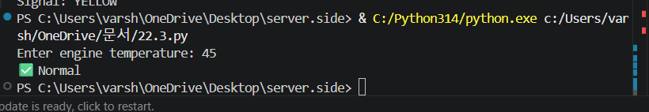

Task 6 – Ethical Use of AI-Generated Code (Alternative Example)
Example Scenario:
Students analyze cases where AI-generated code is used in academic
assignments or startups.
Discussion Points:
• Risks of submitting AI code without understanding it
• Copyright and license violations
Best practices:
o Proper citation
o Manual verification
o Ethical reuse of AI outputs
Note: Report should be submitted as a word document for all tasks in a single
document with prompts, comments & code explanation, and output and if
required, screenshots.

Prompt: Provide examples of using AI-generated code in academic projects or startups. Discuss ethical concerns such as plagiarism, lack of understanding, and copyright issues, and suggest best practices.

Code:
# Written with understanding
def greet(name):
return f"Hello {name}"

print(greet("Student"))

Output:
