Q-1:-Create an XML document which will display the Doctor Information which includes. Doctor_Id, Doctor_Name, Doctor_ContactNo, Doctor_Specialization

<?xml version="1.0" encoding="UTF-8"?>

<?xml-stylesheet type="text/css" href="AS1-Q1.css"?>

<Doctors>

<Doctor>

<Heding1>DoctorId</Heding1>

<Heding2>DoctorName</Heding2>

<Heding3>DoctorContactNo</Heding3>

<Heding4>DoctorSpecialization</Heding4>

</Doctor>

<Doctor>

<DoctorId>1</DoctorId>

<DoctorName>Dr.Vikram Kalra</DoctorName>

<DoctorContactNo>923-456-7890</DoctorContactNo>

<DoctorSpecialization>Cardiology</DoctorSpecialization>

</Doctor>

<Doctor>

<DoctorId>2</DoctorId>

<DoctorName>Dr.Yash Gulati</DoctorName>

<DoctorContactNo>898-765-4321</DoctorContactNo>

<DoctorSpecialization>Neurology</DoctorSpecialization>

</Doctor>

<Doctor>

<DoctorId>3</DoctorId>

<DoctorName>Dr.Sudeep Goyal</DoctorName>

<DoctorContactNo>998-705-4921</DoctorContactNo>

<DoctorSpecialization>Cardiology</DoctorSpecialization>

</Doctor>

<Doctor>

<DoctorId>4</DoctorId>

<DoctorName>Dr.Ajay Kaul</DoctorName>

<DoctorContactNo>998-760-4001</DoctorContactNo>

<DoctorSpecialization>Geneticist</DoctorSpecialization>

</Doctor>

<Doctor>

<DoctorId>5</DoctorId>

<DoctorName>Dr.Rana Patil</DoctorName>

<DoctorContactNo>989-705-2345</DoctorContactNo>

<DoctorSpecialization>Surgeon</DoctorSpecialization>

</Doctor>

<Doctor>

<DoctorId>6</DoctorId>

<DoctorName>Dr.Arun Saroha</DoctorName>

<DoctorContactNo>778-765-8765</DoctorContactNo>

<DoctorSpecialization>Neurologist</DoctorSpecialization>

</Doctor>

<Doctor>

<DoctorId>7</DoctorId>

<DoctorName>Dr.Vivek Vij</DoctorName>

<DoctorContactNo>990-455-4367</DoctorContactNo>

<DoctorSpecialization>Oncologist</DoctorSpecialization>

</Doctor>

<Doctor>

<DoctorId>8</DoctorId>

<DoctorName>Dr.Hitesh Garg</DoctorName>

<DoctorContactNo>790-735-4388</DoctorContactNo>

<DoctorSpecialization>Orthopedist</DoctorSpecialization>

</Doctor>

<Doctor>

<DoctorId>9</DoctorId>

<DoctorName>Dr.Rakesh Mahajan</DoctorName>

<DoctorContactNo>798-786-4323</DoctorContactNo>

<DoctorSpecialization>Osteopath</DoctorSpecialization>

</Doctor>

<Doctor>

<DoctorId>10</DoctorId>

<DoctorName>Dr.Akhil Mishra</DoctorName>

<DoctorContactNo>898-435-4991</DoctorContactNo>

<DoctorSpecialization>Plastic Surgeon</DoctorSpecialization>

</Doctor>

</Doctors>

Doctors

{

margin: 20px;

display:table;

border-collapse:collapse;

}

Doctor

{

display:table-row;

}

Heding1,Heding2,Heding3,Heding4

{

display:table-cell;

padding:10px;

border:2px solid #ccc;

font-weight: bold;

color:#bc49f5;

text-decoration:underline;

}

DoctorId,DoctorName,DoctorContactNo,DoctorSpecialization

{

display:table-cell;

padding:10px;

border:2px solid #ccc;

font-weight: bold;

color:#8e5bf5;

}

OUTPUT :

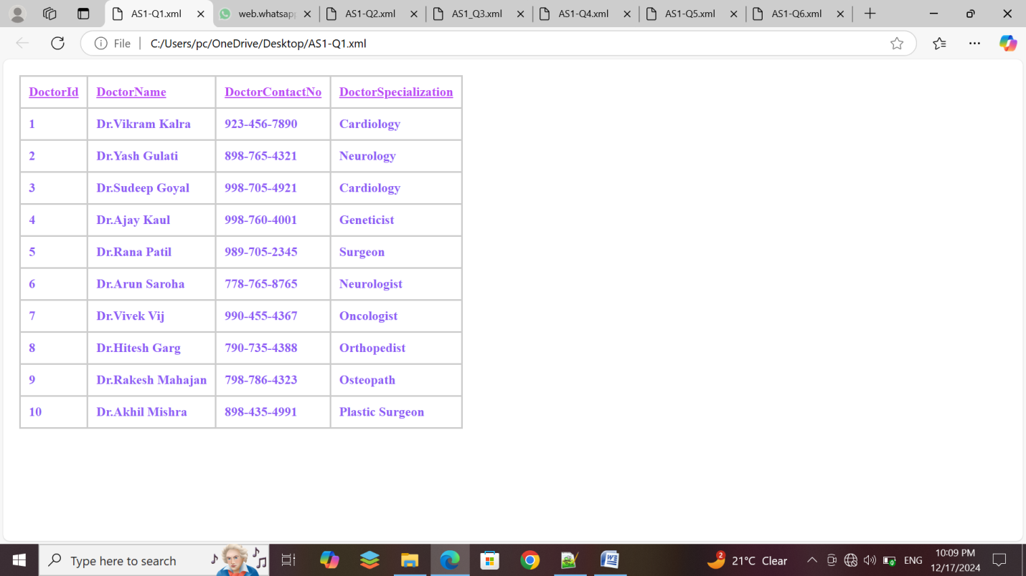

Q-2:-Create an XML document for student where Student where it contains the following data: (Student Name, Personal Info(Address, Birthdate, Gender, Mobile No, Address), Result(Total, Percentage, Grade))

<?xml version="1.0" encoding="UTF-8"?>

<?xml-stylesheet type="text/css" href="AS1-Q2.css"?>

<Students>

<Heding>STUDENTS INFORMATION</Heding>

<Student>

<StudentName>StudentName:-Ronak</StudentName>

<PersonalInfo>

<Address>Address:-123,vinayak nagar,surat</Address>

<Birthdate>Birthdate:-23-05-2001</Birthdate>

<Gender>Gender:-Male</Gender>

<MobileNo>MobileNo:-783-456-7822</MobileNo>

</PersonalInfo>

<result>

<Total>Total:-408</Total>

<Percentage>Percentage:-81</Percentage>

<Grade>Grade:-B</Grade>

</result>

</Student>

<Student>

<StudentName>StudentName:-Mahek</StudentName>

<PersonalInfo>

<Address>Address:-134,prasant soc v-2 palanpur jakatnaka,surat</Address>

<Birthdate>Birthdate:-09-04-2002</Birthdate>

<Gender>Gender:-Female</Gender>

<MobileNo>MobileNo:-883-486-7892</MobileNo>

</PersonalInfo>

<result>

<Total>Total:-450</Total>

<Percentage>Percentage:-90</Percentage>

<Grade>Grade:-A</Grade>

</result>

</Student>

<Student>

<StudentName>StudentName:-Dharmesh</StudentName>

<PersonalInfo>

<Address>Address:-23,santukram soc,surat</Address>

<Birthdate>Birthdate:-03-05-2003</Birthdate>

<Gender>Gender:-Male</Gender>

<MobileNo>MobileNo:-887-422-6750</MobileNo>

</PersonalInfo>

<result>

<Total>Total:-399</Total>

<Percentage>Percentage:-79</Percentage>

<Grade>Grade:-C</Grade>

</result>

</Student>

<Student>

<StudentName>StudentName:-Arjun</StudentName>

<PersonalInfo>

<Address>Address:-18,olpad,surat</Address>

<Birthdate>Birthdate:-03-05-2001</Birthdate>

<Gender>Gender:-Male</Gender>

<MobileNo>MobileNo:-994-466-7436</MobileNo>

</PersonalInfo>

<result>

<Total>Total:-422</Total>

<Percentage>Percentage:-84</Percentage>

<Grade>Grade:-B</Grade>

</result>

</Student>

<Student>

<StudentName>StudentName:-Arun</StudentName>

<PersonalInfo>

<Address>Address:-29, parbhudarshan soc ,kenal rod,surat</Address>

<Birthdate>Birthdate:-02-08-2009</Birthdate>

<Gender>Gender:-Male</Gender>

<MobileNo>MobileNo:-844-406-7556</MobileNo>

</PersonalInfo>

<result>

<Total>Total:-355</Total>

<Percentage>Percentage:-71</Percentage>

<Grade>Grade:-C</Grade>

</result>

</Student>

<Student>

<StudentName>StudentName:-Nell</StudentName>

<PersonalInfo>

<Address>Address:-11,darsan soc,rander rod,surat</Address>

<Birthdate>Birthdate:-22-02-2013</Birthdate>

<Gender>Gender:-Male</Gender>

<MobileNo>MobileNo:-889-887-5400</MobileNo>

</PersonalInfo>

<result>

<Total>Total:-433</Total>

<Percentage>Percentage:-86</Percentage>

<Grade>Grade:-B</Grade>

</result>

</Student>

<Student>

<StudentName>StudentName:-Piya</StudentName>

<PersonalInfo>

<Address>Address:-08,l.p.savani rod,surat</Address>

<Birthdate>Birthdate:-29-09-2019</Birthdate>

<Gender>Gender:-Female</Gender>

<MobileNo>MobileNo:-922-496-7086</MobileNo>

</PersonalInfo>

<result>

<Total>Total:-477</Total>

<Percentage>Percentage:-95</Percentage>

<Grade>Grade:-A</Grade>

</result>

</Student>

<Student>

<StudentName>StudentName:-Anjali</StudentName>

<PersonalInfo>

<Address>Address:-133,sumanlipi aep,navsari</Address>

<Birthdate>Birthdate:-2003-02-16</Birthdate>

<Gender>Gender:-Female</Gender>

<MobileNo>MobileNo:-894-546-7286</MobileNo>

</PersonalInfo>

<result>

<Total>Total:-369</Total>

<Percentage>Percentage:-73</Percentage>

<Grade>Grade:-C</Grade>

</result>

</Student>

<Student>

<StudentName>StudentName:-Sita</StudentName>

<PersonalInfo>

<Address>Address:-12,sumanjyot aep,valsad</Address>

<Birthdate>Birthdate:-17-05-2014</Birthdate>

<Gender>Gender:-Female</Gender>

<MobileNo>MobileNo:-988-443-7226</MobileNo>

</PersonalInfo>

<result>

<Total>Total:-445</Total>

<Percentage>Percentage:-89</Percentage>

<Grade>Grade:-B</Grade>

</result>

</Student>

<Student>

<StudentName>StudentName:-Jatin</StudentName>

<PersonalInfo>

<Address>Address:-20,ramnagar,surat</Address>

<Birthdate>Birthdate:-27-04-2011</Birthdate>

<Gender>Gender:-Male</Gender>

<MobileNo>MobileNo:-884-436-0224</MobileNo>

</PersonalInfo>

<result>

<Total>Total:-390</Total>

<Percentage>Percentage:-78</Percentage>

<Grade>Grade:-C</Grade>

</result>

</Student>

</Students>

Heding

{

margin:0 auto;

display:table;

border-collapse:collapse;

width:100%;

color:#595c10;

font-size : 40px;

background-color :#b5d194;

text-align:center;

}

Student {

display: block;

margin-bottom: 20px;

padding: 20px;

border: 1px solid #ccc;

border-radius: 10px;

box-shadow: 0 0 10px rgba(0, 0, 0, 0.1);

display:table;

border-collapse:collapse;

display:block;

background-color:#aed0b0;

}

StudentName,Address,Birthdate,Gender,MobileNo,Grade,Percentage,Total

{

font-weight: bold;

font-size: 24px;

margin-bottom: 10px;

border-collapse:collapse;

display:block;

background-color:#dcf5de;

}

OUTPUT :

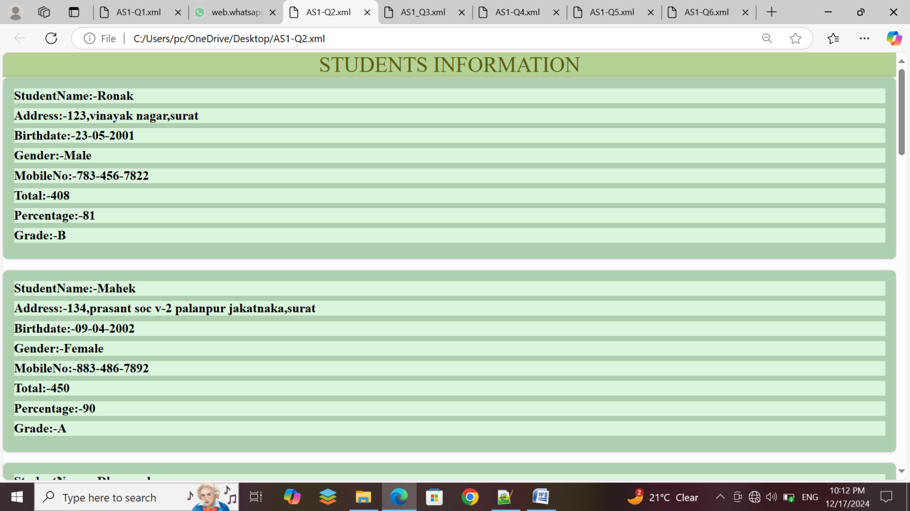

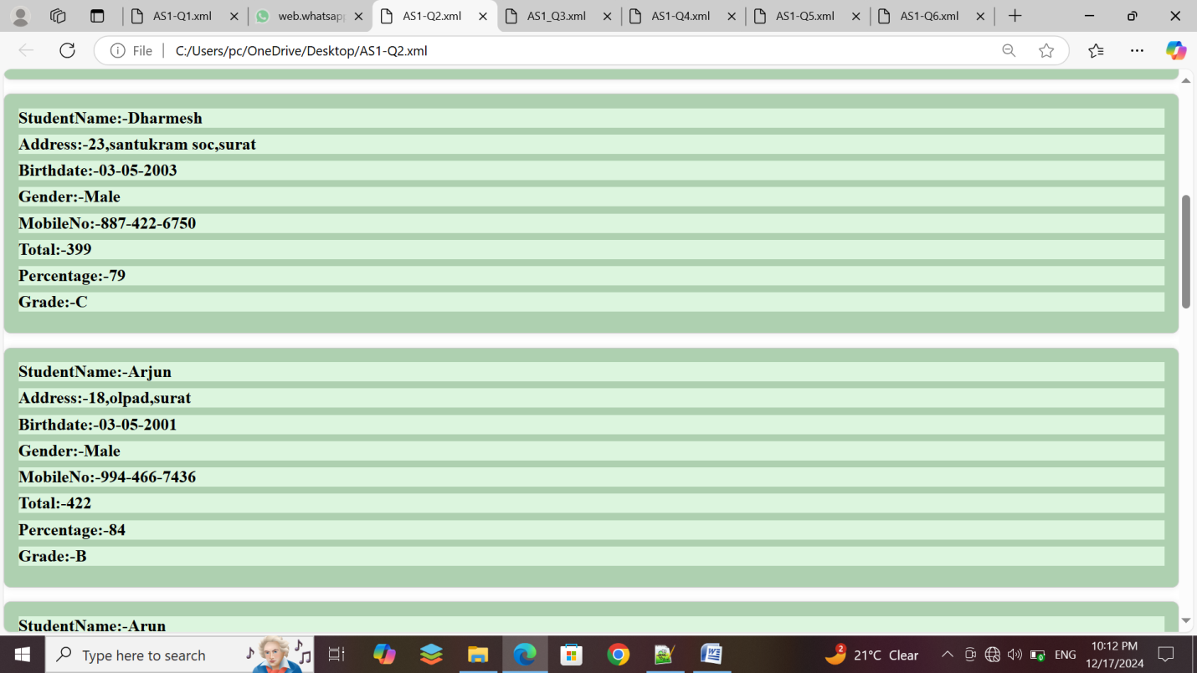

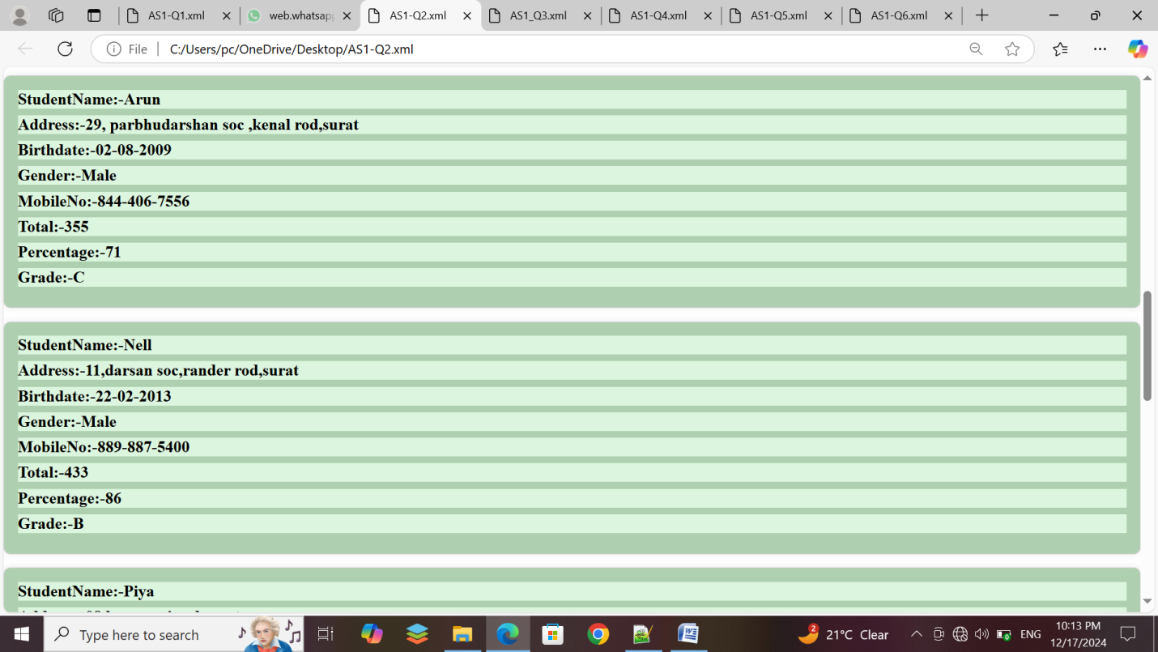

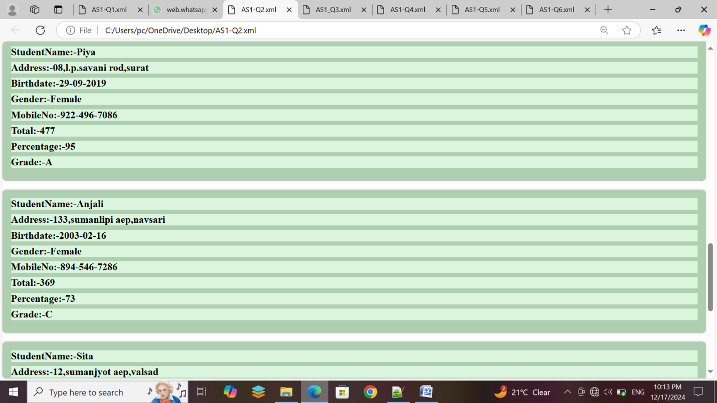

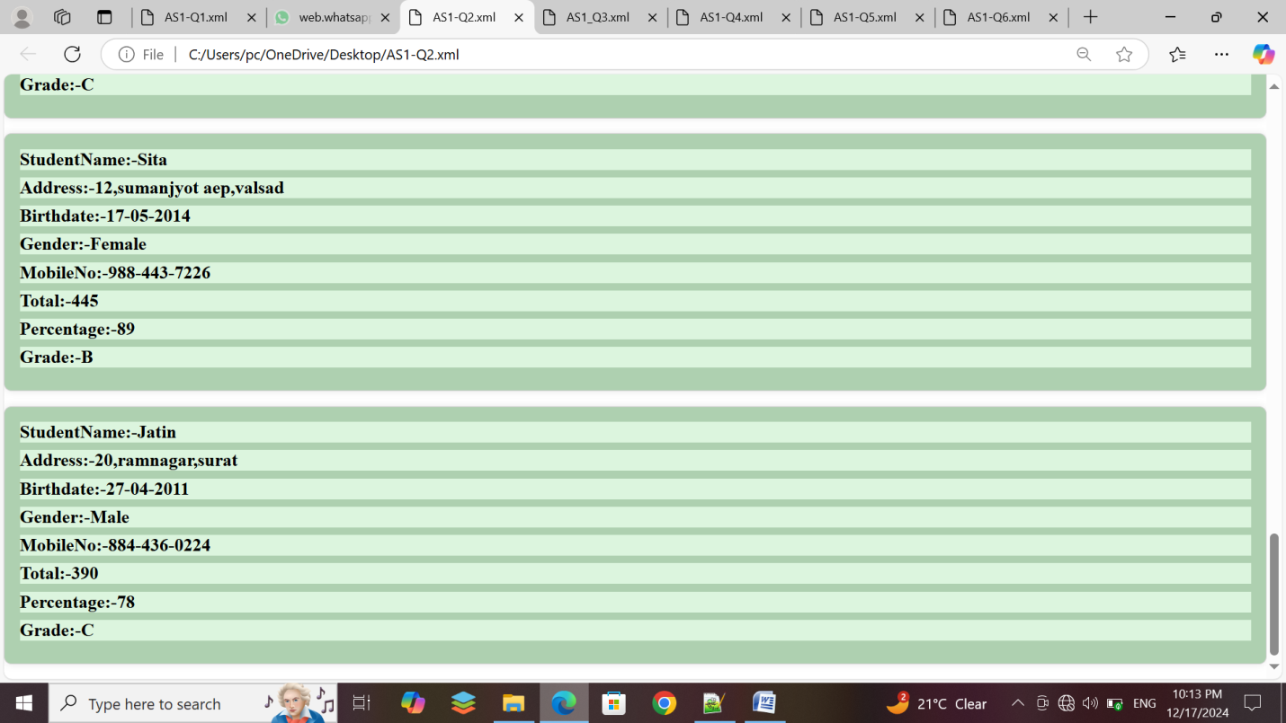

Q-3:-Create an XML document for OrderDetail where it contains the following data: Order_Detail(Order_Number, Order_date,Order_Amount,Ite,_Price, Item_Name,Quantity)

<?xml version="1.0" encoding="UTF-8"?>

<?xml-stylesheet type="text/css" href="AS1_Q3.css"?>

<OrderDetails>

<OrderDetail>

<Heding1>OrderNumber</Heding1>

<Heding2>OrderDate</Heding2>

<Heding3>OrderAmount</Heding3>

<Heding4>Item_ID</Heding4>

<Heding5>Item_Price</Heding5>

<Heding6>Item_Name</Heding6>

<Heding7>Quantity</Heding7>

</OrderDetail>

<OrderDetail>

<OrderNumber>101</OrderNumber>

<OrderDate>2022-01-01</OrderDate>

<OrderAmount>150.00</OrderAmount>

<Item_ID>1</Item_ID>

<Item_Price>1.500</Item_Price>

<Item_Name>Milk</Item_Name>

<Quantity>2</Quantity>

</OrderDetail>

<OrderDetail>

<OrderNumber>102</OrderNumber>

<OrderDate>2022-01-15</OrderDate>

<OrderAmount>200.00</OrderAmount>

<Item_ID>2</Item_ID>

<Item_Price>2.200</Item_Price>

<Item_Name>Eggs</Item_Name>

<Quantity>1</Quantity>

</OrderDetail>

<OrderDetail>

<OrderNumber>103</OrderNumber>

<OrderDate>2022-02-01</OrderDate>

<OrderAmount>300.00</OrderAmount>

<Item_ID>3</Item_ID>

<Item_Price>0.200</Item_Price>

<Item_Name>Chips</Item_Name>

<Quantity>5</Quantity>

</OrderDetail>

<OrderDetail>

<OrderNumber>104</OrderNumber>

<OrderDate>2022-03-01</OrderDate>

<OrderAmount>400.00</OrderAmount>

<Item_ID>4</Item_ID>

<Item_Price>100.000</Item_Price>

<Item_Name>Mobile</Item_Name>

<Quantity>1</Quantity>

</OrderDetail>

<OrderDetail>

<OrderNumber>105</OrderNumber>

<OrderDate>2022-04-01</OrderDate>

<OrderAmount>500.00</OrderAmount>

<Item_ID>5</Item_ID>

<Item_Price>785.50</Item_Price>

<Item_Name>Graphic Card</Item_Name>

<Quantity>15</Quantity>

</OrderDetail>

</OrderDetails>

OrderDetails

{

margin: 20px;

display:table;

border-collapse:collapse;

}

OrderDetail

{

display:table-row;

background-color:#9ae5e5;

}

Heding1,Heding2,Heding3,Heding4,Heding5,Heding6,Heding7

{

color:#210db8;

display:table-cell;

padding:10px;

border:2px solid #ccc;

font-weight: bold;

font-style: italic;

}

OrderNumber,OrderDate,OrderAmount,Item_ID,Item_Price,Item_Name,Quantity

{

color:#053a5c;

display:table-cell;

padding:10px;

border:2px solid #ccc;

font-weight: bold;

font-style:italic;

}

OUTPUT :

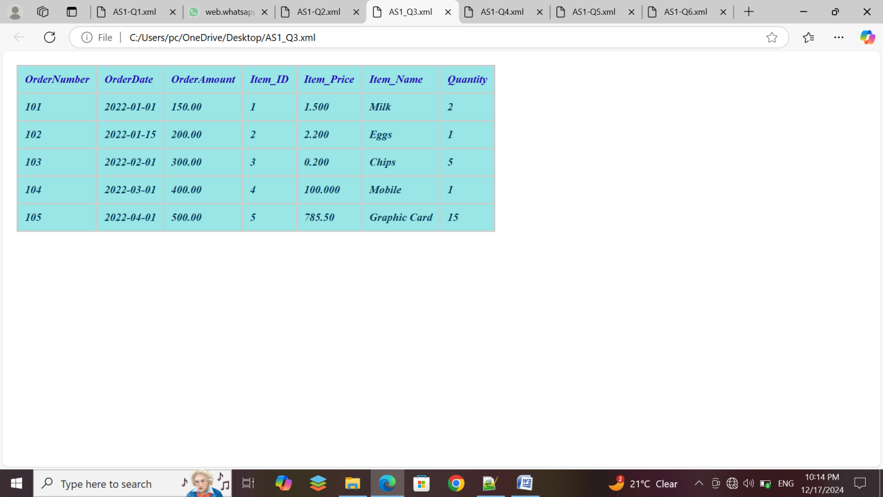

Q-4:-Create an XML document Books where its contain the following data: Books(book(title) as an attribute, author, year, publisher)

<?xml version="1.0" encoding="UTF-8"?>

<?xml-stylesheet type="text/css" href="AS1-Q4.css"?>

<Books>

<Heding>Welcome To Bookstore</Heding>

<book>

<title>Book1:-Harry Potter</title>

<author>Author:-J.K.Rowling</author>

<year>Year:-2020</year>

<publisher>Publisher:-Bloomsbury</publisher>

</book>

<book>

<title>Book2:-Engineering Chemistry</title>

<author>Author:-Manisha Agrawal</author>

<year>Year:-2019</year>

<publisher>Publisher:-Khanna</publisher>

</book>

<book>

<title>Book3:-A Text Book of Engg.Chemistry</title>

<author>Author:-Shashi chawala</author>

<year>Year:-2018</year>

<publisher>Publisher:-Dhanpat rai</publisher>

</book>

<book>

<title>Book4:-Essentials of Physic Chemistry</title>

<author>Author:-BahlTuli </author>

<year>Year:-2017</year>

<publisher>Publisher:-S.chand</publisher>

</book>

<book>

<title>Book5:-Applied Chemistry</title>

<author>Author:-Sunita rattan</author>

<year>Year:-2016</year>

<publisher>Publisher:-Kataria</publisher>

</book>

<book>

<title>Book6:-Engineering Chemistry</title>

<author>Author:-D.Grourkrishana</author>

<year>Year:-2015</year>

<publisher>Publisher:-Vikas</publisher>

</book>

<book>

<title>Book7:-Laboratory manual Engg.</title>

<author>Author:-Anupama rajput</author>

<year>Year:-2014</year>

<publisher>Publisher:-Dhanpat rai</publisher>

</book>

<book>

<title>Book8:-Highway materials and pavement</title>

<author>Author:-Khanna justo</author>

<year>Year:-2013</year>

<publisher>Publisher:-Nemchand bros</publisher>

</book>

<book>

<title>Book9:-database</title>

<author>Author:-patel</author>

<year>Year:-2012</year>

<publisher>Publisher:-Techbooks</publisher>

</book>

<book>

<title>Book10:-Physic</title>

<author>Author:-chan</author>

<year>Year:-2011</year>

<publisher>Publisher:-Techbooks</publisher>

</book>

</Books>

Books

{

color: black;

background-color :pink;

width: 100%;

}

Heding

{

margin:0 auto;

display:table;

border-collapse:collapse;

width:100%;

color:green;

font-size :40px;

background-color:powderblue;

text-align:center;

}

heding, title, author, publisher,year

{

display : block;

font-weight:bold;

}

title

{

font-size : 25px;

font-weight : bold;

}

publisher

{

border-bottom: 2px solid black;

}

OUTPUT :

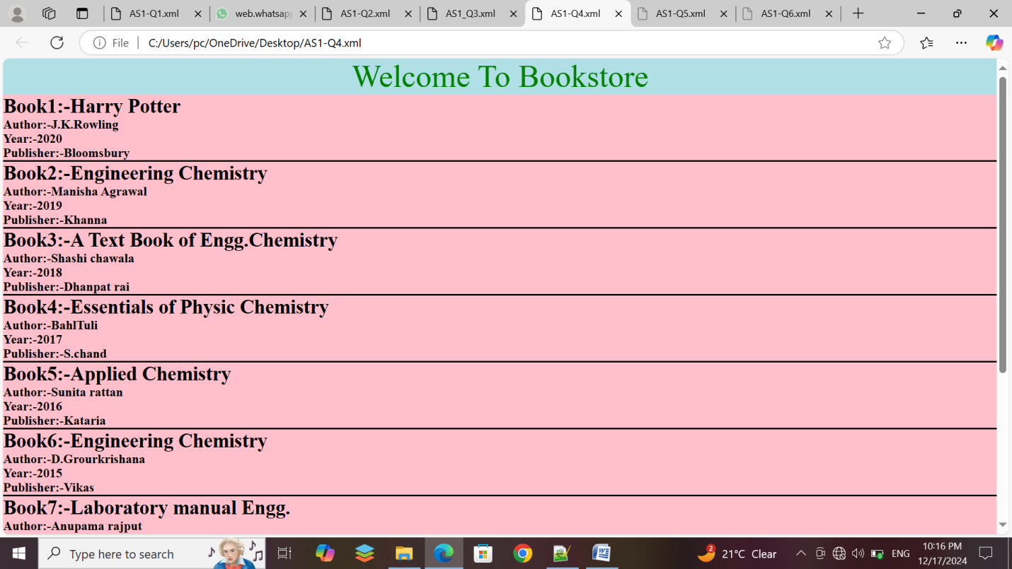

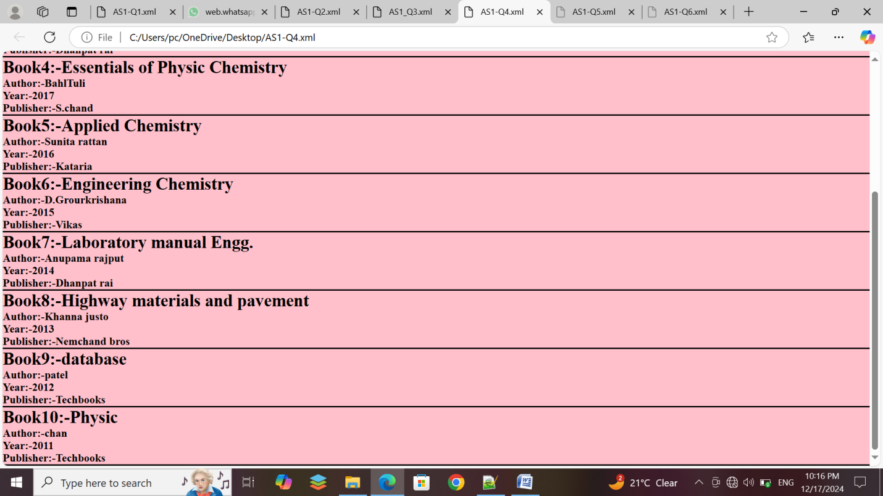

Q-5:-Create an XML document for Result where it contains the following data: Result(Roll_no, Name, Marks, Rank)

<?xml version="1.0" encoding="UTF-8"?>

<?xml-stylesheet type="text/css" href="AS1-Q5.css"?>

<Result>

<Heding>Document For Student Result</Heding>

<Student>

<RollNo>ROLLNO:-101</RollNo>

<Name>NAME:-Patel Yashvi </Name>

<Marks>MARKS:-81</Marks>

<Rank>RANK:-2</Rank>

</Student>

<Student>

<RollNo>ROLLNO:-102</RollNo>

<Name>NAME:-Gangani Ronak</Name>

<Marks>MARKS:-90</Marks>

<Rank>RANK:-1</Rank>

</Student>

<Student>

<RollNo>ROLLNO:-103</RollNo>

<Name>NAME:-Patil Neel</Name>

<Marks>MARKS:-79</Marks>

<Rank>RANK:-3</Rank>

</Student>

<Student>

<RollNo>ROLLNO:-104</RollNo>

<Name>NAME:-Manani Mital</Name>

<Marks>MARKS:-50</Marks>

<Rank>RANK:-4</Rank>

</Student>

<Student>

<RollNo>ROLLNO:-105</RollNo>

<Name>NAME:-Yadav Pooja</Name>

<Marks>MARKS:-36</Marks>

<Rank>RANK:-7</Rank>

</Student>

</Result>

Heding

{

margin:0 auto;

display:table;

border-collapse:collapse;

width:80%;

color:#3377ff;

font-size : 40px;

background-color :#ffe6ff;

text-align:center;

}

Result

{

display: block;

margin: 20px auto;

padding: 20px;

border: 2px solid #ccc;

border-radius: 10px;

box-shadow: 0 0 10px rgba(0, 0, 0, 0.1);

background-color :gray;

}

Student

{

display: block;

margin-bottom: 10px;

padding: 10px;

border-bottom: 2px solid #ccc;

}

RollNo

{

font-weight: bold;

margin-right: 10px;

font-style: italic;

display: block;

color:#ffff00;

}

Name

{

font-weight: bold;

font-style: italic;

display: block;

color:#ffff00;

}

Marks

{

font-weight: bold;

font-style: italic;

display: block;

color:#ffff00;

}

Rank

{

font-weight: bold;

font-style: italic;

display: block;

color:#ffff00;

}

OUTPUT :

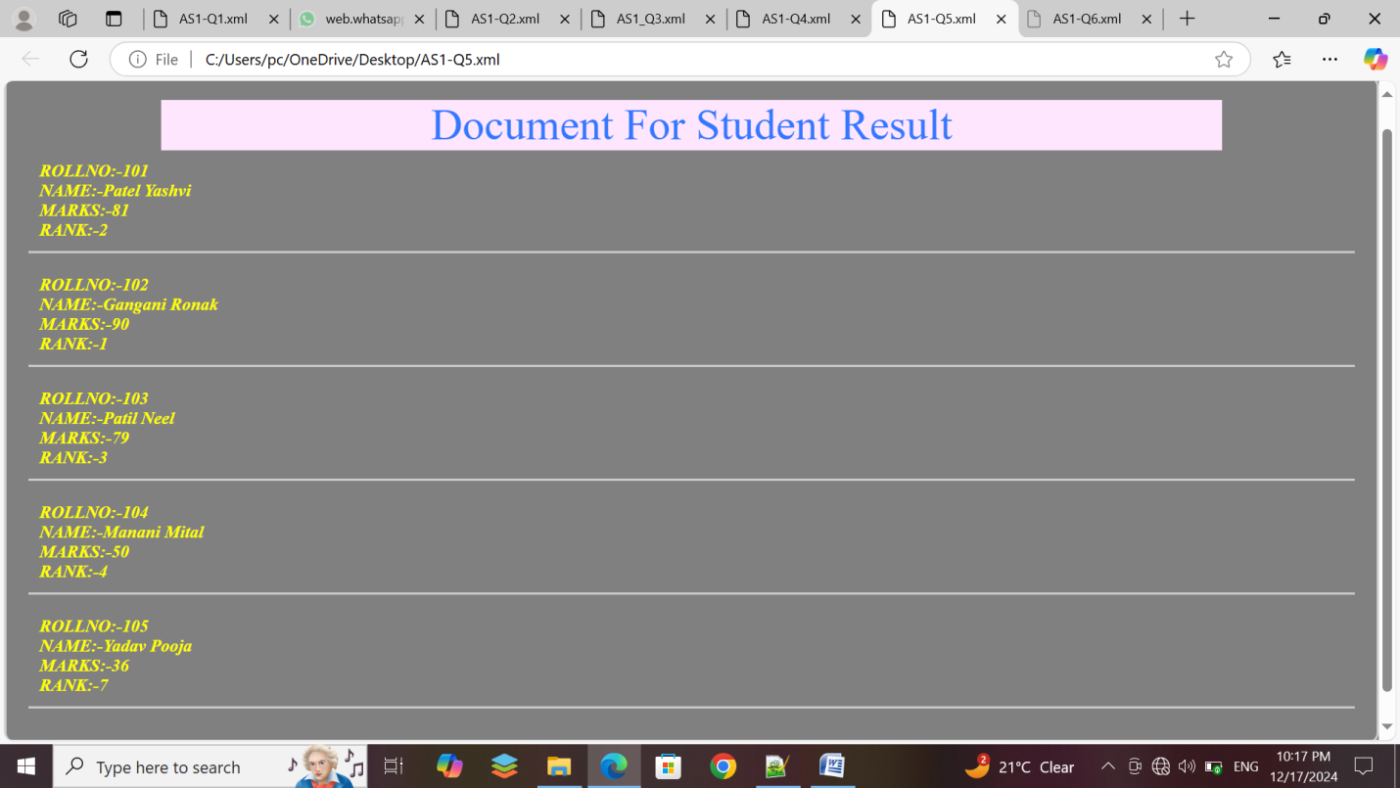

Q-6:-Create an XML document for Employee Student where it contains the following data: Employee (Emp_no, name, Department, Manager Name, Project Assign(Proj_1, Proj_2,Proj_3), Designation)

<?xml version="1.0" encoding="UTF-8"?>

<?xml-stylesheet type="text/css" href="AS1-Q6.css"?>

<Employees>

<Heding>EMPLOYEE DETAILS</Heding>

<EmployeeDetails>

<EmpNo>EMP_NO:-101</EmpNo>

<Name>EMP_NAME:-MAHEK</Name>

<Department>DEPARTMENT:-IT</Department>

<ManagerName>MANAGER_NAME:-Rakesh </ManagerName>

<ProjectAssign>

<Project>PROJECTASSIGN:-Proj 1</Project>

<Project>PROJECTASSIGN:-Proj 2</Project>

<Project>PROJECTASSIGN:-Proj 3</Project>

</ProjectAssign>

<Designation>DESIGNATION:-Software Engineer</Designation>

</EmployeeDetails>

<EmployeeDetails>

<EmpNo>EMP_NO:-102</EmpNo>

<Name>EMP_NAME:-Ganesh M</Name>

<Department>DEPARTMENT:-HR</Department>

<ManagerName>MANAGER_NAME:-Rohit </ManagerName>

<ProjectAssign>

<Project>PROJECTASSIGN:-Proj 4</Project>

<Project>PROJECTASSIGN:-Proj 5</Project>

<Project>PROJECTASSIGN:-Proj 6</Project>

</ProjectAssign>

<Designation>DESIGNATION:-HR Manager</Designation>

</EmployeeDetails>

<EmployeeDetails>

<EmpNo>EMP_NO:-103</EmpNo>

<Name>EMP_NAME:-Deepak </Name>

<Department>DEPARTMENT:-IT</Department>

<ManagerName>MANAGER_NAME:-Vivek </ManagerName>

<ProjectAssign>

<Project>PROJECTASSIGN:-Proj 7</Project>

<Project>PROJECTASSIGN:-Proj 8</Project>

<Project>PROJECTASSIGN:-Proj 9</Project>

</ProjectAssign>

<Designation>DESIGNATION:-Hardware Engineer</Designation>

</EmployeeDetails>

<EmployeeDetails>

<EmpNo>EMP_NO:-104</EmpNo>

<Name>EMP_NAME:-Rina</Name>

<Department>DEPARTMENT:-IT</Department>

<ManagerName>MANAGER_NAME:-Arun </ManagerName>

<ProjectAssign>

<Project>PROJECTASSIGN:-Proj 10</Project>

<Project>PROJECTASSIGN:-Proj 11</Project>

<Project>PROJECTASSIGN:-Proj 12</Project>

</ProjectAssign>

<Designation>DESIGNATION:-Software Engineer</Designation>

</EmployeeDetails>

<EmployeeDetails>

<EmpNo>EMP_NO:-105</EmpNo>

<Name>EMP_NAME:-Ajay</Name>

<Department>DEPARTMENT:-HR</Department>

<ManagerName>MANAGER_NAME:-Ram</ManagerName>

<ProjectAssign>

<Project>PROJECTASSIGN:-Proj 13</Project>

<Project>PROJECTASSIGN:-Proj 14</Project>

<Project>PROJECTASSIGN:-Proj 15</Project>

</ProjectAssign>

<Designation>DESIGNATION:-HR Manager</Designation>

</EmployeeDetails>

</Employees>

Heding

{

margin:0 auto;

display:table;

border-collapse:collapse;

width:100%;

color:#5491ab;

font-size : 40px;

background-color :#bee3f4;

text-align:center;

}

Employees

{

font-family:verdana;

font-size:80%;

margin:0.5sem;

display:block;

background-color:#cbe0f7;

}

EmployeeDetails

{

margin:0.5sem;

padding:0.5sem;

display:block;

border:1px solid silver;

background-color:#cbe0f7;

}

EmpNo, Name, Department, ManagerName, Project, Designation

{

display:block;

text-align:center;

}

EmpNo

{

color:green;

text-decoration:underline;

font-weight:bold;

font-size:20px;

}

Name

{

color:#f013cf;

font-weight:bold;

}

Department

{

color:blue;

font-weight:bold;

}

ManagerName

{

color:#30664f;

font-weight:bold;

}

Project

{

color:red;

font-weight:bold;

}

Designation

{

color:#cc00ff;

font-weight:bold;

}

OUTPUT :

