create database company2_db;
use company2_db;
create table employees1(emp_id int,emp_name varchar(20),salary int,dep_id int,
hiring_date date,location varchar(20));
create table department1(dep_id int,dep_name varchar(20));
insert into employees1 values(101,"Reshma",25000,3,"2024-06-15","Bangalore"),
(102,"Mohit",40000,6,"2026-02-15","Pune"),
(103,"Sagar",25000,3,"2020-07-13","Solapur"),
(104,"John",150000,5,"2019-04-03","Dhule"),
(105,"Devid",220000,1,"2015-10-10","Mumbai"),
(106,"Viraj",35000,2,"2026-01-01","Satara"),
(107,"Kartik",35000,2,"2026-04-01","Nashik"),
(108,"Ritesh",80000,4,"2022-06-08","Hyderabad"),
(109,"Meghraj",70000,6,"2024-09-11","Sangli"),
(110,"Rohan",30000,3,"2025-07-07","Kolhapur"),
(111,"Radhika",75000,4,"2021-04-01","Nagar"),
(112,"Pooja",65000,5,"2025-12-02","Delhi"),
(113,"Rishi",15000,6,"2023-02-02","Lucknow"),
(114,"Yash",55000,2,"2019-11-02","Varanasi"),
(115,"Rjesh",110000,1,"2020-08-19","Goa");
insert into department1 values(1,"Manager"),
(2,"HR"),(3,"Accountant"),(4,"Sales"),(5,"IT"),(6,"Administration");
#-- window function --

#-- ROW_NUMBER—
select emp_name,salary,ROW_NUMBER() OVER (ORDER BY salary desc) AS rn from employees1;

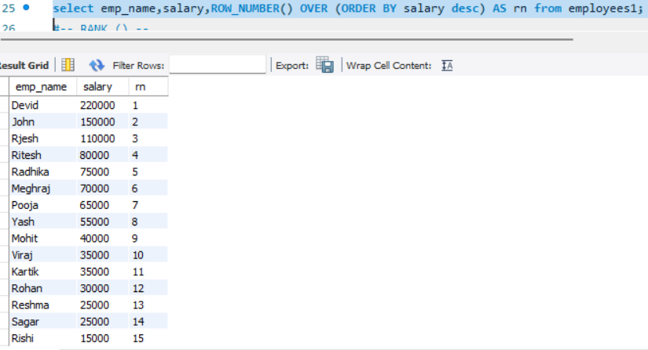

#-- RANK () --
select emp_name,salary,RANK() OVER (ORDER BY salary desc) AS rnk from employees1;
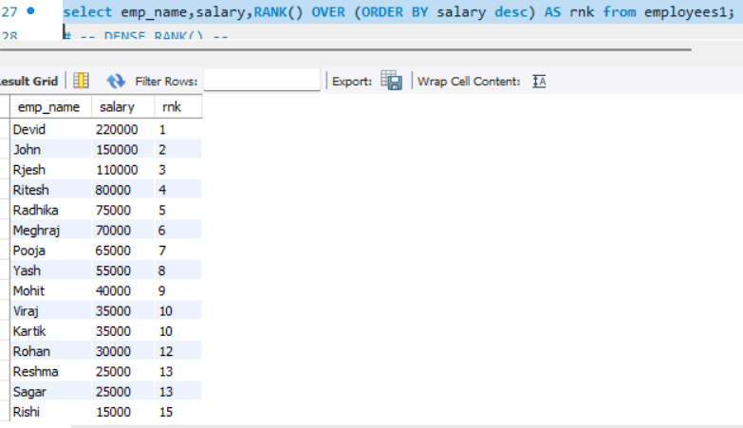

# -- DENSE_RANK() --
select emp_name,salary, DENSE_RANK() OVER(ORDER BY salary desc) AS drnk from employees1;
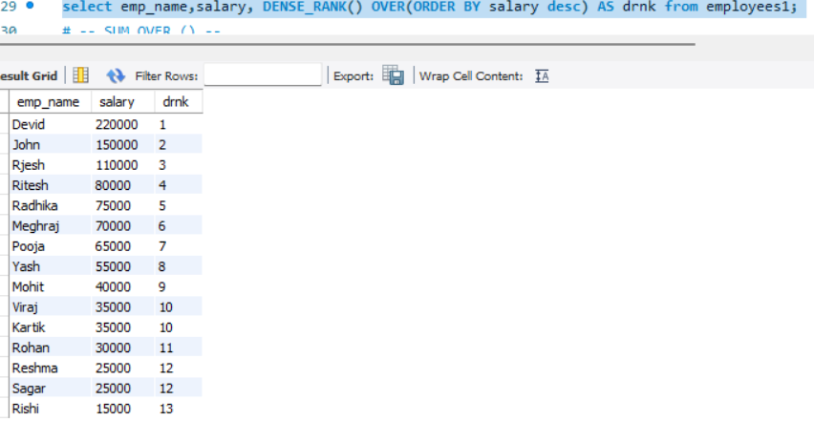
# -- SUM OVER () --
select salary,SUM(salary) OVER(ORDER BY emp_id) AS running_total from employees1;
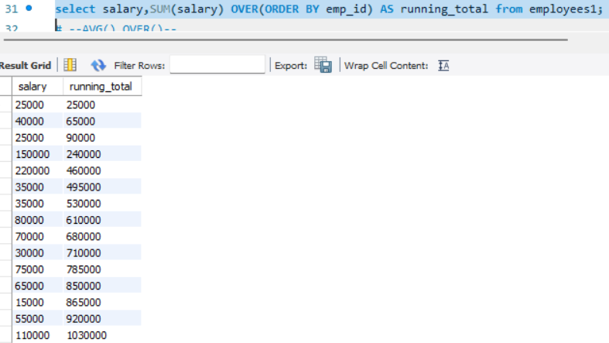

# --AVG() OVER()--
select emp_name,salary,AVG(salary) OVER() AS avg_salary from employees1;
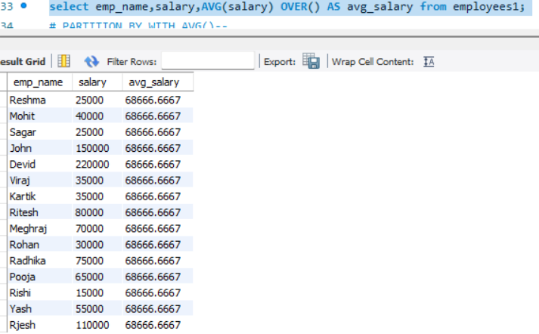
# PARTITION BY WITH AVG()--
select emp_name,dep_id,salary,AVG(salary) OVER(PARTITION BY dep_id) AS did_avg from employees1;
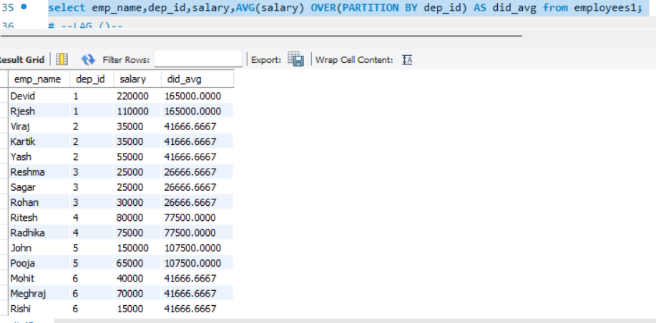

# --LAG ()--
select emp_name,salary,LAG(salary) OVER (ORDER BY salary) AS previous_salary from employees1;
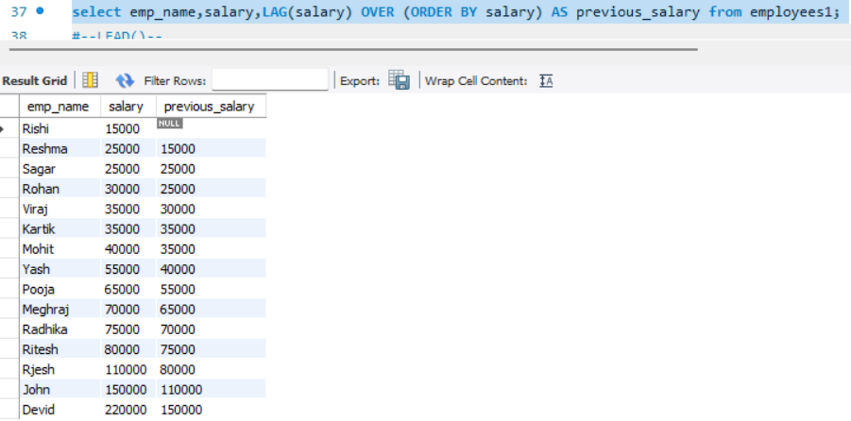
#--LEAD()--
select emp_name,LEAD(salary) OVER(ORDER BY salary) AS next_salary from employees1;
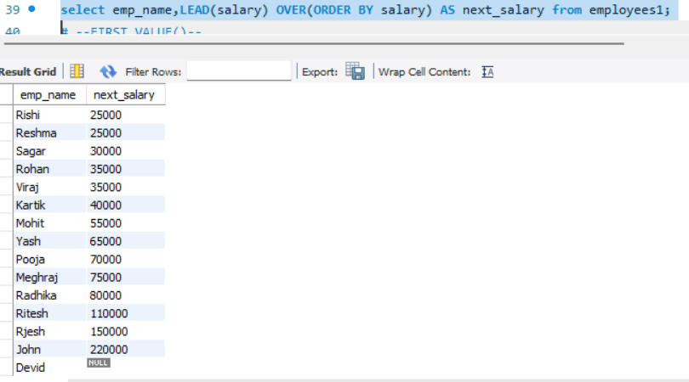

# --FIRST VALUE()--
select emp_name,salary,FIRST_VALUE(salary) OVER(ORDER BY salary desc) AS highest_salary from employees1;
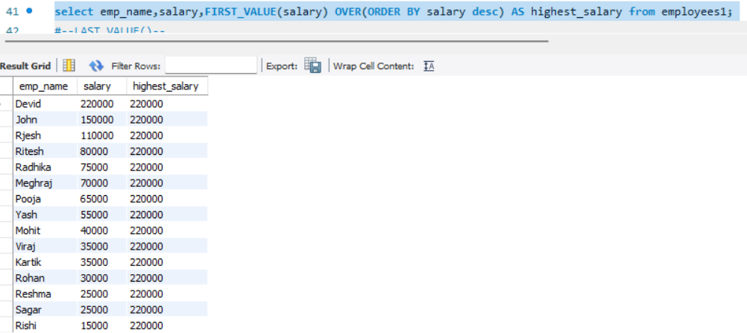
#--LAST VALUE()--
select emp_name,salary,LAST_VALUE(salary) OVER(ORDER BY salary rows between unbounded preceding and unbounded following) AS last_valu from employees1;
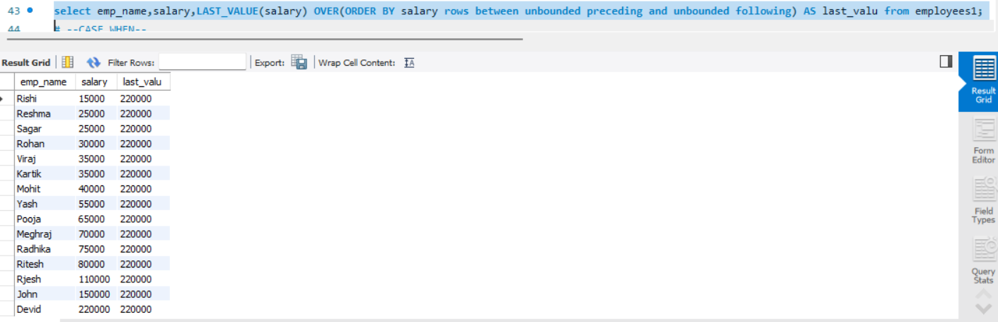

# --CASE WHEN—
select emp_name,CASE WHEN salary > 100000 then 'High salary' WHEN salary >50000 then 'Mediunsalary' ELSE 'Low salary'
END AS salary_category from employees1;
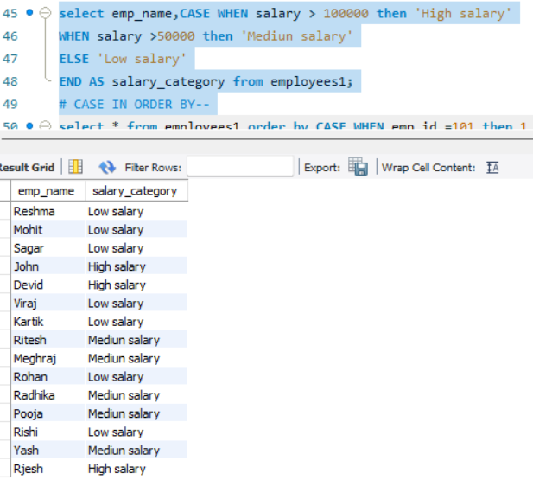
# CASE IN ORDER BY--
select * from employees1 order by CASE WHEN emp_id =101 then 1
WHEN emp_id =102 then 2 ELSE 3 END;
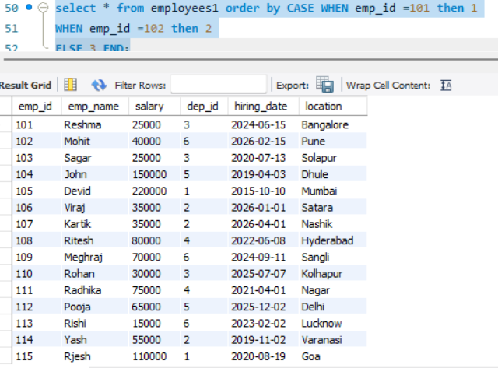

# eligible for bonus using case--
select YEAR(hiring_date) AS year, emp_name,salary, CASE WHEN salary >=100000 then 'eligible'
ELSE 'not eligible' END AS bonus_ststus FROM employees1 ORDER BY YEAR(hiring_date);
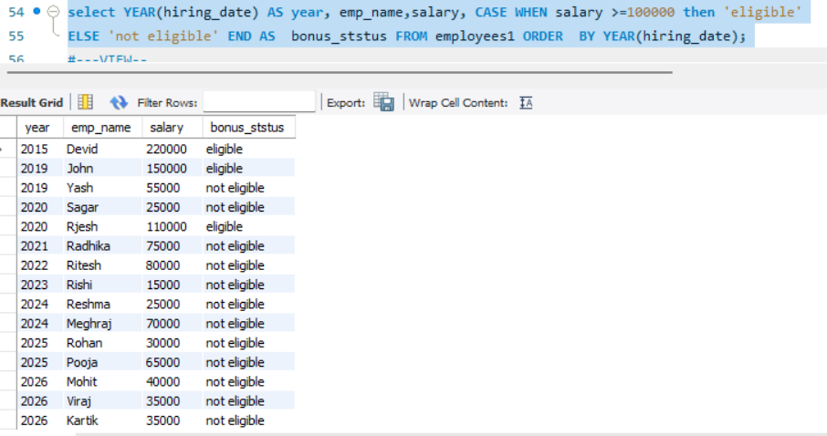
#---VIEW--
#-- CREATE VIEW--
CREATE VIEW emp_view as select emp_id,emp_name,salary from employees1;
select * from emp_view;
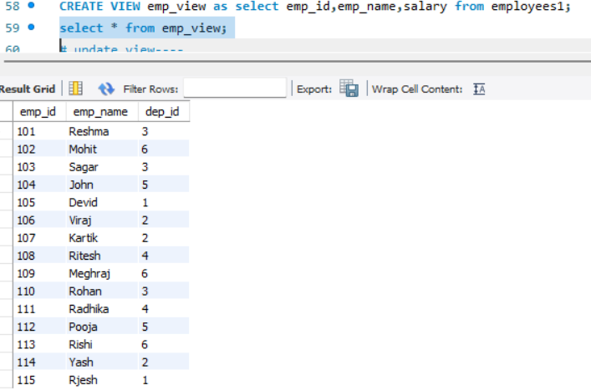
# update view----
create or replace view emp_view as select emp_id,emp_name,dep_id from employees1;
select * from emp_view;
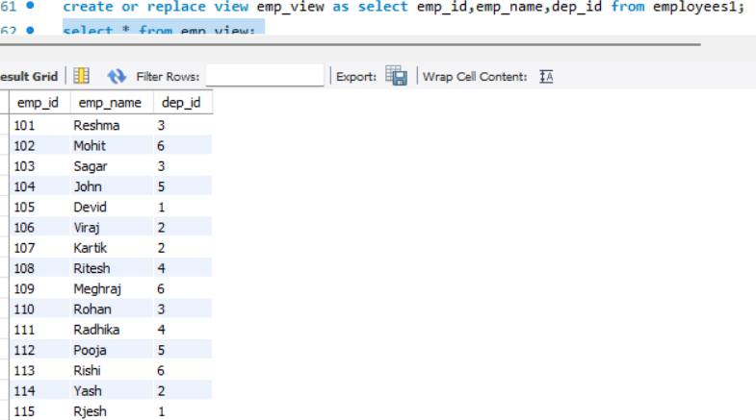
# delete view --
drop view emp_view;
# view with where clause ---
create view high_salary_emp as select * from employees1 where salary >50000;
select * from high_salary_emp;
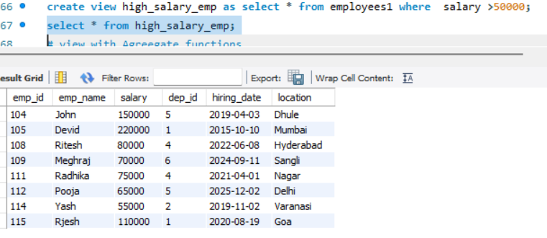

# view with Agreegate functions
create view dep_salary as select dep_id, sum(salary)total_salary from employees1 group by dep_id;
select * from dep_salary;
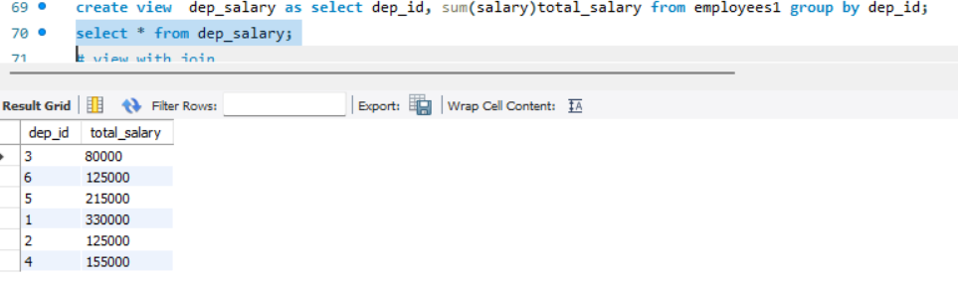
# view with join
create view emp_dep as select e.emp_name ,d.dep_name from employees1 e join department1 d on e.dep_id=d.dep_id;
select * from emp_dep;
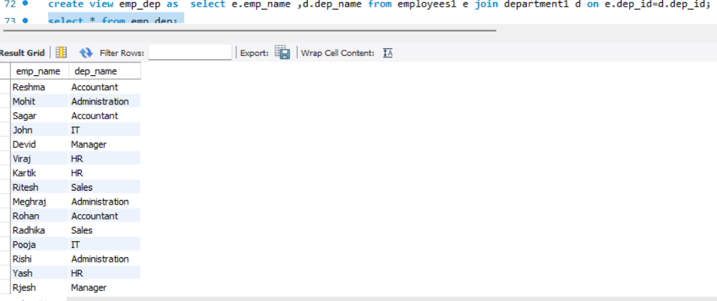
# trigger ----
# create trigger ---
create table logs(
dep_id int auto_increment primary key , message varchar(30));

DELIMITER $$
create trigger dep_insert_trigger after insert on department1 for each row
BEGIN
insert into LOGS (message)
values("new department added");
END $$
DELIMITER ;
insert into department1 values(7,"visiting");
select * from logs;
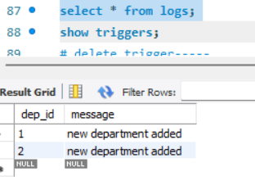

show triggers;
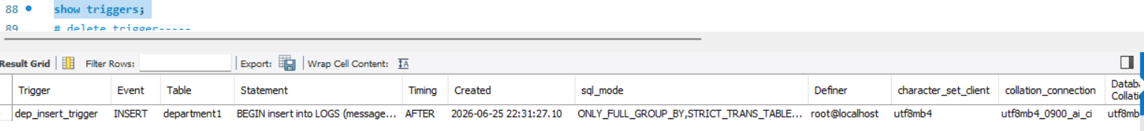

# delete trigger-----
drop trigger dep_insert_trigger;

