**Vehicle Inventory Management**

Vehicle Inventory Management API manage the Vehicle inventory. This API provide services

to add the vehicle, get the available vehicle, update the vehicle details, delete the vehicle and search the vehicle.

API provides below services to manage vehicle inventory:

|  |  |  |
| --- | --- | --- |
| **Services** | **URLs** | **Http Method** |
| 1. AddVehicle | http://localhost:8080/InventoryManagement/vehicles/ | POST |
| 2. UpdateVehicle | http://localhost:8080/InventoryManagement/vehicles/3 | PUT |
| 3. DeleteRecentVehicle | http://localhost:8080/InventoryManagement/vehicles/ | DELETE |
| 4. DeleteVehicleById | http://localhost:8080/InventoryManagement/vehicles/3 | DELETE |
| 5. GetAllVehicle | http://localhost:8080/InventoryManagement/vehicles/ | GET |
| 6. GetVehicleById | http://localhost:8080/InventoryManagement/vehicles/3 | GET |
| 7. SearchVehicle | http://localhost:8080/InventoryManagement/vehicles/search/{Id}&{model}&{brand}&{price}&{color}&{vehicleType}&{description} | GET |

**1. AddVehicle:-** This service add the provided vehicle to database and return the StatusCode

and StatusMessage on success, refer the below screen shot to make

request through postman.

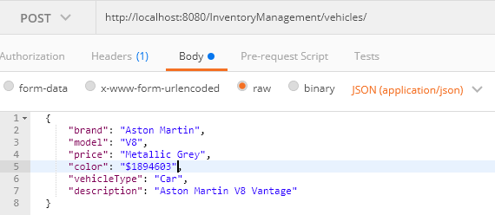

**Sample JSON Request:-**

{

"brand": "Aston Martin",

"model": "V8",

"price": "Metallic Grey",

"color": "$1894603",

"vehicleType": "Car",

"description": "Aston Martin V8 Vantage"

}

**2.** **UpdateVehicle:-** This API service update the provided vehicle to database and return the

StatusCode and StatusMessage on success, refer the below screen shot

to make request through postman.

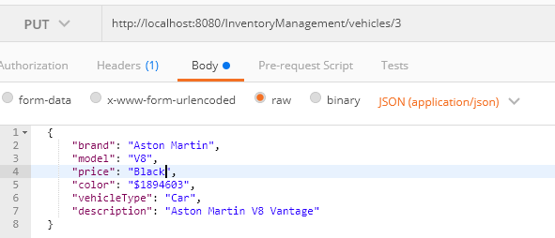

**Sample JSON Request:-**

{

"brand": "Aston Martin",

"model": "V8",

"price": "Metallic Grey",

"color": "$1894603",

"vehicleType": "Car",

"description": "Aston Martin V8 Vantage"

}

1. **DeleterRecentVehicle:-** This API service delete the last added vehicle record from the

database, refer the below screen shot to make request through

postman.

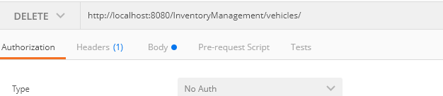

**4. DeleteVehicleById:-** This API service delete the last added vehicle record from the database,

refer the below screen shot to make request through postman.

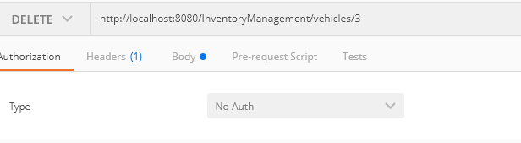

1. **GetAllVehicle:-** This API service fetch all the vehicles available in db, refer the below screen

shot to make request through postman.

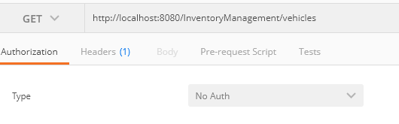

**6. GetVehicleById**:- This service fetch vehicle record based on the provided vehicle id

and return list of the vehicles , refer the below screen shot to make

request through postman.

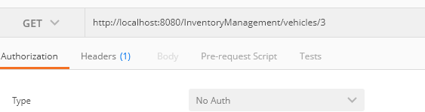

1. **SearchVehicle:** This service fetch vehicle records based on the provided properties of

Vehicle and return list of the vehicles , refer the below screen shot to

make request through postman.

