**NAME:**

**Assignment Title:** Use Cases for ChatGPT vs. Gemini

**Instructions:**

In this assignment, you will explore and analyze the differences between two AI language models: ChatGPT and Gemini. You will assess their performance in responding to various questions and tasks related to electric vehicles, providing insights into how each AI processes information and generates responses.

**Instructions**:

1. **Task**: For each question or topic provided, interact with both ChatGPT and Gemini to gather their responses. Take note of the differences in how each AI formulates its answers.
2. **Comparison**: After collecting responses, write a summary comparing the two AIs based on the parameters above. Highlight which AI performed better in each category and provide examples to support your conclusions.
3. **Reflection**: Conclude your assignment by reflecting on which AI you found more helpful and engaging, and why you think those differences exist.

**Software link –** [ChatGPT](https://chat.openai.com/)

**Software link -** [Gemini](https://gemini.google.com/)

**YouTube link -** <https://youtu.be/W1W6zFTJQQ4?si=sHavNf6ArHfifNlI>

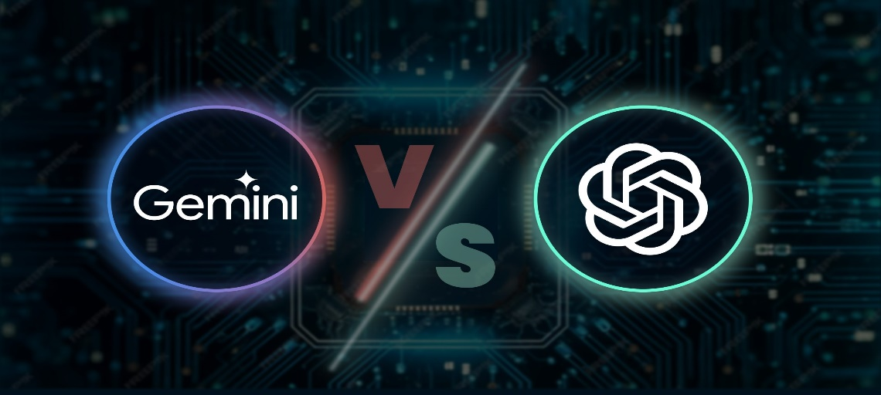

**Problem Statement:**

This assignment aims to help you compare how two AI models, ChatGPT and Gemini, explain concepts related to Electric Vehicles (EVs). You will evaluate their responses based on clarity, engagement, and accuracy.

**Complete the Following Tasks**:

**1. Benefits of Electric Vehicles**

* **Task**: Ask both AIs to list and explain the top 5 benefits of electric vehicles over traditional gasoline vehicles.
* **Questions to Ask**:
  + What are the environmental advantages of electric vehicles?
  + How do electric vehicles save money for their owners?
  + What technological innovations do electric vehicles bring?
* **Comparison**: After receiving the responses, summarize how each AI presents the benefits. Which AI provided clearer and more compelling explanations?
* **Write your observation in the box below**.

**2. How Electric Vehicles Work**

* **Task**: Request both AIs to explain the basic mechanics of how an electric vehicle operates, including concepts like batteries and regenerative braking.
* **Questions to Ask**:
  + Can you explain how the battery in an electric vehicle works?
  + What is regenerative braking, and how does it help electric vehicles?
* **Comparison**: Analyze the clarity and accuracy of each AI's explanation. Which one was more engaging and easier to understand?
* **Write your observation in the box below**.

**3. Future of Transportation**

* **Task**: Ask both AIs to predict the future of transportation with the rise of electric vehicles and self-driving technology.
* **Questions to Ask**:
  + How do you think electric vehicles will change our roads in the future?
  + What challenges do you foresee with the adoption of self-driving electric vehicles?
* **Comparison**: Compare the visions presented by each AI. Which AI provided more innovative ideas, and which highlighted challenges better?
* **Write your observation in the box below**.

**4. Electric Vehicles and Renewable Energy**

* **Task**: Request explanations on how electric vehicles can be powered by renewable energy sources, like solar or wind power.
* **Questions to Ask**:
  + How can electric vehicles be charged using renewable energy?
  + Why is it important for electric vehicles to use renewable energy sources?
* **Comparison**: Evaluate how well each AI connects electric vehicles to sustainable energy solutions. Which explanation resonated more with you?
* **Write your observation in the box below**.

**5. Electric Vehicle Myths vs. Facts**

* **Task**: Ask both AIs to debunk common myths about electric vehicles (e.g., charging time, range anxiety).
* **Questions to Ask**:
  + What are some common misconceptions about electric vehicles?
  + Can you provide facts that counter these myths?
* **Comparison**: Review the effectiveness and clarity of the responses from both AIs. Which AI addressed the myths better?
* **Write your observation in the box below**.