LOW-LEVEL DESIGN
NASDAQ-10 Stock AI Agent
Software developer view, end-user journey, RAG internals, AWS deployment, security, and observability
Design baseline
This document reflects the deployed custom-Python implementation. It does not assume LangChain. The runtime uses Streamlit, Supervisor/RAG/Stock agents, Amazon Bedrock, OpenSearch Serverless, S3, Yahoo Finance, ECS Fargate, Secrets Manager, CloudWatch, GitHub Actions, and Langfuse.

Item | Current implementation
Runtime | Python 3.12, Streamlit, Docker, ECS Fargate
Generation | Amazon Nova Lite via Bedrock Converse
Embeddings | Amazon Titan Text Embeddings V2, 1,024 dimensions
Vector store | Amazon OpenSearch Serverless, Faiss HNSW, cosine similarity
Reports | Amazon S3: dev-dsmay-stock-agent-bucket
Observability | Langfuse metadata traces plus CloudWatch logs
Delivery | GitHub Actions -> ECR -> ECS

1. Architecture goals and boundaries
- Provide a simple end-user experience for live stock quotes and financial-report analysis.
- Route requests deterministically to only the required specialist agents.
- Ground report answers in uploaded or indexed evidence and expose source identifiers.
- Prevent cross-company contamination through uploaded-file isolation and ticker-filtered vector search.
- Use IAM roles and Secrets Manager instead of static AWS credentials in code or images.
- Trace agent, retrieval, model, token, latency, and error metadata without sending report content by default.
Important boundary
Uploaded files are processed in memory for the current request. Stored financial reports are held in S3 and indexed in OpenSearch. The application does not combine both data sources during uploaded-document analysis.

2. End-user point of view
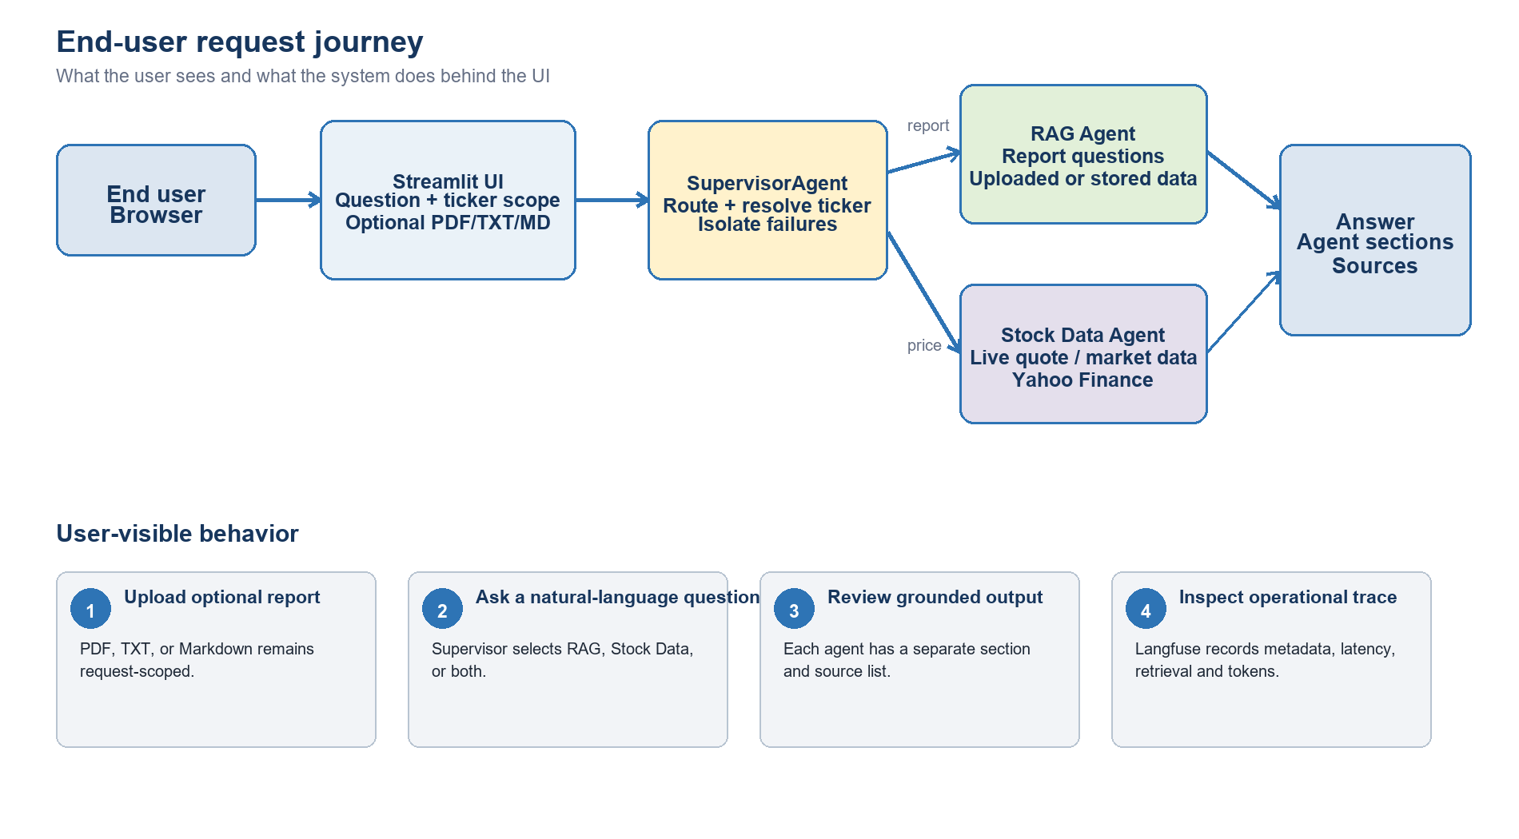
Figure 1. End-user request journey

2.1 User scenarios
User request | Route | Expected output
Cisco Systems share price | Stock Data only | CSCO quote from Yahoo Finance.
Analyse this uploaded COST report | RAG only | Answer from uploaded document; no S3/OpenSearch search.
What is the current price for the uploaded company? | RAG + Stock Data | Report answer plus resolved ticker quote.
Summarize AAPL annual revenue | Stored-report RAG | Ticker-filtered OpenSearch evidence and Bedrock answer.
Refresh dashboard | YahooStockTool directly | NASDAQ-10 table and price chart.

3. Runtime module design
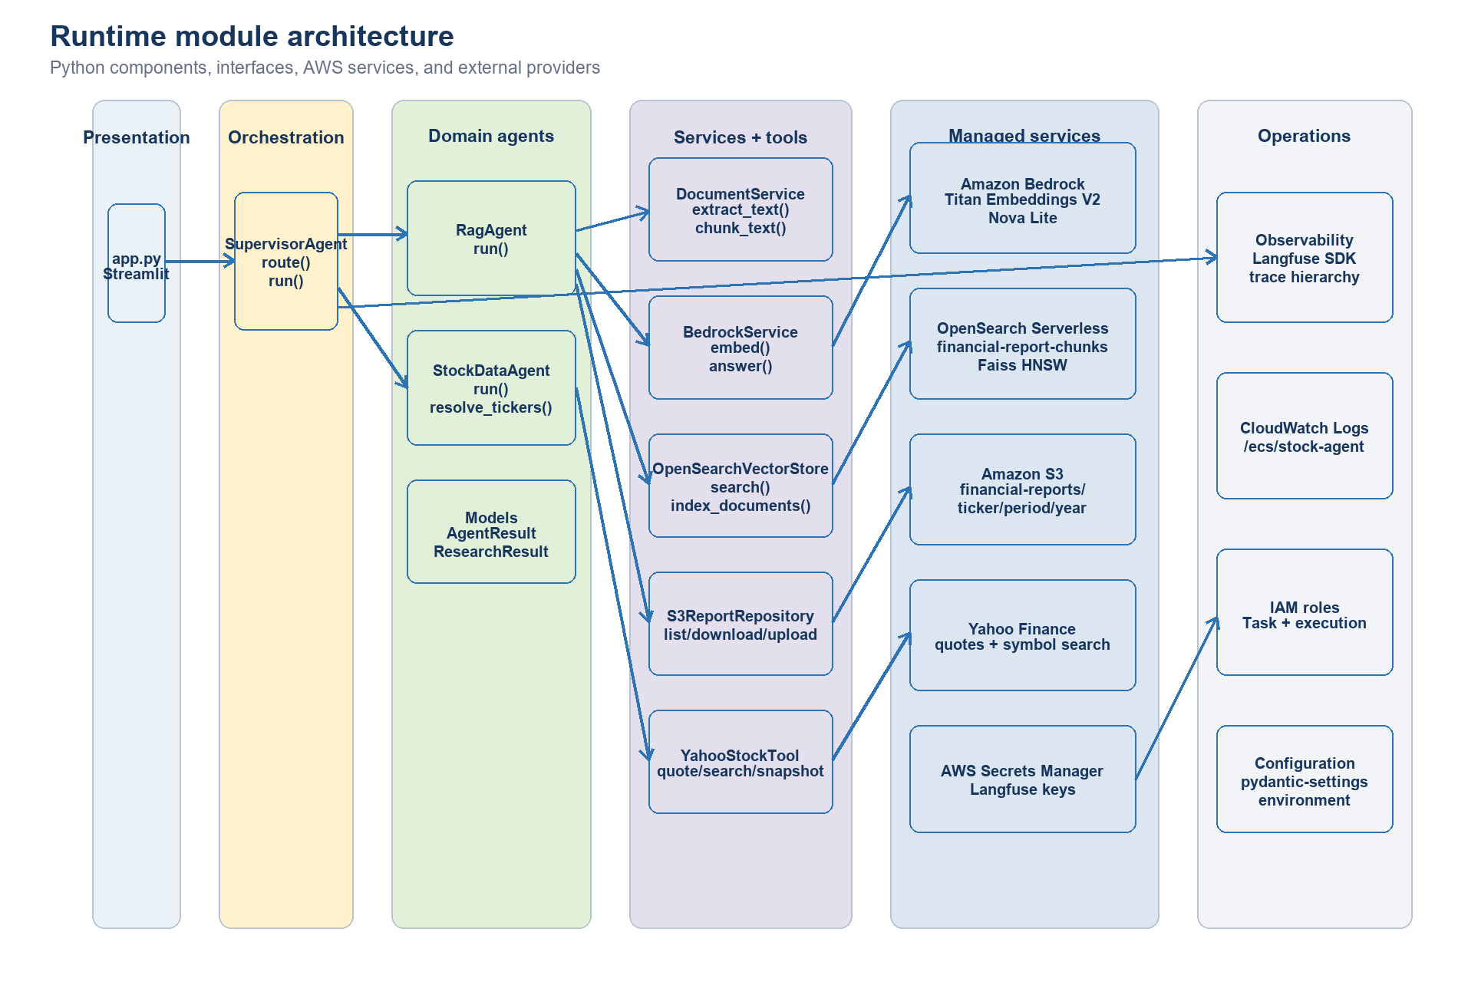
Figure 2. Runtime modules and external integrations

3.1 Module responsibilities and interfaces
Module | Primary interface | Responsibility
app.py | Streamlit event handlers | Collect question/file/ticker scope; render answer, sources, dashboard.
config.py | Settings / get_settings() | Load environment configuration with pydantic-settings.
supervisor.py | SupervisorAgent.route(), run() | Intent routing, ticker resolution, agent execution, error isolation, result merge.
agents/rag_agent.py | RagAgent.run() | Select uploaded or stored-report path; retrieve context; call Bedrock.
agents/stock_agent.py | StockDataAgent.run(), resolve_tickers() | Resolve company symbols and collect live quote data.
services/document_service.py | extract_text(), chunk_text() | PDF/HTML/text extraction and 1,400/200 character chunking.
services/bedrock_service.py | embed(), answer() | Titan embedding and Nova Lite grounded generation.
services/vector_store.py | search(), index_documents() | SigV4 OpenSearch client, ticker-filtered k-NN, bulk indexing.
services/s3_reports.py | list_reports(), download(), upload() | Financial-report object naming and S3 operations.
tools/stock_data.py | quote(), search_symbols(), universe_snapshot() | Yahoo Finance integration and dashboard frame.
observability.py | observe(), safe_text(), flush() | Langfuse trace lifecycle, privacy-safe content handling, immediate export.
models.py | AgentResult, ResearchResult | Stable return contracts between agents, supervisor, and UI.

3.2 Core data contracts
Contract | Key fields | Producer / consumer
AgentResult | agent, answer, sources, data | Specialist agent -> Supervisor/UI
ResearchResult | answer, sections, sources | Supervisor -> Streamlit
VectorMatch | text, source, ticker, period, year, score | OpenSearch store -> RAG Agent
ReportObject | key, ticker, period, year | S3 repository -> sync/index/RAG
Langfuse observation | name, type, input/output metadata, model, tokens, latency | Runtime modules -> Langfuse Cloud

4. Supervisor and routing logic
- Receive question, optional file bytes/type/name, and selected tickers.
- Detect report intent using uploaded-document and financial-report keywords.
- Detect live-market intent using price, quote, market, performance, or trading terms.
- Resolve scope in priority order: explicit ticker in question -> company-name search -> uploaded filename -> sidebar selection -> configured universe.
- Call RAG, Stock Data, or both. Catch each agent exception separately.
- Merge agent sections, de-duplicate sources, update Langfuse trace, flush events, and return ResearchResult.
Routing precedence
The question has priority over the uploaded filename and sidebar. This is why a request for Cisco Systems resolves to CSCO even when a COST file remains in the uploader.

5. RAG low-level design
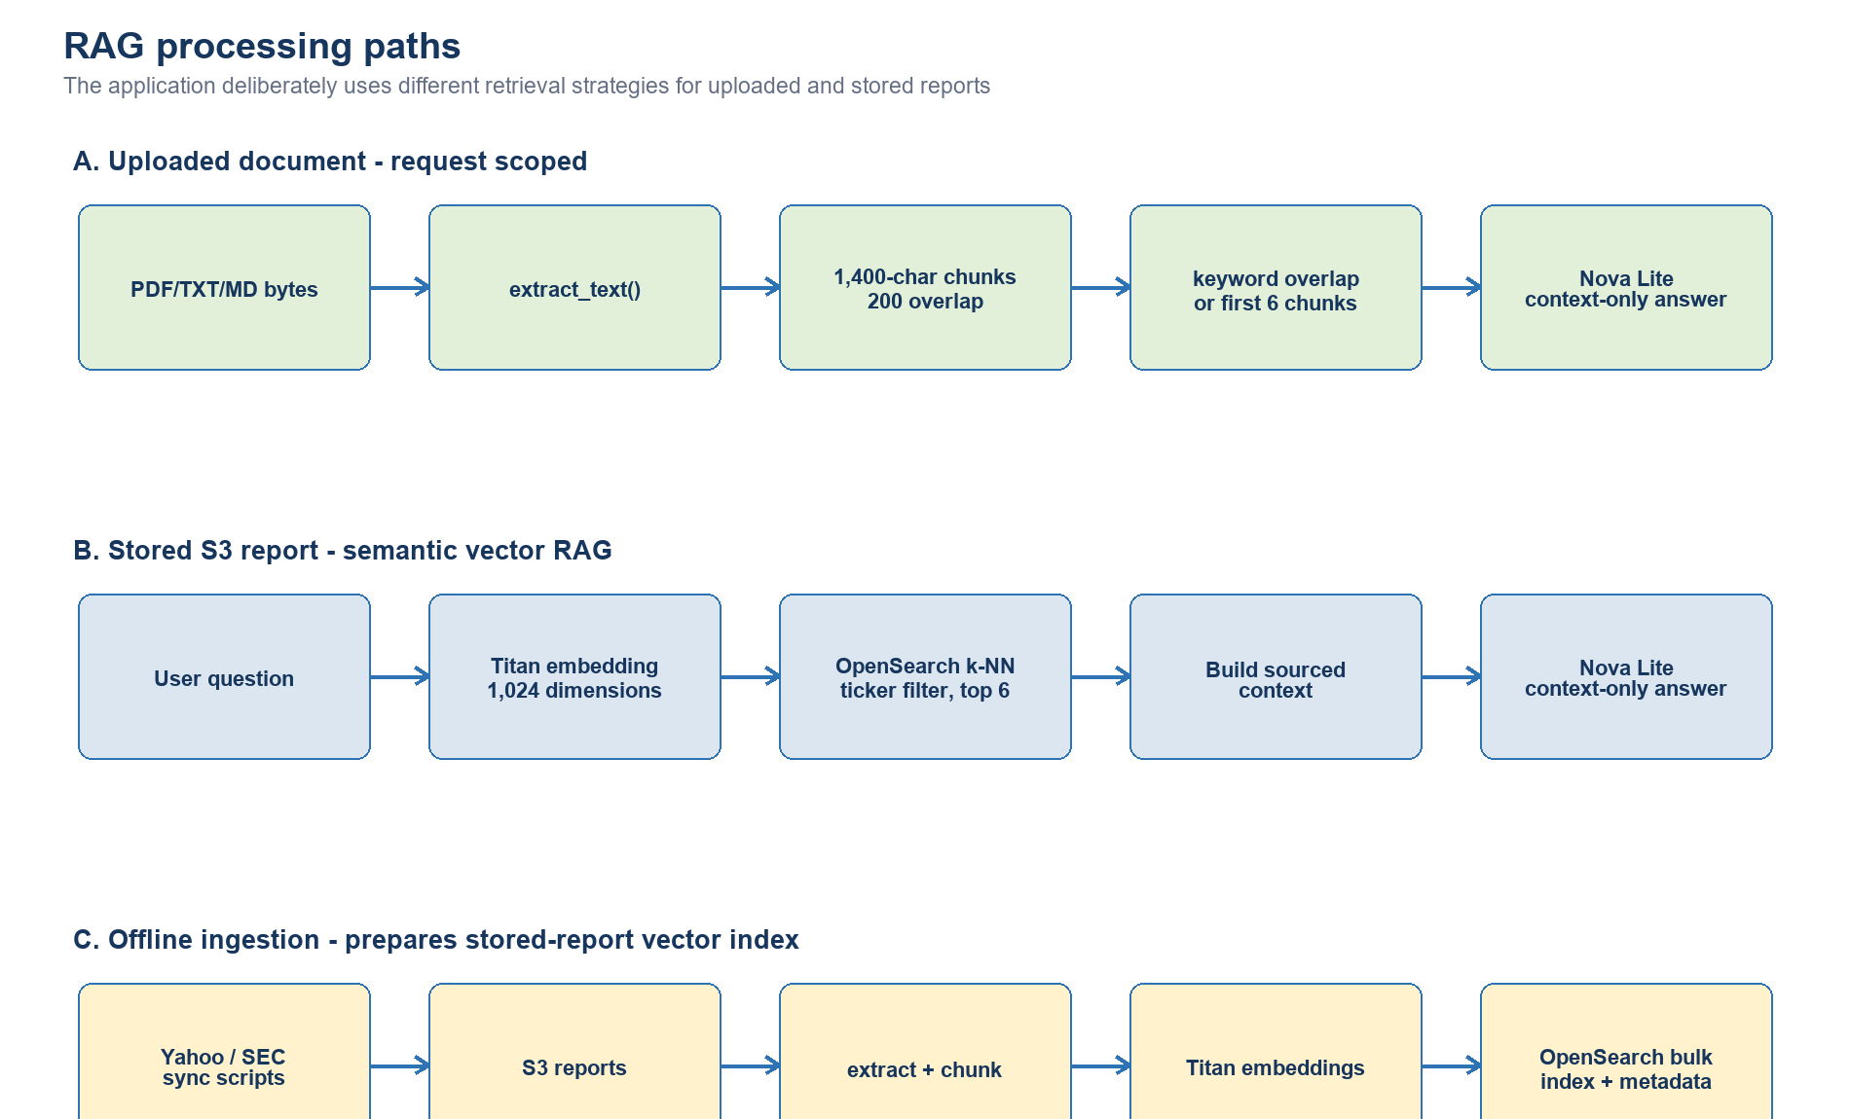
Figure 3. Uploaded, stored-report, and offline indexing paths

5.1 Uploaded-document path
- Read uploaded bytes in Streamlit and pass them directly to SupervisorAgent.
- DocumentService detects PDF via MIME type or signature; PyPDF extracts text. TXT/MD are decoded.
- Normalize whitespace and create 1,400-character chunks with 200-character overlap.
- Use keyword overlap for focused questions or the first six chunks for a generic summary.
- Build context with the source label 'Uploaded document'.
- Invoke Nova Lite with a context-only system prompt and return the answer/source.

5.2 Stored-report semantic path
- Embed the question with Titan Text Embeddings V2 using 1,024 normalized dimensions.
- Query OpenSearch Serverless using k-NN and a ticker terms filter.
- Retrieve the top six chunks with source, ticker, period, year, and similarity score.
- Build a sourced context block and invoke Nova Lite through Bedrock Converse.
- Return the grounded answer and unique S3 source URIs.

5.3 OpenSearch index mapping
Field | Type / setting | Purpose
embedding | knn_vector, dimension 1024 | Semantic similarity search.
text | text | Original report chunk supplied to Nova Lite.
source | keyword | S3 URI citation and de-duplication.
ticker | keyword | Company isolation filter.
period | keyword | Annual, half-yearly, or quarterly metadata.
year | keyword | Reporting-year filter/display metadata.
chunk_index | integer | Stable position within the source report.
method | Faiss HNSW / cosinesimil | Approximate nearest-neighbor engine and similarity space.

6. Market-data low-level design
- Supervisor resolves a ticker directly from the question or via Yahoo symbol search.
- StockDataAgent calls YahooStockTool.quote() for each requested ticker.
- Tool exceptions are converted to per-ticker unavailable rows instead of failing the whole response.
- Prices are formatted only when numeric; missing values display as N/A.
- The dashboard calls universe_snapshot() directly and renders a dataframe plus price bar chart.
External-provider behavior
Yahoo Finance is an external, unofficial data source. The application should expect rate limits, schema changes, temporary missing values, and delayed data.

7. Observability design
Observation | Type | Recorded details
stock-agent-research | Agent | Routes, tickers, file metadata, source count, answer length, total latency.
rag-agent / stock-agent | Agent | Agent input scope, selected source list, answer length, latency and errors.
embed-rag-question | Embedding | Titan model, text length, 1,024 dimensions, latency.
retrieve-financial-report-chunks | Retriever | Top-six matches, sources, scores, ticker, period, year, chunk lengths.
bedrock-nova-answer | Generation | Nova model, region, context length, token usage, model parameters, latency.
yahoo-finance-quote | Tool | Ticker, currency, data availability, provider and latency.

Privacy default
LANGFUSE_CAPTURE_CONTENT=false. Questions, answers, prompts, and report text are represented by lengths and metadata. Changing this to true sends content to Langfuse Cloud and requires explicit data-governance approval.

8. AWS deployment and security
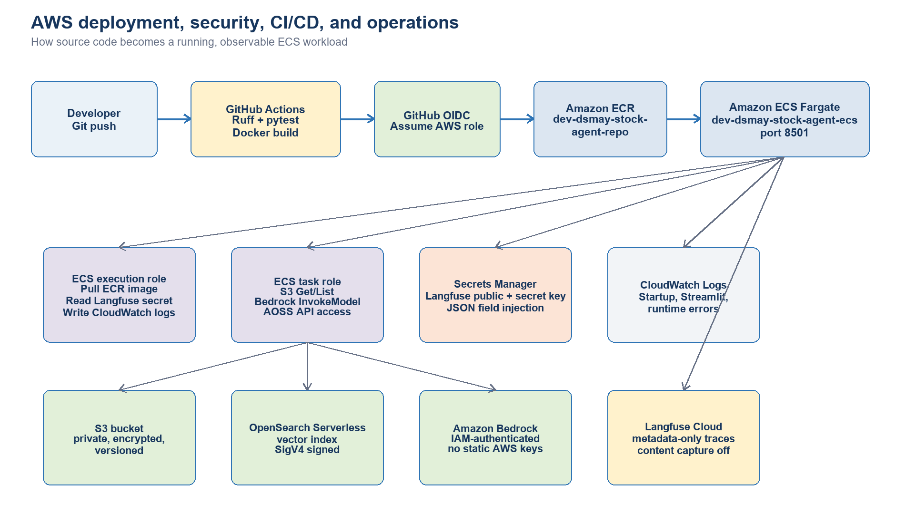
Figure 4. AWS runtime, CI/CD, IAM, secrets, and operations

8.1 Deployed resources
Resource | Name / configuration | Role
ECS cluster | dev-dsmay-stock-agent-cluster | Fargate runtime boundary.
ECS service | dev-dsmay-stock-agent-ecs | Maintains one healthy Streamlit task.
ECR repository | dev-dsmay-stock-agent-repo | Stores deployable Docker images.
S3 bucket | dev-dsmay-stock-agent-bucket | Private financial-report object store.
OpenSearch collection | stock-agent-vectors | Serverless vector retrieval.
OpenSearch index | financial-report-chunks | Chunk vectors and report metadata.
Secrets Manager | dev/dsmay/stock-agent/langfuse | Encrypted Langfuse public/secret keys.
CloudWatch | /ecs/stock-agent | Container startup and runtime logs.

8.2 IAM separation
Role | Permissions | Reason
ECS execution role | ECR pull, CloudWatch logs, Secrets Manager GetSecretValue | Used by ECS while starting the container.
ECS task role | S3 List/Get, Bedrock InvokeModel, AOSS API access | Used by application code at runtime.
GitHub deployment role | ECR push, ECS update/register, iam:PassRole | Assumed through GitHub OIDC; no long-lived AWS key.

9. CI/CD execution sequence
- A pull request or push checks out the repository and installs Python 3.12 with uv.
- Ruff validates code quality; pytest executes unit tests with coverage.
- A Docker smoke build proves the application packages successfully.
- For an enabled push to main, GitHub OIDC assumes the AWS deployment role.
- The workflow logs in to ECR, builds an image tagged with the Git commit SHA, and pushes it.
- The ECS render action updates the container image in the task definition.
- The ECS deploy action registers the task revision, updates the service, and waits for stability.
Current branch behavior
Tests run on pushes to main and Madhavi. Automated AWS deployment runs only from main when AWS_DEPLOY_ENABLED=true. Manual deployments performed during development should be reconciled through a main-branch release.

10. Error handling and failure modes
Failure | Current behavior | Developer action
Yahoo quote unavailable | Ticker row shows unavailable; other tickers continue. | Inspect provider response and tool logs.
No uploaded keyword match | Return no relevant uploaded/S3 content message. | Use summary intent or improve semantic uploaded retrieval.
No OpenSearch match | Return no relevant indexed content message. | Check index population, ticker metadata and endpoint.
Bedrock/S3/OpenSearch exception | Supervisor returns Service unavailable for affected agent. | Use Langfuse error span and CloudWatch logs.
Langfuse unavailable | Application continues; trace export may be absent. | Check secret, base URL, outbound networking and SDK logs.
ECS health failure | Service stops unhealthy replacement task. | Review /_stcore/health, task events and CloudWatch.

11. Developer extension points
- Add a News Agent behind a provider interface without changing the UI result contract.
- Replace uploaded keyword retrieval with an in-memory semantic vector index.
- Add structured citations that connect answer claims to chunk IDs and report metadata.
- Add a portfolio agent using the existing AgentResult contract and Supervisor route list.
- Add authentication and per-user/session identifiers to Streamlit and Langfuse traces.
- Move OpenSearch behind a VPC endpoint and ECS tasks into private subnets.
- Create incremental indexing based on S3 object version/ETag rather than index recreation.

12. Test coverage and acceptance checks
Area | Representative checks
Routing | Price -> stock; uploaded report -> RAG; explicit question ticker overrides sidebar.
Source isolation | Uploaded AAPL report never introduces TSLA/S3 content.
Vector search | Ticker filter present; mapping uses 1,024 dimensions and Faiss.
Stock data | Prices format safely; missing price does not crash dataframe or answer.
Document processing | PDF/text extraction and chunk overlap behave consistently.
Observability | Disabled without credentials; content redacted by default; safe metadata present.
Deployment | Task health endpoint, one running ECS task, CloudWatch startup log, Langfuse trace read-back.

Definition of done
A release is acceptable when Ruff and all tests pass, the image is stored in ECR, the ECS rollout completes with a healthy task, the Streamlit health endpoint responds, and a production trace appears in Langfuse with the expected child observations.

Appendix A. Source-file map
Path | Purpose
app.py | Streamlit UI and dashboard.
src/stock_agent/supervisor.py | Routing, ticker resolution, aggregation.
src/stock_agent/agents/ | RAG and Stock Data agent implementations.
src/stock_agent/services/ | Bedrock, document, S3, and OpenSearch adapters.
src/stock_agent/tools/ | Yahoo Finance and SEC EDGAR tools.
src/stock_agent/observability.py | Langfuse client and privacy-safe tracing.
scripts/sync_yahoo_reports.py | Create financial reports from Yahoo data and upload to S3.
scripts/sync_sec_reports.py | SEC report synchronization utility.
scripts/index_reports_opensearch.py | Offline S3 -> chunks -> Titan -> OpenSearch indexing.
infra/ | Task definition, IAM and OpenSearch/S3 policies.
.github/workflows/ci-cd.yml | Test, build, ECR push and ECS deployment.
tests/ | Unit tests for routing, agents, tools, services and observability.

