Project Notes
Madhawa Rathnayake

1. InkSolver
Handwritten mathematical equation recognition and solver.

Facts
- Type: Computer vision / deep learning
- Repo: https://github.com/PiyumalKK/Inksolver
- Result: 95.66% validation accuracy, 84 symbol classes

Stack

- Python 3
- OpenCV 4.x
- TensorFlow / Keras
- SymPy
- Flask
- Google Colab (T4 GPU) for training

Pipeline
- Preprocess: grayscale, Gaussian blur 5x5, CLAHE, adaptive Gaussian threshold, morphological open + close
- Segment: contour detection, area filter, overlap merge, left-to-right sort, pad + resize to 45x45
- Classify: CNN, 3 conv blocks (32/64/128), BatchNorm, Dropout, dense 256, softmax over 84 classes
- Parse: context rules for ambiguous symbols, implicit multiplication, multi-line splitting
- Solve: SymPy for arithmetic, linear equations and systems

Training
- Datasets: CROHME-derived (xainano 100k+, sagyamthapa 10k), capped at 3000 samples/class

Deployment
- Flask web app: upload image, get solution
- Dual preprocessing pipeline, picks higher-confidence valid result
- 6/6 test samples passed end to end

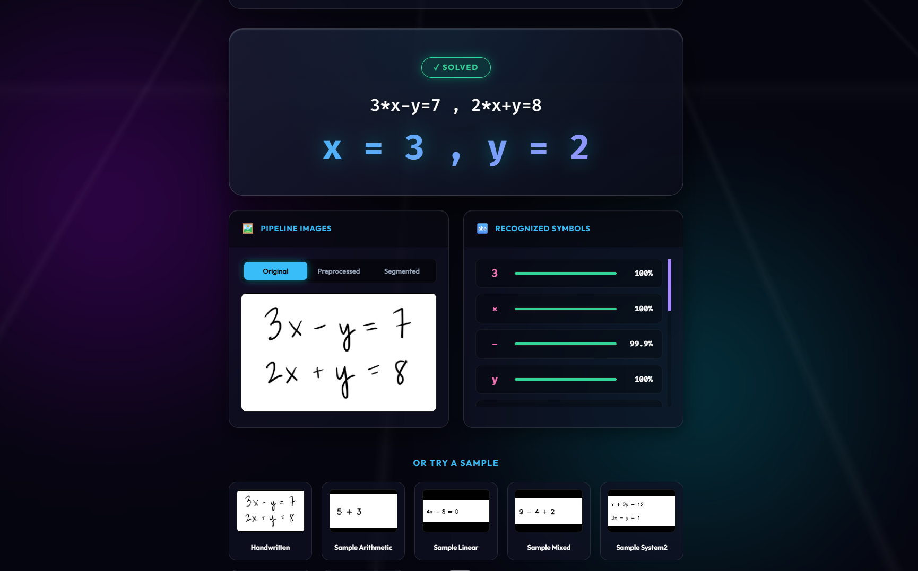

2. Smart Car Parking System
Automated parking slot detection and gate control.

Facts
- Type: Embedded systems / automation
- Validation: Simulated in Proteus before hardware

Stack

- Arduino UNO (ATmega328P)
- IR sensors
- SG-90 servo motor
- 16x2 I2C LCD display
- Proteus (simulation and testing)
- Embedded C

Features
- Detects available parking slots using IR sensors
- Displays real-time slot status on the LCD
- Controls gate access via the servo motor
- Restricts entry when the car park is full

Future scope
- Mobile app integration
- Advanced sensor upgrades
