**1.What is computer?**

- It's an electronic device where it processes a data depending to the rules or instructions that is designated by the computer programs.

**2.What are the essential parts of computer?**

- The essential and major parts of a computer is a motherboard, graphical processing unit (GPU), random access memory (RAM), storage device, power supply (PSU) and a central processing unit (CPU).

- It’s a very important or major components of a computer because, it serves a vital role to allow the organization or storage of the data, as well as the processing of the tasks and functions.

**3.Who are the notable of investors of hardware and software?**

**(5 Software Developers)**

A.) William Henry Gates III (born on October 28, 1955)

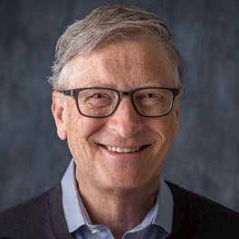

- He's a well-known software developer, businessman, and a philanthropist where Bill Gates is well known for founding the Microsoft, and is the world's largest platform for personal computer software.

B.) Kenneth Lane Thompson (born on February 4, 1943)

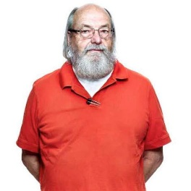

- He's an American pioneer of computer science that created the UNIX operating system at Bell Telephone Laboratories. This operating system became the most portable and capable of running for many different platforms and is very useful until now.

C.) Linus Torvalds (born 28 on December 1969)

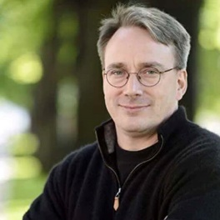

- He's an American software engineer that is behind of the development and creator of Linux kernel.

D.) Ada Lovelace (born on 10 December 1815 – 27 November 1852)

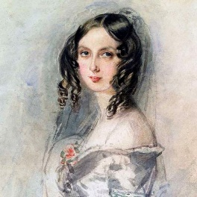

- She's the wealthy women on 1800s and a computer programmer who did not study math and science but still became the world's first computer programmer.

There was also a saying that she had a knowledge of a computer long before there were computers.

E.) Richard Stallman (born March 16, 1953)

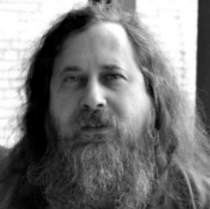

- He's the one who launched the Free Software Movement in 1983 by implementing the development of GMU operating system

**(5 Hardware Developers)**

A.) Tim Cook (born on March 1998)

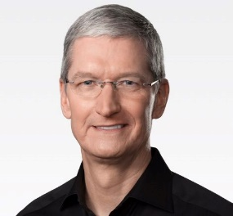

- Tim cook is the Chief Executive Officer (CEO) of the Apple company and he's the one who's responsible for all of the company’s worldwide sales and operations, as well as the managing the overall activities of the company.

B.) Ted Hsu (born on March 4, 1964)

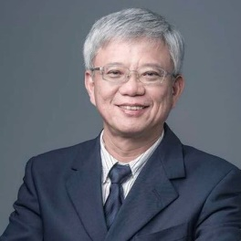

- He's the one of the original and Chief Strategy Officer of ASUS from 2016 to 2018 and is currently operating and serving the position of Vice Chairman.

C.) Michael Dell (born on February 23, 1965)

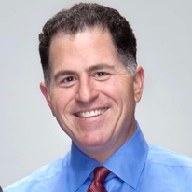

- A American entrepreneur, businessman and is known as the Chief Strategy Officer (CEO) od Dell Inc. which is the number one world's sellers of computers.

D.) Enrique Lores (born on 1965)

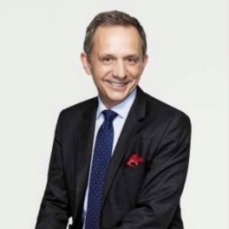

- The president and Chief Executive Officer (CEO) of HP Inc. and is innovative on developing or making such as,  printing and 3d printing, digital manufacturing and also a service portfolio spans personal systems.

E.) Kenichiro Yoshida (born on 20 October 1959)

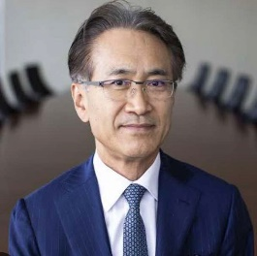

- He's the Chief Executive Officer (CEO) and Chairman of the Sony Group Corporation

**4.Cite your reference/s**

1.) Cointelegraph. (2018, October 18). Latest news on Bill Gates. https://cointelegraph.com/tags/bill-gates

2.) Computer History Museum. (2021, February 12). Ken Thompson - CHM. CHM. https://computerhistory.org/profile/ken-thompson/

3.) The Editors of Encyclopaedia Britannica. (2024, July 16). Linus Torvalds | Biography, Linux, & Facts. Encyclopedia Britannica. https://www.britannica.com/biography/Linus-Torvalds

4.) Hilfrank, E. (2022, March 17). Ada lovelace. History. https://kids.nationalgeographic.com/history/article/ada-lovelace

5.) Internet Hall of Fame. (2023b, September 20). Richard Stallman - Internet Hall of Fame. https://www.internethalloffame.org/inductee/richard-stallman/

6.) Apple.n.d.). Apple Leadership - Tim Cook. https://www.apple.com/leadership/tim-cook/

7.) Ted Hsu. (n.d.). https://press.asus.com/leaders/ted-hsu/

8.) Executive team. (n.d.). HP. https://www.hp.com/us-en/hp-information/executive-team/team.html

9.) Lovos, M. (2018, June 7). Michael Dell. IEEE Computer Society. https://www.computer.org/profiles/michael-dell/

10.) Bloomberg(a.n.d.-b). https://www.bloomberg.com/profile/person/7165929