Smart Fire Detection System
IoT Sensor and Camera Fusion using Machine Learning
Machine Learning Project Report
Name: ____________________ Roll No.: ____________ Date: ____________

Abstract
This project builds an early-warning fire detection system that combines two independent sources of evidence: an ESP8266 sensor node (MQ-2 smoke, temperature and humidity) analysed by a Random Forest classifier, and a camera analysed by a YOLO object detector. The two probabilities are merged by weighted late fusion into three alert levels (SAFE, WARNING, ALERT) and shown live on a React dashboard served by a FastAPI backend. The sensor model was trained on 6,633 cleaned readings collected from the hardware. This report describes the data, the ML pipeline, the system architecture, the evaluation, and the limitations of the work.

1. Introduction and Objectives
Fires are detected too late when only one cue is used: smoke sensors react to cooking fumes, and cameras can be fooled by lighting. Using both a sensor and a camera lets one cue compensate for the other's weaknesses.
Objectives
- Collect real sensor data from an ESP8266-based hardware node.
- Train a classifier that estimates fire risk from MQ-2 smoke, temperature and humidity.
- Add a vision model (YOLO) that detects fire and smoke in camera frames.
- Fuse both probabilities into a single alert level and display it in real time.
- Allow the dashboard to trigger a water pump and servo on the hardware.

2. System Architecture
The system has four layers: edge input (ESP8266 and webcam), a FastAPI backend that runs both models in separate reader threads, a fusion stage, and a React dashboard with actuator control. Figure 1 shows the complete runtime architecture.
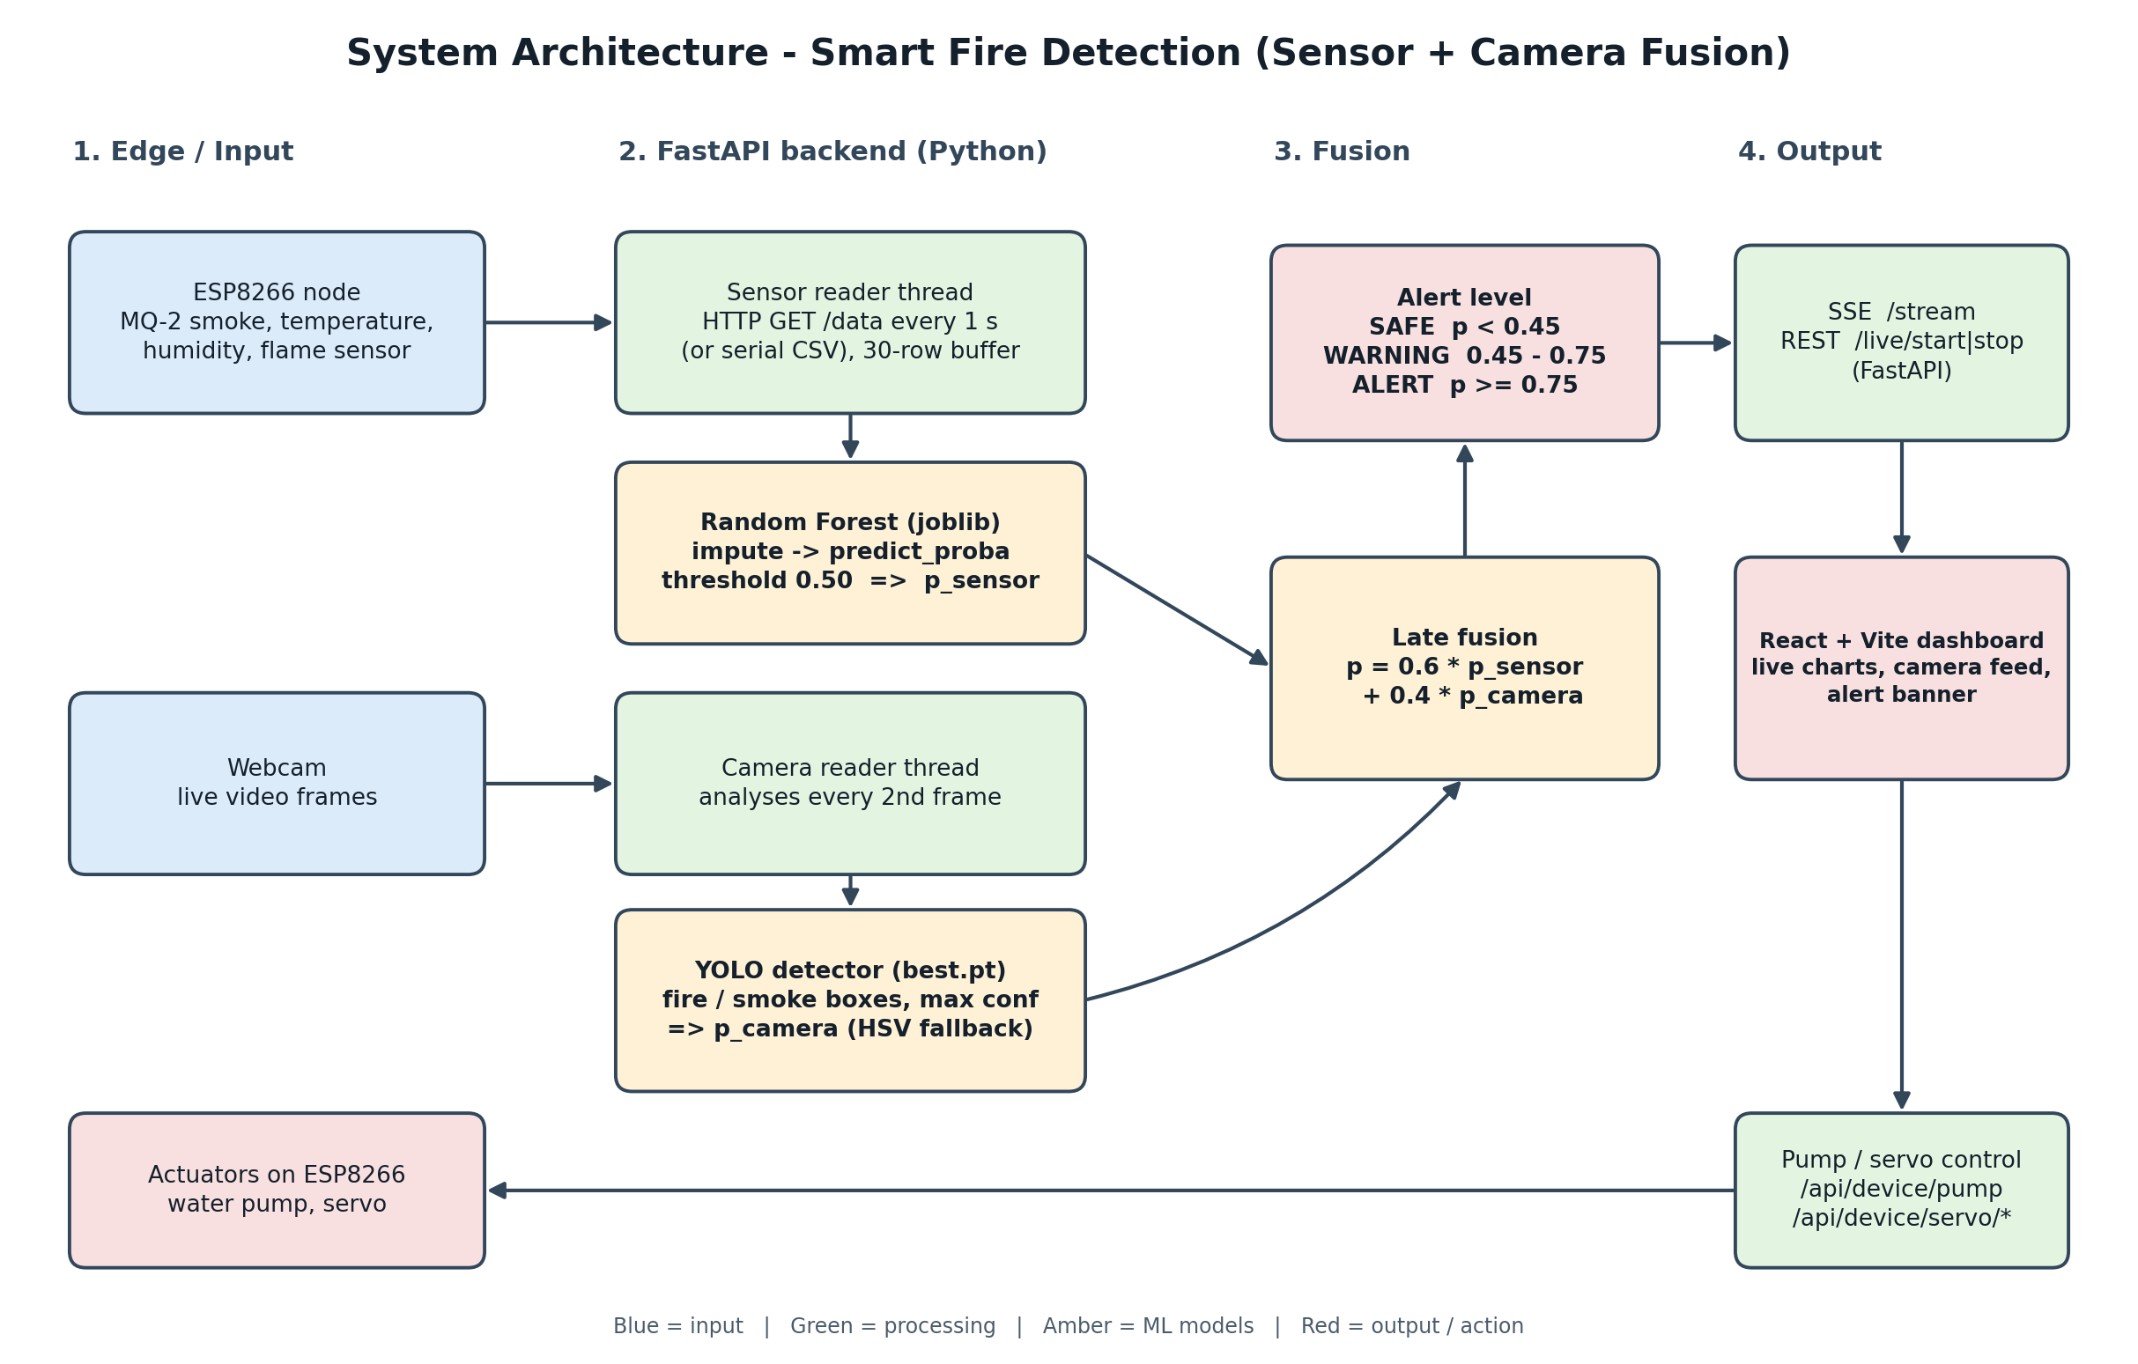
Figure 1: Runtime system architecture

3. Dataset
Sensor readings were logged from the ESP8266 hardware between 19 Nov 2025 and 8 Jan 2026. The raw log holds 7,172 rows; after removing invalid or missing rows, 6,633 rows remain for modelling.
Item | Value
Source | ESP8266 node (MQ-2, MQ-7, temperature/humidity, flame sensor)
Rows after cleaning | 6,633
Input features | mq2_smoke, temperature, humidity
Target | Recorded flame-sensor state (0 = normal, 1 = fire)
Class balance | 5,513 negative (83.1%) / 1,120 positive (16.9%)
Feature ranges | MQ-2: 0-1023 (median 45); temperature: 0-45 C; humidity: 0-99 %

The MQ-7 (CO) column was dropped because the deployed hardware does not expose it. The flame sensor is used only to create the label and is deliberately not fed to the model as an input, which would leak the answer.
During exploration (Jupyter notebook model/book.ipynb) other datasets were also examined: an external industrial-hall fire dataset, a Kaggle smoke-detection IoT dataset and an earlier hardware recording with scenarios (normal, smoke puff, smouldering, flame). They informed feature choice and evaluation design, but the deployed model uses the 3-sensor dataset above.

4. Machine Learning Pipeline
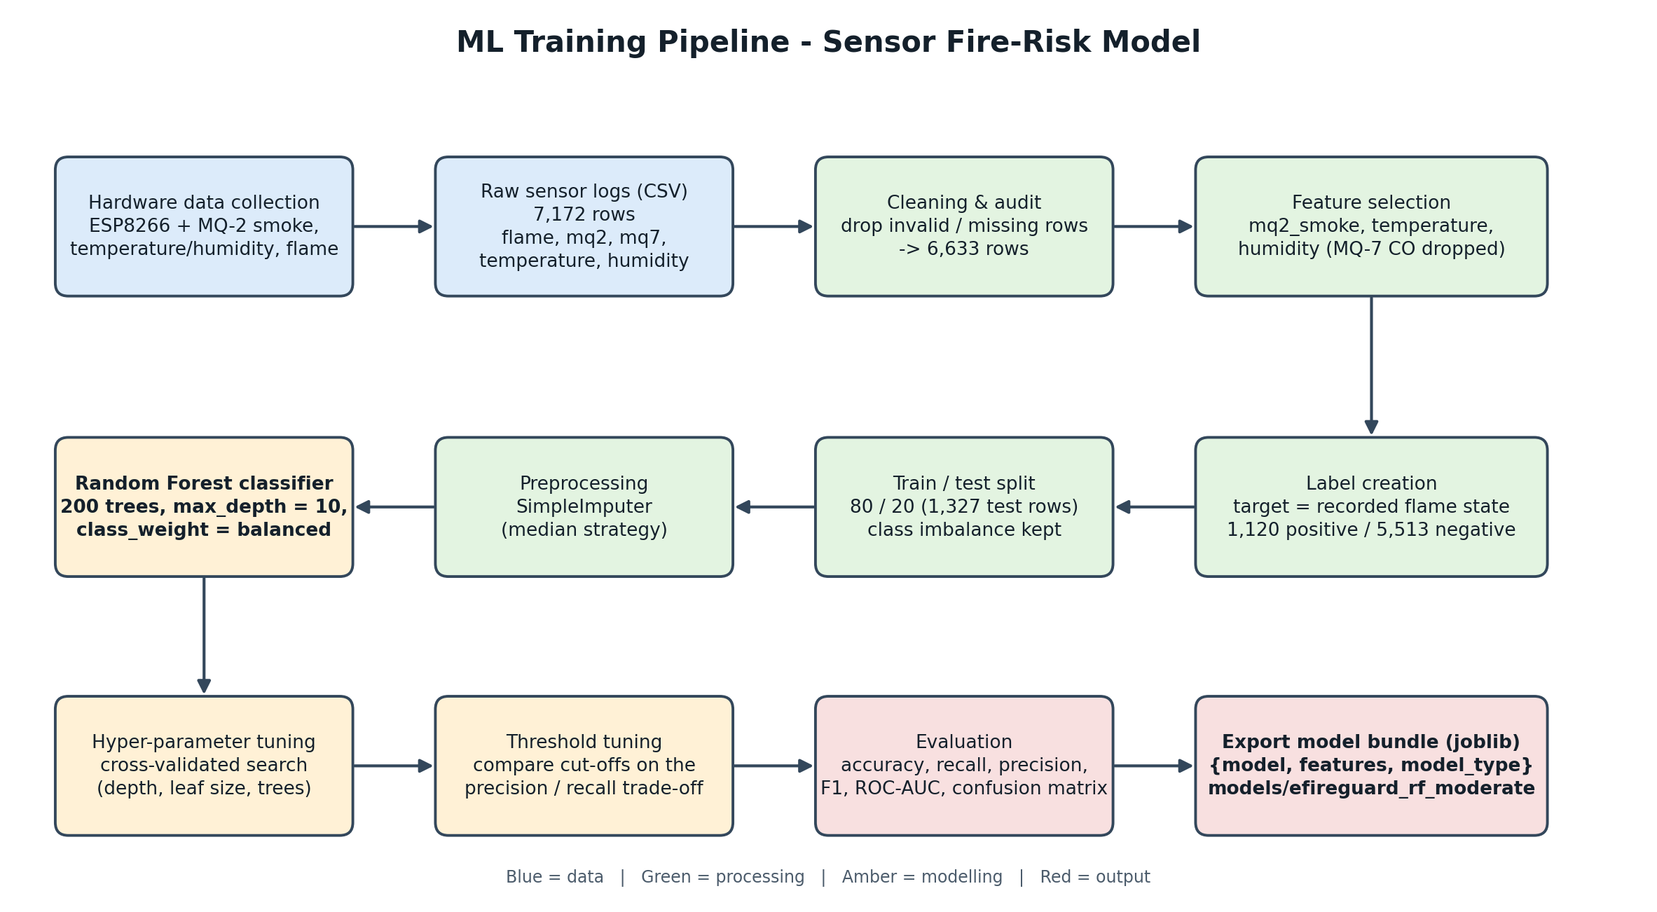
Figure 2: ML training pipeline for the sensor model
Pipeline stages
Stage | What is done | Why
1. Collection | ESP8266 logs smoke, temperature, humidity and flame state | Real hardware data matches deployment conditions
2. Cleaning | Remove invalid / missing rows; 7,172 -> 6,633 | Sensor faults would distort training
3. Features and label | Use 3 sensors; target = flame state | Only features the live device can supply
4. Split | 80/20 train/test (1,327 test rows) | Unseen data for honest evaluation
5. Imputation | SimpleImputer, median strategy | Handles occasional missing readings at inference
6. Model | Random Forest, 200 trees | Robust, non-linear, little scaling needed
7. Tuning | Cross-validated search of depth / leaf size / trees; decision-threshold comparison | Reduce overfitting; trade recall against false alarms
8. Export | joblib bundle {model, features, model_type} | Loaded directly by the backend

5. Models

5.1 Sensor model: Random Forest
The deployed model (models/efireguard_rf_moderate.joblib) is a scikit-learn Pipeline of a median SimpleImputer followed by a RandomForestClassifier. A Random Forest averages many decision trees trained on bootstrap samples, which reduces the variance of a single tree.
Hyper-parameter | Value
n_estimators | 200
max_depth | 10
min_samples_leaf / min_samples_split | 5 / 10
class_weight | balanced (offsets the 17% positive class)
random_state | 42
Inference threshold (backend) | 0.50 on P(class = 1), configurable via SENSOR_THRESHOLD

Other models compared in the notebook included Logistic Regression, Extra Trees, Gradient Boosting and HistGradientBoosting, evaluated with leave-one-session-out cross-validation so that no test session shares data with training.

5.2 Camera model: YOLO
A YOLOv8 detector (starting from yolov8n.pt, trained with camera/train-yolo.py for up to 50 epochs at 640 px with early stopping and a small hue-augmentation limit, since colour is the main cue for fire) detects fire and smoke boxes. The highest box confidence in a frame is used as the camera fire probability. If the weights are missing, the backend falls back to an HSV colour heuristic, which is not a reliable detector.

5.3 Late fusion and alert levels
p_combined = 0.6 x p_sensor + 0.4 x p_camera
Combined probability | Alert level
below 0.45 | SAFE
0.45 to below 0.75 | WARNING
0.75 and above | ALERT

The sensor is weighted higher because it is a continuous, always-on measurement. The weights and cut-offs are design choices and have not been tuned on a labelled combined dataset.

6. Implementation
Component | File / folder | Role
Exploration and training | model/book.ipynb | Data audit, feature study, model comparison
Trained models | models/*.joblib, camera/weights/best.pt | Sensor Random Forest and YOLO weights
Evaluation | evaluation_below_90_v2/ | Metrics, report and CV results for a tuned candidate
Backend | backend/api.py | FastAPI: reader threads, model inference, fusion, SSE stream, pump/servo routes
Camera tools | camera/ (prepare, train, evaluate) | Dataset checks, YOLO training and evaluation
Dashboard | frontend/ (React + Vite) | Live charts, camera feed, alert banner, controls
Launcher | start.bat | Starts the backend (port 8000) and the frontend (port 5173)

Runtime flow: every second the backend polls the ESP8266 (/data), appends the reading to a 30-row buffer and runs the Random Forest on the latest row. In parallel the camera thread analyses every second frame with YOLO. Whenever either value updates, the fusion step recomputes the alert level, which is pushed to the dashboard over Server-Sent Events (/stream).

7. Evaluation
The table below is from the saved evaluation report (evaluation_below_90_v2/evaluation_report.txt) for the regularised Random Forest candidate (max_depth = 3, min_samples_leaf = 80, 200 trees) on 1,327 held-out rows, decision threshold 0.30.
Metric | Value
Accuracy | 0.892
Balanced accuracy | 0.869
Precision (fire) | 0.638
Recall (fire) | 0.835
Specificity | 0.904
F1 score | 0.723
ROC-AUC | 0.932
Average precision | 0.798
Matthews corr. coefficient | 0.667

Confusion matrix (rows = actual, columns = predicted)
 | Predicted normal | Predicted fire
Actual normal | 997 (TN) | 106 (FP)
Actual fire | 37 (FN) | 187 (TP)

Interpretation: the model catches about 83% of fire-state readings and wrongly flags about 10% of normal readings. A low threshold (0.30) was chosen to favour recall, because a missed fire is more costly than a false alarm. The shallow trees (max_depth = 3) and large leaves (80 samples) keep the model simple, which limits overfitting to repetitive readings.
Note: these figures belong to the regularised candidate in the evaluation folder. A separate saved evaluation for the deployed model (max_depth = 10, threshold 0.50) is not included in this report.

8. Limitations
- The label is the recorded flame-sensor state, so the model predicts what a flame sensor would report from smoke, temperature and humidity. It is a proxy, not independently validated fire detection.
- Readings are time-ordered and strongly autocorrelated; a random row split can overestimate accuracy. Splitting by recording session is a stricter test.
- Only about 17% of the data is positive, from one device and environment; generalisation to other rooms and sensors is unproven.
- Fusion weights (0.6 / 0.4) and alert thresholds were chosen by judgement, not optimised.
- The camera test set used for quick checks is small, so camera accuracy figures should not be over-claimed.
- The current model is single-reading; the 30-row buffer is kept for display and future temporal features.
- The system is a prototype and must not replace certified fire alarms.

9. Conclusion and Future Work
The project delivers a working end-to-end pipeline: hardware data collection, a regularised Random Forest sensor model, a YOLO camera model, weighted fusion into three alert levels, and a live dashboard with pump and servo control. Future work: collect more labelled sessions in varied environments, evaluate with session-wise cross-validation, use rolling-window features from the 30-row buffer, tune the fusion weights on a combined labelled set, and calibrate probabilities before thresholding.

Appendix A: Questions to Prepare For
Question | Short answer
Why Random Forest? | Handles non-linear sensor relationships, robust to noise, little preprocessing, gives probabilities.
Why is the flame sensor not an input? | The label comes from it; using it would leak the answer and the model would learn nothing useful.
Why class_weight = balanced? | Only ~17% of rows are fire; it stops the model ignoring the minority class.
Why a 0.30 threshold in evaluation? | Favours recall: missing a fire costs more than a false alarm.
Why fuse sensor and camera? | Independent evidence; each covers the other's failure cases.
Why late fusion? | The two models are trained separately on different data, so combining probabilities is simplest and robust.
Biggest weakness? | Proxy label and a small single-device dataset (see Section 8).

