MediCareConnect – Project Screenshots
The following screenshots show the main configuration, user interface pages, and C# database-handling code used in the MediCareConnect ASP.NET Web Forms project.
Image 1 – Web.config: Database Connection and ASP.NET Configuration
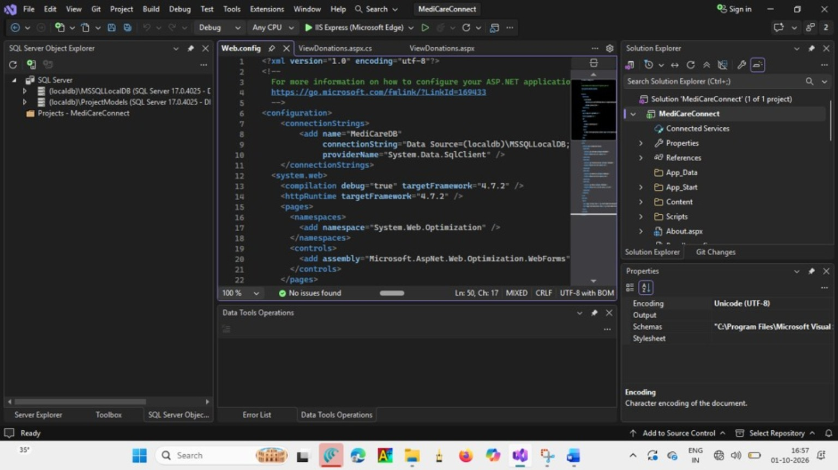

Image 2 – Welcome Page (welcome.aspx): MediCareConnect Home Page Design
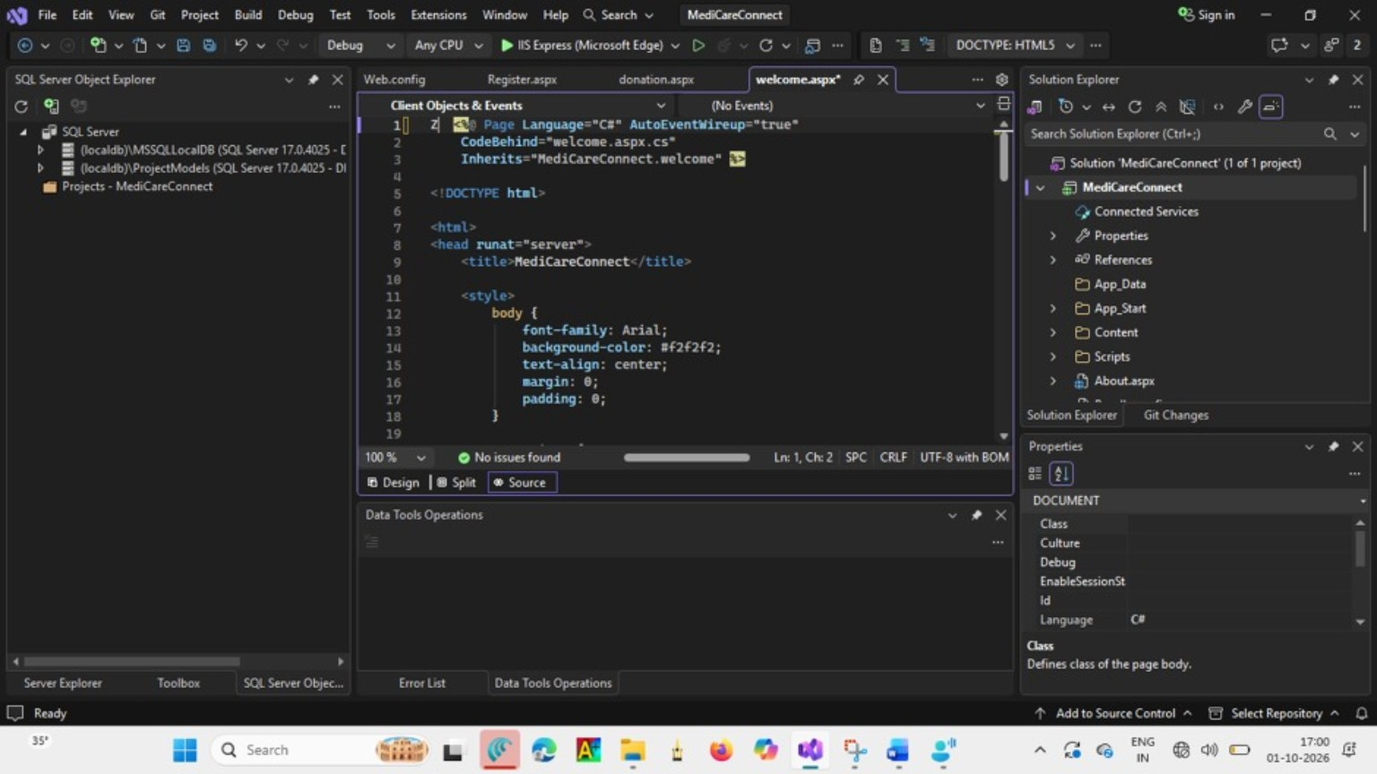

Image 3 – Donation Page (donation.aspx): Make Donation Form
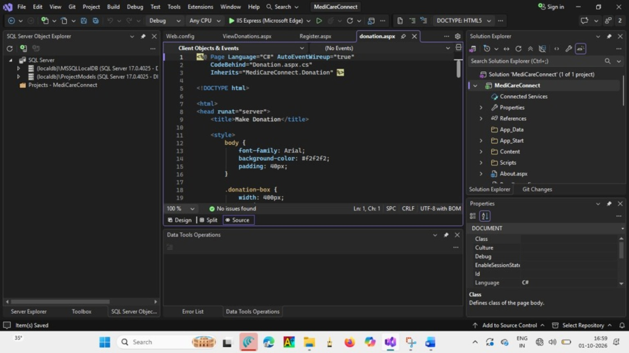

Image 4 – View Donations Page (ViewDonations.aspx): Donation Records Display
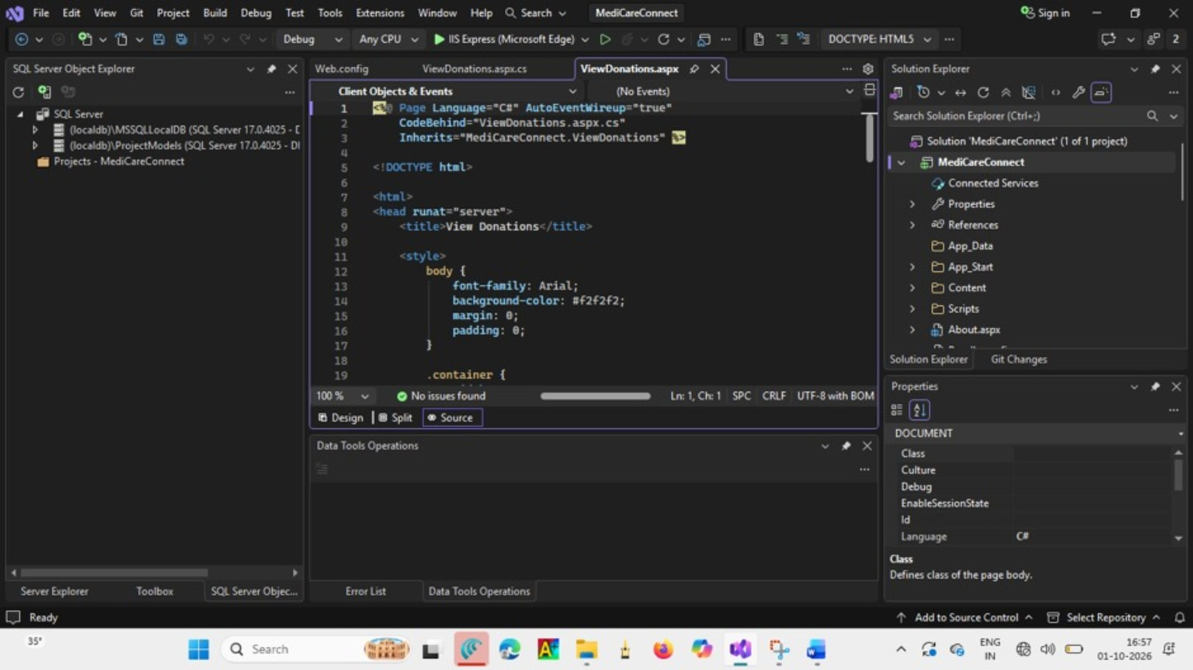

Image 5 – ViewDonations.aspx.cs: C# Code for Loading Donation Data
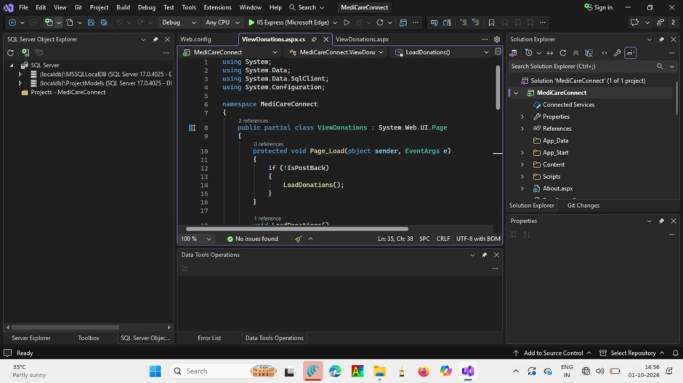

Image 6 – Register Page (Register.aspx): Donor Registration Form
