MediCareConnect – Healthcare Donation Development System
Project Screenshots with Subtitles
1. Welcome Page – MediCareConnect
The welcome page provides an overview of the MediCareConnect platform and highlights the main donation areas: medical camps, medicine support, medical equipment, and donations.
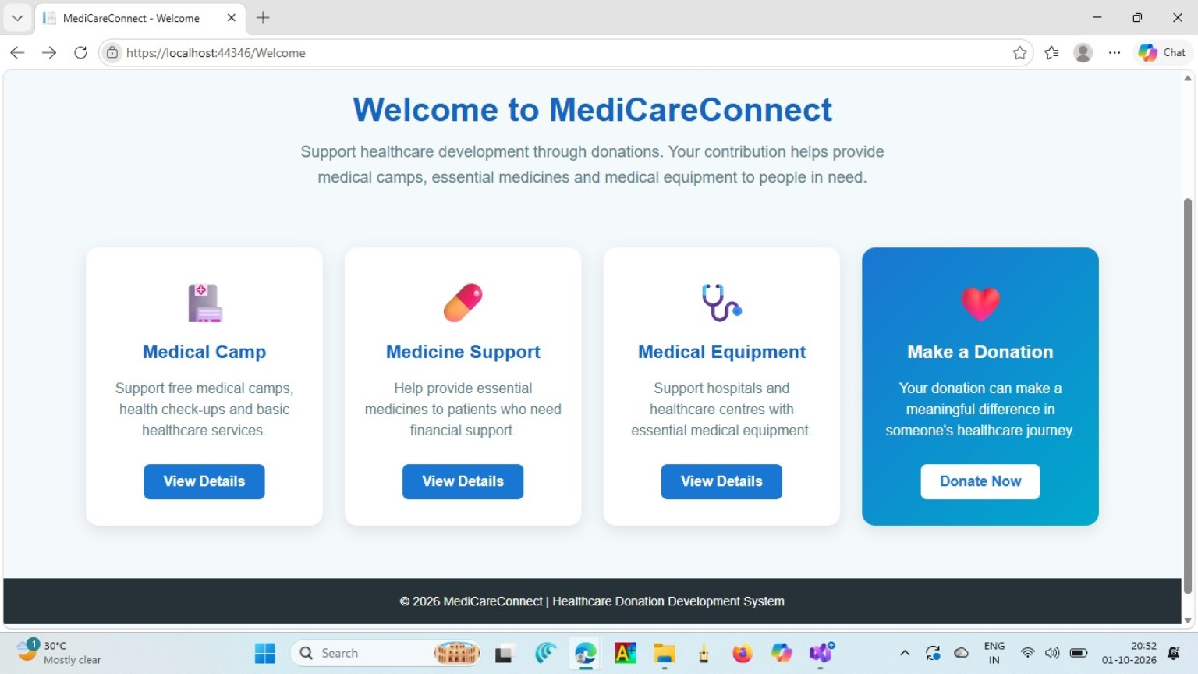

2. Medical Camp Details
The Medical Camp page displays camp information such as date, time, location, doctors available, services, beneficiaries, required donation, and purpose.
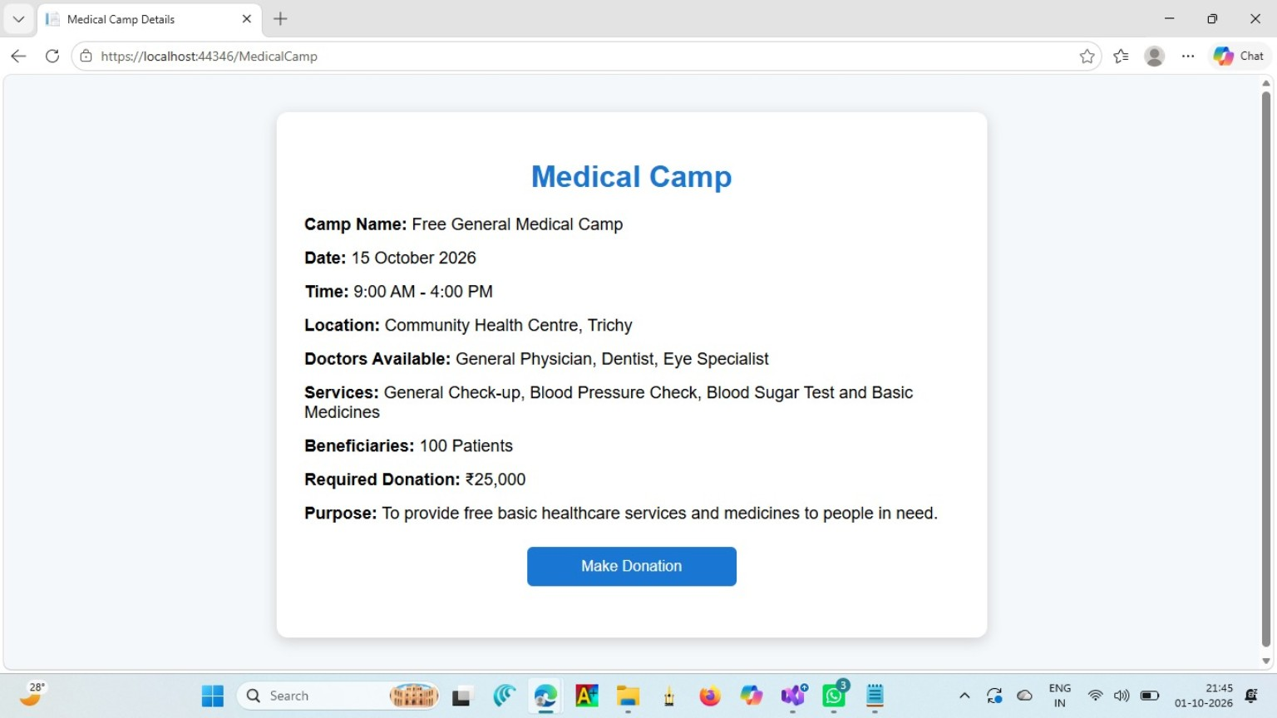

3. Donation Page – Payment Method
The Donation page allows the user to enter the donation amount and select a payment method such as UPI or Card before proceeding with the payment.
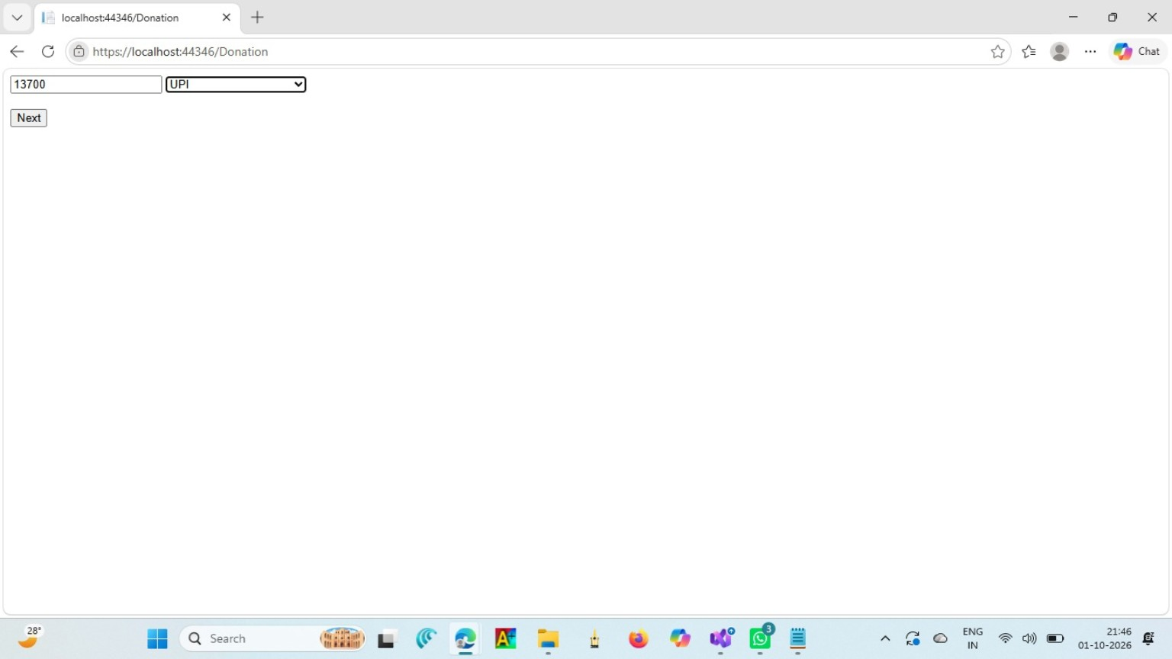

4. Medicine Support Program
The Medicine Support page explains the Essential Medicine Support program, including its purpose, medicines provided, beneficiaries, target patients, support period, and required donation.
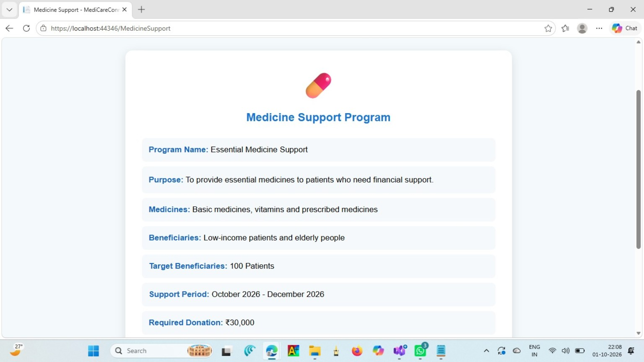

5. Donation Page – UPI QR Payment
The UPI payment screen displays a QR code that can be scanned using a UPI application to complete the donation.
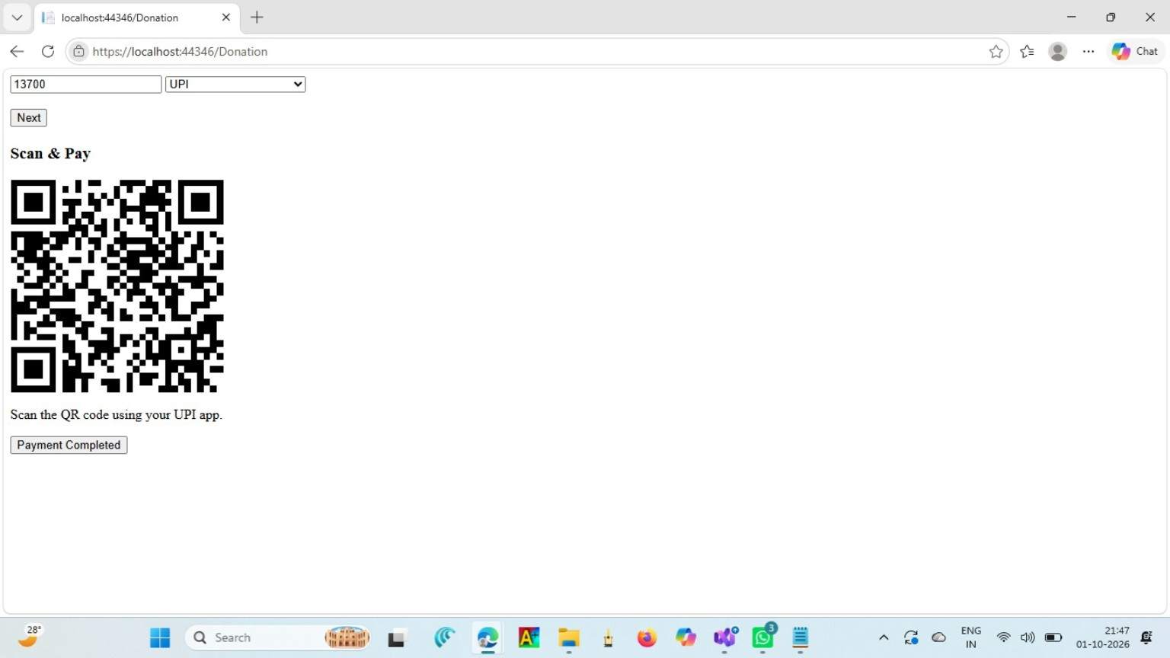

6. Medical Equipment Support
The Medical Equipment Support page describes the equipment required, beneficiaries, target healthcare centres, support period, and required donation.
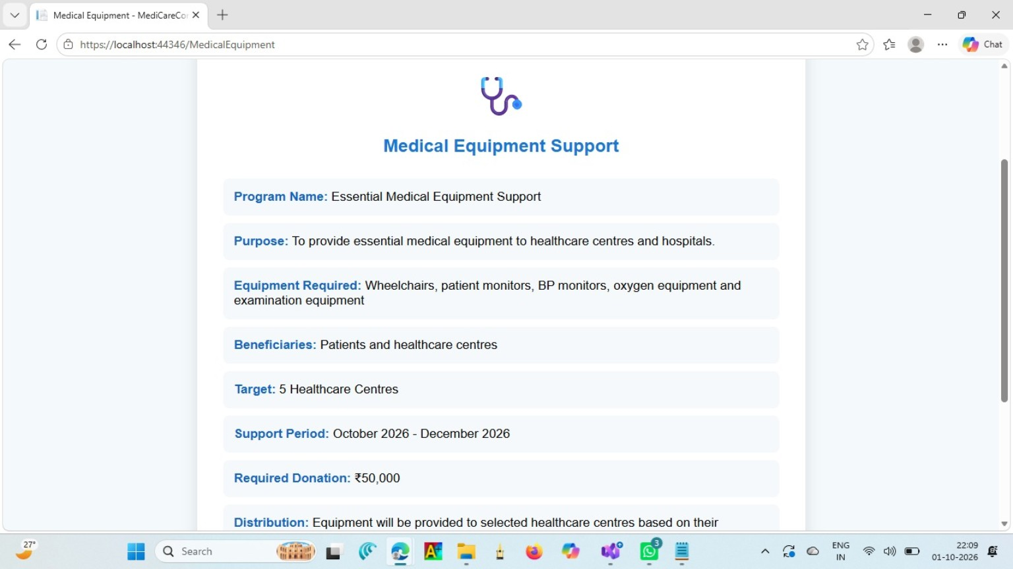

7. Donation Successful – Confirmation
The final screen confirms that the donation has been submitted successfully and displays the donated amount and selected payment method.
