**ABSTRACT**

This project, **The Republic of JAPAN** contains information on the country, Japan. The objective is to provide all those engaged in study of the country, a thorough and down-to-earth understanding of all aspects of the same.

This Project is primarily targeted at those involved in Trade with the country. This provides a comprehensive view of all the Trade aspects of JAPAN from a market perspective.

**JAPAN : THE LAND OF RISING SUN 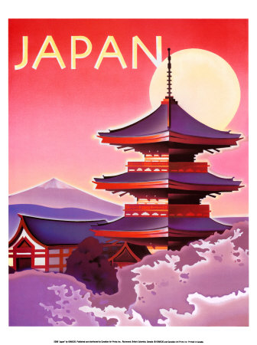**

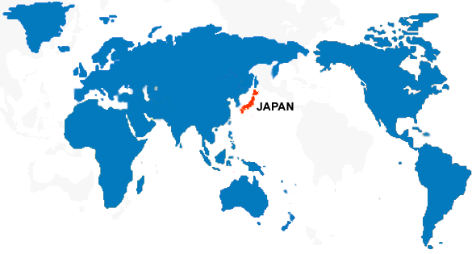

**MAP OF JAPAN**

**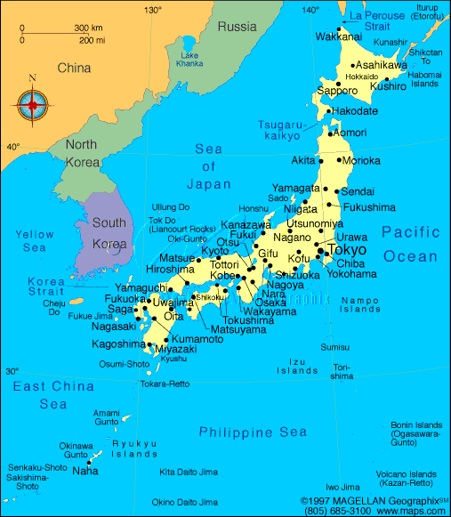**

**FLAG**

**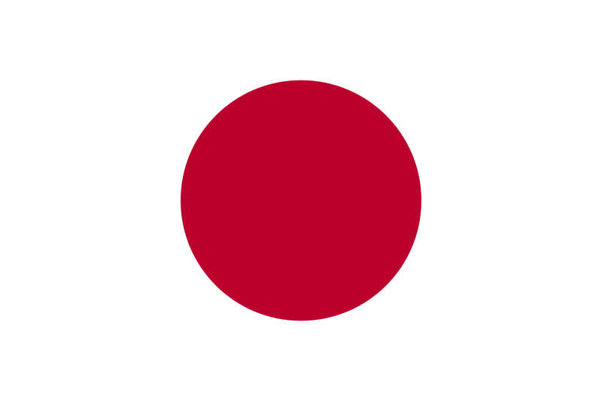**

**IMPERIAL SEAL OF JAPAN**

**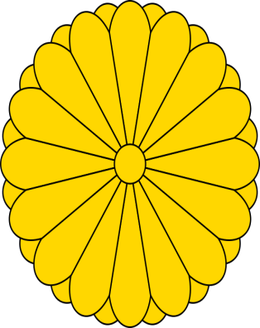**

**GOVERNMENT SEAL OF JAPAN**

**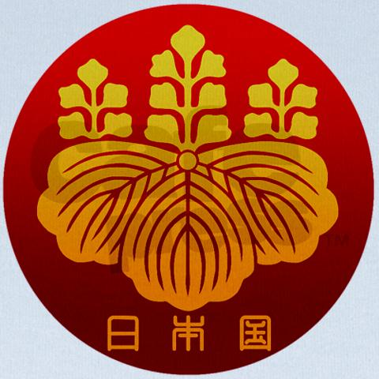**

**FACTS**

**Area**  **:** 377,944 square km (142,771 square miles)

**Population :**  127,960,000

**Emperor**  **:**  AHKHITO

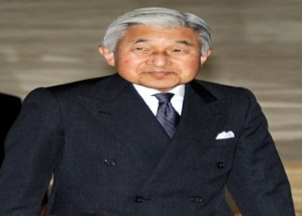

**Prime Minister**  **:** YOSHIHIKO NODA

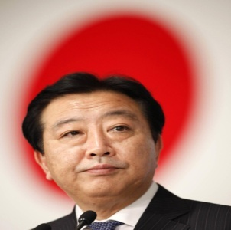

# Capital City : TOKYO

**Currency :** YEN

# stock-photo-11559132-japanese-yen-currency-symbol-over-red-map-of-japan.jpg US Dollar to Japanese currenc($ 1=76.6390)

# Japanese Yen to Indian Rupee (¥ 1 = ₨ 0.6942) Credit Rating : AAA

# Official Languages : NONE

**Government :** UNITARY PARLIAMENTARY DEMOCRACY

**National Bird: National Animal:**

**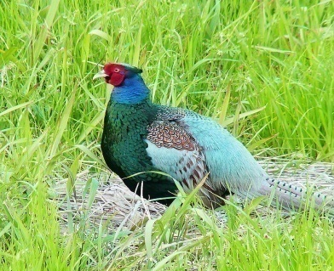 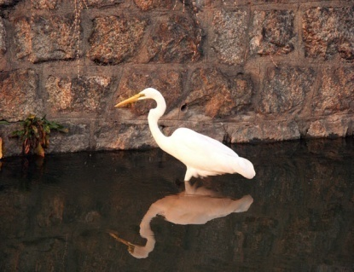**

**Green pheasant Crane**

**National Flower: National Tree:**

**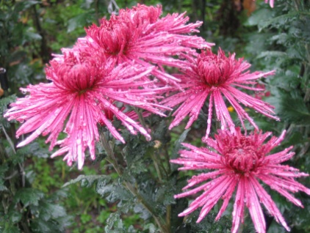 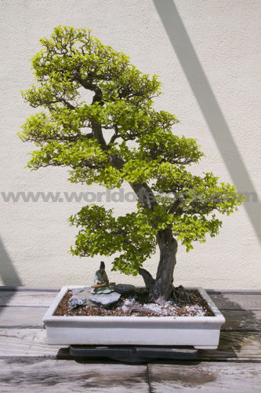**

**Chrysanthemum Cryptomeria japonica**

**INTRODUCTION**

**INTRODUCTION**

In 1603, after decades of civil warfare, the Tokugawa shogunate (a military-led, dynastic government) ushered in a long period of relative political stability and isolation from foreign influence.

For more than two centuries this policy enabled Japan to enjoy a flowering of its indigenous culture. Japan opened its ports after signing the Treaty of Kanagawa with the US in 1854 and began to intensively modernize and industrialize.

During the late 19th and early 20th centuries, Japan became a regional power that was able to defeat the forces of both China and Russia. It occupied Korea, Formosa (Taiwan), and southern Sakhalin Island.

In 1931-32 Japan occupied Manchuria, and in 1937 it launched a full-scale invasion of China.

Japan attacked US forces in 1941 - triggering America's entry into World War II - and soon occupied much of East and Southeast Asia.

After its defeat in World War II, Japan recovered to become an economic power and an ally of the US. While the emperor retains his throne as a symbol of national unity, elected politicians hold actual decision-making power.

Following three decades of unprecedented growth, Japan's economy experienced a major slowdown starting in the 1990s, but the country remains a major economic power.

In March 2011, Japan's strongest-ever earthquake, and an accompanying tsunami, devastated the northeast part of Honshu island, killing thousands and damaging several nuclear power plants.

The catastrophe hobbled the country's economy and its energy infrastructure, and tested its ability to deal with humanitarian disasters

**HISTORY**

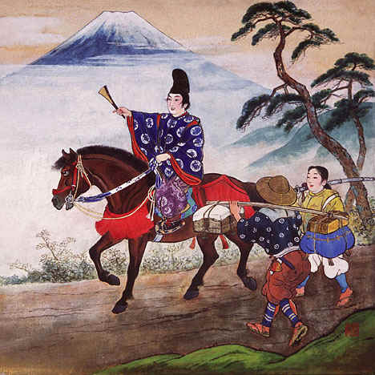

* Japan is one of the world's most ethnically and culturally homogeneous nations, but down the ages its culture and society have been greatly influenced by foreign ideas and institutions, art and literature.
* The wholesale importation of Chinese religious and political institutions during the sixth century was followed by a long and essentially 'Japanese' feudal period, which was to last until the 19th century.
* The Meiji Restoration of 1868 brought to power rulers dedicated to the pursuit of national modernization, under whose guidance Japan quickly became a world power. Although Japan's subsequent bid for empire ended in disaster, the years after 1945 witnessed an economic miracle which brought spectacular wealth as well as the westernization of much of Japanese life
* Asuka period 538 to 710
* Nara period 710 to 794
* Heian period 794 to 1185
* Feudal Japan 1185 to 1868
* Kamakura period 1185 to 1333
* Muromachi period 1336 to 1573
* Sengoku period 1467 to 1573
* Azuchi-Momoyama period 1568 to 1603
* Edo period 1603 to 1868
* Empire of Japan 1868 to194

**WORLD WAR 1 :**

Imperial, territorial, and economic rivalries led to the “Great War” between the Central Powers (Austria-Hungary, Germany, Bulgaria, and Turkey) and the Allies (U.S., Britain, France, Russia, Belgium, Serbia, Greece, Romania, Montenegro, Portugal, Italy, and Japan). About 10 million combatants killed, 20 million wounded.

**1914**

Austrian Archduke Francis Ferdinand and wife assassinated in Sarajevo by Serbian nationalist (June 28). Austria declares war on Serbia (July 28). Germany declares war on Russia (Aug. 1), on France (Aug. 3), invades Belgium (Aug. 4). Britain declares war on Germany (Aug. 4). Germans defeat Russians in Battle of Tannenberg on Eastern Front (Aug.). First Battle of the Marn (Sept.). German drive stopped 25 miles from Paris. By end of year, war on the Western Front is “positional” in the trenches.

**1915**

German submarine blockade of Great Britain begins (Feb.). Dardanelles Campaign—British land in Turkey (April), withdraw from Gallipoli (Dec.–Jan. 1916). Germans use gas at second Battle of Ypres (April–May). Lusitania sunk by German submarine—1,198 lost, including 128 Americans (May 7). On Eastern Front, German and Austrian “great offensive” conquers all of Poland and Lithuania; Russians lose 1 million men (by Sept. 6). “Great Fall Offensive” by Allies results in little change from 1914 (Sept.–Oct.). Britain and France declare war on Bulgaria (Oct. 14).

**1916**

Battle of Verdun—Germans and French each lose about 350,000 men (Feb.). Extended submarine warfare begins (March). British-German sea battle of Jutland (May); British lose more ships, but German fleet never ventures forth again. On Eastern Front, the Brusilov offensive demoralizes Russians, costs them 1 million men (June–Sept.). Battle of the Somme—British lose over 400,000; French, 200,000; Germans, about 450,000; all with no strategic results (July–Nov.). Romania declares war on Austria-Hungary (Aug. 27). Bucharest captured (Dec.).

**1917**

U.S. declares war on Germany (April 6). Submarine warfare at peak (April) On Italian Front, Battle of Caporetto Italians retreat, losing 600,000 prisoners and deserters (Oct.–Dec.. On Western Front, Battles of Arras, Champagne, Ypres (third battle), etc. First large British tank attack (Nov.). U.S. declares war on Austria-Hungary (Dec. 7). Armistice between new Russian Bolshevik government and Germans (Dec. 15)

**1918**

Great offensive by Germans (March–June) Americans' first important battle role at Château-Thierry—as they and French stop German advance (June). Second Battle of the Marne (July–Aug ) start of Allied offensive at Amiens, St. Mihiel, etc. Battles of the Argonne and Ypres panic German leadership (Sept.–Oct.). British offensive in Palestin (Sept.). Germans ask for armistice (Oct. 4). British armistice with Turkey (Oct.) German Kaiser abdicates (Nov.). Hostilities cease on Western Front (Nov. 11).

**World War II**

* It was a global conflict that was underway by 1939 and ended in 1945. It involved most of the world's nations including all of the great powers eventually forming two opposing military alliances: the Allies and the Axis.
* It was the most widespread war in history, with more than 100 million military personnel mobilized.
* It is the deadliest conflict in human history, resulting in 50 million to over 70 million fatalities.
* Although Japan was already at war with China in 1937, the world war is generally said to have begun on 1 September 1939, with the invasion of Poland by Germany, and subsequent declarations of war on Germany by France and most of the countries of the British Empire and Commonwealth. Germany set out to establish a large empire in Europe.
* From late 1939 to early 1941, in a series of campaigns and treaties, Germany conquered or subdued much of continental Europe; amid Nazi-Soviet agreements, the nominally neutral Soviet Union fully or partially occupied and annexed territories of its six European neighbors, including Poland.
* Britain and the Commonwealth remained the only major force continuing the fight against the Axis in North Africa and in extensive naval warfare.
* In June 1941, the European Axis launched an invasion of the Soviet Union, giving a start to the largest land theatre of war in history, which, from that moment on, tied down the major part of the Axis military power.
* In December 1941, Japan, which aimed to dominate Asia, attacked the United States and European possessions in the Pacific Ocean, quickly conquering much of the region.
* The Axis advance was stopped in 1942 after the defeat of Japan in a series of naval battles and after defeats of European Axis troops in North Africa and, decisively, at Stalingrad.
* In 1943, with a series of German defeats in Eastern Europe, the Allied invasion of Fascist Italy, and American victories in the Pacific, the Axis lost the initiative and undertook strategic retreat on all fronts.
* In 1944, the Western Allies invaded France, while the Soviet Union regained all territorial losses and invaded Germany and its allies.
* The war in Europe ended with the capture of Berlin by Soviet and Polish troops and the subsequent German unconditional surrender on 8 May 1945.
* The Japanese Navy was defeated by the United States, and invasion of the Japanese Archipelago became imminent.
* The war in Asia ended on 15 August 1945 when Japan agreed to surrender.
* The war ended with the total victory of the Allies over the Axis in 1945.
* World War II altered the political alignment and social structure of the world.
* The United Nations (UN) organization was established to foster international cooperation and prevent future conflicts.
* The Soviet Union and the United States emerged as rival superpowers, setting the stage for the Cold War, which lasted for the next 46 years.

**GEOGRAPHY**

* Japan has a total of 6,852 islands extending along the Pacific coast of Asia. The country, including all of the islands it controls, lies between latitudes 24° and 46°N, and longitudes 122° and 146°E.
* The main islands, from north to south are HOKKAIDO, HONSHU, SHIKOKU and KYUSHU The RYUKU ISLANDS including OKINAWA, are a chain to the south of KYUSHU Together they are often known as the JAPANESE ARCHIPELAGO .
* About 73 percent of Japan is forested, mountainous, and unsuitable for agricultural, industrial, or residential use.
* The habitable zones, mainly located in coastal areas, have extremely high population densities. Japan is one of the most densely populated countries in the world.
* The islands of Japan are located in a volcanic zone on the Pacific Ring of Fire. They are primarily the result of large oceanic movements occurring over hundreds of millions of years from the mid-Silurian to the Pleistocene as a result of the subduction of the Philippine Sea Plate beneath the continental Amurian Plate and Okinawa Plate to the south, and subduction of the Pacific Plate under the Okhotsk Plate to the north.
* Japan was originally attached to the eastern coast of the Eurasian continent. The subducting plates pulled Japan eastward, opening the Sea of Japan around 15 million years ago.
* Japan has 108 active volcanoes. Destructive earthquakes, often resulting in tsunami, occur several times each century.[]](http://en.wikipedia.org/wiki/Japan#cite_note-77)
* The 1923 Tokyo earthquake killed over 140,000 people. More recent major quakes are the 1995 Great Hanshin earthquake and the 2011 Tōhoku earthquake, a 9.0-magnitude quake which hit Japan on March 11, 2011, and triggered a large tsunami

[Geographic Regions](http://www.photius.com/countries/japan/geography/japan_geography_geographic_regions.html)

1.Hokkaido 2. [Chubu](http://www.photius.com/countries/japan/geography/japan_geography_chubu.html) 3. [Tohoku](http://www.photius.com/countries/japan/geography/japan_geography_tohoku.html) 4. Shikoku 5. Ryukyu Islands 6. [Kanto](http://www.photius.com/countries/japan/geography/japan_geography_kanto.html) 7. [Kinki](http://www.photius.com/countries/japan/geography/japan_geography_kinki.html) 8.[Chugoku](http://www.photius.com/countries/japan/geography/japan_geography_chugoku.html) 9.kyushu

**CLIMATE**

The climate of Japan is predominantly temperate, but varies greatly from north to south.

Japan's geographical features divide it into six principal climatic zones:

**HOKKAIDO:**

The northernmost zone, Hokkaido, has a temperate climate with long, cold winters and cool summers. Precipitation is not heavy, but the islands usually develop deep snow banks in the winter.

**SEA OF JAPAN ZONE:**

In the Sea of Japan zone on Honshu west coast, northwest winter winds bring heavy snowfall.

In the summer, the region is cooler than the Pacific area, though it sometimes experiences extremely hot temperatures because of the wind.

**CENTRAL HIGHLAND:**

The Central Highland has a typical inland climate, with large temperature differences between summer and winter, and between day and night; precipitation is light.

**SETO INLAND SEA**

The mountains of the Chugoku and Shikoku regions shelter the Seto Inland Sea from seasonal winds, bringing mild weather year-round

**PACIFIC OCEAN**

The Pacific coast experiences cold winters with little snowfall and hot, humid summers because of the southeast seasonal wind.

**RYUKYU ISLANDS**

The Ryukyu Islands have a subtropical climate, with warm winters and hot summers. Precipitation is very heavy, especially during the rainy season.[

Average winter temperature in Japan is 5.1 °C (41.2 °F)

Average summer temperature is 25.2 °C (77.4 °F).

**TOPOGRAPHY**

* The Japanese archipelago is located approximately 20-45 degrees north off the eastern coast of the Asian continent.
* It comprises four main islands: Hokkaido, Honshu, Shikoku and Kyushu, plus thousands of other smaller ones.
* Honshu accounts for about 60 per cent of the total area of approximately 378,000 square km, of which around
  + - 66 % - Forest,
    - 14 % - Agricultural use and
    - 20 % - Other purposes.
* In terms of overall land mass, Japan is slightly larger than the United Kingdom.
* Japan is located in a region where several continental plates meet the country experiences an average of 1,500 earthquakes each year representing a tenth of the earth's seismic energy where no fewer than 194 volcanoes, 52 of whichhave been active in historical times. Japan's most famous volcano and highest mountain is Mount Fuji

**Languages:**  Japanese

|  |  |
| --- | --- |
| **RELIGION** | **POPULATION** |
| SHINTOISM | **106.8 MILLION (83.9%)** |
| BUDDHISM | **89. 2 MILLION( 71.4%)** |
| CHRISTIANITY | **3.0 MILLION (2%)** |
| OTHERS | **93.8 MILLION(7.8%)** |

**DEMOGRAPHICS**

* Japan’s population is estimated at around 127.3 million.
* Japanese society is linguistically and culturally homogeneous, composed of 98.5% ethnic Japanese with small populations of foreign workers.
* 134,700 non-Latin American Western and
* 345,500 Latin American expatriates,
* 274,700   Brazilians & the largest community of Westerners.
* Japan has the longest overall life expectancy rate of any country in the world.
* Immigration and birth incentives are sometimes suggested as a solution to provide younger workers to support the nation's aging population.
* Japan suffers from a high suicide rate In 2009, the number of suicides exceeded 30,000 for the twelfth straight year. Suicide is the leading cause of death for people under 30.

|  |  |  |  |  |  |  |  |  |  |
| --- | --- | --- | --- | --- | --- | --- | --- | --- | --- |
| **Largest cities of Japan** | | | | | | | | | |
|  | **RANK** | [**City name**](http://en.wikipedia.org/wiki/List_of_cities_in_Japan) | [**Prefecture**](http://en.wikipedia.org/wiki/Prefectures_of_Japan) | [**Pop.**](http://en.wikipedia.org/wiki/List_of_cities_in_Japan_by_population) | [**Rank**](http://en.wikipedia.org/wiki/List_of_cities_in_Japan_by_population) | [**City name**](http://en.wikipedia.org/wiki/List_of_cities_in_Japan) | [**Prefecture**](http://en.wikipedia.org/wiki/Prefectures_of_Japan) | [**Pop.**](http://en.wikipedia.org/wiki/List_of_cities_in_Japan_by_population) |  |
| [Tokyo](http://en.wikipedia.org/wiki/File:TokyoMetropolitanGovernmentOffice.jpg) [Tokyo](http://en.wikipedia.org/wiki/Tokyo)  [Yokohama](http://en.wikipedia.org/wiki/File:Yokohama_MinatoMirai21.jpg) [Yokohama](http://en.wikipedia.org/wiki/Yokohama) | 1 | [**Tokyo**](http://en.wikipedia.org/wiki/Tokyo) | [Tokyo](http://en.wikipedia.org/wiki/Tokyo) | 8,949,447 | 11 | [**Hiroshima**](http://en.wikipedia.org/wiki/Hiroshima) | [Hiroshima](http://en.wikipedia.org/wiki/Hiroshima_Prefecture) | 1,174,209 | [Osaka](http://en.wikipedia.org/wiki/File:Osaka_Castle_03bs3200.jpg) [Osaka](http://en.wikipedia.org/wiki/Osaka)  [Nagoya](http://en.wikipedia.org/wiki/File:Nagoya_Port_02.jpg) [Nagoya](http://en.wikipedia.org/wiki/Nagoya) |
| 2 | [**Yokohama**](http://en.wikipedia.org/wiki/Yokohama) | [Kanagawa](http://en.wikipedia.org/wiki/Kanagawa_Prefecture) | 3,689,603 | 12 | [**Sendai**](http://en.wikipedia.org/wiki/Sendai) | [Miyagi](http://en.wikipedia.org/wiki/Miyagi_Prefecture) | 1,045,903 |
| 3 | [**Osaka**](http://en.wikipedia.org/wiki/Osaka) | [Osaka](http://en.wikipedia.org/wiki/Osaka_Prefecture) | 2,666,371 | 13 | [**Kitakyūshū**](http://en.wikipedia.org/wiki/Kitaky%C5%ABsh%C5%AB) | [Fukuoka](http://en.wikipedia.org/wiki/Fukuoka) | 977,288 |
| 4 | [**Nagoya**](http://en.wikipedia.org/wiki/Nagoya) | [Aichi](http://en.wikipedia.org/wiki/Aichi_Prefecture) | 2,263,907 | 14 | [**Chiba**](http://en.wikipedia.org/wiki/Chiba,_Chiba) | [Chiba](http://en.wikipedia.org/wiki/Chiba_Prefecture) | 962,130 |
| 5 | [**Sapporo**](http://en.wikipedia.org/wiki/Sapporo) | [Hokkaidō](http://en.wikipedia.org/wiki/Hokkaid%C5%8D) | 1,914,434 | 15 | [**Sakai**](http://en.wikipedia.org/wiki/Sakai,_Osaka) | [Osaka](http://en.wikipedia.org/wiki/Osaka_Prefecture) | 842,134 |
| 6 | [**Kōbe**](http://en.wikipedia.org/wiki/K%C5%8Dbe) | [Hyōgo](http://en.wikipedia.org/wiki/Hy%C5%8Dgo_Prefecture) | 1,544,873 | 16 | [**Niigata**](http://en.wikipedia.org/wiki/Niigata,_Niigata) | [Niigata](http://en.wikipedia.org/wiki/Niigata_Prefecture) | 812,192 |
| 7 | [**Kyōto**](http://en.wikipedia.org/wiki/Ky%C5%8Dto) | [Kyōto](http://en.wikipedia.org/wiki/Kyoto_Prefecture) | 1,474,473 | 17 | [**Hamamatsu**](http://en.wikipedia.org/wiki/Hamamatsu,_Shizuoka) | [Shizuoka](http://en.wikipedia.org/wiki/Shizuoka_Prefecture) | 800,912 |
| 8 | [**Fukuoka**](http://en.wikipedia.org/wiki/Fukuoka,_Fukuoka) | [Fukuoka](http://en.wikipedia.org/wiki/Fukuoka_Prefecture) | 1,463,826 | 18 | [**Kumamoto**](http://en.wikipedia.org/wiki/Kumamoto,_Kumamoto) | [Kumamoto](http://en.wikipedia.org/wiki/Kumamoto_Prefecture) | 734,294 |
| 9 | [**Kawasaki**](http://en.wikipedia.org/wiki/Kawasaki,_Kanagawa) | [Kanagawa](http://en.wikipedia.org/wiki/Kanagawa) | 1,425,678 | 19 | [**Sagamihara**](http://en.wikipedia.org/wiki/Sagamihara,_Kanagawa) | [Kanagawa](http://en.wikipedia.org/wiki/Kanagawa) | 717,561 |
| 10 | [**Saitama**](http://en.wikipedia.org/wiki/Saitama,_Saitama) | [Saitama](http://en.wikipedia.org/wiki/Saitama_Prefecture) | 1,222,910 | 20 | [**Shizuoka**](http://en.wikipedia.org/wiki/Shizuoka,_Shizuoka) | [Shizuoka](http://en.wikipedia.org/wiki/Shizuoka_Prefecture) | 716,328 |

**GOVERNMENT AND POLITICS**

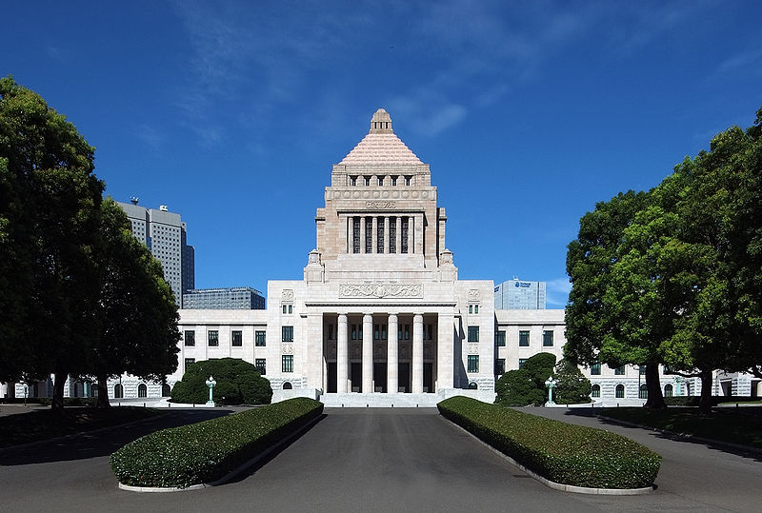

The current Japanese constitution was promulgated in the year 1946 during the occupation by the Allied powers:

**Legislature**:   
The Japanese parliament is called the **Diet**. It consists of the **House of Representatives** (480 members) and the **House of Counselors** (242 members). The members of the Diet are elected by the Japanese people.

**Executive**:   
The **cabinet** is headed by the Prime Minister. The cabinet further consists of the ministers which are appointed by the prime minister and are usually members of the Diet. The prime minister is elected by the Diet.

**Judiciary**:   
The highest court is the Supreme Court. Other courts are district courts, high courts, family courts, and summary courts. Judges are appointed by the cabinet.

**Elections**:   
The minimum voting age is 20 years. Women received the right to vote in the new constitution. Elections for the House of Representatives are carried out every four years, and half of the House of Counselors is elected every three years. Beside the national elections there are prefectural and municipal elections.

**Major Political Parties:**

 DPJ - Democratic Party of Japan

LDP - Liberal Democratic Party

JCP - Japan Communist Party & SDP - Social Democratic party

**ECONOMY**

## **Japan is the 3rd largest economy in the world behind the US and China.** In 2010, Japan's GDP (Current Prices, US dollars) was US$5.458 trillion and its GDP (PPP) was US$4.309 trillion.

Much of Japan’s modern economic success can be traced to two significant periods in its history- the pre-war Meiji Era and the post-war Economic Miracle.

**The Japanese were one of the earliest nations in Asia to industrialise.** During the Meiji restoration period in the mid 19th century, the Japanese government actively pursued Western-style reforms and development – hiring more than 3,000 Westerners to teach modern science, mathematics and technology to Japan.

The Meiji government also created a conducive business environment for private businesses to thrive. Shipyards and factories were built by the government and sold at extremely low prices to entrepreneurs. These entrepreneurs eventually began businesses that quickly expanded into conglomerates known as the Zaibatsu.The Zaibatsu controlled much of Japan’s economic and industrial activity.

By the start of World War II, the Big Four Zaibatsu – Mitsubishi, Mitsui, Sumitomo and Yasuda – had control of over more than 30 percent of Japan's mining, chemical, metals industries, 50 percent of the machinery and equipment market, and 60 percent of the commercial stock exchange. The Zaibatsu also developed interlocking relationships among themselves and Japanese policy makers, thus allowing them a level of control over government policies.

Although World War II devastated most of the Japanese economy, the social foundations laid down during the Meiji Era contributed to the post-war economic miracle from the 1960s to the 1980s. New constitutional and economic policies implemented by the US during the American occupation of 1945-1952, also contributed to the eventual recovery of the Japanese economy. Furthermore, although there were attempts to dissolve the Zaibatsu system, **the Zaibatsu managed to evolved into the Keiretsu with the six major Keiretsu being Mitsubishi, Sumitomo, Fuyo, Mitsui, Dai-ichi Kangyo and Sanwa Groups.**

**However the greatest contributing factor of the Japanese Economic Miracle was the establishment of the Ministry of International Trade and Industry (MITI) in 1949.** MITI implemented numerous policies that led to heavy industrial growth in Japan. Many scholars have described MITI to have had the greatest impact on the economy of a nation than any other governmental regulation or organisation in the world. According to prominent political scientist Chalmers Johnson, author of MITI and the Japanese Miracle, **“MITI formalized cooperation between the Japanese government and private industry. The extent of the policy was such that if MITI wished to “double steel production, the neo-zaibatsu (keiretsu) already has the capital, the construction assets, the makers of production machinery, and most of the other necessary factors already available in-house”.**

During the post-war economic miracle from the 1960s to the 1990s, Japan experienced huge economic growth – at an average of 10 percent annually in the 1960s, 5 percent in the 1970s, and 4 percent in the 1980s.

Growth in the 1990s slowed down largely due to the asset price bubble in late 1980s, and the crash of the Tokyo Stock Exchange in 1990-92. This period is termed as the “Lost Decade” in Japan.

In the aftermath of the 2008 global financial crisis, the Japanese economy began to undergo a strong period of economic recovery.

In 2010, Japan’s real GDP growth (constant prices, national currency) was 3.938 percent – the fastest growing economy among the G-7 nations for the year.

The 2011 Japanese earthquake and tsunami has threatened to derail Japan’s economic growth. **On April 2011, the Japanese government was forced to downgrade its assessment of the economy for the first time in six months.** According to the Economics Minister Kaoru Yosano, “The biggest risks, or uncertain factors for the economy, are when power supplies will recover and whether the nuclear situation will keep from worsening."

The 2011 earthquake and tsunami in Japan is expected to result in US$235-310 billion worth of damages. The Bank of Japan has injected more than ¥325 billion into the economy to stabilize the financial market and slow down the appreciation of the yen.

[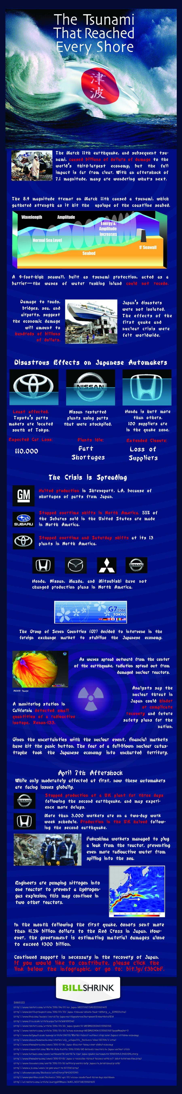](http://www.billshrink.com/blog/11489/japan-tsunami-economic-cost/)

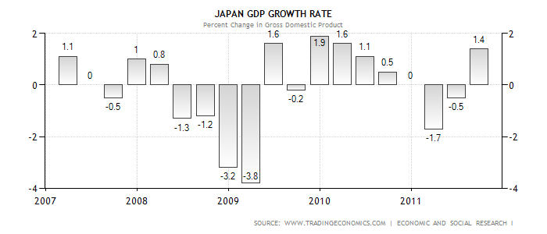

|  |
| --- |
|  |

* The Gross Domestic Product (GDP) in Japan expanded 1.40 percent in the third quarter of 2011 over the previous quarter.
* Japan's industrialized, free market economy is the second-largest in the world. Its economy is highly efficient and competitive in areas linked to international trade, but productivity is far lower in protected areas such as agriculture, distribution, and services.
* Japan's reservoir of industrial leadership and technicians, well-educated and industrious work force, high savings and investment rates, and intensive promotion of industrial development and foreign trade produced a mature industrial economy.
* Japan has few natural resources, and trade helps it earn the foreign exchange needed to purchase raw materials for its economy.

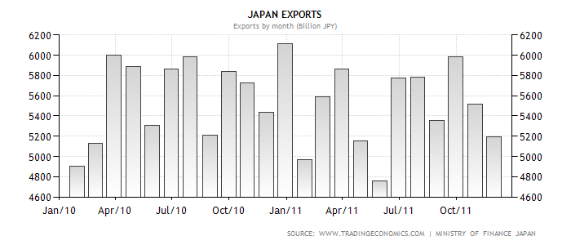

[**Exports - commodities:**](http://www.theodora.com/wfb/wfb2000/definitions.html#exports_commodities)

Transport equipment

Motor vehicles,

Semiconductors,

Electrical machinery

Chemicals

[**Exports - partners:**](http://www.theodora.com/wfb/wfb2000/definitions.html#exports_partners)

China 18.88%,

US 16.42%,

South Korea 8.13%,

Taiwan 6.27%,

Hong Kong 5.49%

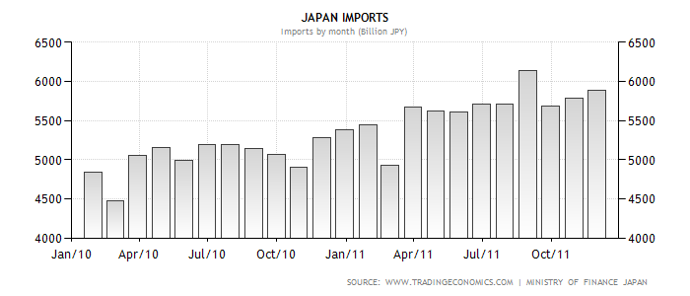

[**Imports - commodities:**](http://www.theodora.com/wfb/wfb2000/definitions.html#imports_commodities)  
machinery and equipment

fuels

foodstuffs

chemicals

textiles

raw materials

[**Imports - partners:**](http://www.theodora.com/wfb/wfb2000/definitions.html#imports_partners)  
China 22.2%

US 10.96%

Australia 6.29%

Saudi Arabia 5.29%

UAE 4.12%

South Korea 3.98%

|  |  |
| --- | --- |
| Trade organizations | APEC, WTO, OECD, G-20, G8 and others Statistics |
| Fiscal year | 1 April - 31 March |
| GDP | $5.458 trillion,$4.309 trillion (PPP) |
| GDP growth | 0.3% |
| GDP per capita | $ 42,820 ,$33,805 (PPP) |
| GDP by sector |  |
| services | 75.7% |
| Industry: | 22.8%, |
| Agriculture | 1.5% |
| Inflation | 0.3% |

|  |  |
| --- | --- |
| CREDIT RATING |  |
| Standard & Poor's | AA- (Domestic) AA- (Foreign)  AAA (T&C Assessment) |
| Outlook | stable |
| Moody's: | Aa2 |
| Outlook | Negative |
| Fitch: | AA |
| Outlook: | Stable |
| Foreign reserves | US$1.154 |

**STOCK EXCHANGE**

| **Rank** | **Economy** | **Stock Exchange** | **Location** | **Market Capitalization (**[**USD**](http://en.wikipedia.org/wiki/United_States_Dollar)**Billions)** | **Trade Value (USD Billions)** |
| --- | --- | --- | --- | --- | --- |
| 1 | http://upload.wikimedia.org/wikipedia/en/thumb/a/a4/Flag_of_the_United_States.svg/22px-Flag_of_the_United_States.svg.png [United States](http://en.wikipedia.org/wiki/United_States) http://upload.wikimedia.org/wikipedia/commons/thumb/b/b7/Flag_of_Europe.svg/22px-Flag_of_Europe.svg.png [Europe](http://en.wikipedia.org/wiki/Europe) | [NYSE Euronext](http://en.wikipedia.org/wiki/NYSE_Euronext) | [New York City](http://en.wikipedia.org/wiki/New_York_City) | 15,970 | 19,813 |
| 2 | http://upload.wikimedia.org/wikipedia/en/thumb/a/a4/Flag_of_the_United_States.svg/22px-Flag_of_the_United_States.svg.png [United States](http://en.wikipedia.org/wiki/United_States) http://upload.wikimedia.org/wikipedia/commons/thumb/b/b7/Flag_of_Europe.svg/22px-Flag_of_Europe.svg.png [Europe](http://en.wikipedia.org/wiki/Europe) | [NASDAQ OMX](http://en.wikipedia.org/wiki/NASDAQ_OMX) | [New York City](http://en.wikipedia.org/wiki/New_York_City) | 4,931 | 13,439 |
| 3 | http://upload.wikimedia.org/wikipedia/en/thumb/9/9e/Flag_of_Japan.svg/22px-Flag_of_Japan.svg.png [Japan](http://en.wikipedia.org/wiki/Japan) | [Tokyo Stock Exchange](http://en.wikipedia.org/wiki/Tokyo_Stock_Exchange) | [Tokyo](http://en.wikipedia.org/wiki/Tokyo) | 3,827 | 3,787 |
| 4 | http://upload.wikimedia.org/wikipedia/en/thumb/a/ae/Flag_of_the_United_Kingdom.svg/22px-Flag_of_the_United_Kingdom.svg.png [United Kingdom](http://en.wikipedia.org/wiki/United_Kingdom) | [London Stock Exchange](http://en.wikipedia.org/wiki/London_Stock_Exchange) | [London](http://en.wikipedia.org/wiki/London) | 3,613 | 2,741 |
| 6 | http://upload.wikimedia.org/wikipedia/commons/thumb/f/fa/Flag_of_the_People%27s_Republic_of_China.svg/22px-Flag_of_the_People%27s_Republic_of_China.svg.png [China](http://en.wikipedia.org/wiki/China) | [Shanghai Stock Exchange](http://en.wikipedia.org/wiki/Shanghai_Stock_Exchange) | [Shanghai](http://en.wikipedia.org/wiki/Shanghai) | 2,717 | 4,496 |
| 7 | http://upload.wikimedia.org/wikipedia/commons/thumb/5/5b/Flag_of_Hong_Kong.svg/22px-Flag_of_Hong_Kong.svg.png [Hong Kong](http://en.wikipedia.org/wiki/Hong_Kong) | [Hong Kong Stock Exchange](http://en.wikipedia.org/wiki/Hong_Kong_Stock_Exchange) | [Hong Kong](http://en.wikipedia.org/wiki/Hong_Kong) | 2,711 | 1,496 |
| 8 | http://upload.wikimedia.org/wikipedia/en/thumb/c/cf/Flag_of_Canada.svg/22px-Flag_of_Canada.svg.png [Canada](http://en.wikipedia.org/wiki/Canada) | [Toronto Stock Exchange](http://en.wikipedia.org/wiki/Toronto_Stock_Exchange) | [Toronto](http://en.wikipedia.org/wiki/Toronto) | 2,170 | 1,368 |
| 9 | http://upload.wikimedia.org/wikipedia/en/thumb/4/41/Flag_of_India.svg/22px-Flag_of_India.svg.png [India](http://en.wikipedia.org/wiki/India) | [Bombay Stock Exchange](http://en.wikipedia.org/wiki/Bombay_Stock_Exchange) | [Mumbai](http://en.wikipedia.org/wiki/Mumbai) | 1,631 | 25 |

**INDUSTRY**

Despite an overall stagnation on the economy for nearly two decades, Japan’s industries are still among the most highly advanced and innovative in the world. Japanese manufacturing products, particularly in electronics and automobiles, are the world leaders in both production and technological advancements in their respective fields.

**In 2010, Industry was responsible for 23 percent of Japan's GDP**.

Japan’s automobile industry produces the second largest amount of vehicles in the world behind China. However, Japanese automobile companies remain among the most valuable and technologically advanced in the world.

**Japan is home to six of the top twenty largest vehicle manufacturers in the WORLD. 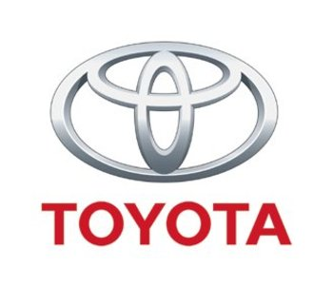 ** 

** 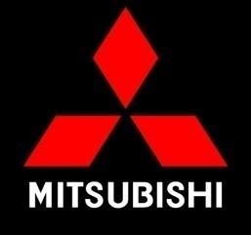**  ****

  

  

The automobile industry also managed to register a massive 10.5 percent growth in 2009, inspite of the global financial crisis.

Japanese electronic products are renowned for their innovation and quality. Backed by its high-tech industries and companies, J**apan had the 8th highest industrial production growth rate in the world for 2010 at 15.5 percent. Simultaneously, Japan’s industrial production growth rate was the highest among the G20 nations.**

**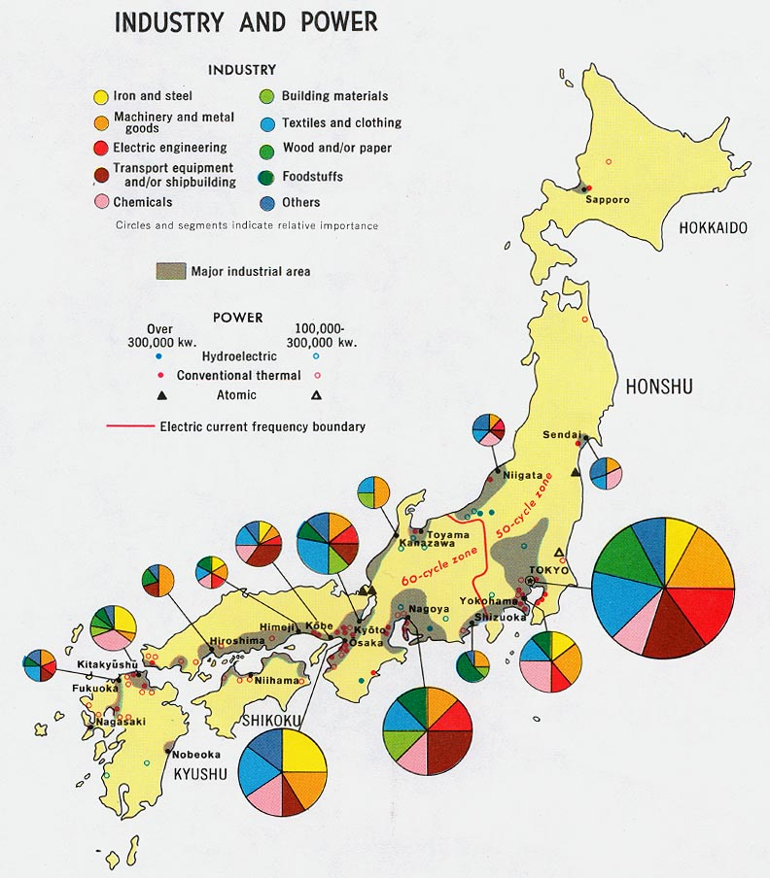**

**AGRICULTURE**:

Agriculture’s contribution to Japan’s economy is fairly small when compared to Industry and Services. In 2010, Agriculture made up only 1.1 percent of the nation’s GDP. Although its contribution appears minute, agriculture is still a highly important component of Japan’s economy and society.

Bottom of Form

* **Rice**
* **sugar**
* **Beets**
* **vegetables,**
* **fruit,**
* **Pork**
* **fish**

**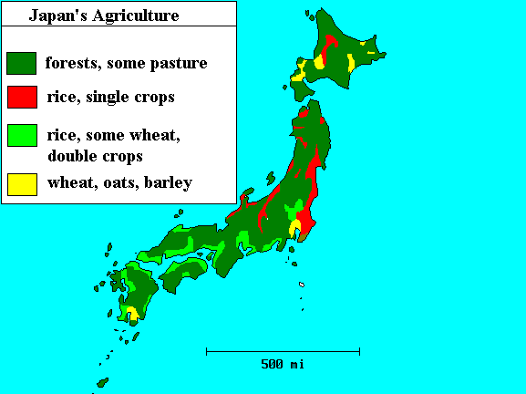**

**ROADS**

* Japan's road spending has been extensive. Its 1.2 million kilometers of paved road are the main means of transportation
* A single network of high-speed, divided, limited-access toll roads connects major cities and is operated by toll-collecting enterprises.
* New and used cars are inexpensive; car ownership fees and fuel levies are used to promote energy efficiency

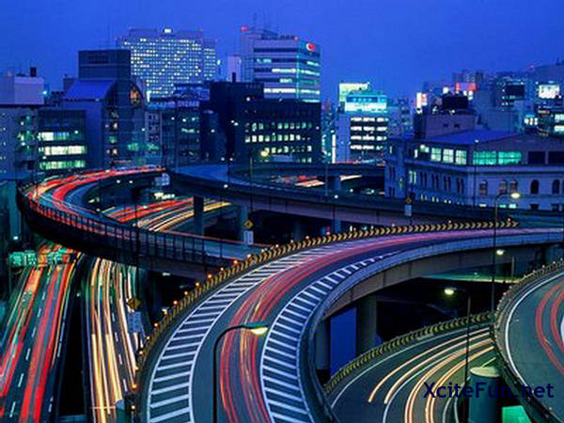

**RAILWAYS**

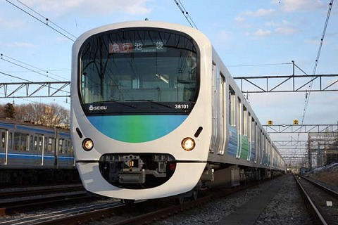

Dozens of Japanese railway companies compete in regional and local passenger transportation markets.

**Major Companies**

JR enterprises Seibu railway Keio corporation

 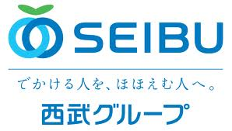 images.jpeg

Some 250 high-speed Shinkansen trains connect major cities and Japanese trains are known for their safety and punctuality.

**Shinkansen**

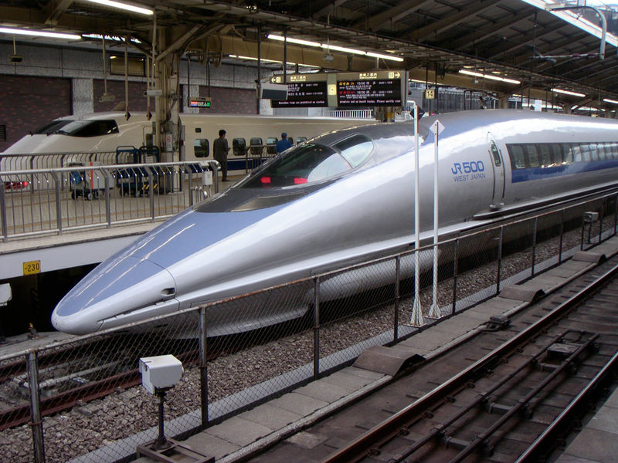

***AIRPORTS:***

HANEDA AIRPORT-Asia second biggest airport

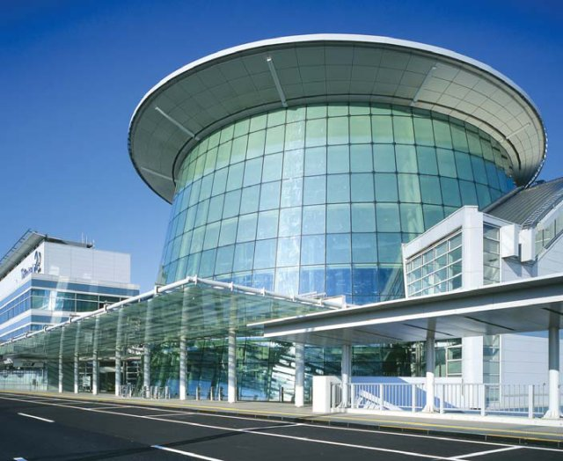

* They are 173 airports in Japan. The largest domestic airport is HANEDA AIRPORT-Asia second biggest airport
* The largest international gateway are
  + - Narita International Airport,
    - [Kansai International Airport](http://en.wikipedia.org/wiki/Kansai_International_Airport) and
    - Chubu Centre International Airport
* [Nagoya Port](http://en.wikipedia.org/wiki/Nagoya_Port) is the country's largest and busiest port, accounting for 10 percent of Japan's trade value

**SCIENCE AND TECHNOLOGY**

***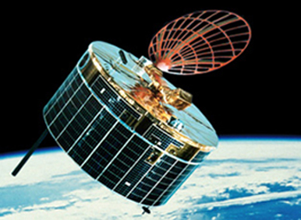***

* Japan is a leading nation in scientific research, particularly technology, machinery and Biomedical research. Nearly 700,000 researchers share a US$130 billion research and development budget, the third largest in the world.
* Some of Japan's more prominent technological contributions are in the
  + 1. Field of electronics,
    2. Automobiles, machinery,
    3. Earth quake engineering
    4. Industrial robotics
    5. Optics
    6. Chemicals
    7. Semiconductors
    8. Metals.
* Japan leads the world in robotics production and use, possessing more than half (402,200 of 742,500) of the world's industrial robots.
* The Japanese aerospace exploration agency (JAXA) is Japan's space agency; it conducts space, planetary, and aviation research, and leads development of rockets and satellites.

**INDIA AND JAPAN**

**50px-Flag_of_India.svg.png 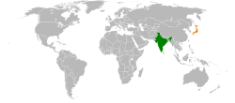 50px-Flag_of_Japan.svg.png**

Japan and India’s relationship is now making progress. Implementation of a major free trade agreement has begun. Japanese aid is financing ambitious infrastructure projects

## Detail

Japan and India have much in common.  There is a feeling on both sides that the relationship has underperformed so far.  But India’s economic growth has contributed to an increasingly significant partnership.

Since 2006, Prime Ministers and defence Ministers have met annually (PM Noda’s visit to Delhi in December 2011 being the latest), and Foreign Ministers have met twice a year.  Among India’s other partners, only Russia enjoys this frequency of exchange.

### Trade

Japan-India trade is below its potential.  Only 6% of India’s software exports go to Japan compared with over 60% to the US.  India’s exports to Japan consist mainly of iron ore, gems, and textiles.  But the Comprehensive Economic Partnership Agreement (CEPA) begun last August, which will eliminate tariffs on products equivalent to 94% of the current bilateral trade value, should change this.  India expects to increase its exports of IT services, pharmaceuticals, and agricultural produce.  The trade target of US$25bn by 2014 (from 15bn last year) is seen as realistic.  At the same time, an expanded currency swap facility (from $3bn up to $15bn) will give India some help with stabilizing the rupee.

Of particular interest is trade in rare earths.  India and Japan have announced their intention to jointly develop India’s deposits.  Japan made this more likely last September by removing the partly state-owned India Rare Earths Ltd from its export control blacklist.

### Investment and aid

Investment may be harder to increase: currently only 1% of Japan’s outward FDI goes to India.  Although some Japanese brands have a noticeable presence via joint ventures (e.g. Honda, Suzuki), Japan’s cumulative investment of US$5.5bn in the last decade puts it sixth in the ranking of investors in India, behind even the Netherlands.

Japan’s aid to India is increasingly focused on trying to address these issues.  For the last decade, it has concentrated on power, transport and water.  Japan has recently agreed to commit US$4.5bn to the hugely ambitious Delhi-Mumbai Industrial Corridor project, which aims to build over 20 new eco-friendly cities around upgraded road and rail links.  And it has begun considering a similar project between Chennai and Bangalore, where most of the Japanese firms in India are located.

Unlike in the past, Japanese aid to India is now mostly untied.  Its large quantity (India replaced China as the leading recipient in 2003), and high visibility – with projects such as the Delhi Metro – have helped Japan become one of the most favorably viewed foreign countries in India.

### Nuclear

Negotiations on a civil nuclear deal have paused for Japan to deal with its Fukushima crisis, but PM Noda made clear during his recent visit that the door remains open.  Both sides seem to be optimistic that a compromise can be found.  India needs the deal so that it can work with US companies like GE and Westinghouse which use Japanese components, and Japanese firms do not want to miss out on the opportunity.

**BILATERAL TRADE**

History

Exchange between Japan and India is said to have begun in the 6th century when Buddhism was introduced to Japan. Indian culture, filtered through Buddhism, has had a great impact on Japanese culture, and this is the source of the Japanese people's sense of closeness to India.

After World War II, in 1949, Indian Prime Minister Jawaharlal Nehru donated two Indian elephants to the Ueno Zoo in Tokyo. This brought a ray of light into the lives of the Japanese people who still had not recovered from defeat in the war. Japan and India signed a peace treaty and established diplomatic relations on 28th April, 1952. This treaty was one of the first peace treaties Japan signed after the World War II.

Ever since the establishment of diplomatic relations, the two countries have enjoyed cordial relations. In the post World War II period, India's iron ore helped a great deal Japan's recovery from the devastation. Following Japanese Prime Minister Nobusuke Kishi's visit to India in 1957, Japan started providing yen loans to India in 1958, as the first yen loan aid extended by Japanese government. Since 1986, Japan has become India's largest aid donor, and remains so.

Recent Relations

Prime Minister Mori's visit to India in August 2000 provided the momentum to strengthen the Japan-India relationship. Since then, annual meetings between prime ministers, including Prime Minister Koizumi's visit to India in April 2005, Prime Minister Singh's visit to Japan in December 2006, Prime Minister Abe's visit to India in August 2007, and Prime Minister Singh's visit to Japan in October 2008, have led to the establishment of the "Strategic and Global Partnership between Japan and India" as well as the further strengthening of the bilateral relationship. Most recently, during Prime Minister Hatoyama's visit to India in December 2009, Japan and India singed the Joint Statement "New Stage of Japan-India Strategic and Global Partnership".

### Main Elements of the Joint Statement "New Stage of Japan-India Strategic and Global Partnership"

* Bilateral Cooperation: Finalization of the Action Plan to advance security cooperation, including the establishment of Subcabinet/Senior Official 2 + 2 dialogue, Acceleration of EPA/CEPA negotiations, Early realization of DFC project, Joint establishment of PDF for DMIC project, Collaboration in IIT Hyderabad, etc.
* Cooperation on Regional and Global issues: Disarmament and Non-proliferation, Climate Change, UN Reform, WTO, Counter-Terrorism, etc.

Cooperation in Security Fields

Both countries have been conducting annual Foreign 0ffice Consultations at the Foreign Secretary level. The Security Dialogue between the two countries was set up in 2001 and six rounds of dialogue have been conducted since then. During the Indian Prime Minister's visit to Japan in 2008, "the Joint Statement on security cooperation between Japan and India" was issued. Furthermore, Action Plan to advance Security Cooperation based on the Joint Declaration on Security Cooperation between Japan and India was issued during the Japanese Prime Minister's visit to India in 2009. The Japan-India 2 + 2 Dialogue, which is the framework established based on the agreement by the Prime Ministers of both countries at the Annual Summit in December 2009, was held in New Delhi in July 2010.

High level exchange is continuing between the defense authorities. From Japan, General Masaki, Chief of Staff (September, 2005), Admiral Saito, Chief of Maritime SDF (February, 2006), General Mori, Chief of Ground SDF (March, 2006), and General Yoshida, Chief of Air SDF (April, 2006) visited India. From India, Admiral Prakash, Chief of Naval Staff, visited Japan in October, 2005. Defense Minister of India, Mr. Antony, visited Japan in November, 2009, and Joint Press Statement was issued to promote defense exchanges and cooperation. In April, 2009, Maritime SDF joined in the "Malabar 09" which was co-hosted by U.S. and India. Furthermore, four Indian navy vessels visited the port of Sasebo and the Maritime SDF's training squadrons visited the port of Goa in May 2009.

Between the coast guards, combined exercises on anti-piracy, search & rescue etc. have been conducted since 2000. The both coast guards conducted 8th joint exercise when the Indian coast guard "Sagar" visited Nagoya in May 2007. Heads of coast guards of both countries visit each other almost every year. The two coast guards exchanged a Memorandum on Cooperation at the occasion of commandant Ishikawa's visit to India in November, 2006.

Economic Assistance

* Loan: 236.04 billion yen (FY 2008)
* Grants: 4.28 billion yen (FY 2008)
* Technical Cooperation: 11.79 billion yen (FY 2008)

Cultural Relations

Both governments held "Japan-India Exchange Year 2007" both in Japan and in India to commemorate the 50th anniversary of the Cultural Agreement.

Number of Residents

Number of Japanese nationals residing in India: 3,284 (as of October, 2008)  
Number of Indian nationals residing in Japan: 22,335 (as of December, 2008)

Bilateral Treaties and Agreements

* Treaty of Peace
* Agreement for Air Service
* Cultural Agreement
* Agreement of Commerce
* Convention for the Avoidance of Double Taxation
* Agreement on Cooperation in the field of Science and Technology

Bilateral trade between Japan and India saw a quantum leap in the financial year 2007-08. The export-import statistics for the last five years as per Ministry of Commerce data bank are as follows :

|  |  |  |  |  |  |
| --- | --- | --- | --- | --- | --- |
|  | **2005-06** | **2006-07** | **2007-08** | **2008-09** | **2009-10** |
| **EXPORT** | **2.48** | **2.87** | **3.86** | **3.02** | **3.63** |
| India’s Total Export | 103.09 | 126.41 | 163.13 | 185.29 | 178.75 |
| %Share | 2.41 | 2.27 | 2.37 | 1.63 | 2.03 |
| **IMPORT** | **4.06** | **4.59** | **6.32** | **7.89** | **6.73** |
| India’s Total Import | 149.17 | 185.73 | 251.65 | 303.69 | 288.37 |
| %Share | 2.73 | 2.48 | 2.52 | 2.60 | 2.34 |
| **TOTAL TRADE (*with Japan*)** | **6.54** | **7.46** | **10.18** | **10.91** | **10.36** |

*(In US$ Billion)*

India’s primary exports to Japan have been petroleum products, iron ore, gems and jewellery, marine products, oil meals, ferro alloys, inorganic/organic chemicals, etc. India’s primary imports from Japan are machinery, transport equipment, iron and steel, electronic goods, organic chemicals, machine tools, etc. The trade balance is likely to continue to be in favour of Japan in the future, given the past trends.

India’s exports to Japan were nearly 2% of its global exports and India’s imports from Japan were 2.6% of its global imports during 2009-10. Considering the low share of Japan in India’s global exports and imports, there is a vast potential for enhancing the bilateral trade.

**HIGH LEVEL VISITS FROM JAPAN TO INDIA**

* 2007Mr. Amari, Minister for Economy, Trade and Industry
* 2007Mr. Abe, Prime Minister
* 2007Ms. Koike, Minister of Defense
* 2008Mr. Nukaga, Minister of Finance
* 2008Mr. Koumura, Minister for Foreign Affairs
* 2009Mr. Ozawa, Minister of the Environment
* 2009Mr. Hatoyama, Prime Minister
* 2010Mr. Haraguchi, Minister of Internal Affairs and Communications
* 2010Mr. Suzuki, Commandant of Coast Guar
* 2010Mr. Naoshima, Minister of Trade and Industry
* 2010Mr. Kitazawa, Minister of Defense

**HIGH LEVEL VISITS FROM INDIA TO JAPAN**

* 2007Mr. Jaipal Reddy, Minister of Urban Development
* 2008Dr. Manmohan Singh, Prime Minister
* 2008Mr. Kamal Nath, Minister for Commerce and Industry
* 2009Mr. Chidambaram, Principal Scientific Advisor
* 2009Mr. Lalu Prasad, Minister of Railways
* 2009Mr. S.M. Krishna, Minister for External Affairs
* 2009Mr. Dayanidhi Maran, Minister for Textile
* 2009Mr. Narayanan, National Security Adviser
* 2009Mr. A.K. Antony, Minister for Defense
* 2010Mr. Kamal Nath, Minister of Road Transport & Highways

**EMBASSY**

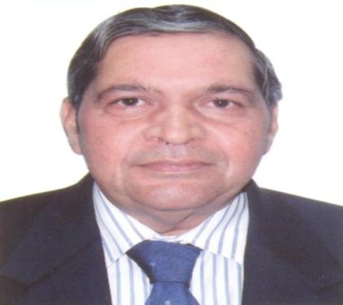

Mr. Alok Prasad  
 Ambassador of India to Japan

Mr. Alok Prasad assumed charge as Ambassador of India to Japan on 09 February 2011.

Immediately prior to his appointment as India’s Ambassador to Japan, Mr. Prasad served as India’s Deputy National Security Adviser, the post which he held since October 2009.

During his career spanning 36 years, Mr. Prasad has held several important assignments including as High Commissioner of India to Sri Lanka (Dec. 2006 – Oct. 2009) and Singapore (Mar. 2004 – Dec. 2006). He has also represented India in various capacities in Germany, United Nations – New York, Netherlands, Nepal, Burma and Botswana.

He headed the Americas Division at the Ministry of External Affairs in New Delhi for five years (Sep. 1995 to Nov. 2000) followed by an assignment as Deputy Chief of Mission in Washington (Dec. 2000 – Feb. 2004). During this period, he played a key role in expanding bilateral relations between India and the United States.

He has also served in the Prime Minister’s Office, where he was closely involved with India’s economic liberalization and structural reforms programme.

Mr. Alok Prasad is a member of the 1974 batch of the Indian Foreign Service. He holds a Masters degree in Economics from the University of Delhi. He is a Fellow of the Centre for International Affairs, Harvard University.

|  |  |  |  |
| --- | --- | --- | --- |
| **1. Consulate-General of Japan, Kolkata** | | | |
| 55, M. N. Sen Lane, Tollygunge, Kolkata-700040. India. Tel: 91-33-2421-1970 Fax: 91-33-2421-1971 | | | |
| **2. Consulate-General of Japan, Mumbai** | | | |
| 1, M.L. Dahanukar Marg, Cumbala Hill  Mumbai-400026. India. Tel: 91-22-2351-7101 Fax: 91-22-2351-7120 | | | |
| **3. Consulate-General of Japan, Chennai** | | | |
| No.12/1, Cenetoph Road, 1st Street Teynampet Chennai-600018 India. Tel: 91-44-2432-3860, 2432-3861, 2432-3862, 2432-3863 Fax: 91-44-2432-3856 | | | |
| **4.Consulate of Japan, Bangalore** | | | |
| 1st Floor, Prestige Nebula No. 8-14, Cubbon Road Bangalore-560 001 India. Tel: 91-80-4064-9999 Fax: 91-80-4166-0114 | | | |
| **Service** | **Tel. No.** | **Fax  No.** | **E-mail** |
| Visa, Passport & Consular Information | (03)3262-2391 to 97 | (03)3234-4866 | cpv@indembjp.org |
| Trade & Commercial Information | (03)3262-0560 | comsec@indembjp.org |
| Education, Culture & Press Information | (03)3263-5285 | [culsec@indembjp.org](mailto:culsec@indembjp.org)  [fspic@indembjp.org](mailto:fspic@indembjp.org) |

|  |  |
| --- | --- |
|  | |
|  | |

**INVESTING IN JAPAN**

Bilateral trade is expanding in the recent years. However, the speed and scope of expansion are still limited. Joint Study Group (JSG), composed of government officials and representatives of business and academia from the two countries, held four meetings after July, 2005. JSG submitted its report to both Prime Ministers when they met in July, 2006, which includes a recommendation for launching EPA negotiations. In December, 2006, the Prime Ministers of the two countries decided to launch immediate negotiations for the conclusion of a bilateral Economic Partnership Agreement/Comprehensive Economic Partnership Agreement aiming to complete in substance as soon as possible in approximately two years. Thirteen rounds of negotiations were held in New Delhi and Tokyo respectively as of July 2010. Japan-India Strategic Dialogue on Economic Issues which reviews the current status of bilateral economic issues discussed at Summit meetings, and undertakes coordination as necessary was held 3 times in New Delhi and Tokyo respectively as of July 2010 since the Dialogue was launched in July 2007. In August 2007, the Business Leaders' Forum was held in New Delhi on the occasion of Prime Minister Abe's visit to India, and the Second meeting was held in Tokyo in October 2008.

#### Japan-India Trade (US$: billion)

|  |  |  |  |  |  |  |  |  |
| --- | --- | --- | --- | --- | --- | --- | --- | --- |
| **Year** | 2001 | 2002 | 2003 | 2004 | 2005 | 2006 | 2007 | 2008 |
| **Trade from India to Japan** | 2.2 | 2.1 | 2.2 | 2.6 | 3.2 | 4.1 | 4.1 | 7.9 |
| **Trade from Japan to India** | 1.9 | 1.9 | 2.4 | 3.0 | 3.5 | 4.5 | 6.1 | 5.2 |

Japanese private-sector's interest in India is rising, and, currently, about 627 Japanese companies have branches in India. (The figure doubled over the last 3 years.)

#### Direct Investment from Japan (Yen: billion)

|  |  |  |  |  |  |  |  |  |
| --- | --- | --- | --- | --- | --- | --- | --- | --- |
| **Year** | 2001 | 2002 | 2003 | 2004 | 2005 | 2006 | 2007 | 2008 |
| **Direct**  **Investment from Japan** | 18.4 | 18.7 | 14.6 | 15.0 | 29.8 | 59.7 | 178.2 | 542.9 |

**ANDHRA PRADESH**

**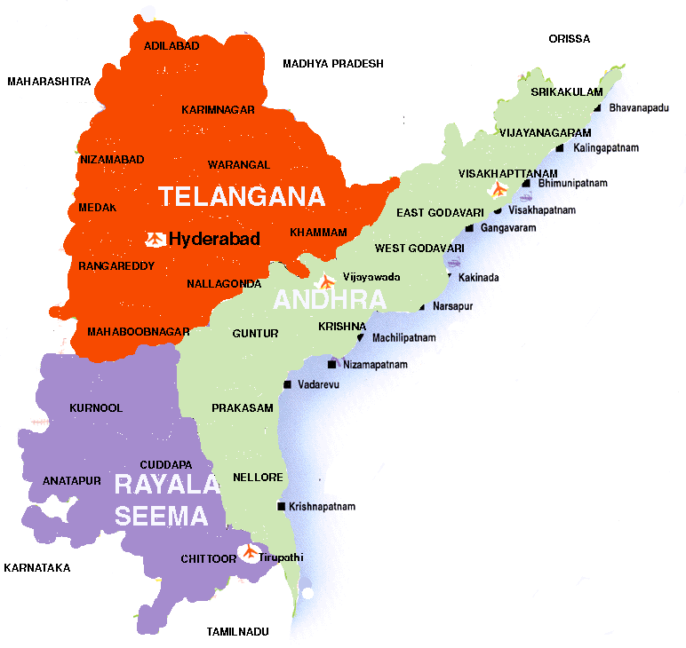**

* Andhra Pradesh (AP) is the fifth largest State in the Indian Union having an area of 275,909 sq. kms and a population of about 75-80 million.
* AP is bound in the North by Orissa and Madhya Pradesh States, in the East by bay of Bengal with a 960 km long coast line, in the South by Tamil Nadu State, and in the West by Karnataka and Maharashtra.
* AP forms a major link between the north and the south of India.
* Andhra Pradesh consists of three distinct regions
* Andhra
* Rayalaseema  &
* Telangana.
* Andhra and Rayalaseema were part of  Madras province of the British empire. For approximately 400 years, Telangana was part of Hyderabad State, an independent kingdom ruled by Muslim Qutub Shahi and Nizam dynasties. Thanks to the sacrifice of Sriramulu Poti, Andhra and Rayalaseema were separated from Madras State in 1953.
* Andhra state (Andhra and Rayalaseema) was the first state that was formed purely on linguistic nationality, like many European states.
* Later Andhra merged with Telangana in 1956, based on their linguistic and national affinity, to form the present state of Andhra Pradesh, Hyderabad as the capital city.   However, this has resulted in two major agitations: Jai Telangana in 1969 and Jai Andhra 1972, both for separate states.
* The *Krishna* and the *Godavari* are the major river systems in AP. The *Godavari* is the largest and the broadest river of South India.
* States like Tamil Nadu, Karnataka, Maharashtra, West Bengal etc. have produced and published comprehensive histories and cultures of their respective people. Several minor and major European nationalities have done the same. For some strange reason, comprehensive histories of Andhra, Rayalaseema and Telangana  peoples and their cultures have remained a dream

**ANDHRAPRADESH AND JAPAN**

**Agricultural products**

****

**Fresh Fruits and dried fruits**

**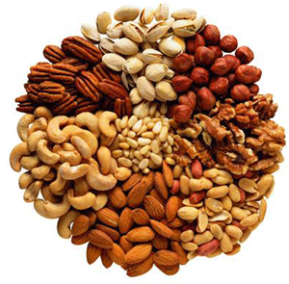**

**Tobacco**

**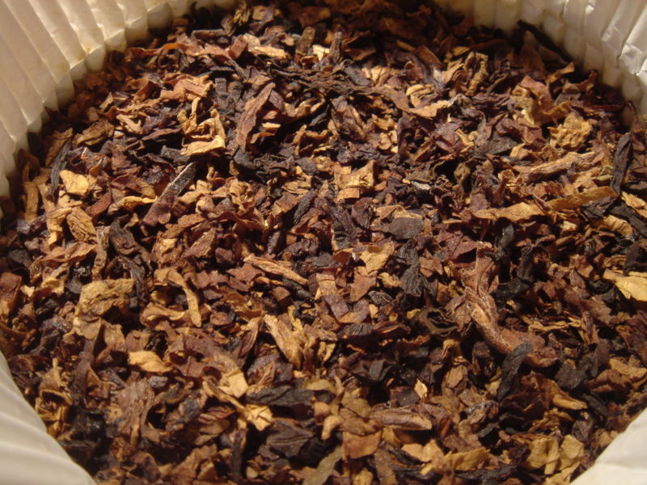**

* **Handicrafts**

**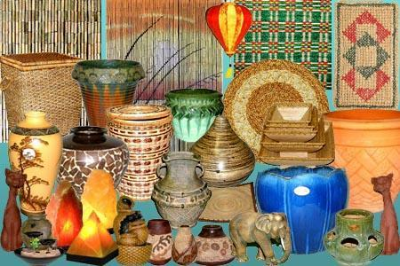**

* **Fisheries**

**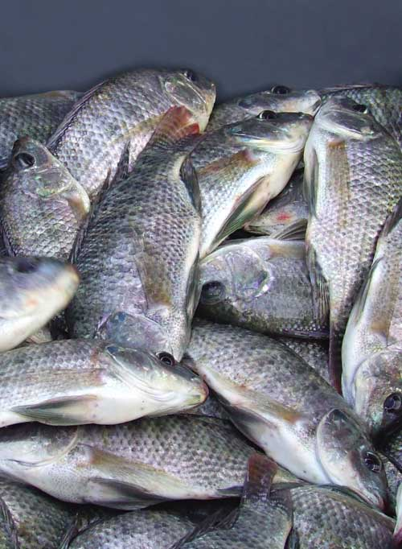**

* **Cotton**

**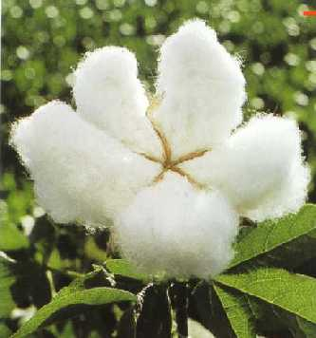**

|  |
| --- |
|  |
|  |
|  |

**List of Japanese Companies in Andhra pradesh**

|  |
| --- |
| **S.No. Name of the Company sector and location** |
| Aisin Engineering Co., Ltd. Auto component   1. designing R&D Hyderabad |
| 2 Canon India Pvt. Ltd. office Equipment sales and  Service Hyderabad |
| 3 Daicelchiral Technologies customer service for  analytical instruments  Hyderabad |
| 4 Deccan Fine Chemicals (India) agrochemical Hyderabad  Limited |
| 5 ETA Melco Engg. Co. Pvt. Ltd. sales of elevator  Hyderabad |
| . 6 Erbis Engineering Co., Ltd. sales & service for  Professional Equipment  Hyderabad |
| 7 Fujitsu Consulting India Private  limited IT service Hyderabad |
| 8 IFFCO-  Tokio General Insurance non life insurance |
| 9 IFFCO-Tokio General Insurance Co non-life insuranceHyderabad  Ltd.Secunderabad Branch |
| 10 IL&FS Education & Technology Services Limited Hyderabad |
| 11 JTB Jupiter Express Service Pvt forwarding Hyderabad  Ltd. Hyderabad Branch |
| JT International (India) Private 12 Ltd cigarrete manufacturing  Hyderabad |
| 13 Kintetsu World Express (India) Pvt. international freight  Ltd. Hyderabad Sales Office forwarding Hyderabad |
| 14. Mitsubishi Corporation India Pvt.  Ltd. Hyderabad Branch trading Hyderabad |
| 15. Mitsui MOL Information Processing BPO for data processing of B/L  Service India Ltd. Hyderabad |
| 16 Nippon Express (India) Pvt. Ltd.  Hyderabad Branch logistics Hyderabad |
| 17 Nippon Koei Co. Ltd. Hyderabad consulting engineer  Liaison Office Hyderabad |
| 18 Nishimatsu Construction Co., Ltd. construction Hyderabad  India |
| 19 NYK Line (India) Ltd. Hyderabad shipping Hyderabad  Office |
| 20 Papyrus Software India Pvt. Ltd. software Hyderabad |
| 21 Ricoh India Limited Hyderabad photocopying machines and printers  Branch |
| 22 . Sakata Inx India Ltd . printing ink Hyderabad |
| 23 Tata Tele services Limited AP Office mobile telecommunication  Hyderabad |
| 24 TPSC (India\_ Pvt. Ltd. power plant instruments Hyderabad |
| 25 ULVAC Inc. India Branch vacuum equipment Hyderabad |
| 26 Orix Auto Infrastructure ServicesLtd. auto leasing Hyderabad |
| 27 Uni-Sankyo Ltd production and sales pharmaceuticals |
| 28 Yusen Air & Sea Service (India forwarding business |
| 29 Eisai Pharmatechnology and production and R&D of  Manufacturing Pvt. Ltd. Pharmaceuticals Vishakhapatnam |
| 30 IFFCO-Tokio General Insurance CoLtd. non-life insurance  Vishakapatnam Branch |
| 31 . JUKI India Pvt. Ltd. Chennai Branch import and re-sell of  Machinery Vishakhapatnam |
| 32 IFFCO-Tokio General Insurance Co.Ltd Vijayawada Branch |

**LIST OF EXPORTERS and IMPORTERS**

|  |
| --- |
|  |
|  | | |
|  | | |
|  | [http://www.eximdata.com/show_logos.php?fName=11110.](http://www.eximdata.com/company/meiho-tsusho-corporation-11110.html)   |  |  |  | | --- | --- | --- | | [**Meiho Tsusho Corporation**](http://www.eximdata.com/company/meiho-tsusho-corporation-11110.html) |  |  | |  |
|  |  |  |
|  | | |
|  | | |
|  | [http://www.eximdata.com/show_logos.php?fName=11118.](http://www.eximdata.com/company/k-i-co-ltd-11118.html)  [**K. I Co. Ltd.**](http://www.eximdata.com/company/k-i-co-ltd-11118.html) |  |
|  | | |
|  | | |
|  | [http://www.eximdata.com/show_logos.php?fName=11117.](http://www.eximdata.com/company/japan-commerce-corporation-co--ltd-11117.html)  [**Japan Commerce Corporation Co., Ltd.**](http://www.eximdata.com/company/japan-commerce-corporation-co--ltd-11117.html) |  |
|  | | |
|  | | |
|  | [http://www.eximdata.com/show_logos.php?fName=11119.](http://www.eximdata.com/company/koyojihan-corporation-11119.html) |  |
|  | [**Koyojihan Corporation**](http://www.eximdata.com/company/koyojihan-corporation-11119.html) |  |
|  | | |
|  | | |
|  | [http://www.eximdata.com/show_logos.php?fName=11109.](http://www.eximdata.com/company/j-max-co-ltd-11109.html)  [**J-MAX Co. Ltd.**](http://www.eximdata.com/company/j-max-co-ltd-11109.html) |  |
|  |  |  |
|  | | |
|  | | |
|  | [http://www.eximdata.com/show_logos.php?fName=11114.](http://www.eximdata.com/company/direct-auction-co-ltd-11114.html) |  |
|  | [**Direct Auction Co. Ltd.**](http://www.eximdata.com/company/direct-auction-co-ltd-11114.html) |  |
|  | | |
|  | | |
|  | | |
|  | | |
|  | [http://www.eximdata.com/show_logos.php?fName=11113.](http://www.eximdata.com/company/japan-parts-access-11113.html)  [**Japan Parts Access**](http://www.eximdata.com/company/japan-parts-access-11113.html) |  |
|  |  |  |
|  | | |
|  | | |
|  | [http://www.eximdata.com/show_logos.php?fName=11111.](http://www.eximdata.com/company/mawar-international-traders-co-ltd-11111.html)  [**Mawar International Traders Co. Ltd.**](http://www.eximdata.com/company/mawar-international-traders-co-ltd-11111.html) |  |
|  |  |  |
|  | | |
|  | | |
|  | [http://www.eximdata.com/show_logos.php?fName=11108.](http://www.eximdata.com/company/v-west-co--ltd-11108.html)  [**V. West Co., Ltd.**](http://www.eximdata.com/company/v-west-co--ltd-11108.html) |  |
|  |  |  |
|  | | |
|  | | |
|  | [http://www.eximdata.com/show_logos.php?fName=11112.](http://www.eximdata.com/company/carnival-co-ltd-11112.html)  [**Carnival Co. Ltd.**](http://www.eximdata.com/company/carnival-co-ltd-11112.html) |  |
|  |  |  |
|  | | |
|  | | |
|  | [http://www.eximdata.com/show_logos.php?fName=11115.](http://www.eximdata.com/company/auto-supply-japan-co-ltd-11115.html)  [**Auto Supply Japan Co. Ltd.**](http://www.eximdata.com/company/auto-supply-japan-co-ltd-11115.html) |  |
|  |  |  |
|  | | |
|  | | |
|  | [http://www.eximdata.com/show_logos.php?fName=11107.](http://www.eximdata.com/company/auto-portal-co-ltd-11107.html)  [**Auto Portal Co. Ltd.**](http://www.eximdata.com/company/auto-portal-co-ltd-11107.html) |  |
|  |  |  |
|  | | |
|  | | |
|  | [http://www.eximdata.com/show_logos.php?fName=9205.](http://www.eximdata.com/company/we-ll-planning-inc-9205.html)  [**We'll Planning Inc.**](http://www.eximdata.com/company/we-ll-planning-inc-9205.html) |  |
|  |  |  |
|  | | |
|  | | |
|  | [http://www.eximdata.com/show_logos.php?fName=1544.gif](http://www.eximdata.com/company/ayase-trading-corporation-1544.html) |  |
|  | [**Ayase Trading Corporation**](http://www.eximdata.com/company/ayase-trading-corporation-1544.html) |  |
|  | | |
|  | | |
|  | [http://www.eximdata.com/show_logos.php?fName=9215.](http://www.eximdata.com/company/auto-trading-rock-co-ltd-9215.html) |  |
|  | [**Auto Trading Rock Co. Ltd.**](http://www.eximdata.com/company/auto-trading-rock-co-ltd-9215.html) |  |
|  | | |
|  | | |
|  | [http://www.eximdata.com/show_logos.php?fName=9222.](http://www.eximdata.com/company/japan-trucks-access-9222.html) |  |
|  | [**Japan Trucks Access**](http://www.eximdata.com/company/japan-trucks-access-9222.html) |  |
|  | | |
|  | | |
|  | [http://www.eximdata.com/show_logos.php?fName=4273.](http://www.eximdata.com/company/mx-japan-ltd-4273.html) |  |
|  | [**MX Japan Ltd.**](http://www.eximdata.com/company/mx-japan-ltd-4273.html) |  |
|  | | |
|  | | |
|  | [http://www.eximdata.com/show_logos.php?fName=9217.](http://www.eximdata.com/company/traffic-co-ltd-9217.html) [**Traffic Co. Ltd.**](http://www.eximdata.com/company/traffic-co-ltd-9217.html) |  |

|  |
| --- |
|  |
|  | | |
|  |  |  |
|  | | |
|  | |  | | --- | | [**Advance Trade Co. Ltd.**](http://www.eximdata.com/company/advance-trade-co-ltd-1409.html), Yokohama, **Japan** [Exporters] | | **Products :**Construction Machinery, Bull Dozer, Used Cranes, Used Dump Truck, New & Used Auto Parts, Auto Parts, Car Parts, Used Car Parts, New Or Used Vehicle, New Vehicles, Used Car, Used Jeep Wagon, Used LCV, Used MUV, Used Saloo [**...more**](http://www.eximdata.com/company/advance-trade-co-ltd-1409.html) | |  |
|  | | |
|  | |  | | --- | | [**Aeon Japan Used Cars**](http://www.eximdata.com/company/aeon-japan-used-cars-3075.html), Niigata, **Japan** [Traders, Suppliers, Exporters] | | **Products :**Vehicles, Trucks, Machinery, Bikes, Parts, Others | |  |
|  | | |
|  | |  | | --- | | [**Alpha Corporation Co., Ltd.**](http://www.eximdata.com/company/alpha-corporation-co--ltd-3069.html), Tokushima, **Japan** [Exporters, Dealers, Agents] | | **Products :**Vehicles, Trucks, Machinery, Bikes, Parts, Others | |  |
|  | | |
|  | |  | | --- | | [**Alps Co. Ltd.**](http://www.eximdata.com/company/alps-co-ltd-9413.html), Osaka , **Japan** [Dealers, Exporters] | | **Products :**Vehicles, Trucks, Machinery, Parts, Others | |  |
|  | | |
|  | |  | | --- | | [**Ange Trading Co. Ltd.**](http://www.eximdata.com/company/ange-trading-co-ltd-3706.html), Saitama-ken, **Japan** [Exporters, Dealers, Agents] | | **Products :**Vehicles, Trucks, Machinery, Bikes, Parts, Others | |  |
|  | | |
|  | |  | | --- | | [**Angolausedcars.com**](http://www.eximdata.com/company/angolausedcars-com-7792.html), Tokyo, **Japan** | | **Products :**Importer, Importers, Auto Dealer, Used SecondHand Car, Car, Cars, Used Car, Sedans, Used Sedan, Japanese Sedan, Used Mazda, Mitsubishi Cars, Used Subaru, Isuzu Cars, Used Suzuki, Daihatsu, Toyota Corona, Honda Accord, Us [**...more**](http://www.eximdata.com/company/angolausedcars-com-7792.html) | |  |
|  | | |
|  | |  | | --- | | [**Apparel Wholesale [apcom]**](http://www.eximdata.com/company/apparel-wholesale-apcom-1434.html), Tennouji-ku, Osaka, **Japan** [Departmental Stores, Exporters, Services] | | **Products :**Japanese Samurai Underwear, Japanese Traditional-modern Mixed Clothing, Wa, | |  |
|  | | |
|  | |  | | --- | | [**Aquafesta Co.,ltd.**](http://www.eximdata.com/company/aquafesta-co-ltd-4919.html), Yokohama, **Japan** [Importers] | | **Products :**Various Fresh Water Fish ,Arowanai,Lobster,Crab,Shrimp,Snail,Platy,Pleco,Plant, Tank,Goldfish,Flower Horn,Loach,Betta,Guppy,Discus,Angel,Tetra,And More... | |  |
|  | | |
|  | |  | | --- | | [**Ara Trading Co. Ltd.**](http://www.eximdata.com/company/ara-trading-co-ltd-3159.html), Izumiotsu, **Japan** [Exporters] | | **Products :**Vehicles, Trucks, Machinery, Bikes, Parts, Others | |  |
|  | | |
|  | |  | | --- | | [**Argentinausedcars.com**](http://www.eximdata.com/company/argentinausedcars-com-7695.html), Tokyo, **Japan** [Manufacturers, Importers, Exporters] | | **Products :**Japanese Used Cars, Used Car, Sedans, Used Sedan, Japanese Sedan, Used Mazda, Mitsubishi Cars, Used Subaru, Isuzu Cars, Used Suzuki, Daihatsu, Toyota Corona, Honda Accord, Used Civic, Honda Civic Honda Ferio, Inspire Car [**...more**](http://www.eximdata.com/company/argentinausedcars-com-7695.html) | |  |
|  | | |
|  | |  | | --- | | [**Auto Parts Find Japan**](http://www.eximdata.com/company/auto-parts-find-japan-3825.html), Ishikari Gun, **Japan** [Exporters] | | **Products :**Vehicles, Trucks, Parts | |  |
|  | | |
|  | |  | | --- | | [**Auto Trader Imports**](http://www.eximdata.com/company/auto-trader-imports-6592.html), Tokyo, **Japan** [Exporters, Traders, Wholesalers] | | **Products :**We Have Over 200 Cars Currently Online. Please Visit Our Website. | |  |
|  | | |
|  | |  | | --- | | [**Bahamas Used Cars Suppliers**](http://www.eximdata.com/company/bahamas-used-cars-suppliers-8453.html), Tokyo, **Japan** [Dealers, Exporters, Importers] | | **Products :**Bahamas, Nassau, Importers, Dealers, Used, Cars, Salvage, Auto Part, Japan, Machinery, Japanese, Export, Exporters, Imports, Toyota, Coaster, Honda CR-V, Nissan X-Trail, Mitsubishi Canter, Toyota Dyna Truck, Honda Inspi [**...more**](http://www.eximdata.com/company/bahamas-used-cars-suppliers-8453.html) | |  |
|  | | |
|  | |  | | --- | | [**Barbados Used Cars Imports**](http://www.eximdata.com/company/barbados-used-cars-imports-8492.html), Tokyo, **Japan** [Dealers, Exporters, Importers] | | **Products :**Barbados, Used, Cars, Japan, Importers, Dealers, Japanese, Automobile, Auto Parts, Truck, Bus, Vehicle, Toyota Hiace, Toyota Hiace Commuter, Toyota Belta, Toyota Vitz, Mazda Demio, Bus, | |  |
|  | | |
|  | |  | | --- | | [**Bizworld International, Japan Pvt. Ltd.**](http://www.eximdata.com/company/bizworld-international-japan-pvt-ltd-2977.html), Niigata, **Japan** [Exporters, Dealers, Agents] | | **Products :**Construction Machinery, Bull Dozer, Heavy Trucks, Used Dump Truck, Used Excavator, New & Used Auto Parts, New Or Used Vehicle, Used Car, Used Dump Truck, Used Large & Mini Trucks, Used Muv, Used Sedan, Used Vehicles, Use [**...more**](http://www.eximdata.com/company/bizworld-international-japan-pvt-ltd-2977.html) | |  |
|  | | |
|  | |  | | --- | | [**Blue Horse Corporation**](http://www.eximdata.com/company/blue-horse-corporation-10629.html), Toshima-ku, **Japan** [Buying Agents, Dealers, Distributors] | | **Products :**Food: Coffee, Tea, Rice, Spices, Honey .... Textile: | |  |
|  |  |  |

**BUSINESS OPERATIONS IN JAPAN**:

Foreign companies generally establish a business presence in Japan in one of four modes.

**Representative office**

Representative offices are established as locations for carrying out preparatory and supplemental tasks aimed at enabling foreign companies to engage in full-scale business operations in Japan. These offices conduct market surveys, collect information, purchase goods and implement publicity/advertising efforts, but they are not permitted to engage in sales activities. The establishment of representative offices does not require registration. A representative office cannot ordinarily open bank accounts or lease real estate in its own name, so agreements for such purposes must instead be signed by the head office of the foreign company or the representative at the representative office in an individual capacity.

**Branch office**

Foreign companies wishing to engage in business operations in Japan must establish a branch office or a subsidiary company. The simplest means for a foreign company to establish a base for business operations in Japan is to set up a branch office. The branch office can begin business operations as soon as an office location is secured, the branch office representative determined, and the necessary information registered. A Japanese branch office is a business location that provides services in Japan decided upon by an organization authorized by the foreign company, and ordinarily is not expected to engage in independent decision making. A branch office does not have its own legal corporate status, but instead is deemed to be encompassed within the corporate status of the foreign company. In general, therefore, the foreign company is ultimately responsible for all debts and credits generated by the activities of its Japanese branch office. A Japanese branch office, however, may open bank accounts and lease real estate in its own name.

**Subsidiary company**

A foreign company establishing a subsidiary company in Japan must choose to establish the subsidiary company as a joint-stock corporation (Kabushiki-Kaisha (K.K.)), limited liability company (Godo-Kaisha (LLC)), or similar entity stipulated by Japan's Corporate Law. Both unlimited partnerships (Gomei-Kaisha) and limited partnerships (Goshi-Kaisha) are granted corporate status under the Corporate Law, but they are rarely chosen in practice because equity participants bear unlimited rather than limited liability. All types of subsidiary companies can be established by completing the required procedures stipulated by law and then registering the corporation. A subsidiary is a separate corporation from the foreign company, so the foreign company will bear the liability of an equity participant stipulated by law for all debts and credits generated by the activities of the subsidiary. Other methods by which a foreign company may invest in Japan using a Japanese corporation but without establishing a subsidiary are by establishing a joint venture with a Japanese enterprise or investment company, and by equity participation in a Japanese enterprise.

**Limited liability partnership (LLP)**

It is also possible to do business by using a Yugen Sekinin Jigyo Kumiai. This type of entity, considered the Japanese version of a limited liability partnership (LLP), is not a corporation, but a partnership formed only by the equity participants, who have limited liability.

LLPs are also distinguished by the fact that internal rules can be freely determined by agreement between the equity participants, and that taxes are levied on profits allocated to equity participants without LLPs themselves being liable for taxation

**General flow of procedures for establishment of branch office**

* Determination of branch office information to be registered
* Examination at the Legal Affairs Bureau of similar corporate names
* Establishment of branch office (date of branch office establishment is at the branch office's discretion)
* Preparation of affidavit on establishment of branch office
* General flow of procedures for establishing a branch office
* Certification of affidavit by embassy/consulate in Japan1)
* Application to the Legal Affairs Bureau for registration of branch office establishment registration of company seal with the Legal Affairs Bureau
* .Acquisition of certificate on registered information and company seal registration certificate (approx. two weeks after application for registration)
* Opening of bank account under branch office name

**General flow of procedures for establishing a joint stock company**

* -stock corporationGENERAL FLOW )
* Determination of profile of joint-stock corporation to be established1)
* Examination at the Legal Affairs Bureau of similar corporate names
* Preparation of joint-stock corporation's articles of incorporation
* .Acquisition of registration certificates, etc. for parent company, and preparation of affidavits regarding profile of parent company and affidavits regarding signatures of representatives of parent company.(affidavits must be attested by a public notary in equity participants' own countries)
* Notarization of joint-stock corporation's articles of incorporation by Japanese notary public
* Application to bank for capital custody and issue of capital custody certificate
* Remittance of joint-stock corporation capital to special bank account
* Appointment of directors and other officers, such as representative directors and auditors
* Examination by directors and auditors of legality of establishment procedures
* .Application to the Legal Affairs Bureau for registration of joint-stock corporation
* Establishment (joint-stock corporation establishment date); registration of company seal with the Legal Affairs Bureau
* Acquisition of certificate on registered information and company seal registration

certificate (approx. two weeks after application for registration)

Opening of bank account under company name Notification of stock acquisition to the Bank of Japan (notification prior to company establishment may be required in certain sectors

**General flow of procedures for establishing a Godo-Kaisha (LLC)**

* Incorporating Your Business
* Determination of profile of Godo Kaisha to be established1)
* Examination at the Legal Affairs Bureau of similar corporate names
* Acquisition of certification regarding equity participants (in equity participants' own countries. Acquisition of registration certificates, etc. for companies that will become equity participants, and preparation of affidavits regarding profiles of companies that will become equity participants and affidavits regarding signatures
* Acquisition of certification regarding equity participants (in Japan),Acquisition of registration certificates for companies that will become equity participants, Acquisition of seal certificates for individuals/companies that will become equity participants

of representatives of companies that will become equity participants

(affidavits must be attested by a public notary in equity participants' own countries)

* Preparation of Godo Kaisha's articles of incorporation
* Payment by members of investment stipulated in articles of incorporation
* Application to the Legal Affairs Bureau for registration of establishment of Godo Kaisha (Godo Kaisha establishment date), registration of company seal with the Legal Affairs Bureau
* Acquisition of certificate of registered information and company seal registration certificate(approx. two weeks after application for registration)
* Opening of bank account under company name

**TAXATION**

**Types of Taxes**

Taxes in Japan are paid on income, property and consumption on the national, prefectural and municipal levels. Below is a summary of some of the most relevant types of taxes paid by individuals:

|  |  |
| --- | --- |
| http://www.japan-guide.com/g4/li.gif | **Income Tax** |
|  | Paid annually by individuals on the national, prefectural and municipal levels. Also known as "resident tax" on the prefectural and municipal level. The amount is calculated based on the net income of the individual person. |
| http://www.japan-guide.com/g3/pixel.gif | |
| http://www.japan-guide.com/g4/li.gif | **Enterprise Tax** |
|  | Prefectural tax paid annually by self-employed individuals engaged in business activities. The amount is calculated based on the person's net income and the type of business. |
| http://www.japan-guide.com/g3/pixel.gif | |
| http://www.japan-guide.com/g4/li.gif | **Property Tax** |
|  | Municipal tax paid annually by individuals who own land, housing and other types of depreciable assets. |
| http://www.japan-guide.com/g3/pixel.gif | |
| http://www.japan-guide.com/g4/li.gif | **Consumption Tax** |
|  | Paid by consumers when they purchase goods and services. The current rate is 5% (4% national, 1% prefectural). Shops and other service providers are required to include the consumption tax in the prices shown. |
| http://www.japan-guide.com/g3/pixel.gif | |
| http://www.japan-guide.com/g4/li.gif | **Vehicle related Taxes** |
|  | A prefectural automobile tax is paid annually by individuals who own a car, truck or bus. In case of passenger cars, the amount is calculated based on the engine displacement. A municipal light vehicle tax is paid annually by individuals who own motorbikes or other motorized light vehicles. A national motor vehicle tonnage tax is paid by vehicle owners at the time of the mandatory inspections (shaken). A prefectural automobile acquisition tax is paid by persons when they acquire a car. |
| http://www.japan-guide.com/g3/pixel.gif | |
| http://www.japan-guide.com/g4/li.gif | **Liquor, Tobacco and Gasoline Taxes** |
|  | The national liquor tax is paid by consumers when they purchase [alcoholic beverages](http://www.japan-guide.com/e/e2037.html). National, prefectural and municipal tobacco taxes are paid by consumers when they purchase tobacco products. A national gasoline tax is paid by consumers when they purchase gasoline. The liquor, tobacco and gasoline taxes are included in the prices shown by shops. |

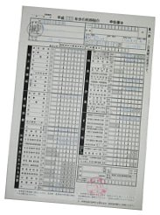

Income Tax Return

**Income Tax**

Income tax is paid annually on income earned during a calendar year.

For tax purposes, people living in Japan are classified into three categories. This categorization is not related to visa types:

|  |  |
| --- | --- |
| http://www.japan-guide.com/g4/li.gif | **Non-Resident** |
|  | A person who has lived in Japan for less than one year and does not have his primary base of living in Japan. Non-residents pay taxes only on income from sources in Japan, but not on income from abroad. |
| http://www.japan-guide.com/g3/pixel.gif | |
| http://www.japan-guide.com/g4/li.gif | **Non-Permanent Resident** |
|  | A person who has lived in Japan for less than five years, but has no intention of living in Japan permanently. Non-permanent residents pay taxes on all income except on income from abroad that does not get sent to Japan. |
| http://www.japan-guide.com/g3/pixel.gif | |
|  | **Permanent Resident** |
|  | A person who has either lived in Japan for at least five years or has the intention of staying in Japan permanently. Permanent residents pay taxes on all income from Japan and abroad. |

Note that tax treaties between Japan and more than 50 countries, including the USA, UK, Canada, Australia, China, South Korea and most European countries, can take precedence over the above guidelines.

**How to pay taxes?**

Income tax in Japan is based on a self-assessment system (a person determines the tax amount himself or herself by filing a tax return) in combination with a withholding tax system (taxes are subtracted from salaries and wages and submitted by the employer).

Thanks to the withholding tax system, most employees in Japan do not need to file a tax return. In fact, employees only need to file a tax return if at least one of the following conditions is true:

* if they leave Japan before the end of the tax year
* if their employer does not withhold taxes (e.g. employer outside Japan)
* if they have more than one employer
* if their annual income is more than 20,000,000 yen
* if they have side income of more than 200,000 yen

Employees, who do not need to file a tax return, will have their national income taxes withheld from their salaries by their employer, and an eventual adjustment is made with the year's final salary. Prefectural and municipal payments have to be paid separately by the employee upon notification by the municipality.

People, who are required to file a tax return, such as self-employed persons, must do so at the local tax office (zeimusho) between February 16 and March 15 of the following year. The tax return for 2011 has to be filed between February 16 and March 15, 2012.

**When to pay taxes?**

If not withheld by the employer, national income taxes are due in full by March 15 of the following year (mid April if you pay by automatic bank transfer), with two prepayments paid in July and November of the running tax year. Prepayments are calculated based on the previous year's income, i.e. you do not pay them during your first year in Japan.

For example, if you have to pay national income taxes for 2011, they have to be fully paid by March 15, 2012 (or April 20, 2012 in case of payment by automatic bank transfer), with the prepayments already paid in July and November 2011.

Prefectural and municipal income taxes are paid in quarterly installments during the following year. For example, the 2011 taxes are paid in four installments due in June, August and October 2012 and January 2013.

**Tax Rates**

The tax rate is determined based on the taxable income. Like in other countries, taxable income is the total earnings minus a basic exemption, exemptions for dependents and various types of deductions, such as deductions for insurance premiums, medical expenses and business expenses of the self-employed.

|  |  |
| --- | --- |
| National Income Tax Rates | |
| Taxable Income | Tax Rate |
| less than 1.95 million yen | 5% of taxable income |
| 1.95 to 3.3 million yen | 10% of taxable income exceeding 1.95 million yen plus 97,500 yen |
| 3.3 to 6.95 million yen | 20% of taxable income exceeding 3.3 million yen plus 232,500 yen |
| 6.95 to 9 million yen | 23% of taxable income exceeding 6.95 million yen plus 962,500 yen |
| 9 to 18 million yen | 33% of taxable income exceeding 9 million yen plus 1,434,000 yen |
| more than 18 million yen | 40% of taxable income exceeding 18 million yen plus 4,404,000 yen |

|  |  |
| --- | --- |
| Prefectural Income Tax Rates | |
| Taxable Income | Tax Rate |
| all | 4% of taxable income |

|  |  |
| --- | --- |
| Municipal Income Tax Rates | |
| Taxable Income | Tax Rate |
| all | 6% of taxable income |

|  |  |
| --- | --- |
| Prefectural Enterprise Tax Rates (in case of self-employed persons) | |
| Taxable Income | Tax Rate |
| all | 3% to 5% depending on the type of business |

|  |
| --- |
|  |
|  |
| **FUTURE OUTLOOK** |

**The Japanese Language**

* Japanese is the sixth most spoken language in the world, with over 99% percent of the country's population using it.  Amazingly, the language is spoken in scarcely any region outside Japan.
* The origin of the Japanese language has many theories in reference to it, some believe it is similar to the Altaic languages, namely Turkish or [Mongolian](http://www.kwintessential.co.uk/language/about/mongolian.html). It is recognized and acknowledged to be close in syntax to the Korean language.
* Dialects are used in areas, particularly in Kyoto and Osaka, but standard Japanese, based on the speech of Tokyo, has become more popular through the use of television, radio and movies.

**Japanese Society & Culture**

**The Japanese and 'Face'**

* . Saving face is crucial in Japanese society. The Japanese believe that turning down someone's request causes embarrassment and loss of face to the other person.   
  .
* If the request cannot be agreed to, they will say, 'it's inconvenient' or 'it's under consideration'.   
  . Face is a mark of personal dignity and means having high status with one's peers.   
  .
* The Japanese will try never to do anything to cause loss of face.  Therefore, they do not openly criticize, insult, or put anyone on-the-spot.  
  .
* Face can be lost, taken away, or earned through praise and thanks.

**Harmony in Japanese Society**

* . Harmony is the key value in Japanese society. Harmony is the guiding philosophy for the Japanese in family and business settings and in society as a whole.  
  .
* Japanese children are taught to act harmoniously and cooperatively with others from the time they go to pre-school.   
  .
* The Japanese educational system emphasizes the interdependence of all people, and Japanese children are not raised to be independent but rather to work together.  This need for harmonious relationships between people is reflected in much Japanese behavior.   
  .
* They place great emphasis on politeness, personal responsibility and working together for the universal, rather than the individual, good.   
  .
* They present facts that might be disagreeable in a gentle and indirect fashion. They see working in harmony as the crucial ingredient for working productively.

**Japanese Non-Verbal Communication**

* . Since the Japanese strive for harmony and are group dependent, they rely on facial expression, tone of voice and posture to tell them what someone feels.   
  .
* They often trust non-verbal messages more than the spoken word as words can have several meanings.   
  .
* The context in which something is said affects the meaning of the words. Therefore, it is imperative to understand the situation to fully appreciate the response.
* Frowning while someone is speaking is interpreted as a sign of disagreement.   
  . Most Japanese maintain an impassive expression when speaking.   
  .
* Expressions to watch out for include inhaling through clenched teeth, tilting the head, scratching the back of the head, and scratching the eyebrow.  
  .
* Non-verbal communication is so vital that there is a book for 'gaijins' (foreigners) on how to interpret the signs!  
  .
* It is considered disrespectful to stare into another person's eyes, particularly those of a person who is senior to you because of age or status.

Business Etiquette and Protocol in Japan

**Understanding of Foreign Ways**

* . Japanese understand that it is very difficult for foreigners to work in Japan.
* They will not expect you to speak or read Japanese, or be conversant with their strict cultural nuances and protocol.
* Mistakes are allowed as long as genuine respect is shown at all times.
* They will usually try to help you but often feel embarrassment at their own lack of understanding or English language ability.

**Relationships & Communication**

* . The Japanese prefer to do business on the basis of personal relationships.
* In general, being introduced or recommended by someone who already has a good relationship with the company is extremely helpful as it allows the Japanese to know how to place you in a hierarchy relative to themselves.
* One way to build and maintain relationships is with greetings / seasonal cards.   
  .

**Business Meeting Etiquette**.

* Appointments are required and, whenever possible, should be made several weeks in advance.
* It is best to telephone for an appointment rather than send a letter, fax or email.
* Punctuality is important. Arrive on time for meetings and expect your Japanese colleagues will do the same.Since this is a group society, even if you think you will be meeting one person, be prepared for a group meeting.
* The most senior Japanese person will be seated furthest from the door, with the rest of the people in descending rank until the most junior person is seated closest to the door.  
  .  It may take several meetings for your Japanese counterparts to become comfortable with you and be able to conduct business with you.
* You may be awarded a small amount of business as a trial to see if you meet your commitments
* If you respond quickly and with excellent service, you prove your ability and trustworthiness.   
  .
* Never refuse a request, no matter how difficult or non- profitable it may appear. The Japanese are looking for a long-term relationship.
* Always provide a package of literature about your company including articles and client testimonials.

A color chart for Japanese colors as referred to in the above list plus a few additionals:

|  |  |
| --- | --- |
| http://www.temarikai.com/infoimages/tradcolorchart1.jpg | http://www.temarikai.com/infoimages/tradcolorchart2.jpg |

***Japanese Traditional and Ceremonial Colors***   
***General Color Meanings***

**FLOWERS**

* Chrysanthemums are a favorite flower for the Japanese.
* Rose is not popular, and even considered bad luck.
* Sakura (cherry blossoms), daisies, plum blossoms are greatly admired.
* Something with many petals can also be related to many years of life (long life) which is another "good fortune" wish.

**COLORS**

* Red and White are auspicious colors (good luck).  These two colors used for many special occasions, such as weddings, and births.
* Blue and White are also prominent colors in Japanese fabrics and dishware.
* White is for a wedding.
* Black is for the funeral.

**MONTHS**  
  ***list of colors from a traditional school of Japanese etiquette.***

* **January**   *Pine:*   sprout green and deep purple
* **February**   *Red blossom plum:*    crimson and purple
* **March**   *Peach:*   peach and khaki
* **April**    *Cherry:*   white and burgundy
* **May**    *Orange Flower:*   deadleaf yellow and purple
* **June**   *Artemesia*:   sprout green and yellow
* **July**    *Lily:*   red and deadleaf yellow
* **August**   *Cicada wing*:    cedar bark and sky blue
* **September**    *Aster:*    lavender and burgundy
* **October**    *Bush Clover*:    rose and slate blue
* **November**   *Maple*:    vermilion and grey-green
* **December**   *Chrysanthemum:*    lavender and deep blue
* Yellow - In the Far East, a sacred color; but it the West it can mean treachery.
* Red - Passion; gets the blood flowing more intensely.
* Orange - Represents knowledge and civilization.
* Violet - Stately and royal
* Blue - Cool, passive, and also symbolizes fidelity (as in true blue)
* Green - Restful and fresh
* White - Purity and truth
* Black - Gloom, sorrow and depression.

|  |  |  |
| --- | --- | --- |
| **Japanese** | **Pronunciation** | **English** |
| Nihongo |  | English |
| good morning | Ohayoo gozaimasu | Good Morning. |
| Good afternoon | Konnichi wa. | Good afternoon. [Good day][Hello] |
| Good evening | Konban wa. | Good evening |
| Good night | Oyasumi nasai. | Good night (said just before going to bed). |
| How are you | Ogenki desu ka? | How are you? [Are you in good spirits?] |
| good spirits | Genki | Well [ good spirits] |
| I am very well | Genki desu | I am very well. |
| Thank you | Arigatoo gozaimasu. | Thank you |
| Thank you - due to kind thought | Okagesama de. | Thank you. [Due to your kind thought, am well] |
| What is your name | Onamae wa nan to osshaimasu ka? | What is your name? |
| What is your name | Onamae wa? | What is your name? |
| My name is Yamada Masao | Yamada Masao to mooshimasu. | My name is Yamada Masao. |
| I am Yamada | Yamada desu. | I am Yamada. |
| My name is Yamada | Watakushi no namae wa Yamada desu. | My name is Yamada. |
| Excuse me. I'm sorry | Gomen nasai | Excuse me. I'm sorry. |
| japanese That's all right | Ii desu. | That's all right |
| Good bye | Sayounara | Good bye. / See you later. |
| You're welcome | Do-itashi-mashite | You're welcome. |
| I'm sorry | Sumimasen | I'm sorry. / Excuse me. / Thank you. |
| I'm terribly sorry | Gomen-nasai | I'm terribly sorry. |
| How are you | Ogenki-desu-ka? | How are you? |
| What's the matter | Do-shimashita-ka? | What's the matter? |
| Take good care of yourself | Odaijini | Take good care of yours |