AI-AUGMENTED BACKEND DEVELOPMENT
PROJECT REPORT
AI BlogNest
AI-assisted blogging platform with React, Node.js, Express, MongoDB, JWT authentication and Google Gemini

Contents
- 1. Project Description
- 2. Scenario
- 3. System Requirements
- 4. Project Architecture
- 5. ER Diagram and Data Model
- 6. Features
- 7. Roles and Responsibilities
- 8. User Flow
- 9. MVC Pattern
- 10. Project Setup and Configuration
- 11. Backend Development and AI API Integration
- 12. Database Development
- 13. Project Execution
- 14. Output / Testing Evidence
- 15. Mandatory Functionalities — Compliance Matrix
Source basis: This report is derived from the supplied AI BlogNest frontend ZIP, backend ZIP, and the supplied AI-Augmented Backend Development Project Template. Where the template requests functionality that is not present in the supplied code, this report explicitly marks it as not implemented rather than inventing implementation details.

1. Project Description
AI BlogNest is an AI-augmented web application for creating, managing, exploring, and summarizing blog content. The supplied system combines a React/Vite frontend with a Node.js/Express REST API, MongoDB persistence through Mongoose, JWT-based authentication, bcrypt password hashing, and Google Gemini integration for AI blog generation and summarization.
The application provides a public story library, authenticated personal dashboard, blog creation and editing, category filtering and text search on the client side, and an AI Studio. The AI Studio sends topic prompts to the backend, which calls Gemini and stores generated blog content as a Blog document. Users can also submit blog content to the summarization endpoint and receive a concise summary.

Technology Stack
Layer | Technology | Evidence from supplied project
Frontend | React 18, React DOM, React Router, Vite | package.json and src/App.jsx
UI | Lucide React icons, custom CSS | package.json and src/App.jsx/styles.css
Backend | Node.js, Express.js | package.json, src/server.js, src/app.js
Database | MongoDB via Mongoose | src/config/db.js and models
Authentication | JWT + bcryptjs | authController.js and authMiddleware.js
AI | Google Gemini via @google/generative-ai | geminiService.js and aiController.js
Validation | express-validator | authRoutes.js, blogRoutes.js, aiRoutes.js
Testing | Thunder Client/Postman collection supplied | thunder-client-ai-blognest-api.postman_collection.json

2. Scenario

Paragraph 1 – Problem
Blog writers often move between separate tools for drafting, publishing, managing posts, and getting help with content. A conventional CRUD blog system can store and display articles, but it does not by itself provide an AI-assisted starting point or a quick way to summarize longer content. The supplied BlogNest project addresses this by combining publishing workflows with AI assistance in a single web application.

Paragraph 2 – AI Solution
BlogNest adds Google Gemini-backed features to the normal blog workflow. An authenticated user can provide a topic to the AI Studio; the backend builds a controlled prompt requesting a 100–150 word blog post, receives the Gemini response, cleans common Markdown formatting, infers a category when one is not supplied, and stores the result as a blog. A separate summarization route accepts blog content and asks Gemini to return a short, easy-to-read paragraph.

Paragraph 3 – Impact
The supplied application is intended to help individual writers create and manage content more efficiently while retaining human editing control. The frontend explicitly presents generated content as a draft that can be edited before publishing. The public Explore page also makes published stories searchable by text and filterable by category, while authenticated users receive a dashboard for their own published stories.

Implemented AI Capabilities
- AI content generation
- AI text summarization
- Prompt-controlled output length and formatting
- Automatic category inference for generated blogs
- Human edit-and-publish workflow
Not evidenced in the supplied code: semantic search, vector search, RAG, document upload/analysis, question answering over uploaded documents, or an intelligent recommendation engine.

3. System Requirements

3.1 Software Requirements
Requirement | Project-specific use
Operating System | Any OS capable of running Node.js, npm, MongoDB and a modern browser.
Node.js | Backend runtime. The template recommends Node.js v18 or above; the supplied package does not pin a Node engine.
npm | Installs backend and frontend dependencies.
React + Vite | Frontend application and development/build tooling.
Express.js | REST API framework.
MongoDB | Persistent database for User and Blog collections.
Mongoose | ODM used to define User and Blog schemas and query MongoDB.
Google Gemini API | External AI service used for blog generation and summarization.
Modern Browser | Runs the React single-page application.
Postman / Thunder Client | API endpoint testing; a collection is supplied.
Visual Studio Code / similar IDE | Suitable development environment; not technically required by the code.
Git / GitHub | Suitable version-control workflow; repository URL was not supplied.

3.2 Hardware / Network Requirements
- A development machine capable of running Node.js, the Vite development server, and MongoDB or reaching MongoDB remotely.
- Internet access is required for Gemini API calls and, when configured, remote MongoDB access.
- The template recommends at least 8 GB RAM and 5 GB free space; these are template requirements rather than measurements from the supplied project.
- A display of 1366 × 768 or above is recommended by the template.

3.3 Environment Variables
PORT=5000
MONGO_URI=YOUR_MongoDB_URI
JWT_SECRET=YOUR_JWT_SECRET
GEMINI_API_KEY=YOUR_API_KEY
GEMINI_MODEL=gemini-2.5-flash
The supplied backend .env contains placeholders rather than a usable secret configuration. Secrets should remain outside source control.

4. Project Architecture
The supplied system is a client-server web application. The React frontend communicates with Express REST endpoints under /api. The backend handles authentication, blog CRUD operations, validation, MongoDB persistence, and Gemini calls. Protected endpoints use a Bearer JWT supplied by the frontend from localStorage.
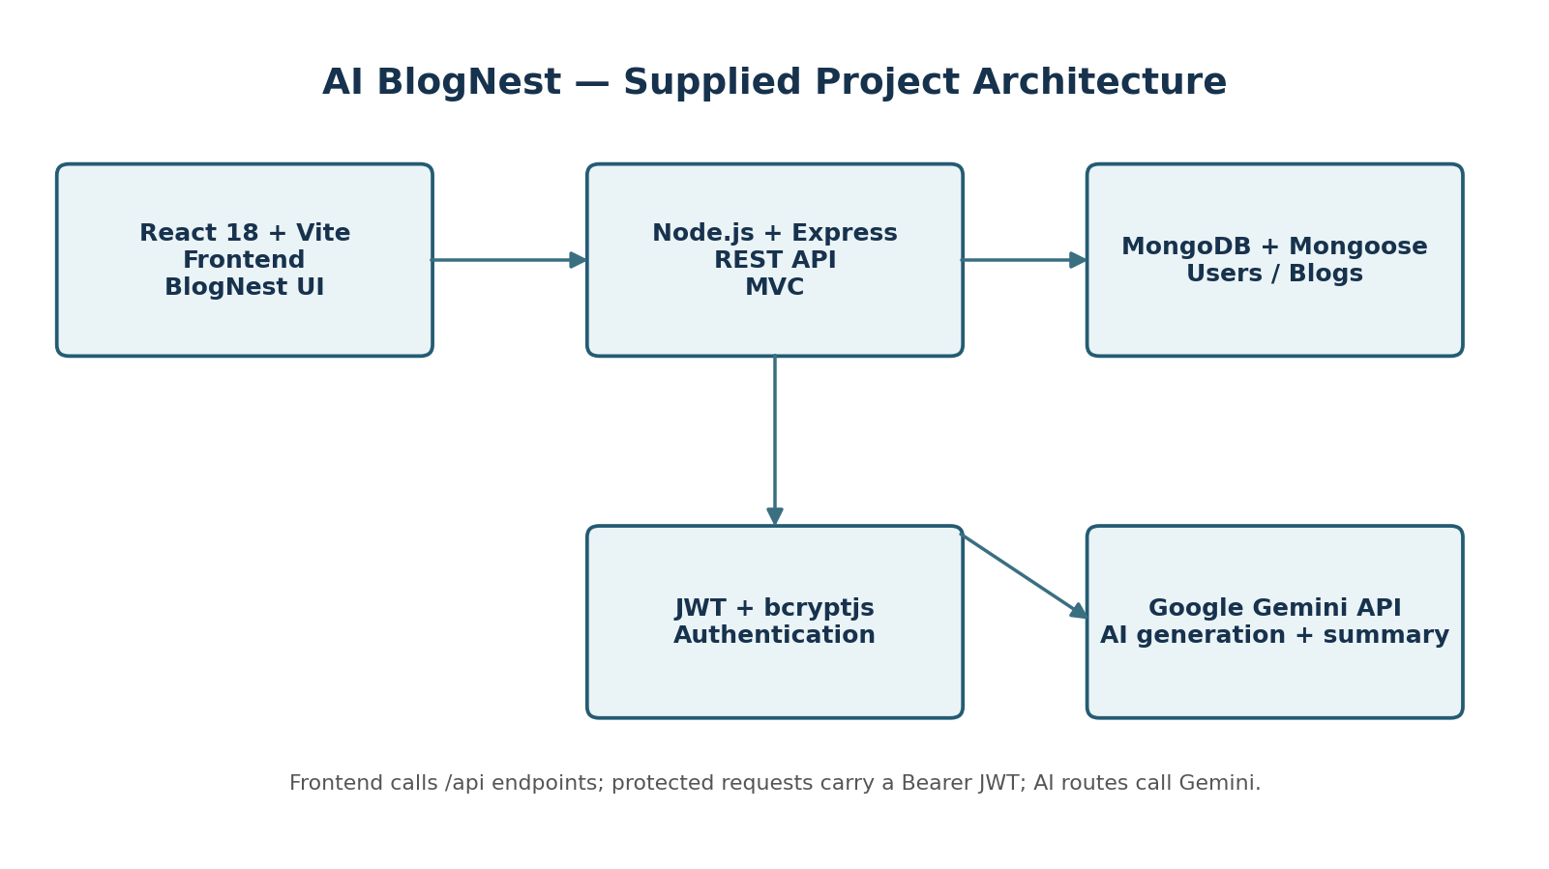

4.1 Backend Layer
- Node.js runtime
- Express.js routing and middleware
- JWT authentication middleware
- REST endpoints for authentication, blogs and AI
- Central error middleware
- Morgan request logging

4.2 AI Layer
- Google Gemini client via @google/generative-ai
- Prompt construction in aiController.js
- Response text extraction in geminiService.js
- Post-processing that removes common Markdown markers
- Automatic category inference for generated blog topics

4.3 Security Layer
- JWT access tokens with a 7-day expiry
- bcryptjs password hashing
- Protected blog create/update/delete routes
- Protected AI blog-generation route
- Bearer-token validation in authMiddleware.js
- Environment variables for JWT secret and Gemini API key
Role-Based Access Control is not implemented in the supplied backend: the User schema has no role field and there is no role-checking middleware.

5. ER Diagram and Data Model
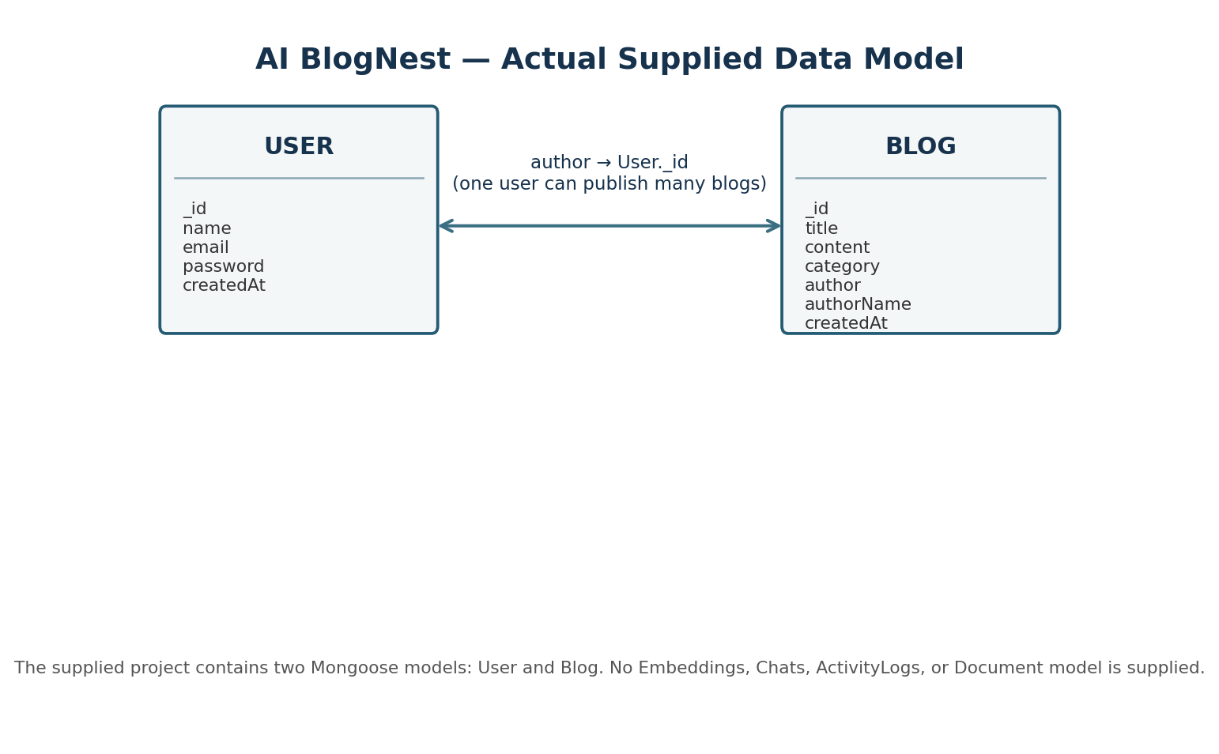

5.1 User Collection
Field | Type / rule | Purpose
_id | ObjectId | MongoDB document identifier
name | String, required, trimmed | User display name
email | String, required, unique, lowercase, trimmed | Login identity
password | String, required, minimum 6 | Stored as bcrypt hash after registration
createdAt / updatedAt | timestamps | Mongoose timestamps

5.2 Blog Collection
Field | Type / rule | Purpose
_id | ObjectId | MongoDB document identifier
title | String, required, trimmed | Blog title
content | String, required | Blog body
category | String, required, trimmed | Content category
author | ObjectId ref User, required | Relationship to author
authorName | String, required, trimmed | Denormalized author display name
createdAt / updatedAt | timestamps | Mongoose timestamps

The template proposes additional Users, Documents, Embeddings, Chats and ActivityLogs collections. The supplied source contains only User and Blog Mongoose models, so those additional collections are not represented in this report as implemented features.

6. Features

6.1 Core Backend Features
- User registration
- User login
- JWT authentication
- Authenticated profile retrieval
- Blog creation
- Blog listing and individual blog retrieval
- Blog update by owner
- Blog deletion by owner
- Input validation with express-validator
- Centralized error response middleware

6.2 Frontend Features
- Home page with featured/latest stories
- Public Explore page
- Client-side text search across title, content and author
- Category filtering
- Blog detail page
- AI summary action on blog detail
- Registration and login screens
- Authenticated dashboard
- Create/edit blog editor
- AI Studio
- Logout and token-based session restoration
- Responsive navigation/mobile menu

6.3 AI Features
- Generate a 100–150 word blog draft from a topic
- Optional category supplied by user or inferred from topic
- Summarize arbitrary submitted blog content
- AI-generated result can be passed into the editor for editing before publishing

6.4 Features requested by the template but not present
- Semantic search / MongoDB Atlas Search
- MongoDB Atlas Vector Search
- Embeddings and vector storage
- RAG pipeline
- Document upload and document analysis
- Document question answering
- Intelligent recommendations
- Activity logging
- Role-based access control

7. Roles and Responsibilities

Authenticated User
- Register and log in
- View own profile
- Create blog posts
- Edit only their own blog posts
- Delete only their own blog posts
- Use AI Studio to generate blog content
- Use AI summarization
- View the public story library

Unauthenticated Visitor
- View the home page
- Browse published blogs
- Search/filter blogs in the frontend
- Open individual blog pages
- Register or sign in

Administrator
The template defines an Admin role with user/document management and analytics responsibilities. The supplied User model does not contain a role field and no admin routes are present. Therefore, an administrator role is not implemented in the supplied source.

8. User Flow
- Open BlogNest home page.
- Browse latest stories or open Explore.
- Register or sign in to obtain a JWT.
- Frontend stores the token in localStorage and calls /api/auth/profile.
- Open Dashboard or AI Studio.
- Create a blog manually or generate a draft with Gemini.
- Edit the generated draft if required.
- Publish through POST /api/blogs.
- Open the published story.
- Optionally request an AI summary.
- Edit or delete the story when the authenticated user is its author.
- Log out by removing the local JWT from localStorage.

8.1 Frontend Routes
Route | Access | Purpose
/ | Public | Home and latest stories
/blogs | Public | Explore/search/filter stories
/blogs/:id | Public | Read a story and request summary
/login | Public | Sign in
/register | Public | Create account
/write | Protected | Create a blog
/write/:id | Protected | Edit a blog
/ai | Protected | AI generation and summarization
/dashboard | Protected | Personal workspace

9. MVC Pattern
The backend follows an MVC-style organization. Mongoose models represent persistent data, controllers implement request handling and business logic, and Express route modules expose the API endpoints. Middleware handles authentication, validation support, logging, and errors.

9.1 Model Layer
- User.js — user schema and persistence
- Blog.js — blog schema and author relationship

9.2 Controller Layer
Controller | Responsibilities
authController.js | Registration, bcrypt hashing, login, JWT generation, profile response
blogController.js | Create, list, retrieve, update and delete blogs
aiController.js | Gemini-backed generation, summarization, category inference and generated-text cleanup

9.3 Route / View Layer
Route group | Endpoints
Authentication | POST /api/auth/register; POST /api/auth/login; GET /api/auth/profile
Blogs | POST /api/blogs; GET /api/blogs; GET /api/blogs/:id; PUT /api/blogs/:id; DELETE /api/blogs/:id
AI | POST /api/ai/generate-blog; POST /api/ai/summarize

9.4 Advantages in this project
- Separation between persistence, routing and business logic
- Clear endpoint organization
- Reusable authentication middleware
- Easier maintenance of AI-specific logic
- Straightforward expansion with additional models/routes

10. Project Setup and Configuration

10.1 Backend Structure
Code/
├── src/
│ ├── config/db.js
│ ├── controllers/
│ │ ├── aiController.js
│ │ ├── authController.js
│ │ └── blogController.js
│ ├── middleware/
│ │ ├── authMiddleware.js
│ │ └── errorMiddleware.js
│ ├── models/
│ │ ├── Blog.js
│ │ └── User.js
│ ├── routes/
│ │ ├── aiRoutes.js
│ │ ├── authRoutes.js
│ │ └── blogRoutes.js
│ ├── services/geminiService.js
│ ├── app.js
│ └── server.js
├── .env
└── package.json

10.2 Frontend Structure
AI-BlogNest-Frontend/
├── src/
│ ├── App.jsx
│ ├── api.js
│ ├── main.jsx
│ └── styles.css
├── index.html
├── vite.config.js
├── .env.example
└── package.json

10.3 Install Dependencies
# Backend
cd Code
npm install
npm run dev
# Frontend
cd AI-BlogNest-Frontend
npm install
npm run dev
The backend package exposes `npm start` for production-style execution and `npm run dev` for nodemon-based development. The frontend exposes `npm run dev`, `npm run build`, and `npm run preview`.

10.4 Frontend API Configuration
VITE_API_URL=http://localhost:5000/api
The frontend API helper defaults to http://localhost:5000/api when VITE_API_URL is not supplied.

11. Backend Development and AI API Integration

11.1 Authentication API
Endpoint | Method | Authentication | Purpose
/api/auth/register | POST | No | Create user and hash password
/api/auth/login | POST | No | Verify credentials and issue JWT
/api/auth/profile | GET | Bearer JWT | Return authenticated user profile

11.2 Blog API
Endpoint | Method | Authentication | Purpose
/api/blogs | POST | Bearer JWT | Create blog
/api/blogs | GET | No | List blogs newest first
/api/blogs/:id | GET | No | Retrieve one blog
/api/blogs/:id | PUT | Bearer JWT | Update own blog
/api/blogs/:id | DELETE | Bearer JWT | Delete own blog

11.3 Gemini AI API — Generate Blog
Purpose: generate a compact blog draft from a topic. The route requires authentication and validates that `topic` is present.
POST /api/ai/generate-blog
{
"topic": "Artificial Intelligence",
"category": "Technology"
}
The backend constructs a prompt requesting an introduction, engaging key points, a conclusion, no Markdown headings/asterisks, and a final output of 100–150 words. Gemini is called through GoogleGenerativeAI. The returned text is cleaned and saved as a Blog document.
Response structure: the route returns the newly created Blog document, including title, content, category, author, authorName and timestamps.

11.4 Gemini AI API — Summarize
Purpose: convert supplied blog content into a short, easy-to-read paragraph. The route validates `content` and calls the same Gemini service.
POST /api/ai/summarize
{
"content": "Long blog content..."
}
Response structure: `{ "summary": "..." }`. The summary is cleaned using the same text-cleanup helper.

11.5 AI API Cost and Security Considerations
- The supplied source does not document Gemini pricing or token-cost calculations. Gemini usage should therefore be treated as an external provider cost that depends on the configured model and provider pricing.
- The Gemini API key is read from GEMINI_API_KEY and should not be exposed in the React frontend.
- The backend validates required fields before invoking Gemini.
- JWT protects the generate-blog endpoint; the summarize endpoint is public in the supplied backend.
- The project does not implement rate limiting, AI usage quotas, prompt-injection defenses, or audit logging in the supplied source.

12. Database Development

12.1 MongoDB Connection
src/config/db.js reads MONGO_URI from the environment and connects through Mongoose. If MONGO_URI is missing or the connection fails, the backend logs the error and exits.

12.2 Relationships
Blog.author is a required ObjectId reference to User. Blog.authorName is also stored as a separate string for display. When blogs are retrieved, the backend populates author name and email.

12.3 Indexes / Search
No MongoDB Atlas Search index or MongoDB Atlas Vector Search index is defined in the supplied source. The Explore page performs filtering and text matching in the React client after GET /api/blogs returns the blog list.

12.4 Sample Documents
User
{
"name": "John Doe",
"email": "john@example.com",
"password": "<bcrypt hash>"
}
Blog
{
"title": "My First AI Blog",
"content": "This is sample content...",
"category": "Technology",
"author": "<User ObjectId>",
"authorName": "John Doe"
}

12.5 Template vs Supplied Database
Template item | Supplied implementation
Users | Implemented as User model
Documents | Not supplied
Embeddings | Not supplied
Chats | Not supplied
ActivityLogs | Not supplied
Atlas Search index | Not supplied
Atlas Vector Search index | Not supplied

13. Project Execution

Step 1: Backend
cd Code
npm install
npm run dev
The supplied backend defaults to port 5000.

Step 2: Configure Environment Variables
PORT=5000
MONGO_URI=YOUR_MongoDB_URI
JWT_SECRET=YOUR_JWT_SECRET
GEMINI_API_KEY=YOUR_API_KEY
GEMINI_MODEL=gemini-2.5-flash

Step 3: Frontend
cd AI-BlogNest-Frontend
npm install
npm run dev
The Vite development server will report the local frontend URL in the terminal. The frontend uses VITE_API_URL when supplied and otherwise targets http://localhost:5000/api.

Step 4: API Testing
A Postman/Thunder Client collection is supplied with requests for registration, login, profile, blog CRUD, AI generation and summarization.

Expected API Test Sequence
- Register a user
- Log in and copy the returned token
- Call profile with Authorization: Bearer <token>
- Create a blog
- List/retrieve the blog
- Update or delete the user's blog
- Call Generate AI Blog with a topic
- Call Summarize with blog content

14. Output / Testing Evidence
The supplied project archive contains source code and a Postman/Thunder Client collection, but it does not contain runtime screenshots or a demo video. Therefore, this report documents the available testable outputs without claiming screenshots were captured.

14.1 API Testing Evidence Available from the Supplied Files
Test area | Available endpoint / evidence
Registration | POST /api/auth/register
Login / JWT | POST /api/auth/login
Profile | GET /api/auth/profile
Blog CRUD | POST/GET/GET by ID/PUT/DELETE /api/blogs
AI generation | POST /api/ai/generate-blog
AI summary | POST /api/ai/summarize
Frontend API integration | src/api.js

14.2 Frontend Screens / Functional Areas Present in Code
- Home / latest stories
- Explore stories with search and category filters
- Story detail with AI summary
- Sign in
- Register
- Dashboard
- Write story
- Edit story
- AI Studio
- 404 page

14.3 Evidence Not Supplied
- API execution screenshots
- Gemini response screenshots
- MongoDB screenshots
- AI Studio runtime screenshots
- Document upload/search screenshots
- Recommendation-engine screenshots
- Demo video URL
- GitHub/Drive source-code link
These items can be added after running the application and capturing the relevant screens. No external links are invented in this report.

15. Mandatory Functionalities — Compliance Matrix
The following matrix compares the template's mandatory requirements with the actual supplied implementation.
Mandatory functionality | Status in supplied project | Evidence / note
MVC Architecture | Implemented | Controllers, models and Express route modules are separated.
JWT Authentication | Implemented | JWT issued on login; authMiddleware verifies Bearer tokens.
Semantic Search | Not implemented | Explore uses client-side text matching, not semantic embeddings.
MongoDB Atlas Search | Not implemented | No Atlas Search index/configuration is supplied.
MongoDB Atlas Vector Search | Not implemented | No vector index or vector data model is supplied.
Prompt Engineering | Implemented | Gemini prompts specify task, formatting and 100–150 word output.
AI API Integration | Implemented | Google Gemini integration in geminiService.js.
Role-Based Access Control | Not implemented | No role field or authorization-by-role middleware is supplied.

Final Project Summary
AI BlogNest, as supplied, is a functional AI-assisted blogging application centered on authenticated blog CRUD and two Gemini-powered capabilities: blog generation and summarization. Its strongest implemented architectural elements are the React/Vite frontend, Express/Mongoose backend, JWT authentication, bcrypt password hashing, input validation, and a dedicated Gemini service. Several advanced capabilities listed in the generic template—especially semantic/vector search, RAG, document analysis, recommendations, activity logging and RBAC—are not present in the supplied code and should be treated as future extensions rather than current functionality.
This document intentionally distinguishes implemented behavior from template requirements so that the project report remains consistent with the submitted source files.

Appendix A — Package Summary

Backend Dependencies
Package | Use
@google/generative-ai | Gemini integration
axios | HTTP client dependency present in package.json
bcryptjs | Password hashing
cors | Cross-origin requests
dotenv | Environment variable loading
express | REST API framework
express-validator | Request validation
jsonwebtoken | JWT creation and verification
mongoose | MongoDB ODM
morgan | HTTP request logging
nodemon (dev) | Development auto-restart

Frontend Dependencies
Package | Use
react | UI framework
react-dom | Browser rendering
react-router-dom | Client-side routing
lucide-react | UI icons
vite (dev) | Development server and build tool
@vitejs/plugin-react (dev) | Vite React integration

Appendix B — Source Files Reviewed
- Frontend: package.json, src/App.jsx, src/api.js, src/main.jsx, src/styles.css, README.md, vite.config.js, index.html.
- Backend: package.json, README.md, src/server.js, src/app.js, src/config/db.js, src/controllers/*, src/middleware/*, src/models/*, src/routes/*, src/services/geminiService.js.
- Testing/config: thunder-client-env.json, thunder-client-ai-blognest-api.postman_collection.json, .env.
- Template: AI-Augmented backend Project Template.docx.

