AI-Powered Lead Generation System

Internship Project

Submitted By
Madhu Sri

Platform
Salesforce Developer Edition

Technology
Salesforce Lightning

Year
2026
- Introduction

The AI-Powered Lead Generation System is developed using Salesforce Lightning Platform.

This project automates lead management by using Validation Rules, Formula Fields, Record Triggered Flows, Approval Process, Reports and Dashboards.

The system reduces manual work and improves lead qualification.

- Objectives

• Automate Lead Qualification

• Improve Lead Management

• Validate Lead Data

• Generate Reports

• Create Dashboards

• Reduce Manual Work

• Improve Business Automation

- Tools Used

Tool | Purpose
Salesforce | CRM Platform
Flow Builder | Automation
Approval Process | Approval
Reports | Reporting
Dashboard | Visualization
Github | Project Repository

- Project Modules

1. Custom Object

2. Custom Fields

3. Validation Rule

4. Formula Field

5. Record Triggered Flow

6. Approval Process

7. Reports

8. Dashboard

- Workflow

Lead Created

↓

Validation Rule

↓

Formula Field

↓

Flow Builder

↓

Approval Process

↓

Reports

↓

Dashboard

- Project Screenshots

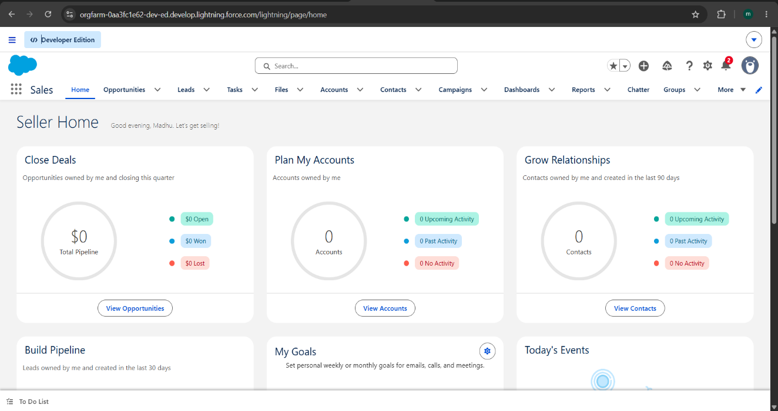
Figure 1 :Home

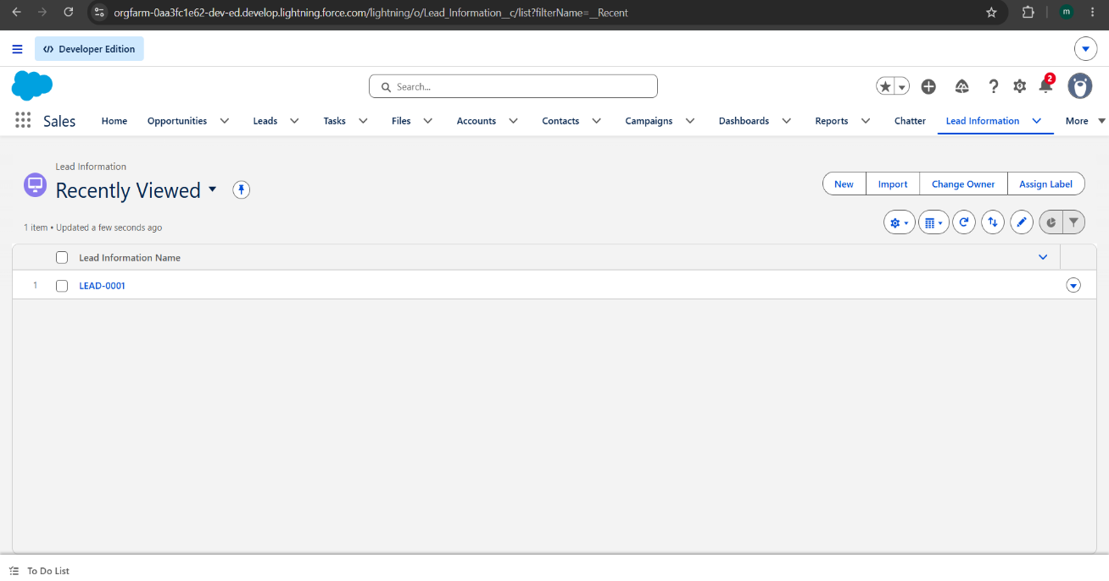
Figure 2 :LeadInformation

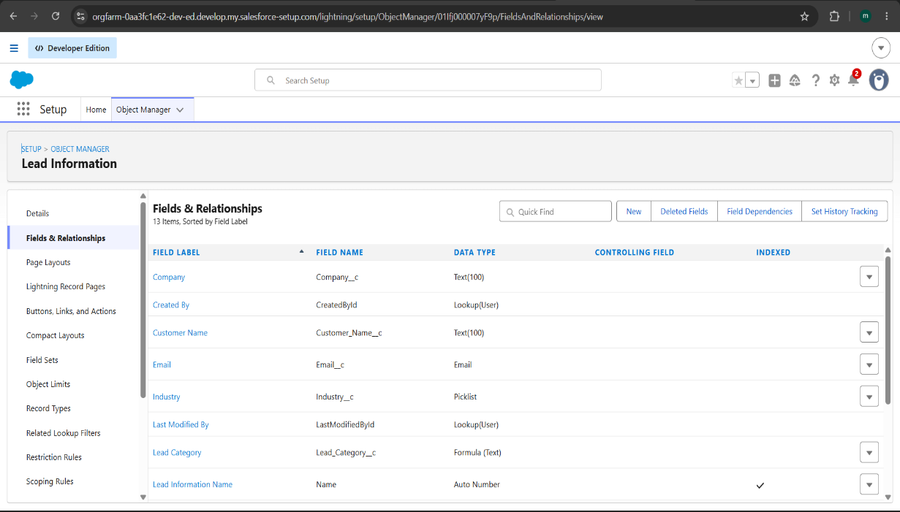
Figure 3 : Fields

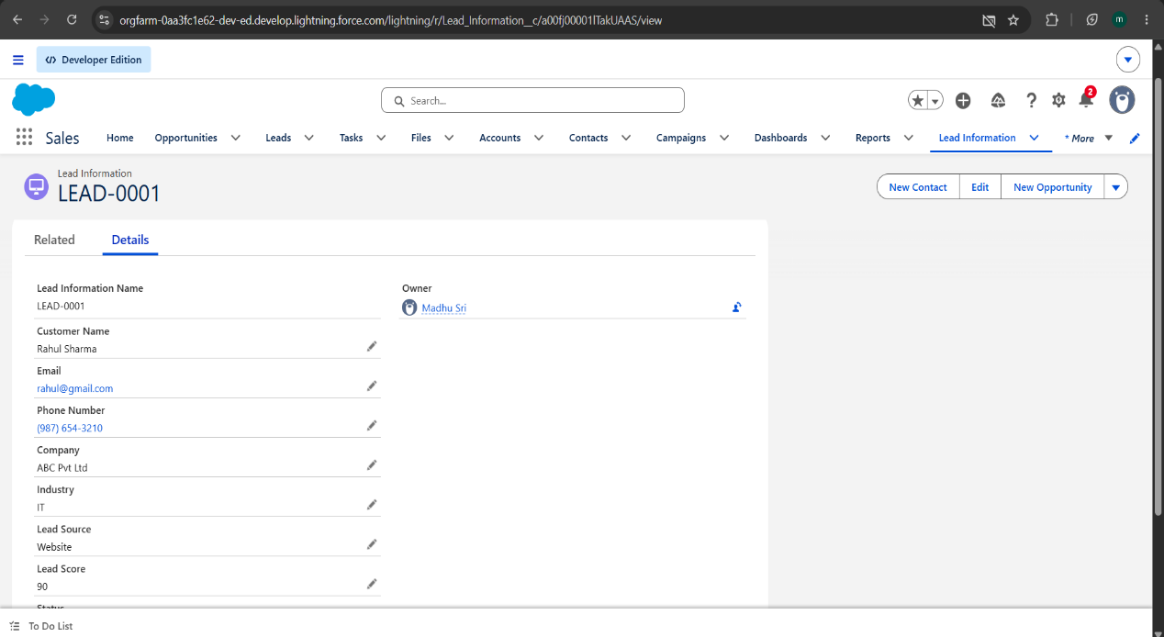
Figure 4 : LeadRecord

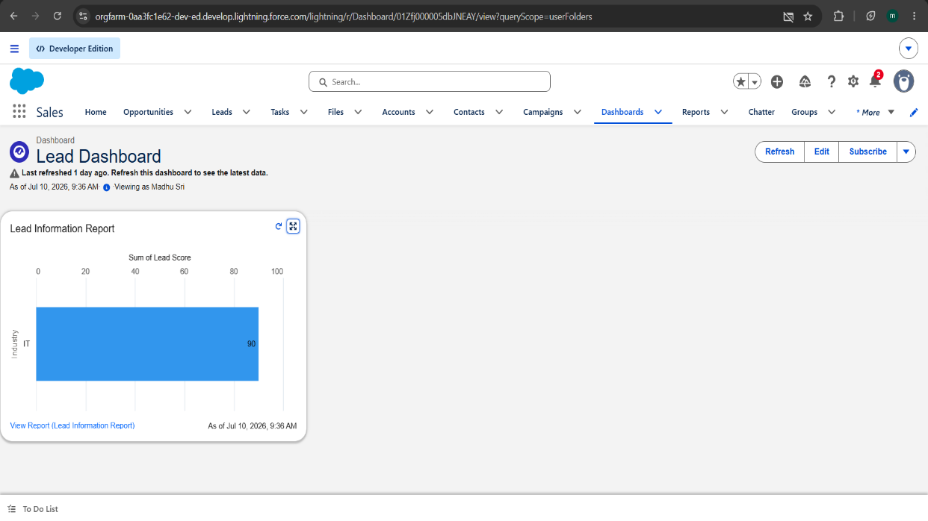
Figure 5 : Dashboard

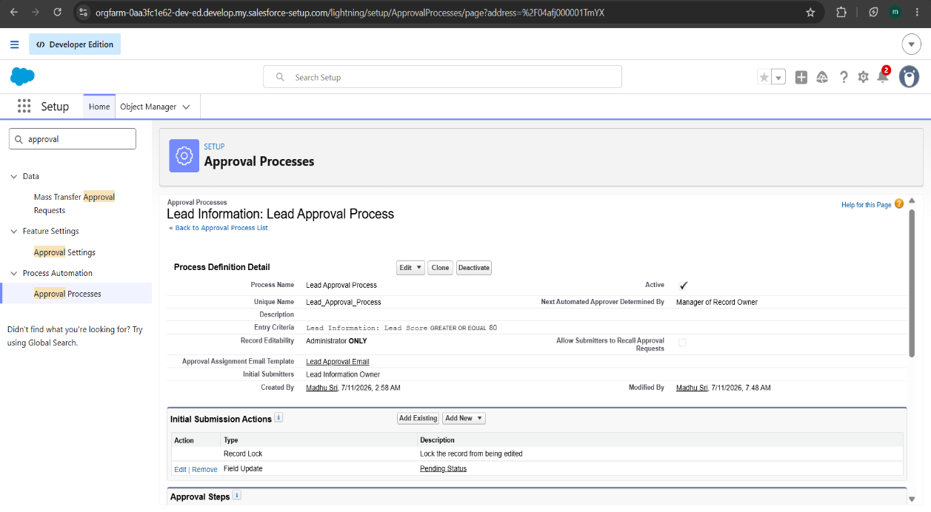
Figure 6 : ApprovalProces

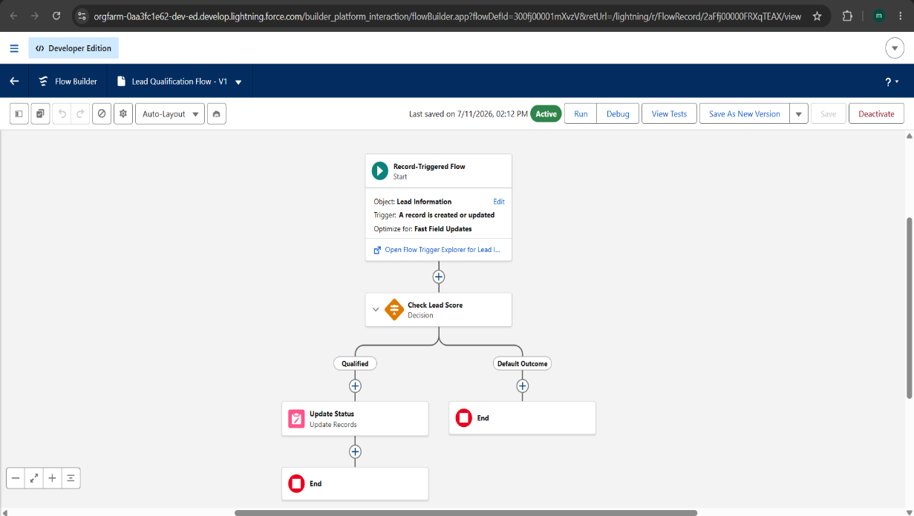
Figure 7 : Flow

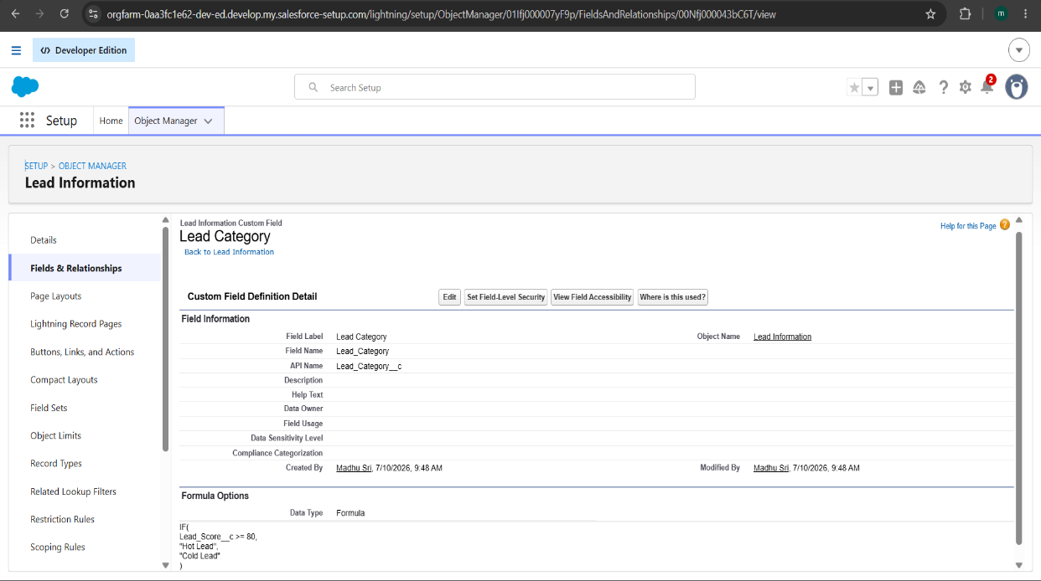
Figure 8 : FormulaField

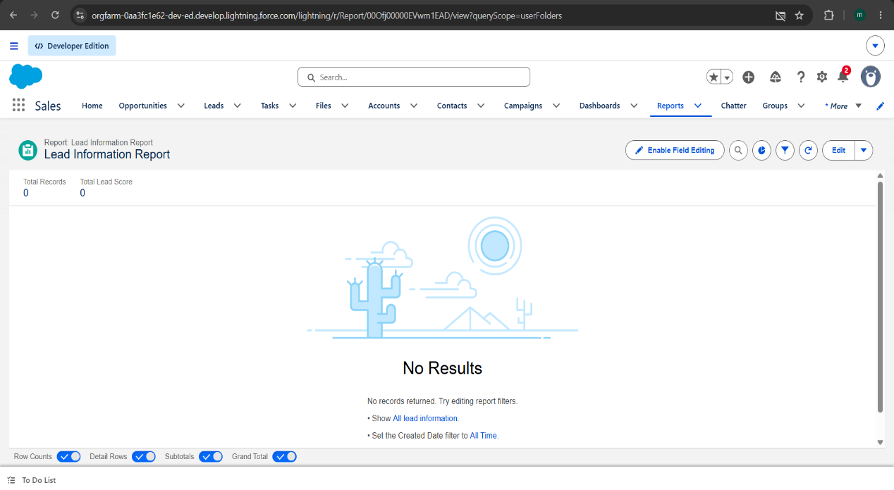
Figure 9 :Report

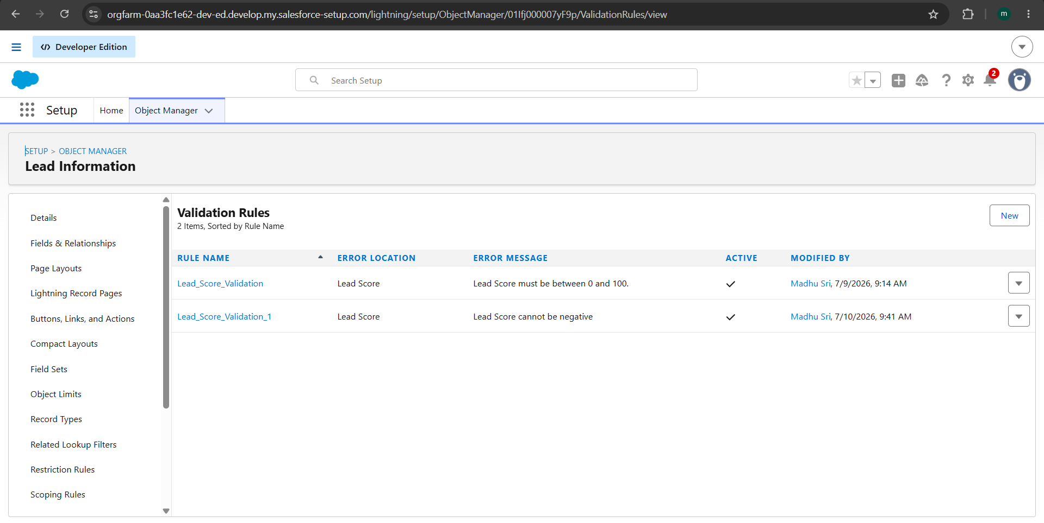
Figure 10 :ValidationRule

- Conclusion

The AI-Powered Lead Generation System successfully automates lead qualification using Salesforce Lightning.

The project demonstrates Validation Rules, Formula Fields, Record Triggered Flow, Approval Process, Reports and Dashboards.

