ASSIGNMENT

Create 2 tables which has odd numbered rows in one table and even numbered rows in one table

1. Creating main table users.

create table users(id serial, name varchar(10));

CREATE TABLE

1. Inserting values into users table

* insert into users (name) values('madhu');

INSERT 0 1

* insert into users (name) values('a');

INSERT 0 1

* insert into users (name) values('b');

INSERT 0 1

* insert into users (name) values('c');

INSERT 0 1

* insert into users (name) values('d');

INSERT 0 1

* insert into users (name) values('e');

INSERT 0 1

* insert into users (name) values('f');

INSERT 0 1

* insert into users (name) values('g');

INSERT 0 1

* insert into users (name) values('h');

INSERT 0 1

* insert into users (name) values('i');

INSERT 0 1

* insert into users (name) values('j');

INSERT 0 1

* select * from users;

id | name

----+-------

1 | madhu

2 | a

3 | b

4 | c

5 | d

6 | e

7 | f

8 | g

9 | h

10 | i

11 | j

(11 rows)

1. Creating tables for odd rows and even rows as odd_table and even_table

* create table odd_table(id int,name varchar(10));

CREATE TABLE

* create table even_table(id int,name varchar(10));

CREATE TABLE

1. Executing query to insert odd and even numbered rows into respective tables

* insert into odd_table (id,name) (select id,name from users where mod(id,2)=1);

INSERT 0 6

* select * from odd_table;

id | name

----+-------

1 | madhu

3 | b

5 | d

7 | f

9 | h

11 | j

(6 rows)

* insert into even_table (id,name) (select id,name from users where mod(id,2)=0);

INSERT 0 5

* select * from even_table;

id | name

----+------

2 | a

4 | c

6 | e

8 | g

10 | i

(5 rows)

OUTPUT:

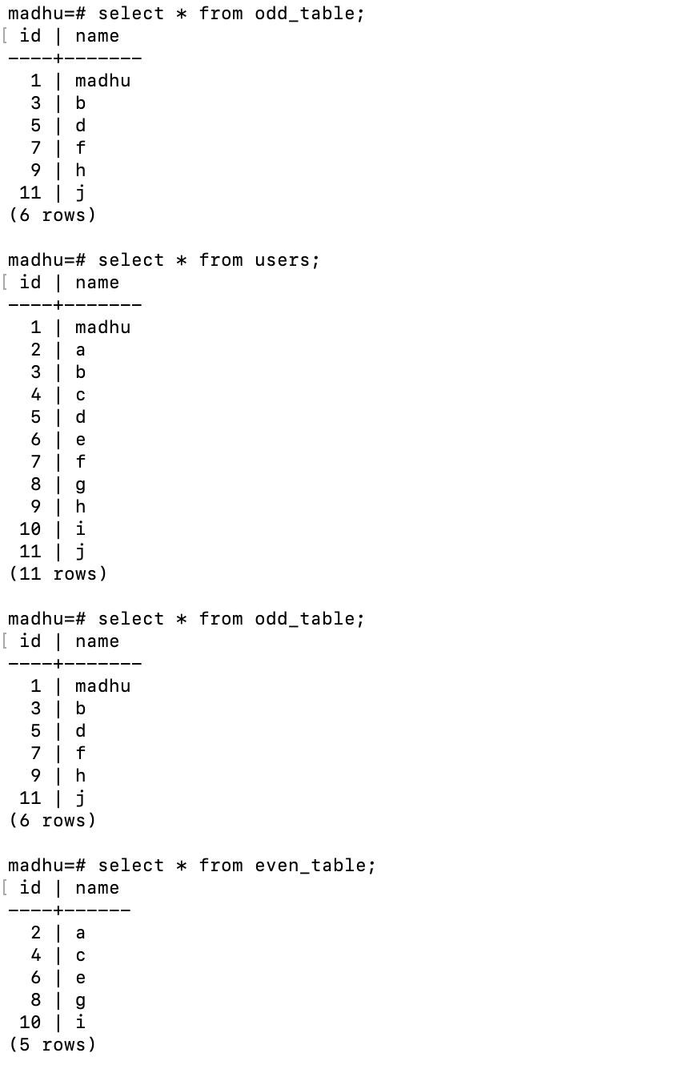

Python program to get the separate odd and even rows from the table.

STEPS

1. Create a csv format file (users.csv)
2. Execute the query to copy to csv file.

copy users to '/Users/mkoralla/Desktop/users.csv' with delimiter ',' csv header;

COPY 11

1. We use pandas here.
2. Open the csv file and get the data as data frame.
3. Perform conditions to get the rows separated and take it in 2 data frames.
4. Write the data frames to csv files.