Internship Task Report
Task 2: Stock Portfolio Tracker (Python Console Application)
Task Name | Stock Portfolio Tracker
Language Used | Python 3
Environment | Python console / terminal (no GUI)
Submission Type | Console-based mini project
Status | Completed and tested

1. Objective
The goal of this task was to build a simple, console-based Stock Portfolio Tracker in Python that calculates a user's total investment value based on manually defined (hardcoded) stock prices. The program takes stock names and quantities from the user, computes the value of each holding, displays a full summary, and saves the results to a text file for record-keeping.

2. Scope of the Task
- User inputs stock names and quantities through the console.
- Use a hardcoded dictionary to define stock prices, e.g. AAPL: 180, TSLA: 250, GOOGL: 150, MSFT: 320.
- Display the total investment value along with a breakdown per stock.
- Optionally save the result to a .txt file (implemented as stock_portfolio.txt).

3. Tools and Technologies Used
- Python 3 - core programming language used to build the tracker.
- Built-in dictionary data structure - used to store hardcoded stock symbols and prices.
- Python console / terminal - used to run the program and enter input interactively.
- Visual Studio Code (or any Python-compatible IDE) - used for writing and editing the script.
- Python file handling (open/write) - used to export the summary report to stock_portfolio.txt.

4. Key Concepts Applied
- dictionary - stock_prices maps each stock symbol to its hardcoded price, used for quick lookups.
- input/output - input() collects stock symbols and quantities; print() displays formatted results.
- basic arithmetic - price multiplied by quantity for each stock, and totals summed across the portfolio.
- loops - a while loop repeatedly accepts stock entries until the user types 'done'.
- if-else - used to validate stock symbols, reject invalid quantities, and control the input loop.
- file handling - the final report is written to a .txt file using Python's built-in open() function.

5. How the Program Works
- The program displays the list of available stocks and their hardcoded prices.
- The user enters a stock symbol and, if valid, the quantity they want to add.
- Invalid stock symbols or non-positive quantities are rejected with a helpful message, and the user is asked again.
- Each valid entry's cost is calculated as price x quantity and stored in a running portfolio list.
- Typing 'done' ends the input loop.
- The program then prints a summary table showing each stock, quantity, price, and subtotal, followed by the total investment value.
- Finally, the same summary is written to stock_portfolio.txt so the user has a saved record.

6. Sample Code (stock_portfolio_tracker.py)
"""
Stock Portfolio Tracker
------------------------
A simple console program that calculates the total value of a user's
stock portfolio using hardcoded stock prices, and saves a summary
report to a text file.
"""

# Step 1: Hardcoded dictionary of stock prices (stock symbol -> price per share)
stock_prices = {
"AAPL": 180,
"TSLA": 250,
"GOOGL": 150,
"MSFT": 320
}

def show_available_stocks(prices):
"""Print the list of stocks the user is allowed to enter."""
print("Available stocks and their prices:")
for symbol, price in prices.items():
print(f" {symbol}: ${price}")
print()

def get_portfolio_input(prices):
"""
Ask the user to enter stock names and quantities one at a time.
Returns a list of dictionaries, each holding details for one stock entry.
"""
portfolio = [] # will store each entry as {"symbol", "quantity", "price", "total"}

print("Enter your stock holdings below.")
print("Type 'done' as the stock name when you are finished.\n")

while True:
symbol = input("Enter stock symbol (or 'done' to finish): ").upper()

# Exit condition for the loop
if symbol == "DONE":
break

# Check if the entered stock exists in our hardcoded dictionary
if symbol not in prices:
print("Sorry, that stock is not available. Please choose from the list above.\n")
continue # go back to the start of the loop and ask again

# Ask for quantity and validate it
quantity_input = input(f"Enter quantity for {symbol}: ")

if not quantity_input.isdigit():
print("Please enter a valid whole number for quantity.\n")
continue

quantity = int(quantity_input)

if quantity <= 0:
print("Quantity must be greater than zero.\n")
continue

# Basic arithmetic: calculate the total cost for this stock
price = prices[symbol]
total = price * quantity

# Store this entry in our portfolio list
portfolio.append({
"symbol": symbol,
"quantity": quantity,
"price": price,
"total": total
})

print(f"Added: {quantity} share(s) of {symbol} at ${price} each = ${total}\n")

return portfolio

def calculate_total_investment(portfolio):
"""Sum up the total value across all stock entries in the portfolio."""
total_investment = 0
for entry in portfolio:
total_investment += entry["total"]
return total_investment

def display_summary(portfolio, total_investment):
"""Print a neat summary table of the portfolio and the final total."""
print("\n----- Portfolio Summary -----")

if len(portfolio) == 0:
print("No stocks were added.")
else:
for entry in portfolio:
print(f"{entry['symbol']:<6} | Qty: {entry['quantity']:<5} "
f"| Price: ${entry['price']:<6} | Total: ${entry['total']}")

print("------------------------------")
print(f"Total Investment Value: ${total_investment}")
print("------------------------------\n")

def save_to_file(portfolio, total_investment, filename="stock_portfolio.txt"):
"""Save the portfolio summary and total investment to a text file."""
with open(filename, "w") as file: # "w" mode creates/overwrites the file
file.write("----- Stock Portfolio Report -----\n")

if len(portfolio) == 0:
file.write("No stocks were added.\n")
else:
for entry in portfolio:
file.write(f"{entry['symbol']:<6} | Qty: {entry['quantity']:<5} "
f"| Price: ${entry['price']:<6} | Total: ${entry['total']}\n")

file.write("-----------------------------------\n")
file.write(f"Total Investment Value: ${total_investment}\n")

print(f"Portfolio report saved to '{filename}'.")

def main():
"""Main function that runs the stock portfolio tracker program."""
print("Welcome to the Stock Portfolio Tracker!\n")

# Show the user which stocks and prices are available
show_available_stocks(stock_prices)

# Collect the user's stock choices and quantities
portfolio = get_portfolio_input(stock_prices)

# Calculate the total investment value using basic arithmetic
total_investment = calculate_total_investment(portfolio)

# Display the summary on the console
display_summary(portfolio, total_investment)

# Save the results to a text file for record-keeping
save_to_file(portfolio, total_investment)

# Run the program only if this file is executed directly
if __name__ == "__main__":
main()

7. Testing and Output Screenshots
The program was tested by entering a mix of valid and invalid stock symbols and quantities, then confirming that the console summary and the saved text file matched.

7.1 Console Run
The screenshot below shows a complete run: the user adds AAPL, TSLA, GOOGL, and MSFT holdings, then types 'done' to see the final portfolio summary.
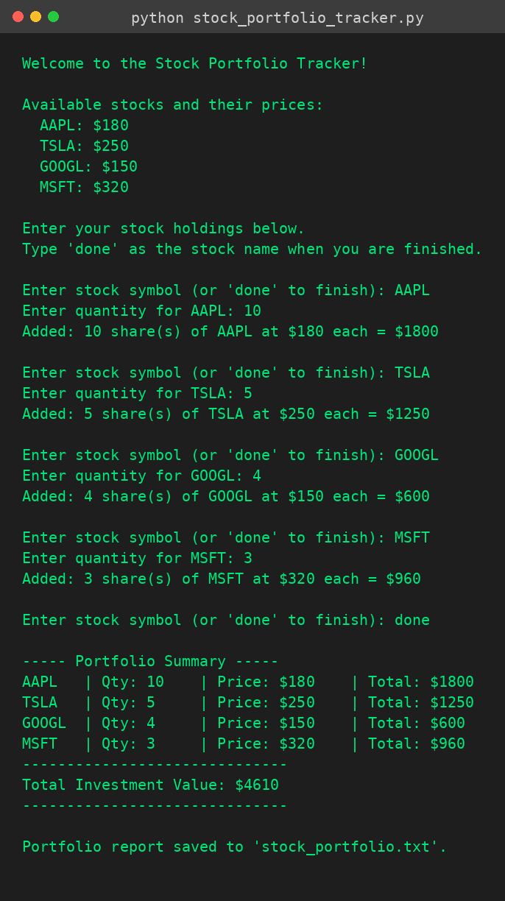

7.2 Saved Report File (stock_portfolio.txt)
After the program finished, it saved a matching summary to stock_portfolio.txt, confirmed here by displaying the file's contents in the terminal.
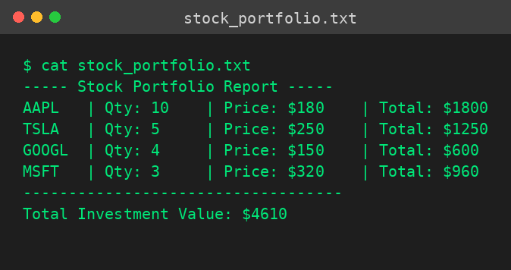

8. Learning Outcomes
- Practiced using Python dictionaries to store and look up fixed reference data (stock prices).
- Strengthened understanding of input validation and loop control using while and if-else.
- Applied basic arithmetic to compute per-item and total costs in a real-world-style scenario.
- Learned to read from and write to text files using Python's built-in file handling functions.
- Practiced structuring a program into small, reusable functions with clear responsibilities.

9. Conclusion
The Stock Portfolio Tracker task was completed successfully using only core Python. The program meets all the requirements in the task scope: it accepts stock names and quantities from the user, uses a hardcoded dictionary of stock prices, calculates and displays the total investment value with a per-stock breakdown, and saves the result to a .txt file. The final program is functional, well-commented, and beginner-friendly, and has been verified through console testing.

