Internship Task Report
Task 1: Hangman Game (Python Console Application)
Task Name | Hangman Game
Language Used | Python 3
Environment | Python console / terminal (no GUI)
Submission Type | Console-based mini project
Status | Completed and tested

1. Objective
The goal of this task was to create a simple, text-based Hangman game in Python where the player guesses a word one letter at a time. The game runs entirely in the console, with no graphics or audio, and is designed as a beginner-friendly exercise to practice core Python concepts such as loops, conditionals, strings, lists, and the random module.

2. Scope of the Task
- Use a small predefined list of 5 words (no external file or API required).
- Limit the player to a maximum of 6 incorrect guesses.
- Provide basic console input and output only.
- Randomly select one word from the list at the start of each game.

3. Tools and Technologies Used
- Python 3 - core programming language used to build the game.
- random module - used to randomly select a secret word from the word list.
- Python console / terminal - used to run and interact with the program.
- Visual Studio Code (or any Python-compatible IDE) - used for writing and editing the script.
- Git/local file system - used to store and organize the project file (hangman.py).

4. Key Concepts Applied
- random - random.choice() is used to pick a secret word from the list.
- while loop - drives the main game loop, continuing until the player wins or runs out of attempts.
- if-else statements - used to check guesses, validate input, and decide win/lose conditions.
- strings - the secret word and guessed letters are handled as strings; the display word is built by concatenation.
- lists - guessed_letters and the predefined word_list are implemented as Python lists.

5. How the Program Works
- A word is randomly chosen from a predefined list of 5 words.
- The word is displayed as underscores, one per letter, to hide it from the player.
- The player enters one letter at a time.
- If the letter is in the word, it is revealed in its correct position(s).
- If the letter is not in the word, an incorrect guess is recorded.
- After every guess, the program shows the current word state, the list of guessed letters, and the number of remaining attempts.
- The game ends in a win if all letters are revealed, or a loss if incorrect guesses reach the limit of 6, in which case the correct word is revealed.

6. Sample Code (hangman.py)
"""
Hangman Game
------------
A simple text-based Hangman game.
The player guesses letters one at a time to reveal a hidden word.
The player loses if they make 6 incorrect guesses.
"""

import random # used to randomly pick a word from our list

def choose_word(word_list):
"""Randomly select one word from the given list of words."""
return random.choice(word_list)

def display_word(word, guessed_letters):
"""
Build and return the current state of the word to display.
Each letter that has been guessed is shown; others are shown as '_'.
"""
display = ""
for letter in word:
if letter in guessed_letters:
display += letter + " " # show the letter if it's been guessed
else:
display += "_ " # hide the letter otherwise
return display.strip()

def play_hangman():
# Step 1: Predefined list of words to choose from
word_list = ["python", "hangman", "computer", "keyboard", "program"]

# Step 2: Randomly choose the secret word
secret_word = choose_word(word_list)

# Step 3: Set up game variables
guessed_letters = [] # letters the player has already guessed
max_incorrect = 6 # maximum allowed wrong guesses
incorrect_guesses = 0 # counter for wrong guesses

print("Welcome to Hangman!")
print("Try to guess the word one letter at a time.")
print("You have", max_incorrect, "incorrect guesses allowed.\n")

# Step 4: Main game loop — continues until the player wins or loses
while incorrect_guesses < max_incorrect:

# Show the current state of the word
print("Word:", display_word(secret_word, guessed_letters))
print("Guessed letters:", guessed_letters)
print("Remaining attempts:", max_incorrect - incorrect_guesses)

# Get input from the player
guess = input("Enter a letter: ").lower()

# Basic input validation: must be a single alphabet letter
if len(guess) != 1 or not guess.isalpha():
print("Please enter a single valid letter.\n")
continue # skip the rest of the loop and ask again

# Check if the letter was already guessed
if guess in guessed_letters:
print("You already guessed that letter. Try a different one.\n")
continue

# Add the new guess to the guessed_letters list
guessed_letters.append(guess)

# Check if the guessed letter is in the secret word
if guess in secret_word:
print("Good guess!\n")
else:
incorrect_guesses += 1
print("Wrong guess!\n")

# Step 5: Check if the player has revealed the entire word (Win condition)
# This works by checking if every letter in secret_word is in guessed_letters
word_complete = True
for letter in secret_word:
if letter not in guessed_letters:
word_complete = False
break

if word_complete:
print("Word:", display_word(secret_word, guessed_letters))
print("You Win! The word was:", secret_word)
return # end the game immediately since the player won

# Step 6: If the loop ends because incorrect_guesses reached max_incorrect, player loses
print("Game Over! You've used all", max_incorrect, "incorrect guesses.")
print("The correct word was:", secret_word)

# Step 7: Run the game only if this file is executed directly
if __name__ == "__main__":
play_hangman()

7. Testing and Output Screenshots
The program was tested with multiple runs to verify both the winning and losing scenarios, as well as input validation for repeated or invalid letters.

7.1 Winning Scenario
The player correctly guessed all the letters of the word “hangman” before running out of attempts, and the program displayed “You Win!” along with the completed word.
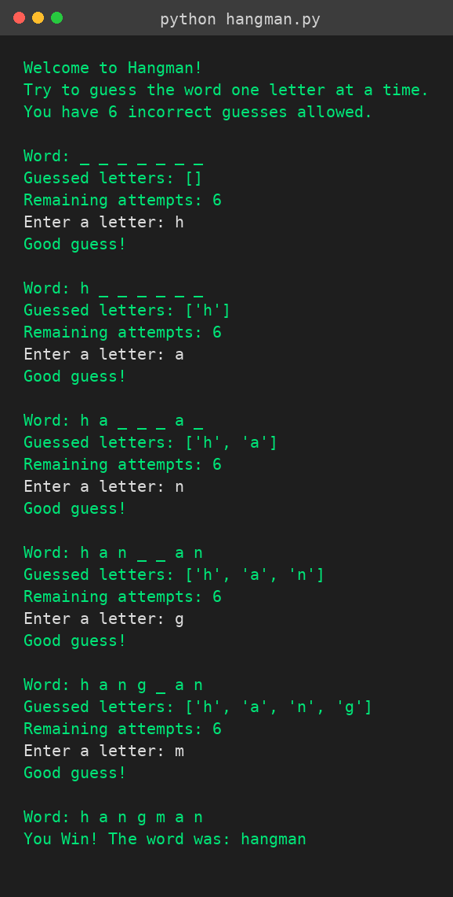

7.2 Losing Scenario
In this run, the player used all 6 incorrect guesses without revealing the word “computer”, so the program displayed “Game Over!” and revealed the correct word.
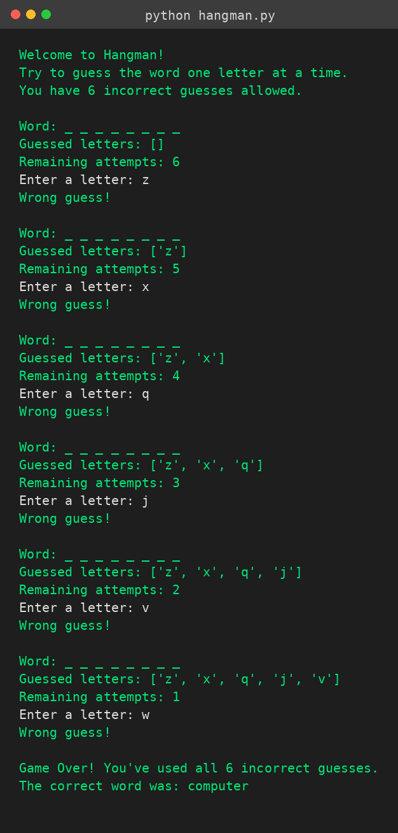

8. Learning Outcomes
- Gained practical experience using Python's random module for randomized program behavior.
- Practiced structuring a program around a while loop with clear exit conditions.
- Improved understanding of string and list manipulation for building dynamic console output.
- Learned to validate user input and handle edge cases (repeated guesses, invalid characters).
- Practiced writing clean, well-commented, beginner-friendly code.

9. Conclusion
The Hangman Game task was completed successfully using only core Python, satisfying all the requirements outlined in the task scope: a predefined 5-word list, random word selection, a maximum of 6 incorrect guesses, and clear console-based feedback after every guess. The final program is functional, well-commented, and beginner-friendly, and has been tested for both winning and losing scenarios.

