Report on PDF Table Extraction System
Automated Table Detection and OCR Extraction

Executive Summary
This document provides comprehensive documentation for an automated PDF table extraction system that leverages computer vision and optical character recognition (OCR) technologies. The system is designed to accurately detect, extract, and digitize tabular data from PDF documents, converting them into structured, machine-readable formats.
The solution combines OpenCV for image processing and table structure detection, Tesseract OCR for text extraction, and Python for data manipulation and export. It can handle complex scenarios including multiple tables per page, varying table layouts, and diverse formatting styles.

1. System Overview

1.1 Purpose
The PDF Table Extraction System automates the process of extracting structured data from tables embedded in PDF documents. This eliminates manual data entry, reduces human error, and enables efficient processing of large volumes of documents.

1.2 Key Features
- Automated table detection using morphological operations
- Cell-by-cell OCR with Tesseract engine
- Support for multiple tables per page
- Intelligent column alignment and row grouping
- Text cleaning and normalization
- Export to CSV and pandas DataFrame formats
- Visual debugging and validation tools

1.3 Technology Stack
Component | Technology
Image Processing | OpenCV (cv2) 4.x
OCR Engine | Tesseract OCR 4.x/5.x
PDF Conversion | pdf2image with Poppler
Data Processing | pandas, NumPy
Programming Language | Python 3.7+
Visualization | matplotlib

2. Technical Architecture

2.1 Processing Pipeline
The system follows an eight-stage pipeline to transform PDF documents into structured data:
- PDF Conversion: Convert PDF pages to high-resolution images (300 DPI)
- Image Preprocessing: Apply adaptive thresholding and noise reduction
- Structure Detection: Identify table boundaries using morphological operations
- Cell Identification: Detect individual cells through contour analysis
- Row Organization: Group cells into rows based on vertical alignment
- Table Separation: Identify and separate multiple tables on the same page
- OCR Extraction: Extract text from each cell using Tesseract
- Data Export: Organize data into DataFrames and export to CSV

2.2 Image Processing Workflow

2.2.1 PDF to Image Conversion
The system uses pdf2image with Poppler to convert PDF pages into high-resolution images. A DPI of 300 is used to ensure sufficient detail for accurate OCR while maintaining reasonable processing times.

2.2.2 Adaptive Thresholding
Adaptive thresholding is applied using the Gaussian method to handle varying lighting conditions and contrast levels across the document. The inverted binary threshold ensures that table lines and text appear as white pixels on a black background, facilitating subsequent morphological operations.

2.2.3 Morphological Operations
The system employs morphological opening operations with specialized kernels to detect horizontal and vertical lines separately. A horizontal kernel (40×1 pixels) identifies row separators, while a vertical kernel (1×40 pixels) detects column boundaries. These are then combined to reconstruct the complete table structure.
3. Component Details

3.1 Table Detection Algorithm
The table detection algorithm uses contour analysis to identify rectangular regions representing table cells. Contours are filtered based on minimum size thresholds (width > 50 pixels, height > 20 pixels) to eliminate noise and artifacts.
Detected cells are then organized into a hierarchical structure:
- Cells are sorted by Y-coordinate (top to bottom)
- Cells with similar Y-coordinates (within 15-pixel tolerance) are grouped into rows
- Within each row, cells are sorted by X-coordinate (left to right)
- Rows are grouped into tables based on vertical spacing between consecutive rows

3.2 Column Alignment System
The column alignment system addresses variations in cell positioning by clustering horizontal centers. Each cell's center point is calculated, and cells with centers within 60 pixels of each other are considered to belong to the same column. This approach handles tables where borders are not perfectly aligned or cells span multiple columns.

3.3 OCR Configuration
Tesseract OCR is configured with specific parameters optimized for table cell recognition:
- OEM 1: Use LSTM neural network engine for improved accuracy
- PSM 7: Treat each cell as a single text line

Before OCR processing, each cell image is upscaled by 2x using cubic interpolation to enhance character clarity and improve recognition accuracy.

3.4 Text Cleaning Pipeline
Extracted text undergoes several cleaning operations to remove OCR artifacts and normalize data:
- Remove common OCR artifacts (degree symbols, special quotes, pipe characters)
- Filter out very short strings (2 characters or less) likely to be noise
- Remove strings containing no alphanumeric characters
- Correct common OCR errors (e.g., hyphen misread as decimal point in numbers)

4. Installation and Setup

4.1 System Requirements
- Python 3.7 or higher
- 4GB RAM minimum (8GB recommended for large PDFs)
- Windows, macOS, or Linux operating system
- Poppler utilities installed
- Tesseract OCR engine installed

4.2 Python Dependencies
Install required Python packages using pip:
pip install opencv-python numpy pytesseract pandas pdf2image matplotlib

4.3 External Dependencies

4.3.1 Poppler Installation
Windows: Download from https://github.com/oschwartz10612/poppler-windows/releases/
macOS: Install via Homebrew: brew install poppler
Linux: Install via package manager: sudo apt-get install poppler-utils

4.3.2 Tesseract OCR Installation
Windows: Download installer from https://github.com/UB-Mannheim/tesseract/wiki
macOS: Install via Homebrew: brew install tesseract
Linux: Install via package manager: sudo apt-get install tesseract-ocr
5. Configuration

5.1 Path Configuration
Update the following paths in the script according to your system setup:
Parameter | Description
PDF_PATH | Path to the input PDF file
POPPLER_PATH | Path to Poppler bin directory
TESSERACT_PATH | Path to Tesseract executable
OUTPUT_FOLDER | Directory for saving extracted CSV files
PAGE_INDEX | Zero-indexed page number to process

5.2 Processing Parameters
The following parameters can be adjusted to optimize processing for specific document types:
Parameter | Default | Purpose
DPI | 300 | Image resolution for PDF conversion
Row Tolerance | 15 px | Vertical tolerance for grouping cells into rows
Column Threshold | 60 px | Horizontal clustering for column alignment
Min Cell Width | 50 px | Minimum width to consider as valid cell
Min Cell Height | 20 px | Minimum height to consider as valid cell
Cell Padding | 4 px | Border padding removed before OCR
6. Usage Guide

6.1 Basic Usage
- Configure the file paths in the script (PDF_PATH, POPPLER_PATH, TESSERACT_PATH, OUTPUT_FOLDER)
- Set the PAGE_INDEX to the desired page (0-indexed)
- Run the script: python pdf_table_extractor.py
- Review the generated visualization plots for debugging
- Check the output folder for extracted CSV files

6.2 Processing Multiple Pages
To process all pages in a PDF document, wrap the processing logic in a loop:
For PAGE_INDEX in range(len(pages)): #processing code here
print(f’Processing page {PAGE_INDEX + 1}…’)

6.3 Output Files
The system generates the following outputs:
- CSV Files: One file per detected table (table_1.csv, table_2.csv, etc.)
- Visualization Plots: Matplotlib figures showing processing stages
- Console Output: Progress information and detected table statistics

7. Troubleshooting
<,

7.1 Common Issues
Issue | Solution
No tables detected | Adjust kernel sizes for morphological operations. Try (60,1) and (1,60) for larger tables.
Cells misaligned | Increase column threshold parameter or adjust row tolerance value.
Poor OCR accuracy | Increase DPI to 400 or 600. Ensure Tesseract language data is installed correctly.
Missing cells | Reduce minimum cell size thresholds (width and height parameters).
Tables split incorrectly | Adjust the gap multiplier (currently 2x average row height) to better match document layout.
Memory errors | Reduce DPI or process pages individually instead of loading entire PDF.

7.2 Debugging Workflow
The script generates several visualization plots that help diagnose issues:
- Thresholded Image: Verify that text and borders are clearly visible
- Horizontal/Vertical Lines: Check if table structure is properly detected
- Detected Table Cells: Ensure all cells are identified with green rectangles

8. Performance Optimization

8.1 Processing Speed
Processing time varies based on several factors:
- DPI Setting: Higher DPI increases accuracy but slows processing
- Table Complexity: More cells require more OCR operations
- Page Size: Larger pages take longer to process
<

8.2 Optimization Strategies
- Use DPI 200-250 for draft processing, 300-400 for production
- Disable visualization plots for batch processing
- Process multiple pages in parallel using multiprocessing
- Consider GPU-accelerated Tesseract for large-scale deployments

8.3 Accuracy vs. Speed Trade-offs
Setting | Fast Mode | Accurate Mode
DPI | 200 | 400-600
Cell Upscaling | 1.5x | 2x-3x
PSM Mode | PSM 7 (single line) | PSM 6 (uniform block)
<<
10. Results
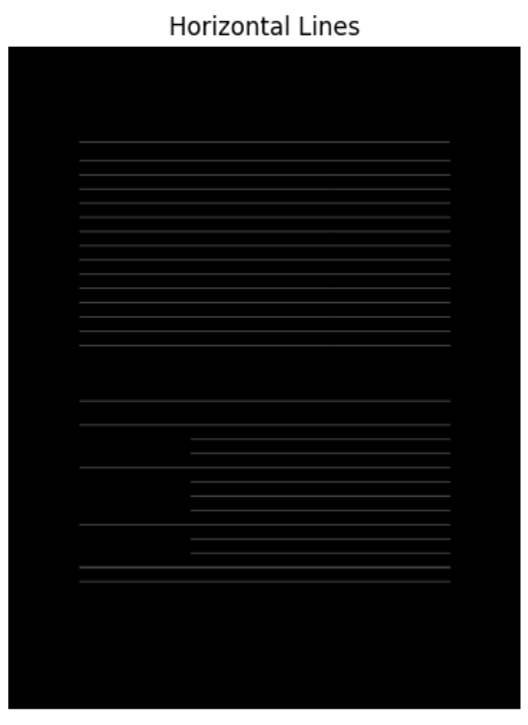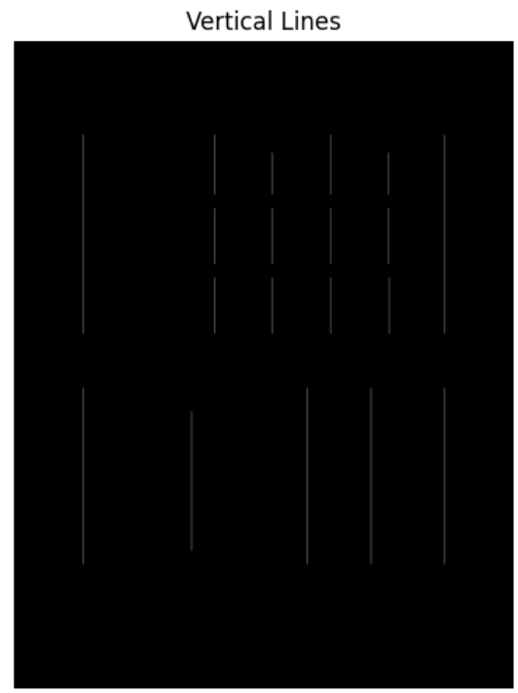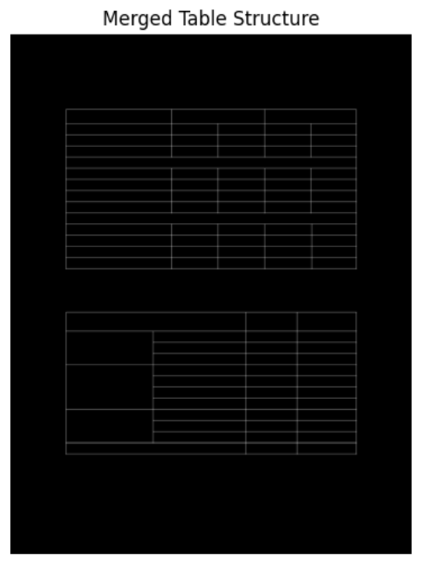

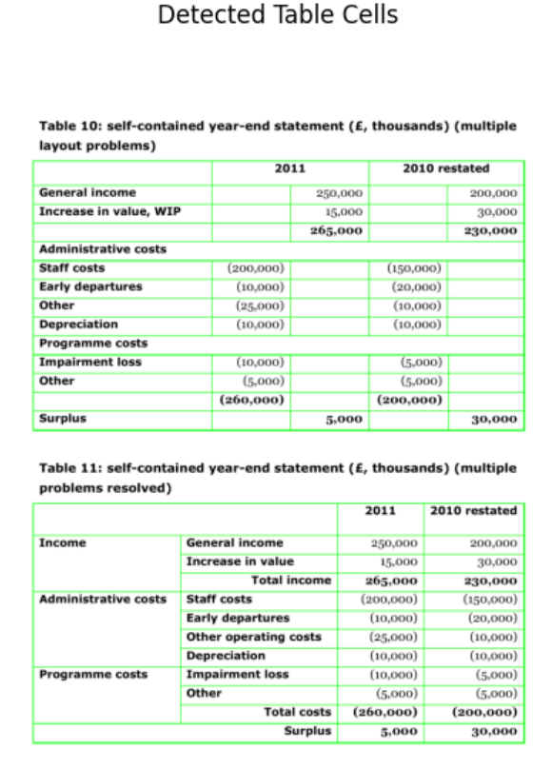
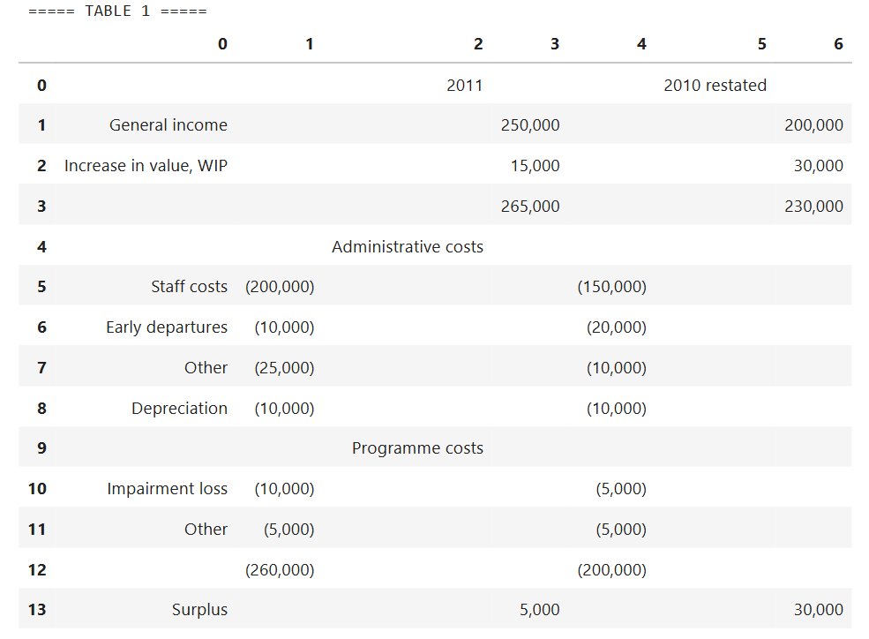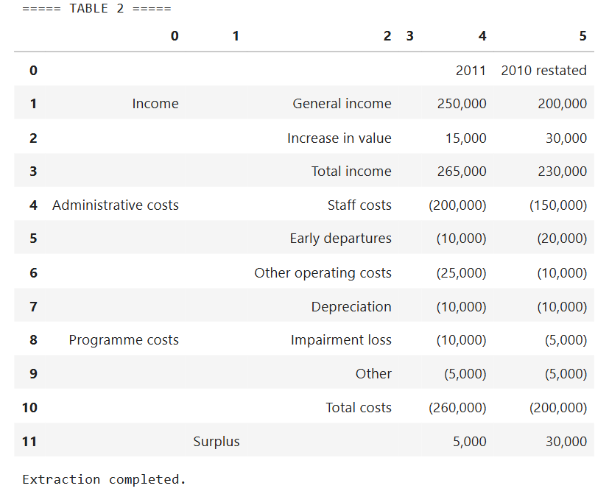

10. Limitations and Future Enhancements

10.1 Current Limitations
- Requires tables with visible borders (cannot detect borderless tables)
- May struggle with heavily merged cells or complex spanning structures
- Limited support for rotated or skewed tables
- Processes one page at a time (no batch processing built-in)
- OCR accuracy depends on image quality and font clarity

10.2 Planned Enhancements
- Borderless table detection using machine learning
- Support for merged cell recognition and handling
- Automatic page rotation and de-skewing
- Batch processing with progress tracking
- GUI interface for non-technical users
- Export to additional formats (Excel, JSON, Database)
- Integration with cloud storage services

<
11. Use Cases and Appl+ications
<<<

11.1 Business Applications
- Financial Document Processing: Extract data from invoices, receipts, and financial statements
- Research Data Extraction: Digitize tables from scientific papers and research reports
- Legal Document Analysis: Extract structured data from contracts and legal filings
- Inventory Management: Convert paper-based inventory lists to digital databases

11.2 Academic and Research
- Digitizing historical data tables from scanned documents
- Converting research data from PDF publications to analysable formats
- Building datasets from multiple sources for meta-analysis

11.3 Government and Public Sector
- Processing census data and statistical reports
- Digitizing archival records and historical documents
- Extracting data from regulatory filings and compliance documents

