

|  |  |  |  |
| --- | --- | --- | --- |
| S.No | NAME | REG NO | ROLL NO |
| 1 | Palagiri.Madhukar Reddy | 11904176 | 12 |
| 2 | Neeraj Kumar Chinde | 11904201 | 14 |
| 3 | Poloju.Nithin | 11904214 | 15 |

Online Job Application Portal

Assignment-1

Submitted to:- Dr. MoinHasan

Submitted by:-

**School of Computer Science Engineering**

**Lovely Professional University, Jalandhar**

**October- 2020**

**ABSTRACT**

In this competitive era, the education among the people is so increasing that the jobs for them are now decreasing. The companies even want the people who are best in their fields. At that time, it becomes difficult to find the people who are intelligent enough to be hired. The work for the companies also increases to find the people who can fulfill their requirements. Thinking about these problems, one can think about the process which can handle this process and make the work less complex.

This project is about the recruitment process which is done online. The recruitment process here is handled by the system. This project will allow the person to apply for a job in the company for the interested vacancy which would be available at the company. The person will be having the account after registration and will be then called the applied user. If he would be qualified, he would be interacting with the system for the updates.

The project is created for fulfilling the requests of the company managers so that the recruitment module can be placed in the company’s website and the users who visit the website can view the vacancies in the company and will be able to apply directly from remote place even. The vacancies will be posted by the administrator on the basis of needs of the manpower in the company. The admin will have all rights of handling this process except the evaluation process as it is the company specific and so the steps of the evaluation process cannot be predicted. It also includes the layers at the admin side so the privileges will have great impact on the functionalities given to the different levels of admin.

The privileges will be user specific, so different admin even at same level will have different privileges and so different functionalities. The higher level admin will handle whole system by himself. Although the lower level admin is given such privileges that he can send any kind of request to the higher level admin. The higher level admin can approve or disapprove the request. Whatever the result of the request approval, the notification will be sent to the lower level admin. This project plays main role at admin side for recruitment process. The start dates and end dates for applications’ acceptance, the grace period, the job vacancies’ postings, modifying the privileges etc. are the special features of this system.

Page 01

**ACKNOWLEDGEMENT**

I would like to express the deepest appreciation to our Professor Dr. MoinHasan.who has the attitude and the substance of a genius: he continually and convincingly conveyed a spirit of adventure in regard to research, and an excitement in regard to teaching. Without his guidance and persistent help this project would not have been possible.

From this project we have learnt a lot about the pythonTkinter library and also the different concepts of python like classes or methods or constructors etc… We have improved our knowledge on not only the python, also How the online job application portal works at the background.

I would like to express my thanks to the people who have helped me most throughout my project. I am grateful to my Professor for nonstop support for the project. A special thank of mine goes to my team mates who helped me out in completing the project, where they all exchanged their own interesting ideas, thoughts and made this possible to complete our project with all accurate information.

Page 02

**ABBREVIATIONS**

TK**:-**Tkinter(python library).

GUI:- Graphical User Interface.

PIL:- Pillow(python library).

PIP:-Pip install packages.

page 03

**CONTENTS**

|  |  |  |
| --- | --- | --- |
| **S.no** | **Topic** | **Page no** |
| 1 | Introduction | 05 |
| 2 | Project Review | 06 to 07 |
| 3 | Project Contribution | 08 |
| 4 | Materials And Methods | 09 |
| 5 | Results | 10 to 14 |
| 6 | Reference | 15 |

Page 04

**INTRODUCTION**

This project is aimed at developing an online search Portal for the Placement Details for job seekers. The system is an online application that can be accessed throughout the organization and outside as well with proper login provided. This system can be used as an Online Job Portal for job seekers. Job Seekers logging should be able to upload their information in the form of a Registration for the respective company. Company representatives logging in may also access/search any information put up by Job aspirants.

The online job portal system is a platform between job seeker(student) and job provider(company). The Student or Job seeker can easily find and apply for job by login into system. The Employer or company can easily get expert employee from our job portal site by posting a job. The job portal website is a common place between job seeker and company.

When job seeker can login in his account then he can get notification of company lists which match with his profile or education detail. So job seeker can easily apply to this job and he can also send message to company for other inquiry.When company login in account, company or employer can get alert of job seeker lists which match with all criteria for posted job.

This system can be used as an Online Job Portal for the Placements providing to the unemployees who are seeking for a job placement. Job Seeker logging into the system and he/she can be able to upload their information in the form of a Registration for the company which will be forwarded to the respective company. Company representatives logging in may also access or search any information put up by Job Seeker from this Online job application portal project.

Page 05

**PROJECT REVIEW**

The online job portal system is a platform between job seeker(student) and job provider(company). The Student or Job seeker can easily find and apply for job by login into system. The Employer or company can easily get expert employee from our job portal site by posting a job. The job portal website is a common place between job seeker and company.

The project start with the main page which contains 3 buttons:-

1. Login

2. Job registration form

3. Job search page

From this Login page by clicking the Login Button, You can be taken to the login page. From the login page you can login to the application if you are a not register user. You will have a registration option to register into the application for 1st time you can use the application. By registering to the registration form with your particular email and password which will be using for the further login.

If user forgot the password used for login, The user will be asked for the Registered email and a security question then the user can update their password. While user registering for the application user will be asked to select a security question which will be answered by user itself that will be asked here .

The job registration form is used to register for the job the register want which has being showed in the available jobs the user needs to enter the details like name, email, phone no., qualification, age, gender, D.O.B, address. After registration the job applied by the user by giving his details will be applied on the left side of the page.

The available jobs will be shown in the job search page and from where user can get the details of the jobs available. From the job search portal user can search by the mentioned column like name, job, company(column titles). By clicking on the column, user will be shown with the entire details of the particular job on the left side of the page. After this the user can register for the application first and after registering into the application user will be allowed to register for the concern job.

Page 06

**Flow Chart of the Project:-**

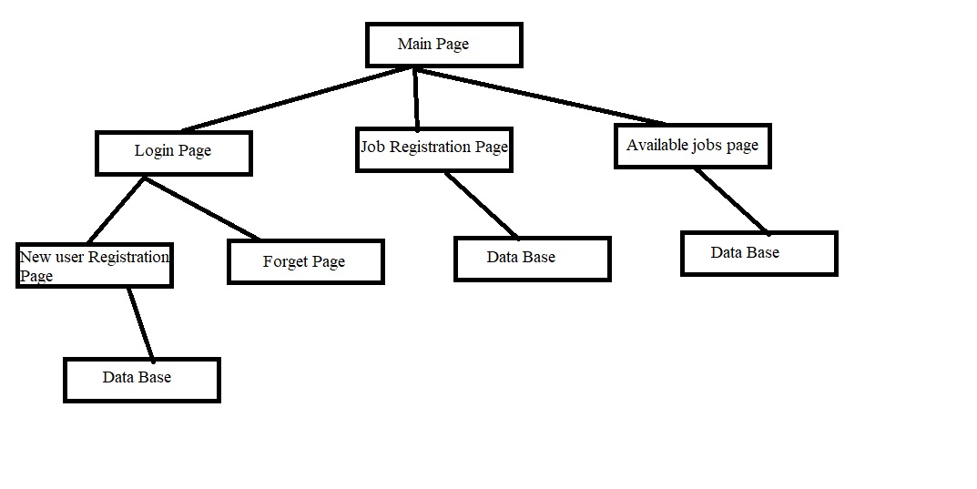

Page 07

**PROJECT CONTRIBUTION**

In this project everyone of our team members contributed their best to do this project. Eachone of our team applied full pledged knowledge to complete this project. Everyone shared their point of views and doubts with each other also we got to know many things which we have doubt at some particular point.

Initially we have shared our work into different modules and we performed according to that. Here are the works we divided for each other in our group

* Login system.
* Registration process system.
* Jobs availability module.
* Job registration system.
* Main page Module.
* Database Module.

We have gathered information from the different sites of Google and also we used YouTube videos to add more potential to our project. We also viewed some of the github repository for the good user interface GUI.

Links of the sites, videos and github repository were given in the References (page no.13)

Page 08

**MATERIALS AND METHODS USED**

For this project we entirely used the Anaconda scientific application development platform. From this platform we used jupyter note book and alone with some of the python libraries given below:-

**Tkinter:-**

Tkinter is the standard GUI library for Python. Python when combined with Tkinter provides a fast and easy way to create GUI applications. Tkinter provides a powerful object-oriented interface to the Tk GUI toolkit.

**Pillow:-**

Python Imaging Library is a free and open-source additional library for the Python programming language that adds support for opening, manipulating, and saving many different image file formats.

For the databases we used MySQL work bench to connect the MySQL work bench to the python we used MySQL.connector. Which is useful python library used for the connection for the MySQL work bench for the python.

**MySQL Workbench:-**

MySQL Workbench is a visual database design tool that integrates SQL development, administration, database design, creation and maintenance into a single integrated development environment for the MySQL database system

**Anaconda Navigator:-**

Anaconda is a free and open-source distribution of the Python and R programming languages for scientific computing (data science, machine learning applications, large-scale data processing, predictive analytics, etc.), that aims to simplify package management and deployment. The distribution includes data-science packages suitable for Windows, Linux, and macOS. It is developed and maintained by Anaconda, Inc., which was founded by Peter Wang and Travis Oliphant in 2012.

Page 09

**RESULTS**

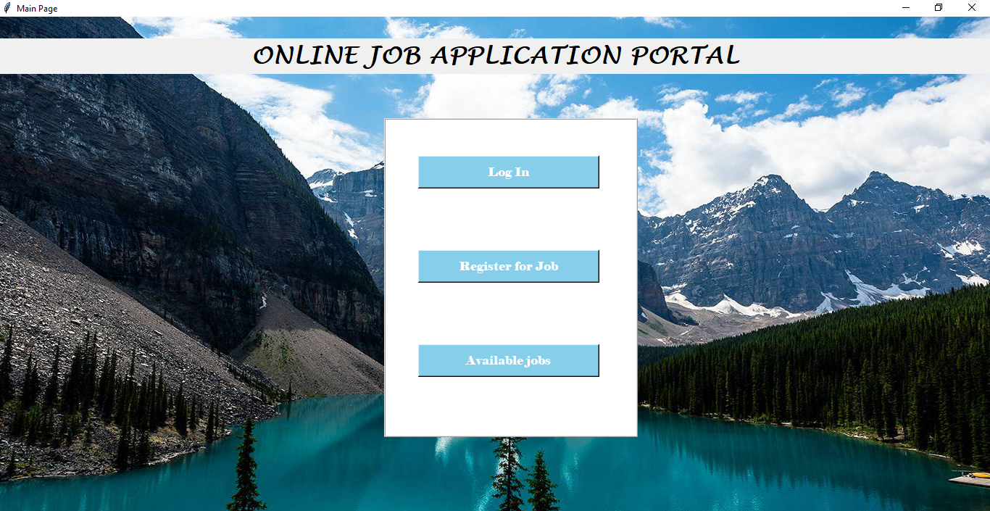

**Main Page which has 3 buttons 1) Login 2) Register for job 3) Available jobs**

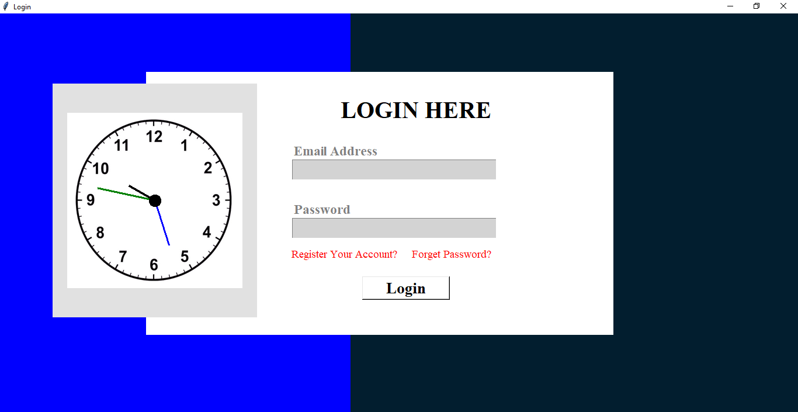

**This the login page which helps user to login**

Page 10

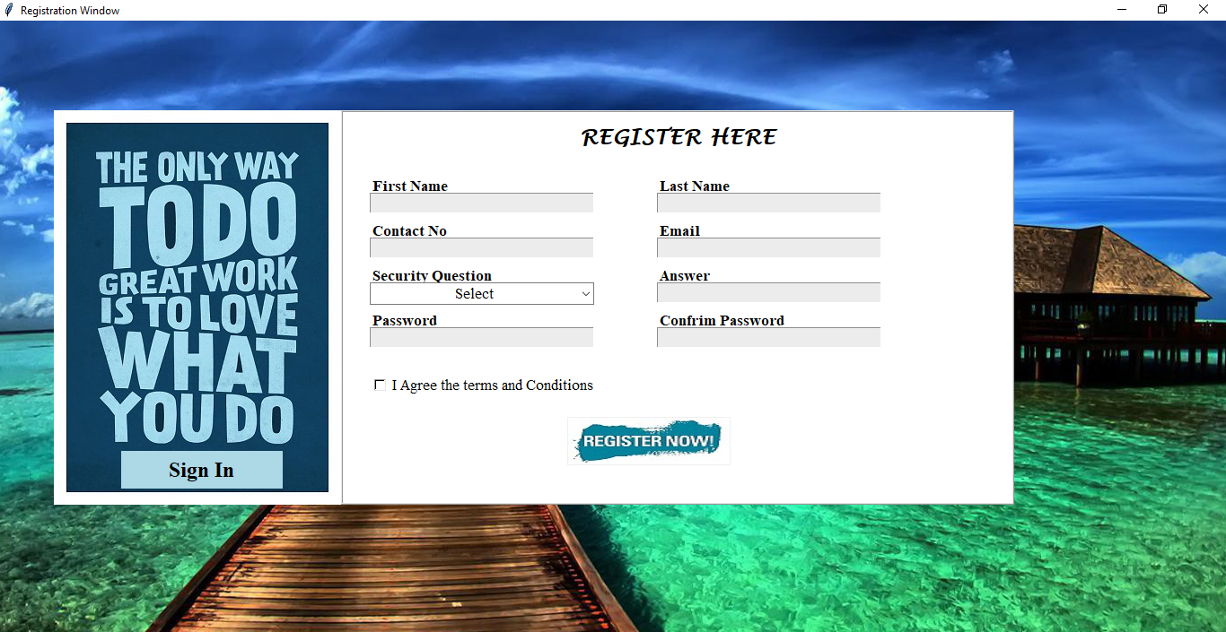

**This is the register page which helps new user to register**

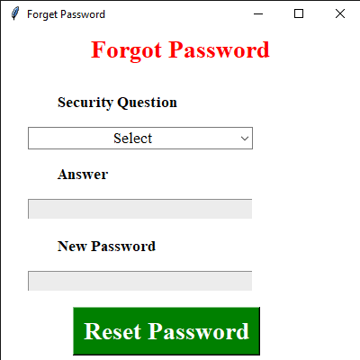

**This the forget page which help user to recover password using security question and answer**

Page 11

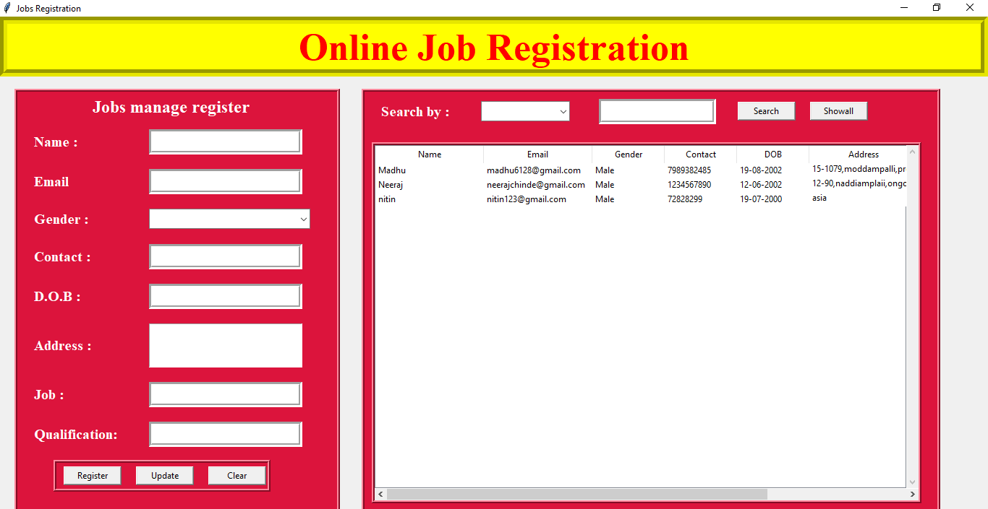

**This is the job registration page which helps user to register for jobs**

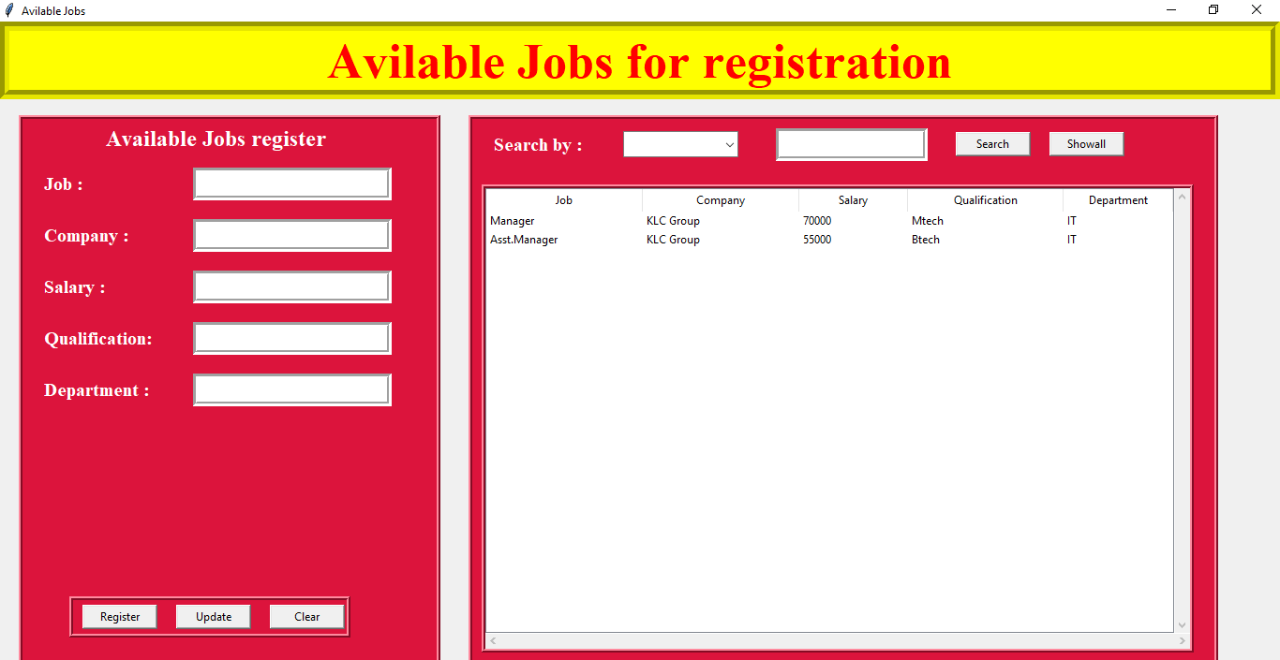

**This is the page which shows the user the available jobs**

Page 12

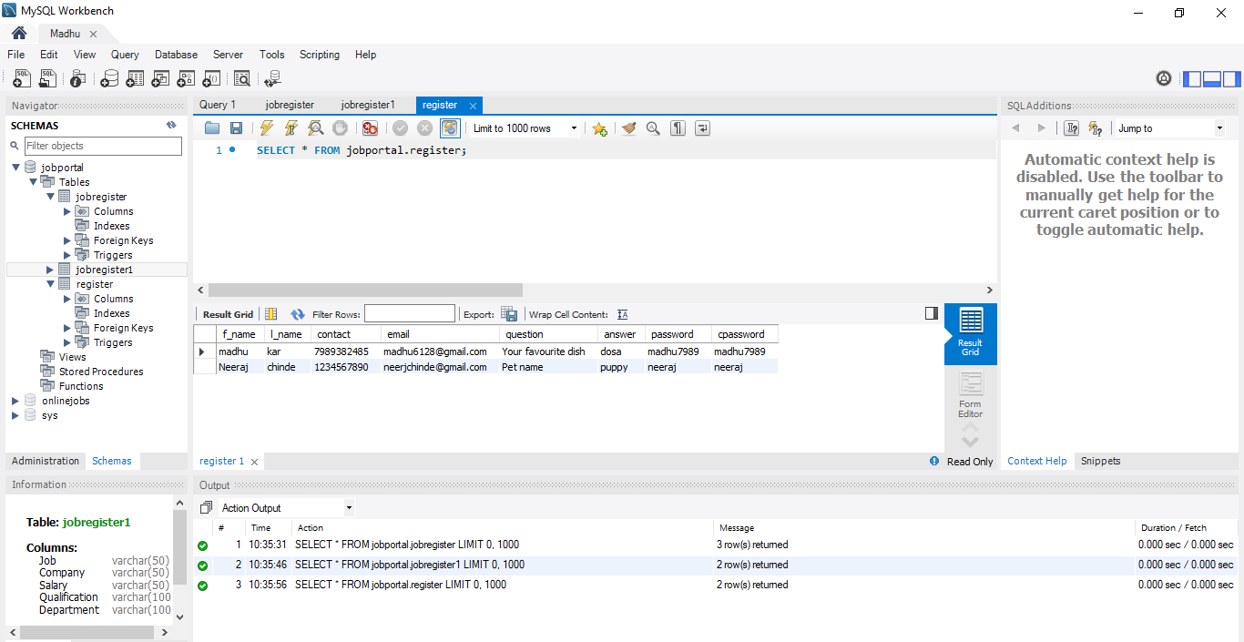

**This is the working database of register page**

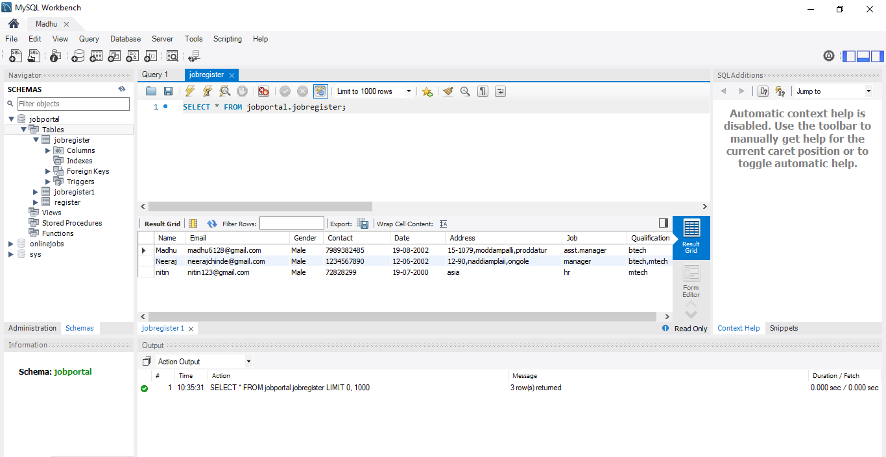

**­This the working database of job registration page**

Page 13

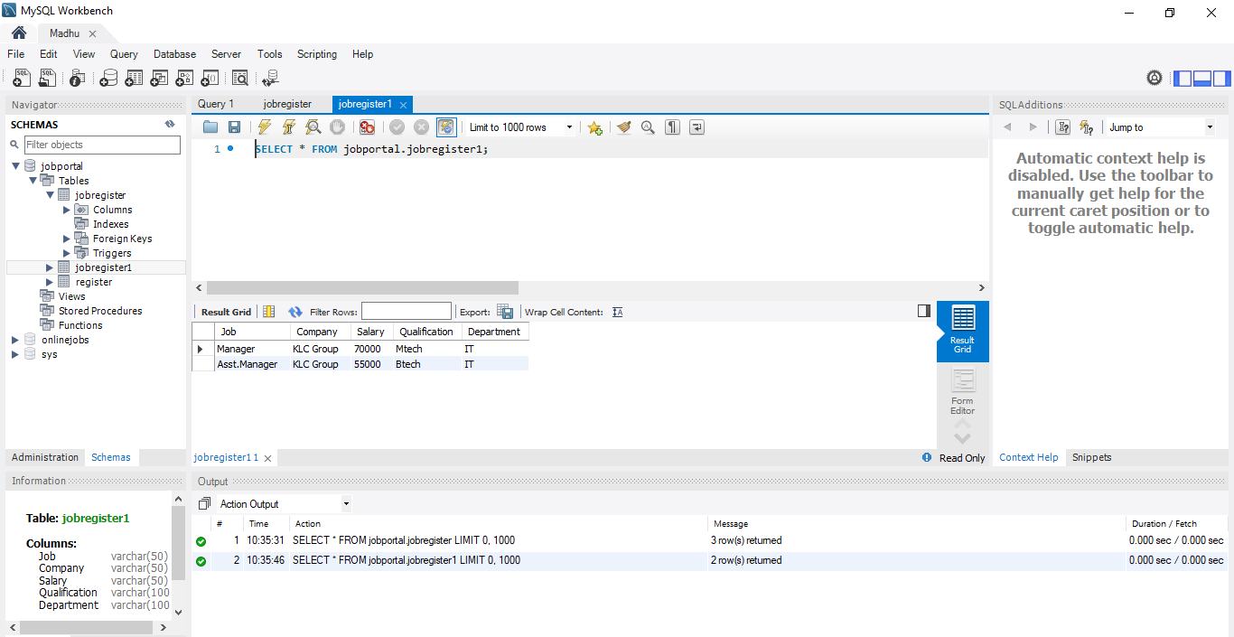

**This is the working database of the available jobs page**

Page 14

**REFERENCES**

**Youtube links:-**

[**https://youtu.be/d56sf29tSzw**](https://youtu.be/d56sf29tSzw)

[**https://youtu.be/DUNn0YAIh1U**](https://youtu.be/DUNn0YAIh1U)

[**https://youtu.be/D8-snVfekto**](https://youtu.be/D8-snVfekto)

[**https://www.youtube.com/playlist?list=PL4P8sY6zvjk5YsiQCcWfSXc_J3pVCr40K**](https://www.youtube.com/playlist?list=PL4P8sY6zvjk5YsiQCcWfSXc_J3pVCr40K)

**Github Link:-**

[**https://github.com/KeithGalli/GUI**](https://github.com/KeithGalli/GUI)

**Google Links:-**

[**https://www.tutorialspoint.com/python/python_gui_programming.htm**](https://www.tutorialspoint.com/python/python_gui_programming.htm)

[**https://docs.python.org/3/library/tk.html**](https://docs.python.org/3/library/tk.html)

Page 15