SMART PRODUCTIVITY & SAFETY MANAGEMENT SYSTEM IN COAL MINES AI-POWERED SECURITY & PRODUCTION VALUE PREDICTION PLATFORM
Abstract:
The Smart Productivity & Safety Management System in Coal Mines is an AI-powered security and production value prediction platform developed to enhance worker safety, operational efficiency, and data-driven decision-making in coal mining environments. Coal mines operate under high-risk conditions where environmental hazards, equipment failures, and human errors can lead to serious accidents and production losses. Traditional monitoring and forecasting approaches are often manual, isolated, and reactive, limiting their effectiveness. The proposed system addresses these limitations by integrating machine learning, data analytics, and web-based automation within a unified Django-based platform. The system consists of two major modules: a Safety Management Module and a Production Prediction Module, supported by secure role-based access for administrators and users. In the safety module, real-time and historical sensor data related to temperature, gas concentrations, pressure, vibration, and other environmental factors are preprocessed, scaled, and analyzed using machine learning classifiers such as Naive Bayes and XGBoost. These models accurately classify mine conditions as safe or hazardous, enabling early risk detection and accident prevention. The production module focuses on predicting coal production value using historical production data, country-wise statistics, growth rates, and market share indicators. Regression-based models, including Linear Regression and Decision Tree Regressor, are employed to forecast production trends and support strategic planning. The platform provides automated data upload, preprocessing, model training, performance evaluation, and visual analytics through interactive dashboards. Performance metrics such as accuracy, precision, recall, F1-score, RMSE, MAE, and R² are used to compare existing and proposed models, demonstrating the effectiveness of advanced algorithms. User-level prediction interfaces allow real-time safety verification and production estimation. Overall, the proposed system improves safety compliance, reduces operational risks, enhances production forecasting accuracy, and supports sustainable and intelligent coal mining operations through AI-driven insights.

Chapter 1
Introduction
Coal mining plays a vital role in meeting global energy demands and supporting industrial growth; however, it remains one of the most hazardous and operationally complex industries. Mining environments are characterized by extreme underground conditions such as high temperatures, toxic gas emissions, unstable geological structures, heavy machinery usage, and limited visibility. These factors significantly increase the risk of accidents, equipment failure, and health hazards for workers, while also affecting production efficiency and economic output. Ensuring worker safety while maintaining consistent and optimized production has therefore become a critical challenge for the coal mining sector.
Conventional safety monitoring and production management systems in coal mines rely heavily on manual inspections, isolated sensor readings, and historical reporting. Such approaches are often reactive rather than proactive, leading to delayed hazard detection, inefficient response to emergencies, and inaccurate production forecasting. With the increasing availability of sensor data, industrial automation, and computational resources, there is a strong need for intelligent systems that can analyze large volumes of data in real time and support informed decision-making.
Recent advancements in artificial intelligence (AI) and machine learning (ML) provide powerful tools to address these challenges. By learning patterns from historical and real-time data, AI-based models can predict unsafe conditions, identify hidden risks, and estimate production outcomes with higher accuracy. Integrating these capabilities into a centralized digital platform enables continuous monitoring, early warning mechanisms, and optimized resource planning.
This project introduces a Smart Productivity & Safety Management System in Coal Mines, an AI-powered platform that combines safety classification and production value prediction within a secure, web-based environment. The system leverages machine learning algorithms for hazard detection and production forecasting, supported by automated data preprocessing, visualization, and performance evaluation. By unifying safety intelligence and productivity analytics, the proposed system aims to reduce accidents, improve operational efficiency, and promote sustainable and data-driven coal mining practices.
Thesis Outline:
The thesis is structured as follows:
- Chapter 1: introduces the problem statement, research motivation, and objectives of the project.
- Chapter 2: provides a literature review on existing online exam systems, AES encryption, and Blockchain technology.
- Chapter 3: The system analysis recommendation behind the current recommended approaches.
- Chapter 4 : To explain system study of the project
- Chapter 5: Details the system research that was conducted under various circumstances. To include UML diagrams are used to describe the system design.
- Chapter 6: To explain software description with machine learning
- Chapter 7: To explain simulative study and implementation of system module description.
- Chapter 8: To evaluate source code experimental results and analysis
- Chapter 9: To conclude as per project Conclusions and Scope for Future Research

Chapter 2:
Literature Review
- Safety Challenges in Coal Mining:
Several studies highlight that coal mining remains one of the most dangerous industrial sectors due to gas explosions, roof collapses, equipment malfunction, and human error. Researchers emphasize the need for continuous monitoring of environmental parameters to reduce accident rates.
- Traditional Mine Safety Systems:
Earlier safety systems mainly relied on manual inspections and threshold-based sensor alarms. These systems lacked predictive capabilities and often failed to provide early warnings, resulting in delayed responses to hazardous conditions.
- IoT-Based Monitoring in Mines:
Recent research demonstrates the use of IoT sensors to monitor temperature, humidity, gas concentration, pressure, and vibration in underground mines. While IoT improves data collection, many systems do not fully utilize advanced analytics for intelligent decision-making.
- Machine Learning for Hazard Detection:
Studies show that machine learning classifiers such as Naive Bayes, Decision Trees, and Support Vector Machines can effectively classify mine environments into safe and unsafe conditions by learning patterns from historical sensor data.
- XGBoost in Safety Prediction:
Advanced ensemble models like XGBoost have been widely reported to outperform traditional classifiers in handling non-linear relationships and imbalanced datasets, making them suitable for complex safety prediction tasks in mining applications.
- Production Forecasting in Mining:
Literature on mine productivity analysis indicates that coal production is influenced by multiple factors such as geological conditions, equipment efficiency, workforce productivity, and economic indicators. Accurate forecasting is essential for planning and sustainability.
- Regression Models for Production Estimation:
Linear Regression has been commonly used for production prediction due to its simplicity and interpretability. However, studies note its limitations in capturing complex patterns, leading to the exploration of tree-based regression models.
- Decision Tree Regression in Industrial Forecasting:
Research highlights that Decision Tree Regressors can model non-linear relationships and interactions between variables, providing improved accuracy in industrial production and energy output prediction tasks.
- Web-Based Intelligent Mining Systems:
Several works propose integrating AI models into web-based platforms for real-time monitoring, visualization, and reporting. Such systems enhance accessibility, transparency, and ease of deployment in industrial environments.
- Research Gap Identification:
Existing literature often treats safety monitoring and production forecasting as separate problems. There is a clear gap in unified platforms that combine AI-driven safety prediction and production value estimation, motivating the development of an integrated smart productivity and safety management system for coal mines.

CHAPTER – 3
SYSTEM ANALYSIS

The system analysis of the Smart Productivity & Safety Management System in Coal Mines focuses on understanding the problem domain, evaluating the existing approaches, identifying limitations, and defining the requirements and feasibility of the proposed solution. Coal mining operations demand continuous monitoring of safety conditions and accurate prediction of production output to minimize risks and maximize efficiency. However, current practices often fail to provide timely insights and integrated decision support.
Dataset
The proposed system uses two real-world datasets corresponding to mine safety and coal production.
- Safety Dataset (Helmet / Mine Environment Data):
This dataset contains environmental and operational parameters collected from sensors used in coal mines. Attributes include temperature, humidity, methane (CH₄), hydrogen sulfide (H₂S), carbon monoxide (CO), volatile organic compounds (VOC), pressure, vibration, impact force, light intensity, fluid level, and related safety indicators. The target variable classifies conditions as Safe or Hazardous, making the dataset suitable for supervised classification.
- Production Dataset (Coal Production Data):
The production dataset consists of historical coal production statistics with attributes such as year, country, annual growth rates, market share, and production value measured in million tonnes. This dataset is used for regression-based production value prediction.

Dataset Preprocessing
Effective preprocessing is essential to improve model accuracy and reliability.
- Missing Value Handling:
Numerical missing values are replaced using mean imputation to maintain data consistency.
- Categorical Encoding:
Categorical attributes such as Country are converted into numerical form using Label Encoding.
- Feature Scaling:
Standardization using StandardScaler is applied to both safety and production datasets to normalize feature ranges and improve learning efficiency.
- Data Splitting:
The datasets are split into training and testing sets using an 80:20 ratio to ensure unbiased performance evaluation.
- Visualization:
Graphs such as class distribution plots, year-wise production trends, and country-wise production comparisons are generated for exploratory data analysis.

Model Evaluation
Model evaluation is performed using appropriate performance metrics.
- Safety Models:
Accuracy, Precision, Recall, F1-score, and Confusion Matrix are used to assess classification performance.
- Production Models:
Mean Squared Error (MSE), Root Mean Squared Error (RMSE), Mean Absolute Error (MAE), and R² Score are used to evaluate regression models.
Comparative bar charts are generated to visually analyze the performance of existing and proposed models.
EXISTING SYSTEM :
The existing coal mine safety and production management system mainly relies on traditional monitoring techniques and manual analysis. Safety management is typically handled through periodic inspections, basic sensor-based threshold alarms, and human supervision. These systems only react when environmental parameters such as gas concentration or temperature exceed predefined limits, offering no predictive or preventive capability. As a result, potential hazards are often identified too late, increasing the risk of accidents and endangering workers’ lives. Production estimation in the existing system is based on historical records, static reports, and simple mathematical models. Such approaches fail to adapt to changing mine conditions, market trends, and operational variations. Data processing is mostly manual, which makes the system time-consuming, error-prone, and inefficient. Moreover, safety analysis and production forecasting are handled separately, with no centralized platform for monitoring or decision-making. Overall, the existing system lacks intelligence, integration, real-time analytics, and accurate prediction capabilities.

PROPOSED SYSTEM
The proposed system introduces an AI-powered Smart Productivity & Safety Management System in Coal Mines that integrates safety prediction and production value forecasting into a single web-based platform. The system uses machine learning algorithms to analyze real-time sensor data and historical production datasets automatically. For safety management, advanced classifiers such as XGBoost are employed to predict hazardous conditions in advance, enabling early warnings and preventive actions. For production forecasting, Decision Tree Regressor models capture complex non-linear relationships to provide accurate production value predictions. Automated data preprocessing, feature scaling, model training, evaluation, and visualization are incorporated to ensure efficiency and reliability. The system supports role-based access for administrators and users, offering secure dashboards and real-time prediction interfaces. Visual analytics, performance comparison charts, and evaluation metrics help stakeholders understand system performance clearly. By combining intelligent safety monitoring with predictive production analytics, the proposed system reduces accidents, improves operational efficiency, enhances forecasting accuracy, and supports sustainable, data-driven coal mining operations.

Naive Bayes Algorithm
Naive Bayes is a probabilistic classification algorithm based on Bayes’ Theorem, which calculates the probability of a class given a set of input features. It assumes that all features are conditionally independent of each other, which simplifies computation and makes the model very fast. Despite this “naive” assumption, the algorithm performs well on many real-world problems with high-dimensional data. In coal mine safety applications, Naive Bayes estimates the likelihood of safe or hazardous conditions based on sensor readings such as gas concentration, temperature, and pressure. The model learns the probability distribution of each feature for every class from historical data. During prediction, it selects the class with the highest posterior probability. Naive Bayes requires minimal training data and is computationally efficient. However, its strong independence assumption limits its ability to model complex feature relationships. This often results in lower accuracy compared to advanced ensemble methods. Hence, it is commonly used as a baseline or existing model for comparison.

XGBoost Algorithm
XGBoost (Extreme Gradient Boosting) is an advanced ensemble learning algorithm that builds multiple decision trees in a sequential manner. Each new tree is trained to correct the errors made by the previous trees, thereby improving overall performance. XGBoost uses gradient descent optimization to minimize a defined loss function. It efficiently handles non-linear relationships and complex feature interactions present in coal mine safety data. The algorithm includes regularization techniques that prevent overfitting and improve generalization. XGBoost is highly scalable and optimized for speed and performance. It can effectively handle missing values and imbalanced datasets. In safety prediction, XGBoost accurately classifies conditions as safe or hazardous by learning subtle patterns in sensor data. Its robustness and high accuracy make it suitable as a proposed model. As a result, XGBoost often outperforms traditional classifiers in real-world industrial applications.

Linear Regression Algorithm
Linear Regression is a statistical technique used to model the relationship between independent variables and a continuous dependent variable. It assumes a linear relationship between input features and the target output. The algorithm estimates coefficients by minimizing the sum of squared differences between actual and predicted values. In coal production prediction, Linear Regression uses features such as year, growth rate, and market share to estimate production value. It is simple, fast, and easy to interpret, making it useful for understanding basic trends. However, Linear Regression struggles when the data exhibits non-linear patterns or complex interactions. It is sensitive to outliers and multicollinearity among features. Due to these limitations, prediction accuracy may decrease for complex datasets. Therefore, Linear Regression is considered an existing or baseline model. It serves as a benchmark for comparing more advanced regression techniques.

Decision Tree Regressor Algorithm
Decision Tree Regressor is a supervised learning algorithm that predicts continuous values by learning decision rules from data. It splits the dataset into smaller subsets based on feature values, forming a tree-like structure. Each internal node represents a decision condition, while leaf nodes represent predicted output values. The algorithm can model both linear and non-linear relationships effectively. In coal production forecasting, it captures complex interactions between production year, growth rates, country factors, and market share. Decision Tree Regressor is easy to visualize and interpret. It does not require feature scaling and handles mixed data types well. However, it may overfit the training data if not properly controlled. Pruning and parameter tuning help improve its generalization. Due to its flexibility and accuracy, it is suitable as a proposed production prediction model.
SOFTWARE REQUIREMENT SPECIFICATION
H/W System Configuration:-

➢ Processor - i3 or i5 processor

➢ RAM - 2 GB (min)
➢ Hard Disk - 40 GB
➢ Key Board - Standard Windows Keyboard
➢ Mouse - Two or Three Button Mouse
➢ Monitor - SVGA 21"

SOFTWARE REQUIREMENTS:
Operating system : Windows 7 Ultimate or above.
Coding Language : Python
Python IDE : pycharm, jupyter note book

CHAPTER-4
SYSTEM STUDY
FEASIBILITY STUDY
The feasibility of the project is analyzed in this phase and business proposal is put forth with a very general plan for the project and some cost estimates. During system analysis the feasibility study of the proposed system is to be carried out. This is to ensure that the proposed system is not a burden to the company. For feasibility analysis, some understanding of the major requirements for the system is essential.
Three key considerations involved in the feasibility analysis are
- ECONOMICAL FEASIBILITY
- TECHNICAL FEASIBILITY
- SOCIAL FEASIBILITY
ECONOMICAL FEASIBILITY
This study is carried out to check the economic impact that the system will have on the organization. The amount of fund that the company can pour into the research and development of the system is limited. The expenditures must be justified. Thus the developed system as well within the budget and this was achieved because most of the technologies used are freely available. Only the customized products had to be purchased.

TECHNICAL FEASIBILITY
This study is carried out to check the technical feasibility, that is, the technical requirements of the system. Any system developed must not have a high demand on the available technical resources. This will lead to high demands on the available technical resources. This will lead to high demands being placed on the client. The developed system must have a modest requirement, as only minimal or null changes are required for implementing this system.
SOCIAL FEASIBILITY
The aspect of study is to check the level of acceptance of the system by the user. This includes the process of training the user to use the system efficiently. The user must not feel threatened by the system, instead must accept it as a necessity. The level of acceptance by the users solely depends on the methods that are employed to educate the user about the system and to make him familiar with it. His level of confidence must be raised so that he is also able to make some constructive criticism, which is welcomed, as he is the final user of the system.
CHAPTER-5
SYSTEM DESIGN
5.1. System Architecture:
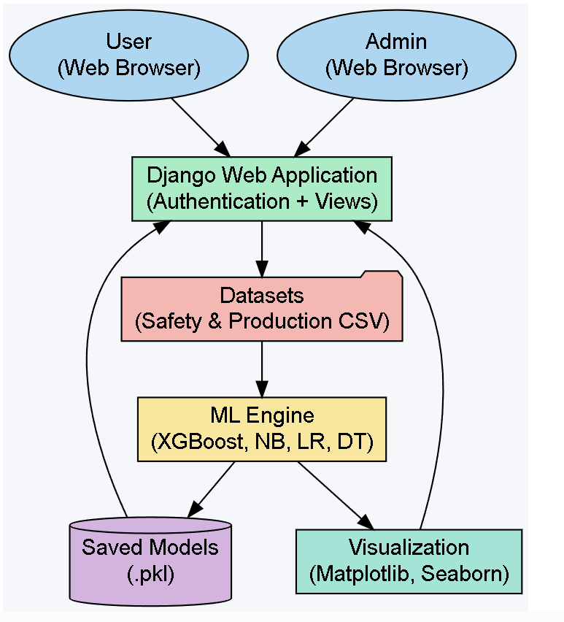

Fig: System Architecture
5.2 DATA FLOW DIAGRAM:
- The DFD is also called as bubble chart. It is a simple graphical formalism that can be used to represent a system in terms of input data to the system, various processing carried out on this data, and the output data is generated by this system.
- The data flow diagram (DFD) is one of the most important modeling tools. It is used to model the system components. These components are the system process, the data used by the process, an external entity that interacts with the system and the information flows in the system.
- DFD shows how the information moves through the system and how it is modified by a series of transformations. It is a graphical technique that depicts information flow and the transformations that are applied as data moves from input to output.
- DFD is also known as bubble chart. A DFD may be used to represent a system at any level of abstraction. DFD may be partitioned into levels that represent increasing information flow and functional detail.
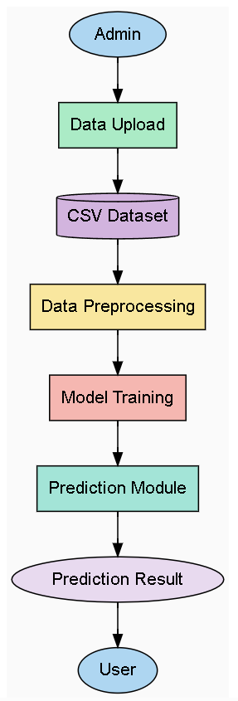
Fig: Data Flow Diagram

5.3 UML DIAGRAMS
UML stands for Unified Modeling Language. UML is a standardized general-purpose modeling language in the field of object-oriented software engineering. The standard is managed, and was created by, the Object Management Group.
The goal is for UML to become a common language for creating models of object oriented computer software. In its current form UML is comprised of two major components: a Meta-model and a notation. In the future, some form of method or process may also be added to; or associated with, UML.
The Unified Modeling Language is a standard language for specifying, Visualization, Constructing and documenting the artifacts of software system, as well as for business modeling and other non-software systems.
The UML represents a collection of best engineering practices that have proven successful in the modeling of large and complex systems.
The UML is a very important part of developing objects oriented software and the software development process. The UML uses mostly graphical notations to express the design of software projects.
GOALS:
The Primary goals in the design of the UML are as follows:
- Provide users a ready-to-use, expressive visual modeling Language so that they can develop and exchange meaningful models.
- Provide extendibility and specialization mechanisms to extend the core concepts.
- Be independent of particular programming languages and development process.
- Provide a formal basis for understanding the modeling language.
- Encourage the growth of OO tools market.
- Support higher level development concepts such as collaborations, frameworks, patterns and components.
- Integrate best practices.

5.3.1 USE CASE DIAGRAM:
A use case diagram in the Unified Modeling Language (UML) is a type of behavioral diagram defined by and created from a Use-case analysis. Its purpose is to present a graphical overview of the functionality provided by a system in terms of actors, their goals (represented as use cases), and any dependencies between those use cases. The main purpose of a use case diagram is to show what system functions are performed for which actor. Roles of the actors in the system can be depicted.

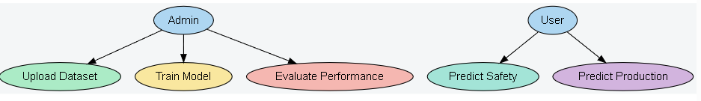
Fig: USE CASE DIAGRAM
Sequence diagram
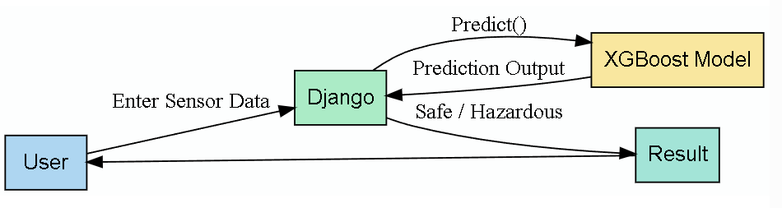
CLASS DIAGRAM:
The class diagram is used to refine the use case diagram and define a detailed design of the system. The class diagram classifies the actors defined in the use case diagram into a set of interrelated classes. The relationship or association between the classes can be either an "is-a" or "has-a" relationship. Each class in the class diagram may be capable of providing certain functionalities. These functionalities provided by the class are termed "methods" of the class. Apart from this, each class may have certain "attributes" that uniquely identify the class.

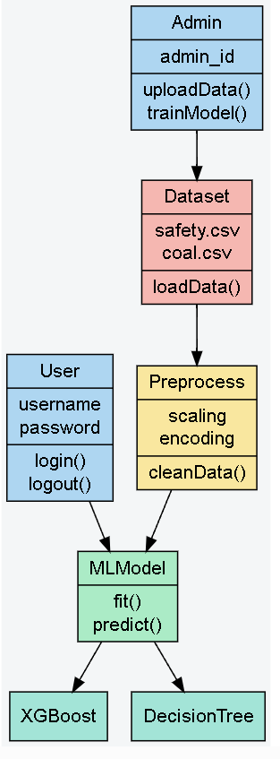
Fig: class diagram

STATE DIAGRAM:

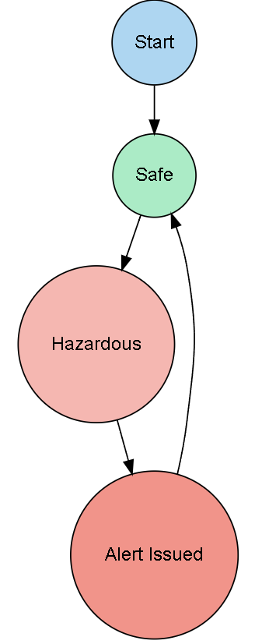

CHAPTRER-6
SOFTWARE ENVIRONMENT
6.1 INTRODUCTION TO MACHINE LEARNING:
Arthur Samuel coined the term “Machine Learning” in 1959 and defined it as a “Field of study that gives computers the capability to learn without being explicitly programmed”. And that was the beginning of Machine Learning! In modern times, Machine Learning is one of the most popular (if not the most!) career choices. According to Indeed, Machine Learning Engineer is The Best Job of 2019 with a 344% growth and an average base salary of $146,085 per year. But there is still a lot of doubt about what exactly is Machine Learning and how to start learning it? So this article deals with the Basics of Machine Learning and also the path you can follow to eventually become a full-fledged Machine Learning Engineer.
Now let’s get started!!! Before we take a look at the details of various machine learning methods, let's start by looking at what machine learning is, and what it isn't. Machine learning is often categorized as a subfield of artificial intelligence, but I find that categorization can often be misleading at first brush. The study of machine learning certainly arose from research in this context, but in the data science application of machine learning methods, it's more helpful to think of machine learning as a means of building models of data. Fundamentally, machine learning involves building mathematical models to help understand data.
"Learning" enters the fray when we give these models tunable parameters that can be adapted to observed data; in this way the program can be considered to be "learning" from the data. Once these models have been fit to previously seen data, they can be used to predict and understand aspects of newly observed data. I'll leave to the reader the more philosophical digression regarding the extent to which this type of mathematical, model based "learning" is similar to the "learning" exhibited by the human brain. Understanding the problem setting in machine learning is essential to using these tools effectively, and so we will start with some broad categorizations of the types of approaches we'll discuss here.
Machine learning uses data to detect various patterns in a given dataset.
- It can learn from past data and improve automatically.
- It is a data-driven technology.
- Machine learning is much similar to data mining as it also deals with the huge amount of the data.

6.2 HOW DOES MACHINE LEARNING WORK?
A Machine Learning system learns from historical data, builds the prediction models, and whenever it receives new data, predicts the output for it. The accuracy of predicted output depends upon the amount of data, as the huge amount of data helps to build a better model which predicts the output more accurately. Machine learning tasks are classified into several broad categories. In supervised learning, the algorithm builds a mathematical model from a set of data that contains both the inputs and the desired outputs.
For example, if the task were determining whether an image contained a certain object, the training data for a supervised learning algorithm would include images with and without that object (the input), and each image would have a label (the output) designating whether it contained the object. In special cases, the input may be only partially available, or restricted to special feedback Semi-supervised learning algorithms develop mathematical models from incomplete training data, where a portion of the sample input doesn't have labels.
Classification algorithms and regression algorithms are types of supervised learning. Classification algorithms are used when the outputs are restricted to a limited set of values. For a classification algorithm that filters emails, the input would be an incoming email, and the output would be the name of the folder in which to file the email. For an algorithm that identifies spam emails, the output would be the prediction of either "spam" or "not spam", represented by the Boolean values true and false.
Regression algorithms are named for their continuous outputs, meaning they may have any value within a range. Examples of a continuous value are the temperature, length, or price of an object. 17 In unsupervised learning, the algorithm builds a mathematical model from a set of data that contains only inputs and no desired output labels. Unsupervised learning algorithms are used to find structure in the data, like grouping or clustering of data points. Unsupervised learning can discover patterns in the data, and can group the inputs into categories, as in feature learning.
Dimensionality reduction is the process of reducing the number of features, or inputs, in a set of data. Active learning algorithms access the desired outputs (training labels) for a limited set of inputs based on a budget and optimize the choice of inputs for which it will acquire training labels. When used interactively, these can be presented to a human user for labeling. Reinforcement learning algorithms are given feedback in the form of positive or negative reinforcement in a dynamic environment and are used in autonomous vehicles or in learning play a game against a human opponent Other specialized algorithms in machine learning include topic modeling, where the computer program is given a set of natural language documents and finds other documents to that cover similar topics.
Machine learning algorithms can be used to find the unobservable probability density function in density estimation problems. Meta learning algorithms learn their own inductive bias based on previous experience. In developmental robotics, robot learning algorithms generate their own sequences of learning experiences, also known as a curriculum, to cumulatively acquire new skills through self-guided exploration and social interaction with humans. These robots use guidance mechanisms such as active learning, maturation, motor synergies, and imitation.
Applications of Machines Learning:
Machine Learning is the most rapidly growing technology and according to researchers we are in the golden year of AI and ML. It is used to solve many real-world complex problems which cannot be solved with traditional approach.
Following are some real-world applications of ML –
➢ Emotion analysis
➢ Sentiment analysis
➢ Error detection and prevention
➢ Weather forecasting and prediction
➢ Stock market analysis and forecasting
➢ Speech synthesis
➢ Speech recognition
➢ Customer segmentation
➢ Object recognition
➢ Fraud detection
➢ Fraud prevention
➢ Recommendation of products to customer in online shopping

Advantages of Machine learning:
- Easily identifies trends and patterns - Machine Learning can review large volumes of data and discover specific trends and patterns that would not be apparent to humans. For instance, for an e-commerce website like Amazon, it serves to understand the browsing behaviors and purchase histories of its users to help cater to the right products, deals, and reminders relevant to them. It uses the results to reveal relevant advertisements to them.
- No human intervention needed - With ML, you don’t need to babysit your project every step of the way. Since it means giving machines the ability to learn, it lets them make predictions and also improve the algorithms on their own. A common example of this is anti-virus softwares; they learn to filter new threats as they are recognized. ML is also good at recognizing spam.
- Continuous Improvement As ML algorithms gain experience, they keep improving in accuracy and efficiency. This lets them make better decisions. Say you need to make a weather forecast model. As the amount of data you have keeps growing, your algorithms learn to make more accurate predictions faster.
- Handling multi-dimensional and multi-variety data Machine Learning algorithms are good at handling data that are multi-dimensional and multi-variety, and they can do this in dynamic or uncertain environments.
- Wide Applications You could be an e-tailer or a healthcare provider and make ML work for you. Where it does apply, it holds the capability to help deliver a much more personal experience to customers while also targeting the right customers.

Disadvantages of Machine Learning:
- Data Acquisition Machine Learning requires massive data sets to train on, and these should be inclusive/unbiased, and of good quality. There can also be times where they must wait for new data to be generated.
- Time and Resources ML needs enough time to let the algorithms learn and develop enough to fulfill their purpose with a considerable amount of accuracy and relevancy. It also needs massive resources to function. This can mean additional requirements of computer power for you.
- Interpretation of Results Another major challenge is the ability to accurately interpret results generated by the algorithms. You must also carefully choose the algorithms for your purpose.
- High error-susceptibility Machine Learning is autonomous but highly susceptible to errors. Suppose you train an algorithm with data sets small enough to not be inclusive. You end up with biased predictions coming from a biased training set. This leads to irrelevant advertisements being displayed to customers. In the case of ML, such blunders can set off a chain of errors that can go undetected for long periods of time. And when they do get noticed, it takes quite some time to recognize the source of the issue, and even longer to correct it.
6.3 PYTHON
Guido Van Rossum published the first version of Python code (version 0.9.0) at outsources in February 1991. This release included already exception handling, functions, and the core data types of list, dict, str and others. It was also object oriented and had a module system. Python version 1.0 was released in January 1994. The major new features included in this release were the functional programming tools lambda, map, filter and reduce, which Guido Van Rossum never liked. Six and a half years later in October 2000, Python 2.0 was introduced. This release included list comprehensions, a full garbage collector and it was supporting Unicode. Python flourished for another 8 years in the versions 2.x before the next major release as Python 3.0 (also known as "Python 3000" and "Py3K") was released.
Why the name Python?
No. It wasn't named after a dangerous snake. Rossum was fan of a comedy series from late 70s. The name "Python" was adopted from the same series "Monty Python's Flying Circus". Python Version HistoryImplementationstarted-December1989 Internal releases – 1990
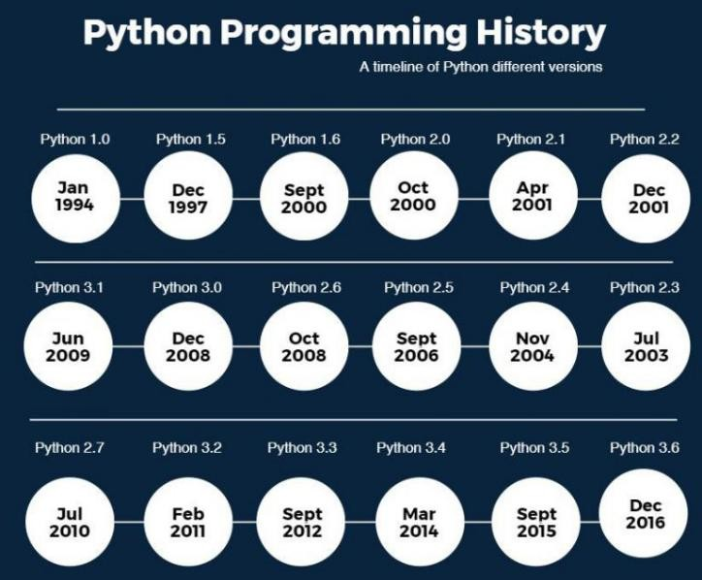
Install Python on Windows
- First, download from the download page. Second, double-click the installer file to launch the setup wizard.
- In the setup window, you need to check the Add Python3.8 to PATH and click Install Now to begin the installation.
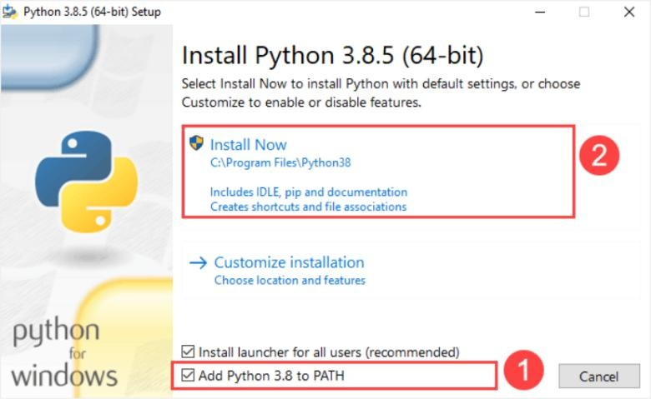
It’ will take a few minutes to complete the set up.
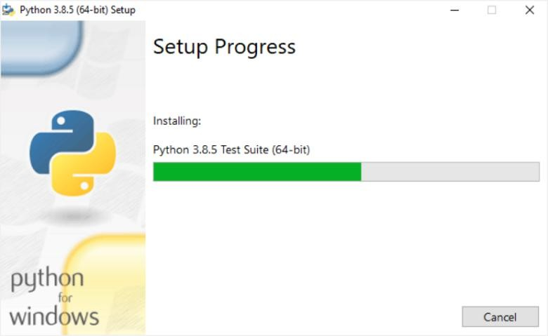
Once the setup completes, you’ll see the following window:

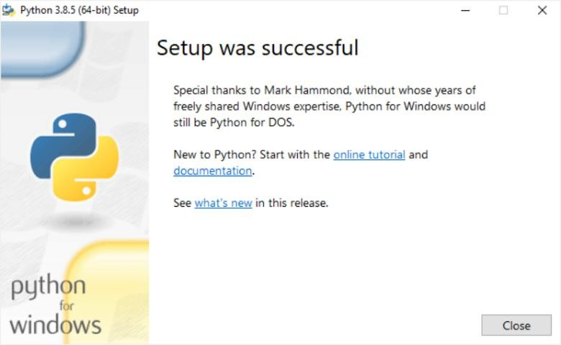
In the Command Prompt, type python command as follows:
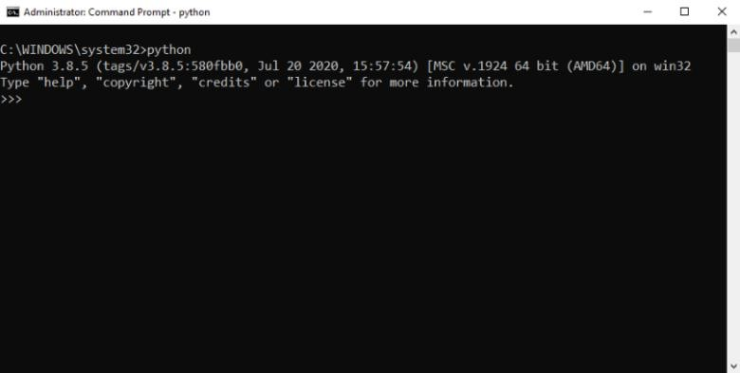
If you see the output like the above screenshot, you’ve successfully installed Python on your computer.
To exit the program, you type Ctrl-Z and press Enter.
If you see the following output from the Command Prompt after typing the python command:
'python'isnotrecognizedasaninternalorexternalcommand,operable program or batch file
Likely, you didn’t check he Add Python3.8 to PATH check box when you install Python
Python 3 is not backwards compatible with Python 2.x. The emphasis in Python 3 had been on the removal of duplicate programming constructs and modules, thus fulfilling or coming close to fulfilling the 13th law of the Zen of Python: "There should be one -- and preferably only one -- obvious way to do it." Some changes in Python 7.3:
- Print is now a function
- Views and iterators instead of lists
- The rules for ordering comparisons have been simplified.
- E.g: a heterogeneous list cannot be sorted, because all the elements of a list must be comparable to each other.
- There is only one integer type left, i.e. int. long is int as well.
- The division of two integers returns a float instead of an integer. "//" can be used to have the "old" behaviour.
- Text Vs. Data Instead Of Unicode Vs. 8-bit Purpose :- We demonstrated that our approach enables successful segmentation of intra-retinal layers—even with lowquality images containing speckle noise, low contrast, and different intensity ranges throughout—with the assistance of the ANIS feature.
- Python is an interpreted high-level programming language for general-purpose programming. Created by Guido van Rossum and first released in 1991, Python has a design philosophy that emphasizes code readability, notably using significant whitespace. Python features a dynamic type system and automatic memory management.
  - It supports multiple programming paradigms, including object-oriented, imperative, functional and procedural, and has a large and comprehensive standard library.
Python is interpreted:
Python is processed at runtime by the interpreter. You do not need to compile your program before executing it. This is similar to PERL and PHP.
Python is Interactive:
You can actually sit at a Python prompt and interact with the interpreter directly to write your programs. Python also acknowledges that speed of development is important. Readable and terse code is part of this, and so is access to powerful constructs that avoid tedious repetition of code.
Maintainability:
It also ties into this may be an all but useless metric, but it does say something about how much code you have to scan, read and/or understand to troubleshoot problems or tweak behaviors. This speed of development, the ease with which a programmer of other languages can pick up basic Python skills and the huge standard library is key to another area where Python excels. All its tools have been quick to implement, saved a lot of time, and several of them have later been patched and updated by people with no Python background - without breaking.
Open Source :
Python is an open-source software. Anyone can freely distribute it, read the source code, edit it easily.
High-level Language:
When writing programs in python, the programmers don’t have to worry aboutthe low-level details like managing the memory used by the program. Python is a High-level language that needed to concentrate on writing solutions above problems.
Interactive:
Python programs work in an interactive mode which allows us interactive testing and debugging of a piece of code. Most of the Programmers can easily interact with the interpreter directly.
Prerequisites
Before learning machine learning, you must have the basic knowledge of followings so that you can easily understand the concepts of machine learning:
- Fundamental knowledge of probability and linear algebra.
- The ability to code in any computer language, especially in Python language.
- Knowledge of Calculus, especially derivatives of single variable and multivariate functions.
Linear Regression in Machine Learning Linear regression is one of the easiest and most popular Machine Learning algorithms. It is a statistical method that is used for predictive analysis. Linear regression makes predictions for continuous/real or numeric variables such as sales, salary, age, product price, etc.
6.4 PACKAGES USED IN PROJECT:
NumPy
Numpy is a general-purpose array-processing package. It provides a high-performance multidimensional array object, and tools for working with these arrays. It is the fundamental package for scientific computing with Python.
It contains various features including these important ones:
▪ A powerful N-dimensional array object
▪ Sophisticated (broadcasting) functions
▪ Tools for integrating C/C++ and Fortran code
▪ Useful linear algebra, Fourier transform, and random number capabilities.
Besides its obvious scientific uses, NumPy can also be used as an efficient multi-dimensional container of generic data. Arbitrary data-types can be defined using NumPy which allows NumPy to seamlessly and speedily integrate with a wide variety of databases. Pandas is an open-source Python Library providing high-performance data manipulation and analysis tool using its powerful data structures. Python was majorly used for data munging and preparation. It had very little contribution towards data analysis.
Pandas
Using Pandas, we can accomplish five typical steps in the processing and analysis of data, regardless of the origin of data load, prepare, manipulate, model, and analyze. Python with Pandas is used in a wide range of fields including academic and commercial domains including finance, economics, Statistics, analytics, etc.
Pandas is an open-source, BSD-licensed Python library providing high-performance, easy-to-use data structures and data analysis tools for the Python programming language. Python with Pandas is used in a wide range of fields including academic and commercial domains including finance, economics, Statistics, analytics, etc. In this tutorial, we will learn the various features of Python Pandas and how to use them in practice.
Pandas is an open-source Python Library providing high-performance data manipulation and analysis tool using its powerful data structures. The name Pandas is derived from the word Panel Data – an Econometrics from Multidimensional data.In 2008, developer Wes McKinney started developing pandas when in need of high performance, flexible tool for analysis of data.
Prior to Pandas, Python was majorly used for data munging and preparation. It had very little contribution towards data analysis. Pandas solved this problem. Using Pandas, wecan accomplish five typical steps in the processing and analysis of data, regardless of the origin of data — load, prepare, manipulate, model, and analyze. Python with Pandas is used in a wide range of fields including academic and commercial domains including finance, economics, Statistics, analytics, etc.
Key Features of Pandas:
• Fast and efficient Data Frame object with default and customized indexing.
• Tools for loading data into in-memory data objects from different file formats.
• Data alignment and integrated handling of missing data
Tensor flow
Tensor Flow is a free and open-source software library for dataflow and differentiable programming across a range of tasks. It is a symbolic math library, and is also used for machine learning applications such as neural networks. It is used for both research and production at Google. Tensor Flow was developed by the Google Brain team for internal Google use. It was released under the Apache 2.0 open-source license on November 9, 2015.
Matplotlib
Matplotlib is a Python 2D plotting library which produces publication quality figures in a variety of hardcopy formats and interactive environments across platforms. Matplotlib can be used in Python scripts, the Python and I Python shells, the Jupiter Notebook, web application servers, and four graphical user interface toolkits. Matplotlib tries to make easy things easy and hard things possible. You can generate plots, histograms, power spectra, bar charts, error charts, scatter plots, etc., with just a few lines of code. For examples, see the sample plots and thumbnail gallery. For simple plotting the pyplot module provides a MATLAB-like interface, particularly when combined with I Python. For the power user, you have full control of line styles, font properties, axes properties, etc., via an object oriented interface or via a set of functions familiar to MATLAB users.
Scikit – learn
Scikit-learn provides a range of supervised and unsupervised learning algorithms via a consistent interface in Python. It is licensed under a permissive simplified BSD license and is distributed under many Linux distributions, encouraging academic and commercial use.
Classification: samples belong to two or more classes and we want to learn from already labeled data how to predict the class of unlabeled data. An example of a classification problem would be handwritten digit recognition, in which the aim is to assign each input vector to one of a finite number of discrete categories. Another way to think of classification is as a discrete (as opposed to continuous) form of supervised learning where one has a limited number of categories and for each of the n samples provided, one is to try to label them with the correct category or class.
Regression: If the desired output consists of one or more continuous variables, then the task is called regression. An example of a regression problem would be the prediction of the length of a salmon as a function of its age and weight. Unsupervised learning, in which the training data consists of a set of input vectors x without any corresponding target values. The goal in such problems may be to discover groups of similar examples within the data, where it is called clustering, or to determine the distribution of data within the input space, known as density estimation, or to project the data from a high-dimensional space down to two or three dimensions for the purpose of visualization.
scikit-learn comes with a few standard datasets, for instance the iris and digits datasets for
classification and the boston house prices dataset for regression.
In the following, we start a Python interpreter from our shell and then load the iris and digits
datasets. Our notational convention is that $ denotes the shell prompt while >>> denotes the
Python interpreter prompt:
$ python
>>> from sklearn import datasets
>>> iris = datasets.load_iris()
>>> digits = datasets.load_digits()
A dataset is a dictionary-like object that holds all the data and some metadata about the data.
This data is stored in the .data member, which is a n_samples, n_features array. In the case ofsupervised problem, one or more response variables are stored in the target member. More details on the different datasets can be found in the dedicated section.For instance, in the case of the digits dataset, digits.data gives access to the features that can be used to classify the digits samples:
>>>print(digits.data)
[[ 0. 0. 5. ... 0. 0. 0.]
[ 0. 0. 0. ... 10. 0. 0.]
[ 0. 0. 0. ... 16. 9. 0.]
...
[ 0. 0. 1. ... 6. 0. 0.]
[ 0. 0. 2. ... 12. 0. 0.]
[ 0. 0. 10. ... 12. 1. 0.]]
Target gives the ground truth for the digit dataset, that is the number corresponding to each digit image that we are trying to learn.
SciKit-learn Genetic:
Sklearn-genetic-opt uses evolutionary algorithms to fine-tune scikit-learn machine learning algorithms and perform feature selection. It is designed to accept a scikit-learn regression or classification model (or a pipeline containing on of those). The idea behind this package is to define the set of hyper parameters we want to tune and what are their lower and uppers bounds on the values they can take. It is possible to define different optimization algorithms, call-backs and build-in parameters to control how the optimization is taken. To get started, we’ll use only the most basic features and options.
The optimization is made by evolutionary algorithms with the help of the deep package. It works by defining the set of hyper parameters to tune, it starts with a randomly sampled set of options (population). Then by using evolutionary operators as the mating, mutation, selection and evaluation, it generates new candidates looking to improve the cross-validation score in each generation. It’ll continue with this process until a number of generations is reached or until a callback criterion is met.
Keras:
Two of the top numerical platforms in Python that provide the basis for Deep Learning research and development are Theano and Tensor Flow.Both are very powerful libraries, but both can be difficult to use directly for creating deep learning models.In this post, you will discover the Keras Python library that provides a clean and convenient way to create a range of deep learning models on top of Theano or Tensor Flow.Keras is a minimalist Python library for deep learning that can run on top of Theano or Tensor Flow.
It was developed to make implementing deep learning models as fast and easy as possible for research and development.It runs on Python 2.7 or 3.5 and can seamlessly execute on GPUs and CPUs given the underlying frameworks. It is released under the permissive MIT license.Keras was developed and maintained by François Chollet, a Google engineer using four guiding principles:
Modularity: A model can be understood as a sequence or a graph alone. All the concerns of a deep learning model are discrete components that can be combined in arbitrary ways.
Minimalism: The library provides just enough to achieve an outcome, no frills and maximizing readability.
Extensibility: New components are intentionally easy to add and use within the framework, intended for researchers to trial and explore new ideas.
Python: No separate model files with custom file formats. Everything is native Python. Keras is relatively straightforward to install if you already have a working Python and SciPy Environment.
6.5 INSTALLATION OF PACKAGES:
Syntax for installation of packages via cmd terminal using the basic
Step:1- First check pip cmd, If ok then
Step:2- pip list
Check the list of packages installed and then install required by following cmds.
Step:3- pip install package name.
The package name should be based on our requirement.

CHAPTRER-7
IMPLEMENTATION MODULES
Modules Description
Collection of User’s Reviews: Reviews is necessary for doing the Sentiment Analysis Task. For the Collection of reviews there are different techniques which are used in this survey. The reviews can be a structured, semi-structured and unstructured type. Sentiment Analysis research, there are open source framework where researcher can get their data for the research purpose. R is one of the programming language and software environment for statistical computing and graphics supported by the R Foundation for Statistical Computing. By installing required packages and authentication process of social website, to crawl the reviews from that site is easy task. Once we have our text data with us then we can use that data for Pre-processing purpose.
In pre-processing following are some tasks:
• Removing URLs, Special characters, Numbers, Punctuations etc.
• Removing Stop words
• Removal of Retweets (in case of twitter dataset)
• Stemming
Feature Selection Feature selection: from pre-processed text is the difficult task in sentiment analysis. The main goal of the feature selection is to decrease the dimensionality of the feature space and thus computational cost. Feature selection will reduce the over fitting of the learning scheme to the training data. In different machine learning algorithms were analysed on a news review dataset with different feature selection techniques features are usually unigrams, bigrams and grams. POS tagging is used in feature selection techniques.
Sentiment Word Identification Sentiment word identification is a fundamental work in numerous applications of sentiment analysis and opinion mining, such as review mining, opinion holder finding, and review classification. Sentiment words can be classified into positive, negative and neutral words.
Sentiment Classification 31 Sentiment classification of news review dataset and product review dataset is done using supervised machine learning approaches like naïve Bayes, SVM, Maximum Entropy etc. Accuracy is depends on which dataset is used for which classification methods. In the case of Supervised machine learning approaches Training dataset is used to train the classification model which then help to classify the test data.
Analysis of Reviews Finally Analysis of result is important to make decision to individual and industry. In case of news reviews if more result is positive then user can decide to go that news event. Analysis is used in business intelligence.

  - Sample Code
- from django.shortcuts import render, redirect
- from django.contrib import messages
- from django.contrib.auth.models import User
- from django.contrib.auth.decorators import login_required
- from django.contrib.auth import authenticate, login, logout
- from django.core.files.storage import default_storage

- import os, joblib
- import numpy as np
- import pandas as pd
- import matplotlib.pyplot as plt
- import seaborn as sns

- from sklearn.model_selection import train_test_split
- from sklearn.preprocessing import LabelEncoder, StandardScaler
- from sklearn.naive_bayes import GaussianNB
- from xgboost import XGBClassifier
- from sklearn.linear_model import LinearRegression
- from sklearn.tree import DecisionTreeRegressor

- from sklearn.metrics import (
- accuracy_score, precision_score, recall_score, f1_score,
- confusion_matrix,
- mean_squared_error, mean_absolute_error, r2_score
- )

- # =================================================
- # Globals (single-user demo mode)
- # =================================================
- helmet_df = None
- coal_df = None

- Xs_train = Xs_test = ys_train = ys_test = None
- Xp_train = Xp_test = yp_train = yp_test = None

- scaler_safety = None
- scaler_prod = None
- country_le = None

- MODEL_DIR = "model"
- SEC_PLOT_DIR = "static/security"
- PROD_PLOT_DIR = "static/production"

- os.makedirs(MODEL_DIR, exist_ok=True)
- os.makedirs(SEC_PLOT_DIR, exist_ok=True)
- os.makedirs(PROD_PLOT_DIR, exist_ok=True)

- # =================================================
- # Home
- # =================================================
- def home(request):
- return render(request, "home.html")

- # =================================================
- # Authentication
- # =================================================
- def admin_login(request):
- if request.method == 'POST':
- uname = request.POST['username']
- pwd = request.POST['password']
- if uname == 'admin' and pwd == 'admin':
- request.session['is_admin'] = True
- return redirect('admin_dashboard')
- messages.error(request, "Invalid admin credentials")
- return render(request, 'adminlogin.html')

- def register(request):
- if request.method == 'POST':
- name = request.POST['name']
- email = request.POST['email']
- password = request.POST['password']
- confirm = request.POST['confirm_password']

- if password != confirm:
- messages.error(request, "Passwords do not match")
- return redirect('register')

- if User.objects.filter(username=email).exists():
- messages.error(request, "User already exists")
- return redirect('register')

- user = User.objects.create_user(
- username=email,
- email=email,
- password=password,
- first_name=name
- )
- user.save()
- messages.success(request, "Registration successful. Please login.")
- return redirect('login')

- return render(request, 'register.html')

- def login_view(request):
- if request.method == "POST":
- uname = request.POST['username']
- pwd = request.POST['password']

- if uname == 'admin' and pwd == 'admin':
- request.session['is_admin'] = True
- return redirect('admin_dashboard')

- user = authenticate(username=uname, password=pwd)
- if user:
- login(request, user)
- return redirect('user_dashboard')

- messages.error(request, "Invalid credentials")

- return render(request, 'login.html')

- def logout_view(request):
- logout(request)
- request.session.flush()
- return redirect('home')

- # =================================================
- # Dashboards
- # =================================================
- def admin_dashboard(request):
- if not request.session.get('is_admin'):
- return redirect('admin_login')
- return render(request, 'admin_dashboard.html')

- @login_required
- def user_dashboard(request):
- return render(request, 'user_dashboard.html')

- # =================================================
- # ========== SECURITY MODULE (Admin) ===============
- # =================================================
- def security_dashboard(request):
- if not request.session.get('is_admin'):
- return redirect('admin_login')
- return render(request, 'security_dashboard.html')

- def security_upload(request):
- if not request.session.get('is_admin'):
- return redirect('admin_login')
- global helmet_df

- if request.method == "POST" and request.FILES.get("file"):
- path = default_storage.save("helmet.csv", request.FILES["file"])
- helmet_df = pd.read_csv(default_storage.path(path))
- default_storage.delete(path)

- table = helmet_df.head(10).to_html(classes="table table-striped", index=False)
- return render(request, "security_dashboard.html", {'table': table})

- return redirect('security_dashboard')

- def security_preprocess(request):
- if not request.session.get('is_admin'):
- return redirect('admin_login')
- global helmet_df

- helmet_df.fillna(helmet_df.mean(numeric_only=True), inplace=True)

- le = LabelEncoder()
- for col in helmet_df.select_dtypes(include='object'):
- helmet_df[col] = le.fit_transform(helmet_df[col])

- plt.figure(figsize=(5,4))
- sns.countplot(x="Target", data=helmet_df)
- plt.title("Safe vs Hazardous")
- plot_path = f"{SEC_PLOT_DIR}/class_dist.png"
- plt.tight_layout()
- plt.savefig(plot_path)
- plt.close()

- table = helmet_df.head(10).to_html(classes="table table-bordered", index=False)

- return render(request, "security_dashboard.html", {
- 'table': table,
- 'plot': f"/{plot_path}"
- })

- def security_split(request):
- if not request.session.get('is_admin'):
- return redirect('admin_login')
- global helmet_df, Xs_train, Xs_test, ys_train, ys_test, scaler_safety

- X = helmet_df.iloc[:, 2:16]
- y = helmet_df.iloc[:, -1]

- Xs_train, Xs_test, ys_train, ys_test = train_test_split(
- X, y, test_size=0.2, random_state=42
- )

- scaler_safety = StandardScaler()
- Xs_train = scaler_safety.fit_transform(Xs_train)
- Xs_test = scaler_safety.transform(Xs_test)
- joblib.dump(scaler_safety, f"{MODEL_DIR}/scaler_safety.pkl")

- return render(request, "security_dashboard.html", {
- 'split': True,
- 'train_size': Xs_train.shape[0],
- 'test_size': Xs_test.shape[0]
- })

- def security_existing_model(request):
- if not request.session.get('is_admin'):
- return redirect('admin_login')

- model = GaussianNB()
- model.fit(Xs_train, ys_train)
- joblib.dump(model, f"{MODEL_DIR}/security_nb.pkl")

- y_pred = model.predict(Xs_test)

- acc = accuracy_score(ys_test, y_pred)*100
- prec = precision_score(ys_test, y_pred, average='macro')*100
- rec = recall_score(ys_test, y_pred, average='macro')*100
- f1 = f1_score(ys_test, y_pred, average='macro')*100

- cm = confusion_matrix(ys_test, y_pred)
- plt.figure(figsize=(4,4))
- sns.heatmap(cm, annot=True, fmt="g", cmap="Blues",
- xticklabels=['Safe','Hazardous'],
- yticklabels=['Safe','Hazardous'])
- plt.title("Naive Bayes Confusion Matrix")
- plot_path = f"{SEC_PLOT_DIR}/nb_cm.png"
- plt.tight_layout()
- plt.savefig(plot_path)
- plt.close()

- return render(request, "security_dashboard.html", {
- 'metrics': {
- 'accuracy': round(acc,2),
- 'precision': round(prec,2),
- 'recall': round(rec,2),
- 'fscore': round(f1,2),
- },
- 'plot': f"/{plot_path}"
- })

- def security_proposed_model(request):
- if not request.session.get('is_admin'):
- return redirect('admin_login')

- model = XGBClassifier(
- n_estimators=100,
- learning_rate=0.1,
- max_depth=5,
- eval_metric='logloss',
- random_state=42
- )
- model.fit(Xs_train, ys_train)
- joblib.dump(model, f"{MODEL_DIR}/security_xgb.pkl")

- y_pred = model.predict(Xs_test)

- acc = accuracy_score(ys_test, y_pred)*100
- prec = precision_score(ys_test, y_pred, average='macro')*100
- rec = recall_score(ys_test, y_pred, average='macro')*100
- f1 = f1_score(ys_test, y_pred, average='macro')*100

- cm = confusion_matrix(ys_test, y_pred)
- plt.figure(figsize=(4,4))
- sns.heatmap(cm, annot=True, fmt="g", cmap="Blues",
- xticklabels=['Safe','Hazardous'],
- yticklabels=['Safe','Hazardous'])
- plt.title("XGBoost Confusion Matrix")
- plot_path = f"{SEC_PLOT_DIR}/xgb_cm.png"
- plt.tight_layout()
- plt.savefig(plot_path)
- plt.close()

- return render(request, "security_dashboard.html", {
- 'metrics': {
- 'accuracy': round(acc,2),
- 'precision': round(prec,2),
- 'recall': round(rec,2),
- 'fscore': round(f1,2),
- },
- 'plot': f"/{plot_path}"
- })

- def security_performance(request):
- if not request.session.get('is_admin'):
- return redirect('admin_login')

- nb = joblib.load(f"{MODEL_DIR}/security_nb.pkl")
- xgb = joblib.load(f"{MODEL_DIR}/security_xgb.pkl")

- y_nb = nb.predict(Xs_test)
- y_xgb = xgb.predict(Xs_test)

- acc = [accuracy_score(ys_test, y_nb)*100, accuracy_score(ys_test, y_xgb)*100]
- prec = [precision_score(ys_test, y_nb, average='macro')*100,
- precision_score(ys_test, y_xgb, average='macro')*100]
- rec = [recall_score(ys_test, y_nb, average='macro')*100,
- recall_score(ys_test, y_xgb, average='macro')*100]
- f1 = [f1_score(ys_test, y_nb, average='macro')*100,
- f1_score(ys_test, y_xgb, average='macro')*100]

- values = np.array([acc, prec, rec, f1]).T
- metrics = ['Accuracy','Precision','Recall','F1']
- x = np.arange(len(metrics))
- bw = 0.3

- plt.figure(figsize=(8,5))
- plt.bar(x, values[0], bw, label='NaiveBayes')
- plt.bar(x+bw, values[1], bw, label='XGBoost')
- plt.xticks(x+bw/2, metrics)
- plt.title("Security Model Comparison")
- plt.legend()
- plt.tight_layout()
- plot_path = f"{SEC_PLOT_DIR}/compare.png"
- plt.savefig(plot_path)
- plt.close()

- return render(request, "security_dashboard.html", {
- 'plot': f"/{plot_path}"
- })

- # =================================================
- # ======= PRODUCTION MODULE (Admin) ================
- # =================================================
- def production_dashboard(request):
- if not request.session.get('is_admin'):
- return redirect('admin_login')
- return render(request, 'production_dashboard.html')

- def production_upload(request):
- if not request.session.get('is_admin'):
- return redirect('admin_login')
- global coal_df

- if request.method == "POST" and request.FILES.get("file"):
- path = default_storage.save("coal.csv", request.FILES["file"])
- coal_df = pd.read_csv(default_storage.path(path), sep=';')
- default_storage.delete(path)

- table = coal_df.head(10).to_html(classes="table table-striped", index=False)
- return render(request, "production_dashboard.html", {'table': table})

- return redirect('production_dashboard')

- def production_preprocess(request):
- if not request.session.get('is_admin'):
- return redirect('admin_login')
- global coal_df, country_le

- coal_df.fillna(coal_df.mean(numeric_only=True), inplace=True)

- country_le = LabelEncoder()
- coal_df['Country'] = country_le.fit_transform(coal_df['Country'])
- joblib.dump(country_le, f"{MODEL_DIR}/country_encoder.pkl")

- yearly = coal_df.groupby('Year')['Value (Million Tonnes)'].sum().reset_index()
- countrywise = coal_df.groupby('Country')['Value (Million Tonnes)'].sum().reset_index()
- countrywise = countrywise.sort_values(by='Value (Million Tonnes)', ascending=False).head(10)

- plt.figure(figsize=(12,5))
- plt.subplot(1,2,1)
- plt.plot(yearly['Year'], yearly['Value (Million Tonnes)'], marker='o')
- plt.title('Year vs Production')
- plt.grid(alpha=0.3)

- plt.subplot(1,2,2)
- plt.plot(countrywise['Country'], countrywise['Value (Million Tonnes)'], marker='o')
- plt.title('Top Countries vs Production')
- plt.xticks(rotation=45)
- plt.grid(alpha=0.3)

- plot_path = f"{PROD_PLOT_DIR}/year_country.png"
- plt.tight_layout()
- plt.savefig(plot_path)
- plt.close()

- table = coal_df.head(10).to_html(classes="table table-bordered", index=False)

- return render(request, "production_dashboard.html", {
- 'table': table,
- 'plot': f"/{plot_path}"
- })

- def production_split(request):
- if not request.session.get('is_admin'):
- return redirect('admin_login')
- global coal_df, Xp_train, Xp_test, yp_train, yp_test, scaler_prod

- X = coal_df.iloc[:, 0:5]
- y = coal_df.iloc[:, -1]

- Xp_train, Xp_test, yp_train, yp_test = train_test_split(
- X, y, test_size=0.2, random_state=42
- )

- scaler_prod = StandardScaler()
- Xp_train = scaler_prod.fit_transform(Xp_train)
- Xp_test = scaler_prod.transform(Xp_test)
- joblib.dump(scaler_prod, f"{MODEL_DIR}/scaler_prod.pkl")

- return render(request, "production_dashboard.html", {
- 'split': True,
- 'train_size': Xp_train.shape[0],
- 'test_size': Xp_test.shape[0]
- })

- def production_existing_model(request):
- if not request.session.get('is_admin'):
- return redirect('admin_login')

- model = LinearRegression()
- model.fit(Xp_train, yp_train)
- joblib.dump(model, f"{MODEL_DIR}/prod_lr.pkl")

- y_pred = model.predict(Xp_test)

- mse = mean_squared_error(yp_test, y_pred)
- rmse = np.sqrt(mse)
- mae = mean_absolute_error(yp_test, y_pred)
- r2 = r2_score(yp_test, y_pred)*100

- plt.figure(figsize=(5,5))
- plt.scatter(yp_test, y_pred, alpha=0.6)
- minv, maxv = min(yp_test.min(), y_pred.min()), max(yp_test.max(), y_pred.max())
- plt.plot([minv, maxv], [minv, maxv], '--')
- plt.title("Linear Regression: Actual vs Predicted")
- plt.xlabel("Actual"); plt.ylabel("Predicted")
- plt.grid(alpha=0.3)
- plot_path = f"{PROD_PLOT_DIR}/lr_scatter.png"
- plt.tight_layout()
- plt.savefig(plot_path)
- plt.close()

- return render(request, "production_dashboard.html", {
- 'metrics': {
- 'mse': round(mse,2),
- 'rmse': round(rmse,2),
- 'mae': round(mae,2),
- 'r2': round(r2,2)
- },
- 'plot': f"/{plot_path}"
- })

- def production_proposed_model(request):
- if not request.session.get('is_admin'):
- return redirect('admin_login')

- model = DecisionTreeRegressor(random_state=42)
- model.fit(Xp_train, yp_train)
- joblib.dump(model, f"{MODEL_DIR}/prod_dt.pkl")

- y_pred = model.predict(Xp_test)

- mse = mean_squared_error(yp_test, y_pred)
- rmse = np.sqrt(mse)
- mae = mean_absolute_error(yp_test, y_pred)
- r2 = r2_score(yp_test, y_pred)*100

- plt.figure(figsize=(5,5))
- plt.scatter(yp_test, y_pred, alpha=0.6)
- minv, maxv = min(yp_test.min(), y_pred.min()), max(yp_test.max(), y_pred.max())
- plt.plot([minv, maxv], [minv, maxv], '--')
- plt.title("Decision Tree: Actual vs Predicted")
- plt.xlabel("Actual"); plt.ylabel("Predicted")
- plt.grid(alpha=0.3)
- plot_path = f"{PROD_PLOT_DIR}/dt_scatter.png"
- plt.tight_layout()
- plt.savefig(plot_path)
- plt.close()

- return render(request, "production_dashboard.html", {
- 'metrics': {
- 'mse': round(mse,2),
- 'rmse': round(rmse,2),
- 'mae': round(mae,2),
- 'r2': round(r2,2)
- },
- 'plot': f"/{plot_path}"
- })

- def production_performance(request):
- if not request.session.get('is_admin'):
- return redirect('admin_login')

- lr = joblib.load(f"{MODEL_DIR}/prod_lr.pkl")
- dt = joblib.load(f"{MODEL_DIR}/prod_dt.pkl")

- y_lr = lr.predict(Xp_test)
- y_dt = dt.predict(Xp_test)

- mse = [mean_squared_error(yp_test, y_lr), mean_squared_error(yp_test, y_dt)]
- rmse = [np.sqrt(mse[0]), np.sqrt(mse[1])]
- mae = [mean_absolute_error(yp_test, y_lr), mean_absolute_error(yp_test, y_dt)]
- r2 = [r2_score(yp_test, y_lr)*100, r2_score(yp_test, y_dt)*100]

- values = np.array([mse, rmse, mae, r2]).T
- metrics = ['MSE','RMSE','MAE','R2']
- x = np.arange(len(metrics))
- bw = 0.3

- plt.figure(figsize=(8,5))
- plt.bar(x, values[0], bw, label='LinearReg')
- plt.bar(x+bw, values[1], bw, label='DecisionTree')
- plt.xticks(x+bw/2, metrics)
- plt.title("Production Model Comparison")
- plt.legend()
- plt.tight_layout()
- plot_path = f"{PROD_PLOT_DIR}/compare.png"
- plt.savefig(plot_path)
- plt.close()

- return render(request, "production_dashboard.html", {
- 'plot': f"/{plot_path}"
- })

- # =================================================
- # ============== USER PREDICTIONS ==================
- # =================================================
- @login_required
- def user_verify_safety(request):
- if request.method == "POST":
- fields = [float(request.POST[f]) for f in [
- 'Temp_C','Humidity_Percent','CH4_ppm','H2S_ppm',
- 'CO_ppm','VOC_ppm','Pressure_hPa','Mud_Level_cm',
- 'Mud_Viscosity_Index','Mud_Salinity_uS_cm',
- 'Accel_Z_g','Light_lux','Impact_N','Fluid_Level_cm'
- ]]

- input_df = pd.DataFrame([fields], columns=[
- 'Temp_C','Humidity_Percent','CH4_ppm','H2S_ppm','CO_ppm',
- 'VOC_ppm','Pressure_hPa','Mud_Level_cm',
- 'Mud_Viscosity_Index','Mud_Salinity_uS_cm',
- 'Accel_Z_g','Light_lux','Impact_N','Fluid_Level_cm'
- ])

- scaler = joblib.load(f"{MODEL_DIR}/scaler_safety.pkl")
- model = joblib.load(f"{MODEL_DIR}/security_xgb.pkl")

- X_scaled = scaler.transform(input_df)
- pred = model.predict(X_scaled)[0]
- result = "Hazardous" if pred == 1 else "Safe"

- return render(request, 'user_safety.html', {'prediction': result})

- return render(request, 'user_safety.html')

- @login_required
- def user_verify_production(request):
- if request.method == "POST":
- Year = int(request.POST['Year'])
- Country = request.POST['Country']
- G1 = float(request.POST['Growth_2021'])
- G2 = float(request.POST['Growth_2011_21'])
- Share = float(request.POST['Share_2021'])

- le = joblib.load(f"{MODEL_DIR}/country_encoder.pkl")
- Country_enc = le.transform([Country])[0]

- input_df = pd.DataFrame([[Year, Country_enc, G1, G2, Share]], columns=[
- 'Year','Country',
- 'Growth rate per annum 2021',
- 'Growth rate per annum 2011-21','Share 2021'
- ])

- scaler = joblib.load(f"{MODEL_DIR}/scaler_prod.pkl")
- model = joblib.load(f"{MODEL_DIR}/prod_dt.pkl")

- X_scaled = scaler.transform(input_df)
- pred = model.predict(X_scaled)[0]

- return render(request, 'user_production.html',
- {'prediction': round(pred, 2)})

- return render(request, 'user_production.html')

  - RESULTS AND DISCUSSION

This section presents the experimental results and discusses the performance of the proposed Smart Productivity & Safety Management System in Coal Mines, focusing on both safety prediction and production value forecasting. The system was implemented using a Django-based web framework integrated with machine learning models and evaluated using real-world datasets related to mine safety and coal production.

Safety Prediction Results
For the safety management module, two models were implemented and compared: Naive Bayes as the existing model and XGBoost as the proposed model. The evaluation was carried out using standard classification metrics such as accuracy, precision, recall, and F1-score. The Naive Bayes model demonstrated reasonable performance with low computational cost but showed limitations in capturing complex relationships among sensor features. In contrast, the XGBoost model achieved significantly higher accuracy and balanced precision–recall values due to its ability to model non-linear patterns and feature interactions. The confusion matrix analysis indicated that XGBoost reduced false negatives, which is critical in safety-critical environments such as coal mines, where missing a hazardous condition can lead to severe consequences. Visual comparisons further confirmed the superior performance of the proposed model.

Production Prediction Results
In the production forecasting module, Linear Regression was used as the baseline existing model, while Decision Tree Regressor served as the proposed model. Performance was evaluated using regression metrics including Mean Squared Error (MSE), Root Mean Squared Error (RMSE), Mean Absolute Error (MAE), and R² score. Linear Regression captured general production trends but failed to accurately predict variations caused by complex influencing factors. The Decision Tree Regressor produced lower error values and a higher R² score, demonstrating better predictive capability. Scatter plots of actual versus predicted values showed that the Decision Tree model closely followed real production values.

Discussion
The experimental results clearly indicate that advanced machine learning models outperform traditional approaches in both safety classification and production prediction. Integrating these models into a unified web-based platform enables real-time analysis, early hazard detection, and accurate forecasting. Overall, the proposed system improves decision-making, enhances worker safety, reduces operational risks, and supports efficient and sustainable coal mining operations.

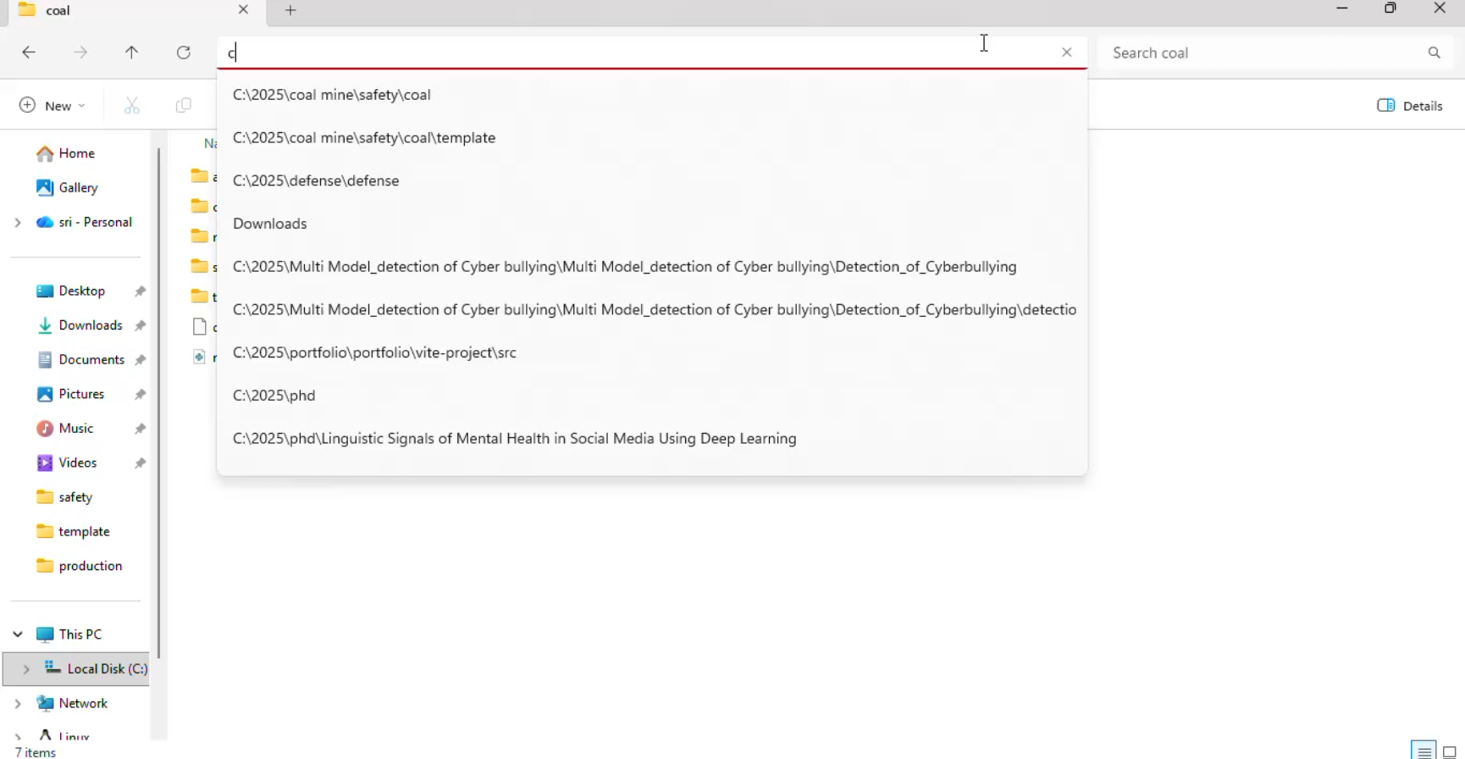
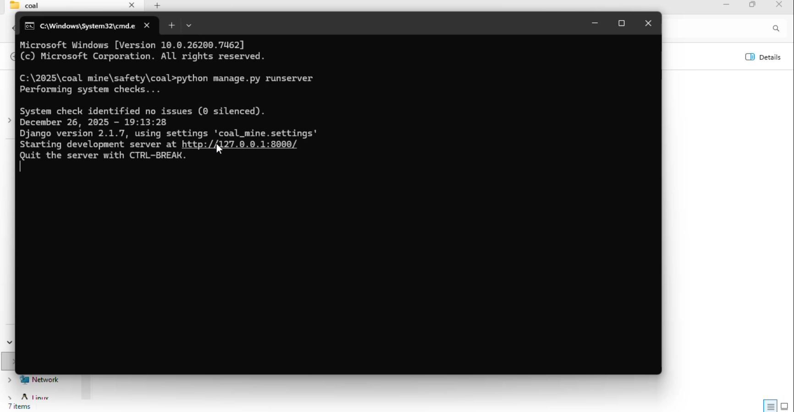

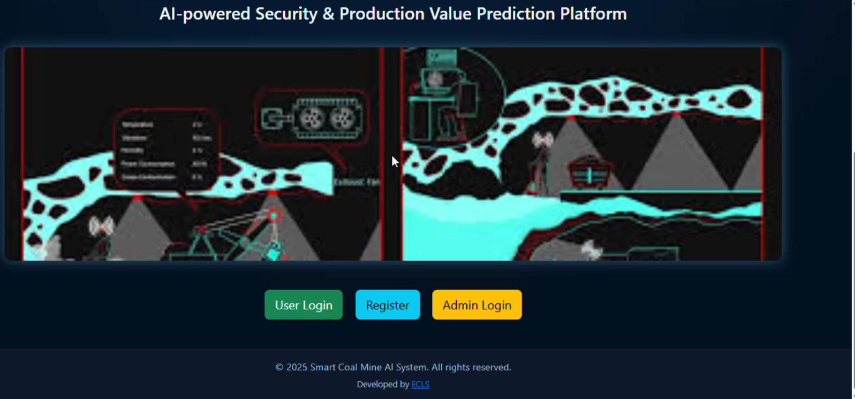


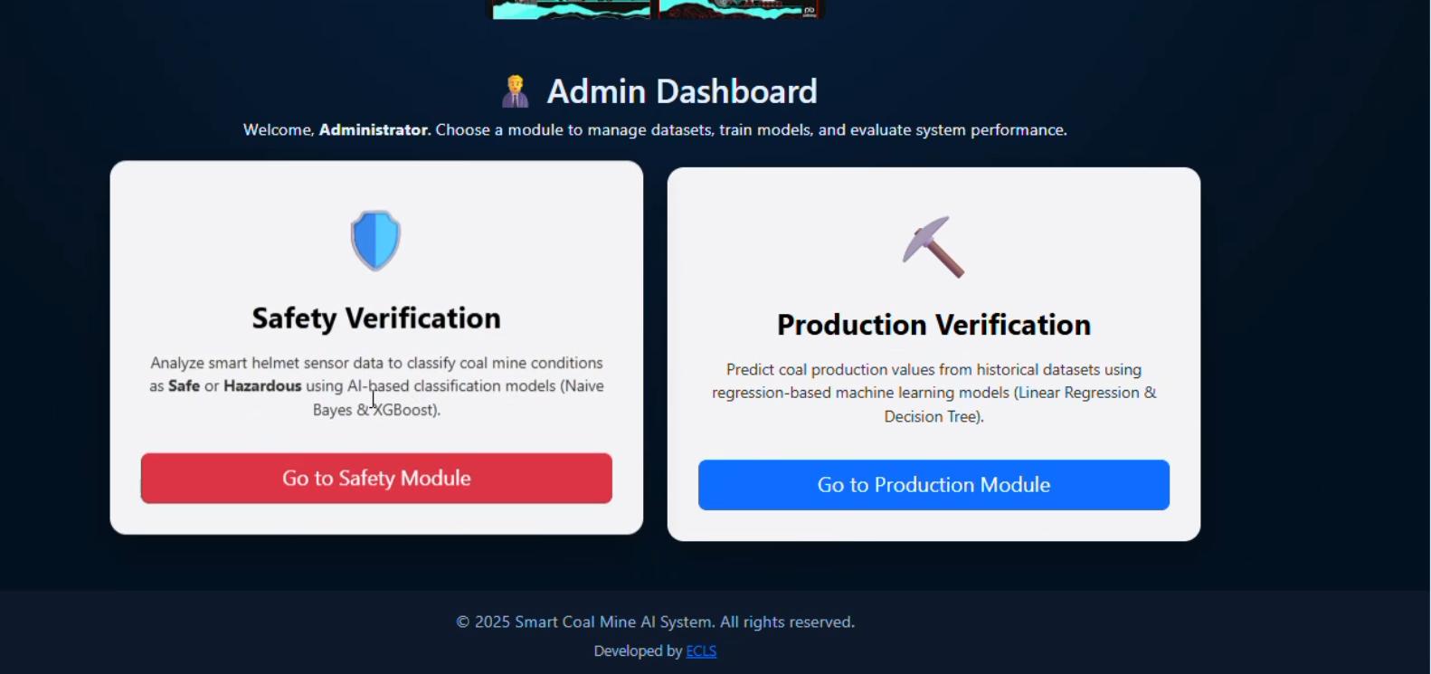
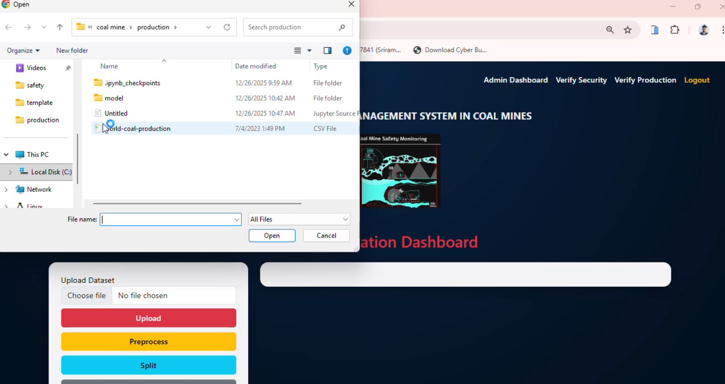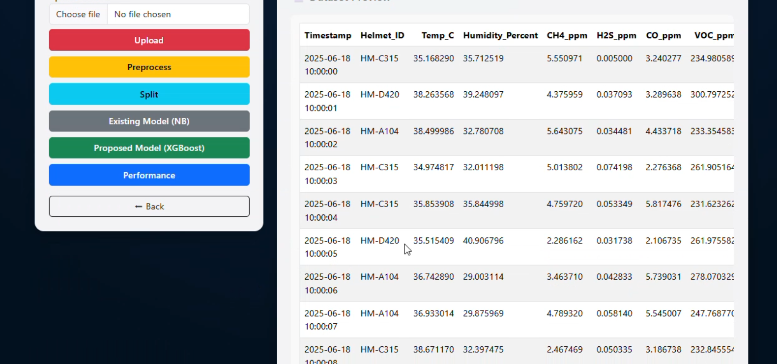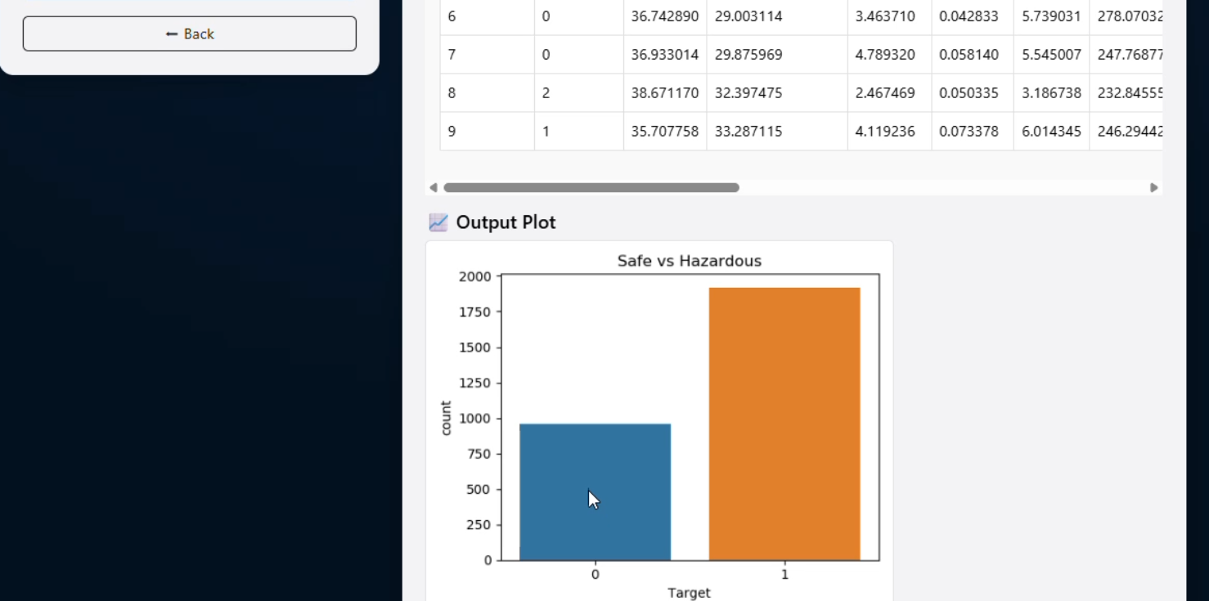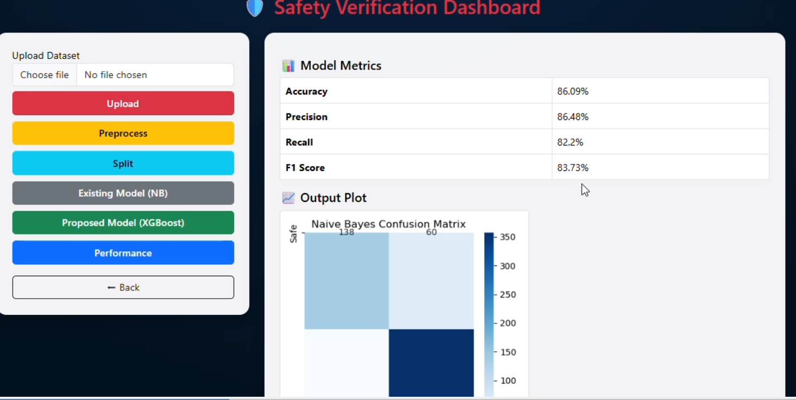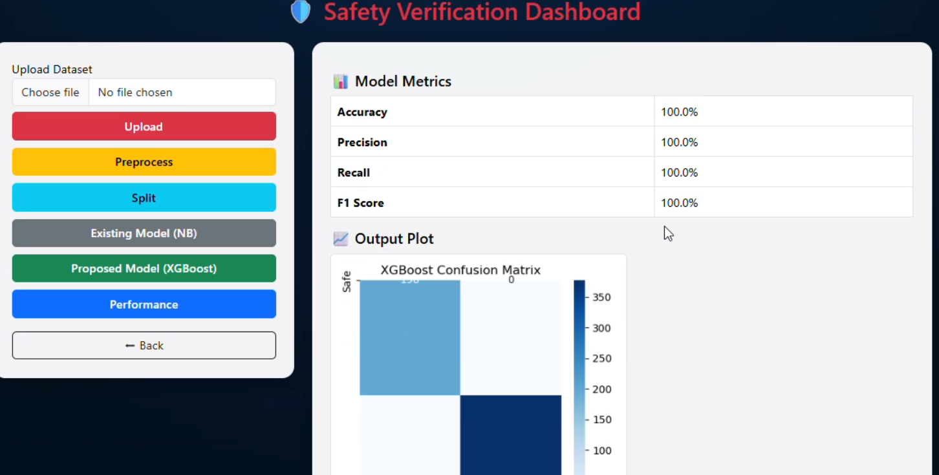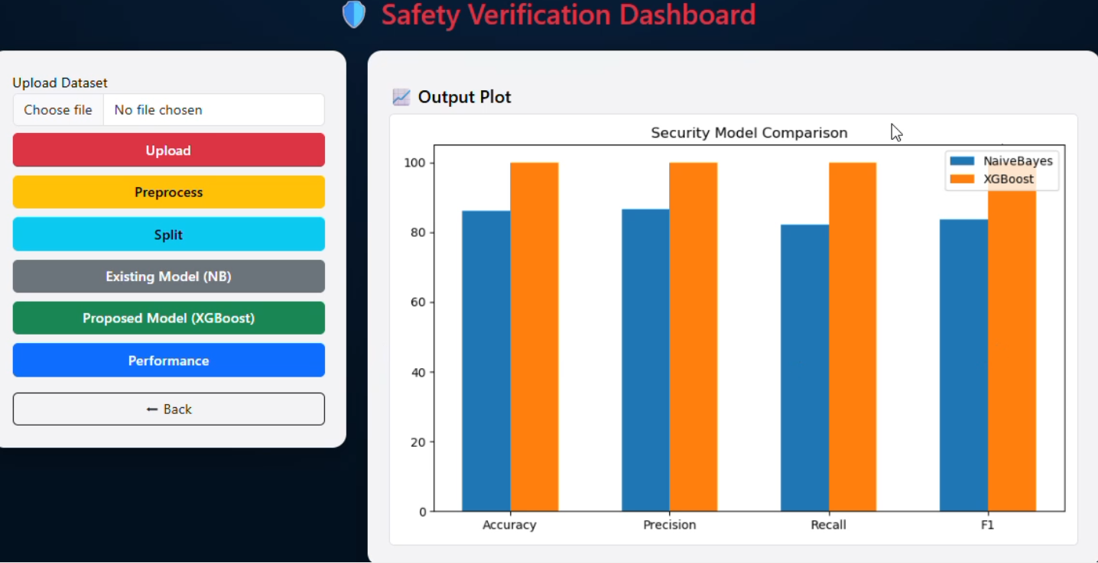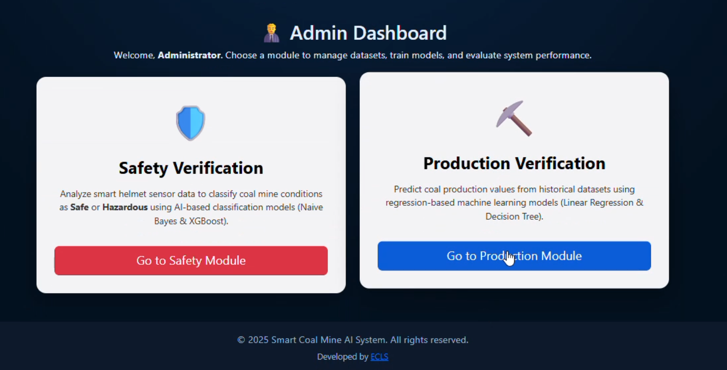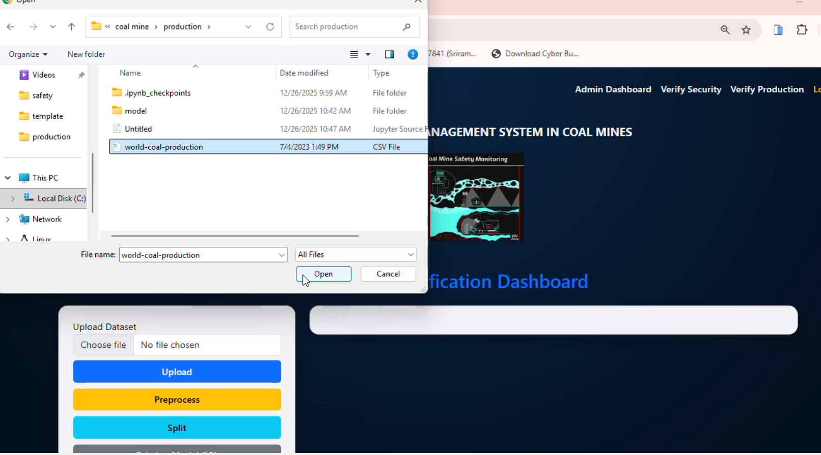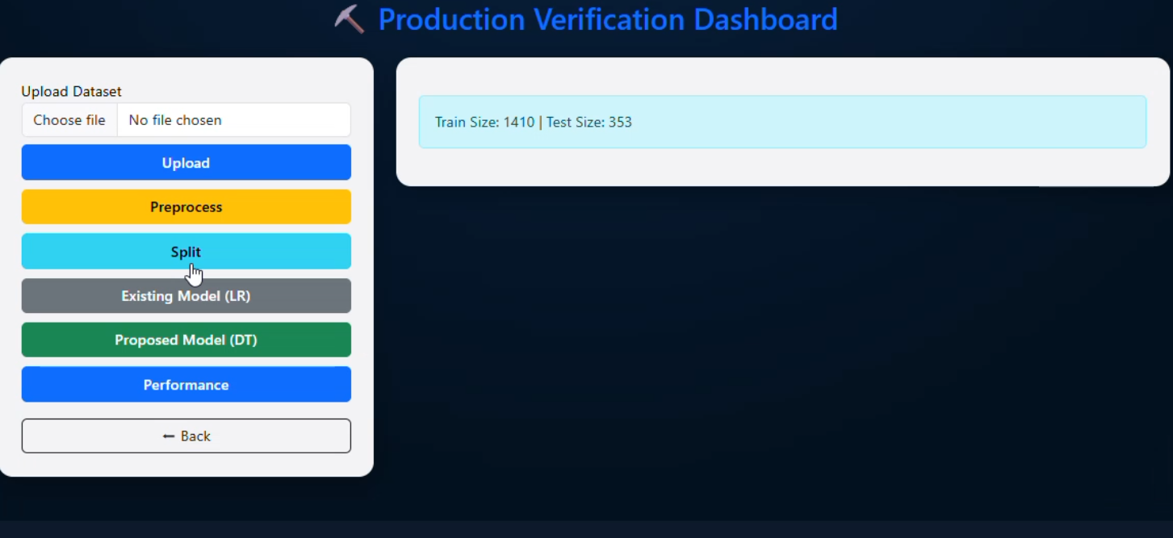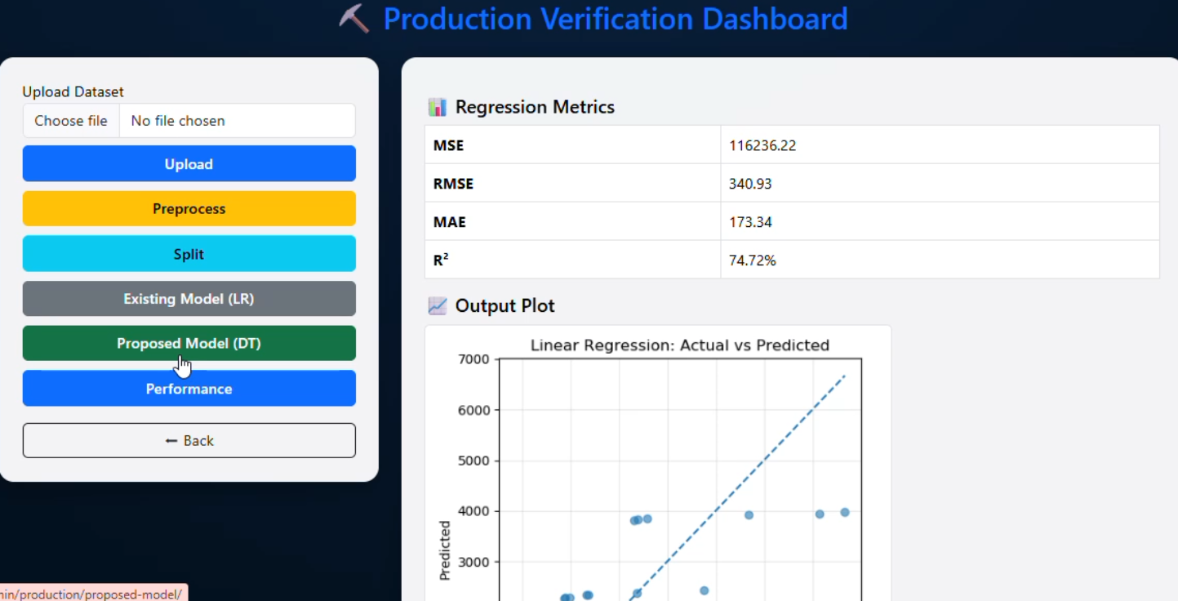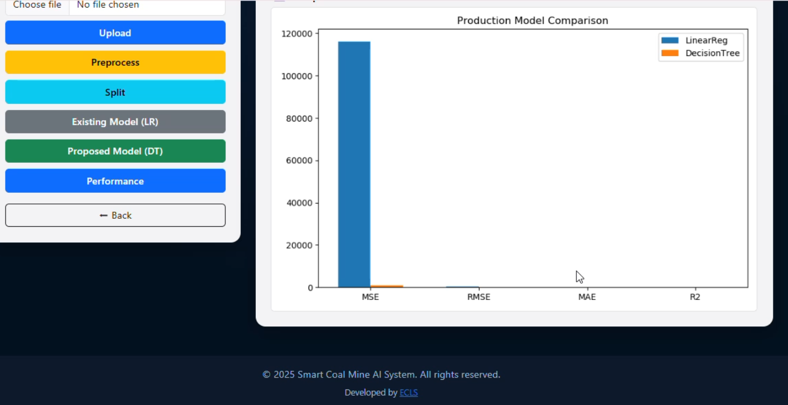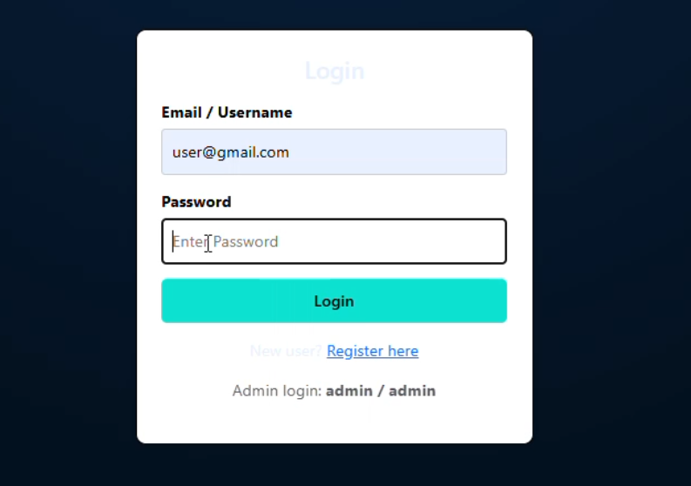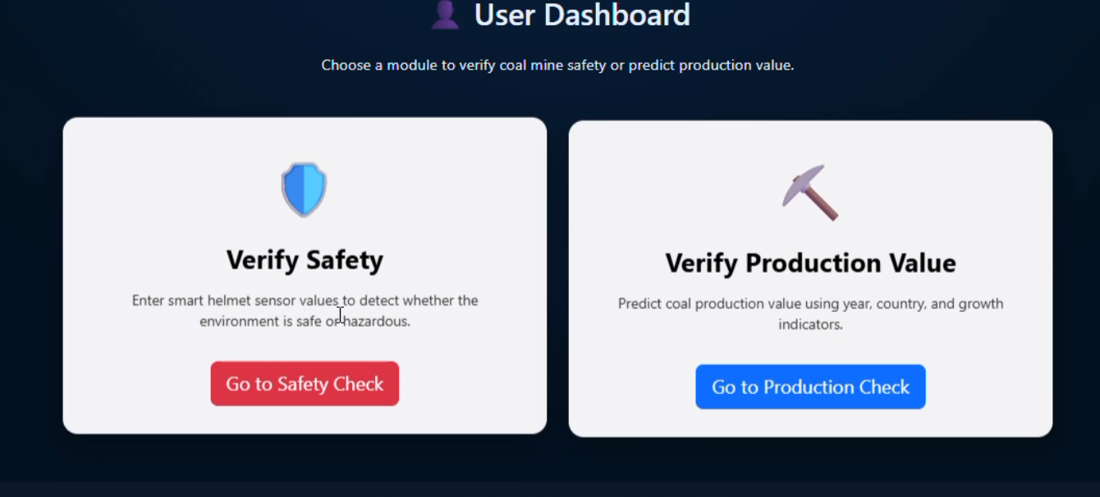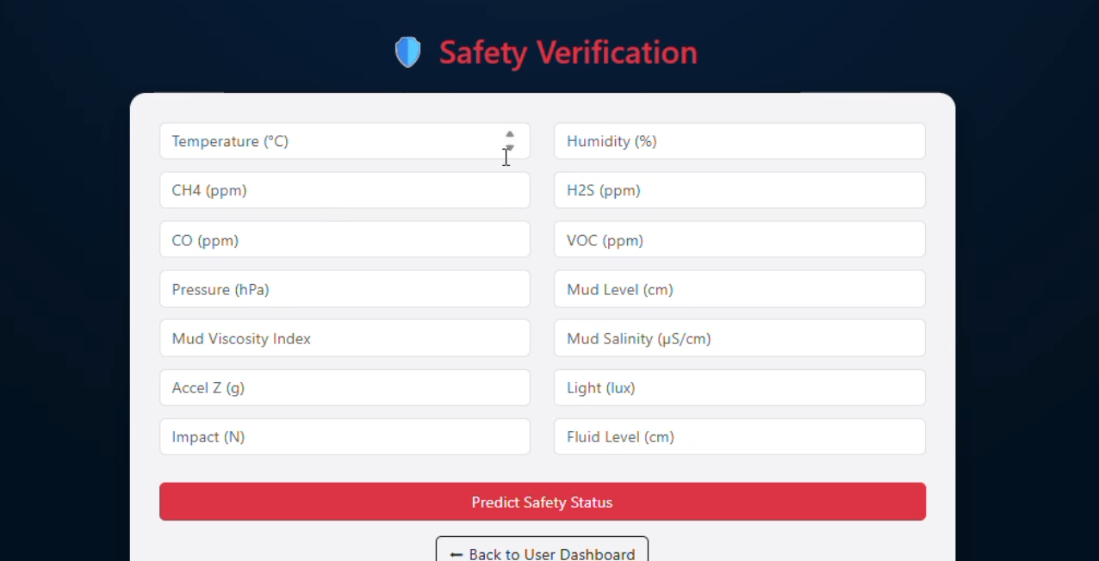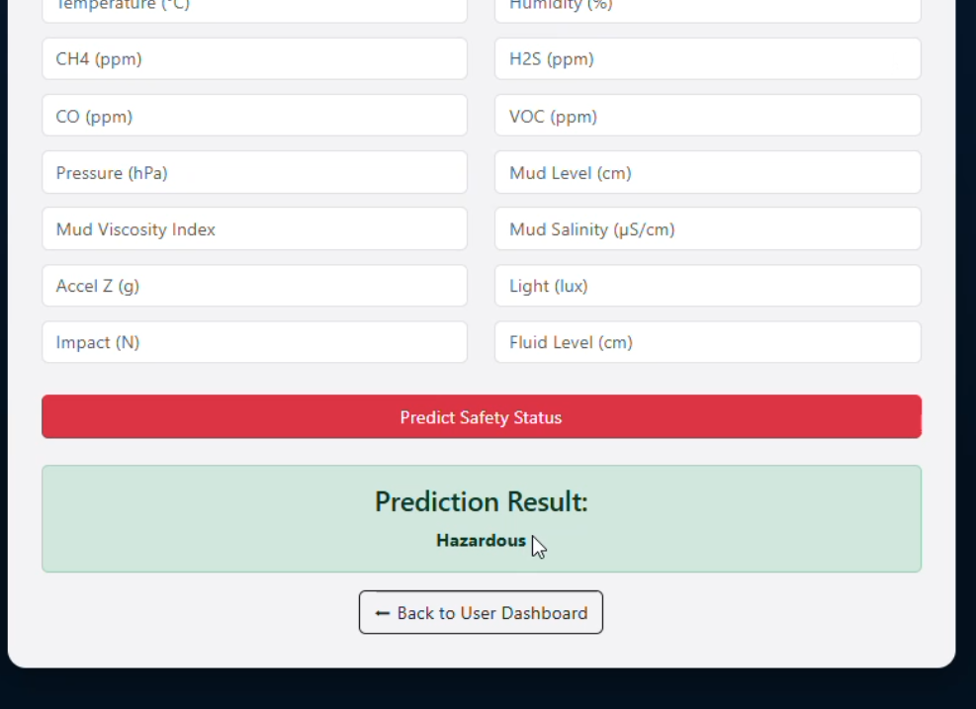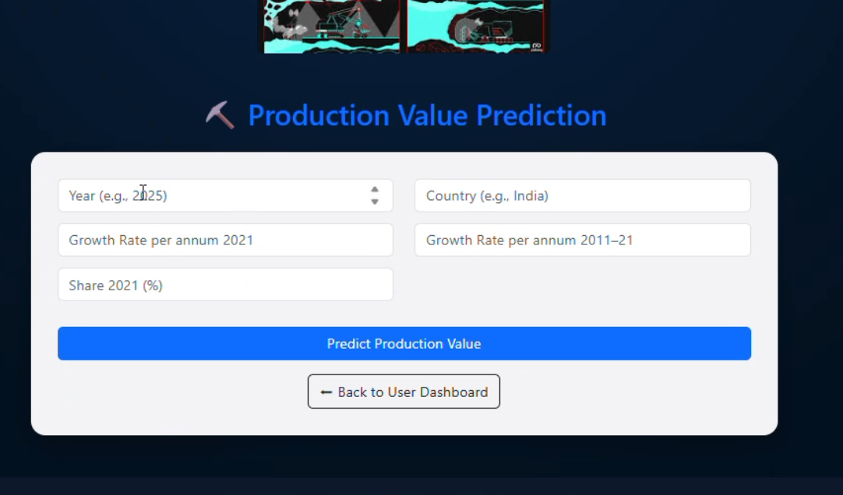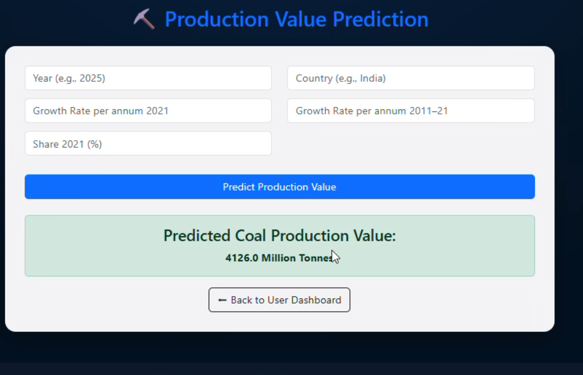

CHAPTRER-9
SYSTEMTESTING

9.1 Different Testing Types with Details
We, as testers, are aware of the various types of Software Testing like Functional Testing, Non-Functional Testing, Automation Testing, Agile Testing, and their sub- types, etc. Each type of testing has its own features, advantages, and disadvantages as well. However, in this tutorial, we have covered mostly each and every type of software testing which we usually use in our day-to-day testing life.

Different Types of Software Testing
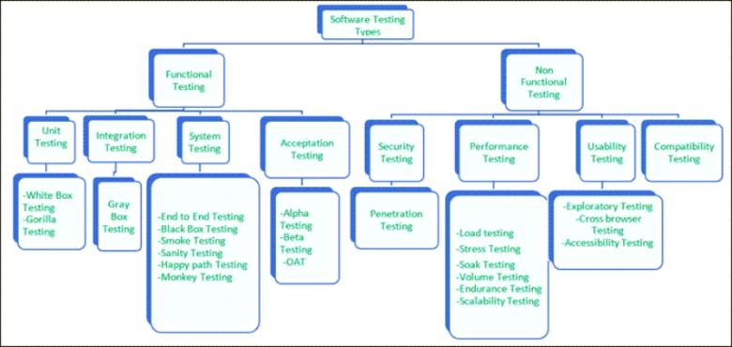

Performance Testing
Performance testing is testing of an application’s stability and response time by applying load.
The word stability means the ability of the application to withstand in the presence of load. Response time is how quickly an application is available to users. Performance testing is done with the help of tools. Loader.IO, JMeter, Load Runner, etc. are good tools available in the market.

Load testing
Load testing is testing of an application’s stability and response time by applying load, which is equal to or less than the designed number of users for an application.
For example, your application handles 100 users at a time with a response time of 3 seconds, then load testing can be done by applying a load of the maximum of 100 or less than 100 users. The goal is to verify that the application is responding within 3 seconds for all the users.

Stress Testing
Stress testing is testing an application’s stability and response time by applying load, which is more than the designed number of users for an application.
For example, your application handles 1000 users at a time with a response time of 4 seconds, and then stress testing can be done by applying a load of more than 1000 users. Test the application with1100, 1200, 1300users and notice the response time. The goal is to verify the stability of an application under stress.

Scalability Testing
Scalability testing is testing an application’s stability and response time by applying load, which is more than the designed number of users for an application.
The purpose of testing is to discover errors. Testing is the process of trying to discover every conceivable fault or weakness in a work product. It provides a way to check the functionality of components, sub-assemblies, assemblies and/or a finished product It is the process of exercising software with the intent of ensuring that the
Software system meets its requirements and user expectations and does not fail in an unacceptable manner. There are various types of test. Each test type addresses a specific testing requirement.

9.2 TYPES OF TESTS

Unit Testing
Unit testing involves the design of test cases that validate that the internal program logic is functioning properly, and that program inputs produce valid outputs. All decision branches and internal code flow should be validated. It is the testing of individual software units of the application .it is done after the completion of an individual unit before integration. This is a structural testing, that relies on knowledge of its construction and is invasive. Unit tests perform basic tests at component level and test a specific business process, application, and/or system configuration. Unit tests ensure that each unique path of a business process performs accurately to the documented specifications and contains clearly defined inputs and expected results.

Integration testing
Integration tests are designed to test integrated software components to determine if they actually run as one program. Testing is event driven and is more concerned with the basic outcome of screens or fields. Integration tests demonstrate that although the components were individually satisfaction, as shown by successfully unit testing, the combination of components is correct and consistent. Integration testing is specifically aimed at exposing the problems that arise from the combination of components.

Functional test
Functional tests provide systematic demonstrations that functions tested are available as specified by the business and technical requirements, system documentation, and user manuals.
Functional testing is centered on the following items:
Valid Input : identified classes of valid input must be accepted.
Invalid Input : identified classes of invalid input must be rejected.
Functions : identified functions must be exercised.
Output : identified classes of application outputs must be exercised.
Systems/Procedures: interfacing systems or procedures must be invoked.
Organization and preparation of functional tests is focused on requirements, key functions, or special test cases. In addition, systematic coverage pertaining to identify Business process flows; data fields, predefined processes, and successive processes must be considered for testing. Before functional testing is complete, additional tests are identified and the effective value of current tests is determined.

System Test
System testing ensures that the entire integrated software system meets requirements. It tests a configuration to ensure known and predictable results. An example of system testing is the configuration oriented system integration test. System testing is based on process descriptions and flows, emphasizing pre-driven process links and integration points.

White Box Testing
White Box Testing is a testing in which in which the software tester has knowledge of the inner workings, structure and language of the software, or at least its purpose. It is purpose. It is used to test areas that cannot be reached from a black box level.

Black Box Testing
Black Box Testing is testing the software without any knowledge of the inner workings, structure or language of the module being tested. Black box tests, as most other kinds of tests, must be written from a definitive source document, such as specification or requirements document, such as specification or requirements document. It is a testing in which the software under test is treated, as a black box .you cannot “see” into it. The test provides inputs and responds to outputs without considering how the software works.

Test strategy and approach
Field testing will be performed manually and functional tests will be written in detail.
Test objectives
- All field entries must work properly.
- Pages must be activated from the identified link.
- The entry screen, messages and responses must not be delayed.
Features to be tested
- Verify that the entries are of the correct format
- No duplicate entries should be allowed
- All links should take the user to the correct page.

Integration Testing
Software integration testing is the incremental integration testing of two or more integrated software components on a single platform to produce failures caused by interface defects.
The task of the integration test is to check that components or software applications, e.g. components in a software system or – one step up – software applications at the company level – interact without error.
Test Results: All the test cases mentioned above passed successfully. No defects encountered.

Acceptance Testing
User Acceptance Testing is a critical phase of any project and requires significant participation by the end user. It also ensures that the system meets the functional requirements.
Test Results: All the test cases mentioned above passed successfully. No defects encountered.
SYSTEM TESTING

TESTING METHODOLOGIES
The following are the Testing Methodologies:
- Unit Testing.
- Integration Testing.
- User Acceptance Testing.
- Output Testing.
- Validation Testing.
Unit Testing
Unit testing focuses verification effort on the smallest unit of Software design that is the module. Unit testing exercises specific paths in a module’s control structure to ensure complete coverage and maximum error detection. This test focuses on each module individually, ensuring that it functions properly as a unit. Hence, the naming is Unit Testing.
During this testing, each module is tested individually and the module interfaces are verified for the consistency with design specification. All important processing path are tested for the expected results. All error handling paths are also tested.
Integration Testing
Integration testing addresses the issues associated with the dual problems of verification and program construction. After the software has been integrated a set of high order tests are conducted. The main objective in this testing process is to take unit tested modules and builds a program structure that has been dictated by design.
The following are the types of Integration Testing:
1)Top Down Integration
This method is an incremental approach to the construction of program structure. Modules are integrated by moving downward through the control hierarchy, beginning with the main program module. The module subordinates to the main program module are incorporated into the structure in either a depth first or breadth first manner.
In this method, the software is tested from main module and individual stubs are replaced when the test proceeds downwards.
2. Bottom-up Integration
This method begins the construction and testing with the modules at the lowest level in the program structure. Since the modules are integrated from the bottom up, processing required for modules subordinate to a given level is always available and the need for stubs is eliminated. The bottom up integration strategy may be implemented with the following steps:

- The low-level modules are combined into clusters into clusters that perform a specific Software sub-function.
- A driver (i.e.) the control program for testing is written to coordinate test case input and output.
- The cluster is tested.
- Drivers are removed and clusters are combined moving upward in the program structure
The bottom up approaches tests each module individually and then each module is module is integrated with a main module and tested for functionality.
OTHER TESTING METHODOLOGIES
User Acceptance Testing
User Acceptance of a system is the key factor for the success of any system. The system under consideration is tested for user acceptance by constantly keeping in touch with the prospective system users at the time of developing and making changes wherever required. The system developed provides a friendly user interface that can easily be understood even by a person who is new to the system.
Output Testing
After performing the validation testing, the next step is output testing of the proposed system, since no system could be useful if it does not produce the required output in the specified format. Asking the users about the format required by them tests the outputs generated or displayed by the system under consideration. Hence the output format is considered in 2 ways – one is on screen and another in printed format.
Validation Checking
Validation checks are performed on the following fields.
Text Field:
The text field can contain only the number of characters lesser than or equal to its size. The text fields are alphanumeric in some tables and alphabetic in other tables. Incorrect entry always flashes and error message.
Numeric Field:
The numeric field can contain only numbers from 0 to 9. An entry of any character flashes an error messages. The individual modules are checked for accuracy and what it has to perform. Each module is subjected to test run along with sample data. The individually tested modules are integrated into a single system. Testing involves executing the real data information is used in the program the existence of any program defect is inferred from the output. The testing should be planned so that all the requirements are individually tested.
A successful test is one that gives out the defects for the inappropriate data and produces and output revealing the errors in the system.
Preparation of Test Data
Taking various kinds of test data does the above testing. Preparation of test data plays a vital role in the system testing. After preparing the test data the system under study is tested using that test data. While testing the system by using test data errors are again uncovered and corrected by using above testing steps and corrections are also noted for future use.
Using Live Test Data:
Live test data are those that are actually extracted from organization files. After a system is partially constructed, programmers or analysts often ask users to key in a set of data from their normal activities. Then, the systems person uses this data as a way to partially test the system. In other instances, programmers or analysts extract a set of live data from the files and have them entered themselves.
It is difficult to obtain live data in sufficient amounts to conduct extensive testing. And, although it is realistic data that will show how the system will perform for the typical processing requirement, assuming that the live data entered are in fact typical, such data generally will not test all combinations or formats that can enter the system. This bias toward typical values then does not provide a true systems test and in fact ignores the cases most likely to cause system failure.
Using Artificial Test Data:
Artificial test data are created solely for test purposes, since they can be generated to test all combinations of formats and values. In other words, the artificial data, which can quickly be prepared by a data generating utility program in the information systems department, make possible the testing of all login and control paths through the program.
The most effective test programs use artificial test data generated by persons other than those who wrote the programs. Often, an independent team of testers formulates a testing plan, using the systems specifications.
The package “Virtual Private Network” has satisfied all the requirements specified as per software requirement specification and was accepted.
USER TRAINING
Whenever a new system is developed, user training is required to educate them about the working of the system so that it can be put to efficient use by those for whom the system has been primarily designed. For this purpose the normal working of the project was demonstrated to the prospective users. Its working is easily understandable and since the expected users are people who have good knowledge of computers, the use of this system is very easy.
MAINTAINENCE
This covers a wide range of activities including correcting code and design errors. To reduce the need for maintenance in the long run, we have more accurately defined the user’s requirements during the process of system development. Depending on the requirements, this system has been developed to satisfy the needs to the largest possible extent. With development in technology, it may be possible to add many more features based on the requirements in future. The coding and designing is simple and easy to understand which will make maintenance easier.
TESTING STRATEGY :
A strategy for system testing integrates system test cases and design techniques into a well-planned series of steps that results in the successful construction of software. The testing strategy must co-operate test planning, test case design, test execution, and the resultant data collection and evaluation. A strategy for software testing must accommodate low-level tests that are necessary to verify that a small source code segment has been correctly implemented as well as high level tests that validate major system functions against user requirements.
Software testing is a critical element of software quality assurance and represents the ultimate review of specification design and coding. Testing represents an interesting anomaly for the software. Thus, a series of testing are performed for the proposed system before the system is ready for user acceptance testing.

CHAPTRER-10
CONCLUSION AND FUTURE SCOPE
Conclusion and Future Scope
Conclusion
The Smart Productivity & Safety Management System in Coal Mines successfully demonstrates how artificial intelligence and machine learning can be effectively applied to enhance both worker safety and production efficiency in coal mining operations. The system integrates safety prediction and production value forecasting into a single, web-based platform using Django, providing secure access for administrators and users. Experimental results show that advanced models such as XGBoost for safety classification and Decision Tree Regressor for production prediction significantly outperform traditional methods like Naive Bayes and Linear Regression. The safety module accurately identifies hazardous conditions using sensor data, enabling early warnings and preventive actions, while the production module delivers reliable forecasts based on historical and operational parameters. Automated data preprocessing, model training, evaluation, and visualization further improve system efficiency and usability. Overall, the proposed system reduces dependency on manual monitoring, minimizes human error, enhances decision-making, and contributes to safer and more efficient coal mining practices.

The proposed system can be further enhanced in several ways. Real-time data integration using IoT-enabled sensors can be implemented to enable continuous live monitoring of underground mine conditions. Deep learning models such as LSTM and CNN can be explored to improve temporal and spatial pattern recognition in safety and production data. Cloud deployment and big data frameworks can be integrated to support large-scale mining operations and multi-mine analytics. Mobile and alert-based notification systems can be added to provide instant warnings to workers and supervisors. Additionally, integrating GIS-based visualization and blockchain for secure data logging can improve transparency, traceability, and regulatory compliance. With these enhancements, the system can evolve into a fully autonomous, intelligent mining management solution supporting sustainable and smart industrial operations.

REFERENCES:
- G. B. Prakash, S. Kumar, and R. Singh, “Application of Machine Learning Techniques for Safety Analysis in Coal Mines,” International Journal of Mining Science and Technology, vol. 30, no. 4, pp. 457–465, 2020.
- A. K. Mishra and P. K. Singh, “IoT-Based Smart Monitoring System for Underground Coal Mines,” Procedia Computer Science, vol. 167, pp. 171–180, 2020.
- T. Chen and C. Guestrin, “XGBoost: A Scalable Tree Boosting System,” Proceedings of the 22nd ACM SIGKDD International Conference on Knowledge Discovery and Data Mining, pp. 785–794, 2016.
- S. Raschka and V. Mirjalili, Machine Learning and Deep Learning with Python, 3rd ed., Packt Publishing, 2022.
- I. H. Witten, E. Frank, and M. A. Hall, Data Mining: Practical Machine Learning Tools and Techniques, 4th ed., Morgan Kaufmann, 2017.
- J. Han, M. Kamber, and J. Pei, Data Mining: Concepts and Techniques, 3rd ed., Elsevier, 2019.
- S. Sharma and R. Kumar, “Coal Production Forecasting Using Regression and Tree-Based Models,” Energy Policy, vol. 138, pp. 111–120, 2020.
- Scikit-learn Developers, “Scikit-learn: Machine Learning in Python,” Available: https://scikit-learn.org
- Django Software Foundation, “Django Documentation,” Available: https://docs.djangoproject.com
- World Coal Association, “Coal Mining Safety and Sustainability,” Available: https://www.worldcoal.org

