**EXPERIMENT-11**

**AIM:** To Implement an application that writes data to the SD card.

**SOURCE CODE:**

<!DOCTYPE html>

<html lang="en">

<head>

<meta charset="UTF-8" />

<meta name="viewport" content="width=device-width, initial-scale=1.0"/>

<title>Write to SD Card</title>

<style>

* {

box-sizing: border-box;

font-family: 'Poppins', sans-serif;

}

body {

margin: 0;

padding: 0;

height: 100vh;

background: radial-gradient(circle at top left, #1f1c2c, #928dab);

display: flex;

justify-content: center;

align-items: center;

}

.mobile-container {

width: 100%;

max-width: 390px;

height: 90vh;

background: rgba(255, 255, 255, 0.05);

border-radius: 20px;

box-shadow: 0 8px 32px rgba(0,0,0,0.3);

backdrop-filter: blur(15px);

-webkit-backdrop-filter: blur(15px);

border: 1px solid rgba(255, 255, 255, 0.1);

padding: 25px 20px;

display: flex;

flex-direction: column;

}

.title {

text-align: center;

font-size: 2rem;

font-weight: 600;

color: #fff;

margin-bottom: 25px;

letter-spacing: 1px;

text-shadow: 0 0 5px #ffffff80;

}

textarea {

width: 100%;

height: 130px;

background: rgba(255, 255, 255, 0.07);

border: 1px solid rgba(255, 255, 255, 0.15);

border-radius: 12px;

padding: 14px;

font-size: 1rem;

color: #fff;

resize: none;

margin-bottom: 20px;

backdrop-filter: blur(10px);

outline: none;

}

textarea::placeholder {

color: #bbb;

}

button {

width: 100%;

background: linear-gradient(135deg, #00f260, #0575e6);

color: white;

font-size: 1rem;

padding: 14px;

border: none;

border-radius: 12px;

cursor: pointer;

font-weight: 600;

box-shadow: 0 0 15px #00f26080;

transition: all 0.25s ease-in-out;

}

button:hover {

transform: scale(1.03);

box-shadow: 0 0 20px #00f260;

}

.status {

text-align: center;

font-size: 0.95rem;

margin-top: 15px;

color: #ddd;

font-weight: 500;

}

.status.success {

color: #6effa2;

}

.status.error {

color: #ff4e4e;

}

.output-box {

display: none;

margin-top: auto;

background: rgba(255, 255, 255, 0.06);

border-left: 5px solid #00f260;

padding: 14px;

border-radius: 10px;

color: #fff;

box-shadow: 0 4px 15px rgba(0, 0, 0, 0.2);

word-wrap: break-word;

font-size: 0.95rem;

backdrop-filter: blur(10px);

}

.output-box.show {

display: block;

}

@media (max-height: 600px) {

.mobile-container {

height: auto;

}

}

</style>

</head>

<body>

<div class="mobile-container">

<div class="title">🚀 Write to SD Card</div>

<textarea id="dataInput" placeholder="Type your message..."></textarea>

<button onclick="writeToCard()">💾 Save Data</button>

<div class="status" id="statusText">Waiting for input...</div>

<div class="output-box" id="outputBox">

<strong>✅ Written Content:</strong>

<div id="writtenContent"></div>

</div>

</div>

<script>

function writeToCard() {

const input = document.getElementById('dataInput').value.trim();

const status = document.getElementById('statusText');

const outputBox = document.getElementById('outputBox');

const contentDisplay = document.getElementById('writtenContent');

if (input === "") {

status.textContent = "Please enter some data!";

status.className = "status error";

outputBox.classList.remove("show");

} else {

status.textContent = "Data written to SD card (simulated).";

status.className = "status success";

contentDisplay.textContent = input;

outputBox.classList.add("show");

}

}

</script>

</body>

</html>

**OUTPUT:**

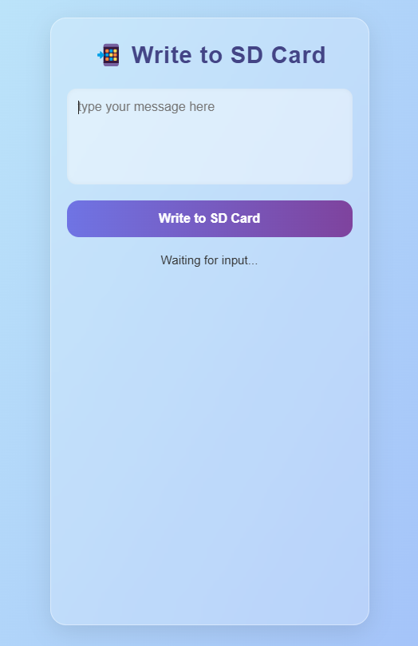 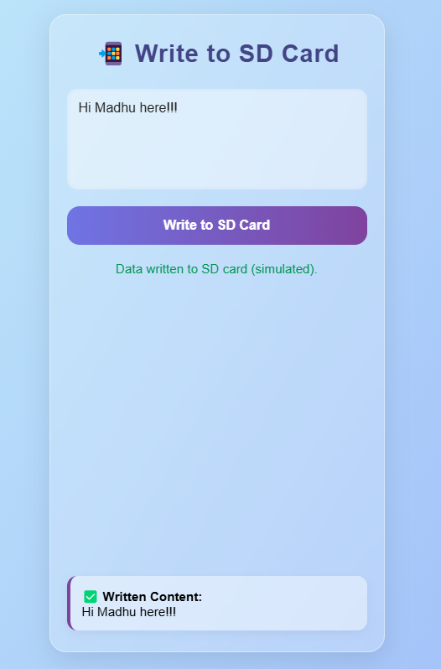

**RESULT:**

Thu**s** an application that writes data to the SD card has been executed successfully.