**EXPERIMENT – 2**

**AIM:**

Write JavaScript to validate the following fields of the Registration page.

1. First Name (Name should contains alphabets and the length Should not be less than 6 characters). b)
2. Password (Password should not be less than 6 characters length).
3. E-mail id (should not contain any invalid and must follow the standard pattern [name@domain.com](mailto:name@domain.com)).
4. Mobile Number (Phone number should contain 10 digits only). e) Last Name and Address (should not be Empty).

**SOURCE CODE:**

**Index.html:**

<!DOCTYPE html>

<html lang="en">

<head>

<meta charset="UTF-8">

<meta name="viewport" content="width=device-width, initial-scale=1.0">

<title>Registration Form</title>

<link rel="stylesheet" href="style.css">

</head>

<body>

<div class="container">

<h2>Registration Form</h2>

<form id="registrationForm">

<label for="firstName">First Name:</label>

<input type="text" id="firstName" placeholder="Enter First Name">

<span class="error" id="firstNameError"></span>

<label for="lastName">Last Name:</label>

<input type="text" id="lastName" placeholder="Enter Last Name">

<span class="error" id="lastNameError"></span>

<label for="email">Email:</label>

<input type="email" id="email" placeholder="Enter Email">

<span class="error" id="emailError"></span>

<label for="password">Password:</label>

<input type="password" id="password" placeholder="Enter Password">

<span class="error" id="passwordError"></span>

<label for="mobile">Mobile Number:</label>

<input type="text" id="mobile" placeholder="Enter Mobile Number">

<span class="error" id="mobileError"></span>

<label for="address">Address:</label>

<textarea id="address" placeholder="Enter Address"></textarea>

<span class="error" id="addressError"></span>

<button type="submit">Register</button>

</form>

</div>

<script src="script.js"></script>

</body>

</html>

**Style.css:**

body {

font-family: Arial, sans-serif;

background-color: #f4f4f4;

display: flex;

justify-content: center;

align-items: center;

height: 100vh;

}

.container {

background: white;

padding: 20px;

border-radius: 8px;

box-shadow: 0px 0px 10px rgba(0, 0, 0, 0.1);

width: 350px;

}

h2 {

text-align: center;

}

label {

display: block;

margin-top: 10px;

}

input, textarea {

width: 100%;

padding: 8px;

margin-top: 5px;

border: 1px solid #ccc;

border-radius: 4px;

}

button {

width: 100%;

margin-top: 15px;

padding: 10px;

background-color: #007BFF;

color: white;

border: none;

border-radius: 4px;

cursor: pointer;

}

button:hover {

background-color: #0056b3;

}

.error {

color: red;

font-size: 12px;

}

**Script.js:**

document.getElementById("registrationForm").addEventListener("submit", function(event) {

event.preventDefault(); // Prevent form submission

let isValid = true;

// First Name Validation (Min 6 Characters, Only Alphabets)

let firstName = document.getElementById("firstName").value.trim();

if (!/^[A-Za-z]{6,}$/.test(firstName)) {

document.getElementById("firstNameError").innerText = "First Name must be at least 6 letters.";

isValid = false;

} else {

document.getElementById("firstNameError").innerText = "";

}

// Last Name Validation (Should not be empty)

let lastName = document.getElementById("lastName").value.trim();

if (lastName === "") {

document.getElementById("lastNameError").innerText = "Last Name cannot be empty.";

isValid = false;

} else {

document.getElementById("lastNameError").innerText = "";

}

// Email Validation (Standard Format)

let email = document.getElementById("email").value.trim();

let emailPattern = /^[a-zA-Z0-9._%+-]+@[a-zA-Z0-9.-]+\.[a-zA-Z]{2,}$/;

if (!emailPattern.test(email)) {

document.getElementById("emailError").innerText = "Enter a valid email (e.g. name@domain.com).";

isValid = false;

} else {

document.getElementById("emailError").innerText = "";

}

// Password Validation (Min 6 Characters)

let password = document.getElementById("password").value.trim();

if (password.length < 6) {

document.getElementById("passwordError").innerText = "Password must be at least 6 characters.";

isValid = false;

} else {

document.getElementById("passwordError").innerText = "";

}

// Mobile Number Validation (Exactly 10 Digits)

let mobile = document.getElementById("mobile").value.trim();

if (!/^\d{10}$/.test(mobile)) {

document.getElementById("mobileError").innerText = "Mobile number must be exactly 10 digits.";

isValid = false;

} else {

document.getElementById("mobileError").innerText = "";

}

// Address Validation (Should not be empty)

let address = document.getElementById("address").value.trim();

if (address === "") {

document.getElementById("addressError").innerText = "Address cannot be empty.";

isValid = false;

} else {

document.getElementById("addressError").innerText = "";

}

// Submit Form if Valid

if (isValid) {

alert("Registration Successful!");

document.getElementById("registrationForm").reset(); // Reset form after success

}

});

**OUTPUT:**

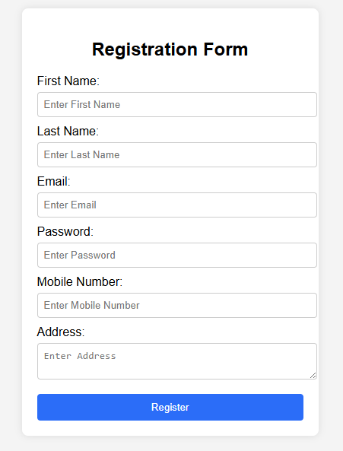

**RESULT:**

Thus the web page is created.