**EXPERIMENT – 3**

**AIM:** To write a Servlet program that prints "Hello, World!" when accessed through a browser.

**SOURCE CODE:**

**HelloWorldServlet.java:**

package com.example;

import java.io.IOException;

import java.io.PrintWriter;

import javax.servlet.ServletException;

import javax.servlet.annotation.WebServlet;

import javax.servlet.http.HttpServlet;

import javax.servlet.http.HttpServletRequest;

import javax.servlet.http.HttpServletResponse;

@WebServlet("/HelloWorld") // URL pattern

public class HelloWorldServlet extends HttpServlet {

private static final long serialVersionUID = 1L;

@Override

protected void doGet(HttpServletRequest request, HttpServletResponse response)

throws ServletException, IOException {

response.setContentType("text/html;charset=UTF-8");

try (PrintWriter out = response.getWriter()) {

out.println("<html>");

out.println("<head><title>Hello Servlet</title></head>");

out.println("<body>");

out.println("<h1>Hello, World!</h1>");

out.println("</body>");

out.println("</html>");

}

}

}

**Index.html:**

<!DOCTYPE html>

<html lang="en">

<head>

<meta charset="UTF-8">

<meta name="viewport" content="width=device-width, initial-scale=1.0">

<title>Hello World Servlet</title>

<style>

body {

font-family: Arial, sans-serif;

background: linear-gradient(to right, #4facfe, #00f2fe);

text-align: center;

padding: 50px;

}

.container {

background: white;

padding: 30px;

border-radius: 15px;

box-shadow: 0px 4px 10px rgba(0, 0, 0, 0.2);

max-width: 400px;

margin: auto;

}

h1 {

color: #333;

}

.btn {

background: #007BFF;

color: white;

border: none;

padding: 10px 20px;

font-size: 18px;

border-radius: 5px;

cursor: pointer;

transition: 0.3s;

}

.btn:hover {

background: #0056b3;

}

#output {

margin-top: 20px;

font-size: 22px;

color: #007BFF;

font-weight: bold;

}

</style>

<script>

function fetchHelloWorld() {

fetch("HelloWorld") // Calls the Servlet

.then(response => response.text())

.then(data => {

document.getElementById("output").innerHTML = data;

})

.catch(error => console.error("Error:", error));

}

</script>

</head>

<body>

<div class="container">

<h1>Welcome to My Servlet App</h1>

<p>Click the button below to get a response from the servlet:</p>

<button class="btn" onclick="fetchHelloWorld()">Say Hello</button>

<div id="output"></div>

</div>

</body>

</html>

**Web.xml:**

<servlet>

<servlet-name>HelloWorldServlet</servlet-name>

<servlet-class>com.example.HelloWorldServlet</servlet-class>

</servlet>

<servlet-mapping>

<servlet-name>HelloWorldServlet</servlet-name>

<url-pattern>/HelloWorld</url-pattern>

</servlet-mapping>

**OUTPUT:**

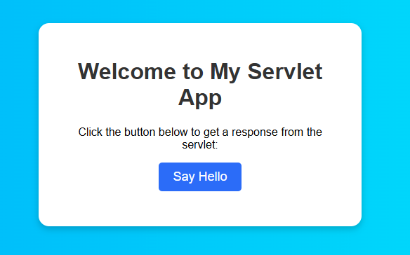

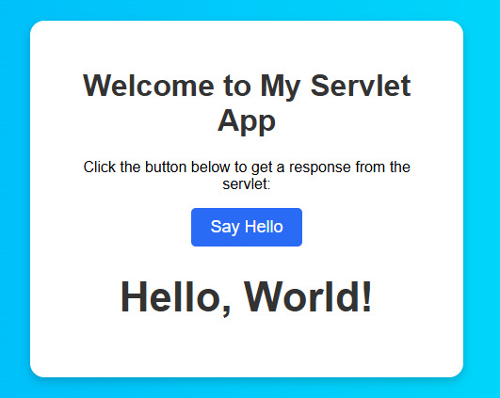

**RESULT:**

Thus the web application is created successfully.