**EXPERIMENT – 4**

**AIM:** To create a web form that accepts a user's name and age. Write a Servlet to process the form data and display it back on the browser.

**SOURCE CODE:**

**ProcessFormServlet.java:**

package com.example;

import java.io.IOException;

import java.io.PrintWriter;

import javax.servlet.ServletException;

import javax.servlet.annotation.WebServlet;

import javax.servlet.http.HttpServlet;

import javax.servlet.http.HttpServletRequest;

import javax.servlet.http.HttpServletResponse;

@WebServlet("/ProcessForm")

public class ProcessFormServlet extends HttpServlet {

private static final long serialVersionUID = 1L;

@Override

protected void doPost(HttpServletRequest request, HttpServletResponse response)

throws ServletException, IOException {

response.setContentType("text/html;charset=UTF-8");

String name = request.getParameter("username");

String age = request.getParameter("age");

try (PrintWriter out = response.getWriter()) {

out.println("<html><head><title>Form Submission</title>");

out.println("<style>");

out.println("body { font-family: Arial, sans-serif; text-align: center; padding: 50px; }");

out.println(".container { background: white; padding: 30px; border-radius: 15px; box-shadow: 0px 4px 10px rgba(0, 0, 0, 0.2); max-width: 400px; margin: auto; }");

out.println("h2 { color: #333; }");

out.println("</style></head><body>");

out.println("<div class='container'>");

out.println("<h2>Form Data Received</h2>");

out.println("<p><strong>Name:</strong> " + name + "</p>");

out.println("<p><strong>Age:</strong> " + age + "</p>");

out.println("<a href='index.html'>Go Back</a>");

out.println("</div>");

out.println("</body></html>");

}

}

}

**Index.html:**

<!DOCTYPE html>

<html lang="en">

<head>

<meta charset="UTF-8">

<meta name="viewport" content="width=device-width, initial-scale=1.0">

<title>Glassmorphic User Form</title>

<style>

* {

margin: 0;

padding: 0;

box-sizing: border-box;

font-family: 'Poppins', sans-serif;

}

body {

display: flex;

justify-content: center;

align-items: center;

height: 100vh;

background: url('https://source.unsplash.com/1600x900/?nature,abstract') no-repeat center center/cover;

}

.container {

background: rgba(255, 255, 255, 0.1);

backdrop-filter: blur(10px);

padding: 30px;

border-radius: 20px;

box-shadow: 0px 4px 15px rgba(0, 0, 0, 0.2);

text-align: center;

width: 350px;

}

h2 {

color: #fff;

margin-bottom: 20px;

}

input {

width: 100%;

padding: 12px;

margin: 10px 0;

border-radius: 10px;

border: none;

outline: none;

font-size: 16px;

background: rgba(255, 255, 255, 0.2);

color: white;

}

input::placeholder {

color: rgba(255, 255, 255, 0.7);

}

.btn {

width: 100%;

padding: 12px;

border: none;

border-radius: 10px;

background: linear-gradient(45deg, #ff416c, #ff4b2b);

color: white;

font-size: 18px;

cursor: pointer;

transition: 0.3s;

}

.btn:hover {

background: linear-gradient(45deg, #ff4b2b, #ff416c);

}

</style>

</head>

<body>

<div class="container">

<h2>Enter Your Details</h2>

<form action="ProcessForm" method="post">

<input type="text" name="username" placeholder="Enter your name" required><br>

<input type="number" name="age" placeholder="Enter your age" required><br>

<button type="submit" class="btn">Submit</button>

</form>

</div>

</body>

</html>

**Web.xml:**

<welcome-file-list>

<welcome-file>index.html</welcome-file>

</welcome-file-list>

**OUTPUT:**

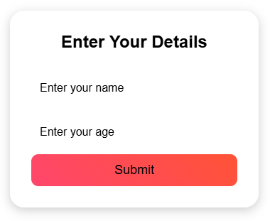

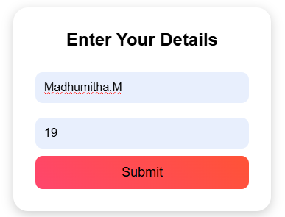

**RESULT:**

Thus the web application is created successfully.