**EXPERIMENT – 5**

**AIM:** To Write a Servlet to demonstrate the difference between HTTP GET and POST methods by creating a form and handling requests accordingly.

**SOURCE CODE:**

**GetPostServlet.java:**

package com.example; // Ensure this matches your package structure

import jakarta.servlet.ServletException;

import jakarta.servlet.annotation.WebServlet;

import jakarta.servlet.http.HttpServlet;

import jakarta.servlet.http.HttpServletRequest;

import jakarta.servlet.http.HttpServletResponse;

import java.io.IOException;

import java.io.PrintWriter;

@WebServlet("/GetPostServlet") // URL pattern to access this Servlet

public class GetPostServlet extends HttpServlet {

private static final long serialVersionUID = 1L;

// Handles GET requests

@Override

protected void doGet(HttpServletRequest request, HttpServletResponse response)

throws ServletException, IOException {

response.setContentType("text/html;charset=UTF-8");

try (PrintWriter out = response.getWriter()) {

out.println("<html><head><title>GET Request</title></head><body>");

out.println("<h2>Welcome! This is a GET request.</h2>");

out.println("<form action='GetPostServlet' method='POST'>");

out.println("Name: <input type='text' name='name'><br>");

out.println("Age: <input type='number' name='age'><br>");

out.println("<input type='submit' value='Submit via POST'>");

out.println("</form>");

out.println("</body></html>");

}

}

// Handles POST requests

@Override

protected void doPost(HttpServletRequest request, HttpServletResponse response)

throws ServletException, IOException {

response.setContentType("text/html;charset=UTF-8");

String name = request.getParameter("name");

String age = request.getParameter("age");

try (PrintWriter out = response.getWriter()) {

out.println("<html><head><title>POST Request</title></head><body>");

out.println("<h2>Data Received via POST Method</h2>");

out.println("<p><strong>Name:</strong> " + name + "</p>");

out.println("<p><strong>Age:</strong> " + age + "</p>");

out.println("<a href='GetPostServlet'>Go Back</a>");

out.println("</body></html>");

}

}

}

**Index.html:**

<!DOCTYPE html>

<html lang="en">

<head>

<meta charset="UTF-8">

<meta name="viewport" content="width=device-width, initial-scale=1.0">

<title>GET vs POST Demo</title>

<style>

/* Google Font */

@import url('https://fonts.googleapis.com/css2?family=Poppins:wght@300;400;600&display=swap');

/* Global Styling */

body {

font-family: 'Poppins', sans-serif;

margin: 0;

padding: 0;

background: linear-gradient(to right, #6a11cb, #2575fc);

display: flex;

align-items: center;

justify-content: center;

height: 100vh;

}

/* Main Card */

.container {

background: white;

padding: 30px;

width: 400px;

border-radius: 12px;

box-shadow: 0 8px 20px rgba(0, 0, 0, 0.2);

text-align: center;

}

h2 {

margin: 0 0 20px;

font-size: 24px;

color: #333;

}

/* Input Fields */

input {

width: 100%;

padding: 12px;

margin: 10px 0;

border: 2px solid #ddd;

border-radius: 6px;

font-size: 16px;

transition: all 0.3s ease;

}

input:focus {

border-color: #6a11cb;

outline: none;

box-shadow: 0px 0px 8px rgba(106, 17, 203, 0.5);

}

/* Buttons */

.btn {

width: 100%;

padding: 12px;

margin-top: 15px;

border: none;

border-radius: 6px;

font-size: 16px;

font-weight: bold;

cursor: pointer;

transition: background 0.3s ease;

color: white;

}

.btn-get {

background: #3498db;

}

.btn-get:hover {

background: #2980b9;

}

.btn-post {

background: #2ecc71;

}

.btn-post:hover {

background: #27ae60;

}

/* Divider */

.divider {

margin: 15px 0;

font-size: 14px;

color: #666;

}

</style>

</head>

<body>

<div class="container">

<h2>Enter Your Details</h2>

<form action="GetPostServlet" method="GET">

<input type="text" name="name" placeholder="Enter Name" required><br>

<input type="number" name="age" placeholder="Enter Age" required><br>

<button type="submit" class="btn btn-get">Submit via GET</button>

</form>

<div class="divider">OR</div>

<form action="GetPostServlet" method="POST">

<input type="text" name="name" placeholder="Enter Name" required><br>

<input type="number" name="age" placeholder="Enter Age" required><br>

<button type="submit" class="btn btn-post">Submit via POST</button>

</form>

</div>

</body>

</html>

Bottom of Form

**Web.xml:**

<dependencies>

<dependency>

<groupId>jakarta.servlet</groupId>

<artifactId>jakarta.servlet-api</artifactId>

<version>5.0.0</version>

<scope>provided</scope>

</dependency>

</dependencies>

**OUTPUT:**

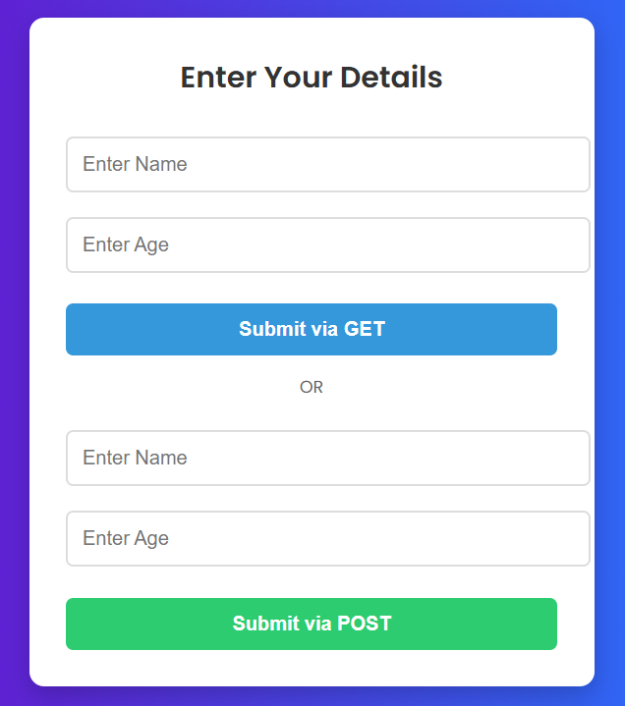

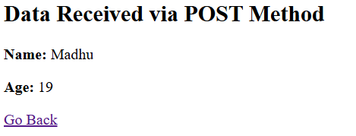

**RESULT:**

Thus the web application is created successfully.